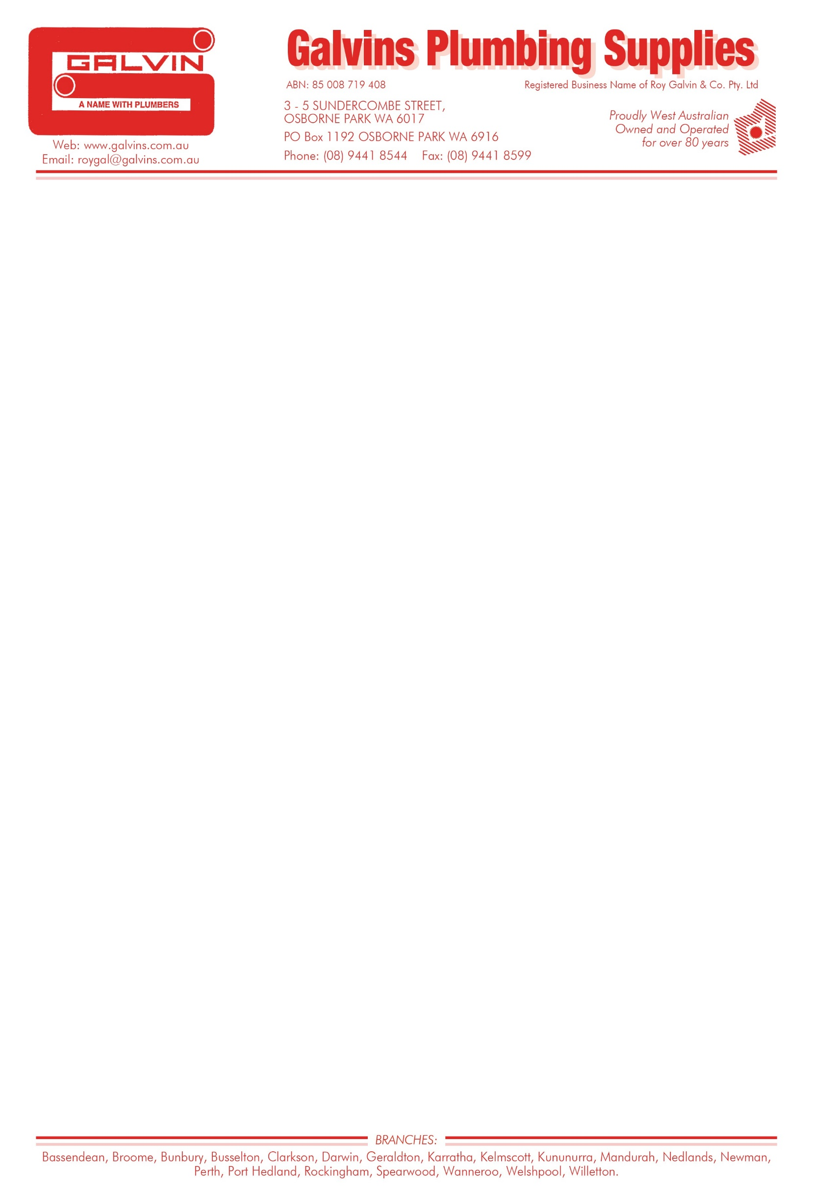

RE: Remote Area Tax Concessions and Payments Paper.

To Whom It May Concern,

Galvins Plumbing Supplies is a Western Australian, family owned, 4th Generation Plumbing Supply Business that has been trading for over 86 years. The Business now operates 21 stores throughout the Perth Metropolitan area, Southwest, Midwest, Pilbara, Kimberley and Northern Territory, giving us a good educated ability to comment from a business perspective on the current Remote Area Tax Concessions and Payments and any potential changes. Understanding this is an initial request for submissions from the Commission, I will keep it brief and to the point by listing the key factors affecting business owners that operate in Regional or Remote areas.

* Cost of living in Regional or Remote areas (Darwin and Geraldton included) is significantly higher than in comparison to Capital Cities or Suburbs thereof.
* Cost of Operating a Business is directly affected by the cost of living for an Employee, which as a direct result requires higher wages to retain good staff along with other incentives.
* Other incentives to attract and keep good staff that are classified as a Fringe Benefit are listed below and something that is not uncommon for a lot of Businesses that operate in Regional and Remote areas (Darwin and Geraldton included).
  + - Company provided Accommodation which in all cases for our business is a fully maintained house with all utilities paid for.
    - Company provided vehicle with all fuel and running cost fully paid for.
    - Company paid Flights for employees and their families.
* The exemption of FBT in many of the Regional and Remote areas we operate in is crucial to the survival and growth of ours, and many other businesses and directly affects employment in these Regional and Remote towns. We believe this needs to be expanded as there are Regional and Remote towns and cities that are not included in this incentive eg: Geradlton and Darwin, that should be due to cost of living and running a business.

Costs of operating Businesses in Remote and Regional areas are continually increasing, any form of assistance through this review will be beneficial to not only the business owners but employees and local community. Lastly, for input requested from the Issues Paper on a way of introducing ZTO to a business, this could be done in the way of Payroll tax exemption.

Yours Faithfully

Reyn Bennell

Managing Director

Galvins Plumbing Supplies

* We would also like to see the ZTO offered to Businesses in the form of Payroll tax exemption in these Remote and Regional areas