National Transport Regulatory Reform
Productivity Commission
LB2, Collins Street East
Melbourne Vic 8003

Email: transport@pc.gov.au

Dear Commissioners,

Accord is pleased to provide this submission to the Productivity Commission Issue Paper on the National Transport Regulatory Reform Inquiry (the Issues Paper).

Accord is the peak national industry association representing the manufacturers and marketers of formulated hygiene, personal care and specialty products, their raw material suppliers, and service providers. Accord member companies make and/or market fast-moving consumer and commercial goods including hygiene, personal care and specialty products, sunscreens, food contact sanitisers, industrial and agricultural sanitisers, household pesticides, disinfectants and specialty commercial products. Member companies include large global consumer product manufacturers as well as small dynamic Australian-owned businesses. A list of Accord member companies is available on our website: http://accord.asn.au/about/members.

Headline statistics for our industry’s economic footprint include:

• Membership is approximately 100 companies.
• Directly contribute more than 12,000 full-time equivalent jobs.
• Nationally, more than 175 offices and more than 65 manufacturing sites.
• 80% of Members export products overseas.

Accord’s comments relate to further opportunities to improve safety and productivity. In this submission, we have focussed our attention on opportunities for reform to further integrate and harmonise the regulation of the national freight market, and the impact of the remit and focus of the regulators on the goal of streamlined national freight market.

We are not a transport industry. However, businesses in the formulated hygiene, personal care and specialty products industry import, manufacture, distribute and export products and are significantly impacted by the Dangerous Goods Transport regulatory system.

There are many government departments and regulatory agencies, and a policy body involved in the regulation of transport of Dangerous Goods in Australia. Like other similar regulations, the regulatory responsibility boundaries are drawn on jurisdictional lines which poses the first hurdle to seamless transport of goods across all modes of transport.

An added layer of complexity is that the regulation for the transport of Dangerous Goods is based on an international standard, the United Nations Recommendations on the Transport of Dangerous Goods (UNRTDG). While the adoption of an international standard should in theory provide a good basis for harmonised regulatory requirements across Australia, the “Australianisms” that are adopted, often only based on perceived safety concerns, and without consideration of the impact on the supply chain, negatively impact on harmonisation.

To further complicate matters, the line of reporting from the responsible regulatory agency to the department and Minister responsible for the policy is either opaque or non-existent.

We have attempted to map the relevant local and international organisations, departments, regulatory agencies, rules and regulations in Attachment 1. Attachment 2 provides a comparison list of Australian state/territory Ministers on the Transport and Infrastructure Council, and Ministers responsible for the regulation of Dangerous Goods Transport in each state and territory.

Some of the issues we have experienced that arise from the complexity of the regulatory system and regulatory culture that has persisted in part due to that complexity are detailed in Attachment 3. These issues impact on the efficiency of industry operations and have the potential to reduce the effectiveness of the regulatory controls.

It is our view that the best method to resolve the issues we have identified is through a single set of regulations and a single regulatory agency with oversight of all Dangerous Goods transport regulations, similar to what occurs in the USA. We note that there are difficulties to this consideration due to our federated system, but it may be possible to develop and implement an approach that mimics a single regulation/regulator approach if there is strong support from all jurisdictions.

We thank you for the opportunity to provide comments to the Issues Paper. If you have any further queries or require any additional details, please do not hesitate to contact me.

Yours sincerely,

Catherine Oh
Assistant Director, Regulatory Reform

28 June 2019

Attachment 1 – map of relevant local and international organisations, departments, regulatory agencies, rules and regulations

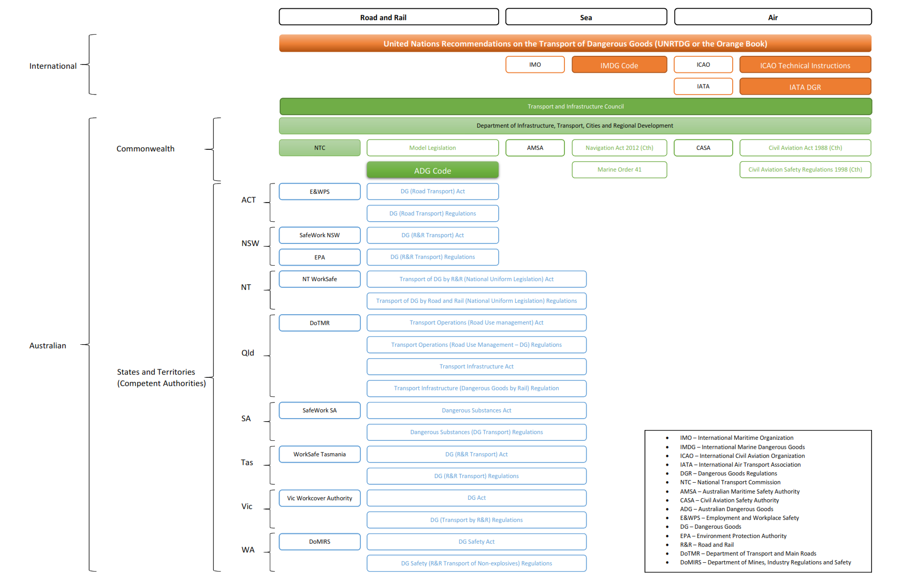
Attachment 2 - list of Australian state/territory Ministers on the Transport and Infrastructure Council, and Ministers responsible for the regulation of Dangerous Goods Transport in each state and territory

State/Territory | Transport and Infrastructure Council Members* | Ministers responsible for regulation of Transport of Dangerous Goods
Australia Capital Territory | Minister for Transport Canberra and City Service; Minister for Higher Education, Training and Research  Assistant Minister for Health; Minister for Climate Change and Sustainability; Minister for Corrections and Justice Health; Minister for Justice, Consumer Affairs and Road Safety; Minister for Mental Health | Minister for Employment and Workplace Safety
New South Wales | Minister for Transport and Roads | Minister for Better Regulation and Innovation; Minister for Energy and Environment
Northern Territories | Minister for Infrastructure, Planning and Logistics; Minister for Environment and Natural Resources; Minister for Climate Change | The Attorney-General
Queensland | Minister for Transport and Main Roads; Minister for State Development, Manufacturing, Infrastructure and Planning | Minister for Transport and Main Roads
South Australia | Minister for Transport, Infrastructure, Local Government;  Minister for Planning | Minister for Industrial Relations
Tasmania | Minister for Infrastructure; Minister for Education and Training; Minister for Advanced Manufacturing and Defence Industries | Minister for Building and Construction
Victoria | Minister for Transport Infrastructure; Minister for Roads; Minister for Road Safety and the TAC; Minister for Fishing and Boating | Minister for Workplace Safety
Western Australia | Minister for Transport; Minister for Planning | Minister for Mines and Petroleum; Energy; Industrial Relations

*The full list of Transport and Infrastructure Council Members can be found here: https://www.transportinfrastructurecouncil.gov.au/council_members/. All the current Council Members’ responsible portfolios are listed.

Attachment 3 - Issues

Lack of clear and transparent national policy on the transport of Dangerous Goods

Good regulation should start with a clear written policy that identifies the problem to be addressed and sets out the approach to addressing the problem. As far as we are aware, there is no clear national policy on the regulation for transport of Dangerous Goods. Instead, the policies are set in each individual jurisdiction for each mode of transport.

As noted in the Issues Paper, regulatory culture can make a significant difference in the regulatory system. This is reflected in our general experience where we have found that the approach to the regulation of transport of Dangerous Goods is different between, for example, the NSW Environment Protection Authority and the WA Department of Mines, Industrial Regulations and Safety.

This has resulted in difficulties in resolving any issues that arise, as there are multiple “goal-posts” that are constantly shifting.

Too many regulators – no overarching regulator

While we note that this is a common issue in Australia, it is an issue that is more acutely felt for transport regulations. Most products in Australia are shipped across Australia, across multiple jurisdictions. Regulatory interpretations that are contrary between jurisdictions cause an immediate issue for the movement of these goods.

Case Study 1 – Segregation requirement

Clause 3.4.3.2 of the Australian Code for the Transport of Dangerous Goods by Road and Rail (ADG Code) states that segregation requirements set out elsewhere in the ADG Code do not apply to Dangerous Goods packed in Limited Quantities in a cargo transport unit.

Clause 8.1.2.4 of the ADG Code states that incompatible Dangerous Goods in a cargo transport unit must be segregated.

The interpretation applied by industry and international regulators is that Dangerous Goods packed in Limited Quantities need not be segregated from each other or from other Dangerous Goods, even if they are incompatible.

Some regulators in Australia e.g. NSW EPA applies an interpretation that while Limited Quantities need not be segregated from each other, other Dangerous Goods must be segregated from incompatible materials within the Limited Quantities packages.

Unfortunately, to follow this unusual Australian regulatory interpretation, Limited Quantities cannot be marked and labelled to meet the Limited Quantities requirement alone, as this may not provide enough information to transport providers in order to segregate goods. This in turn removes some of the benefits of the Limited Quantities clause, which include simpler marking and labelling requirements in line with international practices.

While we note that this is not the interpretation of all Australian regulators, the package will only be marked and labelled once before transportation to its destination which crosses multiple jurisdictions. This is a particular difficult issue for imported products meeting export country and international sea and/or air transport requirements.*

*note 1: while air transport requires class labels on Limited Quantities packages, ID8000 Consumer Commodity is a recognised Class 9 ID number that is not recognised for road and rail transport.
*note 2: while the ADG Code allows movement of imported goods by road and rail to its first destination without amendment to marking, labelling or placarding of cargo, its application is limited to full containers and not to individual packages.

The way we regulate the transport of Dangerous Goods in Australia stands in stark contrast with the USA, where a single national law exists for transport by all modes (air, sea, road and rail) under the Department of Transport (DOT), administered by the Pipeline and Hazardous Materials Safety Administration (PHMSA).

Regulatory awareness and compliance

One of the more serious side effects of a complex regulatory system is that it is difficult to raise regulatory and compliance awareness.

While there are some mandatory training elements e.g. driver training, air transport Dangerous Goods acceptance training, there appears to be no general regulatory awareness or training activity by any of the regulators.

The crux of the issue may be that the information that is needed for such awareness raising and training is spread across multiple jurisdictions and multiple regulators. This means that a multi-regulator approach is needed to raise awareness in a way that is efficient and makes sense to the regulated entities. There appears to be no incentive for regulators to take such proactive approaches.

Best regulatory practice should include engagement with the regulated entities including awareness raising of regulatory and compliance requirements. The current regulatory system for the regulation of transport of Dangerous Goods does not easily allow this essential engagement, leading to reliance on punitive measure to enforce regulations.

The cost of complex regulatory system

There is a significant compliance cost for industry to comply with the transport of Dangerous Goods, some tangible and other less tangible.

Tangible costs

One obvious tangible cost of Dangerous Goods regulation is the Dangerous Goods surcharge applied by transport operators to move dangerous goods, which vary significantly. The cost incurred appears to be related to the size of the company where smaller companies are generally charged more surcharge relative to the overall freight costs. Smaller packages also appear to attract a higher “per package” fee.

We note that it is debatable whether regulation alone is responsible for the high cost associated with transport of Dangerous Goods. However, properly devised law focussed on the management of risks based on identified level of risk can have a positive role in reducing the burden on transport of lower risk goods. This is more difficult to achieve with a complex regulatory system involving multiple regulators with different risk appetites.

Another tangible cost is the up-front costs involved with training and purchase of regulatory compliance documents is more straight forward and easily calculated.

The International Maritime Dangerous Goods (IMDG) Code is referenced in the Marine Order 41, and International Air Transport Association (IATA) Regulations is referenced in the Civil Aviation Safety Regulations 1998 (Cth) as an alternative compliance to the International Civil Aviation Organization (ICAO) Technical Instructions. AMSA accepted training and CASA approved training are mandatory for a number of worker categories including workers that package or consign Dangerous Goods for transport.

The ADG Code is freely available and while no specific training requirements exists within the ADG Code, training cost has been added for general awareness training.

A sample cost of referenced codes and regulations and mandatory training is set out in a table below.

IMDG Code | AMSA accepted training (2 days) | IATA Regulations | CASA approved training (3 days) | ADG Code general awareness (1 day)
$337.50 | $385 | $329 | $550 | $220

The costs are incurred every two years with the exception of IATA regulations and ADG Code general awareness. The training must be repeated every two years (reduced cost for “refresher” trainings) and IMDG Code is updated every two years. IATA regulations are revised annually. There are no requirements to repeat ADG awareness training.

While the cost set out may not appear high, this is the cost incurred by every business simply to gain information on compliance. Generally speaking, compliance is best encouraged if the regulatory requirements are freely available.

Further, as each regulation, code and training only focus on their own silo, individuals that receive the necessary mandatory training may still be at a loss to understand how the requirements translate to their own situation, as they look to comply across all jurisdictions. This is particularly the case where the products are in small packages or are not necessarily easily recognised as Dangerous Goods, as the greatest discrepancy across the modes of transport is in the area of small quantities and small packages.

Significant benefits may be possible if some of these requirements could be finessed. For example, a single training course that covers all three modes of transport over three days can as a minimum halve the cost of the training as well increase productivity of that worker by three days.

Intangible costs

There are regulatory costs arising from “Australianisms” or variations from international requirements that are difficult to identify and quantify. One simple example is provided below in Case Study 2.

Case Study 2 – Inner Packaging Testing requirements only applying to Australian Manufacturers

Section 6.1.4.21 of the ADG Code sets out an “Inner Package” testing requirements that are unique to Australia. It is only applicable to inner packagings that are filled in Australia i.e. imported products that were filled overseas are not required to comply with the test requirements.

Recently, a company with manufacturing facilities in Australia and overseas investigated the viability of moving a manufacturing operation from overseas to Australia, for a product that is already imported into Australia fully packaged. During the course of investigations, it was identified was that the product packaging (Inner Packaging) of currently available overseas manufactured product did not pass the Australian Inner Packaging test requirements set out in Section 6.1.4.21 of the ADG Code.

The company must decide between maintaining manufacturing operations in Canada and continuing to import the product into Australia and redesigning the packaging to meet the ADG Code requirement.

Accord provided an Issues Paper to the NTC for the next round of amendments to the ADG Code. Maintaining the inner packaging testing requirement would continue to unfairly disadvantage Australian manufacturers.

Currently, the onus is on the regulated industry to identify “Australianisms” and justify why these should be removed. Our experience to date is that the regulators pay little to no attention to commercial impacts of deviating from international requirements, to the detriment of Australian industry.

Adapting and future planning

Online retailing is growing. While the usual images of Dangerous Goods are probably not in the mix of this online retailing trend, household consumer goods that are also Dangerous Goods e.g. nail polish, household cleaners, etc. are among the growing number of items shipped through online sales.

The way we regulate dangerous goods needs reconsideration in the face of these trends, which have moved us away from the traditional model of:

Manufacturer Wholesaler Retailer walk in customer

Where increasing number of small quantities of dangerous goods, often mixed with non-dangerous goods make up the freight profile, we need to consider how to adapt our regulations to maintain the efficiency of the regulatory system.

Our regulations should also adapt to new technologies and plan for further technological progress. There are technologies that exist now that have the potential to improve safety and efficiency of transport of Dangerous Goods. One such example is the use of Radio Frequency Identification (RFID) technology, which we understand is currently used in China for identification of freight containers. This has the potential to remove or reduce documentation and labelling, while providing greater, more targeted information when and where they are needed.

It is doubtful whether meaningful future planning, including consideration of the above trends is possible within the current complex web of Dangerous Goods transport regulations.

Results from Accord Industry Size and Scale Survey 2018
https://www.boatbooks-aust.com.au/product/imdg-code-2018-edition-incorporating-amendment-39-18/
http://www.airsafe.com.au/dangerous-goods-by-sea-full-accept-two-day-course-or-online/
https://www.iata.org/publications/store/Pages/DGR-print-manuals.aspx
http://www.airsafe.com.au/dangerous-goods-by-air-acceptance-initial-three-day-course/
http://www.airsafe.com.au/dangerous-goods-by-road/
Top 10 Ecommerce websites of Australia in 2019; https://www.webalive.com.au/ecommerce-statistics-australia/

