Dear Mr Brennan, Dr Roberts, and Ms Siegel-Brown
Submission to the Productivity Commission’s Review of the National School Reform Agreement
The National School Resourcing Board (‘the Board’) welcomes the opportunity to make a submission to the Productivity Commission’s review of the National School Reform Agreement.
The Board is pleased that all Australian governments have acknowledged the importance of nationally consistent data by including the enhancement of the national evidence base within the national policy initiative (NPI) C(iii) Improving national data quality under the current National School Reform Agreement.
The Board plays a significant role in ensuring public confidence in the Commonwealth schools funding model by conducting independent reviews of various aspects of the model as well as providing independent oversight of funding arrangements, including assessing whether jurisdictions and schooling systems are meeting their school funding obligations. Proper resourcing of Australian schools is essential if governments are to meet the National School Reform Agreement’s overarching objective of providing a high-quality and equitable education for all students.
In the course of its work, the Board has become acutely aware of the types of data on schools and students that are currently made available and, more particularly, the types that are not. The lack of certain types of data in the national evidence base has limited the capacity of not just the Board but also of other agencies and governments to accurately assess the effectiveness of school resourcing to improve the educational experience.
The Board supports remedying current shortcomings in the national evidence base by expanding the school level data that states and territories and school systems currently make available to include greater detail on the school funding allocated by governments and systems as well as expenditure at the school level, including enhanced ability to trace the source and application of funding overall and for specific groups (such as students with disability and Indigenous students). It is important for the Board’s work for it to be able to access improved data to analyse the intersection of funding decisions with student wellbeing and improvements in educational opportunities and outcomes.
Thank you for taking the time to consider this important issue. The Board would welcome the opportunity to meet with you to further discuss these issues.

Yours sincerely

Mr Michael Chaney AO
Chair, National School Resourcing Board
16 June 2022

Submission from the National School Resourcing Board

Background
The National School Resourcing Board (‘the Board’) was established under s.128 of the Australian Education Act 2013 (Cth) to provide greater independent oversight of, and advice regarding, Commonwealth funding to Australian schools.
In line with recommendations from the 2011 Review of Funding for Schooling led by Mr David Gonski AC, the Board’s reviews help ensure both public confidence in the funding model and that jurisdictions and school systems meet their school funding obligations.
The Board has eight members with expertise in education and public policy, finance and governance structures, and legislative frameworks. Members are nominated by the Commonwealth, states and territories, and the non-government sector (National Catholic Education Commission and Independent Schools Australia). All members are appointed by the Australian Government Minister for Education.

Overview of the submission
Enhancements to the national evidence base are of particular interest to the Board. We note the progress made in the implementation of a national unique student identifier (USI) and the establishment of the national evidence institute – the Australian Education Research Organisation (AERO) – to inform teacher practice, system improvement and policy development. We also note that there are several projects underway to enhance the national evidence base around school readiness, student wellbeing and post-school destinations in line with NPI C(iii). The Board supports all efforts to expand the national evidence base to provide consistent, reliable information on schooling.
According to the most recently published National School Reform Agreement: 2020 Annual Report on progress in implementing the national policy initiatives, Education Ministers may “consider strategic opportunities to enhance the national evidence base, including options for measures of child development status at school entry, student learning gain, general capabilities, post-school destination information, attainment, retention, wellbeing, post-school outcomes.”
While the enhancements and work undertaken to date are important initiatives, the focus has been limited to national frameworks and approaches and data related to rather narrow measures of student outcomes. There are no initiatives to enhance the national evidence base in relation to wider issues such as the resourcing mechanisms that have a less direct but still significant impact on school outcomes. Similarly, there has been no focus on broadening the national evidence base to consider reporting the broader contextual factors that are known to influence student outcomes. In particular, it is well known that socioeconomic status is a strong driver of student academic performance and broader wellbeing outcomes, particularly at the school level, explaining a significant percentage of the variation in performance between schools and students.
Given the considerable empirical evidence demonstrating the significant impact of school-level socioeconomic status on student outcomes, there is a clear alignment between the Board’s ongoing remit and work in the schools funding space and the Commission’s expressed interest in “the key policy and external drivers of student outcomes related to academic achievement, engagement, and skill acquisition over the past decade” as well as its stated interest in “whether the NSRA is measuring the ‘right’ outcomes, using the ‘right’ metrics.” The Board considers that there is a strategic opportunity to improve the collection of data around school funding so that potential links between resourcing and student outcomes, both academic and wellbeing, can be better examined to inform sound policy development.

The Board’s work
Through its reviews on different aspects of school funding, the Board has become acutely aware of the paucity of information on school-level funding and expenditure, specifically where schools are funded through specific systems (whether state and territory or non-government schools). While aggregate estimates per school are provided and available on allocations, there are no itemised estimates of funding allocations or of expenditure.
The Productivity Commission notes in its call for submissions that “the nationally agreed reforms set out in the NSRA were, in part, a response to evidence that simply providing more funding does not in itself improve student outcomes. The OECD has found that for high-income countries like Australia it matters more how money is spent, than how much is spent (DESE 2021h, p. 1)”.
The Board acknowledges this view, but notes the paucity of evidence available to make cogent policy decisions. In Australia, information on both the quantum of the specific funding that is made available both to systems overall and to individual schools in order to support the needs of different student cohorts as well as the impact, quality and equity of spending is important, although the Board noted that evidence from the OECD’s Programme for International Student Assessment has repeatedly shown that the wealth of a country only impacts on average student achievement for low and middle income countries. In countries like Australia, targeting of resource allocation as well as the overall quantum of funding is important, particularly for socio-economic disadvantaged segments of the population that rely totally on government outlays to support high quality, effective schools. The OECD’s report finds that for high income countries (above a threshold of USD 20,000 per capita) the cumulative expenditure on education is unrelated to student performance. Instead, the OECD argues that international evidence supports the view that top performance in high income countries is more closely related to how money is invested in teachers.
The simple reality is that there is no consistent transparent information currently provided by Australian governments or by the non-government sector that can be used to assess how school funding is being spent, or even how much funding each school actually receives. In order to gain a proper understanding of how resourcing impacts student outcomes, school systems would need to be required to share the more detailed school-level income and expenditure data that are currently not accessible in a transparent or consistent way.
For these reasons, the Board’s view is that the lack of detailed school funding data is a major shortfall in the current national evidence base on schooling.

School funding, accountability and data - what is the value in knowing how schools spend their funding?
It is important that the national education evidence base addresses not only student and school outcomes but also the inputs that are responsible for driving those outcomes, including the allocation and expenditure of school funding. As the ANAO observes “when an entity has large data sets, organising these into data analytics platforms will support informed decision making and policy development.” Allocating funding to ensure that the national evidence base includes the reporting of consistent school-level expenditure data on a regular basis would create a valuable data asset and thus be money well spent. The Board understands from its work that most states and territories already have school level financial data, meaning the challenge is to make it available in a national evidence base.
In its report, The Funding of School Education: Connecting Resources and Learning, the OECD provides analysis and policy options to assist governments in achieving their education policy objectives through the efficient and equitable use of financial resources. The OECD suggests that, regardless of the allocation mechanism, the method used to identify differential resource needs should be subject to periodical reviews and based on national research, reliable data and transparent criteria.
Evaluating and monitoring of school funding should serve to hold decision makers accountable, make the use of resources transparent, and ensure that available resources are used efficiently and equitably. The effectiveness of these activities depends on reliable data and information management as well as adequate indicator frameworks and benchmarking systems. Rather than focusing on compliance alone, systems should develop capacity to relate inputs to associated educational processes and outcomes while bearing in mind the challenges involved in evaluating efficiency and outcomes in the area of education. Policies and programs should be subject to impact evaluations and their results should be used to inform strategic budget planning processes.
In their 2015 analysis, Hanushek and Woessman found that investing money alone only impacted the quality of learning outcomes for students up to a point. In fact, for countries like Australia that invest at least USD 50 000 per student between the ages of 6 and 15 the data showed no relationship between cumulative funding and the quality of students’ learning outcomes: two countries with similarly high funding levels could produce very, very different results for their students.
This important analysis again confirms that for Australia – where essential levels of funding are already assured – the focus for schools and governments should centre on how to best spend resources. For example, Hanushek and Woessman noted that whenever high-performing education systems had to make a choice between a smaller class size or a better quality teacher, they opted for the latter. They also commented on the striking asymmetry in the relationship between skills and money: while improved skills consistently generate more money for individuals and nations, improved skills do not automatically require nations to spend more money.
Other analysis suggests that there may be benefits from re-distributing funding so that more support is provided for students from lower SES backgrounds. For example, in their 2015 analysis in the United States on the effects of school spending on educational and economic outcomes, Kirabo et al. found that USA schools spending 10 percent more per pupil each year for all twelve years of schooling led to “0.27 more completed years of education, 7.25 per cent higher wages, and a 3.67 percentage point reduction in the annual incidence of adult poverty”. They also reported that the effects were much more pronounced for children from low-income families. The gains in student outcomes associated with increased spending were associated with sizable differences in measured school quality - including reductions in student-to-teacher ratios, increases in teacher salaries, and longer school years.
The US analysis was made possible by the availability of school-level data on income, expenditure and classroom practice. The problem in Australia is that data that can link funding, classroom practices and school outcomes are not made publicly available, although they do exist.
In the Deloitte Access Economics (DAE) analysis commissioned by the Australian Government Department of Education and Training in 2016, school level analysis demonstrated significant differences between Australian schools in terms of student performance after controlling for some context factors. This implies that some schools are engaging in pedagogical practices that provide an advantage to their students. DAE suggested that by identifying what these practices were, and using the appropriate policy levers to target them (including funding appropriations), there was scope for Australian governments to improve student outcomes.
Information and data on the interventions being employed in Australian schools would also be useful to Australian researchers and should be included in the national evidence base. It would be valuable to be able to link the employment of specific interventions to the educational outcomes of students – especially those from disadvantaged backgrounds. Work on the national evidence base could be enhanced by the NPIs following the United Kingdom’s Education Endowment Fund’s (EEF) example by providing funding for high-quality, independent evaluations of promising programs and interventions using predominantly randomised control trial (RCT) designs.
While the EEF experienced some initial resistance from the education research community to the use of RCTs, in the past ten years it has commissioned approximately 19 per cent of all known RCTs in education globally. The EEF has achieved this through:
- independent evaluation by appointing a panel of evaluators through a competitive tender process
- reporting transparency – requiring a prespecified protocol and statistical analysis plan to be published on its website for every trial
- data archiving and reproducibility – creating a data archive to enable checking of the reproducibility of evaluator estimates, track long-term outcomes and support secondary research and reanalysis across trials
- evaluation design – paying particular attention to implementation and process evaluation (IPE) and measurement of outcomes.
Through these efforts, the EEF has generated a large body of evidence available to government and researchers to help identify what does and does not work in the United Kingdom’s schools. These trials are part of a range of evidence generated by the EEF, including the Teaching and Learning Toolkit (which is based on meta analyses combining studies of varying quality, and undertaken on different ages, subjects and countries). The Board notes that Australia’s AERO creates evidence-based resources and information for education practices and suggests the Commission consider what the value might be if the AERO remit was expanded, with appropriate funding, to place more emphasis on the value of RCTs to the national evidence base.

The current unavailability of data limits the Board’s ability to conduct reviews
The historic Gonski Review of funding for schooling also stressed the need for an equitable school funding system, noting that “the effectiveness of the schooling resource standard rests on confidence in the independence and transparency of the process for setting the per student amounts and loadings”. The review panel recommended the establishment of an independent National School Resourcing Body that would have responsibility for researching and providing advice on how to best measure school effectiveness. In particular, the Review noted that in order for a National School Resourcing Body to provide this function it would require “significant improvements in the collection of nationally comparable data”. While the Board was established as part of the Commonwealth’s response to the Gonski Review, it is limited in performing this critical independent research and analysis role because of the lack of comparable data between the government and non-government school sectors.
Currently, ACARA’s My School is the only Australia-wide financial data source available to the Board that covers all school sectors. However, this data is limited to very high-level information relating to the ongoing operating costs of schools, capital expenditure, and deductions for income used to invest in capital infrastructure. The lack of detailed school level information on different areas of expenditure severely limits the usefulness of the data not only for the Board but for any Australian researcher.
The Board has sought school-level income and expenditure data from all jurisdictions for the purpose of its Review of Regional Schooling Resource Standards Loadings. The data provided by several states has proved highly valuable for the Board’s analysis, however the results of the review can currently only be regarded as indicative given the lack of data from all jurisdictions. This is an example of the way in which expanding the data reported in the national evidence base would help research and analysis, as geolocation is another well known factor that impacts student outcomes.
The screenshot provided below depicts the MySchool Finance screen for a randomly chosen Australian government school. The high-level data items include:
- Income: Australian Government and State/Territory recurrent funding; Fees, charges and parental contributions; Other private sources
- Deductions: Income allocated to capital projects; Income allocated to future capital projects; Income allocated to debt servicing
- Capital expenditure: New school loans (non-government schools only); Income allocated to current capital projects; Other private sources.
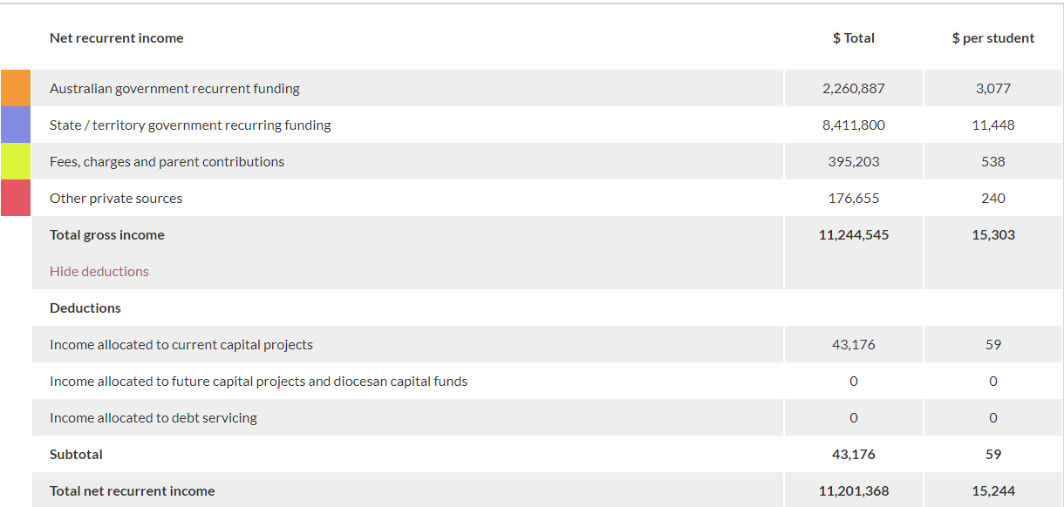
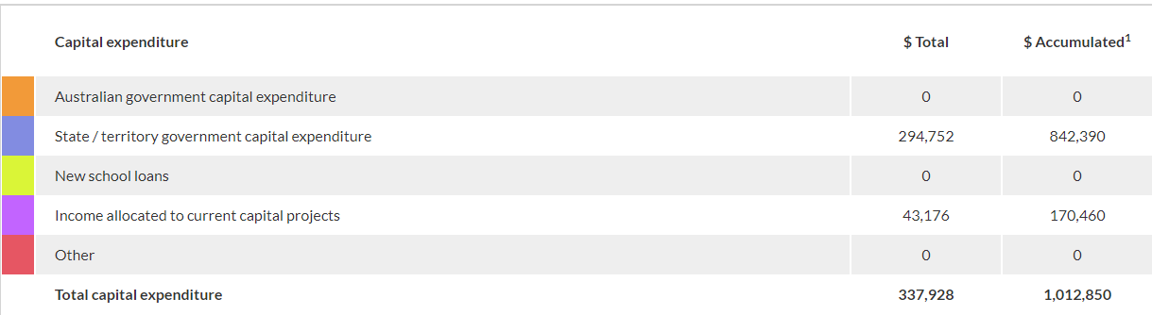
Source: Screenshot of random secondary government school, MySchool, 2022
The Australian Government Department of Education Skills and Employment (DESE) collects Financial Questionnaire (FQ) data for all non-government schools. This includes but is not limited to, line-item breakdowns of all:
- sources of school income (including all grants, gifts and allowances)
- recurrent expenditure (including salaries, wages, allowances, administrative and operating expenses and costs for interest, depreciation and amortisation)
- staff-related expenses (such as insurances, redundancy payments and fringed benefits tax)
- employer contributions for superannuation
- any government capital grants
- capital funds from international students and fees and levies allocated for capital purposes
- other capital income (such as gains on sales of buildings or other investments)
- capital expenditure (with some limited exclusions)
- trading activity and loans
- general financial information (such as current assets and cash and cash equivalents)
- current and non-current liabilities.
The high-level financial information that is reported via MySchool is drawn from the FQ data but does not represent the breadth or depth of the whole of the FQ, which is not made publicly available for the purpose of research and analysis by bodies such as the Board. The FQ exercise not only contributes the non-government sector component of the MySchool Financial data, but also addresses other requirements such as monitoring ongoing income and expenditure for schools and systems and satisfying Australian Charities and Not-for-profits Commission (ACNC) financial reporting requirements.
The Board would see value in the Commission exploring as part of its assessment of the NPIs whether it is possible to achieve this same level of consistency and transparency for the eight organisations which comprise the government sector as it has been for the non-government sector.

How to enhance the national education evidence base
The Board supports and encourages continued development and enhancement of the national evidence base, particularly through the following possible avenues:
- New bilaterals related to the new National School Reform Agreement should include clauses related to provision of data. Having more detailed information at a school level on how funding is being used will help better assess the relationship between school resources and student outcomes as well as support the National School Resourcing Board in its independent oversight of Commonwealth school funding arrangements.
- Any clauses related to data in the new bilateral agreements should require that more granular level data be provided than is currently required to allow more substantial and useful research to be undertaken.
  - At a practical level this could be achieved by the Australian Government working with states and territories to agree a targeted questionnaire for the government sector to allow for provision of meaningful data around school-level income and expenditure – what is currently collected for the non-government sector through the Financial Questionnaire tool could serve as a broad point of reference for a more targeted questionnaire for the government sector.

NPI C(iii) – Improving national data quality, consistency and collection to improve the national evidence base and improve policy
DESE, 2021, National School Reform Agreement: 2020 Annual Report on progress in implementing the national policy initiatives at https://www.dese.gov.au/download/12568/national-school-reform-agreement-2020-annual-report-progress-implementing-national-policy/23709/document/pdf/en
Section 2.1 The factors which contribute to student outcomes – a brief literature review, Deloitte Access Economics, School quality in Australia: Exploring the drivers of student outcomes and the links to practice and school quality, at https://www.dese.gov.au/quality-schools-package/resources/school-quality-australia-exploring-drivers-student-outcomes-and-links-practice-and-schooling-quality
p.7, Productivity Commission, 2022, Review of the National School Reform Agreement - Call for Submissions at https://www.pc.gov.au/inquiries/current/school-agreement/call-for-submissions
Ibid
Note that although this analysis of funding vs student performance was limited to the impact on reading literacy only, OECD research has continuously shown strong evidence that a student’s performance in other key domains such as mathematical and scientific literacy is clearly linked to their reading ability. The Board therefore considers it valid to assert that the government’s focus should be on how funding is best spent to improve student and school outcomes rather than how much funding is given.
OECD, 2012, PISA in Focus #13, Does money buy strong performance in PISA? at https://www.oecd-ilibrary.org/education/does-money-buy-strong-performance-in-pisa_5k9fhmfzc4xx-en
p.13, 2021, Australian National Audit Office, Monitoring the Impact of Government School Funding – Follow-up, Auditor-General Report No. 37 2020-21 Performance Audit at https://www.anao.gov.au/sites/default/files/Auditor-General_Report_2020-21_37.pdf
OECD, 2017, The Funding of School Education – Connecting Resources and Learning, Summary in English, at https://www.oecd-ilibrary.org/sites/d5849abb-en/index.html?itemId=/content/component/d5849abb-en
OECD, 2017, The Funding of School Education – Connecting Resources and Learning, Summary in English, at https://www.oecd-ilibrary.org/sites/d5849abb-en/index.html?itemId=/content/component/d5849abb-en
p.12, Hanushek E & Woessman L, 2015, Universal Basic Skills, OECD at https://doi.org/10.1787/9789264234833-en
C. Kirabo Jackson, R. Johnson and C. Persico, 2015, National Bureau of Economic Research Working Paper 20847 – The effects of school spending on educational and economic outcomes: evidence from school finance reforms, https://www.nber.org/system/files/working_papers/w20847/w20847.pdf
p.xiv, Deloitte Access Economics, 2016 The economic impact of improving school quality, AG DET at https://www.dese.gov.au/download/3942/economic-impact-improving-school-quality/5819/document/docx/en
Edovald, T & Nevill, C, 2020, Working Out What Works: The Case of the Education Endowment Foundation in England, ECNU Review of Education, at https://doi.org/10.1177%2F2096531120913039
p.xviii, Gonski, D et al, 2011, Review of Funding for Schooling: Final Report, https://www.dese.gov.au/school-funding/resources/review-funding-schooling-final-report-december-2011
Ibid

