Australia’s Indigenous art industry is worth a quarter of a billion dollars, so why do artists only end up with a fraction of the profits?

ABC Online news
Politicial reporter Dana Morse
Posted Tue 19 Jul 2022 at 4:18am
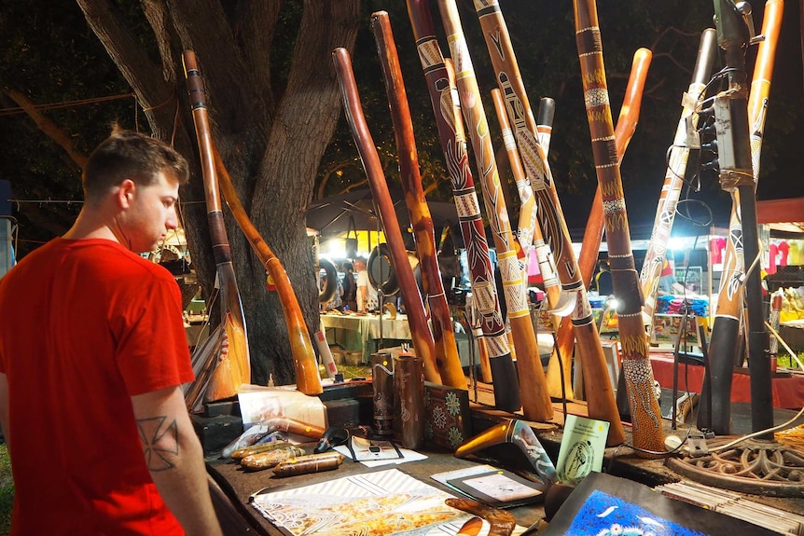
According to a new report, only one in three Indigenous artworks is produced by an Aboriginal or Torres Strait Islander person. (ABC News: Matt Garrick)

Aboriginal art is becoming a big business, with both Australian consumers and tourists wanting to take home a memento from Down Under.

Key points:
- In 2019-20, $250 million worth of Indigenous art and crafts were sold
- However, only one in three Indigenous artworks is produced by an Aboriginal or Torres Strait Islander person
- The Productivity Commission wants inauthentic Indigenous art, crafts and souvenirs to be clearly labelled
However, it's not easy to verify if your boomerang or painting came from an Indigenous artist or if it was made in Indonesia, and it's Aboriginal and Torres Strait Islander people who are suffering as a result.
Around $250 million of Indigenous art was sold in 2019-2020, but a report from Australia's Productivity Commission shows only around one in three items sold were actually produced by an Indigenous artist or business.
Wiradjuri woman Jarin Baigent has seen firsthand how Aboriginal artists get cut out of their own market, with cheap, mass-produced copies forcing traditional owners out of business.
Jarin Baigent says Aboriginal artsists are being cut out of their own work. (Supplied: Jarin Baigent)
"We've got uncles who do make handmade boomerangs, who at one point in time probably had a pretty solid opportunity to supply somewhere," she said.
"Then you see the one of these business models that participate in fake art that will go and find a supplier overseas, generally it's made in Indonesia, and that supplier is going to go with the cheaper option.
"Then you've got an uncle there who doesn't have any income anymore. He's creating authentic Aboriginal art and artefacts, and he's completely cut out of the industry."
It's part of the reason Ms Baigent co-founded Trading Blak, a marketplace for all Aboriginal-owned and operated businesses to sell their products.
Ms Baigent said she also wanted to combat a rise in "business blackface", where non-Indigenous companies selling products commonly produced by Indigenous people but are not up-front about where the profits are going.
"I had a non-Aboriginal business who participates in 'business blackface', where they deceive customers by thinking that they are Aboriginal-owned," she said.
"[They] did a business arrangement with me and then went and duplicated my products.
"What you find is that Aboriginal people who step into business or art as economic pathway, it's encouraged to start off with and then you go into this entire industry where you see such terrible exploitation that is so heavily resourced."

Tackling fakes a tough problem
Fakes and copies are a big problem for Indigenous artists trying to start a business, but it's not easy to enforce rules around who can create certain styles of art.
Productivity Commissioner Romlie Mokak said it was also difficult to expect consumers to be able to tell the difference.
"The consumer would find it very difficult, in some cases, to determine what is authentic and what is inauthentic, so they can't make the judgements themselves. You can't help but lead to the conclusion that this comes at a cost and [an] economic cost," he said.
Previous schemes — such as the boomerang tick introduced more than 20 years ago — were a way for producers to show they were making authentic products, but the uptake was limited and presented another barrier for getting products into the market.
Romlie Mokak says it's difficult for consumers to tell the difference between authentic and inauthentic art.(Image: Twitter)
A new report from the Productivity Commission suggests the problem could be tackled from the other side by putting the onus back on non-Indigenous producers.
It recommends "inauthentic" art, crafts and souvenirs be labelled as such, so that consumers can make an informed choice about the businesses they are supporting.
Mr Mokak said it would be a much-fairer system.
"We think that the burden ought to be on the producers of inauthentic products," he said.
"What that means is that there's less of a burden then on Aboriginal and Torres Strait Islander people themselves who are making authentic products to have to label their products as authentic."
Ms Baigent said she welcomed the idea but would like to see additional deterrents for producers who undercut and copy Indigenous businesses.
"Non-Aboriginal participation and exploitative business models that we're seeing across fake Aboriginal art or blackface businesses or other exploitative models, it's really important to be clear about the fact that they're actively blocking our children's futures," Ms Baigent said.
"They're actively blocking Aboriginal people's ability to thrive and prosper in the business sector.
"I think there needs to be punitive infractions given, too. We need to be issuing fines to people [who] are partaking in this, you know. This has been going on for generations."

Protecting profits and protecting culture
The labelling scheme is just one of a number of measures the Productivity Commission is recommending be implemented to ensure Indigenous producers get a fair share of the art and souvenir market.
Mr Mokak said that it was not just the loss of profits that was harming communities, but the unauthorised reproduction of their stories and knowledge in inauthentic artworks.

Indigenous cultural IP and copyright
Cultural intellectual property is a right that Indigenous people have to protect their traditional art and culture but it can often be overlooked. Here's what it entails.
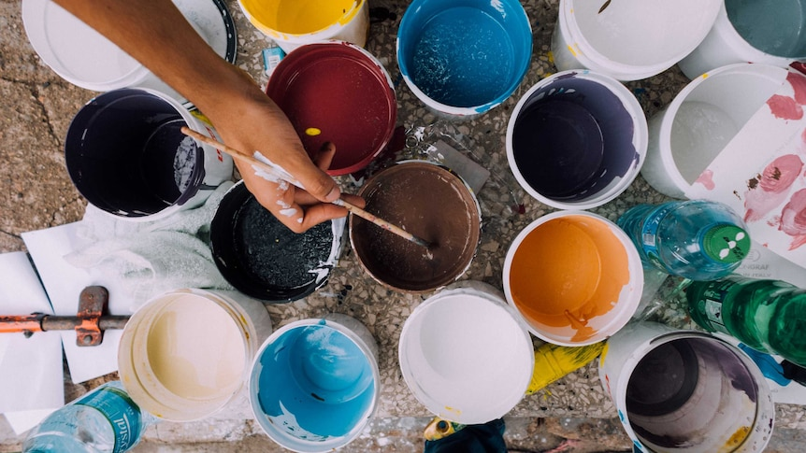
Read more
The commission also wants to see Indigenous Cultural Intellectual Property (ICIP) laws strengthened, so that things such as sacred symbols can be protected from wider use.
"We don't have laws in this country that give specific protections to Indigenous cultural and intellectual property," Mr Mokak said.
"There should be new legislation to recognise the rights of Aboriginal Torres Strait Islander people to their traditional knowledge and cultural expressions.
"They should have an ability, in legal terms, a course of action, where others have breached those protections, where a non-Indigenous person might have plagiarised or copied a traditional motif belonging to traditional owners."
Ms Baigent said the majority of consumers wanted to buy from Indigenous-owned and run businesses and, ultimately, felt conned when they found out that was not where their money was going.
"Every single day, we have a customer that says, 'Oh, my gosh. I thought that was an Aboriginal business. I feel really angry. And I feel really misled'. Every single day we hear those comments," she said.
"We called, probably about two years ago, for non-Aboriginal businesses to clearly state in their marketing that they are non-Aboriginal owned.
"Some complied, others didn't. I think the ones that complied did that because it is legislated that you cannot mislead the public, you cannot mislead consumers."

Inauthentic art just the tip of the iceberg
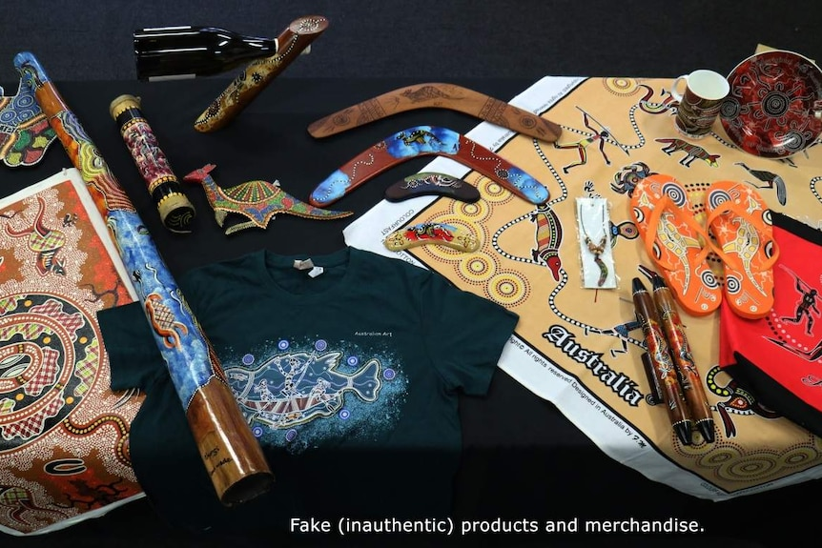
Inauthentic Indigenous items mass-produced overseas.(Supplied: Indigenous Art Code)
Ms Baigent said "business blackface" was rife in a number of industries where Indigenous people have tried to break into the market, including food, tourism and clothing.
"They're using is First Nations knowledge. They're decorating their packaging with our artworks, in our culture. They're heavily marketing their socials and outputs with Aboriginal people's faces, to give a misleading misrepresentation of who and what they are," she said.
"If you actually want to have impact, and respect Aboriginal people, respect our culture and invest in our communities, and know that you're buying something that's authentic, then, yes, we do need something that shows consumers where they can do that.
"An Aboriginal business is going to have impact. We're going to have intergenerational impact. With the setting up of that business, we're more likely to employ Aboriginal people, and that intergenerational knowledge and resources, well, is invaluable."
The report from the Productivity Commission will now go out for consultation, before a final report is compiled and submitted to the federal government at the end of November.

