Submission to the Productivity Commission Inquiry into Mental Health
Professor Leonie Segal, Foundation Chair, Health Economics & Social Policy, University of South Australia
Dr Jackie Amos, Senior Child & Adolescent Psychiatrist, Adjunct Fellow, University of South Australia
This submission draws on:
- a 12-year research program, led by Professor Segal focused on intergenerational transmission of profound disadvantage, including an NHMRC funded study to establish the services required to prevent mental illness. The research has been reported in 8 publications (included within the reference list).
- 20+ years of clinical experience of Dr Amos, a Child and Adolescent Psychiatrist, working with children and families struggling with the consequences of intergenerational child maltreatment, including serious mental health, emotional and behavioural disturbances in the children, who engage with CAMHS or non-government family support programmes
- Doctoral research by Dr Amos to understand why mothers maltreatment their children, in order to hone a therapeutic response to help these highly traumatised families. This work is reported under the ‘Causal pathways’ section of the Reference list.
- Studies of the effectiveness and cost-effectiveness of clinical nutrition therapy in mental health
In this submission we respond first with key understandings (section A) that have come out of this research – which then informs section B comments on the Productivity Commission’s Issues Paper on the Social and Economic Benefits of Improving Mental Health.
A Key Understandings - The case for prevention
The primary causal pathway into psychological distress and disturbed thinking, emotions and behaviours in infants and children and subsequent mental illness in adolescents.
Overview: There is now a large and convincing literature indicating that the primary causal pathway into psychological distress in childhood and adult mental illness is toxic stress (serious adversity) in childhood. This understanding creates the logical possibility of preventing mental illness and the associated consequences of lost quality of life, premature death, cost to services and lost production. Understanding causal pathways informs how to prevent mental illness and minimise the negative consequences.
The implication of this understanding is that in order to prevent childhood distress and disrupt possible escalation into adult mental illness (see Figure 1), as a society we need to ensure that each child has a deeply nurturing and supportive environment (or at least a family environment that is ‘good enough’. In addition, we need to address as early as possible observed psychological distress/disturbed behaviours in children with well-resourced effective strategies. Given the importance of these pathways an effective response holds the possibility of dramatically reducing childhood and adult mental illness.
The primary source of toxic stress (Shonkoff et al., 2012) is child abuse and neglect (especially familial), which creates a profound sense of fear and shame. Other family circumstances are also pertinent, in potentially increasing the stress load such as, deep poverty, insecure housing, parental separation, parental mental illness, death of persons close, food insecurity, sleep deprivation, histories of trauma (child removal, dispossession, racism, exposure to community violence).
Early childhood trauma affects brain development in multiple ways, creating the preconditions for disturbed childhood behaviours (aggression, poor impulse control, lowered capacity for reasoning and forward planning, difficulty in focus and concentration etc.) and mental illness in childhood, adolescence and adulthood. An excellent overview of the myriad ways in which child abuse and neglect affects the developing brain is provided by The US Department of Human Services, Child Bureau, Issues Brief (2015) on the effects of child maltreatment on the developing brain. The science is well-established.
Early life adversities, specifically familial child abuse and neglect disrupts the capacity for healthy relationships. In seminal work by Amos, Segal and colleagues (2011, 2014, 2017, 2018), drawing from animal models and evolutionary biology, it was hypothesised that agonic mode (Price, 1992; Kortmulder and Robbers, 2005) is the relational blueprint in these families, akin to group living mammals exposed to serious threat from within the group. Agonic mode is a low-level equilibrium characterised by tightly defined hierarchical/dominance-submissive ordering, where power is used for the benefit of the powerful, where all parties, as a survival strategy become hypervigilant and threat-driven with narrowed focus of attention. People are perceived and treated as objects rather than subjects, and an individuated sense of self with agency fails to emerge. It is a highly shame-based relationship model, in which compassion and empathy have a limited place. The agonic relational model has profound implications for emotional and behavioural development of infants, children and adolescents and sets the relational map, even when a toxic family environment is no longer present.
Combined effect of relational disturbance and disrupted brain development caused by toxic stress When agonic mode is the relational blueprint, the capacity for successful inter-personal relationships is undermined. This relational model when layered on top of the toxic effects on brain development, and likely early substance use as a self-medication strategy, sets a path into mental illness and for some the preconditions for violence and criminal involvement.
There are only so many insults the brain can take, especially in the early development phase, before the disturbed thinking and behaviours identified with mental illness becomes inevitable. The damage is compounded by adoption of a relational model which is protective in the context of threat but problematic otherwise. Exactly where the tipping point, in terms of how much adversity, will over-whelm capacity for ‘normal functioning’ will vary for each individual. For parents to abuse or neglect their own children is aberrant in a deep evolutionary sense. And for a child to be maltreated by their own parent poses a primal existential threat, that will almost certainly damage mental (and often physical) wellbeing. (Child maltreatment in this context, does not refer to occasional ‘losing it’ with one’s child, but to a consistently and demonstrably disturbed way of engaging that would meet criteria for child protection system concern).
Empirical Support. This work explains why empirical studies consistently find a strong relationship between child maltreatment and mental illness. They are inextricably inter-twined. See for example Fryers & Brugha’s (2014) narrative review of over 400 studies, in which a strong relationship between early life adversity (especially disturbed parenting) and later mental illness across every possible diagnosis is consistently reported. The US Centre for Disease Control’s Adverse Childhood Experiences (ACE) research has been influential, with dozens of publications that report exponentially worse outcomes across every physical and mental health condition studied with exposure to more childhood adversities. (Figures 2 and 3 below are drawn from the ACE study).

Figure 1
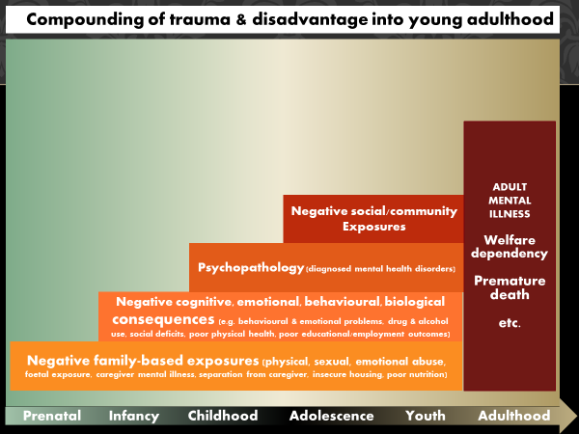
A US study (Duke et al., 2010) of 136,000 Minnesota high school students (grades 6, 9, 12) into the relationship between adverse experiences (physical, sexual familial/non-familial abuse, witnessing abuse, family alcohol/drug use) found all ACEs were significantly associated with risk of adolescent interpersonal violence - perpetration on others (delinquency, bullying, physical fighting, dating violence, weapon-carrying on school property), and self-directed violence (self-mutilation, suicidal ideation, suicide attempt). For example, boys exposed to familial sexual abuse were 15 times as likely to have attempted suicide than children with no abuse history. A study using a UK longitudinal cohort (Johnston et al., 2015) of intergenerational transmission of mental illness found higher transmission from mother to child than father to child, suggesting a primarily environmental (related to adversity) rather than genetic pathway. This study also found that maternal mental health has lasting effects on the child's educational attainment, future household income and probability of criminal convictions.
The conceptualisation of mental illness arising predominantly from early life adversity predicts a strong association between poor mental health and high levels of adversity in childhood, which is what is found. In an analysis of the Longitudinal Study of Australian children (LSAC) (AIFS, n.d.) and Indigenous Children (LSIC) (Aust. Govt. DSS, n.d.), high psychological distress in children (ages 2 to 16) was significantly associated with high levels of adversity in the previous 12 months (and good mental health with low levels of adversity). The study found for example at ages 10 to 11 in the LSAC sample, in children experiencing high psychological distress on the SDQ, 77.1% had experienced 4+ adversities in the previous 12 months, while only 3.2% 0 or 1. A similar finding was observed for Indigenous children (Twizeyemariya et al., 2017) that in Indigenous children aged 8-10 years with an Abnormal SDQ conduct score, >80% had experienced 6+ adversities in the previous 12 months and none 0 or 1.
In short, a core (likely dominant) pathway into mental illness rests on modifiable and treatable childhood adversity factors. This means much of mental illness is preventable, and so are the cost consequences. The possibility of disrupting intergenerational transmission pathways means potential gains constitute an infinite stream into the future; and yet as a society we have failed to make even a modest investment in the prevention of mental illness.
The service system response may exacerbate rather than respond compassionately to trauma.
- The child protection system:
  - primarily resources case finding defined as ‘general protective services’, including investigation 23%, and removal/out-of-home care 60% and generic family support 9%, with just 8% allocated to intensive family support for identified at risk families.
  - Parents who have children removed – a highly disturbing situation – often receive no on-going support, including mental health services, while being exposed to circumstances that will exacerbate an existing mental illness. They are typically offered very limited (say ½ hour per month) and extremely traumatic opportunity to engage with their children – again likely to exacerbate any pre-existing mental illness. Very limited services are allocated to work with families to create a safe emotional environment so that children can be reunified with their birth families. The perversity of governments paying others to look after children, at >$180/placement night per child (equal >$2,500/fortnight) or say $>7,500 per fortnight if three children were removed, while birth families receive nothing is astonishing. This surely needs to be revisited.
- The justice system:
  - Despite it now being well-established that the vast majority of persons caught up in the justice system have serious mental health issues, access to high quality mental health services in these settings is abysmally inadequate. A recent WA study of youth detention centre inmates found 89% had a severe neurodevelopmental impairment on at least one domain and 36% had FASD (Bower et al., 2018). A NSW study of youth detention found 83% met threshold criteria for at least one psychological disorder, and 63% 2 or more, and 58% met thresholds for at least one substance-rated disorder (Indig et al., 2009). In women’s prisons severe mental illness is identified in over 90% of inmates. Yet access to the necessary mental health care to ensure their safety and that of others and to support rehabilitation and reintegration into society is simply not available.
  - The justice system is generally poor at working with people who come into contact with police and the courts who have a mental illness or intellectual disability (Krieg at al., 2016), for example failing to grasp how brain damage might for example affect capacity to meet bail conditions. This has implications for natural justice for persons with mental illness as well as access to mental health services.
- The community response to family violence
  - Attributing family violence to disrespect for women ignores the vast literature demonstrating the role of trauma, brain damage and mental illness in violence. It also ignores the existence of female perpetrated abuse in intimate partner contexts and child maltreatment. The gender construct is highly shaming and in ascribing cause to male attitudes will fail to arrive at solutions that work. Separating men and women, dads from their children the predominant response, is a short-term ‘stop-gap’ at best. Ultimately it is better to work with whole families to support healing, so they can safely remain intact. Abusive behaviour is never justified, but a deep understanding of causal pathways will help in designing the best solutions. Addressing mental illness and brain damage must be a part of any effective response.
- The welfare safety-net
  - Many rely on welfare benefits for their survival, especially those with serious mental health problems. And yet unemployment benefits/New Start has fallen to a level where it does not support the most basic level of living. Mental health and family support agencies working with vulnerable populations note lack of income support (low level of benefits, which can also drop out altogether) undermines the capacity to stabilise mental illness. And yet studies consistently show financial stress is an important risk factor for child maltreatment (Doidge et al., 2017a) and exacerbation of mental illness.
- Drug and alcohol use - For many with mental health problems, use of alcohol and other drugs will exacerbate their mental illness and increase the likelihood of harmful consequences. Many have argued for more effective policies around access to alcohol.
  - Government policy on access to substances has been mixed and too often driven by the interests of suppliers (hoteliers etc). The NT has seen oscillating policies around access to alcohol – and yet when alcohol has been restricted the outcomes have dramatically improved. In October 2018, a minimum floor price for alcohol became operational together with the introduction of Police Auxiliary Licensing inspectors. Over the next 12 months there was a halving of the number of alcohol-related assaults in Alice Springs (486 to 245) (Northern Territory Police, 2019) and a similar reduction in ED attendances at Alice Springs Hospital for alcohol-related presentations (NTARIT., 2019; PAAC, 2019).
  - Application of compulsory in-facility treatment orders for justice involved mentally unwell populations who are at high risk to themselves and others could also be explored as part of an effective mental health strategy.
Desirable policy responses – When to intervene and with Whom?
If we are really interested in prevention, waiting until a child becomes a highly distressed young person in their mid/late teens doesn’t make sense. When the preconditions for heightened mental distress are readily identifiable in childhood; this is where we need to focus. By late adolescence/early adulthood early life adversities have escalated into highly disturbed behaviours including serious self-harming, development of psychotic disorders, substance use addictions, eating disorders and suicide. It will undoubtedly offer better returns to direct resources to help distressed/disturbed infants and children and their families before they reach mid adolescence. And yet youth is where much of the mental health ‘preventive money’ has been directed. Despite this, suicide rates and rates of self-harm and mental illness are not falling. Perhaps rather than spending more money in the same space, it is time to rethink and develop a genuine mental illness prevention strategy that starts earlier in life.
Where to direct resources in child protection was explored by Segal and her team under an ARC grant, core findings of which on effectiveness and cost-effectiveness are reported in a chapter for the Queensland Inquiry into their child protection system (Segal, Dalziel, Papandrea, 2013). While this work was concerned with child protection, because of the intertwining of child protection with mental illness, it is highly relevant to the current Inquiry. Over 60 programs were reviewed across portfolios of family support, mental health, infant home visiting and early childhood education; as well as risk level - from low to extreme risk. We found that investing in high/extreme risk populations was likely considerably more cost-effective than low risk; and that family support programs and therapeutic mental health services offered a better return on investment than other portfolios. A sound program logic, whereby program elements matched well the client population was also critical (Segal L, Opie RS, Dalziel K, 2013). A summary of the results of this research is presented in Table1.
And How? Core Elements of the desirable clinical/service response
Clinical model for working with traumatised children and their families: A highly skilful therapeutic response of adequate intensity will be needed to create an alternate relational pattern in children exposed to child maltreatment, built on trust and compassion, to build a sense of agency rather than victimhood (Amos and Segal, 2019). This alternate ‘win/win’ relational model, which must be the primary objective of therapy is dubbed hedonic mode (Price, 1995). Trauma treatment is widely found to be effective, and cost-effective (Gospodarevskaya and Segal, 2010) in treating post-traumatic stress disorder. Specific family-based trauma therapies (Furber, Segal, Amos, et al., 2013), especially when embedded in a compassion-based social-work model, can work in this highly traumatised population characterised by intergenerational child maltreatment. The evidence is still being generated but case study analysis is clear as to efficacy.
Core elements of what is needed in a service response to help children in distress and reduce the risk of adult mental illness
We propose the serious exploration of a new Centres of Excellence model in Infant, Child, Adolescent and Family Mental Health Service (ICAFS MHS) to replace the current CAMHS model. ICAFS MHS would offer centre-based treatment but also have a strong presence in out-reach-based work, to organisations working with troubled families and to support clients in their homes. The ICAFS MHS would offer clinical training and supervision, employing an inter-disciplinary team. An assured funding based is critical to be able to meet the needs of those aged 0 to 18 and their families in a way that is responsive and flexible and as intensive as required. We have estimated a budget of around 5 times that of current CAHMS services will be required. But much would need to change from the current CHAMS model.
- Philosophy - A compassion-based flexible responsive service model – that recognises possible histories of trauma and current adversity
- Family focused, especially to include expectant parents, infants, children and adolescents and their families – to maximise opportunity to address mental health issues/heal past traumas before they escalate and become more intractable. Seek to engage fathers as well as mothers. Separated families represents a major life trauma perpetuating distress. If families can be repaired that is what we must aim for. In a comparative cost-effectiveness analysis of ways to reduce child maltreatment (and associated mental distress), trauma-based therapies and intensive family support came up as the most cost-effective approaches (Segal L and Dalziel K, 2011).
- Inter-disciplinary, cross agency and cross jurisdictional – rather than adopting the prevalent ‘refer out’ model. Ideally services would be brought together into the one to deal with the high-level mental health problems in infants, children and adolescents and their parents, but also provide social and economic supports (eg income, help with driver’s licence, housing, nutrition, communication/speech/language, employment).
  - Dietitians need to be a core part of the inter-disciplinary team, given strong evidence for the role of a poor diet in mental ill-health (O’Neil et al., 2013; Opie et al., 2015) and the success of dietary interventions in treatment and prevention of relapse (Parletta et al., 2017, Jacka et al., 2017, Bogomolova et al., 2018).
- Flexible – hours per day/days of the week
- Location / welcoming non-traumatising locations are needed to undertake therapeutic work, but in addition in locations wherever people with mental illness will be – eg early childhood centres, primary schools, centre link offices, child protection offices, housing, disability, ED, all staff need to be trauma informed, so as not to escalate mental health issues. This is in addition to employing highly skilled and trained mental health practitioners, who would retain a supervisory connection to the ICAFS MHS
- Enhance trauma-based therapeutic training – many mental health workers are poorly equipped/ trained to deal with the most distressed and disturbed families – infants, children and adolescents. It seems usual for inadequate attention to be paid to on-going on-the-job training or support for attending special training in state-of-the-art therapeutic models (which can be very expensive and typically not supported in the workplace).
- Combat negative male stereotyping. The domestic violence debate in targeting men – without acknowledging the role of trauma and brain damage and access to substances in the etiology of violence. In the continual focus on violence by men against women (even through men are more likely to die through violence) the inference is there that men’s lives don’t matter and in the focus on facilitating separation rather than intensive family support services that dads don’t matter. The campaign does a great disservice to society and men in particular, in using the very strategies that are decried, of shaming, bullying and type casting is likely to exacerbate mental health problems rather than find lasting solutions. For boys, who are as often as girls the subject of child maltreatment, and where dads are often missing from households, where are the positive male role models? Children may not have a male teacher until late primary school. This is a national scandal. As a society we have put effort into getting more women into science, but have done nothing in the face of a disastrous slump in male teachers in primary schools (<15% workforce is male), and with the situation far worse in early childhood education (and early primary years). Plenty of men would go into these fields if there was not so much discrimination.
- Examples of community-based interdisciplinary models where mental health issues can be addressed:
  - Collingwood Neighbourhood Justice Centre, with co-located drug and alcohol, justice, housing and other services, with staff having links back to a core agency,
  - Children’s Centres in SA, incorporating, community development out-reach, early childhood education, nutrition, parenting programs, OT, speech pathology – but would benefit from infant/child mental health therapeutic capacity and medical presence (eg paediatrician).
  - The Children’s Services Unit in CentaCare in SA has employed a child and adolescent psychiatrist with an in-depth knowledge of how to work in a non-traumatising way with distressed children and families to assist in their healing and resocialisation. The combination of specialised mental health expertise and compassion-based social work model has considerable promise.
Funding hurdles
As is the case across the health sector, funding model create a range of perverse incentives. For example, the expensive open-ended Better Access Program is delivering services to the least unwell segment of the population (refs), while community mental health services for children operate under tight budget caps regardless of need. Given that, for the most vulnerable families with serious mental health issues and more complex social and economic contexts there simply are not enough services able to deliver the support required for effective management and a pathway to healing.
Even within the Better Access Items (established to fund allied health services identified in mental health care plans), dietitian services are not covered and this cannot be reimbursed. Attempts to rectify this shortcoming in the MBS have been stonewalled – with an MSAC submission for the inclusion of dietetic services for the treatment of depression - being repeatedly excluded from progressing to formal consideration under the MSAC process by the Department of Health, despite acknowledging the evidence-base, (see above). Dietitian interventions for treatment of mental illness are also identified as highly cost-effective (Segal et al., 2018; Chatterton, et al., 2018) and without the negative side effects of drugs, confirming that subsiding / delivering high quality dietitian services for mental illness would offer an extremely good return in investment. A funding route for dietician services needs to be identified.
More broadly, funding models are urgently needed that support family-based inter-disciplinary work in a variety of community. Essentially inter-disciplinary models are caught up in State/Commonwealth issues – so that inter-disciplinary services are under-funded and under-provided regardless of the evidence with persons with mental illness and their families and the broader economy and the tax payers the clear losers.
Table 1 Effectiveness and cost-effectiveness of programs for addressing child maltreatment (and associated Mental illness)
Population Target Aim/Outcome N studies | Mean Cost  $/family* | Effectiveness  N to treat** | C-E $/ outcome  $2012
Family support programs Aim/Outcome
Children in OHC. Reunification N=7 | $8,300 | 4 | $33,200
High risk of OHC Prevent OHC N=7 | $4,300 | 9 | $38,700
Families involved with CP  Prevent CP report/substantiation N=9 | $5,900 | 8 | $47,000
High/extreme risk no CP involvement  Prevent CM N=4 | $4,500 | 12 | $50,000
Early childhood education
C-E Chicago child-parent centres.  Moderate/high risk families. Prevent CM | $9,600 | 20 | $181,000
Infant home visiting
Low risk N= 3 | $4,580 | 91 | $901,000
Moderate risk N=11 | $7492 | 56 | $>1 million
High risk N=14 | $9,641 | 24 | $660,000
Extreme risk/current abuse N= 5 | $13,296 | 11 | $158,000
Notes: * relative to control group
** number needed to treat per successful outcome
OHC Out-of-home care
CP Child protection
CM Child maltreatment
Source: Segal L, Dalziel K, Papandrea K (2013)
Figures 2A and 2B Number of Adverse childhood experiences and risk of alcoholism and suicide attempt
x
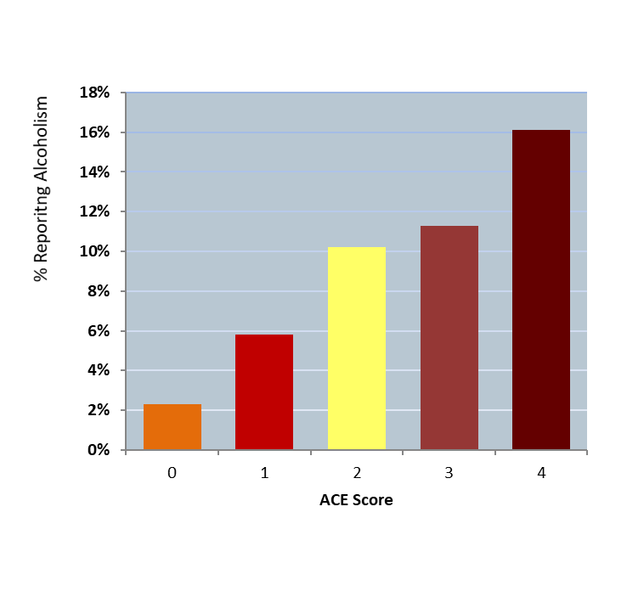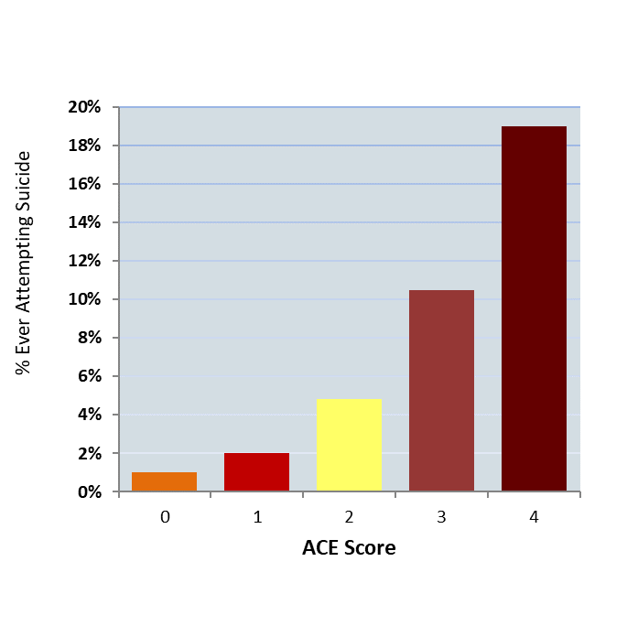
Source: Adapted from Felitti VJ, Anda RF, Nordenberg D, et al. (1998)

B Comments on Productivity Commission Issues Paper on the Social and Economic Benefits of Improving Mental health.
This is a most important inquiry. The extent of mental distress and mental ill-health in children and adults is concerning, with the current service system response clearly inadequate. The breadth of the terms of reference is commendable, especially the focus beyond the mental health sector. I also commend the Commission on what is an insightful and valuable Issues Paper to guide the public debate.
Mortality – p1
The view that most early deaths from mental illness are from physical conditions is based on studies in adults with diagnosed mental illness. In infants, children and adolescents there is a growing body of work that would suggests that in this population a far higher proportion of premature deaths are directly related to extreme psychological distress/mental illness (including drug/alcohol dependence) resulting in excess deaths primarily from suicide and other external causes. For infants and children, parental psychological distress/mental illness (including drug/alcohol dependence), combined with a complex array of family-based adversity, can result in excess rates of premature death of young children from external causes (CDSIRC, 2019; CCYP, 2019; CDRT, 2019; FCC, 2017; OWA, 2017; CDRPC, 2018, COPMM, 2018; Segal et al., current research).
Estimates of production losses due to premature death fail to include attributable deaths in infants, children and early/mid adolescence.
Service gaps p.1
The Issues Paper notes gaps in services for particular groups such as youth. Our work would suggest substantial gaps exist in services for infants, children and adolescents and their families. We estimate service levels are only 20% of what is needed and that the service delivery model needs a radical overhaul (Segal, Guy, Furber, 2018). Individuals from the most disadvantaged backgrounds, facing multiple adversity, are most at risk of lack of an adequate service response. They need a more intensive response, a higher skill level and often multidisciplinary. Such services are uncommon. It is much easier for an adult with depression (but otherwise their life is OK) to see a private psychiatrist or psychologist through Medicare and have their mental health needs met.
While mention is made of continuity of care, the inability of the service system to address multiple adversity is a core issue. The problem of cross portfolio/cross agency/cross jurisdictional response is arguably more acute for mental illness than any other health problem because mental illness/ psychological distress rarely occurs in isolation (Segal et al., 2019). Rather, it almost always presents with a range of serious economic, social, relational adversities that must be addressed simultaneously and in a family context.
Definitions Box 1 p.2
The distinction between a Mental Health Problem, Mental Illness and Mental Disorder seems more suited to the youth/adult context. In relation to infants and children, the suggestion of a hierarchy is likely unhelpful. Infants and children may be exceedingly unwell and extremely troubled – as indicated by unsoothability, aggression, high rates of self-harming behaviours ‒ and caught up in highly disturbing relationship with their parents; but a diagnosis might not be appropriate or could even be unhelpful. In a series of focus groups with child and adolescent mental health clinicians, they let us know that a knowledge of current (and past) adversity exposures and current behaviours/levels of distress was more helpful in understanding children and their needs than a formal diagnosis. The presumed hierarchy will almost certainly underplay the importance of distress in infants and children.
Figure 1 Types of mental disorders p.5
The blue section ‘Areas in which interventions can improve mental health’ is missing ‘Child Protection CP’. Providing far better mental health support as part of child protection services must be a part of an effective preventive response to mental illness. CP services have very high involvement with mentally unwell children and parents. There is the potential, or rather imperative, to work with families to heal trauma and address high levels of mental illness and distress.
Table 1 – p.5. What is in scope – I would strongly support inclusion of substance use disorders. They are clearly intertwined with ‘in-scope’ disorders, in terms of causal pathway/aetiology and comorbidities and the solutions which, to really make progress, must ultimately be able to address addictions. I don’t think the mental health of the community can be addressed without addressing drug and alcohol issues. As noted above, much infant and child distress (which can be extreme) does not necessarily fit into diagnostic categories, so this is not a good way to define scope in pre-adolescents (or even for some adolescents).
Greatest opportunities for improvement p.5
The proposition that focusing on the majority will yield a good return is an empirical question, not a generalisable rule. My research would suggest rather that return on investment and opportunity for benefit are greatest in the more disturbed end, not the mild or moderate end. This relates partly to the extremely high cost at the more serious end and thus capacity for benefit – not just for the individual but also for others in society – family members, household, work colleagues, school community and the wider community. It is a serious flaw in most cost-benefit analyses that they fail to take account of the wider impacts of mental illness (Mortimer and Segal, 2006) and the costs and potential benefits from effective interventions which can improve the lives of others, including the next generations.
The potential benefits for addressing more serious mental illness/distress, the existence of effective interventions of modest cost and lack of cheap effective population approaches at the mild end all support a focus on the more troubled end as offering the best return on investment.
Conceptualising seriousness according to diagnostic criteria is highly problematic. This ignores the fact that level of impact on daily lives is not simply related to diagnosis, but also to severity and acuity of the condition, underlying trauma, comorbidities and associated adversities. The US ACE study (CDC, 2019) has amply demonstrated that risk of poor consequences is associated with multiple adversity not a single clinical diagnosis; (see Figures 2A and 2B).
The term ‘young people’ is often interpreted as adolescents and youth. In thinking about ‘young people’ as a group with greatest potential for benefit, the term must include infants (from conception) and childhood, given the well-established evidence of potential brain damage during this period (Shonkoff, et al., 2012), and lack of services (Segal et al., 2018).
Assessment Approach p.7
Figure 3 Assessment components – Add causal pathways into mental illness and its consequences
The four assessment components identified are important, but a critical component missing is ‘Understanding the causal pathways into mental illness’. Describing and understanding causal pathways into mental illness and severity of impacts is crucial to identify what is modifiable and how these pathways can be disrupted. It is core to identifying effective preventive interventions and potential benefits. This understanding of causal pathways is also a gap in the current policy debate. In contrast the etiology of mental illness in early life adversity is an increasing focus of the literature (Shonkoff et al., 2012; Amos et al., 2011, 2014, 2019; and many others).
There are many non-pharmacological interventions for which there is sound evidence of efficacy and effectiveness in a clinical trial setting and cost-effectiveness. A thorough literature search to identify the myriads of effective non-pharmacological interventions will be a most useful output of the Inquiry. What is important is that the search include family-based therapies designed to support safe and nurturing parenting, given the intertwining of parenting and mental illness.
A few examples of effective non-pharmacological interventions include
- Family support programs to achieve nurturing parenting and reduce child maltreatment). See also Segal et al 2013, note outcomes of intensive family support programs in table 1. While these are child protection outcomes, this will be strongly correlated with mental health.
- Psychotherapy for PTSD and other mental diagnoses in children and parents with child abuse histories for example, see for example:
  - Gospodarveska and Segal (2012), re high cost effectiveness of trauma focused therapies to address PTSD + Depression in children.
- Intensive Parenting programs – to help families with severe relational disturbances. Successful programs include, Circle of Security and PPACT. See for example;
- Furber G and colleagues (2013) - a case series of PPACT a trauma-focused therapy for mothers and children facing intergenerational maltreatment and with multiple mental illness diagnoses
- Diet to manage major depression – There is high quality RCT evidence on the effectiveness (Bogomolova S, et al., 2018; Jacka F, et al., 2017; Parletta N. et al., 2017) and cost-effectiveness of dietary interventions to manage depression - including individual and group programs and for various client populations (Segal et al., 2018; Chatterton et al., 2018).
Figure 4 Cost of mental ill health to the community p 8
While recognising that this Figure is illustrative rather than exhaustive, important aspects are missing, such as child protection and cost of lost production through premature death and cost impact on others.
Child protection represents a major area of spending reflecting on parenting failure, often associated with mental illness and substance use. Further, children in contact with the child protection system are at extreme risk of mental illness.
Reduction in incomes - Lost production will arise from premature death, as well as absenteeism, presenteeism, unemployment and exclusion for the workforce - also an extra dot point p9 para 2.
Intangible costs - impacts on others. Mental illness, perhaps more than any other condition, has major impacts on the quality of life of others (and including survival - as victims of violence or neglect). Most at risk are family members, but also work colleagues, members of a community and the broader society – constituting a very large category of un/under-reported cost – in published studies of violence/maltreatment or mental illness. This is a critical point. It means both that the burden of mental illness is invariably grossly under-estimated, but so are the potential benefits of intervention.
State governments have been allocating relatively few resources to community-based child and adolescent mental health services and intensive family support services as a proportion of total ‘mental health’ expenditures. This is a similar situation for Commonwealth spending on mental health. See Figures 3 and 4. A valuable output of the PC Inquiry will be a current description of the breakdown of mental health services expenditure, to ascertain the allocation to prevention (early in life and intensive community-based supports).
Figure 3 State Government Mental Health payments 2012-13
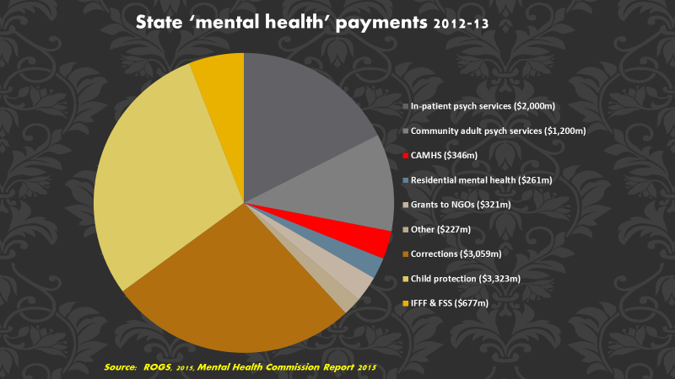

Figure 4 Commonwealth Government Mental Health payments 2012-13

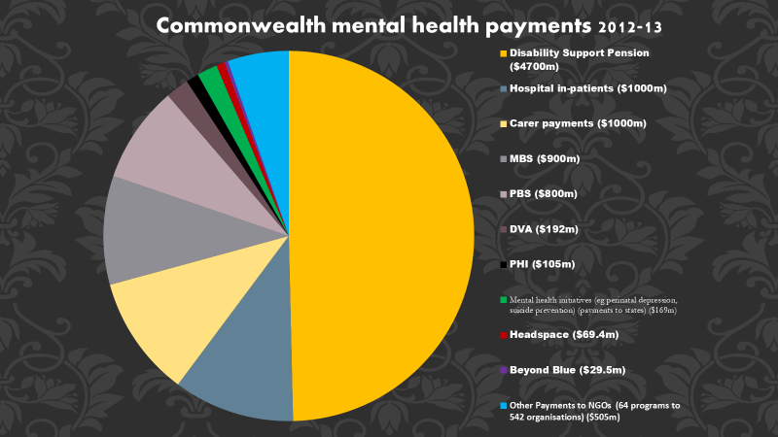

p.10 – comment regarding difference in costs across mental illnesses categories
- We suggest difference in disease burden is more related to complexity and extent and nature of associated adversity – not simply or even primarily about diagnosis. Also, many people will attract more than one diagnosis, further confounding diagnosis as an approach to costing.
Health care system p.11
Actors – include also
- paediatricians - the majority of their work concerns behavioural and development disorders (Hiscock et al., 2016) – note concerns around level of training and whether the predominantly private clinical practice setting supports family-based work and inter-disciplinary teams
- maternal health – pregnancy is a crucial time for address pre-exiting mental illness in parents to prevent conditions like post-natal depression (women with history of mental illness and/or childhood adversity most at risk) and associated poor outcomes for children (Segal and Amos, 2018)
- day-programs for persons with serious mental illness (including psychotic illnesses – noting that the content of those programs could be enhanced. An intervention study found clear benefits for participants through a group dietary intervention, but lack of funding meant the program could not be continued (Bogomolova et al., 2018).
Structural weaknesses p.12
Appears to be a conflation of institutional and ED services with crisis/acute; while those settings do provide crisis and acute care so does the Community setting.
Inequitable access needs to be considered also in relation to illness severity, complexity and multiple adversity. Few parts of service system deal well with complexity, especially in the community setting – more community resources to deal with ‘simple mental illness presentation’, little to deal with complexity. We’d suggest this is the major service gap and highlights an important structural weakness in funding and delivery models.
Fragmentation – few services offer the wraparound multi-component, inter-disciplinary response the more vulnerable families require – Difficult (impossible?) for families to access the services and skill sets required to address their complexity and deep and severe trauma histories
How to deliver the necessary flexibility in the community setting: 24/7, where ever and whatever it takes
Funding perverse. For example
- Private partitioners get paid more to deal with less sick / troubled clients.
- Parents who are struggling to parent well – and dealing with profound trauma histories (and current trauma) and mental health issues may have children removed – with little if any access to intensive family support. Children when removed may be placed with another family (or kin) at a foster care cost of ~ $x/day ($/fortnight in ‘child-related costs’ plus ~$ for recruitment and support for foster carers, while the birth parents receive no such financial support.
Figure 5 stepped model of care p.13
This is a useful framework, but some crucial elements are missing:
Under Non-health supports:
- child protection
- intensive family support services,
- early childhood centres
Whole population
- Need support for a respectful way of engaging that is non-judging, non-shaming in institutions that model the type of respectful behaviour that we want others to adopt. Challenge is to create a non-traumatising environments in which people can find help to get well and stay well. Currently too many respected institutions, pubic campaigns, public debate is bullying in tone, conflates behaviour with goodness (rather than illness) and is highly shaming. The Domestic Violence campaign and approach to refugees or youth involved in the justice system are prime examples.
- Access to drugs/alcohol – still industry pressure to make alcohol freely available despite damage to young brains and amplifies consequences for those who are mentally unwell and their communities. A change in regulations in the NT to limit access to alcohol, including a restricted persons register, has seen a fall in alcohol related violence – observed in a halving of ED attendances for violence and violence related arrests (NTARIT, 2019; PAAC, 2019).
- Access to nutritionists/dietitians to support healthy food choices is critical to a healthy brain and yet dieticians are not funded through Medicare, nor are they typically part of primary and community care / mental health care teams for mental health issues. They tend to be the professional group to be defunded if budgets are tight. For example, every major maternity service should have a dietitian (as well as mental health clinician) as part of the care team, given the important opportunity at this time to address mental health issues (Segal and Amos, 2018) and the impact for the infant of poor maternal nutrition.
Mental health promotion, prevention and early intervention, Suicide prevention p.14.
We agree that health promotion, prevention, early intervention including suicide prevention is most important and an area in which the mental health and human services system is currently failing. We suggest expensive advertising campaigns are unlikely to represent a good investment, given the complexity of the issues and evidence that the primary pathway into mental illness is via adversity and intergenerational trauma transmission – i.e. people are already at high risk - the pathway is not predominantly from well/low risk individuals. In this sense it is very different to say diabetes or heart diseases and the preventive strategies also need to be different. Given the challenges facing those at high risk, intensive on-the-ground support will have to be at the centre of an effective preventive strategy.
- Mental health promotion/prevention needs to be built on an understanding of the causal pathways into mental illness - then options for prevention become clear.
- Important to see prevention in an intergenerational context - healing a young parent might not prevent their mental illness, although could reduce risk and severity of relapse, but might represent primary prevention for their offspring.
- Persons with a child abuse history who experience several times excess risk for suicide - and also boys/men who are far more likely to kill themselves than females. Current research in SA is finding children involved with the child protection system have a far higher risk of death form external causes, starting in early childhood. (Segal, current NHMRC funded project on the consequences of child maltreatment). Given issues of shame and poor sense of self in those with high suicide risk, the adoption of shaming approaches is deeply disturbing.
- We must find better ways to support males. Men are still constructed as ‘privileged’ despite the reality that men die on average 4.4 years earlier than women across the globe and 4 years in Australia, are more likely to commit suicide, do more poorly at school, are more likely to suffer brain damage, and are far more likely to be involved in the criminal justice system. There is a problem of interpreting anti-social behaviour as bad, or a sign of disrespect rather than evidence of a damaged brain and traumatic upbringing which is the most likely explanation.
Mental health treatment
- Comorbidities – Think about comorbid mental illness - given the common causal pathways into a range of mental illnesses is stress and distress in infancy/childhood, comorbid mental illness and physical illness is common. But this also means the potential return on investment is considerable.
- Training upskilling – is absolutely critical – especially in community family-based responses to working with parents and children. All human services personal require training in trauma- informed care to avoid retraumatising vulnerable individuals who represent their client populations. This should include all politicians and senior bureaucrats.
- Specific mental health training to create a workforce of highly skilled practitioners across disciplines able to deliver high quality therapeutic services. Services need to be able to demonstrate capacity to work with highly vulnerable and traumatised populations and funding of services needs to recognise the high skill level required.
Income support /welfare safety-net
- Hard to qualify for disability support or new start/unemployment allowance/benefits. And they do not provide enough to live on which must amplify distress. The evidence is clear that extreme poverty is causally linked with mental illness child maltreatment (Doidge et al., 2017b). It is critical society provides a genuine financial safety net to those too incapacitated to work. Otherwise their possible recovery will be seriously undermined. More broadly there is inadequate wrap-around support to this highly vulnerable and disturbed group. Rather they are treated as pariahs and further traumatised again impeding possible recovery.
- Note perverse financial impact for parents who have their children removes, many of whom will have a mental illness often combined with substance use issues and despite the considerable stress and distress this will mean often no support – and yet considerable funds are allocated to support out-of-home care (average at $/child year) (Productivity Commission, 2019).
Justice
- The importance of mental illness/brain damage in justice involved populations is grossly underplayed in the violence debate and replicated in lack of mental health services available for justice involved persons (Bower et al., 2019; Cumming et al, 2018).
Child Protection
There have been a number of studies of the costs of child maltreatment in Australia (McCarthy et al., 2016). But these are all incomplete, in terms of scope missing cost elements such as premature mortality and intergenerational impacts, the poor quality of data used to inform the estimates and serious methodological flaws. None-the-less cost burden is very high, with major impacts on educational outcomes, productive engagement, and health. Such studies, in estimating mean cost burden per child fails to highlight the highly divergent costs across children – which will vary from a few hundred dollars per child to several million dollars. This of course is pertinent to thinking about preventive intervention strategies, possible size of benefit and return on investment.
Solutions – cross the human services sector
- Child Protection
The evidence concerning what works in protecting children (including assessment of impacts on mental health) is extremely limited. Support for gathering high quality evidence in this area is urgently needed. For example, to address questions such as: Under what circumstances is child removal protective and when is it more likely to exacerbate harms. Linked data provides an extraordinary opportunity to support the interrogation of such questions. Some Programs that appear promising – based on sound program logic and in some cases preliminary case-study evidence:
  - Therapy-based family support services for safe reunification of removed children. Example: Centacare SA reunification program to support the reunification of infants, children and adolescents with birth families. The program is led by a senior child and adolescent psychiatrist leading a team employing a support social work/trauma-based therapeutic mode. A program evaluation is underway led by Professor Delfabbro, Adelaide University and a preliminary report has been provided to the Department of Child Protection, SA – resulting in an extension of funding. A final report is to be delivered September 2019.
  - Professional foster care with the objective of reunification – work with birth parents to maintain connection and seek to create a safe space for children to return to. There is considerable interest within the community (social work, education, psychology, nursing) in professional foster care, even when limited to highly troubled or disabled children (Habel et al., 2016).
- Early childhood settings:
  - Employ high-level mental health clinicians (child and adolescent psychiatrists, speech pathologists, occupational therapists) in Childrens’ Centres as per the South Australian model (SADE, n.d.), although while these Centres employ interdisciplinary teams, they are yet to employ full-time infant/child mental health specialists. The advantage of Children’s Centres as a preventive setting is that they are (or can be) located in disadvantaged communities, offer a very welcoming, non-traumatising space, engage with parents as well as children and have active community outreach remit to engage with the most vulnerable and marginalised families. These centres offer a wholistic approach which can include direct nurturing of infants, early childhood learning, nutrition / provision of food, health and development assessment, access to parenting programs and other specialised services, familiarisation with primary school. A mental health presence could assist in identification of deep emotional, behavioural and development issues and a capacity to work therapeutically with children and parents to heal past traumas and attend to distressed communication patterns before problems become entrenched.
- Maternal and child health
  - Pregnancy and infancy is a critical period for parents and children alike but most particularly for parents with a child maltreatment history (of which they be more or less aware) and/or history of mental illness. Post-natal depression is a considerable risk for these mothers and exacerbation of mental health/behavioural issues in fathers. However, few jurisdictions offer adequate clinical service support. While there are many infant visiting/community child health nurse programs, few have mental health trained clinicians or the resourcing to offer a skilled therapeutic response of adequate intensity. If a mother suffers serious post-natal depression or other serious mental illness ensuring the child/children are safe and attachment relationships are intact. More therapeutic live-in programs that can accommodate mothers (and fathers) and their children are needed. We note for example that Helen Mayo House in SA, which offers an intensive trauma-and attachment-based service for women with serious mental health issues or substance use problems has just 6 beds and is unable to take all women who seek out and desperately need this service. They also have been keen to provide an outreach service, but for which there is no funding.
- Services for Aboriginal communities
  - Given the very high rates of histories of trauma and mental illness in the Aboriginal population, programs which are sensitive to the circumstances of the Aboriginal community are urgently needed. Exceptionally high levels of serious adversity (major financial stress, parental separation, death of persons close, domestic violence, parental mental illness etc) and associated high levels of mentla distress are observed in Aboriginal children. For example, over 45% of Aboriginal children aged 6 to 10 have been exposed in the previous 12 months to 6+ serious childhood adversities and >20% were experiencing very high levels of distress/disordered behaviours or emotions (based in the Strengths and difficulties questionnaire) (Twizeyemariya et al., 2017).
- Criminal justice portfolio
o Fund genuine therapeutic prison environment. An example is the Boronia Women’s Facility in Perth and some of the juvenile settings. But access to mental health services, both medical and other modalities is still a concern even in the more rehabilitative facilities. The impacts on children and associated costs are considerable and need to be taken into account in the planning (Dowell et al., 2018)
o Cross-portfolio Neighbourhood justice centres have been found to support a successful community-based solution for justice involved youth - that seek to involve all key player in the community - the courts, police, young people, schools, shop keepers, other businesses, local government, welfare agencies, to come up with innovative solutions. (This might include street art programs, co-located services – drug and alcohol, justice, mental health, employment, income support, financial services etc.). The Collingwood Neighbourhood Justice Centre (2019) as resulted in a reported reduction in crime, drug and alcohol use, truancy.
Knowledge of clinicians, service providers and the wider community. Urgent need for Education/ Training/Upskilling p.31
There seems to be limited recognition that disturbed behaviours mean that the brain is not working properly. For example, children whose behaviour is problematic (for themselves and others) will often be identified as naughty or bad, rather than a reflection that they are likely struggling and disturbed
Upskilling of the entire human services sector, including teachers, centre-link, public housing, child protection staff. Simply funding more case finding – identifying persons at risk who need a more intensive and specialised response will achieve nothing but impose a cost if the referral pathway is non-existent. Thus, human services staff need to be trained regarding:
  - the underlying source of disturbed thinking and behaviours (usually means damage to the brain) and
  - how to deliver trauma informed practice; how to work with distressed individuals without further traumatising them, but rather reducing their distress.
Alongside high-quality mental health training in trauma-based therapies for a wide range of mental health clinicians, as well as other practitioners who work with patients with serious mental health issues including, GPs, Paediatricians, ED workers, midwives, gastroenterologists, dietitians, oncologists, pain specialist.
Any one in a clinical role needs to understand about the impact of trauma and adversity on mind and body. Access to high quality supervision, reflective practice on-going training must be mandatory in the NGO, private as well as government sector, and this must be built into contracts and funding models.
Over-reliance on medications rather than adopting a wholistic approach (family-based psychotherapeutic, with nutrition, income, workplace/school supports etc) has meant almost no progress in curing mental illness, with at best moderate modification of extreme behaviours, but typically with serious side effect profile. with mixed success. Undoubtedly a wholistic approach would work best to enhance mental health and improve participation and workforce contrition
Mental Health funding eg Figure 10
Important to consider funding by age group. In a study of this issues we found little was spent on infants, children, younger adolescents, despite high levels of distress in children and their families and this period presenting the best opportunity for prevention. (Hiscock et al., 2016; Segal et al., 2018).
We note the activities of the NGO need to be considered as part of the budget model. They are an increasingly important player in intensive family support, working with people with serious mental health/drug and alcohol problems and directly offering mental health services.
It can be seen from Figure 10 the government expenditure on mental health as a % GDP is only ~half that of the Netherlands, does government need to increase this share. (Would be helpful to see USA and UK data.

Final note
Much of mental illness is caused by childhood trauma which damages the developing brain and relational blue-print. This is a hopeful story. It suggests that mental illness can be prevented in the young and mitigated in adults (given brain plasticity). Successful intervention studies confirm the possibility of prevention. We just need to create a service system that is consistent with the aetiology of mental illness, where the prevention of mental illness is an accepted reality and where resources are redirected to make this happen, supported by the requisite training. This does not mean taking resources form those currently experiencing distress. The healing of distressed children and parents represents a large part of the solution, if we are to disrupt intergenerational pathways into mental illness and prevent escalation of distress into more intractable scenarios characterised by multiple mental illness diagnoses carrying very high disease burden. In this way, over time, the prevalence of mental illness could be reduced and the associated burden.

C Key References
Causal pathways - Intergenerational transmission of Child Maltreatment and mental illness and options for disrupting
Amos JA. When wounds from infancy collide: the mother child relationship as trauma, trigger, and treatment. Adelaide: University of South Australia, 2017.
Amos J, Furber G, Segal L. Understanding maltreating mothers: a synthesis of relational trauma, attachment disorganization, structural dissociation of the personality, and experiential avoidance, Journal of Trauma and Dissociation, 2011;12(5):495-509. doi: 10.1080/15299732.2011.593259.
Amos J and Segal L. Disrupting intergenerational maternal maltreatment in middle childhood: therapeutic objectives and clinical translation, Frontiers in Psychiatry, 2018 Nov;9:623. doi: 10.3389/fpsyt.2018.00623.
Amos J, Segal L, Cantor C. Entrapped mother, entrapped child: agonic mode, hierarchy and appeasement in intergenerational abuse and neglect, Journal of Child and Family Studies, 2015;24(5):1442-1450. doi: 10.1007/s10826-014-9950-3.
Johnston DW, Schurer S, Shields MA. Exploring the intergenerational persistence of mental health: Evidence from three generations, Journal of Health Economics, 2013;32(6):1077-1089. doi: 10.1016/j.jhealeco.2013.09.001.
Kortmulder K and Robbers Y. Agonic and Hedonic Styles of Social Behaviour, 2005, Lewiston, NY:Edwin Mellen Press.
Price JS. The agonic and hedonic modes: Definition, usage, and the promotion of mental health, World Futures, 1992;35:1-3:87-113. doi: 10.1080/02604027.1992.9972318.
Segal L and Amos J. Intergenerational transmission of trauma: why pregnancy and the post-natal period pose an elevated risk of mental illness, but also a unique opportunity to intervene, Australian Midwifery News, 2018(Winter):23–24.
Segal L, Guy S, Furber G. High levels of adversities in children and adolescents experiencing psychological distress: the rule rather than the exception. 2009. Submitted.
Shonkoff JP, Garner AS, Siegel BS, Dobbins MI, Earls MF, Garner AS, et al. The Lifelong Effects of Early Childhood Adversity and Toxic Stress. Pediatrics. 2012;129(1):e232-e46. doi: 10.1542/peds.2011-2663.
US Department of Human Services, Children’s Bureau. Understanding the effects of maltreatment on brain development, Child Information Gateway, Issues Brief, April 2015, https://www.childwelfare.gov/pubPDFs/brain_development.pdf.
Solutions: Mental health / other clinical / cross portfolio / public health solutions
Bogomolova S, Zarnowiecki D, Wilson A, et al. Dietary intervention for people with mental illness in South Australia, Health Promotion International 2018;33(1):71–83. doi: 10.1093/heapro/daw055.
Chatterton ML, Mihalopoulos C, O’Neil A, et al. Economic evaluation of a dietary intervention for adults with major depression (the “SMILES” trial). BMC Public Health 2018;18(1):599. doi: 10.1186/s12889-018-5504-8.
Furber G, Amos J, Segal L, et al. Outcomes of therapy in high risk mother-child dyads in which there is active maltreatment and severely disturbed child behaviour. Journal of Infant, Child and Adolescent Psychotherapy, 2013;12(2):84-99. doi: 10.1080/15299732.2011.593259.
Gospodarevskaya E, Segal L. Cost-utility analysis of different treatments for post-traumatic stress disorder in sexually abused children, Child and Adolescent Psychiatry and Mental Health 2012;6:15. doi: 10.1186/1753-2000-6-15.
Jacka FN, O’Neil A, Opie R, et al. A randomised controlled trial of dietary improvement for adults with major depression (the ‘SMILES’ trial), BMC Medicine, 2017;15(1):23. doi: 10.1186/s12916-017-0791-y.
Neighbourhood Justice Centre (Collingwood). About the Neighbourhood Justice Centre. 2019. www.neighbourhoodjustice.vic.gov.au (accessed March 2019).
Opie RS, O’Neil A, Itsiopoulos C, Jacka FN. The impact of whole-of-diet interventions on depression and anxiety: a systematic review of randomised controlled trials. Public Health Nutrition 2015;18(11):2074-2093. doi: 10.1017/S1368980014002614.
O’Neil A, Berk M, Itsiopoulos C, Castle D, Opie R, Pizzinga J, et al. A randomised, controlled trial of a dietary intervention for adults with major depression (the “SMILES” trial): study protocol. BMC Psychiatry. 2013;13(1):114. doi: 10.1186/1471-244x-13-114.
Parletta N, Zarnowiecki D, Cho, et al. A Mediterranean-style dietary intervention supplemented with fish oil improves diets and mental health in people with depression: a 6-month randomised controlled trial (HELFIMED), Nutritional Neuroscience. 2017. doi:10.1080/1028415X.2017.1411320.
Segal L, Twizeyemariya A, Zarnowiecki D, et al. Cost effectiveness and cost-utility analysis of a group-based diet intervention for treating major depression – the HELFIMED trial, Nutritional Neuroscience, 2018. doi: 10.1080/1028415X.2018.1556896.
Northern Territory Police. Statistical publications. 2019. https//www.pfes.nt.gov.au/Police/Community-safety/Northern-Territory-crime-statistics/Statistical-publications.aspx (accessed April 2019)
NTARIT – Northern Territory Alcohol Review Implementation Team. Emergency department presentations. 2019. https://alcoholreform.nt.gov.au/data-and-evaluation/graph (accessed April 2019).
PAAC- People’s Alcohol Action Coalition. Home page. 2019. http://www.paac.org.au/index.html (accessed April 2019).
Productivity Commission. (2019) Report on Government Services (ROGS) 2018. Melbourne: Productivity Commission.
Felitti VJ, Anda RF, Nordenberg D, et al. Relationship of childhood abuse and household dysfunction to many of the leading causes of death in adults: The Adverse Childhood Experiences (ACE) Study. American Journal of Preventive Medicine 1998;14(4):245-58. doi: 10.1016/S0749-3797(98)00017-8.
McCarthy MM, Taylor P, Norman RE, et al. The lifetime economic and social costs of child maltreatment in Australia. Children and Youth Services Review 2016;71:217-26. doi: 10.1016/j.childyouth.2016.11.014.
Empirical Evidence of Relationship between early adversity and mental illness and associated anti-social behaviours / also unequal experience of adversity
AIFS, Australian Institute of family Studies. Growing up in Australia, the Longitudinal Study of Australian Children, https://growingupinaustralia.gov.au/ (accessed March 2019)
Amos J, Segal L. The relationship between child maltreatment, inequalities and later health outcomes. Chapter 4 in: Humanising Mental Health Care in Australia – A Guide to Trauma-informed Approaches, R Benjamin, J Haliburn and S King (eds), 2019.
Australian Govt. Dept. Social Services. Footprints in Time - The Longitudinal Study of Indigenous Children (LSIC), https://www.dss.gov.au/about-the-department/publications-articles/research-publications/longitudinal-data-initiatives/footprints-in-time-the-longitudinal-study-of-indigenous-children-lsic (accessed March 2019)
Bower C, Watkins RE, Mutch RC, et al. Fetal alcohol spectrum disorder and youth justice: a prevalence study among young people sentenced to detention in Western Australia. BMJ Open 2018;8(2):e019605. doi: 10.1136/bmjopen-2017-019605.
CCYP - Commission for Children and Young People. Annual Report 2017-2018. Melbourne, Vic: Government of Victoria, 2019.
CDC – Centres for Disease Control and Prevention. CDC-Kaiser ACE Study. 2019 https://www.cdc.gov/violenceprevention/childabuseandneglect/acestudy/index.html
CDRPC -Northern Territory Child Deaths Review and Prevention Committee. Annual Report 2017-2018. Darwin NT: Government of Northern Territory, 2018.
CDRT - Child Death Review Team. Annual Report 2017-18. Sydney, NSW: Government of New South Wales, 2018.
CDSIRC - Child Death and Serious Injury Review Committee. Annual Report 2017–18. Adelaide, SA: Government of South Australia, 2019.
COPMM - Council of Obstetric and Paediatric Mortality and Morbidity. Annual Report 2016. Hobart, Tas: Government of Tasmania, 2018.
Doidge JC, Higgins DJ, Delfabbro P, et al. Risk factors for child maltreatment in an Australian population-based birth cohort. Child Abuse & Neglect 2017a;64:47–160. doi: 10.1016/j.chiabu.2016.12.002.
Doidge JC, Higgins DJ, Delfabbro P, et al. Economic predictors of child maltreatment in an Australian population-based birth cohort. Children and Youth Services Review (special edition) 2017b;72:14–25. doi:10.1016/j.childyouth.2016.10.012
Dowell CM, Mejia GC, Preen DN, et al. Maternal incarceration, child protection, and infant mortality: Infant children of women prisoners in Western Australia. Health and Justice 2018;6:2. doi: 10.1186/s40352-018-0060-y8.
Duke NN, Pettingell SL, McMorris BJ, et al. Adolescent violence perpetration: associations with multiple types of adverse childhood experiences. Pediatrics 2010;125(4):e778-86. doi: 10.1542/peds.2009-0597.
FCC - Family and Child Commission. Annual Report: Deaths of children and young people, Queensland, 2015-2016. Brisbane: Government of Queensland, 2017.
Fryers T, Brugha T. Childhood determinants of adult psychiatric disorder. Clinical Practice and Epidemiology in Mental Health 2013;9:1. doi: 10.2174/1745017901309010001.
Guy S, Furber G, Segal L, et al. How many children in Australia are at risk of adult mental illness? Australian and New Zealand Journal of Psychiatry. 2016;50(12):1146-1160. doi: 10.1177/0004867416640098.
Habel L, Clark R, Segal L. Interest from tertiary educated persons in fostering children with higher care needs under a professional (paid) model compared with general foster care. Australian Social Work 2013;66(1):8–25. doi: 10.1080/0312407X.2012.732587.
Indig D, Vecchiato C, Haysom L, et al. 2011, NSW Young People in Custody Health Survey: Full Report, 2011 Sydney: Justice Health and Juvenile Justice.
Mortimer D, Segal L. Economic evaluation of interventions for problem drinking and alcohol dependence: Do within-family external effects make a difference? Alcohol & Alcoholism 2006;41(1):92-98. doi: 10.1093/alcalc/agh224.
OWA - Ombudsman Western Australia. Annual Report 2016-17: Child Death Review. Perth, WA: Government of Western Australia, 2017.
Segal L, Dalziel K, Papandrea K. Where to invest to reduce child maltreatment – a decision framework and evidence from the international literature, report as Appendix F to Taking Responsibility: a roadmap for Queensland Child Protection, pp 619-641. Brisbane: Queensland Child Protection Commission of Inquiry, 2013.
Segal L, Dalziel K. Investing to protect our children: Using economics to derive an evidence-based strategy. Child Abuse Review 2011;20(4):274-89. doi: 10.1002/car.1192.
Segal L, Guy S, Leach M, et al. A needs-based workforce model to deliver tertiary-level community mental health care for distressed infants, children and adolescents in South Australia: a mixed-methods study. Lancet Public Health 2018;3(6):e296–e303. doi: 10.1016/S2468-2667(18)30075.
Segal L, Opie RS, Dalziel K. Theory! The missing link in understanding the performance of neonate/infant home-visiting programs to prevent child maltreatment: a systematic review. The Milbank Quarterly 2012;90(1):47-106. doi: 10.1111/j.1468-0009.2011.00655.x.
Twizeyemariya A, Guy S, Furber G, et al. Risks for mental illness in Indigenous Australian children: A descriptive study demonstrating high levels of vulnerability. The Milbank Quarterly 2017;95(2):319-57. doi: 10.1111/1468-0009.12263.
The service system
Cumming C, Kinner SA, Preen DB, et al. In sickness and in prison: the case for removing the Medicare exclusion for Australian prisoners. Journal of Law and Medicine, 2018;26(1):140-158.
Hiscock H, Danchin MH, Efron D, et al. Trends in paediatric practice in Australia: 2008 and 2013 national audits from the Australian Paediatric Research Network. Journal of Paediatrics and Child Health 2016;26(1). doi: 10.1111/jpc.13280.
SADE – South Australia Department of Education. Children’s centres. n.d. https://www.education.sa.gov.au/parenting-and-child-care/child-care/services-and-programs/childrens-centres (accessed April 2019).
Segal L, Guy S, Furber G. What is the current level of mental health service delivery and expenditure on infants, children, adolescents, and young people in Australia? Australian and New Zealand Journal of Psychiatry 2018;52(2):163–172. doi: 10.1177/0004867417717796.
Segal L and Amos J. Why pregnancy and the post-natal period pose an elevated risk of mental illness, but also a unique opportunity to intervene. Australian Midwifery News 2018(Winter):23–24.
System issues
Krieg A, Guthrie J, Levy M, et al. “Good kid, mad system”: The role for health in reforming justice for vulnerable communities, Medical Journal of Australia, 2016;204(5):177–179. doi: 10.5694/mja15.00917.

Annex: Additional Material
 | Males% | Females% | ATSI%
Parent ever in prison | 44 | 48 | 61
Attend school prior to custody | 38 | 36 | 42
Placed in OH care | 25 | 40 | 38
Child abuse or neglect | 57 | 81 | 59
Alcohol or substance use disorder | 63 | 64 | 69
Illicit drug use ≥weekly in the year prior to custody | 65 | 65 | 72
Any psychological disorder | 86 | 92 | 92
Attention/behavioural disorder | 68 | 82 | 75
2+ psychiatric disorders | 70 | 92 | 79
Low IQ < 80 | 54 | 31 | 59
Source: Indig et al; 2009 NSW Young people in Custody Health Survey: Full Report NSW Human Services, Juvenile Justice; NSW Health, Justice Health
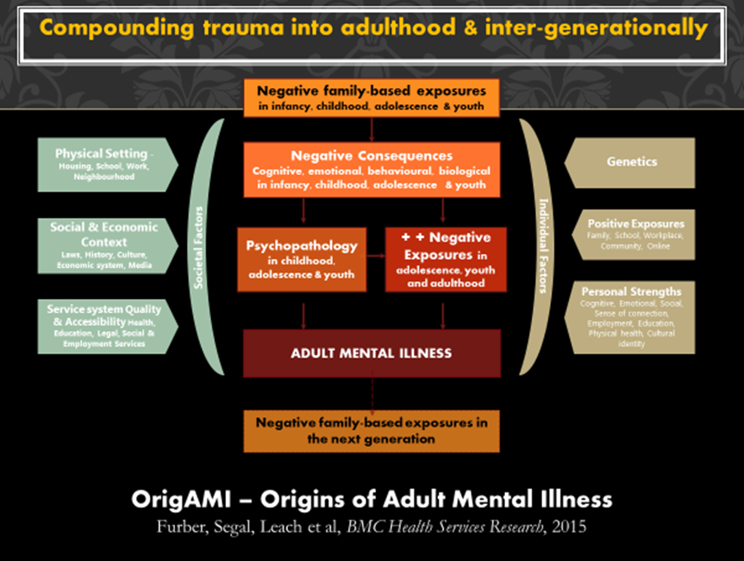

 | Males% | Females% | ATSI%
Parent ever in prison | 44 | 48 | 61
Attend school prior to custody | 38 | 36 | 42
Placed in OH care | 25 | 40 | 38
Child abuse or neglect | 57 | 81 | 59
Alcohol or substance use disorder | 63 | 64 | 69
Illicit drug use ≥weekly in the year prior to custody | 65 | 65 | 72
Any psychological disorder | 86 | 92 | 92
Attention/behavioural disorder | 68 | 82 | 75
2+ psychiatric disorders | 70 | 92 | 79
Low IQ < 80 | 54 | 31 | 59

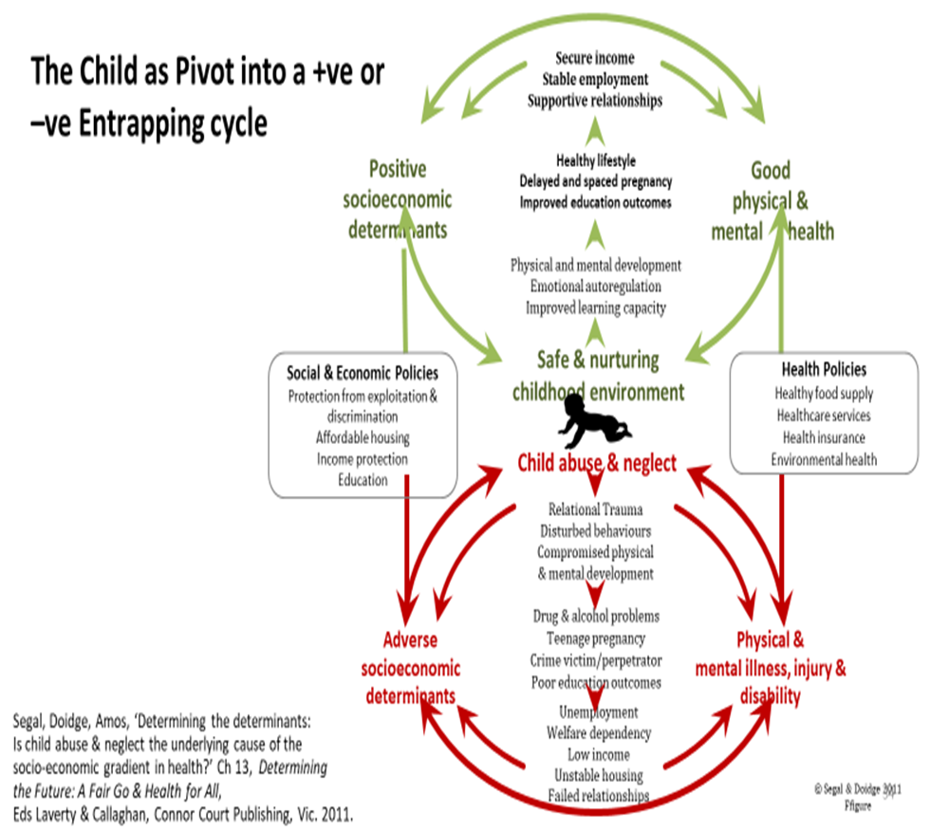
Additional Literature
Amos J, Segal L. Disrupting intergenerational maternal maltreatment in middle childhood: Therapeutic objectives and clinical translation, Frontiers in Psychiatry, 2018 Nov;9:623. doi: 10.3389/fpsyt.2018.00623.
Dalziel K and Segal L. Home visiting programmes for the prevention of child maltreatment: cost effectiveness of 33 programmes. Archives of Disease in Childhood 97(9):787-798. doi:10.1136/archdischild-2011-300795, September 2012
Dalziel K, Dawe S, Harnett PH, et al, Cost-effectiveness evaluation of the Parents Under Pressure Programme for methadone-maintained parents. Child Abuse Review 2015 Mar;24(5):317–331. doi: 10.1002/car.2371.
Dalziel K, Halliday D, Segal L. Assessment of the cost-benefit literature on early childhood education for vulnerable children: What the findings mean for policy. SAGE Open 2015 Feb;5(1)2158244015571637. doi: 10.1177/2158244015571637.
Doidge JC, Edwards, B, Higgins DJ, et al. Adverse childhood experiences, non-response and loss to follow-up: Findings from a prospective birth cohort and recommendations for addressing missing data. Longitudinal and Life Course Studies (LLCS), 2017;8(4):382-400. doi: 10.14301/llcs.v8i4.414.
Donato R, Segal L. Does Australia have the appropriate health reform agenda to close the gap in Indigenous health? Australian Health Review 2013;37(2):232-8. doi: 10.1071/AH12186.
Dowell C, Preen D, Mejia G, et al. Determinants of infant mortality for children of women prisoners: a longitudinal linked data study. BMC Pregnancy and Childbirth 2018 Jun 6;18:202. doi: 10.1186/s12884-018-1840-z.
Dowell CM, Mejia GC, Preen DB, et al. Low birth weight and maternal incarceration in pregnancy: A longitudinal linked data study of Western Australian infants. SSM - Population Health. 2019;7:100324. doi: 10.1016/j.ssmph.2018.11.008.
Dowell C, Preen D, Segal L. Quantifying maternal incarceration: a whole-population linked data study of Western Australian children born 1985-2011. Australian & New Zealand Journal of Public Health 2017;41(2):151–157. doi: 10.1111/1753-6405.12613.
Furber G, Leach M, Guy S, et al. Developing a broad categorisation scheme to describe risk factors for mental illness, for use in prevention policy and planning, Australian and New Zealand Journal of Psychiatry, 2017 Mar;51(3):230–240. doi: 10.1177/0004867416642844.
Furber G, Segal L. Give your child and adolescent mental health service a health economics makeover. Children and Youth Services Review 2012;34:71-75. doi: 10.1016/j.childyouth.2011.09.001.
Furber G, Segal L. The validity of the Child Health Utility instrument (CHU9D) as a routine outcome measure for use in child and adolescent mental health services. Health and Quality of Life Outcomes 2015 Feb;13:22. doi: 10.1186/s12955-015-0218-4.
Furber G, Segal L, Cocks J, Investigating the Quality of Life of Children in Southern Mental Health - Child and Adolescent Mental Health Service (SMH-CAMHS), January 2013
Furber G, Segal L, Leach M, et al. Mapping scores from the Strengths and Difficulties Questionnaire (SDQ) to preference-based utility values. Quality of Life Research 2014 Mar;23(2):403–411. doi: 10.1007/s11136-013-0494-6.
Furber G, Segal L, Leach M, et al. Preventing mental illness: closing the evidence-practice gap through workforce and services planning, BMC Health Services Research 2015 Jul;15:283. doi: 10.1186/s12913-015-0954-5.
Hanckel J, Segal L. The Inspir=Ed Project, a holistic early childhood project for enhancing parent-child wellbeing. Childhood Education 2016;92(1):10–21. doi: 10.1080/00094056.2016.1134236.
Loughhead M, Furber G, Guy S, et al. Consumer views on youth-friendly mental health services in South Australia?’ Advances in Mental Health 2018;16(1)33–47. doi: 10.1080/18387357.2017.1360748.
Nguyen H, Segal L. A preliminary cost effectiveness analysis of the Queensland Helping out Families initiative, a report to the Queensland Child Protection Inquiry. Report in Appendix E to Taking Responsibility: a roadmap for Queensland Child Protection, report by Queensland Child Protection Commission of Inquiry, pp 607-617, 28 June 2013.
Nguyen H, Zarnowiecki D, Segal L, Gent D, Silver B, Boffa J. Feasibility of implementing infant home visiting in a Central Australian Aboriginal community. Prevention Science. 2018;19(7):966-76. doi: 10.1007/s11121-018-0930-5.
PHIDU – Public Health Information Development Unit. Social Atlas.(see eg death rate of 15-24 YOs) http://phidu.torrens.edu.au/current/maps/sha-aust/lga-single-map/sa/atlas.html (accessed March 2019.
Segal et al. Current research – excess death rate and cause of death in infants and children (NHMRC funded project). 2019.
Segal L. Economic issues in the community response to child maltreatment. In: Mathews B, Bross D, editors. Mandatory reporting laws and the identification of severe child abuse and neglect. New York: Springer; 2015. p. pp 193–216. doi: 10.1007/978-94-017-9685-9_10.
Segal L. Submission to The Royal Commission into the Prevention and Detention of Children in the Northern Territory. The Royal Commission into the Protection and Detention of Children in the Northern Territory, Australia, 25 May 2017.
Segal L, Dalziel K, Donato R. Economics-informed policy can drive better health; but there will be few gains without structural change. Dialogue, Issue: ‘A Healthy Society - How to get it? How to keep it?’ 2011;30(2):44-50.
Segal L. doidge J, Amos J. Determining the determinants: Is child abuse and neglect the underlying cause of the socio-economic gradient in health? In: Laverty M, Callaghan L, editors. Determining the Future: A Fair Go and Health for All. Ballan, Victoria: Connor Court Publishing; 2011. p. pp 159-76..
Segal L, Nguyen H, Final Report: Evaluation of the Intensive Family Support Services (IFSS) implemented by Central Australian Aboriginal Congress Aboriginal Cooperation, report to Central Australian Aboriginal Congress Aboriginal Cooperation, 26 August 2014
Segal L, Nguyen H, Gent D, et al. Child protection outcomes of the Australian Nurse Family Partnership Program for Aboriginal infants and their mothers in Central Australia, PLoS One 2018;13(12):e0208764. doi: 10.1371/journal.pone.0208764.
Shonkoff JP. From neurons to neighborhoods: old and new challenges for developmental and behavioral pediatrics. Journal of Developmental & Behavioral Pediatrics. 2003;24(1):70-76.
Shonkoff J, Boyce W, McEwen B. Neuroscience, molecular biology, and the childhood roots of health disparities: building a new framework for health promotion and disease prevention. Journal of the American Medical Association 2009;301(21):2252-9. doi: 10.1001/jama.2009.754.
Shonkoff JP. The neurobiology of early childhood development and the foundation of a sustainable society. In: Marope PTM, Kaga Y, editors. Investing Against Evidence. Paris, France: UNESCO Publishing; 2015. p. 55-72.
Zarnowiecki D, Nguyen H, Hampton C, et al. The Australian Nurse Family Partnership Program for Aboriginal mothers and babies: Describing client complexity and implications for program delivery. Midwifery 2018;65:72–81. doi: 10.1016/j.midw.2018.06.019.

