Review of the NDIS Costs

Productivity Commission Issue Paper

February 2017

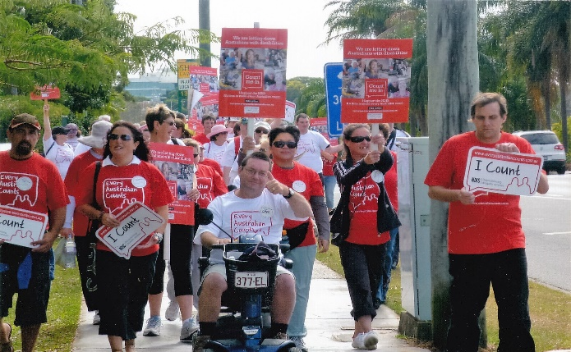
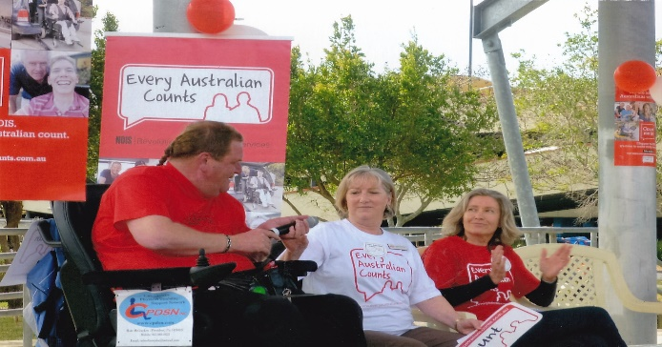

© Homelife Association Inc. March 2017

The following is a response to Productivity Commission Review of the NDIS Costs from Homelife Association Inc. A small not-for-profit service provider in Queensland. Homelife Association Inc has strongly supported the movement from the Every Australian Counts Campaign to the NDIS trial sites and the full rollout of the National Disability Scheme.
We participated in the launch of the Every Australian Counts Campaign in Geelong, held one of the first rallies in support of the campaign in Caboolture and attended rallies and forums throughout the campaign.
We acknowledge the Productivity Commission Review of the NDIS Costs in 2017 is continued affirmation of the bipartisan commitment by federal and state government to the continued implementation of the National Disability Insurance Scheme in Australia.

This report has been prepared by Leanne Peipman. (Quality and Business Manager)

Preface
The timing of this review in and of itself presents issues. Trial site information provided information relative to the specific target groups of each trial site and was heavily influenced by the geography and demographics these areas. Some states chose not to participate. The information from trial site areas provides indicators influenced by the factors specific to the trial areas. It is virtually impossible to identify broader trends from the information as it stands at this time. The trends identified in the review appear to be heavily related to the trial sites and information. Figure 1 of the Issue paper is evidence this phenomenon. The population and demographics of the ACT do not provide substantially valid information on the potential trends across other states and territories.
Given full roll out commenced in July 2016 across all states and territories with the exception of Western Australia. The rollout met with significant challenges in the transition to the new ICT system impacting on the proposed numbers of people accessing NDIS and the processes. Again the roll out in each state has been driven by the initial trial site criteria and it appears for all intents and purposes the comparison and contrast of information from the states and territories and from the roll out areas cannot be compared or indicative of general trends at this time. Generalised information can provide indicators only on issues, costs and concerns as the National Disability Insurance Scheme begins to gather momentum.
Our organisations position on the National Disability Insurance Scheme is simply this, at best it has great opportunity to meet its full potential and provide for people with a disability and their families opportunities to claim their human rights as citizens of our country. At worst if the number of people with disabilities receiving assistance doubles then we have made progress and people with disabilities and their families are no longer geographic prisoners tied to state funding.
I would also like to identify the parameters of the information provided by our service. We are not operating in an NDIS area, we are an NDIS registered service, we are located in the last roll out area of the state being January 2019. We have visited many services in trial site areas, formed working partnerships with some of these services and attempt to stay abreast of the constant and significant changes to the scheme.
Having prefaced our response to this Issues Paper we will now present our response.

2. Scheme Costs

Why are utilisation rates for plans low?
Are the supports not available for participants to purchase (or are there local or systemic gaps in markets)? Do participants not require all the support in their plans? Are they having difficulty implementing their plans? Are there other reasons for the low utilisation rates?
Low utilisation of plans has occurred for many of the reasons stated in the latter questions.
There are gaps in the system and the markets, not all supports in the plan are required or cannot be met. There is difficulty with the implementation of plans by individuals.
There is limited understanding from all stakeholders concerning the NDIS. It is a “new scheme” particularly in Queensland and many felt that it would not eventuate in our state. The state has provided funds to assist participant preparation and this has had an impact on those who are currently accessing services or have access to information from main stream services: eg “special schools”.
There is a focus on plan preparation for potential participants with limited information on plan implementation. We have had a number of inquiries from people who have had plans approved requesting plan management from our service but have not included this as a request in their initial plan. Much of the focus of their plan and requests was developed on their capacity to self-manage their plan. Because this has not been able to occur these individuals have then needed to seek services from registered traditional services which was not their original intent and so they have settled for having their basic needs met by services they had previously accessed until such time as their plan can be reviewed.
Participants who have previously received funding and assistance are more likely to request the services they have historically received. Much or part of this assistance may not have been needed or necessary for the individual but was the assistance the service provider would or could provide and so it was better than nothing.
Do participants not require all the support in their plan?
There are definitely those who do not require the supports they have requested or as much as they have requested but you can’t know what you don’t know. Parents, families, service providers and people with a disability are caught in a 24 hour support model thinking. This is a traditional, risk aversive model of support and is not necessary for more people than it currently supports.
If you have only ever eaten toast how can you know there is more on the menu or even what the items on the menu are or mean? Even less so for those who were not offered toast and did not even know there was a menu.
Many people have been caught out by not understanding the ramifications of not including such things as, transport or equipment in their plans. For many the equipment they have historically received has been inadequate and not suited to meet their needs but to meet a fiscal budget. There have been long waiting periods for repairs and co-contributions have been required to achieve necessary modifications to meet the individual’s needs. Most people with disabilities and their families have spent their lives making do or doing without.
There is a significant market gap in equipment, technology and supplies and although this is emerging if we return to the previous point there is limited knowledge and understanding from participants about this anyway.
Plan management is critical for participants in the initial phase of the NDIS. It provides opportunities for exploration of potentially different and innovative ways of meeting needs. New and emerging markets can develop to meet the needs and requests of participants based on innovative thinking and planning. Plan management provides a pathway to self-management through the development of skills and capacity building.
Homelife has operated on self-directed framework for many years. We moved to the model of self-direction in a more formal way in 2008. All funds are individualised, service users receive annual budgets, work from signed Service Agreements and engage their own team members to provide the support and assistance they request working within the parameters of their available funds.
In more recent time through the Your Life Your Choice legislation we registered as service provider where self-management of funds is supported and assisted through a more intermediary type role.
We do not have empirical data to support the following but have access to information and through observation and experience can confidently report that as people progress with the management of their own lives including funds, services, equipment and technology they requires less than anticipated unless there are significant changes, anticipated deterioration or unexpected life events. People become economic participants in their communities and valued members of their communities.

Why are more participants entering the scheme from the trial sites that expected? Why are lower than expected participants exiting the scheme?
An increase in the expected number of participants in trial site areas can be attributable to a number of factors.
Families of people, in particular children, with a disability relocated from other states to the trial site areas to access the NDIS. The significance of the impact on the expected numbers I do not believe has been captured in the available information. It would be reasonable to suggest the impact on this phenomenon be followed up as this will also impact the numbers expected to roll out in other areas.

The demographics of the trial site areas themselves will skew the projected number of participants and for many people not receiving support from within their own state or related to the eligible participants in the trial site areas. Hidden populations of children with a disability are becoming more aware of the NDIS and advancements in diagnosis and identification of disabilities in children at an earlier age has also increased. The diagnosis of children with Autism spectrum disorder
“The number of people who are diagnosed with autism spectrum disorder (ASD) continues to rise in Australia. Autism, once considered rare, is now 31% of NDIS participants, the largest disability group in the scheme according to recent the NDIS Quarterly Report issued in June 2015.” 1.
Lower numbers than expected participants exiting the scheme should be considered based on the timeframe of this review. Early intervention for children has not had sufficient time to realise the identified outcomes for young participants. The development of the ECEI approach has not had sufficient time to be reviewed from implementation. For a portion of participants the economic benefits of Early Intervention for an individual may not be fully realised until the participant reaches adulthood.
What factors are contributing to increasing package costs?
It has certainly come to our attention the amount of funds approved has not necessarily equated to the reasonable and necessary needs of the individual. Considering 6% of the total population of people with a disability live with a disability that significantly impacts their capacity to function without significant support in core activities of life there has been approval given on sizeable funds for participants who would not be included in this 6%.
Where participants’ first plans are being approved from existing plans that have operated at state level there is little opportunity to review the financial implications of historically approved funding.
Why is there a mismatch between benchmark package costs and actual package costs?
One of the primary reasons we have identified is the plan and planning process. It would be interesting to compare the actual package amount of participants who were previously receiving state funding for support and assistance and new participants who have never received funding for support and assistance.

3. Scheme Boundaries
To what extent is the speed of the NDIS rollout affecting eligibility assessment processes?
Eligibility: Page 13 of the Issues Paper says:
“To streamline the process of accessing the NDIS, people receiving support under specified state and territory disability programs are generally assumed to meet the disability requirements specified under the Act.”
The Productivity Commission in its Overview of the Disability Care and Support Inquiry Report said:
“The current disability support system is underfunded, unfair, fragmented, and
inefficient, and gives people with a disability little choice and no certainty of access to
appropriate supports. The stresses on the system are growing, with rising costs for
all governments.”

If this is the case why would we assume people currently receiving support under state and territory programs continue to meet the requirements? The old lottery system for receiving support and assistance was often expedited by those whose advocates were strong in their representation to government and persistent in their requests. If people’s circumstances change this provides the opportunity to reassess eligibility. For some the approval for eligibility for funding was based on attendance at “special school”.
People will not exit NDIS when this is not an expectation. Expediting the process of confirming eligibility to the NDIS may well be a costly exercise in the short term but is necessary and can have an impact on the long term.
Two options for addressing this issue could be greater resources to meet the requirements for the initial rollout phase or slow the process. It may not be possible to fix in 7 years what it took us over 60 years to break.

The Intersection with mainstream services

General comment: Feedback and discussion has identified poorly defined boundaries currently exist. This requires strong communication between NDIS agencies and government. Mental health and education are two critical areas where barriers and gaps are most evident.

4. Planning Process

Is the planning process valid, cost effective, reliable, clear and accessible? If not how could this be improved?
Issues Paper Pg 3 states:
“The scheme is distinguished from precious approaches in number of ways…
- Funding is determined by an assessment of individual needs rather than a fixed budget”
It then goes on to identify the Referencing Package and first plan approach which is a budget-based approach.
From experience in the model of self-direction we have observed that individuals generally do not require as much as is anticipated by the service. Although the NDIS is not a fixed budget process providing capacity for adjustment the budget based approach shifts the focus from the person, their goals aspirations and reasonable and necessary needs to the funds. This raises a high risk of the Scheme becoming as inequitable at a National level as it was at a state level.
Creating plans for individuals in the initial stages of the NDIS trials required extensive periods of time. A number of contacts with the prospective participants were required to ensure the plans met the needs of the individual. It appears this was a contributing factor to the Scheme meeting the projected trial budget outcomes.
Effective planning is essential in establishing unique individual needs. It is not sufficient to suppose a first plan process or budget based approach is adequate nor that individuals will request excessive or unrealistic support and assistance. While a quick phone call to an approved participant regarding their first plan may assist in meeting the required timeframes and support political agendas and timing, it simply does not meet the requirements, values or ethos of the NDIS Act.
There is an ethical responsibility of services currently providing support and assistance to people with a disability to be plan ready.

5. Market Readiness

The requirements for the provision of support and assistance through choice and control of individuals sits juxtaposed to the way in which support and assistance have traditionally been provided. The current Modern Award and conditions is life a square peg attempting to fit into a round NDIS hole.
When rollout is completed and industry is deregulated there will be greater capacity to understand the impact of the free market on the NDIS. This transition period is not a clear indicator of the future of the industry.
We anticipate there will be innovative solutions and market entry, as yet, not considered. We will see the development in technology which has remained underdeveloped due to limitations on funding and systemic barriers.
The economic participation of informal carers and people with a disability is difficult to project and will this offset the expenditure required to meet the projected increase of expenditure on the requirements of people with a disability accessing the NDIS?
We have seen a trend in the area of self-management to engage Independent Contractors for both support and assistance from specialists and from mainstream services.
Web Platforms such as Better Caring and Find a Carer are emerging in the market place and provide a clear indication of the potential this type of service has in the growing market.
Quality and Safeguarding is important into the future and the Working Committee continues to address these issues. It would be prudent to consider a Purple Card for those receiving payments from NDIS which includes a Police Check and Minimum Requirements of completion of Mandatory training on a regular basis.
The training required for those entering the workforce does not need to be accredited training. This only increases the cost to the service or individual and the current training does not meet the changing environment.
Non-accredited training is sufficient to ensure those providing services have the level of skill required and risk is decreased.
People with a disability do not operate from 9am – 5pm. They want flexibility in the people providing support and assistance to them. While we consider the industry based on the capacity for full time work and career paths as the optimum there will remain a tension between the market demand and the market supply.
Whilst the NDIS rolls out under the existing bilateral agreements in a price regulated market there will be a need for the traditional services to meet the increased demand with limited scope for innovation under these circumstances. It is after the rollout has been completed the market will have greater capacity to flourish.
Traditional services have begun to meet the challenges of change into the NDIS environment. For many this has resulted in quite harsh cutbacks, redundancies and reshaping of organisations. It has been proposed services will need to operate at 12% back of house operating. Many, particularly the larger services have operated at 18 -25% back of house. When there have been challenges in meeting the costs of operation there has been the response from state governments to “top-up” services. Organisation that operate effectively and efficiently are not rewarded but penalised. Funds unspent must be returned and this includes efficient use of operational funds. Has the projected reduction in funds required for the operation of traditional disability services been included in the costing analysis?

Conclusion

The original intent of the NDIS and Act has changed as the entity has developed. There has been a greater scope than originally intended. There have been many changes and there will continue to be many more. NDIS must continue to move forward and as is required develop, implement, monitor and review.
If more people with a disability have an opportunity to receive something then this has all been worthwhile.
It is with great hope we anticipate citizens of our country and community who live with a disability can live a life that most citizens would hope to be able to live.

Homelife mission statement aligns strongly with the stated purpose of reasonable and necessary supports under the NDIS Act (s. 4):
Figure 1
Homelife Mission Statement  Homelife supports people with a disability | NDIS purpose
To be independent | Support people with a disability to pursue their goals and maximise their independence
To do the things all other citizens have a right to do | Support people with a disability to live independently and be included in the community as fully participating citizens
To belong to the community | Develop and support the capacity of people with disability to undertake activities that enable them to participate in the community and in employment

Our aim is to do ourselves out of a job!

Reference

Transition to full scheme - Regulation Impact Statement. NDIA. May 2015
http://www.abs.gov.au/ausstats/abs@.nsf/Latestproducts/4428.0Main%20Features32012
http://www.a4.org.au/prevalence2015
http://www.pc.gov.au/inquiries/completed/disability-support/report/disability-support-overview-booklet.pdf

