# Submission to the Productivity Commission regarding its inquiry into Superannuation: Assessing Efficiency and Competitiveness

Contact: Kevin Bungard, CEO

Phone: 1300 851 057

# Submitted by: Class Limited, ABN 70 116 802 058 Date: 20 July 2018

***About Class***

*Class Limited is the largest cloud-based software provider used by accountants and specialist administrators to administer SMSFs. Over 160,000 SMSFs, about 27% of all SMSFs, are managed on Class Super, which was launched in 2009.*

*Class software is used to prepare all the financial statements, member reporting and to submit tax returns and regulatory reporting for these funds.*

*As part of its services, Class performs data analysis of these funds, and publishes the results on a quarterly basis as the Class SMSF Benchmark report.*

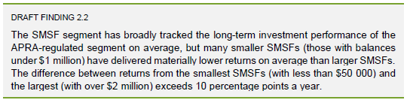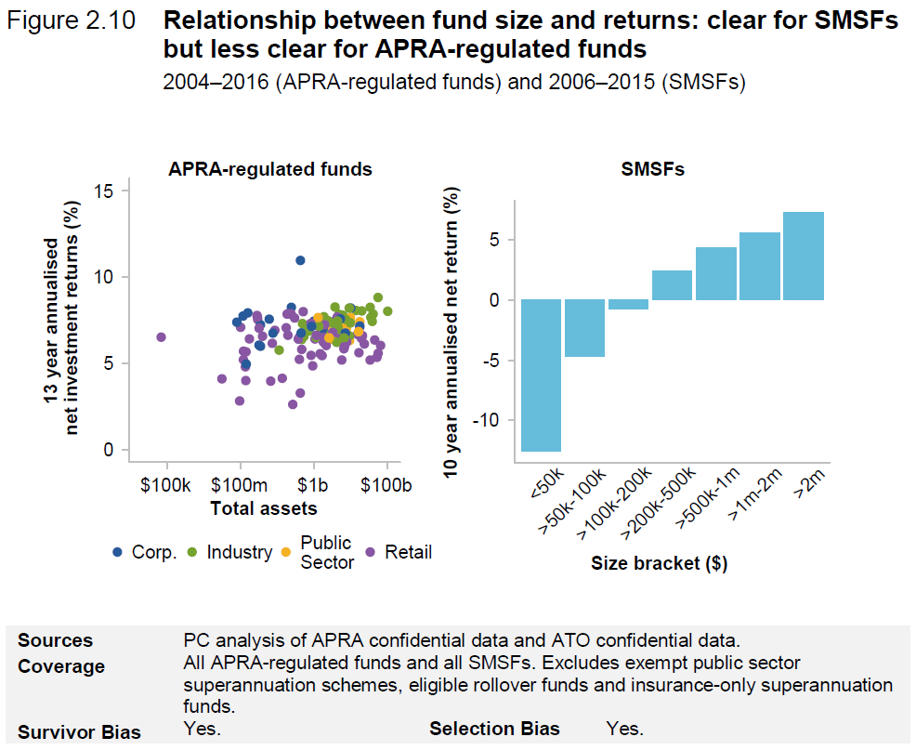**1. About this Submission**

Class is concerned about comments and findings related to the performance of SMSFs in the Commission’s *Superannuation: Assessing Efficiency and Competitiveness, Draft Report,* dated April 2018.

Of particular concern is Draft *Finding 2.2*, and the way that *Figure 2.10* from the Draft Report has been presented. We believe there is a fundamental misunderstanding about what *Figure 2.10* illustrates in terms of SMSF performance, and that the performance is grossly understated; and we are concerned about how that may have factored into the Commission’s findings.

*Figure 2.10* (reproduced to the right) includes two graphs, one related to the APRA funds and one related to SMSFs. In this submission we refer to the former as 2.10(a) and the latter as 2.10(b).

*source: PC*

Simply put, we think *Figure 2.10(b)* grossly misrepresents the average returns of SMSFs and the scale of the misrepresentation of returns for small balance SMSFs is so alarming that the results have been called out in the draft report’s *Draft Finding 2.2* and by the media.

This misrepresentation is caused by two sets of factors. One set relates to the ROA formula used by the ATO, and how it understates performance compared to APRA’s ROR, and the other relates to the way in which funds have been selected and grouped in *Figure 2.10*. We discuss these factors in the remainder of this submission.

**2. ROA factors**

The Productivity Commission notes in numerous places that the ATO’s ROA and APRA’s ROR are not directly comparable – however it then proceeds to do so anyway. In Technical Supplement 4 accompanying the draft report the Commission explains that:

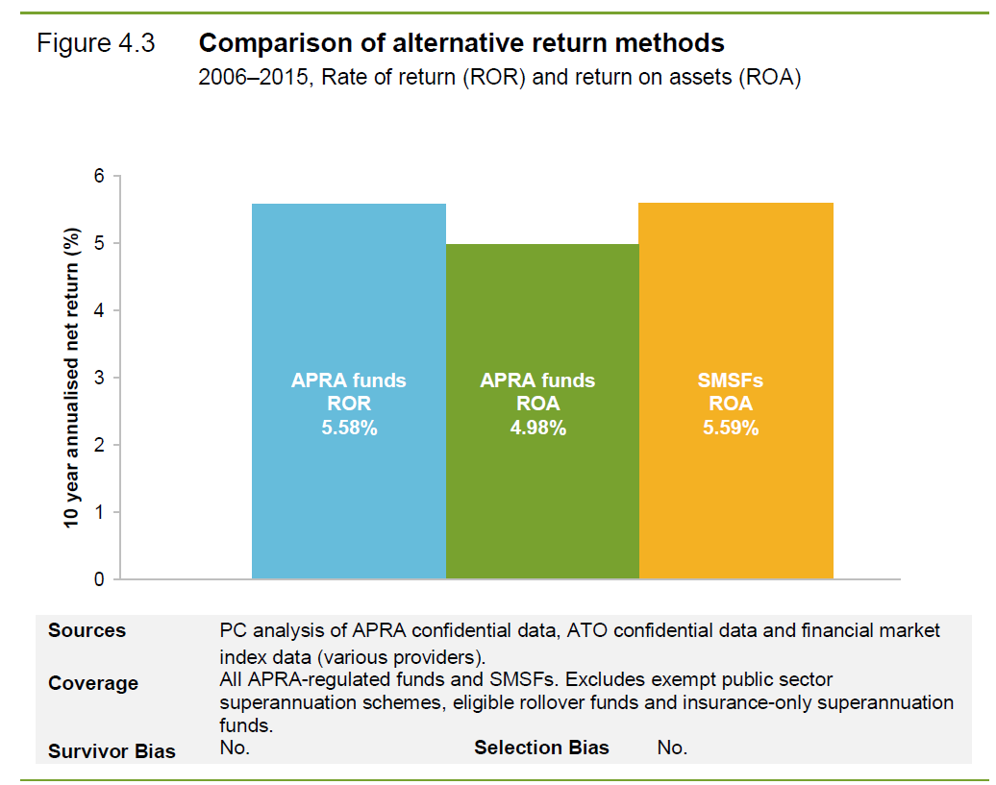*“The Commission has tested the impact of these different methods (figure 4.3), using advice provided by ATO. This entailed calculating ROA for APRA-regulated funds using the ATO’s formula. This results in a fall in the 10-year return for APRA funds (using the same data) and implies that SMSF returns may appear higher if measured using APRA’s ROR method.”*



*Emphasis added*

*source: PC*



Although we agree that the ROA and ROR are not directly comparable, we do not understand why more has not been done by the regulators to:

1. explain the major differences in the formulae
2. explain what the impact of those differences are
3. standardise or harmonise the approach to reporting performance across the industry

This submission sets out the differences below. We think that this analysis illustrates that ROA is not an appropriate formula for reporting performance of SMSFs and that a ROR formula is highly preferable both in terms of its methodology, and because it is already in use by APRA.

When we look at *Figure 2.10(b)* later in this submission we will look at how the ROA formula doesn’t just understate overall SMSF performance, but it is also highly regressive, with SMSFs being more heavily penalised the smaller they are.

We do not accept that data collection differences between the ATO and APRA mean that an ROR cannot be calculated and compared for SMSFs; once the significant differences in the formulae employed are understood, making adjustments to arrive at an estimated ROR for SMSFs is relatively straightforward. We think the methodology differences beyond that are relatively minor and would not prevent comparing SMSF and APRA fund performance.

**2.1 ROA vs ROR**

It is generally accepted that investment performance for a period is measured by:

$$\frac{earnings}{assets invested}$$

Unfortunately agreeing on how to count *earnings* and *assets invested* is not so easy and this is at the heart of the differences between the two formulae. As stated in the draft report, the formulae are:

$ROR=\frac{Net earnings after tax}{Cashflow adjusted net assets}$ vs. $ROA=\frac{Net earnings after tax}{Average assets over the period}$

**2.1.1 Agreeing on assets invested for the period**

The formulae can be expanded to:

$ROA=\frac{Net earnings after tax}{Net assets at start of year + \frac{1}{2}(Net member flows + Net insurance flows + Net earnings after tax)}$

$ROR=\frac{Net earnings after tax}{Net assets at start of year + \frac{1}{2}\left(Net member flows + Net insurance flows\right) }$

The difference is that ROA includes half the period’s earnings in the denominator – we do not find this intuitive and it leads to the ATO’s ROA formula consistently understating returns in comparison to the ROR method.

We do not think there is a reason for this difference and we feel that the practice fails the 'pub test' e.g.

*If* ***$100*** *is invested and earns* ***$20*** *in interest, the ROA shows an* ***18%*** *return rather than the expected* ***20%*** *return.*

Note: the ROR formula shows 20% as expected.

**2.1.2 Agreeing on net earnings after tax**

The ATO and APRA also look at “earnings after tax” differently, the two main factors being the treatment of insurance flows (premiums and payouts) and contribution tax.

The ATO includes both of these in earnings whereas APRA does not; there are arguments for and against which practice is better, but we agree with APRA that they should be excluded because:

**Contribution Tax** – is effectively income tax (at a concessional rate of 15%) on income that has been directed *to be* invested; it is not tax on earnings *derived* from that investment.

**Insurance** – premiums and insurance payouts are not part of the super system. The decision to *invest* in insurance is effectively a decision to *divert* investment outside the super system i.e. premiums are not a superannuation cost, insurance payouts are not superannuation income and neither should affect superannuation returns.

Let’s define these different “net earnings after tax” amounts as:

$$ROA net earnings=Net earnings after tax after contribution tax and insurance flows$$

$$ROR net earnings=Net earnings after tax before contribution tax and insurance flows$$

The formulae can then be restated as:

$ROA=\frac{ROA net earnings}{Net assets at start of year + \frac{1}{2}\left(Net member flows before contributions tax + Net insurance flows + ROA net earnings\right)}$

$ROR=\frac{ROR net earnings}{Net assets at start of year + \frac{1}{2}\left(Net member flows after contributions tax + Net insurance flows\right) }$

**2.2 Adjusting ROA to compare to ROR**

Regardless of debate about the treatment of insurance premiums etc. the important thing is to be able to compare performance on a consistent basis across the superannuation sector.

Now that we understand the significant differences, leaving aside the other minor differences between the two formulae, we can make adjustments that allow for a reasonable comparison of SMSF and APRA fund performance.

The ATO already has the data required to make these adjustments (contribution tax and insurance flows) and, given that the ATO also makes this information publicly available, Class has been able to perform these adjustments to the ATO data published in the draft report:



***Table C.1*** *source: ATO, Class*

Using the *10 year* *estimated ROR* above, *Figure 2.3* from the draft report would look like this:

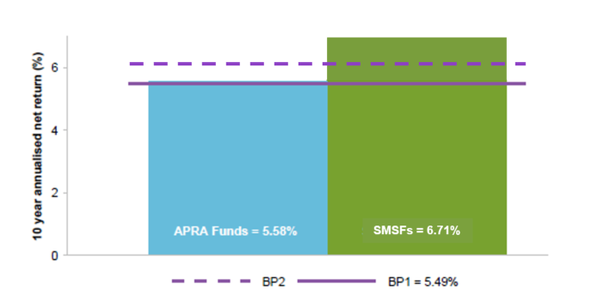

***Figure 2.3 with Class estimated SMSF ROR*** *source: PC, Class*

**2.3 ATO Confirmation**

Although we are confident that our estimates are accurate, it would clearly be better if the ATO were to apply the required adjustments and provided estimated ROR data to the Commission.

**3 Bracket Bias Factors**

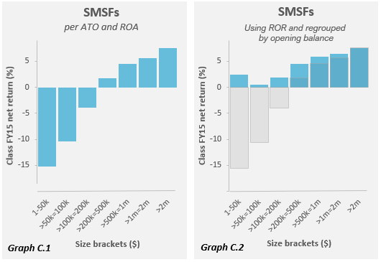As noted earlier, Class analysis has shown that not only does the ATO’s ROA calculation understate performance compared to APRA’s ROR formula, but it also does so in a way that is highly prejudiced to small balance funds. Below *Graph C.1* follows guidelines provided by the ATO to produce a chart equivalent to *Figure 2.10(b)*, but using Class Super data for over 60,000 SMSFs, administered on Class Super for the FY15 year.

*Graph C.2* uses the same data set as *Graph C.1* but after making changes to remove substantial bias in the reported performance, particularly for smaller funds.

How is it that these graphs can be so different? Along with the basic understatement, inherent in the ROA method vs. ROR, there are three other factors expanded on below.

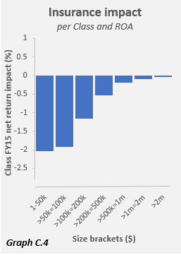**3.1 Insurance**

The draft report made the observation that insurance premiums are regressive and that members with small balances are impacted disproportionally, given the premium amount is a larger proportion of the small balance. This impact applies to small SMSFs just as it does to small member balances. *Graph C.4* illustrates the impact on SMSF returns using the ATO’s brackets.

Since ROA includes the impact of insurance flows, switching to ROR removes this penalty and because of its regressive nature, the impact on smaller balances is dramatic.

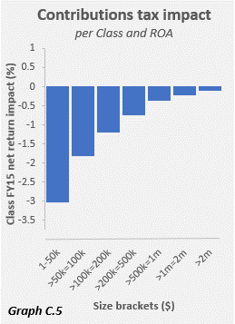**3.2 Contribution Tax**

Like insurance, contribution tax is regressive in its impact e.g. the $3k contribution tax on a $20k contribution will have a much more significant impact on a $50k fund than on a $500k fund. This is illustrated in Graph C.5.

Again, switching to ROR removes this effect and the impact of switching is more significant the smaller the fund.

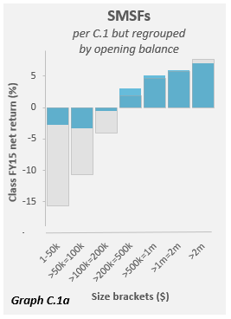**3.3 Selection Bias**

*Figure 2.10(b)* brackets funds from each year based on their size i.e. funds that perform badly will decrease balances and migrate down to smaller brackets and funds that are making good returns will increase and migrate up into higher brackets.

The criterion for selecting funds to belong to a group is based on “closing balances” i.e. the 1-50k bracket selects all funds that ended the year on $50k or less. This effectively selects for underperformance compared to grouping based on “opening balances”.

For example, a $46k SMSF with a 10% return will move up to the next bracket but a $55k fund with a -10% return will migrate down into the lower bracket – if the funds reversed their fortunes in the following year then they would swap brackets, with only the poor performance years being included in the lowest bracket.

If we regroup the funds in *Graph C.1* based on “opening balance” it makes a greater than 10 percentage point improvement in the return for the 1-50k bracket. *Graph C.1a* shows the dramatic difference that this change in criteria makes.

The impact of this bias is substantial, especially in light of the smaller $50k bracket size at the low end of the scale vs. the $1m bracket size at the large end of the scale.

This selection bias makes up majority of the exaggerated underperformance seen in *Figure 2.10(b)*.

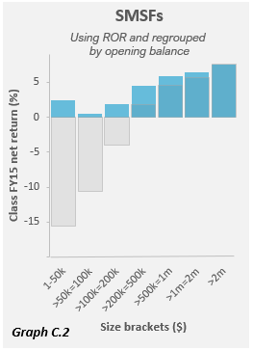**3.4 Regrouping and switching to ROR**

*Graph C.2* shows the dual impact of switching to ROR and regrouping based on opening balance.

As noted above the regrouping makes up much of this improvement, but the switch to ROR still makes a more than 4% improvement in the average return for the $1-50k bracket.

**4 What does *Figure 2.10(b)* illustrate?**

*Figure 2.10(b)* covers the 10-year period 2006 to 2015. You might assume that this graph answers the questions...

*“How did those funds with $1-50k in 2006 perform, on average, over the next 10 years?”*

and similarly,

*“How did those funds with $1-2m in 2006 perform, on average, over the next 10 years?”*

...however it does not.

What *Figure 2.10(b)* shows is an average of:

1. a vastly different group of funds for each year in the period.
2. funds which migrate up or down through the groups based on their performance – poor performers migrating downward and good performers migrating upward.
3. many of the funds included do not appear in all years (being wound up and/or established at different points in the period).

We are not convinced that this graph is particularly helpful for investors and although *Figure 2.10(b)* does show that “poor performing funds end up with smaller balances” over time, it says nothing about how funds that start with small balances have performed over the period.

**4.1 How do SMSFs grow over time?**

As part of their *Self-managed super funds: a statistical overview* for 2015-2016, the ATO produced some analysis of funds over time in an infographic: [*SMSFs first lodged in 2012 FY: where are they five years on?*](https://www.ato.gov.au/uploadedFiles/Content/SPR/downloads/smsfs_where_are_they_%20five_years_on_2015-16.pdf) This Analysis illustrated nicely how SMSFs had grown over the period and as summarised in *Table C.2* a significant number of the funds migrate into larger brackets within the period.

Unfortunately, the infographic did not include performance data but if the ATO could provide that data we think it would be a useful addition to the commission’s review of performance.

***Table C.2*** *source: ATO*

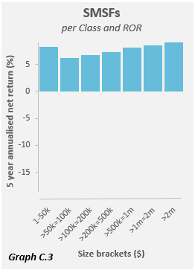**4.2 How do SMSFs of varying sizes perform over time?**

*Graph C.3* opposite does answer the above questions and shows data for funds groups based on their opening balance in FY13, and tracks their ROR performance for the 5 years to June 2017.

We think that this graph is what the regulator should be producing and consider it is more informative both for investors considering an SMSF, and for investors who have an SMSF and would like to compare how they have performed, relative to their peers.

It is clear that the smaller funds do not have as good a return as larger funds, however the effect is much smaller than indicted in *Figure 2.10(b)* and it reduces as the funds grow.

**4.3 Small balances and fixed fees**

In fact, the observation about small balances affects small member balances as the regressive impact of fixed fees is made in the draft report’s *Figure 3.8*. The correlation is strong because SMSFs have an average of 1.9 members and the effect of fixed fees for administration creates a regressive effect on members and SMSFs alike.

It would seem counter-productive to suggest that members and funds with small balances should avoid investing in super because of this small balance penalty.

**5. Acknowledgement of *Draft Recommendation 22***

It should be acknowledged that the ATO and the Commission are largely working with the data they have available, and that the issues we highlight in this submission do not appear to be due to policy or error, but simply due to misunderstandings and/or lack of a full consideration of the impact of some of the choices made, and differences in the methods employed by the ATO and APRA.

We acknowledge that the Commission has called out a number of the return calculation concerns in the report and in its associated *Technical Supplement 4*, but without alternative data and illustrations many of these notes of caution are simply ignored by the media, resulting in articles like the following from the AFR, 29 May 2018:

# “Got less than $1m in assets? Forget a self-managed super fund”

# AFR, 29 May 2018

We also acknowledge that *Draft Recommendation 22* could address some of the concerns raised here, however we think a number of the improvements such as providing ROR values could be implemented by the ATO regardless of the recommended workshops.