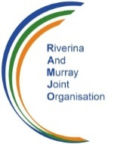
Level 3, 553 Kiewa Street, Email admin@ramjo.nsw.gov.au
PO Box 3572, Fax (02) 6023 8169
ALBURY NSW 2640 Phone (02) 6023 8791

10 October 2018

The Secretariat,
Murray Darling Basin Plan Review,
Productivity Commission,
CANBERRA ACT

By email to basin.plan@pc.gov.au

Dear Secretariat,
Murray Darling Basin Plan: Five-year assessment
The Riverina and Murray Joint Organisation (RAMJO) welcomes this opportunity to provide comment on the Productivity Commission’s Draft Report – Overview and Recommendations.
PROFILE
The Riverina and Murray Joint Organisation (RAMJO) is a Local Government authority legislated in May 2018 under the NSW Local Government Act, comprising 11 Member Councils in the Murray, Murrumbidgee and Lower Lachlan river catchments in south west New South Wales.

The Member Councils of RAMJO are as follows:-
Albury City Council
Berrigan Shire
Carrathool Shire
Edward River Council
Federation Council
Griffith City Council
Hay Shire Council
Leeton Shire Council
Murray River Council
Murrumbidgee Council
Narrandera Shire Council

A location and Member Council map is set out on the following page.

The legislated core functions of NSW Joint Organisations are as follows:-

- To establish strategic regional priorities for the Joint Organisation’s area and to establish strategies and plans for delivering those priorities;
- To provide regional leadership for the Joint Organisation and to advocate for strategic issues and priorities, and
- To identify and take up opportunities for inter-governmental co-operation on matters relating to the Joint Organisation’s area.
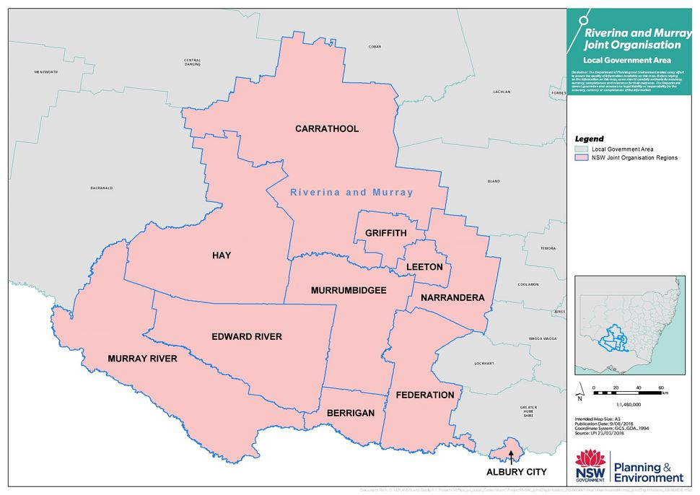

The RAMJO region covers an area of 72,724 sq km and has a total population of 148,500. The southern part of the region extends along the Murray and Lower Murray-Darling Valleys, from Albury City at the eastern end through to the western border of the Murray River Council.
The northern and western part of the region extends generally within the Murrumbidgee and Lower Lachlan Valleys, and includes Griffith, Leeton, Narrandera, Murrumbidgee, Carrathool and Hay Councils.
The RAMJO region has a mix of large regional cities, medium sized irrigation based urban centres, through to a number of predominantly dryland farming shires which are large in area but with a low population base.
The major regional centres are Albury City (pop 52,886) and Griffith City (pop. 26,648). These cities are significant manufacturing, education, government and medical service centres for the whole of the Riverina Murray region and cross border into northern Victoria.
A large part of the rural region contains significant irrigation areas, the largest and best known ones being Murray Irrigation, Murrumbidgee Irrigation and Coleambally Irrigation. There are also an extensive number of smaller private irrigation schemes and river based irrigators.
The RAMJO region is an important food and fibre source for Australian consumption and for export purposes, producing a wide range of summer and winter grain crops, cotton, almonds, fruit and vegetables, horticulture, viticulture, dairy and livestock.

RAMJO OVERVIEW COMMENTS:-
- The Productivity Commission’s Draft Report is comprehensive, in easy to read format, and clearly summarises the steps taken to date to implement the Murray Darling Basin Plan, as well as the challenges that lay ahead;
- The Draft Report indicates that the Basin Plan is a significant step in resetting the balance between environmental and consumptive use of water and establishing a new sustainable water management system. This is not necessarily so, because a practical and working balance between environmental needs and food / fibre production already existed, particularly because some 900 GL of water had already been redirected from consumptive use for environmental purposes between 1995 and 2007, as a result of new Water Sharing Plans and the Living Murray, Water for Rivers and state based environmental programs;
- The 2007 Water Act and 2012 Basin Plan have predominantly focussed on environmental demands, at the expense of production and sustainable communities. There has been no fair and reasonable triple bottom line balanced assessment encompassing all environmental, economic and social considerations;
- Some $8 billion has been expended and there appears to be very little quantifiable assessment of environmental benefits and ecological outcomes. On the other hand, there have been very substantial adverse impacts on many rural centres and their communities, businesses, farmers and residents, which have been well documented in both independent and MDBA reports;
- It would be very interesting for the Federal and State Governments in hindsight to undertake a Cost Benefit Analysis (CBA) of the Basin Plan, in order to assess value for money;
- The Draft Report appears to devote very little attention to the economic and social impacts that have been experienced and which will continue into the future. Some RAMJO communities and individual people are under extreme stress as a result of the Basin Plan implementation.
- In this regard, I am separately attaching some indicative statistics as examples of adverse socio-economic impacts for the NSW Murray region (around Deniliquin) and for the Hay Shire. These are by no means exclusive, but are indicative of impacts across the region’s irrigation communities. (Refer to Appendices A and B attached)

RAMJO RESPONSES TO KEY FINDINGS AND RECOMMENDATIONS OF THE DRAFT REPORT

Chapter 3 – Recovering water for the environment
RAMJO Notes and concurs with the Draft Findings and Recommendations contained in Chapter 3.

Chapter 4 – Supply Measures and Toolkit
RAMJO opposes any suggestion that failure to deliver Supply Measure projects by the deadline date may require Governments to make good the shortfall through further water recovery. Any additional water recovery from basin communities would certainly aggravate the adverse impacts which have been experienced to date.
In other respects, RAMJO notes and concurs with the Draft Findings and Recommendations contained in Chapter 4.

Chapter 5 – Efficiency measures
RAMJO is very concerned about the potential implications of recovery of an additional 450GL of water to pursue increased environmental outcomes through a range of efficiency measures.
One of the major concerns of RAMJO is in relation to the Basin Plan’s definition of “neutral or improved socioeconomic outcomes”. The Basin Plan definition is that such outcomes are evidenced by “voluntary participation in projects to recover water through works to improve water use efficiency”
That definition is patently ambiguous and meaningless (for example voluntary participation by whom).
A far better definition is required, one that is specifically relevant to the actual economic and social impacts that would be experienced. The words “voluntary participation in projects” is certainly not a measure of determination as to whether or not there is likely to be a neutral or improved social or economic impact.
RAMJO notes that the efficiency measures are unlikely to be achieved by the 2024 deadline. In that regard RAMJO would be strongly opposed to any attempt to deliver the 450 GL target by way of additional water recovery, as that would also aggravate the harm that communities have already endured to date.
In other respects, RAMJO notes and agrees with the Draft Findings and Recommendations contained in Chapter 5.

Chapter 6 – Water resource planning
RAMJO notes and concurs with the Draft Findings and Recommendations contained in Chapter 6.

Chapter 7 – Indigenous values and uses
RAMJO notes and concurs with the Draft Findings contained in Chapter 7.

Chapter 8 – Water quality
RAMJO notes and concurs with the Draft Findings and Recommendation contained in Chapter 8.

Chapter 9 – Critical human needs water
RAMJO notes and concur with the Draft Findings contained in Chapter 9.

Chapter 10 – Water trading rules
RAMJO councils, communities and agriculturalists are deeply concerned about the combined impacts of Government legislation to separate land and water titles, the extent of ownership of water by multi-national companies, the stringency of legislative powers and general reluctance to trade CEWH and State Environmental Water, as well as other water trading restrictions within the Basin, all of which have contributed to the extremely high cost of permanent and temporary water.
The unfortunate result of these impacts is that water has generally become unaffordable to farmers, or alternatively farmers make an annual business decision to trade their water rather than use it for production purposes, which then has a domino effect on associated businesses such as processing, transport and storage etc.
In other respects, RAMJO notes and concurs with the Draft Findings and Recommendations contained in Chapter 10.

Chapter 11 – Environmental water planning and management
RAMJO strongly maintains that the Water Act and Basin Plan fail to achieve a fair and equitable triple bottom line balance between environmental, social and economic outcomes.
To that extent, RAMJO is concerned that Draft Report Findings and Recommendations contained in Chapter 11 again fail to recognise the need for an effective triple bottom line balance.
The Findings and Recommendations perpetuate the focus on environmental water and still fail to identify how environmental outcomes are to be measured and accountable, in order to clearly achieve a positive cost benefit.

Chapter 12 – Compliance
RAMJO notes and concurs with the Draft Findings and Recommendations contained in Chapter 12.

Chapter 13 – Reporting, monitoring and evaluation
RAMJO notes and concurs with the Draft Report and Recommendations contained in Chapter 13, with a suggestion that there be an explicit date in 2019 nominated (refer to the last line of Recommendations 13.2 and 13.3.)

Chapter 14 – Institutions and governance
RAMJO notes and concurs with the Draft Finding and Recommendations contained in Chapter 14.

SUPPLEMENTARY RAMJO OBSERVATIONS TO THE DRAFT REPORT AND RECOMMENDATIONS
Other approaches to recovering water for the Murray Darling Basin environment
RAMJO Councils have consistently argued that improved harnessing and management of the nation’s water resources is achievable, in order to supplement water availability throughout the Murray Darling Basin. The time has come, and is in fact well overdue, for water solutions to be implemented, either by Governments or by private enterprise, because water is the lifeblood and major economic driver for our nation’s agriculture, tourism, industrial and business prosperity, employment opportunities and sustainability of regional and rural communities.
Submissions to various Federal and State Government Inquiries over the past eight or more years have made the following points:-
- In northern Australia, 500,000 gigalitres (GL) of annual rainfall is largely unused and flows into the sea. Only an average of around 22,000 GL actually flows into the Murray Darling Basin, of which only some 50% is then used for productive purposes;

- Over a hundred years ago, Australia’s political leaders had the foresight that in order for Australia to grow and prosper west of the Great Dividing Range, that effective water conservation was essential. Before that time, history clearly shows that the inland rivers often ran dry and were sometimes no more than a series of salty and muddy pools of water;

- The commencement of Burrinjuck Dam in 1907 began an era of nation building water conservation projects and irrigated agriculture. Since then, construction of storages such as Blowering, Wyangala, Hume, Dartmouth and of course the Snowy Mountains Hydro Electric Scheme have provided the nation with magnificent and tangible benefits in terms of:-
- Production of food, fibre and wine and associated industries
- Electricity generation
- Regular and well managed environmental flows and asset protection
- Healthy rivers and sound ecological systems
- Reliability of water availability for urban and rural water supplies, industries, recreation, and tourism
- Security of water for the urban and agricultural needs of South Australia and Adelaide’s urban supply
- Flood management and drought relief strategies as required
These benefits and advantages have significantly diminished over the past 40 years. The construction of additional water storages has come to a virtual halt, mostly due to unfounded and often extremist environmental representations, coupled with a lack of political strength and nation building leadership;

The Murray Darling Basin Plan provides for the removal of up to 3,200 GL of water from irrigated food and fibre production for use as increased environmental watering. This is of course in addition to some 900 GL previously set aside under various State Water Resource Plans and programs such as The Living Murray and Water for Rivers;

The time has come for water infrastructure solutions to be found – Australia’s economy can no longer afford to be prejudiced through lack of water availability. Water is the key to the nation’s future prosperity and the Murray Darling Basin Plan objectives must now be the catalyst for far greater harnessing and storage of precious water resources, be that by way of new water storages and/or diversion schemes from northern Australia, and /or coastal river systems, and by innovation, technology, research and development and the ongoing development of effective river and irrigation management systems;

From any national interest point of view, these are matters that simply can no longer be ignored by Commonwealth and State Governments. It is unacceptable for Governments to keep relying on the customary excuses that major projects are “too expensive or don’t meet the required cost benefit requirements”, or that they are “environmentally unacceptable”. This is an unfortunate attitude that unless overturned will see Australia fall far behind the rest of the world;

RAMJO is conscious of the fact that there are realistic project proposals which have been raised with both Federal and State Governments over many years, which potentially can effectively and efficiently divert surplus water resources from the northern states and/or from coastal regions in New South Wales;

Water storage and diversion projects have the potential and capacity to substantially contribute towards the environmental and healthy river requirements of the MDB system, as well as maintaining sufficient water resources for urban requirements and for growth in food production and associated processing and transport industries;

Real solutions require innovation and vision and the development of nation building projects. Australia is fast becoming a net importer of food, our food exports are diminishing and inferior cheaper food imports are increasing at a horrendous rate;

Potential projects that would divert surplus flows from northern Queensland and / or NSW coastal rivers into the Murray Darling Basin system have been proposed for many years as realistic water and power projects that could be privately funded and which would provide substantial financial returns to State Governments. For example, these projects include:-

- Sourcing surplus flows from the Burdekin Falls Dam south of Townsville and diverting the flows by pipeline and rivers into the Darling River system – potential to source some 600 GL per year,
- Sourcing surplus flows from the Wivenhoe Dam west of Brisbane into the Darling River system – potential to source 500-600 GL per year,

- A New South Wales Clarence River / Copeton Dam Scheme has potential to source surplus flows of some 200 GL per year for irrigation in the Clarence Valley and up to a further 1,000 GL per year westward into the Darling and Murray River systems,
- Sourcing surplus flows from the Shoalhaven River’s Tallowa Dam by pipeline to the Murrumbidgee Valley and potentially also to the west of the MD Basin – potential to source 200-300 GL per year.

Associated with these diversion schemes would be the potential for aquifer storage and recharge, as well as the potential for development of renewable energy sources such as solar power to reduce pumping costs.

Other sensible ways to review water management arrangements are at the southern end of the system, for example mechanisms to reduce the average of 900 to 1000 GL of water that is wasted annually through evaporation in the Lower Lakes.

In relation to these end of system issues, a feasible and significant project has been proposed by Ken Jury, Senior Investigative Journalist Marine and Aquatic Ecology from Goolwa in South Australia. Ken’s proposal titled “A Better Way – for the Murray Darling Basin” provides a series of processes necessary to enhance Basin growers’ water availability, to protect Adelaide’s river water supplies, to return the Lower Lakes back to estuarine and to revitalise one of Australia’s largest estuarine fisheries.

The Ken Jury concept principally provides for one additional River Lock “Zero” between Wellington and Tailem Bend in South Australia, in addition to a package of other measures to improve and better manage the Barrages. This project has potential to make available some 2,000 GL per year of water for upstream production and for additional and improved environmental outcomes.

Unfortunately, endeavours to have MDBA or the Federal and South Australian Governments and their Agencies seriously study the Ken Jury proposal have unfortunately met with a lack of interest and absolute inaction.

RAMJO SUMMARY
RAMJO councils and communities appreciate the opportunity to provide comment of the Draft Report and Recommendations prepared by the Productivity Commission in relation to the five-year assessment of the Murray Darling Basin Plan.
In general, RAMJO agrees with the Findings and Recommendations which have been made in the Draft Report, except for the specific concerns which have been expressed in the initial overview comments and as set out in response to each Chapter of the Draft Report.
Some additional notes have been included to strengthen the view of our region’s communities that there are other nation building ways in which additional water resources can be harnessed and managed in eastern Australia and which could well service the whole of the Murray Darling Basin for both environmental and productive purposes.
The RAMJO Chairman Cr Kevin Mack and Interim Executive Officer Ray Stubbs would be pleased to add to this submission if the Productivity Commission feels that would be of benefit.

R O Stubbs
Interim Executive Officer

