This submission under the areas of Health and Medical Service.
Mental health in the justice system.

Refer:
https://theconversation.com/if-were-to-have-another-inquiry-into-mental-health-it-should-look-at-why-the-others-have-been-ignored-105728
,Inquiries are not new in mental health. There were 32 separate statutory inquiries into the sector between 2006 and 2012 alone, typically gathering first-person experiences. Despite years of stories and recommendations, very few, if any, have been implemented.
Storytelling in mental health is often traumatic. Healing comes not just with recognition but also through genuine action. If there must be a new inquiry, perhaps what is really needed is a community review into the failed implementation of mental health reform.

I am writing this now because previously I was discouraged from making public what happened.
My mother and sister were brutally murdered when I was seven.
I survived after being shot twice. My mother and I had returned home from shopping, my mother was unpacking the shopping on the kitchen table and I went to the front door to look down the street to see if my father was coming. I turned and was shot by Mr R who was in the bathroom. My mother ran to my aid and was shot. She got up and fought with the shooter, he knocked her down and bashed her violently before shooting her twice. He went into the kitchen did something then came back and shot me. (a brief summery.) After 3 months in hospital my father collected me and took me to stay with some people. No one talked with me about what had happened, I suspected the other people knew that I had upset Mr R. When I returned home I developed flashbacks I also noticed that me father behaved strangely. I suspect he also had flashbacks. On one occasion he smashed a cabinet to pieces with a broom and on another occasion he knocked me unconscious. I lived in fear until he died when I was 21. I didn’t bother to run away because other people also seemed uncaring. When the shooting happened at our place the neighbours did nothing because they viewed it as a dispute between our family and the R's they did not even bother to call the police or an ambulance. My fathers problems were made worse because Mr R left a message (Something that I did not find out about until many years later.) for my father apologising because he had come to kill him but because he was not home did the next best thing and killed his family. Fortunately Mrs L had taught me that when someone does something bad you are no better than them when you behave like them then you are no better than they are. I found out many years later that my recall was incorrect because the psychiatrist had heard some gossip and believed the gossip. However this is psychiatry at the highest level. The medical Practitioners Board acknowledged that psychiatry is based on gossip.
Apparently this is very good for business. The psychiatrist is taught how to manipulate you and push your emotional buttons so to speak to achieve his/her goals. From my experience with psychiatrists they have no interest in what actually happens to you. Apparently you are just an object to be drugged and manipulated for the purpose of selling more drugs. As the greatest practising psychiatrist in Australia said he was not a teacher and he was forbidden from teaching me anything about my situation other than take the drugs as prescribed. THAT IS ALL.

I trust that something meaningful will result from this enquiry so my mother and sister’s passing and my survival may have contributed in some way to humanity and our society.
I have 22 pages of doctor B’s report and letters from the Health Commissioner, the medical Practitioners Board and the Ombudsman. If necessary I can produce all the documents.
A brief summery from my experiences with psychiatrists. I have a more detailed account if required.

P51.
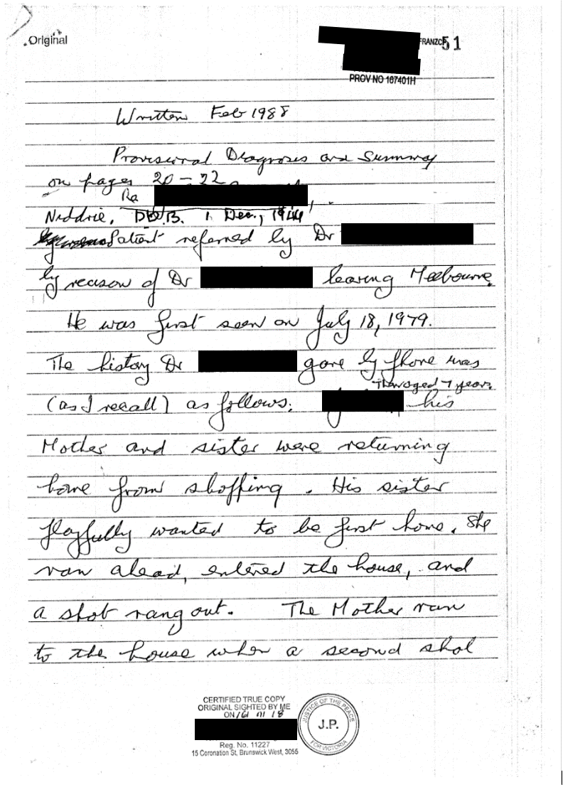

*1.Dr B dated this report as written Feb 1988 expecting that there would be a requirement for this letter in 1998, It was received in 1998.
*2.He recorded my birth date with a day of his choosing. As a psychiatrist there is no requirement for accuracy.
*3. He claimed that I was referred to him by a Dr W. I have never seen or heard of a Dr W.
*4. He claimed that Dr. W gave him my history over the phone, this conversation took place in 1979 and I believe he was writing this in 1998. And added “as I recall”. Then proceeded to give a brief account of what Dr B could recall of this conversation. From this recall he based all of his work. In reality what had happened was that Dr B had heard some gossip about me from someone that I had never met. Then he based all of his work with me on this gossip. It would seem that the basis for psychiatry is gossip. Using this gossip as the basis of his work Dr B then concluded that I was deluded and had no recall of past events in my life. The story that this Dr W had given was not accurate. If the psychiatrist Dr B had any integrity at all he would have checked the daily newspapers stories, the medical reports or the police reports of this event and he would of got a story that matched my recall of events. ( he may have also noted some inconsistencies in the newspaper stories. Today this is known as fake news. A Trumpism.) However as I have established the basis of psychiatry is gossip and if you as a patient are unable to recall the events of the past if line with the gossip that the psychiatrist has heard about you the you are at least delusional. (or select any other adjective that the psychiatrist may choose to describe you.) I later
- discovered that the psychiatrist is forbidden from talking to you the patient about your condition. The psychiatrist may if he chooses talk to your GP or other health professional about you. This ensures that you never find out the basis of your problem. The psychiatrist will pass on information based on gossip he has heard and pass this gossip on as gospel. With the communication skills that this profession have it ensures that you will never see the light of day. In my case as far as I know Dr B never contacted or spoke with Dr L. The basis of the referral was initially a recommendation by Dr M and the fact that Dr B had used LSD in the past. Later what impressed Dr L was the Dr B had worked with the man he idolised as a psychiatrist Dr H . Doctor B left Australia for a while and left his documents behind. Apparently he wanted to get away from what he perceived as a problem at Newhaven Private Hospital.

*Dr B says “as I recall.” implying no notes or records kept. Dr B’s report was passed on to another health professional.

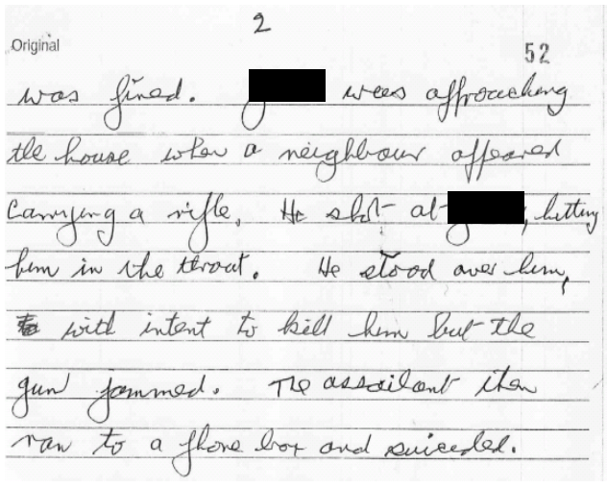

*Second column at word [name withheld].
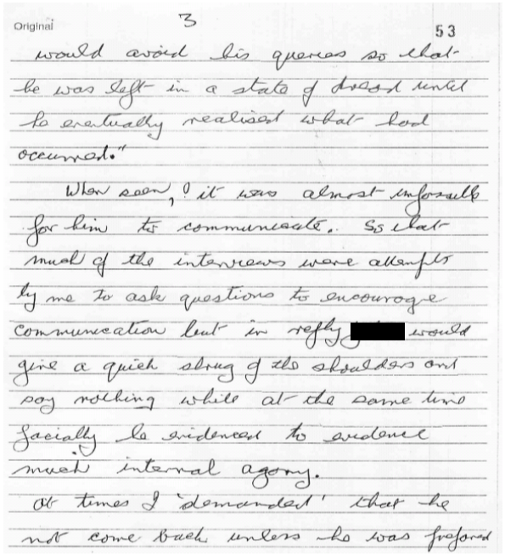

*5. The version that Dr B gave about the shooting was based on gossip or something made up by Dr B from his active imagination. This was as Dr B had said earlier quote “As I recall” ends Quote. When I first saw this letter it was the first time that I had heard of this version of events concerning the shooting when I was seven. I suspect that this was a story made up be Dr B and used as the basis of his work with me. In Dr B’s sickened state (He told me he was 4 days out of hospital after a major heart attack.)when he first saw me I suspect that he saw me as someone that was deluded. From this point on his work was to be righteous about his initial assessment of me. As a psychiatrist Dr B had no requirement to have integrity in how he related to me. He was forbidden from having a straight conversation with me about his clinical assessment of my condition. Refer letter dated 23rd January 1998. Where it stated “as DR G has indicated, as at the present time, a patient does not have a legal right to access a treating doctor’s records. Nor is DR B obliged to give you a written summary of his diagnosis and management of you whilst you were under his care. Dr B is ethically obliged to provide on request by your current treating doctor a sufficiently detailed report of his management of you, which would allow the currant health professional to continue your management satisfactorily. This request for clinical information should be accompanied by a written authority from you if Dr B is to supply the requested clinical information signed this letter. REGISTRAR. If I had gone to another psychiatrist and had that psychiatrist get information from Dr B I would have continued to be treated as someone who was deluded. That person would have treated me from the information in the clinical report. They would not have been obliged to tell me about Dr B's assessment of me and would have taken this as gospel. I would have never found out that I had been shot only once and that the gun jammed when I was about to be shot on the second occasion. Interestingly according to Dr B, Mr R went to a telephone booth and committed suicide with a gun that had jammed. Eventually the treating practitioners
would have hoped to convince me that the second scar on my body was imaginary or caused in some other manner and that the newspaper reports from after the shooting claiming that I was shot twice were false.
This is what doctor B referred to as working to the highest level. This is the brilliance of psychiatry.

*6. The assailant did not run to a phone box and suicide. According to newspaper reports and what I was told later, he went to the nearest tram stop placed the barrel of the rifle in his mouth and fired.
This was done in front of two elderly women. One of these women either called the police or got someone else to ring for the police. Again this is another example of Dr B’s active imagination. This is also not unprofessional conduct to make up stories.

SUMMARY:
As a consequence of the trauma that I had gone through as a child I had adopted severe limitations onto who I was to become. Whilst most of these were done unconsciously, I was aware of others. What I was unaware of was my ignorance of the ramification of these actions. This ignorance is I suspect something that is common to all children. I became a fairly shy timid child, I lived in fear of the consequences about what I had done lest anyone find out about my actions. I lived in fear of my father who on one occasion knocked me unconscious. After the trauma I developed flashbacks which I recognised as memories. The dilemma I had was that I tried to stop the flashbacks/memories from surfacing. I suspect my father also had flashbacks, this was noticeable from the change of expression on his face. He would not talk about what was happening. During my childhood I was virtually a slave. There were some redeeming features to this, I was taught to drive a car at an early age and I got a shotgun to go hunting with my father whilst quite young.
After my father died I felt very lonely as the last living member of our family in Australia. I went and visited my GP Dr L who concluded that I was depressed and prescribed a course of antidepressants. Three months later after the antidepressants had made no difference I visited Dr L again. After a brief talk in which Dr L suggested that I see a psychologist or a psychiatrist. I figured that the psychiatrist is more intelligent than the psychologist is and opted for the more intelligent of the two. Note this was done in total ignorance because I had actually never met anyone who worked in these professions. I had thought that because psychiatrists were intelligent they would also be honourable. (an assessment made in ignorance.) Dr L idolised the psychiatrist Dr H who he thought of as an extremely gifted and intelligent person he had met during some of his schooling. (Dr L was completely unaware the doctor H was idolising Anne Hamilton-Byrne as the reincarnation of Jesus Christ.) Apart from professional contact they had little to do with each other. Dr L made an appointment for me. I met Dr H, he listened to my story and then explained briefly what he did.
He claimed he used the latest therapy called Narcotherapy. This he claimed had produced very successful results and would be extremely suitable for my situation. He described that with the drugs that he used I would be able to relive the events of my past and this would provide a “cathartic release”.
(Defined as: “a purifying release of the emotions or of tension by bringing repressed material to consciousness.) This would give me emotional freedom from these past events in my life. Ideally the task is to re-experience the past traumatic event in one session. Dr H would use LSD, peyote and other drugs to achieve this. I had two drug sessions and two talk sessions with Dr H prior to moving on to Dr J who continued this work. Dr J introduced me to re-incarnation and yoga. I never managed a session of drug use to re-live the traumatic event in one session. On one occasion I asked about my mothers actions of running to my aid after I was shot. Doctor J replied that mothers do that sort of thing. I often pondered how I would find a woman who would be as brave as my mother. During the last session with LSD I got a death sentence from Dr J, I believe he told me that he had given me as much LSD as he dared and that if this did not set me free nothing would. Psychologically this is a death sentence. For this profession this is good business practice, it ensures that if you are not free from your troubles in the future you know that nothing will set you free. It ensures that other psychiatrists will continue to prosper from your misfortunes.
Also at that stage of my life I was unaware of the ramifications of having my basic belief structure altered. With the use of the LSD and Peyote Dr J had attempted to created a reincarnationist as an identity for me. Also if I had accepted that in a previous lifetime I had gone around murdering women and children this would have reduced my feeling of guilt and shame associated with the murder of my mother and sister. My being shot was my Karma and should have been completion for me in this area of my life. Apparently as a man of medicine and a distinguished doctor reincarnation was a scientific fact because I consulted doctor J as a doctor and psychiatrist not as a religious figure or guru. He was a man of medicine and I believe that what he did was approved of by the medical board. Its interesting that a psychiatrist can believe in reincarnation worship someone as the reincarnation of Jesus Christ and this is acceptable. Yet when a patient would do this they would be viewed as someone who was delusional (or some other adjective of the doctors choosing and recommend treatment of some kind to help boost the amount of money spent on mental health.) However this is psychiatry at its highest level.

Also at that stage I was unaware that the use of LSD was virtually in the experimental stage where it was being used for a trial period and not something as I was told as being part of a very successful therapy program. Apparently it was obtained free of charge for a while from a Swiss drug company in the hope of creating a market for this drug. Newhaven Hospital was once owned by the sect member associated with Anne Hamilton-Byrne. Three of the psychiatrists that I met had been associated with Anne Hamilton-Byrne.
Apparently members of the Anne Hamilton-Byrne sect worshipped her as the reincarnation of Jesus Christ.
Next came Dr C, who apparently was a more down to earth individual. He claimed the he used a more conventional approach. He was using Ritalin, and claimed that he had very successful results using this drug. Yes it was successful in that it did not kill patients. I would see him, lie down on the couch be injected with Ritalin and see greyish images and talk about them. Somehow this was going to solve my issues.
Later in America some teenagers prescribed this drug, committed suicide. It could possibly still be viewed as successful by the psychiatrists because they could possibly view this as removing those that were inferior from the human race. I discovered that I was viewed as inferior because I sought help to solve my problems.
This mild approach was followed by a more old fashioned approach used by Dr S.
According to Dr S my only problem was that I was depressed. Dr S said My past should not effect me at all. Apparently he had been taught that we all live in the “now”. So therefore even if I had not gone through the traumatic event of being shot and watching my mother being murdered I would still have become depressed because my body lacked certain chemicals or minerals. Remind yourself that this as the highest level of psychiatry. Over approximately seven years I was given shock treatment and was prescribed just about every antidepressant listed in a dark blue booklet, all without any meaningful result other than I progressively got worse.. I was deemed to be a manic depressive because my system lacked sufficient lithium and lithium was added to my intake of drugs. I also took sleeping pills regularly and tranquillisers. At the beginning of a session I would talk for a some minutes then doctor S would take over claiming that I was still depressed. He would claim that there is no point talking to a person when they are depressed. This statement would be repeated on numerous sessions. Then doctor S would review and or discuss my medication regimen and would continue. This was very deadening and depressing because it seemed that there was no hope for me, ever until the magic pill was discovered. Apparently I was depressed because my body lacked certain chemicals/minerals. According to doctor S there was no other reason for me being depressed. (other than having a brain defect,) During this time my weight went from about 72Kg to 92 Kg however apparently this is normal for depressed people.
The only other possibility was according to Dr S was that there was something wrong with me because the antidepressants did not work and recommended that he arrange for brain tissue samples to be taken to find out why these antidepressants did not work. I became incredibly anxious had nightmares and parted company from Dr S.
Later when I reflected on Dr S’s work with me I had a revelation. Obviously every person who is depressed suffers from a chemical or mineral shortage. The supply of this shortage for the rest of their life would cure depression world wide for these people. Alternatively they have a defective brain which causes the issue and in which the chemical or mineral does not work. Doctor S had no answer for this sort of issue.
I know of about a dozen people who have gone through similar experiences with psychiatrists and have given up. Some take up another legal (alcohol) or illegal drugs because they see no future for themselves. They give up.
Briefly saw Dr H looking for LSD however he had advanced to hypnosis.
Consulted Dr M briefly who recommended that I forget about my past and focus on what I want in life. He referred me to the greatest practising psychiatrist in Australia Dr B.
Met Dr B when he was 4 days out of intensive care after a major heart attack. He did not add this into his report when claiming I was barely able to talk. The reason I did not say much was that I wanted to get away while he was still alive and said as little as possible. Dr B's work was based on gossip and without telling me what this gossip was, I was expected to be able to recall my past in line with this gossip. This was referred to as “the highest level of psychiatry”. At this highest level of psychiatry there is no right or wrong for the psychiatrist, however when I gave incorrect answers Dr B would shout at me. He would shout “no or don’t”. I was expected to answer the questions in line with what Dr B had been taught whilst being trained as a psychiatrist. I became fascinated by Dr B’s antics. Not having any clear direction for my life at that time it was quite easy for doctor B to string me along for his own purposes. He knew that I wanted L S D. I found out later that the Citizens Commission on Human Rights established in 1969 by the Church of Scientology to investigate and expose psychiatric violations of human rights had been perusing Dr B. Dr B eventually acknowledged that he had used me and a few other people to abuse because he had no direct way at getting back at the Scientologists.
In the time that I saw Dr B not one of my issues was dealt with in any meaningful way. Dr B did more harm to me than any other person with the exception of Mr R who had murdered my mother and sister and had shot me twice. What Dr B did was not unprofessional according to the medical practitioner’s board. Dr B worked “to the highest level”.
In Doctor B’s report he stated that as he could recall, some one advised him in a telephone conversation the details of the incident when [name withheld]’s mother and sister were murdered. Doctor B did not discuss these details with me. Doctor B acted on this gossip as though it was gospel. Apparently he had not made or kept any written notes. He had already decided that I was deluded. (I suspect that this assessment was made during the initial consultation or shortly afterwards whilst Doctor B was very sick and had cancelled all his other appointments except mine.) I believe that I was viewed as deluded because I had been unable to recount the details of the shooting in line with the gossip that Doctor B had heard about me. At the highest level of psychiatry the patient is expected to be able to recall events from the past in a manner that match any gossip, visions or thoughts that the psychiatrist may have. When the patient is unable to do this, this is further evidence that he is deluded, or any other adjective that the psychiatrist chooses to describe the patient’s condition.
Extract from Page 51 of doctor B’s Report.

*** The History as I (Dr B) recall (advised by someone other myself.) was as follows: [Name withheld] then aged 7 his mother and sister were returning home from shopping. His sister playfully wanted to be home first, she ran ahead entered the house and a shot rang out. The mother ran to the house when a second shot was fired. [Name withheld] was approaching the house when a neighbour appeared carrying a rifle. He shot at [name withheld] hitting him in the throat. He stood over him with the intent to kill him but the gun jammed. The assailant ran to a phone box and suicided. *** (Herald stated Mr R sat down in tram shelter and shot himself using his rifle.) ****
Also if doctor B had bothered he could have easily checked the newspapers reporting the events of the day. Part of the headline story was, ""[Name withheld] is in the royal children’s hospital with bullet wounds to the head and eye, [name withheld] had entered the house clutching a jigsaw puzzle....." Further in the newspaper report it stated my sisters body was found under her bed.
However this would be too much to ask of a psychiatrist, there's is a world of power and it seems that when they decree that something is so the members of the Medical Practitioners Board accepts fully and totally what the psychiatrist says. As they say power corrupts and absolute power corrupts absolutely. The psychiatrists have absolute power. Their word is akin to the word of god in our community. In any business Caveat emptor applies, "let the buyer beware." And when the patient (buyer.) is not aware that’s their bad luck.
My problem was this was my ignorance; I was unaware that this was the procedure that psychiatrists who worked to the “Highest Level” used.
I went looking for reports from psychiatrists without much success. I contacted the Health services Commissioner And received a reply dated 15 Jan 2013 stating that the copy of the report I requested was returned to doctor D. According to letter from the Ombudsman dated 1 Nov 2002 the action by the health Commissioner in returning the report was contrary to the public records Act. Earlier I had been told that I had a right to see the psychiatrists report, however the psychiatrist does not need to comply with this right.

Claim against Dr B to the medical Practitioners Board.

From the letter written by Dr B I drafted a letter of complaint to the Medical Practitioners Board. In the letter I detailed errors made by Dr B in his letter to a Counselling Service. I sent this letter off to the Medical Practitioners Board.
When I had not received a reply after four weeks I sent off a letter requesting a reply.
Eventually I got a reply on 14th November 1997 stating that the complaint will be investigated. In October 1998 I went for an interview at the premises of the board with Dr C and Dr A. I was politely greeted by Dr C and Dr A greeted me with “I should be ashamed of myself for lodging a complaint against Dr B.” This had me realise that this was going to be a farce. I went through the formality of the meeting and was advised that Dr C would complete the investigation and will advise in due course. I was advised of the time and date for the hearing. I attended the hearing and was advised that Dr B had been interviewed separately and would not be present. It was acknowledged that he had taped some sessions when I saw him however this was for training purposes (He never had my approval to do this and never advised me that some sessions were being recorded.. It seemed that the purpose of the hearing was to obtain information from me that may be useful if I took legal action against Dr B. Shortly afterwards I received a letter dated 11 March 1999 ref:73/98 JHS.BS stating that Dr B had been found not guilty of unprofessional conduct as defined in section 43 (1) (b) of the medical practises act.
This told me that the psychiatrist has the right to tape record your sessions without permission and allow others to listen to these tapes. The psychiatrist can form a social relationship with you to extend his influence over you. Can make numerous errors in writing a report about you and passing it on to others that does not need to be factual. The psychiatrist bases his work on gossip and this is not unprofessional. The psychiatrist has no requirement for integrity in how he relates to you. This is the highest level of psychiatry.
Reminder as Dr B said “He was a psychiatrist not a teacher it was not his role to teach me anything.” end quote.
As a psychiatrist he must treat your symptoms.
With his skill in language and the context of using words, he was to make sure that I did not benefit from what he said.
He must not teach me anything.
I recall hearing that “the truth liberates” however in psychiatry this is forbidden. It seems that they used the film “A few good men.” where it is stated “You (In my case the patient) can’t handle the truth.”. I believe Psychiatrists prefer the saying “Ignorance is bliss.” and go laughing all the way to the bank.
And then the politicians are left to ponder where did the money go!

Request that all psychiatrists publicise their religious beliefs in a notice in the office.

Advertise that it is forbidden for the psychiatrist to teach you anything significant re your issues.

Advertise that a psychiatrist will advocate the use of the latest legal drugs or experimental drugs used to treat your symptoms. He must not address the underlying cause.

Suggestion that all meetings are recorded and that all records are kept. The benefit for patients is that they would notice inconsistencies in what they say.

A challenge for the commission:

********** Test for Psychiatrists.**********

As I was advised by the Medical board I was required to know details

about my past based on the gossip that the psychiatrist had heard about me.

This action was deemed to be correct according to 43 (1) (b) of the

medical practises act. So working to the same guidelines I propose a test

for the top ten psychiatrists in Australia.

Have the psychiatrists tested by myself or an honourable unbiased

authority and when they are unable to recall details about a past event in

line with gossip heard about them have them certified as delusional. As

delusional they should be prohibited from working until they are cured.

This would require another test to see if they are fit to continue work.

Surely an elite profession should use the same guidelines that

they practise be suitable to treat their sanity.

I defy any psychiatrist to pass this test.

***********************************
Please find an intelligent person in Australia who could pass this test. A challenge for the commission.
Find participants who could pass this test and save billions.

Top of the list would be Patrick Dennistoun McGorry AO FAA FASSA FAHMS FRCP FRANZCP. He is eminently suitable because I wrote to him on numerous occasions, He preferred to keep details about how drugs could cure ignorance secret.
Please let me know when you test him and advise his results.

*****************************************************
Please let me know the results.
Please answer the following questions:
For basic issues of depression bipolar PTSD and others.
As I see it the patient goes looking for answers on how to resolve their issues. The psychiatrist has a completely different agenda.
Please conduct a survey into what patients actually look for when seeing a psychiatrist.
e.g. Saw Dr H who deceived me claiming Narcotheraphy was a very successful therapy. (An experimental treatment.)
Saw Dr J issue with results of trauma. Dr J, experiment with LSD and my religious beliefs. (Experimental work.)
Dr C experiment with Ritalin. (Trial period.)
Dr S Look for drug/chemical to cure depression. (Looking for drug cure.)
Dr B, have me believe my dreams come true re murder of my mother and get me to recall past events based on gossip he had heard about me whilst drugging me with legal drugs. (A delusional psychiatrist trying to get by financially)

Not one of them had shown any real interest in the details of what I had experienced whilst growing up.

Please explain in detail how any of these psychiatrists could have been successful in how they related to me. What constitutes success for a psychiatrist in his/her relationship with a patient?
Is there any time frame or follow up on progress in this process.
F Y I.
Because of my concern about the spending/waste of money on mental health I contacted several politicians.
Senator Bob Brown. Initially no reply. Then at an election I had a conversation with the Greens candidate and advised her of this and a few weeks later got a generalization as a reply. I also contacted Bill Shorten and Nick Xenophon requesting certain info they both passed me on to the minister for health. I also contacted Senator Scott Ryan who did not reply in a meaningful manner.
I also contacted the Hon Minister for health Greg Hunt. Initially no reply. I followed up my initial request for no reply. I contacted the PM of the day and a few weeks later received a reply on behalf of the minister. In the reply I got two suggestions to go to web sites for generalised stories and an insult. I have followed this up with the minister and the PM of the day on numerous occasions for no reply. Still waiting. I suspect my questions are too difficult for the Honourable minister Greg Hunt or his assistants to reply to in a meaningful manner. If the commission has any integrity please arrange for the honourable Minister Greg Hunt to answer my questions in a meaningful manner. The main question is “I contend that depression is caused by ignorance. Therefore how can drugging and deceiving a person cure ignorance? The Hon. Minister Greg Hunt preferred to keep this secret. I recall seeing Minister Hunt on the news when he was in the NT and he had upset someone. His way of resolving the issue was to upset them then say “sorry” and apparently this is how he resolves issues.
Apparently it does not matter where the money goes all that is important is to put on a good show.

For the legal profession once you mention the word “psychiatrist” this stops all action and it was suggested forget about what happened and get on with your life. They did not even want to know the details.

I also contacted Beyond Blue re bullying. I watched a news story about parliament question time. PM Turnbull and Scott Morrison were berating (bullying) Bill Shorten. They were loudly saying Bill who was short on (some quality and repeating as they laughed and gloated about his short coming’s.) Apparently this is done to teach young children the correct way to bully people.

Refer : Beyond the aetiology debate:
the “great LSD scandal” at Newhaven Private Hospital
& the social foundations of mental health legislation
in Victoria, Australia

The “great LSD scandal” at Newhaven is best understood then as
an example of how the practice of the art and science of experimental psychiatry and medicine is negotiated in its social context.

cc: B A
cc: the Age.. cc:mhlc

