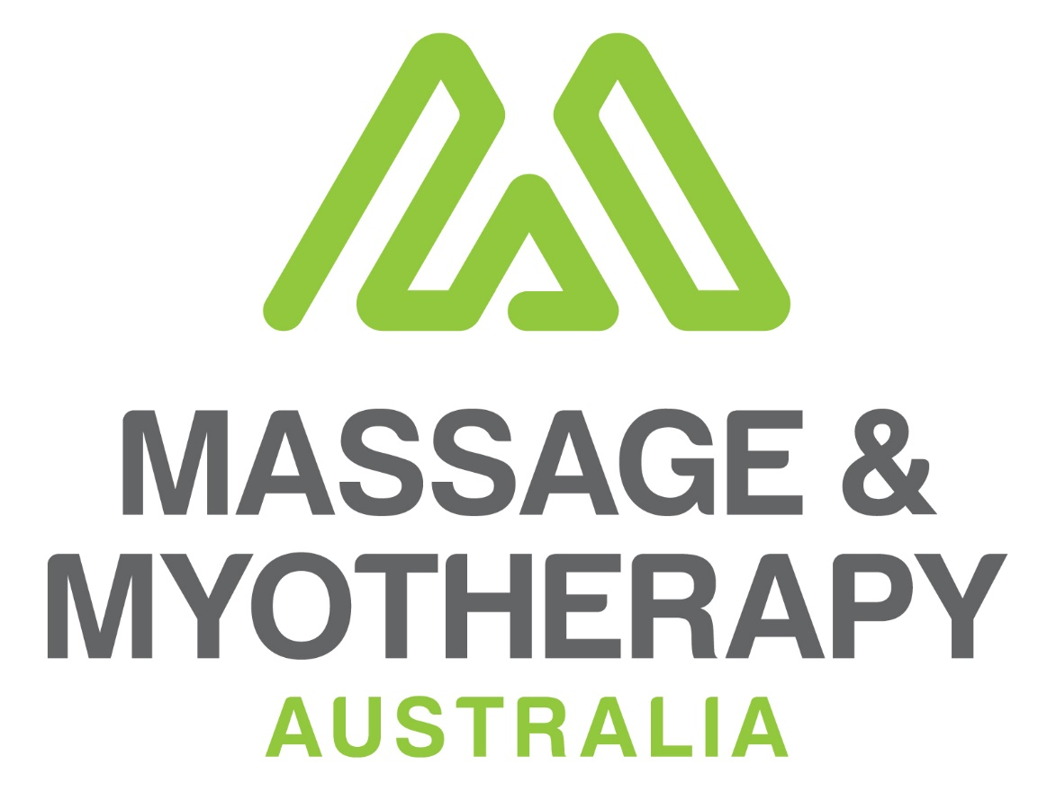
Addressing psycho/physical mental health risk factors associated with chronic pain, mobility and related stress

A submission to the Productivity Commission’s Draft Report, Volume 2, October 2019
Mental Health

January 2020

Contents
1. Executive Summary 3
Addressing pain and mobility as part of response to improving mental health 4
Addressing physical pain and limited mobility to improve mental health 5
A solid evidence base 6
2. Opportunity for structural reform 10
Where the cost savings lie 10
More informed funding and treatment arrangements 12
3. Structural reform that integrates research 13
Tracking and measuring the benefits 13
4. Healthier workplace reforms 14
Massage and myotherapy services in the workplace 14
An available skilled workforce 14

Executive Summary
While Massage & Myotherapy Australia (the Association) supports the Mental Health Draft Report Overview & Recommendations, concerning structural reforms and prevention, a key factor affecting mental health and identified in the Productivity Commission’s Draft Report Social and Economic Benefits of Improving Mental Health, Volume 1 warrants further examination. This factor concerns the relationship between physical health, mobility and mental illness.
The Association proposes that the relationship between physical health, pain, addictions and mental health provides significant opportunity in the area of prevention, and early intervention among adults. Treatments involving physical therapies such as manual manipulation and exercise are known to lead to positive outcomes for those assessed within the mild spectrum, those who self-manage mental health issues or those who are classified as low intensity patients.
While massage and myotherapy are not cures for mental illness involving depression, anxiety or substance abuse, they already play an important role in prevention, management and rehabilitation as mental health issues percolate through the lives of people.
In higher intensity patients, these therapies can also help to address physical health issues.
The Draft Report Volume 1 cites that those with mental illness are 18-36% more likely to have musculoskeletal problems and the body of evidence supporting these physical therapies in managing pain and stress across all population groups is growing rapidly, especially in primary care and by those who self-manage their condition.
In this regard, the Association’s submission highlights the positive effects on mental health that are derived from the use of massage and myotherapy for users.
On a regular basis, qualified massage therapists and myotherapists provide care and relief from stress and anxiety through self-management and low intensity care. Massage therapists and myotherapists often fill the gap when patients seek alternatives to medications and other therapies because they feel that massage and myotherapy provide a level of relief that is appropriate to their needs.
This submission outlines opportunities within the recommendations where further integration of manual manipulation therapies applied through Primary Health Networks (PHNs) can play a more influential role and cost-effective management response in the Stepped Care approach outlined in the Draft Report.
We propose that massage and myotherapy administered by professional therapists offers another significant layer of options for clinicians and institutions managing the care of people who are at risk of falling into long-term depression and mental illness due to pain and stress caused by chronic disease, addiction or injury.
More formal inclusion of massage therapists and myotherapists also promises considerable improvement in the quality of massage services already being delivered to mental health patients, under government funded programs, without placing undue or additional costs on the mental health care system.
While funded services occur in isolation by various jurisdictions, more formal inclusion in a coordinated spectrum of services that are uniformly available and appropriately funded across jurisdictions, clinicians and institutional providers would add considerably to the depth and access to mental health care and prevention services currently available.
We are not suggesting that massage therapists or myotherapists depose the role of Medical or Allied Health services, but that these therapies have a more valuable cost-effective role to play when administered by massage-qualified and experienced career professionals.
The following information provides responses to relevant questions raised in the Draft Report in relation to how massage and myotherapy may affect better outcomes for people living with mental illness.

Addressing pain and mobility as part of response to improving mental health
The Australian Pain Management Association reports that people living with pain are more prone to psychological distress, such as anxiety and depression, than those in the general community.
Long-term pain puts a lot of stress on the brain and cognitive issues such as low mood, difficulty with memory or concentration, are familiar, no matter what the underlying pain condition is.
Chronic pain and depression are frequently comorbid (2013). The presence of depression in a patient with chronic pain is associated with decreased function, poorer treatment response and increased health care costs.
An accurate diagnosis of major depression can be challenging in the setting of comorbid chronic pain. Antidepressants and psychological treatments can be effective and are best delivered as part of a coordinated, cohesive, multidisciplinary pain management plan.
The AIHW’s Mental health services—In brief 2018 report stated that 45% of Australians will have a common mental disorder in their lifetime. This includes anxiety disorders such as post-traumatic stress disorder and social phobia.
The National Institute of Mental Health risk factors for depression state that this can include a family history of mood disorders, major life changes, trauma, other physical illnesses and medications.
Despite science yet fully determining the physiological effect of massage, examination of pressure, movement, friction, touch and human interaction as experienced by patients in a massage or myotherapy setting delivers consistent conclusions that massage makes people feel better, by offering a sensory experience that relieves feelings of pain and mood, and other health-related quality of life issues (2016).
Importantly, improving the quality of people’s daily lives through massage can have profound effects on their mental health.
For example, improvements in a patient’s ability to walk with less pain (2018), drive (2006), engage in social activities (2016), engage in work or avoiding absenteeism, improve mobility (2017) and maintain social ties for older people or people with chronic disease such as diabetes (2017).
Easing the debilitating symptoms of cancer (2015) or improving sleep after cardiac surgery (2017) in order to achieve a more positive disposition and normal functions are profound improvements for seriously ill patients that warrant deeper investigation.
HILDA survey as outlined in the Report—Box 26.1 of ‘Measuring health-related quality of life’, combines a person’s answers to the physical and mental health-related questions.
Additionally, the US Pain Collaborative Report (2019), driven by survey data on patient awareness and satisfaction with current chronic pain assessment instruments, provides patient-informed recommendations that should be taken by physicians, patients, and advocacy organisations immediately to improve the lives of people living with chronic pain.
Figure 5 of the report (below) underscores that comprehensive chronic pain assessment methods should reflect the multiple aspects of the patient's pain experience and capture chronic pain's impact on daily life, which in turn can impact their mental health.

Figure 1: Life Aspect Assessment US Collaborative Pain Report
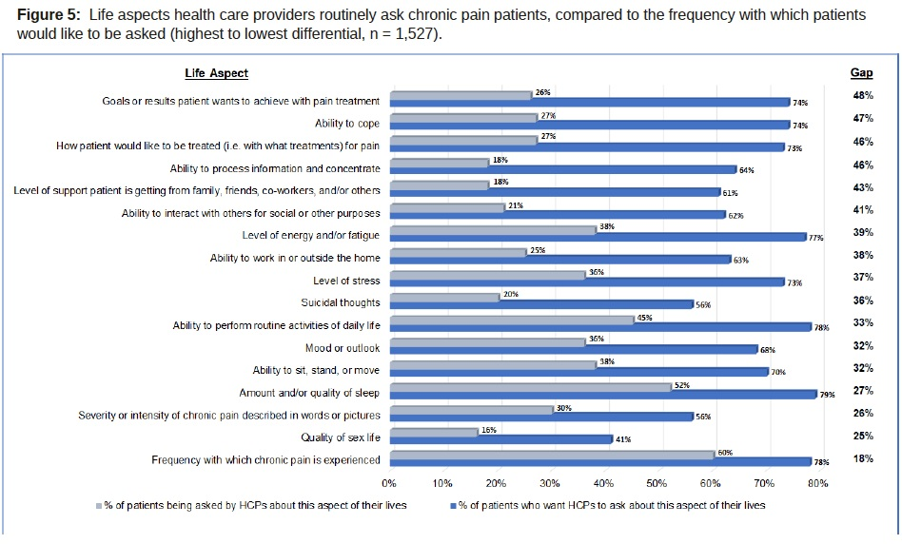
The experiences listed in the two assessments are not dissimilar and suggest that broader criteria of assessment and treatment options can have a positive effect on understanding the complex relationship between physical ill health and improving mental health.
Hence, qualitative measures involving sustained attitudinal and behavioural change alongside self-assessed feelings of wellbeing can provide clinicians with a more holistic understanding of the benefit of therapeutic responses to massage or myotherapy and mental health.

Addressing physical pain and limited mobility to improve mental health
Physical exercise is known to improve mental and physical health. Close associations between physical functional limitations and psychological distress highlight special needs among individuals experiencing daily functional limitations (2018). Commonly, those enduring acute and chronic pain, who experience trouble with daily living skills like walking, sleeping or leaving the house, seek alternatives to pharmaceutical pain killers.
Pain Australia reports that there are many conditions such as migraine, osteoporosis, arthritis and other musculoskeletal ailments that are well recognised chronic diseases and chronic pain conditions. These can also include not so well-known conditions related to nerve pain, pelvic pain, abdominal pain, facial pain and persistent post-surgical pain.
The Australian Institute of Health and Welfare (2018) cites the Australian Physical Activity and Sedentary Behaviour Guidelines which recommend people aged 18 to 64 exercise for at least 150 minutes over 5 sessions per week; and over 65 years, at least 30 minutes per day. Unfortunately, limited functionality and increased pain often translates to a limited ability to exercise or undertake the recommended exercises and activities as outlined in the Australian Physical Activities and Sedentary Behaviour Guidelines.
Hence, the recognised functions and benefits of remedial massage and myotherapy massage in freeing up muscles, improving mobility, and reducing pain and stress when administered by professional, qualified therapists, has significant relevance.

A solid evidence base
Massage is the most used complementary therapy. What is known about the effects of massage indicates a complex interplay between biomechanical, physiological, neurological, and psychological pathways.
In recent times, a considerable body of new evidence has emerged that attests to the value of massage therapy and myotherapy in relieving pain and stress for a range of conditions and in cases of serious disease or illness.
The following provides a considerable array of clinical evidence concerning the merits of broadening the assessment base with a view to involving qualified professional massage therapists and myotherapists in the delivery of these therapies to reduce chronic pain and subsequent depression, anxiety and stress.
Musculoskeletal disease
While massage is not a cure for musculoskeletal disease it does provide symptom relief for pain sufferers allowing for a higher degree of mobility and exercise.
- The Final Evidence Report, Effectiveness of Massage and Myotherapy for any Clinical Condition: Evaluation of the Evidence Prepared for the National Health and Medical Research Council (NHMRC) 2012, found that Massage may be more effective than control (no treatment, sham) in reducing pain in people with acute/subacute low back pain in the short term.
- A randomly controlled 2018 trial involving 200 patients in an 8 and 52-week assessment found that the efficacy of symptom relief and safety of a weekly massage make it an attractive short-term pain treatment option for knee osteoarthritis. As expected, while the additional benefit beyond the usual care 8-week treatment provided no additional improvement, the longer-term bi-weekly dose over 52 weeks maintained the improvements achieved in the first 8 weeks.
- A Massage & Myotherapy Australia commissioned RMIT University 2011 study that looked into the Effectiveness of Massage Therapy found that massage therapy is effective in managing subacute/chronic low back pain, delayed onset muscle soreness (DOMS), anxiety, stress and relaxation, and helps support the wellbeing of patients with chronic diseases, life-threatening diseases such as cancer, and/or terminal illnesses.
- A Massage & Myotherapy Australia commissioned 2013 study by the International Centre for Allied Health Evidence, University of South Australia, found an emerging body of evidence, albeit small, that supports the effectiveness of massage therapy for the treatment of non-specific low back pain, especially in the short term.
Stress and cardiovascular disease related symptoms
The body of research that investigated the effects of massage on symptoms of cardiovascular disease and surgery, such as hypertension and blood pressure during the past 10 years suggest that massage could be a useful intervention.
- A massage research review (2014) found that when moderate and light pressure massage have been compared, moderate pressure massage reduced depression, anxiety and heart rate, altered EEG patterns and increased vagal activity, as in a relaxation response.
- Findings of the study in 2013 that investigated durability of the effect of massage therapy on blood pressure indicated that massage therapy was a safe, effective, applicable, and cost-effective intervention in controlling blood pressure of pre-hypertension women and can be used in health care centres and even at home.
- A 2013 study into the effects of Swedish Massage Therapy on blood pressure, heart rate and inflammatory markers in hypertensive women, found that Swedish Massage Therapy or resting for an hour weekly significantly reduced blood pressure, heart rate and vascular endothelial adhesion molecules. However, the effect of rest on blood pressure does not extend to four weeks as compared to Swedish Massage Therapy. In addition, massage also reduces the resting heart rate in hypertensive women.
- Researchers investigated the effect of massage therapy on pain, anxiety, relaxation, and tension after colorectal surgery. The randomised study concluded that massage may be beneficial during post-operative recovery for patients undergoing abdominal colorectal surgery. Further studies are warranted to optimise timing and duration and to determine other benefits in this clinical setting.
- A 2016 meta-analysis titled ‘Massage therapy reduces pain and anxiety after cardiac surgery: A systematic review and meta-analysis of randomised clinical trials concluded that massage therapy might be a useful method to reduce pain and anxiety in patients undergoing cardiac surgery.
- Based on the findings of a 2016 study to learn more about the effect of massage therapy on physiological responses in patients with congestive heart failure, researchers concluded that massage therapy was effective in blood pressure, heart rate, respiration rate and oxygen saturation in patients with Congestive Heart Failure, and suggested that massage therapy be used as a complementary method to stabilise their vital signs.
- Research during 2016 that investigated the effectiveness of massage therapy on the mood of patients after open-heart surgery found that the use of massage therapy as an effective nursing intervention can improve the patient's mood after open-heart surgery. Due to the low cost and simplicity of this method, it can perhaps be used as a complement to drug therapy and post-operative interventions used in these patients.
- Researchers of a study titled ‘The long-term effect of massage therapy on blood pressure in prehypertensive women’ concluded that although massage therapy seems to be a safe, effective, applicable, and cost-effective intervention to control blood pressure of prehypertensive women, its effects do not persist for a long time.
- A 2016 systematic review of the effects of massage on blood pressure in patients with hypertension and prehypertension: A meta-analysis of randomised controlled trials found a medium effect of massage on systolic blood pressure and a small effect on diastolic blood pressure in patients with hypertension or prehypertension. High-quality randomised controlled trials are urgently required to confirm these results, although the findings of this study can be used to guide future research.
- A 2012 randomised controlled trial that investigated massage therapy for cardiac surgery patients concluded that massage therapy significantly reduced the pain, anxiety and muscular tension and improved relaxation and satisfaction after cardiac surgery.
- The short-term effects of myofascial trigger point massage therapy on cardiac autonomic tone in healthy subjects were reported in a study that found that in normal healthy subjects, myofascial trigger-point massage therapy to the head, neck and shoulder areas is effective in increasing cardiac parasympathetic activity and improving measures of relaxation.
- The authors of a 2018 study titled ‘Effects of Manual Lymphatic Drainage Massage associated with physical exercise program in morphological-functional blood pressure parameters’, reported that manual lymphatic drainage massage may be a valuable nonpharmacological auxiliary therapy in the control of arterial hypertension, also indicating that when performed in association with a regular program of aerobic physical exercises, it significantly increases the reduction of values blood pressure of hypertensive subjects. In view of these findings, it is suggested that new studies be carried out with a larger sample and with new experimental designs to ratify the results of this research and extend this line of research.
Cancer and cancer treatments
- A systematic review of studies on aromatherapy and massage for relieving symptoms in people with cancer looked at 10 studies including 8 randomised controlled trials. It found that massage consistently reduced anxiety and depression. Massage also helped lower nausea and pain, but not as consistently.
- A 2009 article briefly describes research illustrating the promise of integrative approaches for the treatment of cancer-related neuropathic pain. The authors concluded that the advantage of complementary approaches such as massage therapy, acupuncture, and mind–body therapies such as meditation and self-hypnosis is that they are inexpensive, safe, non-invasive, and absent of side effects, in contrast to pharmaceuticals administered for pain management. Evidence for the efficacy of these approaches continues to accumulate. Furthermore, these techniques should be especially welcome considering current and pending health care realities, especially increasing costs and the decreasing availability of physicians.
- A large study published in 2004 looked at the effects of massage therapy on almost 1,300 people with cancer over three years. People in hospital had a 20-minute massage, and people treated as outpatients had a 60-minute session. The study found that overall, massage therapy reduced pain, nausea, fatigue, anxiety and depression. The benefits lasted longer in the patients who had the 60-minute session.
- The results of a study aimed at describing the experience of massage for breast cancer patients during chemotherapy treatment revealed five themes: The patients experienced distraction from the frightening experience, a turn from negative to positive, a sense of relaxation, a confirmation of caring, and finally they just felt good. The findings of this study showed that massage offered a retreat from uneasy, unwanted, negative feelings connected with chemotherapy treatment. It is an intervention that can be added to the arsenal of treatment choices available to the oncological staff.
Surgery pain mobility and anxiety
- A 2018 Study that sought to determine the value of myofascial massage to address surgery pain and mobility limitations found that myofascial massage is a promising treatment to address chronic pain and mobility limitations following breast cancer surgery. Further work in several areas is needed to confirm and expand on the study findings.
- During 2017, researchers assessed the effects of massage therapy on pain management among post-operative patients by conducting a systematic review and meta-analysis and reported that the effect of single dosage massage therapy on post-operative pain showed significant improvement and the anxiety subgroups showed substantial heterogeneity. They conclude that the findings of this study revealed that massage therapy may alleviate post-operative pain, although there are limits on generalisation of these findings due to low methodological quality in the reviewed studies.
Fatigue and depression
- A 2017 study evaluated the efficacy of weekly Swedish massage therapy versus an active control condition (light touch) and waitlist control on persistent cancer-related fatigue in breast cancer survivors. The authors concluded that Swedish massage therapy produced clinically significant relief of cancer-related fatigue. The findings suggested that six weeks of a safe, widely accepted manual intervention causes a significant reduction in fatigue, a debilitating sequela for cancer survivors.
General symptoms relief
- During 2017 researchers published the results of their study which sought to learn about the effects of the use of therapeutic massage in children with cancer, and concluded that therapeutic massage improves the symptoms of children with cancer, but there is a need for more research that may support the effects attributed to it. Techniques used included Swedish massage, effleurage, petrissage, frictions, pressures which reportedly obtained benefits in the symptoms present during the illness, such as decrease of pain, nausea, stress, anxiety and increase of white blood cells and neutrophils.
- The 2004 study referenced previously to the Cancer Council involved the Memorial Sloan-Kettering Cancer Centers’ examination of changes in symptom scores and the modifying effects of patient status (in- or outpatient) and type of massage. Over a three-year period, 1,290 patients were treated. Symptom scores were reduced by approximately 50%, even for patients reporting high baseline scores. Outpatients improved about 10% more than inpatients. Benefits persisted, with outpatients experiencing no return toward baseline scores throughout the duration of a 48-hour follow-up. They concluded that these data indicate that massage therapy is associated with substantive improvement in cancer patients' symptom scores.
Pain and stress
- A 2017 study that explored the experiences towards aromatherapy massage use, and examined the perceived benefits and adverse effects of aromatherapy massage among adult female cancer patients, reported that the perceived benefits included physical and psychological dimensions: overall comfort, relaxation, reduced pain, muscular tension, lymphoedema and numbness, improved sleep, energy level, appetite and mood.
- A 2015 meta-analysis, which aimed to investigate the effects of massage therapy for cancer patients experiencing pain, indicated a beneficial effect of massage for relief of cancer pain. Further well-designed, large studies with longer follow-up periods are needed to be able to draw firmer conclusions regarding the effectiveness.
- The purpose of a 2009 study was to describe the feasibility of massage therapy and to examine the effects of massage therapy on present pain intensity, anxiety and physiological relaxation over a 16- to 18-hour period in 30 Taiwanese cancer patients with bone metastases. Researchers reported that clinically, the time effects of massage therapy can assist health care providers in implementing MT along with pharmacological treatment, thereby enhancing cancer pain management. Randomised clinical trials are needed to validate the effectiveness of massage therapy in this cancer population.
Palliative care
Among the palliative care community, massage is well known for improving the quality of life of patients, however many professional therapists are often asked to provide their services for free.
- A 2011 Study exploring the extent that massage therapies are able to reduce the amount of pain, anxiety and depression that cancer patients feel while in palliative care, found that massage therapy reduces the subjectively perceived symptom of pain in oncological patients receiving palliative care. Reduction of the symptoms of anxiety and depression was also achieved.
- A 2014 study that looked at integrating massage therapy within the palliative care of veterans with advanced illness found that all short-term changes in symptoms showed improvement and all were statistically significant. Pain intensity decreased, anxiety decreased, patients’ sense of relaxation increased, and inner peace improved. The authors concluded that massage is a useful tool for improving symptom management and reducing suffering in palliative care patients.
- A 2009 study which sought to demonstrate how people with incurable cancer experienced soft massage in a palliative care setting in which massage was used as an established and integrated part of the nursing care, found that during the massage the patients felt dignified, while memories from past massage sessions were about becoming free. These experiences of dignity and freedom brought hopes for the future. The authors concluded that soft massage ought to be offered in the ordinary palliative care. More research is needed to understand what is required to integrate and establish methods such as soft massage in palliative care.

Opportunity for structural reform

Where the cost savings lie
The inclusion of massage therapists and myotherapists in a multi-disciplinary team promises considerable savings to the cost of human health services, and an improvement in the quality of massage services delivered for mental health patients.
This can occur without placing undue or additional costs on the mental healthcare system.
Medicare guidelines recognise massage as a legitimate treatment for subsidies under the chronic pain management system and provides guidance to services offered by various departments such as the Department of Veterans Affairs (DVA).
Various government departments offer support funding for massage therapies when approved by a General Practitioner (GP), and under the guidance of Registered health professionals. Massage can also be delivered and oversighted by physiotherapists, chiropractors or osteopaths.
Importantly, these funded precedents, and the high number of self-funded clients who use professional massage therapists and myotherapists mean that no additional funding is necessary, nor would they compete significantly for funding provided for GPs or Allied Health practitioners.
However, the subsidies for ongoing multiple consultation provided through these programs is around 1/3 of actual delivery costs of delivering a standard one (1) hour remedial massage.
Table 1:Approximate charges for Remedial Massage consultation
Approximate rates—Remedial Massage (Qualified Therapists)
30 min per session | $55
45 min per session | $80
60 min per session | $100
90 min per session | $145
The Australian Association of Massage Therapists: Practitioner Survey, Preliminary Report II, January 15, 2013, involved determining the kinds of services that therapists provide and their patients’ characteristics. Table 2 below presents the ‘recorded reason for applying massage therapy,’ varying from four (4) sessions for headaches and migraines, to ten (10) sessions for diabetes effects management.
Table 2: Massage consultations in relation to condition treated
Complaint or condition | Number of sessions
 | Average | Median
Diabetes Effects Management | 10 | 6
Addictions Rehabilitation Support | 10 | 6
Cancer Treatment Issues | 9 | 5
Other Chronic Conditions | 9 | 5
Health and Wellness | 9 | 5
Motor Vehicle Accident and Rehabilitation | 8 | 6
Psychological Distress | 8 | 6
Joint Pain and Stiffness, including Arthritis | 8 | 5
Back Pain and/or Other Back Problems | 6 | 4
Repetitive Strain Injury Syndromes | 6 | 5
Neck/Shoulder Pain | 5 | 4
Other Acute Injury or Pain Conditions | 5 | 4
Sports Injury Management and Rehabilitation | 4 | 4
Headaches or Migraines | 4 | 3
In comparison, the following provides examples of funding support available through Private Health Insurance and government programs.

Government funded programs
Massage and myotherapy-funded programs are administered by various state and federal jurisdictions in isolation and with a focus that is primarily limited to physical function and injury. For example, the following Table 3 presents 2019 fee schedules that are available to patients:
Table 3: Government subsidies provided for remedial massage services
 | Service | Initial consultation | Reports | Standard consults
Worksafe Victoria | Remedial Massage | $59.18 |  | $39.84
Return to Work SA | Remedial Massage | $80.30 | $80.30 | $40.20
 | Duration | 60 minutes | 45 minutes | 30 minutes
SIRA NSW | Massage therapy consultation and treatment | $83.80 | $62.00 | $42.00
WorkCover Queensland | Pays for massage as part of a normal treatment session by physiotherapists. There are no individual item codes for massage under the table of costs. This must be charged under the standard consultation item codes as appropriate.
Medicare | Does not provide cover for remedial massage.

Private Health Insurance
Remedial massage and myotherapy subsidies are also available through the Private Health Insurance Rebate for complementary therapies for those therapists who have an eligible Provider number. However, as presented in the following examples, rebates vary considerably and are well below the cost of provision.
Table 4: Private health insurance rebates for remedial massage services
Fund | Rebate | Combined limit
ACA Health | Up to $20.00 | $100.00
AHM | $31.00 | $400.00 per person
Australian Unity |  | $100.00
CUA | 60% to total cover | $250.00

More informed funding and treatment arrangements
In Australia, the presence of massage in private and public care settings has occurred largely on an ad-hoc basis. Organisations have either responded to consumer demand, or massage has been championed by key personnel within the organisation who are motivated by the effectiveness of massage therapy as evidenced in the scientific literature or anecdotal and personal experiences related by patients.
An integrated solution involving these therapies would have the effect of improving online information for GPs and other health professionals about effective pain and stress management services available through qualified professional massage therapists and myotherapists.
The structural limitation involving government-funded massage therapies when approved by a GP mean that these therapies must be administered by a Registered Health professional or under the guidance or oversight by physiotherapists, chiropractors or osteopaths. However, there is no incentive for Allied Health practitioners to refer the administration of massage to qualified specialist massage therapists.
This adds considerable cost to the delivery or these therapies and the outcome assessments available.
We are not suggesting that massage therapists or myotherapists depose the role of Allied Health services. However, there are limitations to the benefits the current arrangements afford given the skills offered by specialist remedial massage therapists and myotherapists who have recognised qualifications such as Bachelor Degrees in Health Science, Advanced Diploma or Diploma, and who undertake at least 1,000 hours of specialty training.
It is with these professional therapists that the opportunity lies to improve services to patients at a lower cost. In comparison, Allied Health practitioners can administer massage under Medicare subsidies with as little as 200 hours of training and limited massage qualifications and experience, which is likely to limit the benefit that massage treatments afford patients.
As illustrated in the section headed ‘Where the cost savings lie’ the comparative cost of massage services when administered by a qualified massage or myotherapists is considerably less than that provided by Allied Health professionals.
A 2008 review by the Canadian Institute of Work and Health concluded that massage was most effective when combined with education and exercise, and when administered by a licensed therapist.
We propose that massage and myotherapy continue to be approved by General Practitioners but enabling professional qualified massage therapists to administer the therapies as standalone professionals, and not under the supervision of Allied Health Practitioners.
A national workforce survey found that there are high levels of support for massage therapies among Australian GPs, relative to other CAM professions, with low levels of opposition to the incorporation of these therapies in patient care.
- GPs (76.6%) referred to massage therapy at least a few times per year
- 12.5% of GPs referred at least once per week
- 95% of GPs believed in the efficacy of massage therapy
- 95% of GPs perceived a lack of other treatment options
- 95% of GPs who had prescribed any complementary and alternative medicine previously were all independently predictive of increased referrals to massage therapy
- GPs were more likely to refer a patient to a massage therapist if they had obtained their medical training in Australia.
Additionally, a 2019 USA study reported that massage is the most often recommended therapy at 30%, with women being the highest referrals. Researchers found that ‘overall, more than half of office-based physicians recommended at least one CHA to their patients. Female physicians recommended every individual CHA at a higher rate than male physicians except for chiropractic and osteopathic manipulation. These findings may enable consumers, physicians, and medical schools to better understand potential differences in use of CHAs with patients'.
Anecdotal evidence is also supportive. During 2018/2019, Massage & Myotherapy Australia displayed information brochures through the brochure dispensing facilities located in the waiting rooms of GP clinics. Distributed by Tonic Health Media, and titled The benefits of Massage & Myotherapy. Tonic Health Media reported that the take up rate by patients of the massage and myotherapy brochures is the highest ever recorded, compared to all other brochures that they have distributed.
Women access massage services at a ratio of 2:1 to men. A significant Australian longitudinal study indicates that over 50% of women visited a massage therapist in the previous 12 months. Women with lower quality of life scores in terms of bodily pain and/or emotional health are more likely to consult a massage therapist than those with higher scores. Additionally, older Australian women experiencing chronic bodily pain prefer a concurrent multimodality approach (accessing conventional treatments alongside massage therapy) to cope with their condition).

3. Structural reform that integrates research

Tracking and measuring the benefits
Pain relief, and the positive psychological/physiological effects of touch and human interaction, make massage an efficient and effective service, and the additional time may well be a contributing factor as to why patients tend to choose massage therapy when it is available.
Despite this, massage is often administered alongside other interventions, and/or by nurses or physiotherapists who rarely document the specific massage modalities and interventions used in the patient or client notes, or in any data collection or public record.
Also, patient responses concerning how they feel or evaluation of massage or myotherapy techniques and modalities used, are rarely gathered, measured or assessed through follow-up patient evaluation such as interviews. Hence, the value of these massage modality treatments in these settings is unclear and unacknowledged.
This highlights three limitations:
- our understanding of the benefit that massage and myotherapy affords
- the veracity of any informed decision about the value and efficacy of massage to address pain and stress
- the potential positive effects and outcomes of massage-specific modalities applied by qualified remedial massage therapists.
An effective program that involves delivery of these services by professional massage therapists and myotherapists, would include appropriate documentation of therapies and modalities applied to given conditions and enable an improved deeper level of tracking analysis and reporting of the outcomes.
Myotherapists, and remedial therapists with advanced training, apply the higher-level skills required for advanced assessment and treatment protocols, and can communicate appropriately with registered health professionals concerning patients’ conditions and the therapies administered.
They generally use an integrated approach, drawing on a variety of techniques and adjunct services to address the specific condition, and are practiced in appropriate patient documentation and privacy; and hence can communicate effectively, using the correct terminology with other health providers.
Importantly, being a whole-system approach, massage therapy tends to involve spending longer with each client—both a strength and a limitation. While massage therapy costs less than other pain and stress relief services, it is not particularly time efficient as compared to say physiotherapy or medication.

4. Healthier workplace reforms

Massage and myotherapy services in the workplace
Supporting massage and myotherapy, with incentives for employers to provide healthcare packages that include these therapies, offers a ‘coal face’ opportunity to improve the management of stress, anxiety and injury in the work place.
The findings of a paper that looked at workplace massage (2013) revealed that massage programs deliver more than the expected physical and psychological outcomes.
Overwhelmingly, all the participants in this study believed that workplace massage provided positive outcomes for both the organisation and those taking advantage of the program. Such findings imply that the effects of the program can resonate far beyond the expected physiological and psychological benefits for the participants and for the productivity of the organisation.

An available skilled workforce
A 2017 Australian study looked into the practice characteristics of Australia’s complementary medicine workforce in Australia and found that the skills and training of many qualified therapists are underutilised with a sizeable proportion of this workforce also engaged in other nonclinical roles. For example, the average number of hours per week in which therapists are engaged in massage was 18.6, and myotherapy and musculoskeletal therapy was 21.3 hours per week.

AAMT Practitioners Survey 2012 – Massage & Myotherapy Australia

