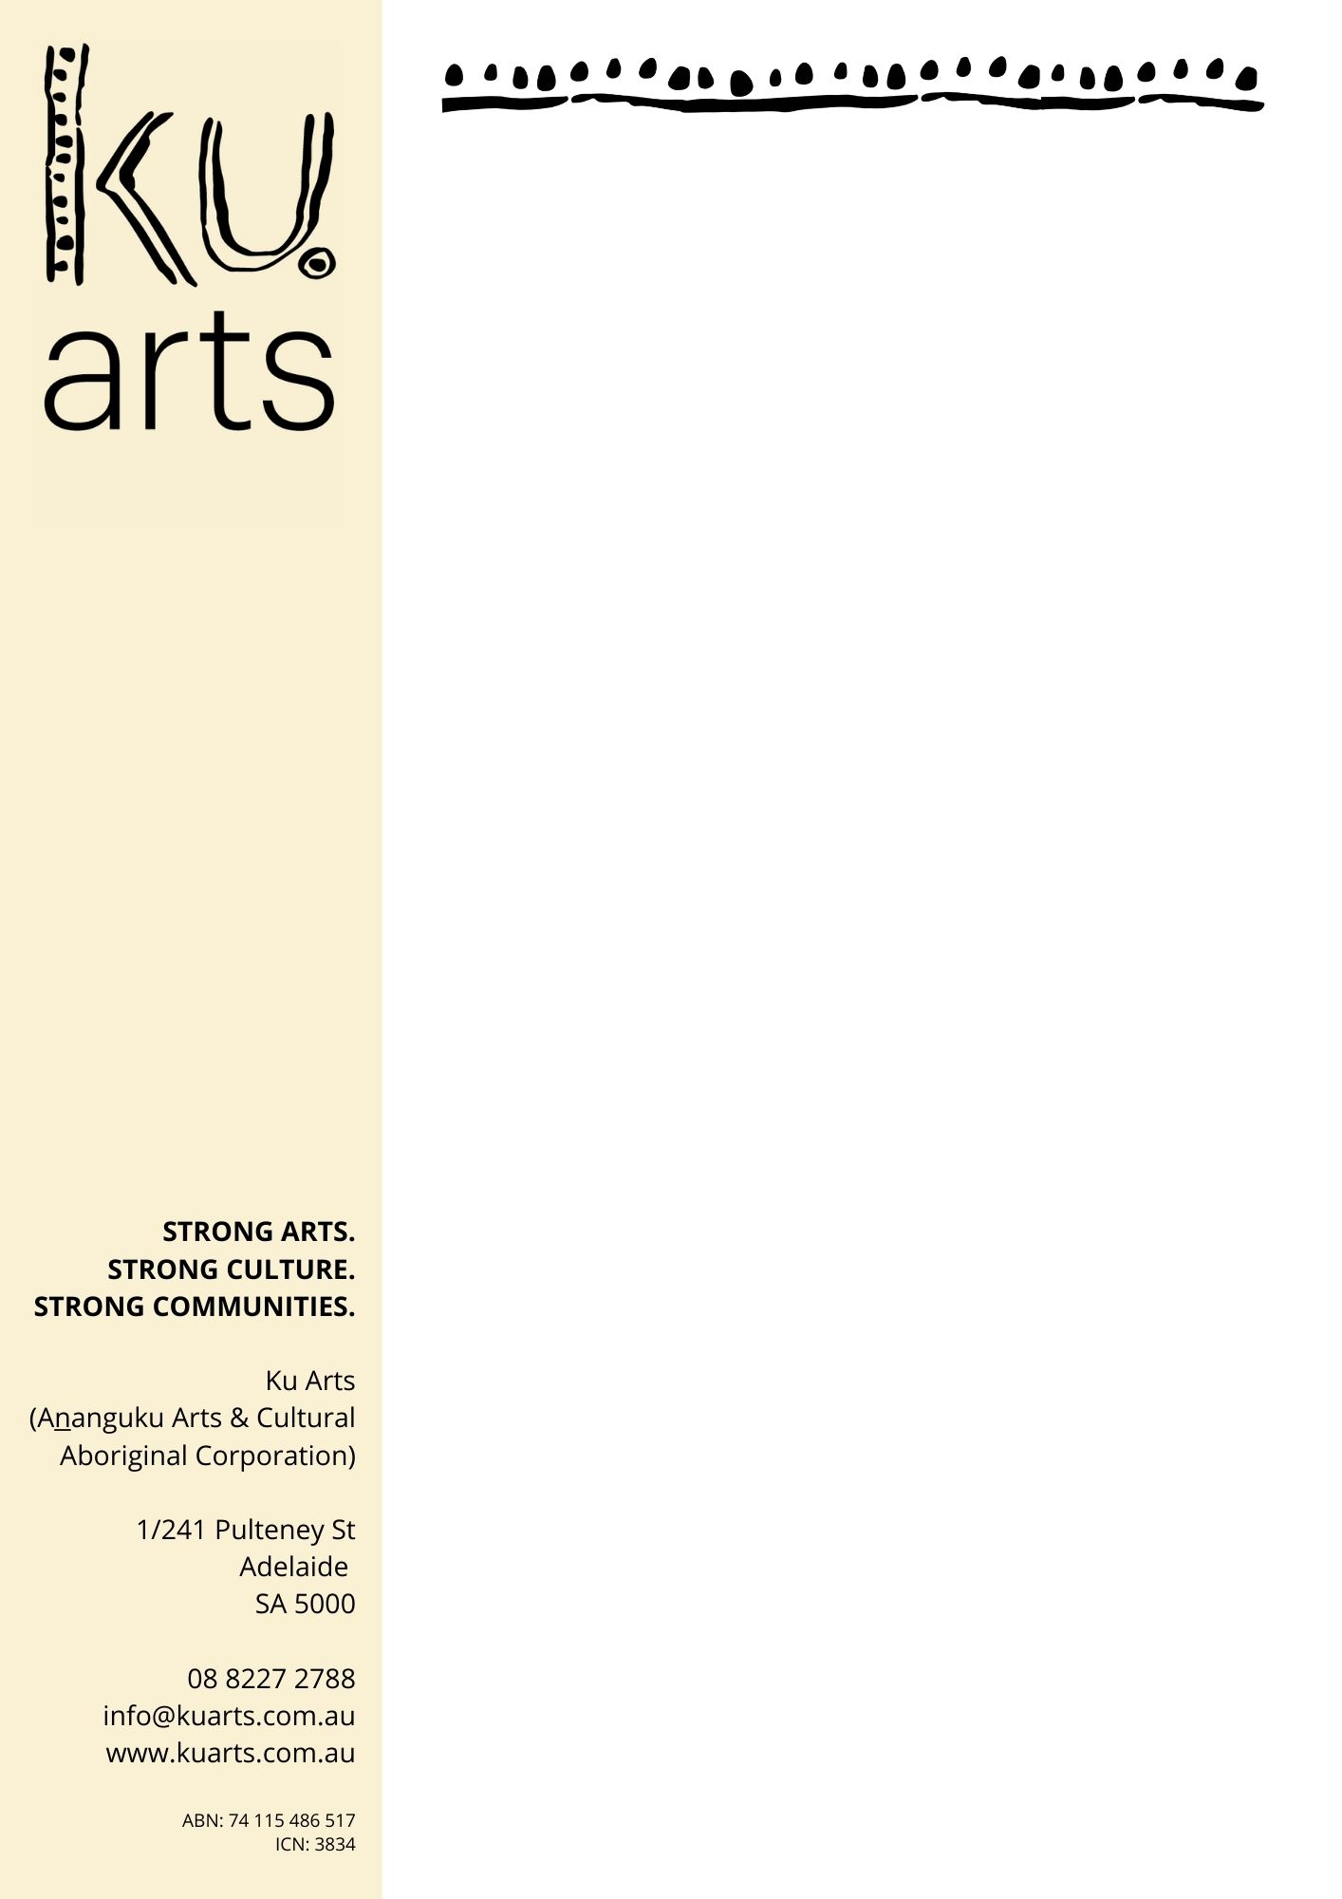

Productivity Commission’s draft report on Aboriginal and Torres Strait Islander Visual Arts and Crafts

Submission

Ku Arts – Ananguku Arts and Cultural Aboriginal Corporation, August 29, 2022

Cultural Context

On behalf of the Ku Ars board and the Aboriginal artists and art centres that we serve, we urge the Productivity Commission to consider our response to the draft report as an opportunity to open up discussion about a number of issues of significance to the development of the Indigenous Visual Arts and Crafts sector in Australia.

Please note that use of the terms Aboriginal, Indigenous and Anangu in this document are interchangeable which reflects the differing preferences of such use by artists associated with Ku Arts.

Strong arts, strong culture, strong communities is the vision that has guided our organisation since forming 25 years ago and it remains our driving force today. A strong Indigenous artist sector relies on strong communities.

Our vision recognises the symbiotic relationship that arts and culture have with individual and community health, education and wellbeing.

The Indigenous Visual Arts Sector cannot grow without investment in the health and wellbeing of Aboriginal peoples. This is particularly vital in remote communities, where increased support services, particularly mental health and aged care services, are required.

Participation in cultural activities has an intrinsic relationship with the creative practices of Aboriginal artists and should be recognised as a form of professional development within the sector.

Greater investment must be made in cultural projects that acknowledge the significance of customs, kinship, language, ceremony, practices including sorry business, connections to country and family.

These activities must be nurtured without the expectation of commercial artistic outcomes. They are essential to the maintenance and continuity of what is the world’s oldest living culture.

Strong Governance

Strong governance is the foundation upon which the sector can grow. Investment in developing and sustaining Aboriginal designed systems of governance is vital to ensuring successful, ethical and empowered business models. It can be all too easy, especially under commercial and market pressure, for those who work closely with Anangu to anticipate and assume ownership in decision-making and direction on behalf of Aboriginal corporations.

Governance by Aboriginal owners necessarily takes time, requires face-to-face interaction, encourages discussion and debate, respects differences of perspective, involves numerous meetings in order to reach consensus, but ultimately through this time-consuming process brings rich and rewarding outcomes for those involved. In many respects this process is the antithesis of western capitalism which is more frequently driven by financial and performance measures of success.

Investment in leadership and mentoring programs for next generations of Aboriginal arts and cultural leaders is critical. Ku Arts has established a youth governance initiative to support for young artists in taking responsibility for their custodianship of Aboriginal corporations. Art Centre managers, board directors, community arts officers and local community leaders would benefit from structured, professionally facilitated and appropriately orientated governance training.

There needs to be a focus on inter-community knowledge exchange and development of Aboriginal governance and business structures in which the agency of artists is fundamental. The sustainability and growth of the Indigenous Visual Arts sector and doing business the ‘right way’ will be highly dependent on respect for, and implementation of, Aboriginal principles.

Authentic Art

Ku Arts supports the recommendations of the Fake Art Harms Culture campaign 2016-2020. This requires a strengthening of the Indigenous Art Code, Arts Law (‘Artists in the Black’), Artists’ Resale Royalty Scheme and other sector agencies including peak service organisations to further educate, support and empower Aboriginal artists in their development and decision making. Legislation needs to be introduced that protects Indigenous Cultural Intellectual Property (ICIP) supported by the establishment of an appropriate regulatory framework.

There should be an outright ban on the sale of inauthentic art which would according to data in the Productivity Commission’s draft report would open up a $41-54 million economic opportunity to Aboriginal artists. Alternative industry models could be explored to increase economic return to Aboriginal artists and their communities to ensure artists receive more than the estimated 10-15% of the total value of sales across all markets. Greater business development initiatives could be developed to support Aboriginal entrepreneurs, including galleries, retailers, manufacturers, artists as sole traders and co-operatives.

These initiatives would give the artists the right to control their cultural assets, decide on their authorised use and protect against misappropriation. Properly resourced, the Indigenous Art Code would extend its capacity to support what is essentially a self-regulatory industry. Through a process of review, investigation and dispute resolution, issues arising between artists /art centres and dealers /galleries could be resolved in a more timely and satisfactory manner.

Strengthened transparency would contribute to learnings about how the industry self-regulates and provide useful benchmarks for participants in striving for best practice. Education about how the sector operates would be aided by establishing practice standards and codes of conduct.

Consumer awareness strategies would assist the public in discerning fake from authentic artworks which could be aided by online digital tools that promote understanding of how to buy Indigenous art, what questions to ask, what to look for in terms of quality and style, and how to conduct background checks on the artist/s. Improved awareness by the public about the central role that artists play in maintaining culture is imperative as a means for protecting the traditional rights and intellectual property of Indigenous artists.

Increased Capacity

Art centres are often the only source of meaningful income and employment in remote communities; communities that have the highest cost of living anywhere in the country. They are community governed, culturally safe spaces that support intergenerational cultural knowledge learning. Beyond this, remote art centres provide a range of social support services that fall outside of the remit of their funding, particularly to the elderly and those living with disability.

Professional support provided to artists working through a remote Aboriginal owned and governed art centre includes access to art making, creative skills development, artist management, i.e. administration support, contract negotiation, artwork sales, grant writing, exhibition and project development. All of this leads to the professionalisation of practice and self-determined economic opportunities.

There is an urgent need to increase funding for art centre operations in order to lift the capacity of art centres to attract, remunerate, professionally develop the cultural, business and governance expertise of art centre managers and arts workers. Aboriginal art centres in regional and remote communities need access to resources to become operationally sustainable as essential social and economic infrastructure for artists, their families and their communities. Artists should not have to fund these essential businesses with 40-50% of their earnings through artwork sales.

According to the latest Desart report, the ratio of government funding to total revenues, especially for art centres in South Australia, has declined significantly. On the one hand this may reflect increased sales and/or pricing of artworks. In reality, the decreased proportion of government funding has placed additional pressure on staff, boards and artists to cover operational costs from sales. Art centres have not been able to grow their staffing and operational capacity which is particularly concerning in an environment where there is increased market demand and the potential for higher levels of production.

Facilities and Resources
Access to art making, creative development, exhibition and sales opportunities for Aboriginal and Torres Strait Islander artists, as well as skills development for roles in arts administration, curation and collection management is necessary, especially in regional and remote areas. Many regions across the country, particularly in South Australia, lack culturally and community appropriate spaces for this fundamental access and participation. Ku Arts supports the development of more regional and remote Aboriginal art centres, hubs and networks that are Aboriginal owned and governed and expertly managed to provide the requisite professional support for Aboriginal artists in their career development.

The model of an art centre or hub, and whether it need be a physical space or a supported network, should be determined by each community for that community. Appropriate business and artistic development support by experienced professionals and cultural mentors should be provided for these initiatives. Funded art centres must be owned and governed by Aboriginal artists, and not structured as an arm or subsidiary of a gallery, to ensure that artistic and cultural integrity is maintained, without undue commercial pressure.

In remote areas, properly staffed and resourced art centres could form a hub that generates other essential services within the community, such as, a mechanic, soup kitchen, clothing store, bike tracks, sports coaching, youth centre, digital connectivity. These businesses would employ more local people, effectively shifting the balance back to Anangu and away from the high dependency on government services which in many cases are woefully inadequate. By extending the scope of art centres in these remote communities, improved social wellbeing support could be made available within the community for men’s groups, youth programs, elders-in-residence rather than these needs being addressed through removal of individual’s to regional and capital cities.

Not all artists want or choose to work through art centre structures but prefer to remain independent. It is important to provide professional development support that enables informal groups of artists to collaborate in a variety of business models. Peak service delivery organisations such as Ku Arts need to be adequately funded to meet the demand for assistance by independent Aboriginal artists, particularly those who choose not to work through art centres or where this infrastructure does not exist. This vital artist support includes access to art materials, equipment, mentoring, prizes and awards, grant advice, networking, creative skills workshops, professional skills training, knowledge about the sector and how the visual arts market operates.

Universal Wage
Establishing a minimum living wage for Aboriginal artists and cultural practitioners would encourage greater participation, provide a cultural and economic safety net and recognise the significance of the contribution these artists make to our national identity. The inflated cost of remote and regional living expenses would need to be taken into account and there should be no obligations attached to receiving the living wage, other than maintaining an artistic and/or cultural practice. Recognising art making and cultural maintenance as work will rightly ensure artists and cultural practitioners are exempt from JobSeeker obligations and Community Development Programs (CDP), which have presented real challenges for many individuals and communities.

The introduction of a living wage must be concurrent with raising unemployment benefits to a liveable standard to support strong families and strong communities. Additionally, the cost of the time requirement of Aboriginal artists to engage in language, customs, ceremony, cultural practices, family commitments and learnings from their Elders should be factored into funding arrangements. For Aboriginal artists and cultural leaders, a minimum living wage would recognise art making for the important contribution their artistic and cultural expression makes to our National Identity. It would send a message that the Government of Australia values them and wants them to succeed.

Professional Recognition

Businesses and governments, needs to respect, recognise and compensate Aboriginal artists and cultural leaders for their work in interpreting, translating, speaking, training, advising that takes place within institutions and at a community level. New initiatives to see more Aboriginal people employed within culturally safe institutions, utilising cluster hiring as a cultural safeguard for individuals, creating employment pathways, and providing professional and cultural development at all levels of institutions, including as managers and arts workers in remote art centres.

There needs to be a concerted effort to build on previous initiatives to establish training and educational programs and courses, including work placements in Aboriginal corporations, that are designed to invest in knowledge and skills development for Aboriginal people. This is especially important for Aboriginal young people in the early phase of their career and as a means for growing the workforce in art centres, arts and cultural organisations, government and business entities.

Amongst the non-Indigenous workforce there is an appetite for opportunities to engage with Aboriginal artists and communities. This enthusiasm for cultural experiences needs to be balanced by careful recruitment, professional training and development, access to cultural awareness programs and well supported induction and ongoing business and governance advice for managers and artists seeking to work on-country alongside Aboriginal artists.

About Ku Arts - Ananguku Arts and Cultural Aboriginal Corporation

Ku Arts is owned and governed by Aboriginal artists as a not-for-profit organisation. Our board represents a diversity of Aboriginal artists and art centres from across South Australia. Visual arts and crafts are the mediums used by our artists in their creative practice to tell their stories of connections to family, country and culture.

Founded by women artists in the Anangu Pitjantjatjara Yankunytjatjara (APY) lands in 1998 from Ernabella Arts in Pukatja, Kaltjitji Arts in Fregon, Iwantja Arts in Indulkana and Tjala Arts in Amata, their collaboration and vision led to the establishment of more APY Aboriginal art centres with Tjungu Palya in Nyapari, Ninuku Arts in Kalka and Mimili Maku Arts in Mimili.

In 2005, our founding artists looked beyond the APY lands to regional areas of South Australia with support for a state-wide program for independent artists and the development of an art centre in Ceduna. We provide creative skills and professional development programs, promote best practice to enable the voice and agency of artists, and assist artists and arts workers to access resources and career opportunities.

As the peak Aboriginal arts service delivery organisation in South Australia, Ku Arts looks forward and outward, building connections across sectors locally, nationally and internationally, while supporting Aboriginal artists in their creative and cultural practices.

Guiding Principles
Ngapartji Ngapartji Kulinma Munu Iwara Wanama
Respect each other and follow the lore and the law straight

Piluntjungku
Peaceful and calm

Kalypangku
Conciliatory

Kututu Mukulyangku
Kindhearted

Tjungungku
United

Strong arts, strong culture, strong communities - Arts kunpu, tjukurpa kunpu, waltja Tjuta kunpu

