The most important factor over the next few decades is our projected natural growth, or more importantly its rapid decline.

Why no mention or calculations on what will be the biggest demographic shift to come in <http://www.pc.gov.au/inquiries/current/migrant-intake#draft> ?

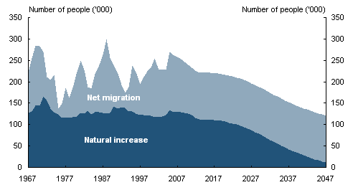

<http://archive.treasury.gov.au/igr/igr2007/report/html/docshell.asp?URL=03_Part_2.htm>

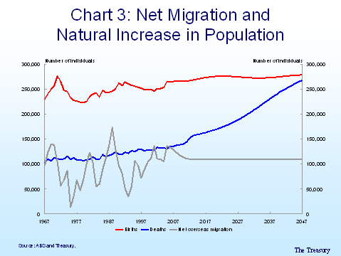  
  
<http://archive.treasury.gov.au/documents/1329/HTML/docshell.asp?URL=03_Conceptual_challenges_on_the_road_to_the_second_Intergenerational_Report.asp>

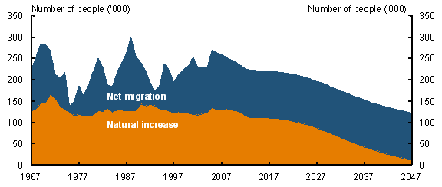  
  
<http://archive.treasury.gov.au/documents/1317/HTML/docshell.asp?URL=Address%20by%20David%20Gruen%20to%20the%20Conference%20of%20Economists.htm>

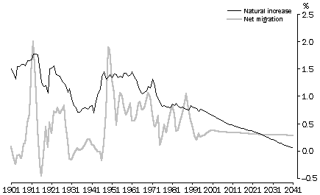  
  
[http://www.abs.gov.au/AUSSTATS/abs@.nsf/2f762f95845417aeca25706c00834efa/e2f62e625b7855bfca2570ec0073cdf6!OpenDocument](http://www.abs.gov.au/AUSSTATS/abs@.nsf/2f762f95845417aeca25706c00834efa/e2f62e625b7855bfca2570ec0073cdf6%21OpenDocument)