Productivity Commission Inquiry into Resources
Sector Regulation

Submission by Dr Peter Burnett
Honorary Associate Professor
College of Law
Australian National University

1. Introduction and Overview of Submission
I am a researcher at the ANU College of Law with particular interests in environmental policy and regulation. I am also a former Environment Department official, with extensive experience at senior levels in environmental regulation and policy, including responsibility for both administering, and developing reforms to, the Environment Protection and Biodiversity Conservation Act 1999 (Cth) (EPBC Act).
I note that the Government has announced a review of the EPBC Act by Professor Graeme Samuel AC (the Samuel Review). Given the size and complexity of that Act, the likely time needed to develop proposed reforms and the potential difficulty of securing passage of those reforms in the Parliament, I have confined my submissions to several measures that the Government might take in the shorter term to enhance the efficiency and effectiveness of the EPBC Act, without significant legislative amendment. In short, the Government could:
- make bioregional plans under the Act and then make a declaration that various classes of development do not need the usual DAA (a ‘plan and exempt’ approach)
- allocate additional resources to the administration of the Act to improve the efficiency and timeliness of regulatory processes, along with the level of service available to proponents
2. Identifying best-practice regulatory approaches
The Commission seeks feedback on whether its assessment criteria for best-practice regulation are appropriate.
I support the three broad groupings of regulatory design, governance and conduct, but suggest a minor amendment to the criterion concerning objectives, to make express mention of the federal dimension of regulation in Australia. I also suggest an additional criterion of regulatory design, to complement the criteria concerning clarity of objectives and avoiding complexity.
Dealing first with the minor amendment, where responsibilities are shared between levels of government, as responsibility for environmental policy is shared under the Constitution, considerations of regulatory efficiency and effectiveness require coordinatation between different levels of government. As this is a significant dimension of some classes of regulation, I suggest criterion two under ‘regulatory design’ be amended to add reference to this, for example:
Objectives of regulation are clearly defined and consistent across different regulations including, where applicable, between levels of government.
This is a broader aspiration than the avoidance of duplication, a matter covered by the first criterion under regulatory governance, because it encompasses considerations of effectiveness as well as efficiency.
The additional regulatory design criterion would be that the regulatory scheme is well-adapted to its stated objectives. This approach is consistent with the underlying ‘ends and means’ paradigm of public policy (see xxx 1978; Howlett et al 2009) which requires, in essence, that, in response to an identified social problem capable of being addressed by official action and having clearly defined a desired end, government should select well-adapted means to achieving that end.
This would mean that regulators should be equipped with powers that allow them to achieve the regulatory objectives assigned to them by law, using an approach or combination of approaches that is optimal in the circumstances. For example, the EPBC Act allows the environment minister to pursue the protection and conservation of threatened species (among other things) through several regulatory and quasi-regulatory means (planning, statutory agreements and regulatory condition-setting) and also by non-regulatory means (grants). Applying this criterion as I propose to this example, it would be necessary to consider first, whether this suite of policy tools was, in principle, well-adapted to the regulatory objectives, and secondly, as the Commission has recognised in its Issues Paper, whether the suite was overly complex or excessively prescriptive as drafted, as applied, or both.
Submission One
a) Amend the second criterion for regulatory design to add reference to the need for regulatory consistency between levels of government where responsibilities are shared, as follows:
Objectives of regulation are clearly defined and consistent across different regulations including, where applicable, between levels of government.
b) Add a criterion for regulatory design, to the effect that the regulatory scheme is well-adapted to its stated objectives.

4. Make bioregional plans and declarations that classes of development need no DAA

Under the EPBC Act, the Minister can make bioregional plans (Part 12) and then declare that specified classes of development do not need a DAA if the development is in accordance with a particular plan (Part 4 Div 3). This ‘plan and exempt’ approach has the obvious advantage of removing the need for Federal approval of a project entirely. On the other hand, the approach requires that various steps be taken by government. Broadly, it rolls planning and DAA into one, including public consultation and application of the standard ‘avoid, mitigate, offset’ decision-making hierarchy. As the declaration is a legislative instrument, the process also involves Parliamentary scrutiny. Overall, the process bears some resemblance to substance of the Regional Forest Agreement process. It has not been used to date, presumably because of the cost to government of preparing plans and the need to negotiate cooperative arrangements with States and Territories.

More specifically, the ‘plan and declare’ process involves the following steps:
- Prepare a bioregional plan in cooperation with the relevant States or Territories (some bioregions cross State borders) allowing at least 60 days’ public consultation (reg 2A.03, EPBC Regulations 2000)
- Identify biodiversity and heritage values in the plan, along with:
  - conservation objectives
  - ‘important economic and social values’ (para 176(4)(b)), eg areas of high mineral prospectivity
  - ‘priorities, strategies and actions’ relevant to identified values (para 176(4)(c) and (d))
- In developing the plan, undertake ‘an adequate assessment of the relevant impacts of actions which can be taken under the bioregional plan’, including:
    - the characteristics of the environment which will be impacted by the actions, including MNES
    - the impacts of those actions
    - feasible measures to prevent or mitigate those impacts, to ensure that such actions do not have and unacceptable or unsustainable impact on MNES (reg 2A.03)
- Declare the classes of action that do not need a DAA on the basis that they are in accordance with a bioregional plan, eg mining in a particular region that avoids impacts on certain values, eg a threatened species (or perhaps avoids net impacts, allowing for the plan to include an offset regime as a ‘strategy’)
  - If appropriate, make the declaration on the condition that certain parties take certain measures consistent with the plan, such as environmental monitoring (reg 2A.03(d))
- Table the declaration in Parliament, noting that it is subject to disallowance by either House (see Legislation Act 2003)

As there are 69 terrestrial bioregions in Australia (constituted by 419 subregions, if a narrower scope were adopted), pursuit of the ‘plan and declare’ approach would involve considerable cost to government. On the other hand, the approach might be restricted to those regions with the highest economic values, or restricted to a trial. Further, a cost-benefit analysis might well show that the budgetary costs to government of this approach were more than outweighed by the overall economic benefits of a single and ‘front loaded’ process, together with the environmental benefits of a landscape-scale approach, which minimises cumulative impacts and guides the prioritisation of investment in environmental restoration.

Should the Commission see benefit in recommending this approach, note that the scope of bioregional plans is currently limited to biodiversity and heritage values. Although wetlands and water more generally are often closely linked with biodiversity and natural heritage, I would recommend an amendment to extend the scope of plans to align with the MNES: ie to include wetlands and water resources associated with coal seam gas and large coal mining within the scope of bioregional plans, which might be renamed ‘regional plans’, as recommended by the Hawke Review. I note also that the Craik review was supportive of regional planning, although Dr Craik’s recommendation was for a non-statutory approach.
Submission Two
Consider recommending that the government fund, at least on a trial basis, the ‘plan and exempt’ approach under the EPBC Act as it stands. Note that if this approach were to be used regularly, it would be useful to widen the scope of the provisions dealing with bioregional plans, consistent with the scope of the Matters of National Environmental Significance to which the Act applies.

5. Allocate additional resources to administering the EPBC Act
The Commission’s fourth criterion of best-practice regulation under ‘regulatory governance’ is that regulators are adequately resourced and have necessary capabilities. There is significant evidence suggesting that the administration of the EPBC Act is not adequately resourced. I discuss this evidence below and submit that a full review of resourcing would be appropriate.
To my knowledge governments have never undertaken a full assessment of the resources needed to implement the Act. The Commonwealth did not announce additional resources when the Act commenced (see Hill, 2000). The only decisions of which I am aware to allocate net additional resources to administration of the Act are a 2007 decision to allocate $70.6m over for years for enhanced administration of the Act (see Turnbull 2007) and some funding for specific strategic assessments (see Burke 2012).
I suggest that if a best-practice criterion of adequate resourcing is to be met, government needs to define performance standards and reviews need to address, not only whether regulators are meeting those standards, but whether they are resourced adequately to do so. In this regard, the EPBC Act embodies a number of performance standards in the form of statutory timeframes for various stages in the DAA process (but not the overall elapsed time as this depends on the proponent as well as regulator). Compliance with these standards falls significantly short. For example, in the EPBC Act Annual Report 2018-19, DEE figure 2.4 shows that compliance with DAA timeframes has deteriorated in each of the last 5 years, reaching 40% non-compliance in 2018-19 (DEE 2019, 32). As the figure shows, this is despite a significant overall decline in the total number of statutory decisions.

DEE Figure 2.4: Number of EPBC Act statutory referral decisions versus late decisions, 2014–15 to 2018–19 (DEE 2019, 33)
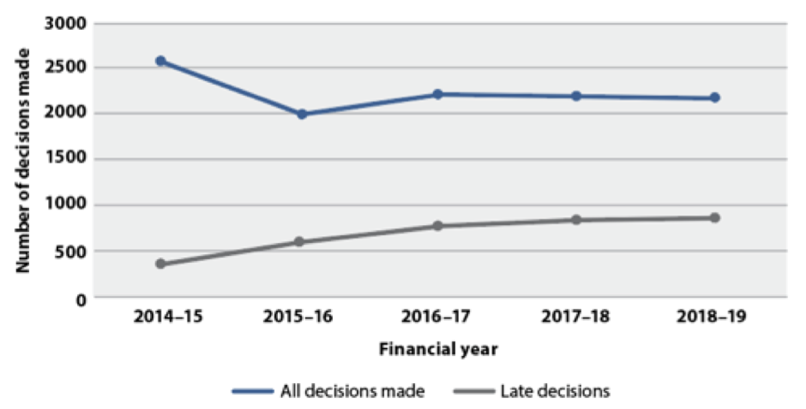
Perhaps this increase is not surprising against the backdrop of the apparent general trend of resourcing for the Department: analysis by the Australian Conservation Foundation suggests that the department has experienced an overall reduction of resources since 2013 of just under 40%, a reduction forecast to reach 47% by 2020-21 (ACF 2018, 2019) subject of course to any expenditure initiatives in the 20-21 budget.
Note in this regard that the Craik Review found that DEE was insufficiently resourced to enable timely appropriate and effective assistance to project proponents in the agricultural sector (Craik 2018, 73). As DAA for the agricultural sector is not undertaken separately from other DAA, it is reasonable to infer that this conclusion is likely to be valid for all sectors. It seems that staff may be of this view as well. Apparently a Public Service Commission census reveals that Department of Environment and Energy staff are of the view that they lack the resources to perform their functions well (Canberra Times 2019).
Submission Three
Conduct a comprehensive review of resourcing for the administration of the EPBC Act, with a view to allocating sufficient funding to ensure that:
a) existing statutory timeframes can be met
b) other levels of service as the government might specify, such as standards for the availability of online and personal advice to proponents, are met also.
References
ACF (Australian Conservation Foundation) 2018. Background Brief:
Environment spending in Australia (ACF).

ACF 2019. Morrison Government’s Budget 2019–20: devaluing our environment while fuelling global warming, media release, 2 April 2019.

Burke, Tony 2012. Portfolio Budget Statements 2012-13, Budget Related Paper No 1.18, Sustainability, Environment, Water, Population and Communities Portfolio.

Canberra Times 2019. No funds to do our jobs, 21 September 2019, 1.

Craik, Wendy, 2018. Review of interactions between the EPBC Act and the agriculture sector: Final report (Aither 2018).

DoE (Department of the Environment) 2013. Matters of National Environmental Significance: Significant impact guidelines 1.1, Environment Protection and Biodiversity Conservation Act 1999 (Department of the Environment, Canberra).

DEE (Department of the Environment and Energy) 2019. Department of the Environment and Energy Annual Report 2018–2019 (Department of the Environment and Energy).

Hill, Robert, 2000. Budget Initiatives and Explanations of Appropriations 2000-01, Budget Related Paper No. 1.7 (Environment Australia).

Howlett, Michael, M Ramesh and Anthony J Perl 2009. Studying Public Policy: Policy Cycles and Policy Subsystems (Oxford University Press).

Jenkins, William I 1978. Policy analysis: a political and organisational perspective (Martin Robertson).

Turnbull, Malcolm, 2007. Protecting Australia’s Future, Environment Budget Overview 2007–08 (Department of the Environment and Water Resources).

The requirement for cooperation does not apply in areas of exclusive Commonwealth jurisdiction. In that regard, not that the Commonwealth has prepared four bioregional plans in the Commonwealth marine area.See https://www.environment.gov.au/marine/marine-bioregional-plans.

