SUPERFRIEND – Industry Funds’ Mental Health Initiative

Response to the Productivity Commission Inquiry into
The Social and Economic Benefits
for Improving Mental Health
(Draft Report)

Key contact:

Margo Lydon
Chief Executive Officer
SuperFriend - Industry Funds’ Mental Health Initiative

A: Level 2, 157 Spring Street, Melbourne Victoria 3000
W: www.superfriend.com.au

This is a public response – it does NOT contain ‘in confidence’ material in the main response or it’s attachments and can be placed on the Productivity Commission’s website.

Date Submitted: 23 January 2020

About SuperFriend
SuperFriend is a national workplace mental health and wellbeing organisation, partnering with the superannuation and life insurance industry to achieve our vision for an Australia where all workplaces are mentally healthy.
SuperFriend advocates for, equips and empowers industry superannuation funds and insurers to achieve mentally healthy workplaces for their staff and members.

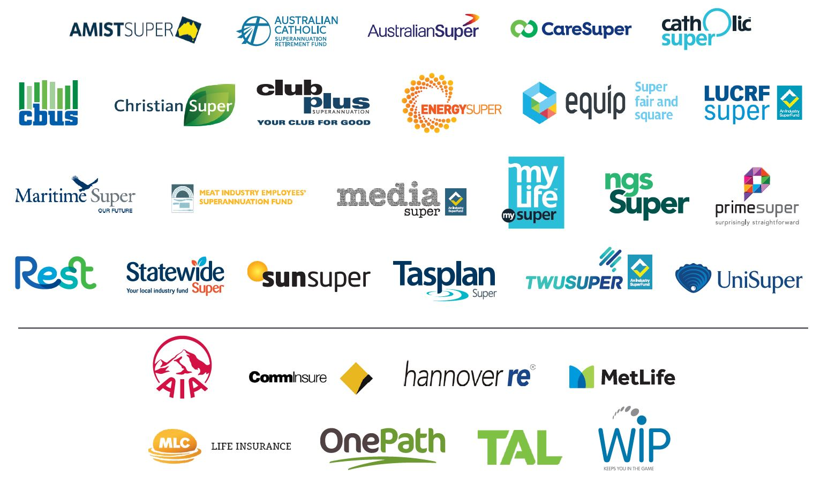
SuperFriend’s Submission
SuperFriend provided submission 216: Creating Mentally Healthy Workplaces – Taking Action in the Superannuation and Life Insurance Industry to the Productivity Commission’s Mental Health Enquiry in April 2019. This submission builds on our previous submission and is centred around three key themes and the related reform objectives as outlined in the Productivity Commission’s draft report released in October 2019. The three themes are:
- early intervention and prevention
- workplace mental health– developing and supporting mentally healthy workplaces
- social inclusion
This submission also provides an additional seven recommendations and provides feedback on the Productivity Commission’s Draft Recommendation’s 19.1-19.5, 20.2, 20.6 and Draft Findings 19.2-19.3. SuperFriend has also responded to Information Request 19.2.
SuperFriend also reiterates to the Productivity Commission its endorsement of the submissions by:
          - The life insurance industry
          - The Mentally Healthy Workplace Alliance
          - Shared Value Project
Table of Contents

Executive Summary 1
Pulling Together the Reforms 6
SuperFriend Recommendation 1 6
Early Intervention and Prevention 8
SuperFriend Recommendation 2 8
SuperFriend Recommendation 3 9
SuperFriend Recommendation 4 12
Draft Recommendations 19.1-19.5: Develop and support mentally healthy workplaces 14
Draft Finding 19.2 The role of workers compensation in addressing mental health 15
Draft Finding 19.3 Employee Assistance Programs 16
Information Request 19.2 – Personal care days for mental health 16
SuperFriend Recommendation 6 17
SuperFriend Recommendation 7 17
SuperFriend Recommendation 5 18
Draft Recommendation 20.2 — Awareness of mental illness in the insurance sector 18
Draft Recommendation 24.6 — Life Insurers & Funding of Mental Healthcare 18
Conclusion 20
Appendix I: Importance of workplaces in population-wide mental health 21
References 25

Executive Summary
Early intervention and prevention approaches are essential if we are to see the much-needed transformational shift in Australia’s mental health and wellbeing, as inspired by the broader scope of this Productivity Commission’s inquiry.
All future national mental health policies, if they are to be economically and socially sustainable, must be concerned with mental ill-health, mental health conditions as well as broader factors that enable and foster positive mental health and wellbeing. Furthermore, all mental health policies and practices need to be considered beyond a ‘health system only lens’. They need to reflect a whole of population approach to complex systems change and therefore a whole of Government(s) and community strategy is required.
Mental health affects all of us, every day. Given the significant population employed (approximately 13 million), it makes sense to consider the levers for change that workplace mental health can provide. SuperFriend believes this will only occur if the relevant recommendations to Government explicitly mention the critical combined role of workplaces as contributors, collaborators, evaluators and implementers of the broader mental health policy reforms. Every day, SuperFriend advocates for, and helps organisations to include, in an integrated and embedded way, mental health into all policies, processes and procedures in a business. This integrated approach is best practice and has the greatest chance for sustainable impact across a whole organisation. It is not effective nor impactful to have mental health siloed or in a stand-alone policy. If we were to apply that thinking, we would be limiting ourselves to how Australia’s CURRENT mental health system ‘works’ – purely through the lens of health. This inquiry, and its broad terms of reference, provides opportunity to change this, and recommend to Government a truly integrated approach.
Therefore, we urge the Productivity Commission to be more explicit in the specific inclusion of the non-health ‘actors’ in the final report and its recommendations. Otherwise, there is a risk of Governments defaulting to ‘health-only’ thinking and approaches. This is especially relevant when considering the plethora of early intervention and prevention reforms needed, and the tremendous opportunities of engaging non-health actors in system-wide reform for social and economic impact.
Therefore, while broadly supportive, SuperFriend sees the draft report as under-emphasising the importance of two key actors in intervention and prevention: workplaces and the life insurance industry.
Workplaces
In October 2019, SuperFriend released its latest research findings on the state of workplace mental health in Australia. The Indicators of a Thriving Workplace Survey shares the results from our fourth annual survey of 10,000 workers. This statistically credible and valid survey is Australia’s largest survey of workplace mental health and wellbeing. It provides the most contemporary evidence and insights into workers, managers and business owners actual experiences in their current workplace of workplace mental health. ITW uses 40 scientifically validated indicators. It is a representative sample of the Australian workforce by industry, age, gender and geographical location.
The 2019 results provide compelling endorsement for system-wide reform.
The key findings from 2019 Indicators of a Thriving Workplace include:
      - Australia’s national workplace mental health and wellbeing score of 62.7 out of 100. This score, which hasn’t budged from 2018, indicates Australia is not yet two thirds of the way towards optimal workplace mental health and wellbeing.
      - Only 5% of Australian workplaces are thriving. A thriving workplace scores 80 or above.
      - One in two (50.5%) workers report they have experienced a mental health condition and, of those with a lived experience, 43% of people perceive their workplace is contributing to or causing their mental ill-health. This is a disturbing statistic that endorses the need for urgent reform.
      - The majority (63.4%) of people who believe their workplace contributed to their mental health condition work in organisations that haven’t implemented any actions. The more actions the workplace implements, the less common it is for their people to attribute their mental ill health to work.
      - More than half of Australian workers (56.8%) don’t believe their workplace has committed to any actions.
      - The biggest perceived barrier to achieving a thriving workplace is a lack of appropriate skills among managers.
      - Only 13% of Australian workers say their workplace encourages open discussion on mental health, however this improves to roughly 50% if mental health and wellbeing training is provided.
      - Education and training about mental health and wellbeing helps break down many barriers, particularly those related to skill gaps, recognition of the importance of mentally healthy workplaces, stigma and managerial commitment and action.

A ‘carrot and stick’ approach is required to ensure the productivity benefits of workplace interventions are maximised. SuperFriend’s research shows that employers who invest in mentally healthy workplaces see a reduction in sickness absence, along with increased productivity and higher retention, leading to more productive workplaces with lower costs (e.g. recruitment, staff training and leave costs).
The 2019 insights from the Indicators of a Thriving Workplace survey reiterate the conclusions drawn from many other reports, inquiries and research findings that have been conducted and presented to Government(s) over the last decade. Each of these individually, and collectively, support the need for coordinated and collaborative efforts by many stakeholders - Governments, industry, unions, work health and safety authorities, life and health insurers and other workplace mental health and wellbeing ‘actors’ working together. The unique vehicle already established is the Mentally Healthy Workplace Alliance (Alliance). Further support and funding by Government of the Alliance and its work, and other collaborative entities underpins our recommendations for reform, as included in this submission. The Government has a clear opportunity to lead, facilitate, support and endorse more cross-sector collaborations.
Life Insurance
The life insurance industry (the Industry) including SuperFriend, has collaborated to develop a separate submission signifying the Industry’s consensus in response to the Productivity Commission’s Draft Report. It includes recommendations for further consideration by the Productivity Commission and demonstrates the industry’s willingness, capacity and capability to be a valuable collaborator and stakeholder in achieving system-wide reform for better mental health and wellbeing outcomes for all Australians.

Through SuperFriend’s partnership with the life insurance and superannuation industry, we have witnessed a significant rise (approximately 10% increase over ten years) of mental health-related claims (primary cause of claim) as a proportion of overall primary claim causes. This is for both income protection and total and permanent disability insurance products. These claims causes are not necessarily work-related (as with work health and safety) but represent a broader contextual view of Australian society’s experience with mental health conditions needing financial supports. Life insurers are investing heavily in prevention to reverse this trend, which should be supported.

Each year approximately $543m of workers’ compensation is paid, compared to $709 million through life insurance, according to recent research. After Government, the life insurance industry is the largest contribution of financial and other supports for people with a mental illness. Governments, as an example, would do well to include life insurers when designing, developing and implementing broader mental health reforms, such as those proposed in Part V: Pulling together the reforms, of the draft report. Other recommendations for utilising the insights, knowledge, data and expertise of the life insurance industry in transforming mental health for all Australians, is detailed the life insurance industry’s response and are unreservedly endorsed by SuperFriend.

Summary of SuperFriend’s Recommendations
We encourage the Productivity Commission to incorporate SuperFriend’s feedback and include the following new recommendations and observations in their final report.
- That the national reforms being proposed (Part V Pulling together the Reforms) are explicit in their inclusion and articulation of the role of employment, employers and workplaces as important non-health supports and partners.

- Request that ASIC issues clarification on Superannuation (Industry) Supervision Act regulation Section 68A to confirm that evidence-based mental health education initiatives provided to members via the employer are not considered employer inducements under the regulations.

- Amend Workplace Health & Safety standards to:
        - Require Work Health and Safety Regulators to develop clear, definitive and evidence-based guidance material for workplace competency training in mental health, with a minimum content requirement of:
          - Symptoms of compromised mental health (mental ill-health and mental health conditions)
          - Definition of psychological safety (as it pertains to work and the legislation)
          - How to identify at risk co-workers, and
          - How and where to refer or self-refer.
        - Require employers, where there has been a psychological injury claim (irrespective of liability), to provide evidence-informed prevention initiatives that focus on reducing risk factors for mental ill-health and enhancing protective factors (for promoting positive mental health and wellbeing) through EAPs or other suitably qualified providers, meeting the above minimum content requirement. The work health and safety regulator should ensure employers are meeting this requirement.
- Provide Government funding for implementation support of the Mentally Healthy Workplace Alliance’s National Workplace Initiative.

- Include the new and modified recommendations (1 through 8) from the Life Insurance Industry Submission in their final report.

- The National Workplace Initiative should monitor and collect evidence from employer-initiated interventions to create mentally healthy workplaces and improve and protect the mental health of their employees. The National Workplace Initiative should advise employers of effective interventions that could be appropriate for their workplace (provided Recommendation 4 is also made).

- WHS agencies, in collaboration with life insurers, workplace rehabilitation and other health experts, people with lived experience, and business should develop, monitor and collect evidence of return to work and stay at work employer-initiated interventions. WHS agencies should advise employers of effective interventions that could be appropriate for their workplace and provide guidance the NWI in the promotion of evidence informed return to work and stay at work interventions.

Pulling Together the Reforms
SuperFriend endorses the draft recommendation in Part V: Pulling together the reforms, and the interjurisdictional statutory authority role being proposed (information request 22.1) for the National Mental Health Commission. SuperFriend urges the Productivity Commission to consider the following modifications to those draft recommendations.
Given mental health affects ALL Australians, it makes sense to have a whole of government strategy with responsibility and accountability through COAG. It will be system reform that reorients ALL governments to consider and demonstrate the mental health and wellbeing impacts of all decisions, legislative reforms and policies on the Australian population, alongside economic and other desired impacts. Aspirational as this may seem, we are seeing other countries such as New Zealand (e.g. wellbeing budget) and Canada (e.g. National Standards for Psychological Safety in the Workplace) emphasise and invest in whole of government mental health-oriented policies and initiatives to benefit their countries citizens and their economy.
One aspect, that is central to SuperFriend’s work, is the role of work and workplaces and how creating flourishing workplaces enable people to be their best selves, be safe doing good work and go home with enough energy to spare. This is fundamental for all Australian workers and employers. As proposed in this section of the draft report, it relies on more integrated approaches across Government and led by Governments.
To strengthen the existing recommendations in Part V, and to avoid repeating the challenges of the current health-oriented focus to mental health, SuperFriend is proposing the following recommendation.
SuperFriend Recommendation 1:
That the national reforms being proposed (Part V Pulling together the Reforms) are explicit in their inclusion and articulation of the role of employment, employers and workplaces as some of the non-health supports or partners.
Consideration for:
- Specifically calling out and including mention of workplaces and employers as key partners in developing the National Mental Health and Suicide Prevention Agreement (draft recommendation 22.1). Workplaces can play an instrumental role in assisting Governments to implementing it, and therefore need to be at the table when developing such an agreement. The Mentally Healthy Workplace Alliance could facilitate this role effectively.
- The whole of Government strategy (draft recommendation 22.2) to articulate clearly the role of workplaces (in addition to other non-health factors) in improving mental health for Australians. Therefore, we propose that COAG Health Council’s terms of reference and focus is articulated in the recommendation as being broader than health system reforms, to include the role of work and workplaces (such as through collaboration with the Mentally Healthy Workplace Alliance)
- Targets for outcomes (draft recommendation 22.4) including workplace targets (delivered and measured through work health and safety authority work and the National Workplace Initiative being developed by the Mentally Healthy Workplace Alliance)
- Evaluation of impact (draft recommendation 22.5) should explicitly include expectations of impact measurement for the ‘actors’ in workplace mental health. This includes work health and safety authorities, the National Workplace Initiative, and other government funded workplace initiatives (that should consider mental health impacts, irrespective of the intended nature of the initiative).

Early Intervention and Prevention
Mental health conditions are not inevitable and there is now considerable scientific evidence that shows many conditions are preventable.
There is also good evidence showing the prevention of mental health conditions is cost effective and can produce savings.

SuperFriend Recommendation 2
Request that ASIC issues clarification on Superannuation (Industry) Supervision Act regulation Section 68A to confirm that evidence-based mental health education initiatives provided to members via the employer are not considered employer inducements under the regulations.

Section 68A prohibits a trustee or its associates from engaging in particular conduct if it would reasonably be expected to influence an employer to:
    - choose a default fund for employees, or
    - encourage employees to choose or retain membership of a fund

Rationale
In its clarifying memo on the regulations, ASIC specifically mentioned workplace wellbeing seminars as an activity that may breach the regulations. This has led to the unintended consequence that some superannuation fund trustees have interpreted the guidance to prohibit the super fund’s provision of workplace mental health education and training. This limits the super fund’s ability to improve the claims experience through preventative workplace programs, clearly an unintended consequence of the regulations.
This unintended consequence could have wide-ranging impacts.
Superannuation funds and life insurers have opportunities to assist their members and support workplaces to be mentally healthy through the provision of education, training and information. Regulations that do not provide clear guidance can inadvertently restrict helpful activities that could benefit members and workplaces. Clarification should include parameters such as ensuring that the education and training being provided is evidence informed. This would provide much needed guidance to the industry, and would sure-up another cost-effective, trusted, and influential channel for prevention and early intervention promotion of workplace mental health and wellbeing.

SuperFriend Recommendation 3
Amend Workplace Health & Safety standards to:
        - Require Work Health and Safety Regulators to develop clear, definitive and evidence-based guidance material for workplace competency training in mental health, with a minimum content requirement of:
          - Symptoms of compromised mental health (mental ill-health and mental health conditions)
          - Definition of psychological safety (as it pertains to work and the legislation)
          - How to identify at risk co-workers, and
          - How and where to refer or self-refer.
        - Require employers, where there has been a psychological injury claim (irrespective of liability), to provide evidence-informed prevention initiatives that focus on reducing risk factors for mental ill-health and enhancing protective factors (for promoting positive mental health and wellbeing) through EAPs or other suitably qualified providers, meeting the above minimum content requirement. The work health and safety regulator should ensure employers are meeting this requirement.

Rationale
Mentally healthy workplaces are thriving workplaces where people do good work, can be their best selves and go home with enough energy to spare. Positive mental health and wellbeing adds value and uplift to productivity across the overall workplace, and research has shown that promoting wellbeing is positively correlated to work performance. Alongside the human benefits, the economic benefits are also clear. SuperFriend’s research shows that employers who invest in mentally healthy workplaces see a reduction in sickness absence, along with increased productivity and higher retention, leading to more productive workplaces with lower costs (e.g. recruitment, staff training and leave costs).
In 2016, SuperFriend and Beyond Blue commissioned KPMG to conduct over 70 consultations with experts and key stakeholders as part of the development of a discussion paper on workplace mental health. The study found the following barriers:
- lack of understanding of what best practice is and how to achieve meaningful change at work (i.e. what to do)
- lack of guidance focusing on implementation (i.e. how to create a mentally healthy workplace)
- perceptions that improving workplace mental health and wellbeing can be costly and is time-consuming or is only relevant to large organisations and
- perceptions that addressing mental health in the workplace creates additional risks.
SuperFriend’s Indicators of a Thriving Workplace 2019 report identified the biggest perceived hurdle to achieving a thriving workplace is a lack of appropriate skills among managers. Education and training about mental health and wellbeing helps break down many of these barriers, particularly those related to skill gaps, recognition of the importance of mentally healthy workplaces and managerial commitment and action. Stigma of mental illness is also considered a barrier to improving mental health and wellbeing in 17.8% of Australian workplaces. Only 13% of Australian workers say their workplace encourages open discussion on mental health however this improves to roughly 50% if mental health and wellbeing training is provided.
Other compelling facts that support this recommendation, resulting from the 2019 Indicators of a Thriving Workplace survey include:
      - One in two (50.5%) workers report they have experienced a mental health condition and, of those with a lived experience, 43% of people perceive their workplace is contributing to or causing their mental ill-health. This is a disturbing statistic that endorses the need for recommendation.
      - The majority (63.4%) of people who believe their workplace contributed to their mental health condition, work in organisations that haven’t implemented any actions.
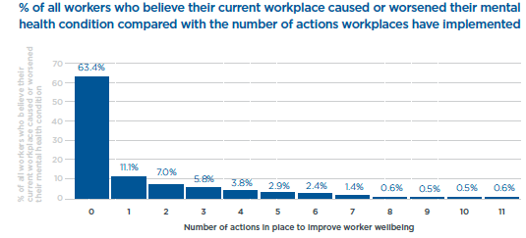

Figure 1. Percentage of workers who believe their current workplace caused or worsened their mental health condition compared with the number of actions workplaces have implemented
      - The more actions the workplace implements, the less common it is for their people to attribute their mental ill health to work.
      - More than half of Australian workers (56.8%) don’t believe their workplace has committed to any actions. (Refer Appendix for list of Actions)

Figure 2. Number of workplaces that are demonstrating action in workplace mental health
SuperFriend recognises that many individuals and organisations are undertaking Mental Health First Aid training or education sessions provided by EAPs. This needs to be commended. However, it’s important the Productivity Commission recognises that a ‘one-size’ does not fit all needs. The prevalence and types of interactions with customers, as well as staff experiencing, or at risk of mental ill-health should dictate the appropriate type of training, frequency etc. Contextual relevance and identified desired behaviour change (through skill and capability development) is critical to impactful education and training. Confidence and capability in using new skills is vastly different to awareness building or education. Therefore fit-for-purpose training is essential to achieve the desired outcomes. This nuance should be included as guidance for the work health and safety authorities when developing their guidance materials.
Further information about early intervention and prevention is provided in Appendix 1.

SuperFriend Recommendation 4
Provide Government funding for implementation support of the Mentally Healthy Workplace Alliance’s National Workplace Initiative.

Rationale
Funding the Implementation Support component of the National Workplace Initiative (NWI) (even if seed funded), would substantially increase the likelihood of:
- greater national consistency in implementation, achieving efficiencies from tailoring and scaling implementation approaches
- a consistent approach to impact evaluation and continuous improvement methodology implementation
- help to remove the known barriers of employer inaction due to overwhelming information and uncertainty over how to take action.

The benefits of implementation support through the NWI would go a long way to reducing the real costs to workplace mental health and wellbeing and enable employers to implement actionable and tangible prevention interventions. The funding should also allow for tracking progress in changes to productivity at an individual business level, as a result of investing in workplace mental health interventions.
SuperFriend’s 2019 published results from our fourth annual Indicators of a Thriving Workplace Survey show that over 10,000 workers were surveyed to determine Australia’s national workplace mental health and wellbeing score of 62.7 out of 100 (Figure 3).
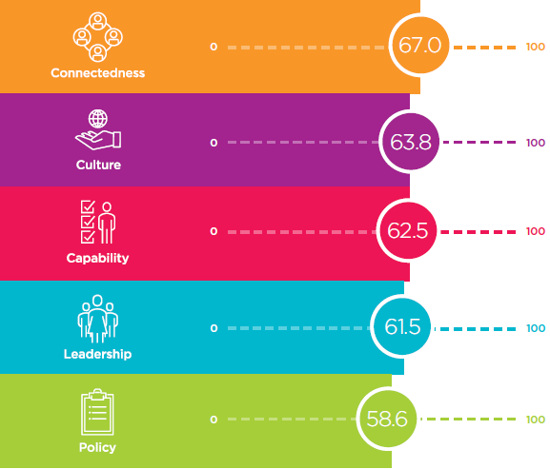
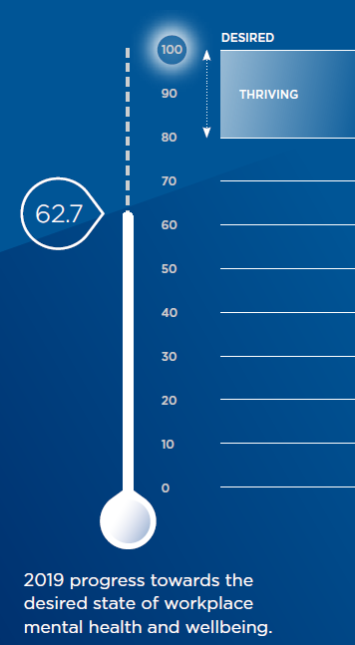

Figure 3. Australia’s national workplace mental health and wellbeing scores, 2019 and scores broken down by the five domains – Connectedness, Culture, Capability, Leadership and Policy.

This score demonstrates that Australia is not yet two thirds of the way towards optimal workplace mental health and wellbeing. A thriving workplace would score 80 or above. Only 5% of Australian workplaces are thriving.
There is more work to do to help employers take action across all five domains – Leadership, Capability, Policy, Connectedness and Culture. Many employers want to know and need to know the ROI for their business, if they are to implement any workplace mental health and wellbeing initiatives. Yet this data is not readily available or consistent. Large costs, such as the presenteeism costs to the Australian economy, are not sufficient motivators for change, especially at the individual employer level. A known lever for business and Government is understanding the economic benefits of investing in prevention – as it pertains to them. Therefore, funding implementation support for the National Workplace Initiative, will provide the best opportunity to:
- provide Governments with whole of population data on progress, implementation and outcomes of the NWI
- provide Businesses with organisational-level data and information
- provide Industry level data,
- provide regional level data which can help with monitoring the impact of WHS schemes, and
- encourage and incentivise (through natural market forces) service providers to develop stronger impact evaluation and reporting capability

This will enhance and support the broader recommendations contained in section 25 of the draft report and provide response to the information request for that section, as they pertain to workplace mental health monitoring, reporting and evaluation.

SuperFriend response to Draft Report Recommendations
WORKPLACES

Draft Recommendations 19.1-19.5: Develop and support mentally healthy workplaces

Any future national mental health policies, if they are to be economically and socially sustainable, must be concerned both with mental ill-health, mental health conditions and with broader factors that enable and foster positive mental health and wellbeing to create flourishing workplaces.
SuperFriend is, in principle, supportive of recommendations 19.1 to 19.4. SuperFriend is not fully supportive of recommendation 19.5 and proposes amendments below. In summary, SuperFriend feels that the recommendations haven’t gone far enough and suggest the Productivity Commission considers several modifications to these recommendations to strengthen their desired impact, as well as new recommendations as outlined below.
Given the growing evidence of the effectiveness of positive psychology interventions in workplaces, SuperFriend recommends the Productivity Commission reviews the emphasis on Work Health and Safety (WHS) agencies as the primary distribution channel, evaluator and disseminator for information on workplace interventions.
Typically, WHS agencies bring a risk mitigation and compliance focus to worker safety – which is acknowledged as an essential foundation and standard that is required and must be achieved. However, promoting more positive aspects of work, that fall outside ‘meeting compliance’, is not the known expertise of WHS authorities. It also does not fall within their remit for regulation enforcement and therefore may be counterproductive in achieving widespread action by employers.
The Productivity Commission has an opportunity to reorient these recommendations, noting the intended impacts, to recognise there are many other ‘actors’ in the workplace mental health and wellbeing system that are equally (if not better) placed to promote the complex mix of interventions required, including positive or strengths based approaches. When a complex construct exists – such as workplace mental health and wellbeing - it requires a mix of solutions, delivered by a diverse range of coordinated and suitably skilled providers.
From our experience in working with business, there can be a genuine reluctance by workplaces (and workers) to proactively engage with WHS agencies, due to their ‘regulatory’ role. This is a very real barrier, slowing uptake and change, and should be considered when making recommendations to Government for workplace mental health reform. There is certainly a valuable role for WHS agencies in promoting preventative strategies and risk mitigations. However, SuperFriend believes a cross-sector, collaborative and non-regulatory approach is likely to achieve more positive outcomes and changes in workplace behaviours, more quickly and at scale. The Mentally Healthy Workplace Alliance’s (MHWA) National Workplace Initiative provides such a vehicle. Concentrated effort and support for this national initiative is essential.

Draft Finding 19.2 The role of workers compensation in addressing mental health
SuperFriend acknowledges the valuable role of workers compensation schemes in addressing mental health. We support the draft finding to more effectively deal with mental health claims and improve outcomes for employers and employees by providing early intervention, early treatment and early return to work to avoid isolation, feelings of identity loss and an inability to contribute economically to their households. Moreover, feelings of separation from their social networks. All these factors play a role in an individual developing a secondary psychological injury or worsening of compensable condition.
In order to successfully achieve an early return to work, case workers should focus on understanding the psychological injury, from a biopsychosocial perspective to fully comprehend how the injury impacts the individual’s functioning, and in collaboration with the employer, individual and their treating health practitioners, design a graduated return to work plan where the individual can successfully return to work earlier, in some capacity.
SuperFriend believes the finding 19.2 needs to go beyond just workers compensation arrangements in dealing with mental health claims. There is increasing recognition in Australia and internationally that to be effective in addressing mental health in the workplace a more holistic approach needs to be applied. Where employers are supported to promote, protect and support the mental health of employees in their workplace.
As per SuperFriend’s recommendations 3, 5 and 7, we would like to see WHS agencies work in partnership with other mental health agencies (as demonstrated in the case study below) to support employers to increase focus on integrated approaches to workplace mental health which seek to simultaneously prevent work related harm, promote the positive aspects of work and manage mental illness as it manifests in the workplace.
Case study – A Collaborative Approach
An example of where WorkCover authorities have collaborated with other partners with expertise in mental wellbeing and health promotion to provide an integrated approach to worker safety, health and wellbeing is the Victorian Workplace Mental Wellbeing Collaboration (SuperFriend, VicHealth and WorkSafe Victoria) and the Leading Well Queensland Collaboration (Office of Industrial Relations Queensland – Workplace Health and Safety, SuperFriend and WorkCover Queensland).
These partnerships have been established to promote positive mental wellbeing in Victorian and Queensland workplaces. This approach allows for a holistic approach to developing, testing and sharing world-class programs and resources for workplaces. Through a collaborative approach, strategic leadership events have been conducted and thousands of workplaces have been given access to practical tools and resources to support positive approaches being embedded in workplace practice.

Draft Finding 19.3 Employee Assistance Programs
Employee Assistance Programs (EAPs) and counselling are common workplace interventions which many organisations, especially larger ones, provide as a support service for staff. SuperFriend believes there is a need for EAP services to use evidence-based approaches and not in isolation when assisting those reporting stress or other problems. SuperFriend is supportive of investment in the evaluation of the impacts of these services and bench marking of best practice in the wider provision of EAP services. Encouragingly, we are seeing a slow trend in EAPs repositioning their value proposition to support employees through any life event change or challenge (changing jobs, having children, buying a house, moving interstate), not just crisis situations.

Information Request 19.2 – Personal care days for mental health
Organisations are required to provide a mentally safe place for employees. Most full-time employees are entitled to ten days of paid personal leave each year, which can be used for physical or mental health reasons. The requirement for medical certificates for personal leave often varies depending on the organisation. SuperFriend believes taking leave for mental health can be just as important for wellbeing as taking it for physical health. Employees should be given the flexibility to use their personal leave for preventative self-care. In many cases, employees may not feel the need to visit a GP when they need a mental health day and requiring a medical certificate may increase presenteeism.
Creating a culture of trust, where employees feel empowered to take leave for any reason when they need it, can increase wellbeing and productivity. In organisations with open communication around mental health, creating mental health-specific personal care days could be beneficial for employees. However, caution is essential before recommending wholesale change such as designating leave for mental health, as this could increase or create sigma around mental ill-health. SuperFriend therefore suggests that personal care days for mental health remains at the discretion of the employer, with mechanisms, such as the NWI and their champions, being able to promote these concepts as evolutionary cultural norms over time.
Draft Recommendations 19.5 – Disseminating Information on Workplace Interventions

SuperFriend does not support this recommendation as it stands. We do not believe that monitoring and collecting evidence from employer-initiated interventions is the role of WHS agencies. Nor do we believe that WHS agencies are best placed to advise workplaces on effective interventions that would be appropriate to their workplace. We see this as the role of the National Workplace Initiative and recommend redrafting this recommendation. WHS agencies should be assisting in disseminating and promoting this information, but not be the collector and evaluator of evidence.

SuperFriend Recommendation 6

The National Workplace Initiative should monitor and collect evidence from employer-initiated interventions to create mentally healthy workplaces and improve and protect the mental health of their employees. The National Workplace Initiative should advise employers of effective interventions that could be appropriate for their workplace (provided Recommendation 4 is also made and funded).

Rationale
SuperFriend does however believe there is a greater role for WHS agencies to collect and evaluate interventions for return to work and stay at work. WHS agencies could play a bigger role in supporting the evolution of better return to work and recover at work interventions. This could also assist in the draft finding of 19.1 regarding small business. We would encourage the opportunity for WHS agencies, life insurers, rehabilitation and return to work experts, businesses of all sizes and other health and non-health actors to work together in developing enhanced return to work and stay at work guidance materials for all workplaces. Likewise, we would urge the Productivity Commission to recommend the opportunity for this information to be fed forward/utilised by the NWI.

SuperFriend Recommendation 7

WHS agencies, in collaboration with life insurers, workplace rehabilitation and other health experts, people with lived experience, and business should develop, monitor and collect evidence of return to work and stay at work employer-initiated interventions. WHS agencies should advise employers of effective interventions that could be appropriate for their workplace and provide guidance the National Workplace Initiative in the promotion of evidence-informed return to work and stay at work interventions.

Rationale
WHS agencies are well placed to develop, collect, evaluate and promote better return to work or stay at work outcomes. Employers and workers alike would value guidance and supports to improve these experiences and outcomes. Not all businesses have experienced supporting a worker either to recover at work or return to work after a psychological illness or injury – these are not common processes or practices for most workplaces. Therefore, it would be ideal for greater evidence and support to be available to improve the experience for all.

Further information supporting these recommendations is provided in Appendix 1.

SOCIAL INCLUSION

Life Insurance, and the broader financial services industry, has a critically important role to play in enabling improved mental health and wellbeing outcomes for Australians.

SuperFriend has worked collaboratively with the Life Insurance Industry (the industry) to develop a united response to these recommendations. The Industry’s response demonstrates the willingness, capacity and capability to be a valuable collaborator and stakeholder in achieving system reform for better mental health and wellbeing outcomes for all Australians.

SuperFriend Recommendation 5
SuperFriend encourages the Productivity Commission to include the new and modified recommendations (1 through 8) from the Life Insurance Industry Submission in their final report.

Draft Recommendation 20.2 — Awareness of mental illness in the insurance sector
SuperFriend in principle supports draft recommendation 20.2 however recommends changes as included in the insurance industry submission.

Rationale
Life Insurance, and the broader financial services industry, has a critically important role to play, which is different to Government(s) and other support agencies, in enabling improved mental health and wellbeing outcomes for Australians. After Government, the life insurance industry is the largest contributor of financial and other supports for people with a mental illness, paying over $700 million in mental illness related claims in 2018.
Furthermore, the industry now collects detailed up-to-date data on mental illness which, when compared or augmented with other large population-based data sources, could be immensely beneficial in identifying trends and addressing system reform for social and economic benefits. Therefore, for Government(s) to fully understand the entirety of the ‘system’ and the opportunity for genuine system reform for sustainable social and economic impact, it will be essential that the Productivity Commission, in its final report and recommendations to Government, considers and articulates the non-government ‘actors’ roles and responsibilities in creating social and economic gains for Australia through reform.

Draft Recommendation 24.6 — Life Insurers & Funding of Mental Healthcare
SuperFriend supports changes to legislation to allow life insurers to fund mental health treatments of income protection insureds as proposed under draft recommendation 24.6. However, SuperFriend supports this provision being extended to Total and Permanent Disability (TPD) Claims as well. We believe that life insurers should be given the ability, more broadly, to fund treatment regardless of the type of condition or insurance policy for which the member is insured. The impact of forced absenteeism due to injury or illness is well documented and any effort to return persons on claim to good health and gainful employment in a more effective and efficient way should be explored. By focusing purely on mental health claims, we overlook secondary psychological ill-health brought about by a period of incapacity.

Conclusion
SuperFriend applauds the Productivity Commission’s emphasis on prevention and intervention and its recognition of the important role played by workplaces and Australia’s insurers in the mental health system.

However, maximising the preventative impact of workplaces and insurers requires the Commission to go further in its recommendations.

Proven, evidence-informed interventions to enable mentally healthy workplaces must be mandated in whole of government approaches (recommendation 1) and barriers removed (recommendations 2). Likewise, utilising the levers of Government, regulators, industry and economic markets can be powerful mechanisms to help progress and propel reform agendas (recommendation 3, 4, 6 and 7). The essential role of life insurers in the prevention and treatment of mental health conditions must be articulated (recommendation 5) and supported.

Coordination, promotion and – where necessary – legislation to ensure psychological safety is safeguarded and improved through early intervention and prevention will deliver the improvements needs to reduce the human and economic costs of mental illness in Australia.

SuperFriend thanks the Productivity Commission for the opportunity to submit these recommendations for consideration.

Appendix I: Importance of workplaces in population-wide mental health

Systems Approach is needed
The draft report underplays the broader population’s mental health, focusing more on people currently experiencing mental ill-health. This is short-sighted and will not be enough to change the trajectory of health costs, impacts and prevalence. Steps are needed to also promote and protect people’s mental wellbeing by amplifying genuine preventative and early intervention initiatives. A nationally consistent approach to reform is critical.
SuperFriend’s recommendations recognise, acknowledge and emphasise both mental health and wellbeing and mental ill-health are influenced by the settings and events of everyday life. To be effective and sustainable, reforms need to consider three key areas that influence mental health:
Structural-level factors including social, economic and cultural factors that are supportive of mental health and wellbeing
Community-level factors including a positive sense of belonging, community connectedness, diversity that is highlighted and embraced, and meaningful participation in society
Individual-level factors such as the ability to manage thoughts and cope with stressors; and well-developed communication and social skills to support connection with others.
Figure 4 shows the dynamic model of wellbeing and describes how an individual’s external conditions (bottom left), such as their income, employment status, housing and social context act together with their personal resources (bottom right), such as their health, resilience and optimism, enable them to function well (middle) in their interactions with the world and therefore experience ‘feeling good’ (top). When all elements of the system work, it enables a state of optimal mental health, known as flourishing.
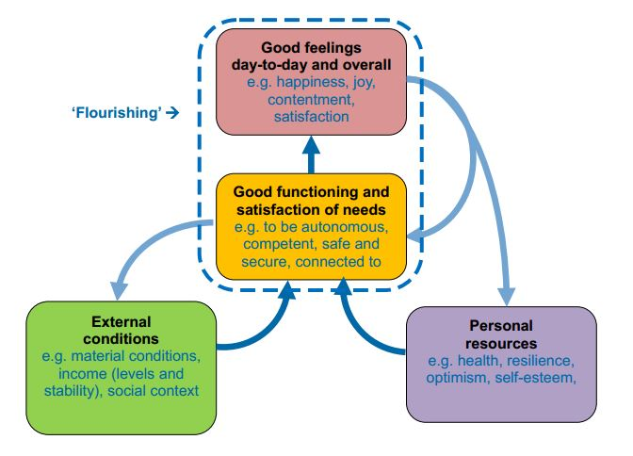

Figure 4. Dynamic model of wellbeing
A population health approach involves implementing prevention initiatives that take place across a range of settings and involve contributions from many different sectors and organisations. It also requires a nationally consistent approach. Prevention initiatives are relevant to all people, regardless of their mental health status or geographic location. Funding and recommendations should focus on a mix of primary, secondary and tertiary prevention strategies. The Ottawa Charter for Health Promotion provides an excellent framework to guide development of activities to prevent poor mental health. This Charter and its fundamental principles for the health of populations provides a template for “prevention rather than cure”.

Effective workplace strategies for a mentally healthy workplace
There is increasing evidence that workplaces play an important and active role in influencing, either positively or negatively, the mental health and wellbeing of their workers. SuperFriend’s Indictors of a Thriving Workplace survey and report identified eleven tangible ways that employers can improve worker wellbeing (Figure 5).
11 Ways to Improve Worker Wellbeing
      - Actively provide professional development opportunities
      - Recognise people who do good work and reward them appropriately
      - Let people see the mental health policy, strategy or action plan in action
      - Implement effective policies and practices against workplace bullying and harassment
      - Make it easy for everyone to access to confidential counselling or support services
      - Develop good return to work policies and practices for people who have had time off work with mental health conditions
      - Make sure that all leaders regularly participate in mental health and wellbeing training by making it an organisation-wide policy
      - Put clear structures in place so that decision- making is transparent
      - Develop policies to ensure that changes are managed in clear, supportive and positive ways
      - Provide access to mental health and wellbeing education (i.e. information, training)
      - Help people to practice good work/family/life integration
Figure 5. 11 Ways to improve worker wellbeing
These activities, based on 40 scientifically validated indicators, are shown to improve worker wellbeing. One of the most compelling results from the ITW report is that more than half of Australian workers (56.8%) don’t believe their workplace has committed to any actions. Further analysis shows 26% are doing 1-3, 11% are doing 4-7 and only 6.3% are doing 8 or more actions. Implementing even one of these actions can make a huge difference to worker mental health.
The more actions the workplace implements, the less common it is for their people to attribute their mental ill health to work. The majority (63.4%) of people who believe their workplace contributed to their mental health condition work in organisations that haven’t implemented any actions.
The evidence base for effective preventative workplace strategies is strong. A report commissioned by the Mentally Healthy Workplace Alliance outlined several evidence based/informed strategies for the workplace:
- designing and managing work to minimise harm (encouraging flexible work and employee participation)
- promoting protective factors at an organisational level to maximise resilience (providing manager and leadership training)
- promoting and facilitating early help seeking (CBT based stress management/resilience training, resilience training for high risk occupations, coaching and mentoring and worksite physical activity programs) and
- supporting workers recovery from mental illness and increasing awareness of mental illness and reducing stigma.

Workplace Stress
SuperFriend’s 2019 Indicators of the Thriving Workplace report featured a special focus on stress. Workload and deadlines are the two biggest stressors across the nation, affecting one in five workers. Workers who are stressed on a regular basis are leaving their jobs. Figure 6 outlines stress levels of current jobs and the frequency of stress occurring.
Figure 6. Stress Levels of Australian Workers, 2019.

Workload and deadlines are the two biggest stressors across the nation, affecting approximately one in five people. However, workers in people-facing roles like education, retail, health, and hospitality find customers and clients cause more stress, than deadlines. Public sector workers tend to feel more stressed by management issues than by deadlines.

Retention of workers
This year SuperFriend also observed a substantial and worrying drop from 75.6% in 2018 to 65.5% in workers’ commitment to staying with their employer. Mentally healthy workplaces help to retain staff, which can be a substantial cost saving to employers (and the broader economy) including continuity of workforce productivity. In thriving workplaces one in five people experience high levels of stress each week, compared to one in three in workplaces which are not thriving. We know that when people work in mentally healthy environments, they typically feel more valued and willing to contribute to the organisation.

References

SuperFriend. Indicators of a Thriving Workplace Survey. Melbourne: SuperFriend; 2019, 3 – 29 https://www.superfriend.com.au/further-resources/2019-indicators-of-a-thriving-workplace-survey/
SuperFriend. Building Thriving Workplaces: Guidelines and Actions: Melbourne: SuperFriend; 2018 https://www.superfriend.com.au/resources/building-thriving-workplaces/
Financial Services Council. State of the industry, 2019 (internet). Sydney: Financial Services Council; 2019; 60p (cited 2020 Jan 21) https://www.fsc.org.au/resources/1826-fsc-state-of-the-industry-report-2019
Mendelson TT, Eaton WW. Recent advances in the prevention of mental disorders. Social Psychiatry and Psychiatric Epidemiology; 2018, 53(4), 325-339
McDaid D, Park A. Investing in mental health and wellbeing: findings from the DataPrev project. Health Promotion International, 26 (Supp_1)i108-i139.doi: 10.1093/heapro/dar059; 2011
SuperFriend. Building Thriving Workplaces: Guidelines and Actions: Melbourne: SuperFriend; 2018 https://www.superfriend.com.au/resources/building-thriving-workplaces/
KPMG, commissioned by the Mentally Healthy Workplace Alliance and funded by Beyond Blue and SuperFriend. National Workplace Mental Health Framework for Australia Discussion Paper; 2016
SuperFriend. Indicators of a Thriving Workplace Survey. Melbourne: SuperFriend; 2019, 3 – 29 https://www.superfriend.com.au/further-resources/2019-indicators-of-a-thriving-workplace-survey/
World Health Organisation Mental Health: strengthening our response (internet) 2014 (cited 2020 Jan 15). https://www.who.int/news-room/fact-sheets/detail/mental-health-strengthening-our-response
Allianz sees a surge in secondary mental health conditions (internet). 6 March 2018 (Cited 2020 Jan 21) https://www.allianz.com.au/media/news/2018/allianz-sees-a-surge-in-secondary-mental-health-conditions
University of Tasmania, Health and Wellbeing Network. An integrated approach to workplace mental health: Nine priorities for implementation in Australia. University of Tasmania; 2017.
Mentally Healthy Workplace Alliance., Developing a mentally healthy workplace: A review of the literature. Sydney; 2014 (cited 2020 Jan 21) https://www.headsup.org.au/docs/default-source/resources/developing-a-mentally-healthy-workplace_final-november-2014.pdf?sfvrsn=8
Everymind. Prevention First: A Prevention and Promotion Framework for Mental Health. Version 2. NewCastle, Australia; 2017
NEF. Measuring our progress: The power of wellbeing (internet). London, NEF; 2010 (cited 2020 Jan 15) https://neweconomics.org/uploads/files/Measuring_our_Progress.pdf
World Health Organisation. The Ottawa Charter for Health Promotion. Geneva, WHO;1986 (cited 2020 Jan 15) https://www.who.int/healthpromotion/conferences/previous/ottawa/en/
Harvey S, Joyce s, Tan L, Johnson A, Nguyen H, Modini M, Growth M. Developing a Mentally Healthy Workplace Alliance. Developing a mentally healthy workplace: A review of the literature; A report for the National Mental Health Commission and the Mentally Healthy Workplace Alliance. Sydney; 2014 p7

