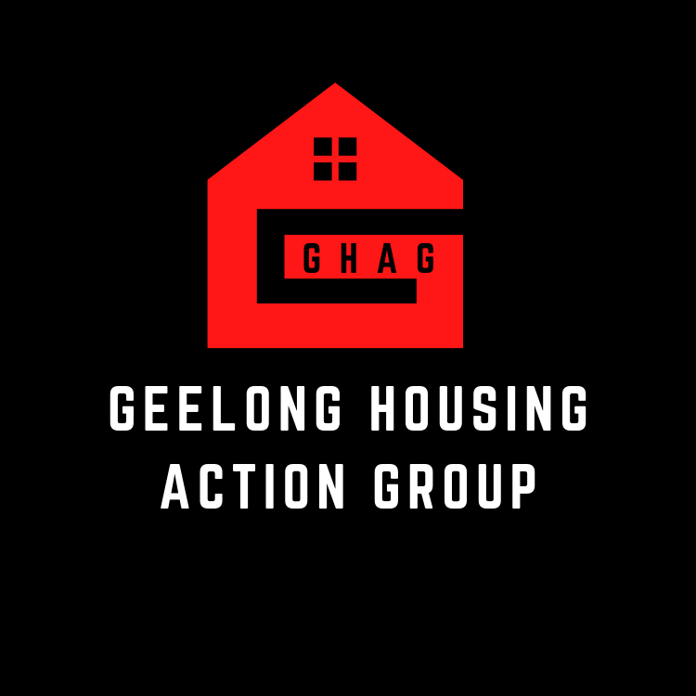
GEELONG HOUSING ACTION GROUP (GHAG)
HOUSING IS A HUMAN RIGHT | DEMAND CHANGE
homelessnessactiongeelong@gmail.com

National Housing and Homelessness Agreement Productivity Commission Review Issues paper
Submission by Geelong Housing Action Group (GHAG)
We acknowledge the Traditional Owners of the land, we acknowledge Elders past, present and emerging. We acknowledge this is a stolen Land. Always was always will be Aboriginal land.
Preamble
We are a grassroots group formed in May 2021 in response to the growing Housing and Homelessness crisis in the Barwon region, whilst also recognising the dramatic increase in homelessness and housing insecurity across Victoria and Australia over the last decade.
Our members include people who have lived experience of homelessness, public and community housing tenants, and community service workers including those working in the housing & homelessness sector amongst other interested community activists.
Geelong Housing Action Group do not support the continual privatisation of the Public Housing sector. We argue that privately run Community Housing providers do not adequately house the most vulnerable in our community and the viability of the industry from a financial perspective is not sustainable.
We strongly oppose the treatment of housing as a commodity. We uphold the view that everyone has a fundamental human right to adequate housing. We argue for the urgent regulation of the Community Housing sector and transparency of policies to tenants and the public. We oppose the operation of housing by for profit providers.
Definitions
Social Housing: A generic term used by the government to describe Community & Public Housing. The two models of housing operate in very different ways and therefore GHAG refute the use of the term ‘Social Housing’ as it is problematic and deliberately misleading to the public.
Community Housing owned and operated by private or not for profit sector housing providers.
Public housing owned and operated by the state.
Affordable housing deemed as any housing that costs a household no more than 30% of their income. Accessing affordable housing remains a concerning and persistent challenge, particularly in the private rental market for people on low to moderate incomes.

Outcomes of the Agreement p6 of the issues paper.

“The National Housing and Homelessness Agreement (NHHA) is intended to contribute to the following aspirational, overarching national outcomes”
And: “Are the outcomes of the NHHA suitable for the next agreement, and why (or why not)? To what extent should the outcomes of the next agreement be aspirational rather than achievable within the life of the agreement? p7”

We have major concerns that the NHHA is aspirational which gives no concrete targets for the proposed outcomes. The NHHA needs to have targets and goals that focus on building suitable sustainable public housing that is located within reach of essential services such as public transport, public health and basic shopping needs. This agreement needs to look at a starting point where housing is seen as essential basic human right and not a market force.

Of particular concern is point 5 p6:
- “a well-functioning housing market that responds to local conditions”
and a question on p7:
“… has the NHHA contributed to a better functioning housing market?”

We see this as an inappropriate approach to housing for members of this society who are either homeless, suffering rent stress or live in public and community housing because the income they have does not even cover the basics.

Questions p9
“Are the outputs of the NHHA still relevant? Are different outputs needed? Should outputs be more prescriptive? Are the national housing priority policy areas the right priorities? If not, what should they be? “
We believe that housing should not be driven by market forces. People in the community are homeless, suffering rental and mortgage stress because housing is seen as a focus for profit and not a fundamental human right. Professor Guy Johnson states the need to remove “... various tax incentives such as negative gearing, reduced the capital gains discount, swapped stamp duties for general property taxes ….”. Taken from: in his essay Getting out of the Policy Quagmire 2019 Homelessness in 2030 Essays on possible futures.

In answering this question: “Are the national housing priority policy areas the right priorities? If not, what should they be?” Geelong Housing Action Group (GHAG) believes government at all levels need to refocus their commitment from an economic one to a social one. Overseas models including the Finnish ‘housing first model’ is government managed and controlled (pdf in references). It provided appropriate housing with the needed support services for the individual to maintain their homes. It actual saves the government money. And while there is a reference to it, it is not the focus of the NHHA.
“…there are many examples of innovative initiatives in Australia that have improved outcomes, including initiatives aimed at young people and initiatives incorporating Housing First principles. However, these initiatives have not been brought to scale” p16

National housing priority policy areas from NHHA, p.16.

We feel these are blurred and need clarification and the order of priority changed.

Under Social Housing we believe that:
  - “appropriately renewed and maintained (which may include redevelopment and new construction)”

We support maintenance which makes Public Housing the priority. However, we are concerned about what is meant by ‘redevelopment and new construction’.

  - “utilised efficiently and effectively (which may include redevelopment and stock transfers)
  - responsive to the needs of tenants (which may include redevelopment and stock transfers)
  - appropriately renewed and maintained (which may include redevelopment and new construction)” P 8 of the Issues paper

We strongly oppose the transfer of any stock particularly public housing. This does not create more housing. It shifts the responsibility for housing to the private sector. And if tenants do not want their public housing redeveloped or transferred to NGOs will government at all levels listen? Current indications are that tenants aren’t being consulted adequately and not being listened to. An example of this is Ormond Road, East Geelong Project summary – December 2021 (See pdf in references.) Where from GHAG interaction with tenants this was the first information they received. There is a mixed response to the redevelopment with some tenants seeking to leave and others unsure and others wanting to stay.

- “tenancy reform that encourages security of tenure in the private rental market.”
We agree with the concept of tenancy reform that supports security of tenure in the private housing market, however, we believe that government needs to provide adequate support to individuals to help them maintain their tenancies in the private rental market. Again, we refer to the Finnish Housing First Model.
“home ownership including support for first home buyers.”

We take issue with home ownership within the context of it being driven by market forces as in financial institutions. It is out of reach of a significant layer of Australian society. Better to put subsidies into construction of more public housing.
- “planning and zoning reform and initiatives, including consideration of inclusionary zoning and land release strategies.”

And while we see planning and zoning as a primary concern we believe this needs to be addressed in a separate issues paper because it is extremely complex. There is the risk of developers taking advantage of changes designed to improve housing stock for those who can’t afford to enter the current housing market.

A case study of this is the Ormond Road, East Geelong Project summary –20 December 2021 put out by the Victorian state government. We are led to believe in discussions with some of the tenants that this pdf is the only source of consultation they have had. The diagram of the site indicates that at least a third to a half of the sight will be ‘private property’. For what? A developer to build privately owned housing for a profit? This is public land and should have public housing built on it.

We take issue with this statement on p 14
“Nearly all Australian households either own their own home (with or without a mortgage) (66 per cent) or are living in affordable or private rental accommodation (27 per cent). Just over 4 per cent of households live in social housing (figure 2). “
The figures for homelessness are guess work at best and at worst an appalling underestimation of the actual figure. Does it include the invisible homeless as in those that ‘coach surf” and temporally live in spare rooms and garages? As for people in public and community housing (called social housing ) again the figure is low because there isn’t the public housing stock needed in the community. Surely waiting times for housing in this sector would indicate this. According to the last census 116,400 Australians are without a home- the highest number since the census began estimating the prevalence of homelessness. Without a home - FactFile ABC News
We believe this is completely under estimating the actual numbers due to the invisible homeless eg. those who are ‘coach surfing’.

P15-16
We support the following section:
“The causes of homelessness are complex and include both individual factors (such as physical and mental ill-health, domestic and family violence, low incomes, low educational attainment, unemployment and underemployment) and structural factors (such as housing affordability, the limited availability of social and affordable housing, and discrimination in the private rental market). The interaction of these factors makes addressing homelessness difficult, with many people who become homeless experiencing multiple problems (Muir et al. 2018).”
And more recently the consequences of the pandemic and climate change including bush fires and flooding which could create further homelessness.
p16
“There have been many reviews and studies on homelessness in Australia. These reviews have found that:
- the homelessness service system is increasingly ‘crisis orientated’ and many people do not receive the services they need
- addressing homelessness is complex and requires an integrated, cross-sector response using a variety of approaches aimed at key risk factors
- there is not enough investment in prevention and early intervention services
- there are many examples of innovative initiatives in Australia that have improved outcomes, including initiatives aimed at young people and initiatives incorporating Housing First principles. However, these initiatives have not been brought to scale
- data on the prevalence of homelessness and outcomes in Australia needs improvement
- shortages of short- and medium-term accommodation, and longer-term social and affordable housing, make it difficult to address homelessness (for example, HRSCSPLA 2021; LCLSIC 2021; Pawson et al. 2020; Spinney et al. 2020).”
And in spite of all the studies and understanding the NHHA in its current and many earlier forms appears to be aspirational and driven by a market focus. Both of which appear to have failed ordinary Australians. Again, we refer to the Finnish housing first model.
Social Housing p 17
“However, as the Commission has previously noted, there is no ‘right’ level of social housing and the level of housing need depends on a number of factors, including other housing assistance and the level of income support provided (PC 2017).”
We struggle to comprehend what the commission means by ‘no ‘right” level of public housing (referred to in the statement as social housing). Simply put a ‘right’ level of housing would remove market forces and provide adequate housing for all who need it as in the Finnish Housing First model.

P18
“The composition of the social housing stock has also changed — community housing now accounts for a larger share of the social housing stock (figure 5). Some of the change is because State and Territory Governments have transferred the management or ownership of some public housing units to community housing providers. This change could be partly in response to tenants in community housing being eligible for Commonwealth Rent Assistance (CRA), which allows community housing providers to charge higher rents than public housing agencies. However, public housing continues to make up about 70 per cent of all social housing dwellings (AIHW 2021a).”
We see this as a form of privatisation. Commonwealth rental Assistance (CRA) presents as a form of subsidy to the community sector providers who can’t make a profit from the low rents paid by the tenants. Again, housing should not be seen as a source of profit. It should be seen as a basic right. And any shift away from public housing to a market driven approach will only dimmish this basic right and lead to a greater crisis.

P19
“One of the reasons for long wait times is that social housing households often have long term, or lifetime, tenure in their dwellings, and are less likely to move than other households (PC 2019). Social housing exits and transfers are about 10 per cent of all social housing households each year (AIHW 2021a).”
We don’t understand why this is an issue. Long term or life time tenure equates to security of tenure. Home ownership in the private sector of housing and the long term use of the property is acceptable. This being the case then long term tenancy in the government managed and controlled housing sector provides the equivalent housing security. Building more public housing on a large sustainable scale would reduce the waiting lists, create lots of jobs in construction, maintance, administration, design and be cost effective compared to subsidies to the private sector of housing. Which has failed to meet demand.
What it would also demonstrate is that Australia could become a world leader in creating sustainable climate change adapted housing. Housing that could take from the Finnish Housing First Model and adapt it to our social circumstances. Now this is not just an aspirational perspective but a descriptive goal oriented approach. We believe this is possible if government has the will to shift its policy approach from market forces to social equity. We believe it is more than possible for government to have the will to shift their current policy approaches from market forces to housing as a basic right of all Australians.

References
Bio:
Professor GUY JOHNSON has been involved in the area of housing and homelessness for over two decades. He is the inaugural Unison Housing Chair of Urban Housing and Homelessness. He leads the Unison Housing Research Lab at RMIT University, Australia, a unique education and research collaboration between RMIT University and Unison Housing, Victoria’s largest social housing provider.
Taken from: Homelessness in 2030 Essays on possible futures
© Y-Foundation Editors: Johanna Lassy and Saija Turunen, Y-Foundation Layout and illustrations: Kaskas Media ISBN 978-952-94-1416-1 (binded) ISBN 978-952-94-1417-8 (pdf) Printing: Otava Book Printing Ltd, Keuruu 2019, First Edition
Homelessness in 2030 − Essays on possible futures - Y-Foundation (ysaatio.fi)
Without a home - FactFile ABC News
www.abc.net.au/news/2021-02-24/regional-housing-insecurity-hurting-older-women-victoria/13182874

