Northern Rivers Preschool Alliance
Cl- Bridget isichei
President NRPA
49-51 Bottlebrush Cresent
Suffolk Park, NSW, 2481

Thursday, 8 February 2024

Productivity Commission Review on Early Childhood Education and Care
Submission on the Draft Report from the Northern Rivers Preschool Alliance

Who are we?
The Northern Rivers Preschool Alliance is a volunteer, not-for-profit, advocacy and support organisation representing 40 preschools in the Northern Rivers of NSW. The organisation provides mentoring, staff development, advice, and runs networking groups for Educational Leaders, Directors, and Aboriginal Educators. The organisation also builds relationships with government bodies, early childhood stakeholders, consultants, and academics to advocate for the not-for-profit community preschool sector.

Acknowledgement:

- We acknowledge the traditional custodians of the Bundjalung, and Gumbaynggirr peoples, the custodians of the land that we communicate across, including Elder’s past, present and emerging.
- We thank the commission for the thorough, detailed, comprehensive review of Early Childhood Education and Care (ECEC). We applaud the clear vision and values of the report placing children and families at the centre of research and recommendations.
- We acknowledge the critical importance of this inquiry and appreciate the Commission’s foresight, which forms a significant step towards Australia’s journey towards accessible, quality ECEC for all Australian children and families.

NRPA key responses:

- Draft Finding 6.2: Give all children an entitlement to up to 30 hours or 3 days a week of subsidised care without an activity requirement.
Thirty hours free ECEC for 0-1year olds must be balanced with increased opportunities for paid parental leave:
- We welcome the recommendation to provide 30 hours of free ECEC to all Australian children 0-5 years. We ask that the Commission concurrently consider recommendations to also support new parents to spend time attaching to their infant through options for paid parental leave for the first year of infancy. Australia lags well behind the OECD average in supporting paid parental leave (0ECD, 2024). Although in many circumstances young infants may benefit from time in an ECEC centre, a robust body of research supports that primary care givers and infants first and foremost benefit from supported time together to attach (Gholampour, Riem, Heuvel, 2020).

We are concerned that providing free ECEC for infants in their first year of life, without also providing primary care givers with supported options to stay home with their baby risks a situation where parents return to work, before they and their infant are ready. This policy would risk increasing family exhaustion, stress levels and could reduce young babies’ opportunities for initial attachment and bonding. We acknowledge the breadth of diversity in family needs and situations in Australia and ask the Commission to consider research supporting the importance of maternal-infant bonding during the first year of life (Winston, Chicot, 2016) which must be balanced with goals relating to workforce participation, and the ECEC needs of vulnerable families with babies.

- The NRPA would like to highlight the urgency of combining recommendations about access to ECEC with ensuring quality of provision. Increasing access to ECEC without first ensuring quality is insufficient - we ask that steps be taken to ensure that the provision of greater access does not result in loss of quality, for example, a reduction in staff-child ratios or access to an ECT or qualified educator. It is critical quality is first built and maintained.

- The NRPA notes that in regional areas, access to ECEC is often provided by not-for-profit services. Privatisation in the sector has done little to improve access in regional towns and cities, and so it is important that not-for-profit services are encouraged and incentivised. An example of this occurred following the 2022 Northern Rivers floods- many private providers did not reopen following the flood as the services were deemed to be no longer profitable. In contrast, most of the not-for-profit services had reopened in alternative venues within days of the flood event, providing much needed routine and respite for local children. It should also be noted that not-for-profit community preschools are, on average, rated as higher quality than long day care centres operated by private providers (according to the ACECQA, NQF snapshot Q4, 2023).

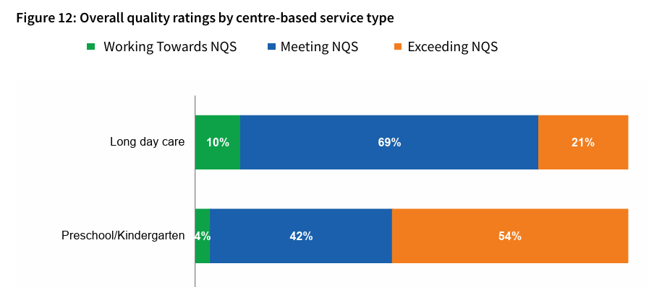

*ACECQA, 2023, NQF Snapshot, Q4

- Draft Recommendation 3.1: Fair Work Act processes addressing pay and conditions
We request development of the recommendation to reflect clarity and urgency regarding workforce retention, with specific consideration of risks to the community preschool workforce
- We thank the Commission for recognising the urgent and critical issues related to workforce recruitment and retention in ECEC in Australia. Although the Commission is correct this could be rectified (for Long Day Care (LDC)) under fair work enterprise bargaining, the NRPA believes the request for increased wages could be more specific and the solutions less dependent on undetermined adjacent processes. Regardless of whether wage increases (for the LDC section of the awards) are being currently negotiated, wage increases, (and pay parity for degree trained ECEC teachers with public school counterparts) should be highlighted as a key urgent priority independently by the Commission. We also note- negotiations are not currently underway for educators and teachers in community preschool in NSW. We would like to flag that any time period between when wages are increased in LDC through enterprise bargaining, and when wages are increased in community preschool, could further deteriorate the current debilitating staffing crises in NSW community preschool.

- The NRPA asks the commission for more clarity and clearer recommendation for an immediate, urgent- 25% wage increase for all educators service delivery models, and immediate pay parity for all degree trained registered teachers in Australia with equivalent degrees.

- Draft Recommendations 3.1: Reduce barriers to upskilling, 3.4: Lift support and mentoring for new early childhood teachers and 3.6: Provide greater support for professional development
Funding and utilising volunteer ECEC organisations already established and building the workforce
- We thank the Commission for recognising the importance of providing increased Professional Development (PD), networking, mentoring, and training to Teachers and Educators across NSW and Australia. We ask the commission to consider a recommendation that funding is provided to the volunteer organisations that are already in place. These organisations (including the Northern Rivers Preschool Alliance) have established active networks and relationships, and already work effectively in the sector to train, mentor and support ECEC staff development.

NSW for example has a network of ‘preschool alliances’, where highly experienced and qualified early childhood professionals, volunteer time on the alliance committees to support the growth of the preschool sector. This model produces burnout for our most experienced teachers and educators, and without funding- is unsustainable. We ask the Commission to recommend utilising and funding established volunteer organisations to carry out PD, networking and mentoring.

- We specifically highlight the urgent need for increased PD funding in small and remote community preschools.

- Draft Recommendation 3.2: Support innovative delivery of teaching qualifications and 3.3 Improve registration arrangements for early childhood teachers.
Fast tracking qualifications waters down the early childhood teacher degree and results in poor quality ECEC
- We thank the Commission for recognising the significance of early childhood teachers. In recognition of the importance of highly skilled, knowledgeable and experienced early childhood teachers we ask that this important qualification remain specialised in early childhood content (not covering years 0-12) and for it not to be fast tracked. Watering down, or fast tracking the ECEC degree creates inexperienced and ineffective early childhood teachers, and results in reduced quality across the sector. Australia must keep the bar high. If ECEC teachers are paid well more bright students will take on the challenge and rise to the high intellectual standard and skill required for this critically important work.

- The NRPA note that recent strategies to build the ECEC workforce, have been aimed at the attraction and training of new early childhood teachers. The NRPA request greater emphasis on the retention of existing early childhood teachers, including strategies such as wage increases, career pathways, and increased opportunities for high-quality professional development. Our most experienced teachers are critically important to lead the sector and mentor a new generation of ECEC teachers. These experienced teachers are leaving our sector in droves, urgent action is needed.

- Draft Finding 7.6: Support out of preschool hours ECEC
Respecting the diversity of service models:
- We thank the Commission for recognising the importance of a universal system of ECEC for all children. We ask the Commission take extra care to ensure recommending that the universal system supports diversity of service types, ensuring different service models are able to keep their unique identities and functions.

Preschool service model- a purposeful design
- We thank the Commission for recommending ECEC services should be flexible and responsive to families. We agree more must be done to ensure every region can provide a range of diverse service models to suit different family needs.

- We point out that ‘dedicated preschools’ run shorter session times and hours, not by design fault. The length of hours children spend at preschool (balanced with the number of hours children spend with key attachment figures) has been developed as an intentional delivery model using evidence-based approaches about what is best for children’s development.

We acknowledge LDC models are necessary to support some family’s workforce participation needs, but shorter hours better suit the needs of many children. The dedicated preschool design with short session times produces higher quality ECEC (see ACECQA Snapshot, 2023, Q4 above). Shorter session times allow for reduced educator/child burnout and increased time for planning and critical reflection. The service model has been designed to put children’s needs before adults. While ‘wrap-around care’ may work for some preschools, for many it could compromise the high-quality model already in place. We ask the Commission to value and respect the unique design of the preschool service model, which allows children to engage in shorter bursts of high quality ECEC, while allowing them the opportunity for increased unhurried time with important family members.

- Draft Findings 2.3: Amend eligibility requirements for inclusion funding, 2.4: Review and amend additional educator subsidies, 2.5: Reduce administrative burden of ISP applications
DIP Funding
- We thank the Commission for recognising the critical importance of increased funding to ensure the inclusion of every child, so that every child in Australia can be fully supported to attend ECEC. We ask the Commission to specifically include increasing Disability Inclusion Program funding, and expanding this funding to include all children who have additional support needs.

Start Strong and Fee Relief Funding for Community Preschool:
- NRPA Directors unanimously raise the pressing issue of changing funding models, time consuming funding applications and varying unpredictable amounts of funding. We ask the commission to ensure recommendation include prioritising funding increases, immediate funding for wage increases, streamlined, efficient funding amounts and processes.

- Draft Finding 8.2: Review how services are assessed against NQF
Assessment and Rating under the NQS:
- The NRPA asks the commission to recommend prioritising the reduction of bureaucratic processes and laborious, uncooperative systems relating to documenting and reporting Assessment and Rating against the NQF for the Department of Education.

The Northern Rivers Preschool Alliance thanks the Commission for this opportunity to respond to the draft report into Early Childhood Education and Care.

Kind Regards,
Bridget Isichei

M.Ed., B.Ed., Dip ECEC, Cert IV TAE
President- Northern Rivers Preschool Alliance
Director- Byron Bay Preschool Coogera and Cavanbah Centres
On behalf of the Northern Rivers Preschool Alliance Committee and Members
We acknowledge the Arakwal people, the traditional custodians of this land where we live, play and learn.
References:

Australia Children’s Education and Care Qualifications Authority (2023) National Quality Framework Snapshot, Quarter 4. Retrieved from: https://www.acecqa.gov.au/sites/default/files/2024-02/NQF%20Snapshot%20Q4%202023%20FINAL.PDF

Gholampour, F., Riem, M. and Heuvel M., (2020) Maternal brain in the process of maternal-infant bonding: Review of the literature, Social Neuroscience, 15:4, 380-384, DOI: 10.1080/17470919.2020.1764093

OECD (2024) OECD Family data base, parental leave systems. Retrieved from: https://www.oecd.org/els/soc/PF2_1_Parental_leave_systems.pdf

Winston R, Chicot R. (2016) The importance of early bonding on the long-term mental health and resilience of children. London J Prim Care. Feb 24;8(1):12-14. doi: 10.1080/17571472.2015.1133012.

