Submission by Interns Australia
Productivity Commission Review of the Workplace Relations Framework

September 2015

Authors of this report
Colleen Chen, Joe McKenzie, Dimity Mannering, Lachlan Schields
Contact details

www.internsaustralia.org

Table of Contents

About Interns Australia 4
Introduction - The extent and growing prominence of unpaid internships in Australia and relevant Terms of Reference 4
1. To what extent have unpaid internships become more commonplace in the economy? 5
The extent of unpaid internships 5
Prevalence and characteristics across industries 7

2. Has any growth in such arrangements led to problems rather than opportunities? 9
Internships as avenues to employment 9
Real world examples and experiences 10
Perpetuating the divide between advantage and disadvantage 13
The impact of internships on business and the economy 14
Gender and internships 15

3. Potential remedies to any issues 17
Recommendation 1: that the Parliament of Australia launch an inquiry into the legal status of internships and the appropriate regulatory settings around unpaid work. 17
Recommendation 2: that a taskforce be set up by the relevant government departments (state and federal departments responsible for education and employment) to collaborate with employers and other stakeholders to find ways of better integrating internships with formal education. 18
Recommendation 3: that official Australian Bureau of Statistics data reports statistics on interns and internships. 19
Recommendation 4: that interns and businesses are given better access to information on internships. 19

References 21
Appendix 1 Interns Australia 2015 Survey 23
Appendix 2 Australia Institute of Architects 2015 Survey 30

About Interns Australia
Interns Australia is the support and advocacy body for interns and students undertaking work placements in Australia. As an apolitical organisation, our goal is to engage and empower interns, employers, legislators, government and other stakeholders to create an employment landscape that is fair, regulated and protects the dignity of interns.

Introduction - The extent and growing prominence of unpaid internships in Australia and relevant Terms of Reference
With lawmakers, government, industry and the community becoming aware of an apparent growth in unpaid internships in Australia, it is increasingly important to evaluate the nature and prevalence of unpaid work arrangements across the economy.
In its Draft Report on the Review of the Workplace Relations Framework, the Productivity Commission requested data to provide greater insight into the scale of unpaid internships in Australia and the impact of the apparent trend. In response to this request, this submission draws together several sets of empirical data and research to provide statistical support to the anecdotal evidence that unpaid internships are now widespread in Australia. It addresses the matters outlined in the Workplace Relations Framework Draft Report released in August 2015:
“The Productivity Commission seeks feedback on the extent to which unpaid internships have become more commonplace across the economy, whether any growth in such arrangements has led to problems rather than opportunities, as well as the potential remedies to any specific issues.”

1. To what extent have unpaid internships become more commonplace in the economy?

In 2015, Interns Australia conducted a survey of 490 respondents on their experiences with internships. Of these, 90.61 per cent of had completed at least one internship. 53.47 per cent had completed two or more internships. 28.98 per cent of these respondents had completed three or more. This data indicates that not only are Australians undertaking internships on a wide scale but that they are undertaking a significant number of them.
Due to a paucity of long-term historical data and information on internships in Australia, it is difficult to accurately gauge the growth in the extent of unpaid (or paid) internships. While this absence of longitudinal data renders an exploration of unpaid internships over a substantial period of time difficult, the lack of information may imply that unpaid internships were previously not prevalent enough to compel such research.
In contrast to the Australian experience, internships in the United States have been more thoroughly documented. In that region, they are overwhelmingly unpaid, and since the 1930s have metamorphosed from a medical training arrangement to a key feature of the employment landscape across almost all industries. As a result, internships are now a virtual prerequisite for employment in professional labour markets.

The extent of unpaid internships
While in the United States internships are a dominant feature of the employment landscape, “Australia’s market for internships has traditionally been small.” In 2010, Universities Australia research indicated that 19 per cent of Australian students had completed an internship alongside their studies. By 2013, when the first substantial academic research into internships in Australia was published by Rosemary Owens and Andrew Stewart of the University of Adelaide, the authors asserted that the 2010 figure of 19 per cent was increasing rapidly, and that internships were then “on a scale substantial enough to warrant attention as a serious legal, practical and policy challenge in Australia.”
Over recent years, the issue of internships has received mounting attention. The bulk of this relates to the Fair Work Act, which, through ambiguity, leads many employers to take on interns outside formal education without offering remuneration. Under the Act, it is legal to employ an unpaid intern if the internship is part of vocational education or training. Recent case law dictates that when an internship is not undertaken for course credit, interns must be paid.
Since the 2010 Universities Australia research, there appears to have been a considerable transformation in the nature and extent of internships in Australia. In 2014, Interns Australia conducted a survey of 160 respondents. This indicated that 17.5 per cent of respondents had completed internships as part of tertiary education. 58.75 per cent had completed internships outside formal education (the remainder of the responses did not fall within either category). Despite this, the survey indicated that only 12.5 per cent of respondents had been remunerated for their internships. For employers to comply with the Act, around 58.75 per cent of internships should have been paid.
Similar data were recorded in this year’s Annual Survey. This survey indicated that 90.61 per cent of respondents had completed at least one internship. Of these, 38.65 per cent were undertaken as part of formal education. 61.35 per cent were undertaken outside study. Despite the overwhelming number of internships completed outside study, only 11.86 per cent of respondents received remuneration (“paid” defined as earning national minimum wage of above). 0.82 per cent received a stipend. For employers to comply with the Fair Work Act, roughly the same number of people who completed an internship outside their studies – 61.35 per cent - should have been remunerated.
The 2014 and 2015 figures analysed with reference to the 2010 figures suggest that it is likely that there has been a growth in internships completed as part of formal education and independent of it. The collected data also indicate that the vast majority of internships are unpaid, even when the Fair Work Act dictates that they should be remunerated.

Prevalence and characteristics across industries
The extent of internships across the economy is also highlighted by recent data from Interns Australia and other representative bodies. While previously internships were confined to medicine due to the considerable training required to complete study, the breadth of internships across industries appears significant. The 2015 Interns Australia Annual Survey reflects this and suggests that, like the United States, internships are prevalent in a broad range of professions.
In this year’s Annual Survey, internships were found to be most common in media and communications (23.43 per cent), the arts (15.70 per cent), law (11.35 per cent), non-profits (11.59 per cent) and government (8.94 per cent). Interestingly, while there are fewer internships in IT, technology and engineering, roughly 50 per cent of them are paid compared to only two to 11 per cent which are paid across the industries in which internships are more prevalent. (See Appendix 1, Q6)
In line with the findings made by Interns Australia, the 2015 survey conducted by the Australian Law Students Association also found that only 15 per cent of internships in the law were paid. Of the 85 per cent that were unpaid, 54 per cent were not undertaken as a vocational placement. This suggests that 54 per cent of unpaid internships should have been paid because they were not completed as part of education and training. In the survey that collected this data, students reported that they were at times given secretarial and administrative tasks. Other times they were given duties significantly beyond their expected level of competence without further guidance by their supervisors. As many as 66 per cent of the students who responded said that there have been times where they have felt pressured to undertake unpaid work.
Likewise, in the 2015 survey conducted by the Australian Institute of Architects, responses indicated that internships in architecture were most common in small enterprises of one to 15 employees (69.78 per cent). While the award for trainee architects is published and updated regularly, almost all students reported that the internships were unpaid. Some form of stipend was at times paid to cover travel and basic expenses (13.95 per cent).
These findings are consistent with the observation that infringement and misunderstanding on the issue tends to occur more frequently on the level of small and medium sized businesses rather than large enterprises. (See Appendix 2)

2. Has any growth in such arrangements led to problems rather than opportunities?
Internships are in many cases an opportunity to build skills and networks and gain an insight into working life. However, there is growing concern about the consequences of a market where internships are a necessary part of securing paid employment.

Internships as avenues to employment
As internships have become a feature of the employment landscape, it has resulted in a widespread view that they provide an opportunity for a job seeker to connect with a potential employer, demonstrate value and leverage the internship to secure an offer of paid employment. With Australia’s youth unemployment rate at 13.81 per cent in July 2015 (compared with the general unemployment rate of 6.3 per cent), such a result may be meritorious.
However, statistical and anecdotal evidence does not support the view that internships lead to paid employment. In its 2015 Annual Survey, of the 416 respondents who registered a response, 78.61 per cent reported that their internship(s) did not lead to employment with the same employer. Only 21.39 per cent of respondents received a job offer from the same company following an internship.
Interns Australia survey data also shows that unpaid internships are far less likely to result in an offer of employment than paid internships, with only 19.83 per cent of unpaid interns receiving a job offer with the same employer. This compares with 35.42 per cent of those in paid internships who received an offer of employment.
Despite these figures, many young people view internships as necessary to securing paid employment. In the 2014 Interns Australia Annual Survey, 51 per cent of respondents reported that they believe an internship is a pre-requisite to finding a job. This view creates a perceived need to intern among young people and job seekers, leading to a growing number of people who are willing to work for free.
This glut of job seekers consequently creates an environment where employers are able to market unpaid internships as an avenue to paid employment while substituting entry-level staff with unpaid interns. This may contribute to the problem of youth and general unemployment.

Real world examples and experiences
The below redacted advertisements and comments from interns and former interns shed some light on the impact that unpaid internships (both those associated with formal study and those offered outside it) have on the availability of paid work.
Business Process Internship
“We’re currently recruiting for a driven, high achieving Intern to join our talented Operations team and help support the business to automate processes […] The project is to:
- Research possible automation solutions that will provide intermediate to long term efficiencies gains in our […] Kit Rooms
- Analyse the options and document the cost/benefits, assumptions
- Create proposals listing objectives, scope, justification, financials, and risks
- Present an array of proposals to the Operations Leadership Team and select members for the […] Leadership Team
The intern would report to the […] Manager. Tasks and milestones would be allocated to the intern to work independently and with key resources or subject matter experts.
Please note: Must be currently undertaking tertiary qualifications.
This example is reflective of many internship advertisements. Frequently, notices require applicants to be in tertiary education because the Fair Work Act legalises unpaid internships when they are part of formal education. This vocational placement exception only applies when a student receives course credit. On its face, this internship appears to be in breach of the Act and is substituting unpaid labour for duties which should be performed by a paid employee.
Marketing Internship
“A unique opportunity to undertake a 30-day marketing/event management internship to gain real world experience in social media, digital marketing, content creation, CRM and eDM in an online travel and event management company […]
You will gain exposure to the some of the following areas:
- Online and off-line marketing activities
- Client database marketing and management
- Internet Market Research
- Social media and digital marketing
- Creation of marketing blog and monthly e-newsletters
- eDM
Upon successful completion of the internship, a reference will be provided to assist your future job seeking effort. There will be potential for a permanent role within the organisation on a part time or full time basis […]
In the second advertisement, there is no requirement that the intern be enrolled in study. In the absence of providing course credit, it is mandatory that this internship be paid. While the internship would in many instances be considered an entry-level role, the internship is marketed as an “opportunity” to gain “real world experience” and a “reference”. As is often the case, it offers the potential for future employment with the business.
In a competitive market, references, skills acquisition, time in a professional role and the possibility of a job offer hold significant value for a job seeker. It is worthy to note that the marketed benefits in these job advertisements are the inevitable side effects of paid employment. In a difficult job market, however, they are not side effects but payment for labour.
These above examples give some context to the marketing of internships to vulnerable and inexperienced workers in a hyper-competitive labour market. They also demonstrate how unpaid internships are increasingly replacing entry-level jobs. For interns themselves, there are varying opinions on whether these arrangements constitute valuable opportunities or exploitation, as comments from the 2015 Annual Survey demonstrate:
“If companies had to fork out money each time for interns, there would be less opportunities for students and people to gain an internship since there will be less internships.”
“Where I interned did not exploit me and was focused on what we wanted to get out of it as much as what they did.”
“Most of the internships that I’ve undertaken have been in the community sector where they have limited resources. I think potentially in such situations this can be acceptable IF the relationship is mutually beneficial for employer and intern. However, I think that this also leaves the option of individuals being strung along indefinitely as they complete more and more work for the organisation with no financial support.”
“If no-one interned, they would pay staff to do the same work, because it needs to be done either way.”
“These internships often replace entry-level jobs; now, you can’t get an entry-level job without having done internships.”
“Interns do real work and add real value and make the company money.”
“I was performing duties at a professional standard to improve and expand the organisations specialisations.”
“In my experience as an intern you are performing the same tasks as a paid employee why should you not be paid the same? Unpaid internships have replaced entry level positions.”
“There are often still privileges with interning eg hours not as long, fewer responsibilities. Being paid changes the meaning. In my last internship type placement however, I was doing the exact job and hours as those being paid and therefore payment would have been appropriate.”

Perpetuating the divide between advantage and disadvantage
Perhaps the most concerning factor in the rise of unpaid internships is the role that unpaid work arrangements play in perpetuating disadvantage. As recognised in the 2008 text, Intern Nation, author Ross Perlin embarks on a thorough exploration of the advantage that arises when students or job seekers are able to work for free. By contrast, for those who cannot work for free to add more prestigious or relevant unpaid work to their CVs, the opportunity to gain employment in a chosen field is significantly diminished.
Australian researchers Owens and Stewart reinforce Perlins’ position, saying:
“Where not regulated effectively, [unpaid internships] become part of an informal economy where there is a heightened risk of social exclusion for those who cannot afford lengthy periods of unpaid work, or who do not have the contacts to obtain the ‘best’ internships.”
While an intern may benefit greatly from gaining work experience, the financial loss that results from unpaid work is also significant. In the 2015 Annual Survey, the median length for an internship was recorded as 45 days, or nine weeks. This means that the average unpaid internship in Australia costs the intern $5913.18 in foregone wages, calculated based on the intern earning the national minimum wage.
This is in addition to the substantial financial cost imposed on interns during periods of unpaid work. Because the employer is not providing a wage, the absence of income is a burden carried either by the intern or, alternatively, by those who support them, such as parents or the taxpayer. When external financial support is not available, a person who cannot fund periods of unpaid work is prevented from accessing internship opportunities.
The commentary offered by respondents in the 2015 Interns Australia Annual Survey provides some illumination of this.
“Those of us who live out of home need an income to survive – when an internship takes 3 days out of your week and you study there isn’t much time to make an income.”
“Unpaid internships become unavailable for those who can’t afford to work for free, and thus make it hard for those people to find a job in the industry.”
“Students often give up paid hours to do internships, and it’s incredibly discriminatory for those who have no other means of support during their internship.”
“I worked as a full time employee with responsibilities of my own for only $100/week when I couldn’t even work my other job to make ends meet.”
“I have completed my degree and have been unable to obtain a job in my field due to a lack of experience. I believe an internship would help tremendously with this however I can’t afford to quit my job (waitressing) to try one.”
“Without any financial income, it’s hard to survive financially, and at the same time expected to dedicate the same amount of time to be there with no extra time to get extra income.”
“If a company is unable to pay interns who contribute, then that firm follows as unsustainable business model. Unpaid internships are a form of modern day slavery. Student should not be expected to ‘volunteer’ as an intern to try and gain industry experience.”
“If you’re doing work that they are billing for they are exploiting you. It’s just another word for unpaid labour. We study for 4 years to gain proficiency in a field but then have to do 3 months full time for free because we don’t know enough yet? Ridiculous.”

The impact of internships on business and the economy
While unpaid internships are likely to disadvantage those who cannot afford to work for free, the phenomenon of unpaid internships also has consequences for businesses and the economy generally.
As internships become necessary to be considered for paid employment, employers face the possibility of a significantly reduced talent pool as competent talent from lower socio-economic groups are excluded from consideration. The result will be that employers will choose talent from a far more limited group, and one that is based on the resources available to an individual rather than merit. For business and the broader community, this transition will have a significant impact on economic efficiency given the known commercial advantage that comes from more diverse talent pools and the broader advantage of increased social mobility.
The unfair competitive advantage that results from businesses employing unpaid interns is also important to consider. By avoiding what is frequently a business’ greatest expense – wages – employers breaching the Fair Work Act gain an unfair competitive advantage over their rivals that comply with labour laws. This works to undermine Australia’s fundamental legal, political and economic objectives and sets employers on a “race to the bottom”. Additionally, for each unpaid internship, the government faces a sum of lost tax revenue that a paid employee would ordinarily attract.

Gender and internships
It is widely acknowledged that gender inequality in the workforce impacts negatively on productivity, competitiveness, social outcomes and living standards. With the gender pay gap a well-known but equally well-entrenched part of the workforce, the role that unpaid work has on the incomes of women as they transition from study into full-time employment is worthy of analysis, though there is currently little supporting research on it.
Interns Australia’s data combined with other research suggests that there are significant gender challenges that arise with the growth of unpaid internships. 74.14 per cent of respondents to the 2015 Annual Survey were women. This reflects data in the US whereby women were 77 percent more likely than men to take unpaid internships.While the percentage of male and female interns who do unpaid internships is the same, given that three times as many interns are women, there is a significant gender aspect related to unpaid internships.
In this year’s Interns Australia Annual Survey, internships were found to be most common in female-dominated industries such as media and communications (23.43 per cent), the arts (15.70 per cent), law (11.35 per cent), non-profits (11.59 per cent) and government (8.94 per cent). As noted in section one, while there are fewer internships in IT, technology and engineering, approximately 50 per cent of them are paid. This is compared to only two to 11 per cent of internships that are paid across the industries in which internships are more prevalent.

3. The potential remedies to any specific issues

In Interns Australia’s March 2015 submission to the Review of the Workplace Relations Framework, we recommended that:
- the Commission formally recognise that there is widespread and increasing non-compliance with the FW Act provisions obliging remuneration and conditions to interns properly characterised as national system employees.
- the Commission formally recognise that this non-compliance leads to social inequities and market inefficiencies, including creating barriers to entry into professional labour markets for persons from lower socio-economic status groups and a diminished pool of skilled labour due to underutilisation of skills.
- the Commission recommend that the FWO address this noncompliance through further education and prosecution campaigns, including by raising awareness among interns and prospective interns of their workplace rights.
- That the Commission investigate an appropriate regulatory body to oversee the compliance of ‘vocational placement’ programs under the FW Act.
- the Commission review the ramifications of the internship provider industry in the sale and marketing of work experience as a product, converting the labour issue into a consumer issue, and diminishing the FWO’s abilities to prosecute noncompliant businesses.

We take this further opportunity to recommend the following.

Recommendation 1: that the Parliament of Australia launch an inquiry into the legal status of internships and the appropriate regulatory settings around unpaid work.
A Parliamentary Inquiry is an appropriately serious and sophisticated forum to develop a solution on an issue that affects many young Australians and is expected to affect many more in future without action. A Parliamentary Inquiry should determine the scope of internships across Australia, review the legal status of internships in the Fair Work Act and determine the role of regulators in overseeing internships in Australia.
Scope
Interns Australia’s Annual Survey shows that internships are widespread across the economy. Breaches of the Fair Work Act are commonplace. To find a solution, it is imperative that stakeholders have a clear and comprehensive understanding of the extent and impact of the internship phenomenon in Australia.
Legal definition of internships
The Interns Australia 2015 Annual Survey indicates that 79.62 per cent of respondents believe that all internships should be paid. This figure is worth serious consideration. An overwhelming majority of respondents who have undertaken internships believe that the work that they have done deserved remuneration even when it was undertaken as part of a university or TAFE course.
If Australia has a clear definition of “internship” and other like arrangements, business, interns, the Fair Work Ombudsman and other stakeholders can more easily and effectively understand their rights and obligations under law.
Any changes to the legal status of internships will require extensive consultation with a range of stakeholders including educators, employers, regulators and, most importantly, interns themselves. The most appropriate forum for this is through a Parliamentary Inquiry. Our survey data indicates that, provided with assistance, a majority of our respondents (58.13 per cent) would be willing to make a statement about their internship experience if there were a parliamentary inquiry into internships.
Regulators
Regulators such as the Fair Work Ombudsman are crucial to ensuring employers comply with the Fair Work Act and play an important role in representing interns and educating stakeholders.
A Parliamentary Inquiry should examine the possibility of a Fair Internship Ombudsman, greater resourcing for the Fair Work Ombudsman service for its activities relating to internships and the role of other regulators in reducing the exploitation of interns.
Recommendation 2: that a taskforce be set up by the relevant government departments (state and federal departments responsible for education and employment) to collaborate with employers and other stakeholders to find ways of better integrating internships with formal education.
Most stakeholders believe that internships have an important role to play in education and vocational training. However, the relationship between internships and formal education and vocational training systems is ambiguous.
Interns Australia’s data reflects the concerns outlined in the draft Productivity Commission report that internships are often not integrated with formal education and do not have set learning outcomes. This lack of connection between the internship and learning and mentoring denies interns the opportunity to gain skills, and so internships often do not fulfill their purpose. At the same time, because internships are considered to be for education and training, interns often do not receive a wage for their labour. This obfuscates the barrier between an intern and an employee as the legal framework around internships emphasises the need for educational outcomes.
Recommendation 3: that official Australian Bureau of Statistics data reports statistics on interns and internships.
One of the difficulties in studying both the nature and prevalence of internships on the economy is the lack of published data on these arrangements. This lack of data is both caused by and a symptom of the ambiguity surrounding the legal status of internships. This has resulted in internships not being recorded in official workforce surveys such as the ABS Labour Force Statistics.
Our survey found that 88.86 per cent of respondents would like to see internships included in official workforce data. This would allow both regulators and policymakers to have a more complete understanding of this part of our workforce.
Clearer information could also help professional bodies establish code of conduct and internal guidelines for employer members.
Recommendation 4: that interns and businesses are given greater access to information on internships
Both current and prospective interns and the employers who hire them must be well-informed about their rights and obligations relating to internships. An overwhelming number of respondents (95.50 per cent) said that they would like to see better information on internships available.
With evidence of the growing problem of internships, Interns Australia strongly supports the Fair Work Ombudsman receiving increased resources in order to address unpaid internships.

References

Legislation and case law

Fair Work Act 2009 (Cth).

Fair Work Ombudsman v Crocmedia Pty Ltd [2015] FCCA 140.

Books, articles and speeches

Misa Han, “Productivity Commission warns companies over using unpaid interns instead of paid employees” Australian Financial Review 6 August 2015 http://www.afr.com/news/economy/employment/productivity-commission-warns-companies-over-using-unpaid-interns-instead-of-paid-employees-20150804-girqy8 - ixzz3i5fXkdfl.

Clay Lucas, “Companies freeloading on unprotected interns,” The Age (20 April 2014) http://www.theage.com.au/victoria/companies-freeloading-on-unprotected-interns-20140420-36yxm.html.

Caroline Milburn “Desperately seeking new skills” The Age, 23 April 2010.

Ross Perlin, Intern Nation, Verso, London (2011).

Reports

Australian Bureau of Statistics August 2015, available at Trading Economics http://www.tradingeconomics.com/australia/youth-unemployment-rate, accessed on 17 September 2015.

Australian Institute of Architecture student survey 2015.

Australian Law Student's Association, Submission to the Productivity Commission Workplace Relations Framework, 2015.

Laurence Geffen, ‘A brief history of medical education and training in Australia’, The Medical Journal of Australia, 2014; 201, https://www.mja.com.au/journal/2014/201/1/brief-history-medical-education-and-training-australia.

Fair Work Ombudsman , Work Experience and Internships Fact Sheet, http://www.fairwork.gov.au/pay/unpaid-work/work-experience-and-internships, accessed on 17 September 2015.

Intern Bridge, ‘The Debate over unpaid college internships’ http://www.ceri.msu.edu/wp-content/uploads/2010/01/Intern-Bridge-Unpaid-College-Internship-Report-FINAL.pdf.

Interns Australia Annual Survey 2014, available online: http://www.internsaustralia.org.

Interns Australia Annual Survey 2015, available online: http://www.internsaustralia.org.

Interns Australia, Submission to the Productivity Commission Workplace Relations Framework, 2015, available from: http://www.internsaustralia.org.

Clara Jordan-Baird, ‘Experience Essential, Remuneration: None,’, Centre for Employment and Labour Relations Law, The University of Melbourne, June 2013.

McKinsey & Company, “Why Diversity Matters” (2015) available at: http://www.mckinsey.com/insights/organization/why_diversity_matters, accessed on 10 September 2015.

National Association of Colleges and Employers, as quoted in CCH International, Australian Managing Training and Development, vol 1 (at 08-02-12) ¶86-500.

Rosemary Owens and Andrew Stewart, 2013, Experience or Exploitation? The Nature, Prevalence and Regulation of Unpaid Work Experience, Internships and Trial Periods in Australia, Fair Work Ombudsman, available online: http://www.fairwork.gov.au/Publications/Research/UW-complete-report.pdf

Productivity Commission, Inquiry into the Workplace Relations Framework Draft Report (4 August 2015) available online: http://www.pc.gov.au/inquiries/current/workplace-relations/draft/workplace-relations-draft.pdf.

Seek advertisement, 4 September 2015, available online: http://www.seek.com.au/job/29220869?pos=9&type=standard&engineConfig=control&tier=no_tier&whereid= accessed on 10 September 2015.

Seek advertisement, 20 August 2015, available online: http://www.seek.com.au/job/29317629?pos=19&type=standard&engineConfig=control&tier=no_tier&whereid= accessed on 10 September 2015.

Appendices

Appendix 1

Interns Australia 2015 Survey

The graphs and tables display results from the 2015 National Internship Survey. They omit open-ended responses as well as those which reveal the identity of the survey respondents.

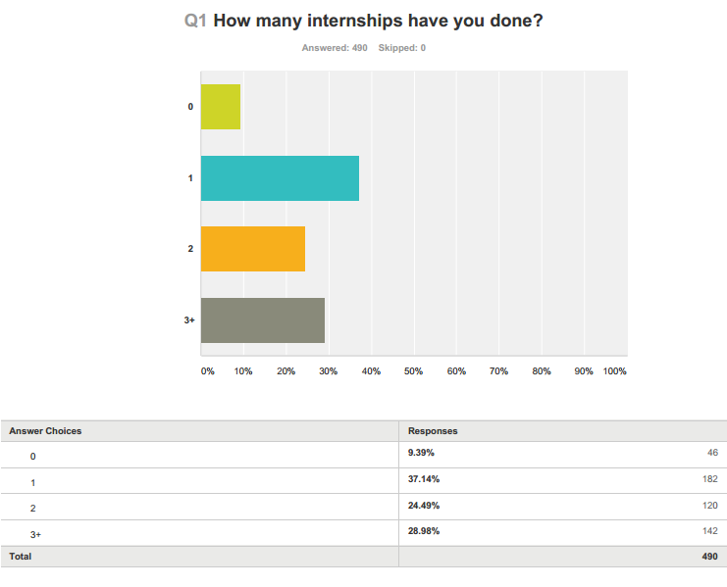
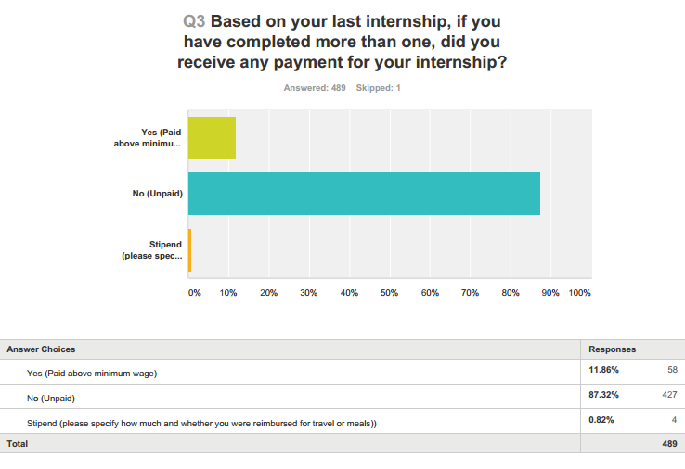

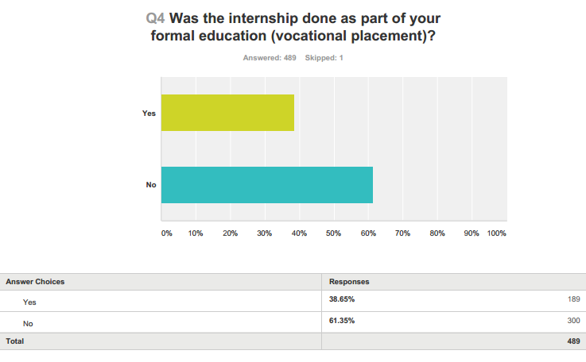

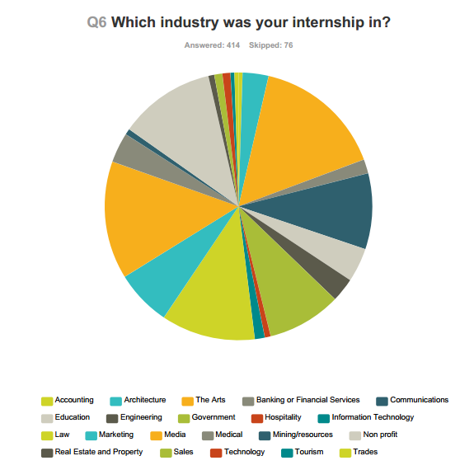

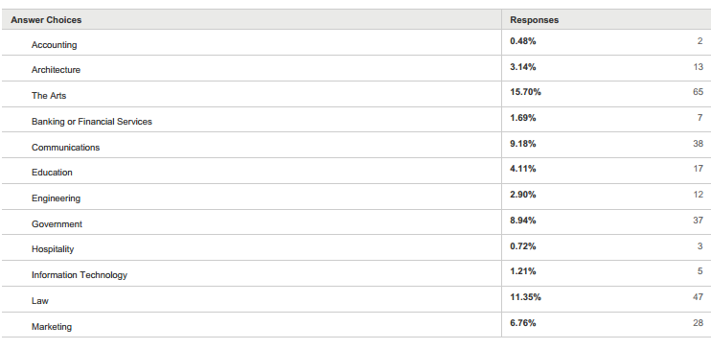
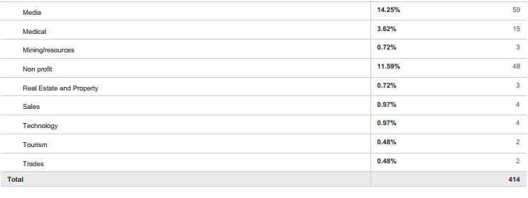

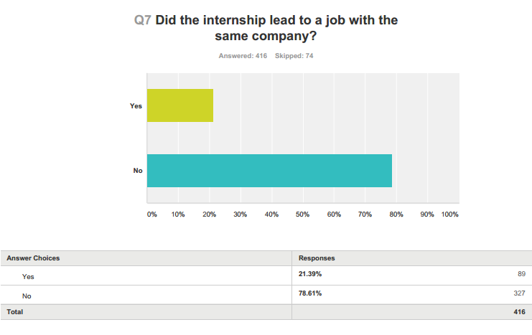

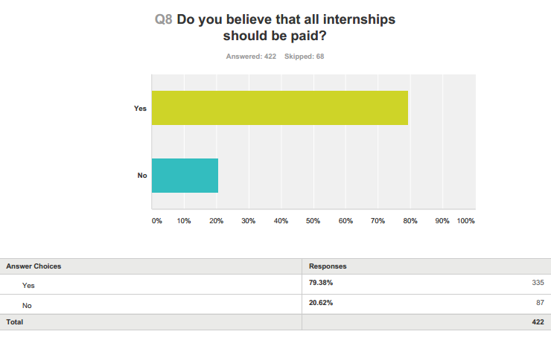
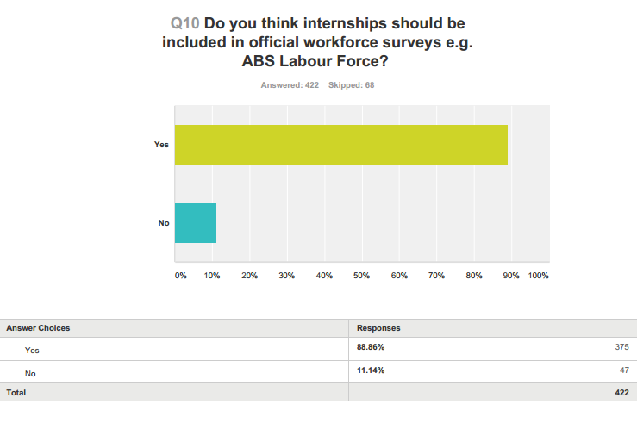

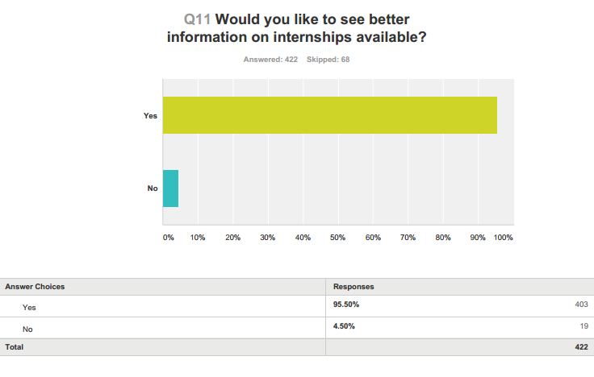

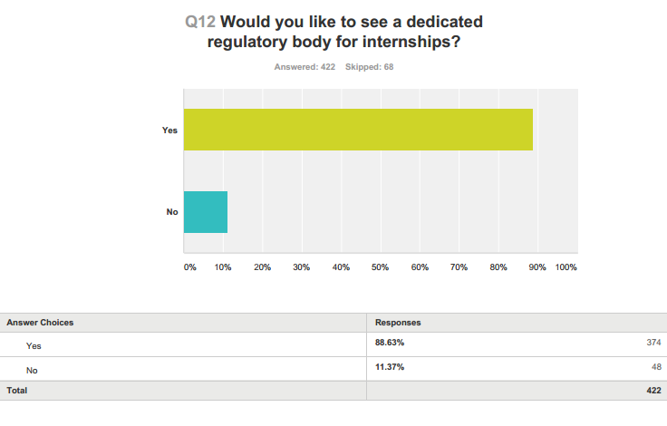

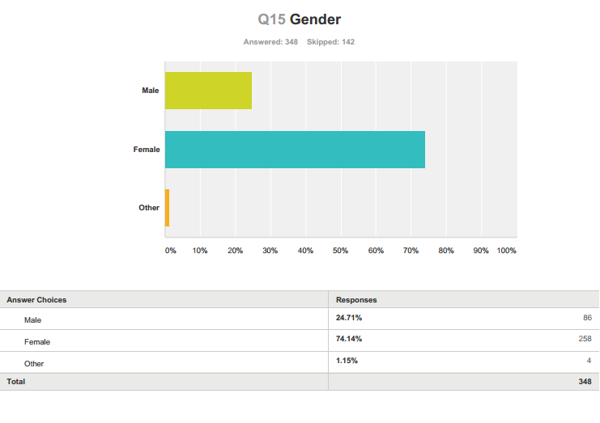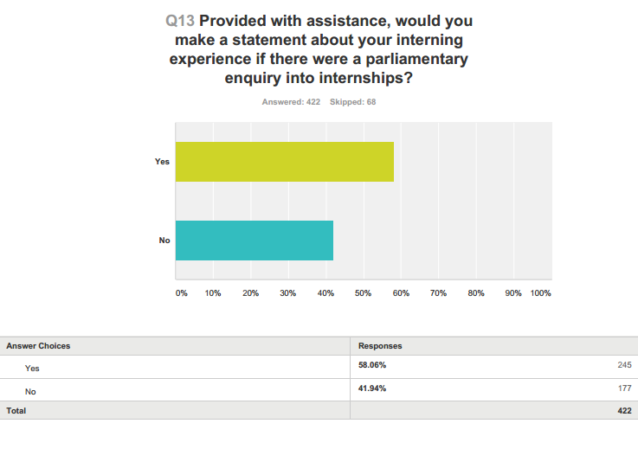

Appendix 2

Australian Institute of Architects 2015 Survey

Misa Han, “Productivity Commission warns companies over using unpaid interns instead of paid employees” Australian Financial Review 6 August 2015 http://www.afr.com/news/economy/employment/productivity-commission-warns-companies-over-using-unpaid-interns-instead-of-paid-employees-20150804-girqy8#ixzz3i5fXkdfl; Clay Lucas, “Companies freeloading on unprotected interns,” The Age (20 April 2014) http://www.theage.com.au/victoria/companies-freeloading-on-unprotected-interns-20140420-36yxm.html.
Inquiry into the Workplace Relations Framework Draft Report (4 August 2015) available online http://www.pc.gov.au/inquiries/current/workplace-relations/draft/workplace-relations-draft.pdf , 60.
Ibid.
Interns Australia Annual Survey 2015 (see appendix).
Ibid.
Andrew Stewart and Rosemary Owens, 2013, Experience or Exploitation? The Nature, Prevalence and Regulation of Unpaid Work Experience, Internships and Trial Periods in Australia, Fair Work Ombudsman, available online: http://www.fairwork.gov.au/Publications/Research/UW-complete-report.pdf
Ross Perlin, Intern Nation, Verso, London (2011).
Laurence Geffen, ‘A brief history of medical education and training in Australia’, The Medical Journal of Australia, 2014; 201, https://www.mja.com.au/journal/2014/201/1/brief-history-medical-education-and-training-australia.
David Yamada, ‘The Employment Rights of Student Interns’, 35 Connecticut Law Review, 215.
Clara Jordan-Baird, ‘Experience Essential, Remuneration: None,’, Centre for Employment and Labour Relations Law, The University of Melbourne, June 2013, 1 Caroline Milburn “Desperately seeking new skills” The Age, 23 April 2010 http://www.theage.com.au/national/education/desperately-seeking--new-set-of-skills-20100423-ti12.html
Clara Jordan-Baird, ‘Experience Essential, Remuneration: None,’, Centre for Employment and Labour Relations Law, The University of Melbourne, June 2013.
Ibid, xi.
Fair Work Act 2009 (Cth) s.13,
Ibid.
Fair Work Ombudsman v Crocmedia Pty Ltd [2015] FCCA 140.
Andrew Stewart and Rosemary Owens, 2013, Experience or Exploitation? The Nature, Prevalence and Regulation of Unpaid Work Experience, Internships and Trial Periods in Australia, Fair Work Ombudsman, available online: http://www.fairwork.gov.au/Publications/Research/UW-complete-report.pdf.
Interns Australia Annual Survey 2014, available online: http://www.internsaustralia.org.
Ibid.
Interns Australia Annual Survey 2015 (See appendix)
Ibid.
Ibid.
Clara Jordan-Baird, ‘Experience Essential, Remuneration: None,’, Centre for Employment and Labour Relations Law, The University of Melbourne, June 2013.
Australian Law Student's Association, Submission to the Productivity Commission Workplace Relations Framework, 2015.
Ibid.
Ibid.
Ibid.
Australian Institute of Architecture student survey 2015.
Australian Institute of Architecture student survey 2015.
Ibid.
Ibid.
Ibid.
Australian Bureau of Statistics August 2015, available at Trading Economics http://www.tradingeconomics.com/australia/youth-unemployment-rate, accessed on 17 September 2015.
Interns Australia Annual Survey 2015 (see appendix).
Interns Australia Annual Survey 2014, available online: http://www.internsaustralia.org.
Seek advertisement, 4 September 2015, http://www.seek.com.au/job/29220869?pos=9&type=standard&engineConfig=control&tier=no_tier&whereid= accessed on 10 September 2015.
Seek advertisement 20 August 2015 http://www.seek.com.au/job/29317629?pos=19&type=standard&engineConfig=control&tier=no_tier&whereid= accessed on 10 September 2015.
Ibid.
Ross Perlin, Intern Nation, Verso, London (2011).
Ibid.
Andrew Stewart and Rosemary Owens, 2013, Experience or Exploitation? The Nature, Prevalence and Regulation of Unpaid Work Experience, Internships and Trial Periods in Australia, Fair Work Ombudsman, available online: http://www.fairwork.gov.au/Publications/Research/UW-complete-report.pdf, xi.
Interns Australia Annual Survey 2015 (see appendix).
McKinsey & Company, “Why Diversity Matters” (2015) available at: http://www.mckinsey.com/insights/organization/why_diversity_matters, accessed on 10 September 2015.
Intern Bridge, ‘The Debate over unpaid college internships’ http://www.ceri.msu.edu/wp-content/uploads/2010/01/Intern-Bridge-Unpaid-College-Internship-Report-FINAL.pdf.
Interns Australia Annual Survey 2015 (see appendix).
Ibid.
National Association of Colleges and Employers, as quoted in CCH International, Australian Managing Training and Development, vol 1 (at 08-02-12) ¶86-500.
Interns Australia Annual Survey 2015 (see appendix).
Ibid.

