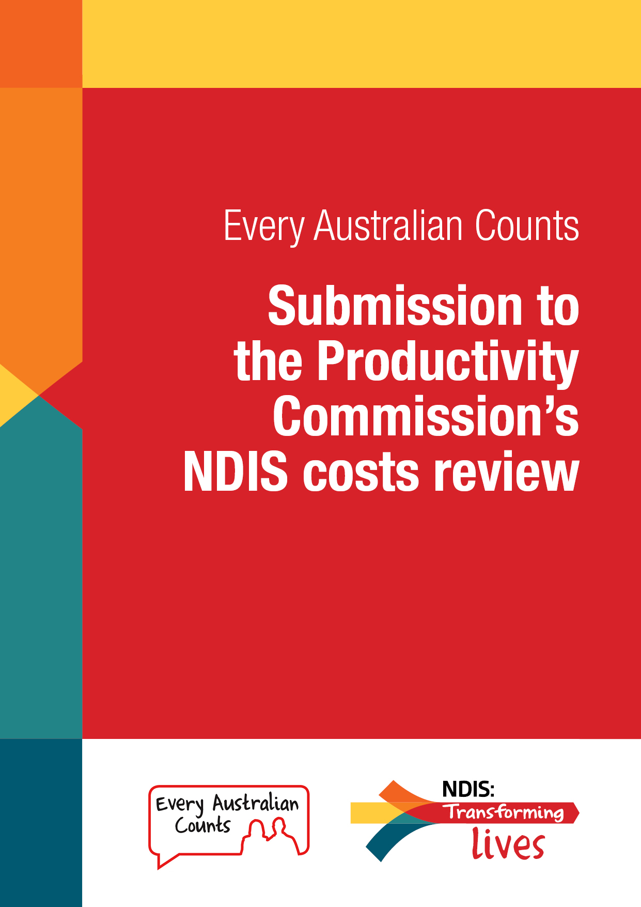

Every Australian Counts

Submission to the Productivity Commission’s NDIS costs review

Summary

At its heart, the NDIS is about people.
The Scheme is a once-in-a-lifetime change to the way disability support is delivered in Australia.
It is going to affect millions of Australians.
Because of the relative unfamiliarity of this model, there are issues that need ironing out. A reform of this size will take time to get right.
Long-term, the NDIS will give back to the economy. Indeed, it would cost far more not to implement it.
The NDIS will create jobs in the sector; improve long-term outcomes for people with disability, families and carers; and decrease reliance on health care and welfare.
Every Australian Counts (EAC) has over 164,000 supporters across Australia. Many of them have shared their stories for this submission about how the NDIS is transforming their lives, and why the Scheme is so important to people with disability, their families and carers.
These stories include real life examples of increasing choice and control for people with disability, and opportunities to give back to the economy through employment and growth.
Along with input from a survey of over 2000 EAC supporters, this submission offers a snapshot of the importance and the potential of the NDIS, how it is already changing peoples’ lives, and how it can be maximised.

Content
From November 2016 to January 2017, over 2000 Every Australian Counts supporters completed an online survey about the NDIS.
EAC also requested and received many stories around personal experiences of the NDIS in response to our call for submissions on the Productivity Commission’s NDIS costs review.
Find a selection of statistics from the survey and stories we have collected from EAC supporters below.

EAC survey recommendations
(See full report at Appendix A)
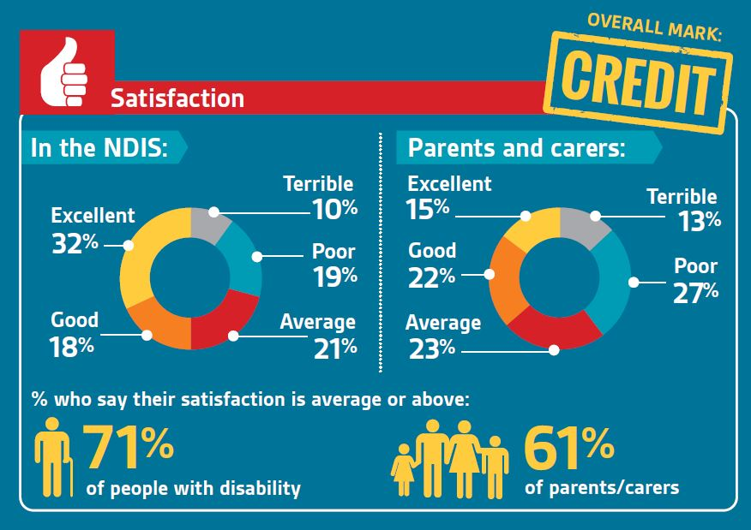
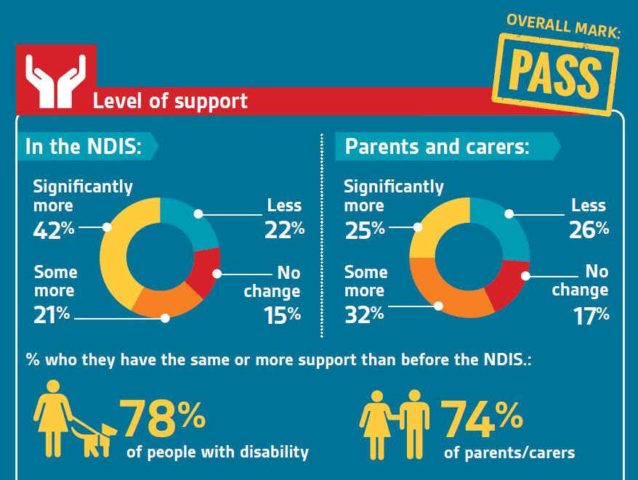

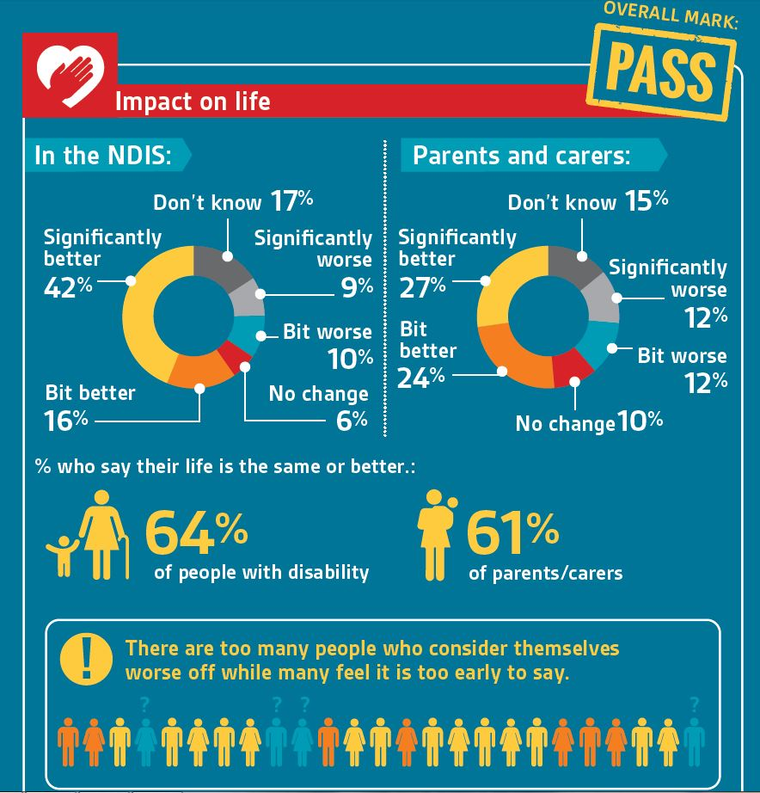

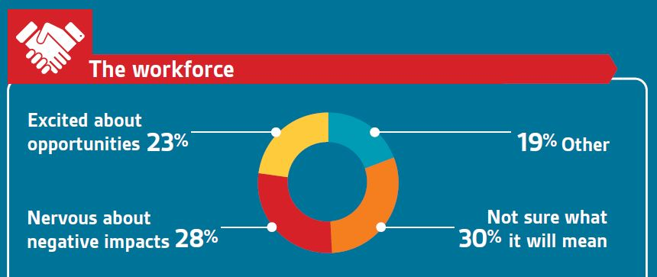

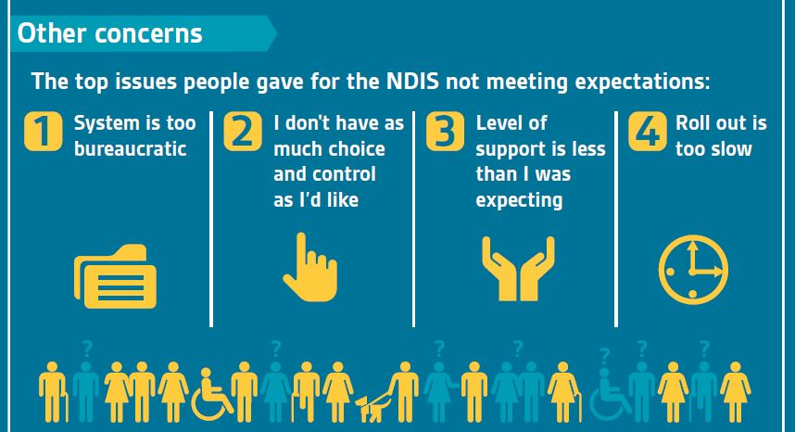

Submissions

EAC asked our supporters for their submissions outlining what the NDIS means to them, how the NDIS has improved their lives (and services, in the case of organisations), how choice and control have increased, the Scheme’s effects on economic participation, and crucial areas for improvement so that the NDIS is the best it can be.
Below is a selection from those submissions, highlighting the importance and impact of the NDIS.

The necessity of NDIS support

Karene Gravener -
“The NDIS has changed my life. If this stopped, it would devastate me and my family. I have improved physically, emotionally and mentally because of the support of the NDIS. We, as a family, have been able to live life, and pursue our dreams. My husband has been able to be in full-time employment without the stress of being a carer, and we are building our own home.
If my level of support was to change, or if any of the assistance through the NDIS was to be stopped, I would suffer in so many ways. I am improving dramatically with support in personal care, physiotherapy and occupational therapy.
Before the NDIS, I was a different person; life was always stressful and I was always wondering where the next amount of funding was going to come from. I was on edge; upset because I could only ever have my very basic level of care needs met, so I didn't go outside of my funding allowance. I could never plan ahead in the hope of being more independent and being a part of my community.
Now, I've been able to dream and set goals; some of which have already been achieved, and some are well on their way. I have been able to be the mother that I want to be and live my life. Everyone deserves that. The NDIS is in its beginning stages, and I appreciate that some mistakes have been made, and people have not got the plans that they wanted, but I believe that through a thorough review process, and clear communication with families and individuals, we can only get better from here. We need more professionals supporting families and individuals to piece together appropriate and strong evidence based plans.
This CAN be done!
The NDIS needs to stay. Lives will potentially be shattered if it doesn't. Furthermore, if it's financial scope is altered; lives will be limited, and we will be back to a ‘deserving vs undeserving’ model of service, as opposed to the power of choice and control that we have now. PLEASE don't take our human right of choice away!”

Karen Wakely –
“We began implementing our plan in Jan 2016. In a little over 12 months, the change it has facilitated has been extraordinary.
For the first time, we have been able to access meaningful therapeutic supports. Previously, therapy was only once a month, and was inadequate for gaining any momentum. Now we access either psych or occ therapy every week, and it has been far more effective in developing the social and practical skills needed for independent living. For the first time, my child is beginning to successfully participate in mainstream community activities.
Watching the way in which the psych works with and responds to my child has been of immense value to me as a parent. He has modelled strategies that have helped me to adopt more effective responses to difficult situations.
We have been somewhat isolated as a family, with all other family living overseas or interstate. Outside of school, there were few other adults in my child's life, but I can now hold over difficult issues to discuss with my child at therapy in a supported environment, and we are actually making headway on issues that we have been struggling with for years. Therapists help me to reinforce expectations of respectful behaviour, and this provides support to me as a mother that I have not had before.
There is room for improvement in the way plans are structured. We have three goals, which tend to duplicate each other. Only two of them identify strategies to achieve them, and there are no KPIs. We have had our difficulties with the planning process, and it is still not all that clear to me what the objectives of the NDIS are, and what it will/won't fund, but overall, our experience has been very positive.
I am beginning to see a more positive future that includes a greater prospect for independent living, and may also include employment.”

Heather Batt –
“NDIS means freedom from the powers of money-driven organisations who do not respect the personal needs of PWD nor the natural authority of the family.
NDIS means the opportunity to have a good, ordinary life engaging in everyday activities like exercise, visiting family, enjoying things PWD specifically like and engaging in income-producing activities the PWD find fulfilling and capable of doing.
NDIS means family can be the most influential people in PWD lives again, encouraging and supporting PWD to embrace as full and rich a life as anyone in the community with support. NDIS means seeing the smiles on PWD faces again.”

Jane Bringolf –
“As a campaigner for universal design across all design disciplines so that everyone can be included in the designs of our world, I find the talk only of costs of the NDIS very discourteous. You are saying that some people cost too much; that some people are not "worth" as much as others.
And then you forget the other side of the ledger - the benefits, both social and economic. It has started a wave of new jobs and employment for carers and supporters who will pay tax. And it opens doors for people to work now where they couldn't before.
It has also released family carers from 24/7 care so that they can now get jobs, pay tax and get superannuation benefits. If our policies as well as environments and products were designed more universally, we wouldn't even be talking about people with disability (and older people) as a separate group needing separate treatment. We would be an inclusive society. We would be enacting fully the National Disability Strategy and complying with our obligations under the UN Convention.”

Estelle Shields –
“Our son was born with a severe intellectual disability forty years ago. We felt driven to give him every intervention possible and for his first two decades, it was our privilege to do this for him. For the next two decades, as we cared for him, we felt exploited and abandoned by our country.
Our son needed to gain his independence and to move out of home and I needed to return to work. This was out of the question because there was no way for us to achieve this. I had returned to university and gained a Master’s degree so I could be more employable but the state disability agency had no funding for non-urgent cases like ours. The years went by and we all lobbied, held meetings, wrote submissions and letters and then finally - there was the NDIS.
It has had a difficult birth but it is up and kicking. Our son's funding has enabled him to move out of home and he is so happy in his new setting. He has committed carers and a better quality of life than we could give him, because it is not cool to hang out with one's ageing parents. He has a new lease on life and has taken on new roles.
These days, we sleep in and have weekends away and do things spontaneously - without applying five months in advance for respite. For me, the NDIS came too late to go back to work but there is comfort in knowing this will not be the case for future carers. For all our family, there is the most profound relief in knowing that our son and brother is settled and content and that there will not be trauma and upheaval when we depart this world.
I cannot express adequately the transformation that the NDIS has made for me. I was ashamed to be an Australian. I felt that disability comes randomly and that those who it visits are left to cope unsupported and alone. Now I feel that my country has taken responsibility for its disabled citizens and that we as a nation are sharing the caring, looking after each other and acting as a civil and humane society should. Advance Australia Fair!”

Joyce Schroeter -
“I would like to inform the Commission on how important the NDIS has been to me.
I also wish to advise I see what a significant change [the NDIS] is giving people with a disability. They are being given more opportunities than ever before to reach their potential. This has not been obtainable prior to the NDIS.
I am an ageing parent with health issue and advocate for my 44-year-old daughter and her 20-year-old son. Both were born with acrodysostosis and intellectual disabilities. Prior to the NDIS, they were on waiting lists for supports and it was becoming more stressful for me every day wondering how they would ever manage.
They both now have NDIS Plans with goals and aspirations. This is giving them the best opportunity to help with capacity building, build independence and have support to access the community and respite.
The support from the NDIS is vital to our family, without this help we would not be able to manage.”

Florence Davidson, The Christie Centre Inc –
“The Christie Centre Inc - founded over 60 years ago by parents in the rural region of Mildura - established a solution-focussed, place-based service to meet the needs of their community.
Christie Centre Inc continues to do this offering and providing person-directed opportunities to meet the individual needs of people living with disability.
Our experience and evidence show that when people exercise choice and control over their lives, the need to utilise tertiary service is reduced. Our decision-making is informed by the feedback of people, their families, the community and other stakeholders, [which tells us] that when people are encouraged to live their lives as social, economic and participating citizens, the whole community benefits.
The NDIS is a vital and long awaited shift removing the inequity of rationed funding and ensuring that all eligible people are provided with the range of supports to live a good life, a productive life and one that is on par with the rest of Australian society. We ask for no more and no less than what is equitable and fair.
The challenges with the roll out and the uncertainty the political environment have been distracting us from embracing the most fundamental shift in societal thinking about capability and citizenship. This has the potential to derail the benefits for so many.
People with a disability are not burdens on the tax payer; they are citizens, and with support to meet their needs, they contribute broadly to the fabric of Australian society.”

Lisa Jackson –
“I am 53 years old. In 2011, I became physically disabled after severe Miller Fisher Variant Guillain Barre syndrome.
I spent two years in hospital at Robina Queensland before having no option other than to discharge to a nursing home, where I still reside today.
Life goes on. I have made great strides in my everyday independence. Living in a nursing home surrounded by elderly people with dementia, and watching people slowly deteriorate and die around me is a mentally cruel way to live.
Last August, after three operations… I finally got rid of my tracheostomy - I am ready to move forward now to doing some hydrotherapy. I am using the last of my Superannuation to fund this.
As both myself and the physiotherapist believe, after four years with no rehab, I can still regain my strength to stand up and eventually walk. I am currently using an electric wheelchair. My fingers are clawed due to nerve damage. Despite this I have found aids and devised ways to write legibly, independently feed myself, prepare sandwiches, open and heat microwave meals, clean my teeth, operate my computer and mobile phone and travel independently using wheelchair taxis, the train, and the g link tram.
I aspire to making my present dreams a reality. I want to cook my own meals, do my own washing, live my own life, as independently as possible. My other goal this year is to work part time again using a computer. I am a people-orientated person who enjoys helping others.
I have done everything within my power to move forward, onwards and upwards in my life. A nursing home setting has restricted my ability to move forward greatly. I ring disability services every six months but I remain waiting. I need a helping hand up to rejoin, contribute to, and become a valuable member of my community again. This is what the NDIS can do for me personally and thousands of other deserving Australians.”

Quality of life

Richelle Carta -
“I am a woman with quadriplegia - spinal cord injury - since I was 13 years old. I am now 40. I am married and a mother of two daughters. I work full time. I require personal care support every day to help me maintain my busy lifestyle.
I was struggling to sustain my lifestyle with very minimal funding but due to the NDIS I can continue to be a wife, mum, work full time and have a life with my family by having ongoing funding to provide me with morning and night personal care support seven days a week.”

Robert Altamore -
“The NDIS has changed my life because it has given me the ability to set my own goals, exercise my choices and given me control of my money to spend on the adaptive technology and the training I need to change my life and participate in the general community.
I can now get my adaptive equipment repaired and maintained, access braille with my own braille embosser and access digital information because I am being trained to use a mobile phone. This makes me independent and able to access information which sighted people access and has enhanced my life.”

Lauren McGowan –
“My experience of the NDIS hasn't all been smooth sailing. There have been problems with plans and providers that are part of the teething problems, but it has still been worth it.
My condition got worse about seven years ago, and at my worst, I couldn't get out of the house and sometimes even bed. Last week I started full time work, a feat that was once seen as impossible. It's not easy. I get fatigued and crash out most evenings and end up in bed quite early, but I don't mind because I am living a meaningful life!
Because of the NDIS, I have supports that mean I can do a job that works with my disability and have the physical home tasks I can't do taken care of. I can sit and use my brain with no worries, so that is what I do for work, but I struggle to do physical tasks so I get help for that.
I am excited to be a taxpayer again; it fills me with so much pride to be giving back again. With the NDIS I can afford to get to work: The transport contributions mean I don't have to reduce my work days to afford taxis. I have adaptive technology which means I can do things by myself and be safe.
I am also blind and I can finally read again and I used funding to get me to a functional level so I could work. I can go places I have never been able to go, finally I am not only alive, I am living. I am paying taxes, I am giving people work when I purchase supports, I am happier and healthier. I can afford to buy healthier food and get help preparing it instead of having to buy pre-prepared meals, so I have had less digestive problems, and I don't see the doctor as often. I have a person who can be with me when I do exercise so I can exercise effectively without being afraid of falling over or getting injured when I lose muscle control.
The NDIS for me makes sense. I have supports that contribute to the economy, so I can contribute to the economy.”

Susanna Goodrich –
“My son Toby is 16. He has Down Syndrome. He's had a rough few years with an autoimmune condition.
Until the NDIS funding, Toby was isolated, withdrawn and I wondered if he was depressed. He was a young man needing lots of contact with his peers and the wider world, yet he was confined to activities and socialising that his mum and dad could fit into their busy lives of full-time work and caring for four children.
Toby’s social behaviours were becoming more unpredictable and his self-esteem and mood seemed to be plummeting. He had few experiences of his independence as a 16-year-old young man and he was not learning essential living skills like travel on public transport, how to socialise with peers with and without intellectual disabilities and how to be an employee like many of his peers.
The NDIS has provided funding that has changed Toby’s life. His week has opened up from a routine of school, family life and the occasional social event, to a week that looks much like his other teenage brothers: he plays sport, goes out with peers, works in a part time job and will soon be learning how to catch the bus to the local shopping and entertainment hub.
He walks taller, smiles more and behaves more like a young man ought to behave. He just needed the opportunities and support that the NDIS has provided him with. His life has become more healthy, independent, and enriched. It reflects back the amazing success and productivity of this ground-breaking social policy. Thank you so much.”

Lynne Foreman –
“What the NDIS means to me: I can now choose who cares for me, as I now have a choice.
I have the hours I need to live my life and also - because of flexibility in my plan - I am now an employee, so in a way the funding I have left over because of my life now will go back into the Scheme to help others.
These days, we are saving on the funding as most can get out and enjoy life to the full - yes, some with support. But I know if something happens - say I fall out of my wheelchair and break something - the NDIS would put more hours in until I was back on track. So it’s also there as a lifeline if you need it.
Most of us now feel we can take part in the community, and I know some because of the NDIS have part-time jobs. We are healthy in our minds and that's a good thing in itself.”

Helen Harrop –
“My son has been a NDIS participant since August 2016.
He is 26 years old, and while it should be acknowledged that while the NDIS is not without its problems, the benefits to my son within this short time span have been terrific.
For the first time in his life he has control. Within his plan he has more opportunity to get out and experience many different options so he can enjoy life.
He is receiving increased assistance to develop the skills to be able to not only to look after himself by learning to cook, clean and shower himself but to participate in society which is the right of every individual.
As a parent, the NDIS gives me certainly in the knowledge that once I am no longer around, there will be a variety of options for my son so he will be supported to have a greater quality of life.”

Andrew Brak –
“Our son had his NDIS plan approved at the end of September 2016.
Since then, the activities he's doing and ongoing support have been fundamental in developing a better future for him.
Without the NDIS, his possibilities in developing a better life would have been very limited.
It's extremely important for the NDIS to continue for many years to come helping people with disabilities with their already challenging and difficult lives.”

Dale Kennedy –
“My son Nicholas is 32, profoundly physically disabled, but high-functioning intellectually. He is treated like a child in that day program hours are school hours and his group home don't have the funds or the motivation to do anything with him other than take him out once a month for a one-on-one. He constantly watches DVDs and listens to music when all he desperately wants to do is go out into the community.
NDIS has changed his life this year. We have been able to negotiate his costs with his day program provider and have been able to spend the residual funding on community access outside of day program school hours. He has been to two discos on a Friday night and is planning to go to every disco every month between now and Christmas. He is going out for a few hours every Saturday, with carers he has chosen, to destinations he has chosen.
While this is still not enough for a young man of 32, it is way better than the 'ground hog' existence he had up until receiving his NDIS package. It has not been an easy journey learning about NDIS and what we can and can't do, but just to see the smile on my son's face - while out with one of his carers, that he has chosen, at a time that is not dictated to him, and a venue that he has had input into - makes everything we do on behalf of him so worthwhile.”

Complex needs

Jackie Noyes –
“My middle-aged son requires direct support all day and night and has behaviours of concern. Even though ISP funding has helped him to live in his own home, he has still required an average of 60 hours a week support from both of his parents working with support workers, managing supports and filling in gaps in the roster.
The NDIS means he can look forward true independence and family members can look forward to a normal life too.
It is not just about to dollars spent. It is about the dollars saved when we get it right: fewer visits to the hospital; no need to call on police assistance; no injured workers.
It is about opportunities to learn and enjoy life. It is about the benefits to those who gain employment, and their families. It is the opportunity to support local businesses by taking part in more programs and attending community events.
The money spent will not just improve one life: the effect will ripple out through the whole community.”

Beryl Power –
My eldest son had severe cognitive disabilities, was non-verbal and profoundly blind. He passed away at age 54, having lived in supported accommodation from age 6 after he was expelled from the Blind Institute School as 'ineducatable', even though he was a day pupil. Nor was there any day support service then for children with intellectual disabilities that had adequate resources for him, simply because he could not independently feed and/or toilet himself. Had such a place been available, it would have been possible for him to remain with his family, as he and his family wanted. My son had two younger brothers, one of whom also had special needs.
Individual day support did not become available to him until he was 40. Up to then, he and others with very high support needs - especially communication deficits - received significantly less developmental support than other individuals. For the next eight years, 18 different 'individual support' workers came and went because they did not know how to help him due to their inadequate training.
When he was 48, my son was finally lucky enough that the right person came along for his individual support, formed a relationship with him, and transformed his life for the next six years, during which he was the most contented he had ever been.
For 42 of his 54 years, he was frustrated by being unable to communicate, due to both inappropriate and inadequate levels of developmental activities, resulting in sensory deprivation leading to self-harm.
He shouldn't have had to wait until he was 48 to receive the meaningful support he needed. The NDIS is the most encouraging development I have seen in 50 plus years… I believe it offers the potential for children with multiple and severe disabilities to get appropriate and ongoing developmental support from the earliest age possible.
People like my son have been the hidden consequences of ignorant outmoded beliefs that 'nothing can be done for them' when the reality is the opposite.”

Areas for improvement

Tania Hornberg –
“I have C4-C5 spinal cord injury and use a Powerchair. I require a lot of daily assistance, not just with my personal care needs but with my social life and two jobs (part time Administration Assistant and casual Workshop Presenter). I love my jobs but I need assistance with some tasks. I have a very active social life and need assistance with getting in and out of bed/dressed etc.
My transition to the NDIS has improved my position compared to the state funding. But I am still underfunded and it's extremely important that the NDIS is improved so that people like me don't have to continually worry about not having the funding to employ support workers when you need them.
If you don't have adequate funding then you end up in bad health and cannot work. I want to be able to work for as long as I can. So it's important that the NDIS functions well and is in a position to funding people well and in a flexible timely manner.
The NDIS also needs to allow more flexibility for adults with disabilities to employ their relatives, especially in situations where the relative knows how to provide support better than anyone else and can be utilised as trainers for new support workers who don't have a clue what they are doing.
With spinal cord injury, you need well trained workers and there aren't many available… It's worse in regional areas. The NDIS needs to be kept in good working order, otherwise it has dire consequences for people with disabilities. It's extremely important for people with disabilities to have timely support when it's required, otherwise there are serious health issues that develop. Disability issues don't wait for bureaucracy, so the NDIS needs to be timely and flexible.
The board needs to have people with disabilities for personal insight and input into flexible policies and procedures.
The NDIS needs to gather ongoing feedback from people with disabilities and their families to make improvements and make it the best it can be for everyone.”

Rosie –
“We as a family are struggling to manage giving our son (35 years old) a good life in the community and ensuring he is not in a 'Day Placement' forever!
For us to have organised for him to be living in his 'own place' four nights a week (and wanting it to be seven nights), has been, and still is, a huge effort, but as the support dollars are not here now to do this, it makes it so much more difficult!
We have come this far on our own. Now, we really need the NDIS funds to get our son that bit further into the community; to 'live like others live' and to try to ‘work like others work'.
Please see our plea and how important NDIS funds will be to be able to go the whole way, after all the effort we have already put in to get our son this far!

Evelyn Ware –
“My husband and I are 89 and 82 years old respectively, and have a daughter aged 55 with autism and intellectual disability.
Although living in the community, she requires a considerable amount of support with budgeting, health matters, cooking and general management of her life. She receives minimal assistance at present via her ISP, but once we are unable to provide the assistance we are now providing, she will need to have more support from NDIS, or go into supported accommodation as her disability prevents her from living independently in the community.
Her lifestyle is very good now but we are very concerned for the future.”

Samantha Baker –
“I live in the Northern Territory and still do NOT have access to the NDIS, and I have a severely disabled son! I think the wait on the roll out has taken far too long and it has fallen down in helping those who need it most - with the roll out being done by areas rather than need.
My fear is that by the time we are meant to have it roll out in Darwin, the whole scheme will be bankrupt.”

The NDIS is already transforming the lives of thousands of people, with more transitioning to the scheme every day.
But it must be delivered effectively and sustainably to realise the enormous potential and long-term benefits for every Australian who needs it.
There is still a long road ahead. We need to make sure the NDIS is the best it can be.

John Della Bosca
for the Every Australian Counts team

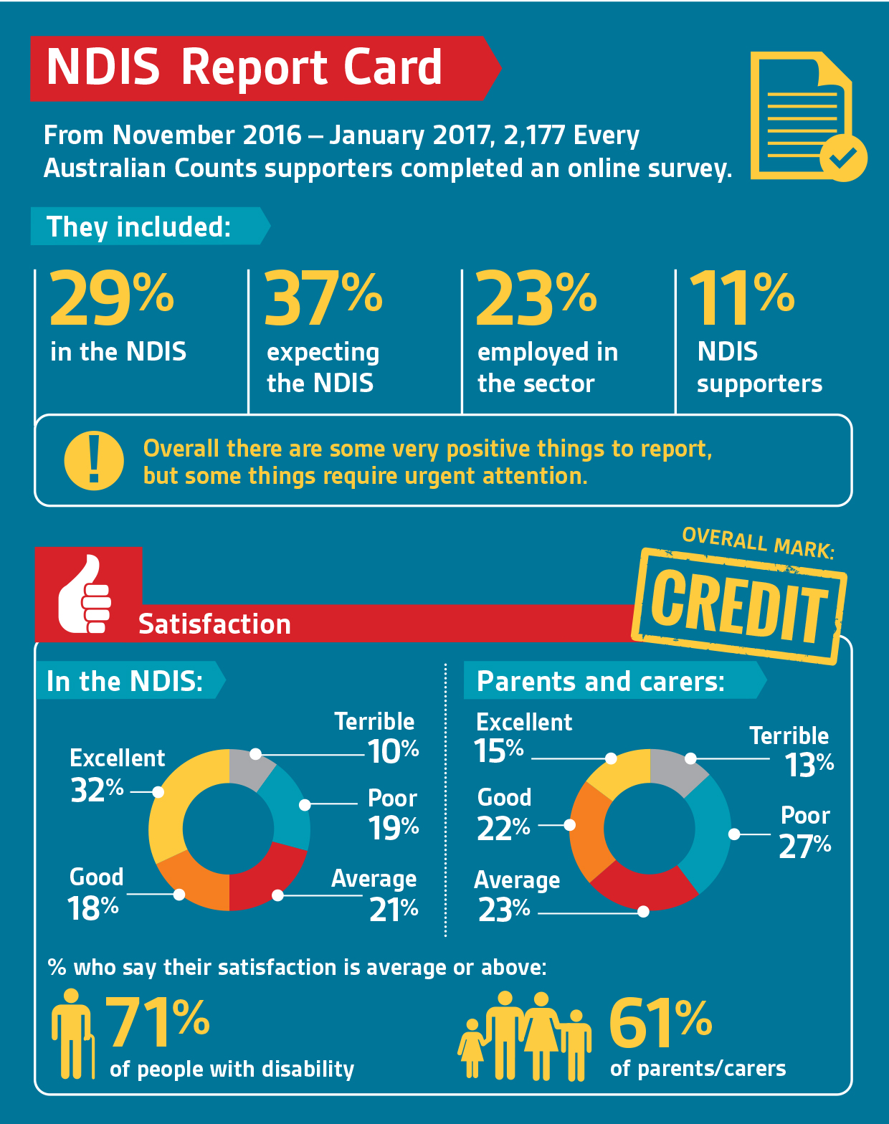
Appendix A
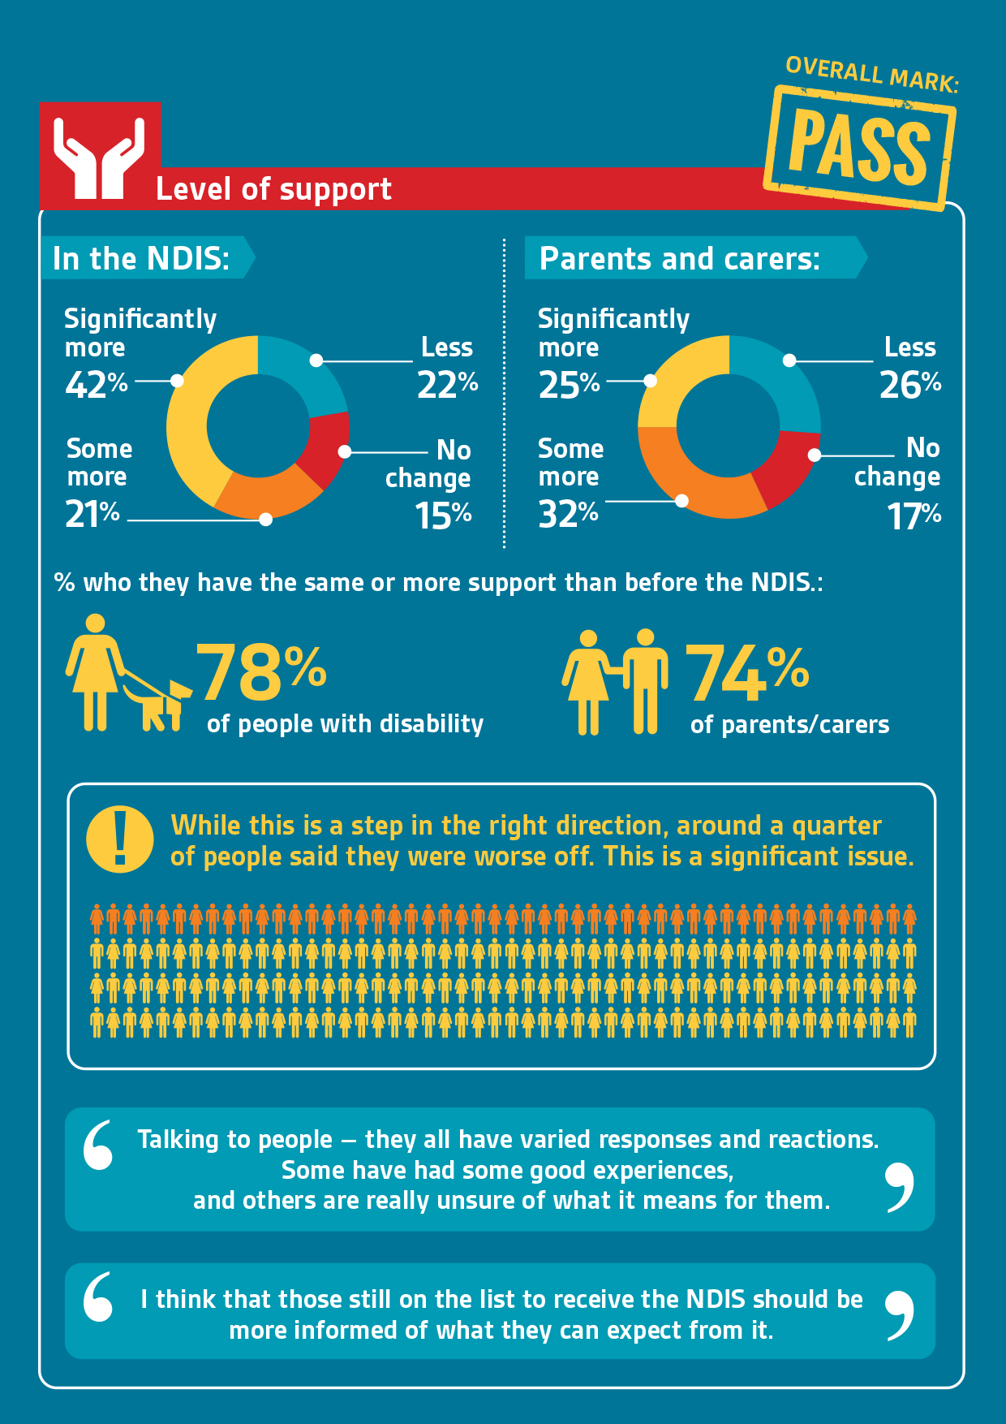
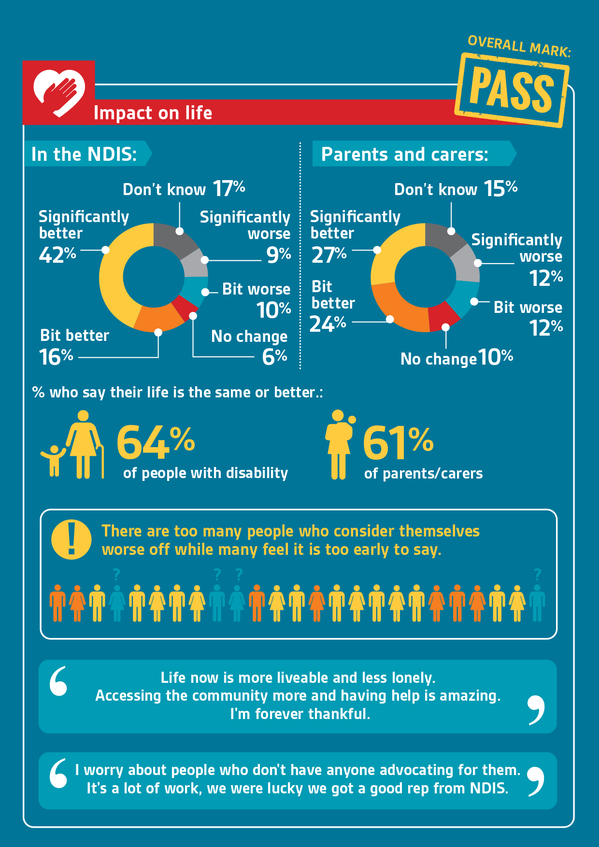
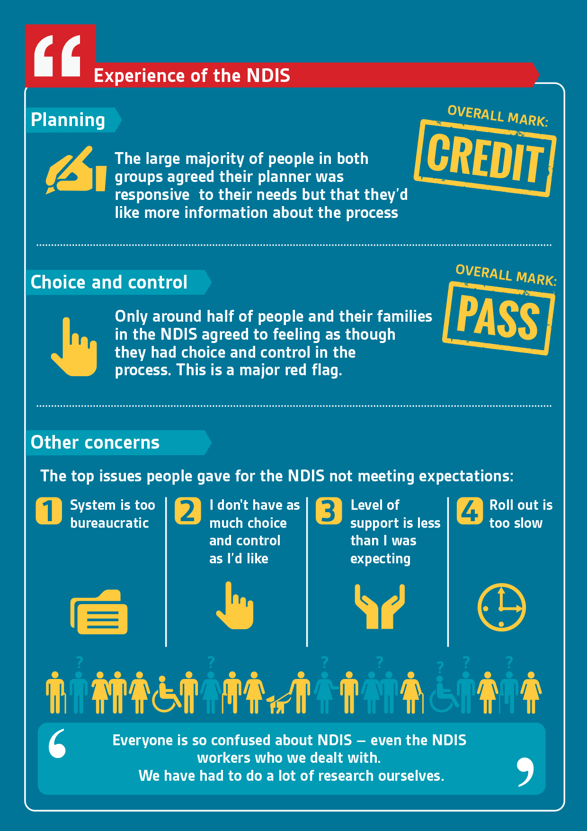
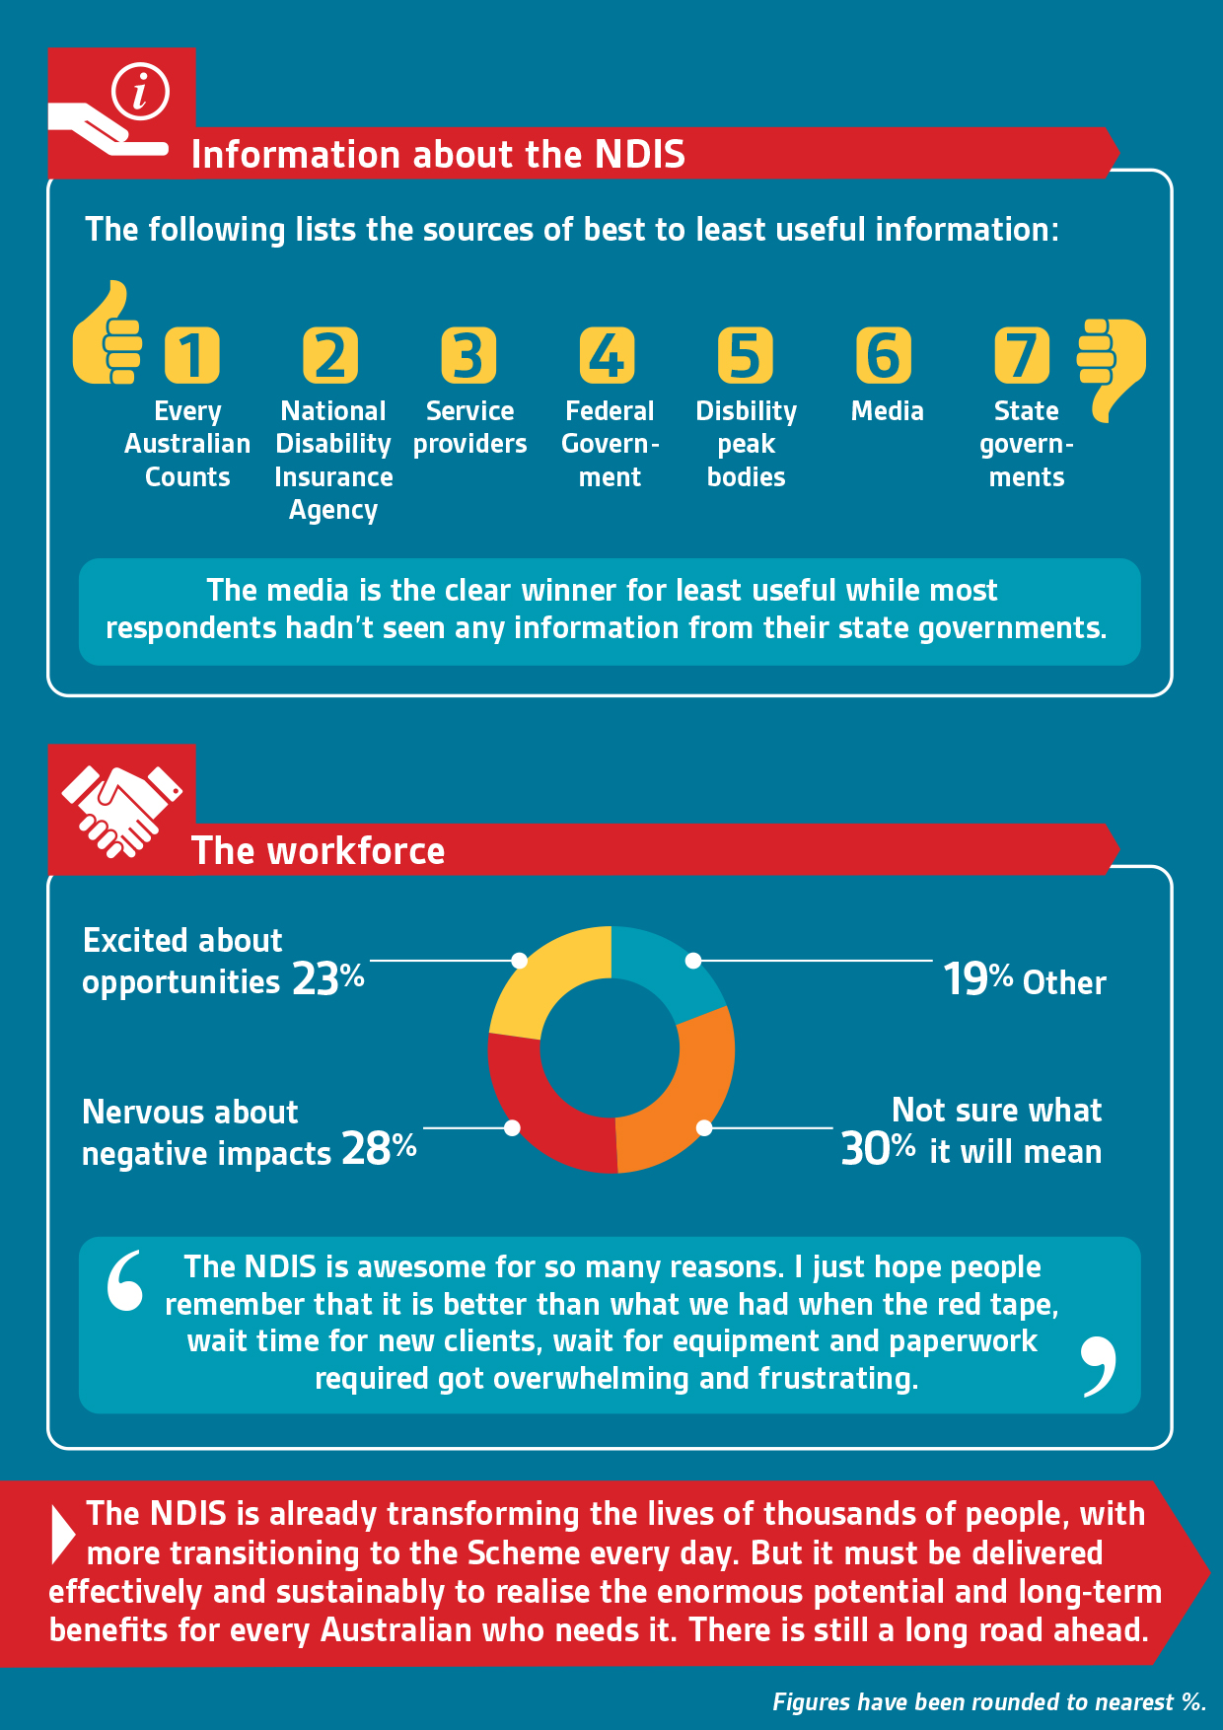

Every Australian Counts
Led by people with disability, Every Australian Counts is an alliance of the disability sector governed by National Disability Services, Carers Australian and the Australian Federation of Disability Organisations.

