Netsweeper Tax Enforcement & Collection
Advancedr Network
& Web Security
August 29, 2017

Follow Up to Initial Submission
Collection Models for GST on Low Value Imported Goods
Productivity Commission

Submissions to the Commissions: “follow up to Productivity Commission”

THE NETSWEEPER PAYMENT STACK ENFORCEMENT and COLLECTION SOLUTION (NPSEC)
“Bringing Tax Remittance Collection and Enforcement back to the Government’s Management and Control.”
Netsweeper is proposing a Goods and Services Tax Model (GST) that not only collects the GST on Low Value Goods, The Netsweeper Payment Collections Stack Enforcement Model also “enforces” compliance and remittance at the lowest total cost. This Netsweeper Payments Collections Stack Enforcement Model utilizes 17 Years of Netsweeper’s Network Software Enforcement Technology and leverages Netsweeper’s Interface Patents and the eCommerce Stack processes. Looking closer, the Netsweeper solution is the tool that merges and augments the current Australian legislation strategy with Australian Post and other transporter data capabilities. Netsweeper has reduced the costs, modernized and ensured the money is in the hands of the Government during the sale, in advance, with transparency, and the process is completely enforced locally/internationally and managed by the Australian Government. Netsweeper can meet the July 2018 implementation timeline.
The interface portion of the Netsweeper Payment Stack Enforcement Solution is standalone, however it is capable of leveraging and/or Integrate/Interface/API into the 2012 Parcel Processing Advanced Technological improvements and data access. The Netsweeper Solution also can interface with time and future planning, into the Customs Data Solution, the Post UPU (and the World’s Post EUP), Data Information Solutions, Agriculture Data Solutions and other data solutions that the Australian Government would like to cross interface with. Netsweeper delivers interoperability data to all.
An important “Part” to recognize is Who will take on “The Burden” of Tax Remittance, Compliance and Enforcement.
Rather than imposing the Burden on vendors or transporters, Netsweeper’s Payment Collections Stack Enforcement Model “Takes On this Burden” of Remittance, Collection and Enforcement while being managed and controlled by the Government. This releases the burden, liability, conflict of interest and truly levels the playing field for not just one stake holder, ALL the Stakeholders and Opposition.
The Netsweeper Payment Stack Enforcement and Collections Solution Ensures the Remittance is in the hands of the Government In Advance. The Transporters, The Vendors, The Marketplaces, Customs, Postal Offices will not be burdened.
Predicted, Total Lowest Cost. The Netsweeper Payment Stack Enforcement and Collections Solution proposes a 100% tax remittance. Netsweeper has recognized the Total Costs of Ownership. The Costs to Deliver this Netsweeper are split. Internal Costs to the Government (Costs of Acquisition) and direct Costs to the Vendors (which ultimately the Vendors costs are passed to the consumer). All solutions must be the lowest total cost of Ownership for both the Government to Operate and Manage and the Consumer in order to keep as much money in the economy of Australia as possible. (Any solutions costs will be ultimately passed to the consumer reducing the economy’s inputs.) It appears other proposed solutions do not have the costs, both consumer and Government nailed down making this decision on how to proceed very difficult. Transparently knowing the Lowest Total Cost of a solution is seen by Netsweeper as a key decision-making input. Costs can duplicate and more as pointed out by the MD of Fedex in the Productivity sessions. The Netsweeper Automated Payment Stack Solution projects a 1.1-1.2% cost to the Purchase to be paid for by the Merchant and a 5% cost of Acquisition to the Government. (Traditional Costs of Country Wide Tax Acquisition are around 2-3%)
There is no need for a minimum value or an Annual Revenue per Merchant increasing the amount of projected Remittance to the ATO. The Automated Netsweeper solution truly levels the Playing field for All Stakeholders, increases the Projected Remittance while taking the Burden away from the Opposition of this Legislation. This can meet the current Time Line schedule of July 2018. The Netsweeper Proposal leverages/Augments All the Efforts and work to date by the Treasury and other Teams by merging with the Netsweeper Solution. The Netsweeper Payment Stack solution preserves the Values and Goals of the current GST Legislation with minimal addendum changes. The Stakeholders are at a level playing field and the Burden concerns of the Opposition are addressed.
The Challenge of the Transporters Model
It has been suggested that Transporters take on the Burden to collect, enforce and remit the Tax Payers/Governments GST Money.
Challenges That Exist:
- Data Capabilities do not seem to Exist in completion at Australia Post, the World and all other Transporters (Netsweeper’s Solution is NOT dependent on the Postal or Transporters Data. In fact, Netsweeper’s Payment Solution is A Source of Data to Feed/Augment other Solutions)
- Not all Transporters have Data Capabilities. This does not follow the Level Playing field and will cause other protests within the Transporter community.
- In the Submission committee in Melbourne one member of the Transporters Group stated the costs would be 3 to 1 meaning 3 times the cost of the tax that is collected.
- Who takes on the Task of Central Single Data Operability? The Netsweeper Solution performs this Data Operability Centrally and owns the task.
- Why Shift the Burden further away from the Government to the Transporters?
- Recently Transporters have taken on the Burden of “National Security of Packages and Possible Terrorism”. It is Netsweeper’s believe and concern that “adding” more burden to Thousands of Transporters will dilute the already Tasking Efforts of National Security and add Risk.
- Having the Tax Payers/Governments Money in the hands of the Transporters Systems will delay remittance, increase risk of remittance, Cause Massive Audit Costs to the Government, and dilute the futureproofing of the WWW issues. This Risk of transferring the Burden and cost to the Thousands of Transporters is unknown and high. When additional requirements occur in the future, you will get more pushback and additional Costs from the Transporters. This is not Future Proofed.
- The Transporters Model will involve Too Many Touch Points. Not all transporters will have technology where Manual processing will be required. This convoluted and Not Known. Thousands of Transporters do not have Equal Capabilities resulting in a diluted playing field, or NOT meeting the goals of a level playing field.
- The Transporter Model still has the Self-Assessment Challenges where the Government will have to Audit Thousands of Transporters to Ensure Compliance and Assessment”
- There are two kinds of Burdens; Collection and Enforcement. The Transporter Enforcement Burden “Trail” is not in the control of the Transporters. This is a Fundamental Flaw. It was outlined that “not all” Money is not collected in advance like Netsweeper in some cases as pointed out by Amazon leaving the Risk and Burden in the Transporters System. When packages are abandoned, the system falls.
- The Transporters solution does not include the process of defining the tax and if it does it is after the payment, rendering dilution. Netsweeper’s Payment Stack Solution includes a process that Electronically Automates the Tax amount to the Merchant as part of the service to the Merchant and Payment System.
- What are the fees to Amazon? This is still not transparent. There is evidence on Amazon’s web site that Amazon has a 2.5% fee for this potential process.
Enforcement
The Netsweeper Payment Stack Enforcement and Collection Solution Included a Unique Proven World Wide Web Law Enforcement Tool from Netsweeper. With Legislation Current, Future Payment stack companies will Interface with Netsweeper. The consequences include the Non-Operations of their Vendors and Payment Gateway Web sites in the country of Australia utilizing Netsweeper’s 17 years of Law Enforcement on the Internet.
Big Interoperable Data
Payment systems and Merchant invoices contain this data source. The Netsweeper solution is Centralized, Secure, Certified to Financial Standards and the Data will be located in in Australia. Netsweeper uses Data Bases that are currently running Major Stock Exchange Transactions around the world. The Burden of operable Data is again taken away from the Vendors and Transporters. Further Expansion of Features and other Departments will not be opposed (unless you put the burden on others) The Netsweeper solution assures Current and Future scalability.
Private Company Concerns
Netsweeper has taken Steps to ensure the Australian Government’s Procurement and Vendor processes are Transparent and Assured. Set up: The Canadian Government has a program www.ccc.ca . The set-up transaction could be an Optional Government to Government transaction with the assurance of the Canadian Government. Operate: Netsweeper Proposes a Private Public Partnership where the controlling ownership is with the Australian Government or ATO. Netsweeper will assign all Patents, Technology to the PPP and support the entire system ensuring Operations with Teams located in Australia run by Australians.
Set up, Time Line, Complimentary to Current Legislation and Transporter solution.
The Netsweeper solution will meet the July 2018 Time Line. The current legislation in place will fit with the Netsweeper solution and take the burden away from the opposition to this legislation. The UPU and other Transporter data sets can interface with Netsweeper at some time however Netsweeper will not be dependent on this UPU data making this a hybrid solution of Netsweeper and Transporter without the costs or burden of the Transporters collecting the tax.

Document Flow
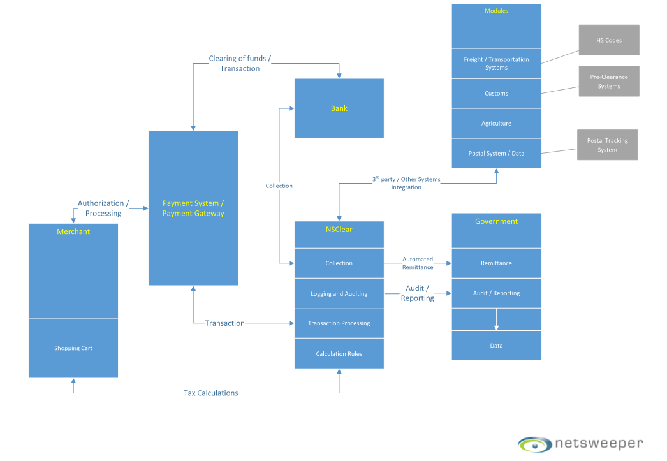

Ransom/Holding of Goods Prior to Release or Non-Claimed
The Netsweeper Payment Stack Collection and Enforcement Solution ensures collections remittance at source. The Government will be remitted solving one of Amazons (And other express delivery companies) Major concerns where the goods will not be held for tax payment purposes. The Process flow will speed up delivery and meet their requirements. With regards to non-claimed goods and the cost of these, again the tax is paid so the Government is compensated. With the Automation of Netsweeper there is Data Set capabilities to “Optionally” allow ideas for countries to insert a “Ransom Cost” Line. (Like a recycling fee for electronics only for the cost of uncollected goods) No other solutions are addressing future issues in the way Netsweeper offers.
Legal Execution and Document Flow
With the Netsweeper Payment Stack Enforcement and Collections Solution, the Legal Document Flow passes the responsibility to the consumer and merchant. One of the requirements will be the Payment System will embed the EULA language (End User License Agreement) (The box that everyone checks when asked during the purchase) so that the Process is included and follows the laws of the Australian Government. This box that is checked when the purchase is made allows the Merchant, Payment Stack, PPP to accumulate Data, enforce the laws, Allow Data transfer, Overcome Privacy, Indemnify All Parties and ensure execution.

Other Issues Raised in Submissions to the Committee
3P Vendors
The Netsweeper Payment Stack Enforcement and Collection Solution will meet the needs of the Marketplace Platforms. Each vendor small or large on the Marketplaces Platforms has a current and future payment system. As new Payment Systems are deployed, Netsweeper will manage this process and keep the burden from the 3P and other Merchant Vendors. If the Marketplace vendors do not comply The Netsweeper Solution will enforce the laws of Australia.
Transporters costs - “3 times the cost of the Tax Collected.”
As mentioned in this response and the Committee submissions, the Transporters Representative Groups estimate three times the tax costs to their industry. Other submissions suggest a cost eventually of $3.00 per package. (Modernized Transporter Model) pending data interoperability. The unknown factors and transparency of thousands of transporters create doubt.

Returns/Refunding the tax portion
Current eCommerce policies around the world often negate returning the tax portion of the purchase. If the Government/PPP decided to change this common policy Netsweeper again will have the data, take the burden away from the other stakeholders and develop a process that could meet the needs of the ATO for this possible Return policy and other future policy changes. One entity to work out the solution.
Interoperability and Data
With the Netsweeper Platform and Tool being managed by the PPP/Government the Data will be Centralized and consolidated. With Netsweeper as the partner, All additional projects, needs and other Interface requirements (for example with UPU, Customs, Agriculture) and more would not be pushed or Burdened out to the stakeholders and the valuable results of the processes are in the management hands of the PPP/Government.
Black Market Goods Department
With the Netsweeper Platform Solution it is important to mention that other departments of the Australian Government “could have” access to information pending the ATO’s permission. This data could be of significant importance to the Security of the Australian Citizens, Counterfeit Operations and possible criminal activity.
Digital
With the recent ATO Netflix Tax, the Netsweeper Platform Solution can be extended to the Digital Download portion of the eCommerce economy which is projected to be an additional 24 Billion annually vastly increasing the effectiveness of the ATO efforts and keeping the Tasks and the Burden away from the Stakeholders while benefiting Customs, Agriculture, Post and Transporters.

Opposition/Stakeholders to the Australian Legislation:
Vendors
The Netsweeper Solution will remove the burden from the Vendors at the total lowest costs to the Merchant, Consumer and Government. Netsweeper will Enforce and collect for All Vendors locally and internationally as well as the marketplaces (3P’s)
Burden
The Common theme to Opposition is the push back of the ATO to other Stakeholders while keeping a Level Playing field. The Netsweeper solution relieves the Opposition. Payment Stack Possessing companies will comply to the laws and be enforced by ATO. Payment Stack processing companies will receive a fee to Interface with Netsweeper’s Technology.
Transporters Post
See Previous outlines. Claim that the costs will be 3 to 1, The post is not ready with technology. This is anything but a Level Playing field.
Australian Retail Association
Want a level playing field and to get this process in place ASAP. Netsweeper will meet the July 2018 time line.
Customs
Netsweeper has included Customs in the equation providing Customs with Web Based Administration to all Data. Suggest Phase 2 where Netsweeper would Interface into the Customs Data Systems. We should never neglect the Customs requirements and needs.
Citizens/ Consumers/Purchasers
With the Netsweeper Payment Stack Enforcement and Collection Solution the Purchasers receive the Lowest costs to collect the GST. This leaves more money in the Australian Economy. With regards to Cost of Acquisition to the Government, the Netsweeper Solution provides transparent and predictable costs and delivers and executes the ATO plan.
Government ATO - Meet exceed goals
The Netsweeper Payment Stack Enforcement and Collections Solution provides the ATO with Management. Transparency and Ownership of the Enforcement and Collection of GST at the lowest cost to the consumer and the Best Acquisition cost to the ATO. The Legislation can be Augmented with the NPSECS and overcome All Objections from the Stakeholders. The NPSECS will meet the July 2018 time line and can expand into other areas increasing the ATO Return on their time and investment.
Projected tax remittance on $4 Billion of eCommerce is $400 Million Annually. If we extend this to digital, reduce the minimums, enforce Customs challenges with Goods value and Counterfeit this could equal one day a $30 Billion eCommerce Opportunity with a $3 Billion Projected Tax remittance to the ATO.
Thank you
Sincerely,
Perry Roach
Chief Executive Officer, Netsweeper
