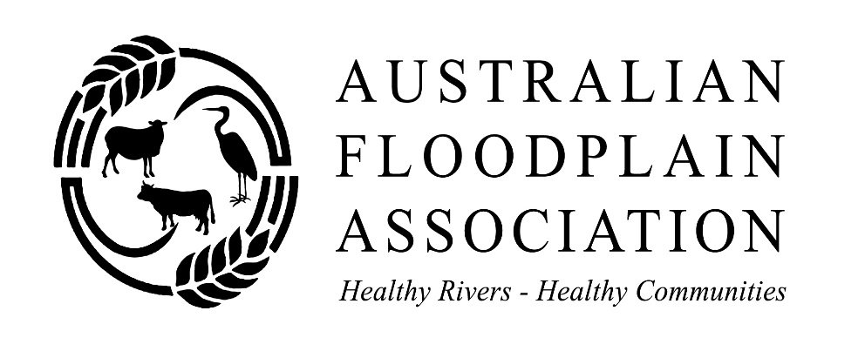
Hard copy correspondence to Julie McClure, Secretary AFA, Kallara Station, Tilpa, NSW 2840.
Email: Terry Korn PSM, President AFA, ausfloodplain@bigpond.com,

Submission by the Australian Floodplain Association – April 2018
Productivity Commission Review of the Murray Darling Basin Plan

The Australian Floodplain Association (AFA) arose from a conference held in Dubbo in 2005 to address the plight of rivers, floodplains, wetlands and communities dependent on those systems in both the Lake Eyre and Murray Darling Basins. It was formally constituted in 2006 with the aim of benefiting communities and land managers whose livelihoods depend on healthy, sustainably managed river systems and associated floodplains.
Its membership consists of floodplain graziers, community groups, shire councils and individuals from both urban and rural areas. All understand that healthy rivers mean healthy communities.
The AFA is pleased that it has the opportunity to contribute to the Productivity Commission Review into the Murray Darling Basin Plan and it looks forward to contributing to the working group you have established for the review.
The AFA has addressed request numbers 2, 3, 4, 5, 7, 8, 10, 11, 12, 13, 14.

Terry Korn PSM
President
Australian Floodplain Association
19 April 2018

Information Request 2 SDL Adjustment Projects
- Most of the SDL projects do not meet the criteria according to a comprehensive report by the Wentworth Group of Concerned Scientists.
- The projects are speculative on their environmental water returns. The question has to be asked “Have any risk analyses been conducted on the likely success or failure of these expensive projects?”
- A neutral or improved socio-economic outcome is sought which is admirable but the inference here is for irrigation communities only rather than for all communities. An improved socio-economic outcome should be sought for the broad basin community and as such any analyses must include the broader community.
- It is proposed that SDL adjustment projects must be implemented by 2024. Projects implemented in 2023 and 2024 will be impossible to evaluate in terms of yield if 2024 is the measurement year.
- The AFA sees no novel approaches which can achieve neutral socioeconomic outcomes. In fact wishing to achieve neutral socio economic outcomes from a $13 billion adjustment program is an unrealistic aspiration. There will always be losers. It can be argued that we seek a “net” neutral socio-economic outcome across the Basin but how do you measure this?
Information Request 3 Achieving SDLs in the Northern Basin
- There is an assumption that the original (390 GL) is incorrect. However, the imprecise modelling and application of questionable assumptions underpinning the recommendation to increase the SDL by 70GL make it a high risk action unworthy of support. It was rightly rejected by parliament.
- The AFA believes the current diversion limit should be retained and that the 390GL dedicated to the community remain.
- The present situation is compounded by the NSW proposal to implement its Floodplain Harvesting Policy and licence diversions which greatly exceed those estimated to exist when the Basin Plan was set. No explanation has been given by either the Commonwealth or NSW as to how these diversion quantities will inform the original SDL figures agreed in the Plan and what adjustments are to be made.
- No Northern Basin SDL adjustment should occur until the NSW Floodplain Harvesting Policy implementation impacts are assessed. This means abandoning the claim that the Gwydir and Macquarie systems have been over-recovered..
Information Request 4 Constraints Management
- The AFA believes that prior to the Four Corners Program NSW demonstrated little enthusiasm to progress the issue of constraints management in NSW.
- There has been a churn of staff at both the Commonwealth and State level in the constraints area leading to lack of continuity and trust.
- The slow progress arising from a series of factors will prevent social, economic, cultural and environmental outcomes from being met.
- Lower volumes of water are now delivered than pre-Plan because of constraints. Pre and post operational figures are :
Murray River downstream of Yarrawonga 30,000ML/day and 15,000ML/day in spring
Murrumbidgee River at Gundagai 30,000ML/day and 20,000ML/day
Goulburn River at McCoy’s Bridge 20,000/day and 15,000ML/day

- Better partnerships between governments will improve the situation as will stable staffing within government.
- All systems have constraints but there may be opportunities to buy more community (environmental) water in systems with the fewest or least limiting constraints.

Information Request 5 Recovery of Water for the Environment
- There is a too heavy reliance on infrastructure projects which are speculative in yield and environmental outcomes. This is a great risk to achieving recovery targets by 1 July 2019.
- It has been demonstrated many times that the recovery of water through infrastructure projects is much more expensive than purchase via the open market.
- The 1500GL limit on buyback should be lifted so that willing sellers can operate in a true open market situation.
Information Request 7 Water Resource Plans
- A big risk to meeting timelines is due to the lack of corporate capacity in NSW
- The MDBA has improved its structure to work with the sates on water resource planning – this is good.
- There needs to be better coordination and liaison intra-state, inter- state and between the commonwealth and the states to ensure seamless connectivity between WRPs. The MDBA has the responsibility to ensure this happens and the newly restructured unit called the Water Resource Plans and Basin Policy section under General Manager Peta Derham is a positive action.
- But the unit has to have resolve and discipline to ensure there is compliance and connectivity between WRPs.
- Modelling inputs should be closely monitored so that Long Term Averages are only used if they are applicable
- Use of long term averages are NOT applicable to modelling in the unregulated sections of the Northern Basin, particularly the Barwon Darling.
- Community (environmental) water requirements should be based on the Long Term Watering Plans rather than solely relying on the current flawed models.
Information Request 8 Coordination of Environmental Water Delivery.
- NSW OEH and the CEWH have a good working relationship with MOUs underpinning arrangements for the management of community (environmental) flows in NSW.
- In the northern Basin a Community Water Advisory Group would be beneficial in managing the delivery of low flows and community (environmental) water.
- Shepherding must be included in WRPs where a stream includes both unregulated and regulated sections.
- The original stream gauges were established for a purpose very different to what they are expected to do today with informing community (environmental) water management.
- Gauge location should be reviewed to ensure that the gauges are positioned to ensure best management of both community (environmental) water delivery as well as irrigation water delivery.

Information Request 10 Water Trading Rules.
- The Basin Plan has not resulted in a noticeably improved access to market information in NSW. The Four Corners program has forced NSW to act by preparing a transparency consultation paper. Hopefully there will be improved access to market information in the future .
- Downstream third party impact of low or no flows is not properly addressed. Focus seems to be on the third party impact of flooding by environmental water rather than impact of having no water or little water of poor quality. This has been a significant factor in the Barwon Darling Water Sharing Plan management zone where trading and water management rules seriously affect downstream users.
Information Request 11 Critical Human Water Needs. .
- The Plan has not addressed the needs of communities along the Darling River. The Water Sharing Plan for the Barwon Darling River severely limits the availability of CHNW below Bourke, a stretch of river about 1500kms long.
- The accredited Water Resource Plan for the Barwon Darling must contain rules which ensure CHWNs for all communities are met.
- The establishment of a Community Water Advisory Group would assist government manage low flows and community (environmental) water flows under extreme conditions.
- A first principle must be applied to all Water Resource Plans in the northern Basin which ensures CHWNs are given a higher priority than irrigation extraction along the complete Darling River. Access by people in Pooncarie to a healthy water supply should be a higher priority than access by irrigators upstream of Bourke.
Information Request 12 Compliance
- River communities have no confidence that the MDBA can or will effectively monitor or enforce compliance based on its performance to date.
- The MDBA has established a new Office of Compliance to address this issue which is a positive.
- But so much social capital has been lost it will be difficult for the MDBA to regain the confidence of the community.
- The newly established Office of Compliance has to act swiftly, decisively and resolutely in the future if it is to stand any chance of winning back community confidence.
- The MDBA must work with Queensland and NSW to ensure the Northern Basin is quickly metered to a suitable standard otherwise compliance will not be possible.

Information Request 13 Monitoring, Evaluation and Reporting
- This area is rarely adequately resourced in almost any program.
- An area that is not effectively monitored, evaluated and reported on is the social, cultural and economic impact of community (environmental) water. Water quality and natural environmental indicators are monitored adequately but not the other three important pillars of the quartet.
- Should monitoring, evaluating and reporting be expanded to cover the quartet (natural environment, social, cultural, economic) across a broader section of the Basin rather than irrigation communities the true impact of the Basin Plan would emerge.
- Reporting should be timely, comprehensive, transparent, frequent, readily understood and easily accessible to communities in the Basin.
- There seems to be inadequate attention being paid to the future impacts of climate change and how this will change the availability of Basin water resources.
Request 14 Basin Institutional and Governance Arrangements
- There is a strong belief in the non-irrigation community of the Basin that the board of the MDBA is skewed to irrigation interests. This perception needs to be corrected by appointing new members who are not irrigation centric or perceived to be irrigation centric. While irrigation is a major contributor to the economy of the Basin it occupies a relatively small area of the Basin. Large numbers of other stakeholders are spread throughout the rest of the Basin, contributing to its economy but they do not have credible representation on the Board of the Murray Darling Basin Authority.
- Had the Four Corners program not exposed water management deficiencies the skew towards irrigator centric membership may have been greater.
- The Basin Community Committee is a useful feedback tool from a governance perspective.

Terry Korn PSM
President
Australian Floodplain Association
19 April 2018

