Supportive Residents and Carers Action Group Inc

SUBMISSION TO THE PRODUCTIVITY COMMISSION INQUIRY INTO
MENTAL HEALTH
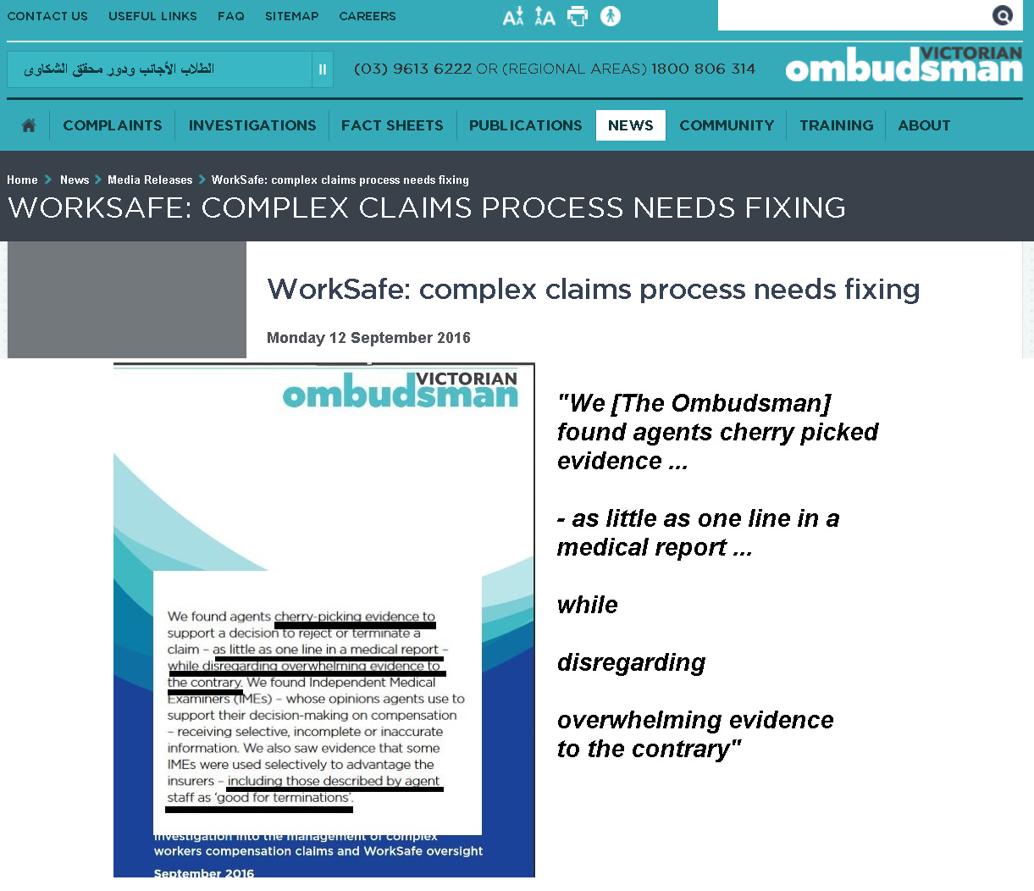

About us:
Our Association is under the patronage of a medical practitioner who was formerly a chair of the Queensland Crime and Corruption Commission’s predecessor.
Our Association registers Whistleblowers with international law enforcement regulators such as the American SEC Office of the Whistleblower Program.
Our colleagues in California and Nevada in Maverick Ministries were published by the US Department of Justice Anti-Trust Division review on international cooperation between international law enforcement agencies in a climate where Whistleblowers tend to be vilified and victimised and discredited including by psychiatrists in Melbourne who ended up being investigated by the Victorian Ombudsman and now by Worksafe’s Independent Medical Examiner Review.
Our spokesman has appeared on ABC TV business programs relating to the Royal Commission into banking and insurance scandals.
Our committee member and others have, alone or with politicians, appeared on television shows such as 60 Minutes’ series on farm suicides/ANZ Landmark where the CEO of the ANZ apologised to the 85 year old farmer three years before the ANZ official was questioned about the scandal at the Royal Commission.
Our Association is one of the submitters that is referred to in footnote 372 of the Judgement of Victorian Supreme Court in “Commonwealth DPP v Brady & Others”, which was the international bribery case which involved officials in the Reserve Bank’s subsidiaries where those submissions properly reflect the same conclusion reached by Her Honour and expressed by US SEC Director of Foreign Corrupt Practices about the unfathomable light-on investigations by Australian law enforcement compared to investigations by international law enforcement agencies.
Our Association lobbied extensively for the Royal Commission into Australian banking in part due to the massive number of suicides by farmers who had lost all hope.
Our Association was published by the FSI Review into Australian banking problems which blossomed into the Royal Commission.
Our members have been published at the Banking Royal Commission, the Whistleblower Inquiry initiated by Independent Senators and many other Inquiries.
Our Association was formed in the late 1990s in response to Victorian State Government passing laws that rendered low care shared accommodation facilities financially unviable to keep intellectually challenged and brain-injured people under a roof with 3 meals and medication and washing dressing showering and bathing under the supervision of retired nurses.

Gas lighting:
Gas Lighters are mentally ill officials often in positions of power who seem to delight in employing a bullying tactic which belittles their victims. In our experience with numerous cases at the Financial Ombudsman Service it took a Royal Commission to uncover that FOS had arbitrarily decided (possibly at the instigation of officials in a bank with support from officials in ASIC) to ignore one of their Terms of Reference which would allow predatory loans to be written off. You are welcome to cross-reference the evidence at the Royal Commission of their lead Ombudsman.
Hapless victims seemed incredibly traumatised when they know that the FOS has the power to return them to the original position they would have been in if they had never stepped into the bank, and the bank Ombudsman service mis-portrayed itself as independent and mis-portrayed itself as an Ombudsman whereas it turns out it is an arbitration scheme controlled by the banks and which arbitrarily decided to stop writing off predatory loans.
There will be many instances like this in many bureaucracies where the so-called helpful staff have hidden agendas.
Many stories abound for example about the Robocop at Centrelink issuing arbitrary and false demands for repayment of fictional debt.
The powerless invariably suffer mental health consequences, and one has to query whether mentally ill senior management come up with these ideas because senior management suffers mental illness themselves.
In the workers compensation field, we would specifically refer your attention to the entire report by the Victorian Ombudsman in September 2016 which reflects the alarming revelations of CBA Whistleblowers which featured on Four Corners regarding the Commonwealth Bank insurance scandal and falsification of medical records. The emails that featured on 4 Corners are appended.
Also appended are extracts from another CBA Whistleblower that appeared in Fairfax Newspapers and the Submission at Parliament where the Whistleblower states that a psychiatrist told him of concerns about being shot. The Submission refers to the stress the CBA Whistleblowers were under, one dying reputedly from stress at age 34 in his bed.
Other examples are cited as Fraud on the Court in the litigation field. In other words, are the mentally ill running the asylum? The cost to the economy must be monumental.
Victorian Ombudsman’s investigation into faux-independent expert psychiatrists:
The productivity commission will undoubtedly be aware of the concept of doctor shopping.
Over November 2015 until September 2016 the Victorian Ombudsman found that some Independent Medical Examiners would appease their instructors from insurance companies and law firms by ignoring overwhelming evidence.
Victims would be traumatised all over again.
Many victims were police and ambulance professionals.
In July 2018 the Victorian Ombudsman required Worksafe to go through their faux-independent medical experts with the benefit of internal emails where instructors boasted about reaching targets and earning bonuses while, of course, throwing their bully victims under a bus.
The productivity commission might like to contact Worksafe Victoria and/or the Victorian Ombudsman for further information.
Financial Ombudsman Service:
In the middle of 2014 our association’s concerns about the bank -controlled Financial Ombudsman Service (FOS) were release by the FSI Review.
We posed the question How Much Evidence of Illegality On the Part of Australian Banks Does FOS Require?.
The same set of facts were submitted to US law enforcement, and the US Organized Crime Drug Enforcement Task Force found Reserve Bank of Australia documents were being passed through criminal networks to lawyers for credit card companies in circumstances that were so egregious and unethical that they were cited by US DOJ Prosecutors in the sentencing memorandum on the lawyer in New Jersey and by US Judges and the New York Supreme Court Disciplinary Committee.
In a nutshell, in the USA is unethical for criminals to collude over international bank evidence in bank cases against class-action retail stores. FOS and the Victorian Legal Services Board and Commission remarkably could not see what bank victims and US law enforcement could see.
In our experience from being inundated with elderly victims of predatory banking who were victims of FOS’ refusal to return people to their original position, e.g. by cancelling predatory loans, it is quite disgusting to think that it took a Royal Commission and hundreds or thousands of farm suicides to get the powers-that-be questioned by the Royal Commission into Banking & Insurance.
The mental health consequences of institutionalised wilful blindness must be staggering on the entire economy.
The Culture of Cover-Up: Re-traumatizing victims.
Our Members and their affiliates in various associations attended rallies at Parliament and the Royal Commission into banking.
We believe that prevention is best, and we note for example that the Queensland Inquiry into Organized Crime in October 2015 found that the number of fraud squad police could be counted on one hand, and were greatly under resourced and unable to deal with the epidemic of bank fraud, child exploitation and organized crime and boiler room fraud operations. Traumatic Crime and corruption can bloom like a toxic bloom in a swamp.
The Productivity Commission should, we believe, recommend that whistleblowers services be funded so that the culture of cover-up is washed away.
Royal Commission into Abuse in Church Institutions, and the Pennsylvanian Grand Jury into Paedophile Priests:
The most senior levels of the church, apparently including the Vatican, maintained locked records of extensive Child abuse over many decades.
During the investigations, US law enforcement found that psychiatrists were used to discredit victims.
We believe the same practices were employed in Australia.
“The Doom Loop”:
We concur with our colleagues at the Banking & Finance Consumer Support Association who describe a ‘doom loop’. Complaints to bank regulators etc received letters that said the regulators couldn’t see any banking crimes. However the head lobbyist at the Bankers Association has stated in the newspapers that bankers fear that the Bank Royal Commission will recommend criminal charges be laid against banks or bankers. Victims feel traumatised at being fobbed off, ignored, labelled as nutters, and destroyed. They wouldn’t be traumatised if the law had been enforced.

Conclusion:
We are very concerned with so-called independent medical experts in Melbourne who were found to be not independent and little better than hired guns for very questionable people in the insurance and legal industry.
Yours faithfully
Wayne Styles and Spencer Murray
Committee,
Supportive Residents & Carers
Action Group Inc.

EXTRACTS FROM THE VICTORIAN OMBUDSMAN INVESTIGATION INTO MELBOURNE’S ‘INDEPENDENT’ MEDICAL EXAMINERS
. 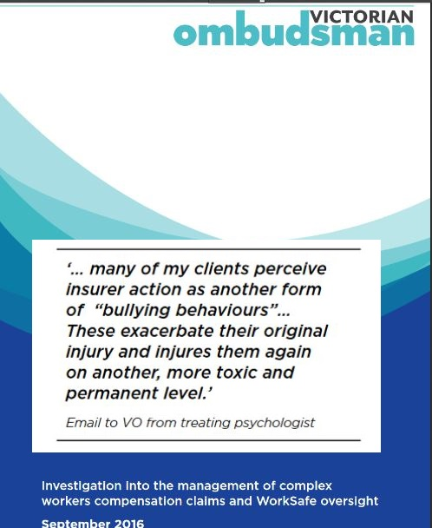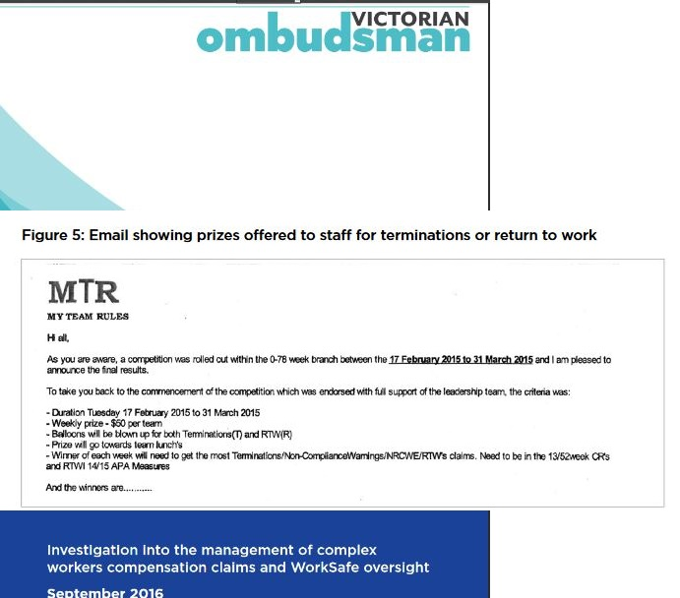

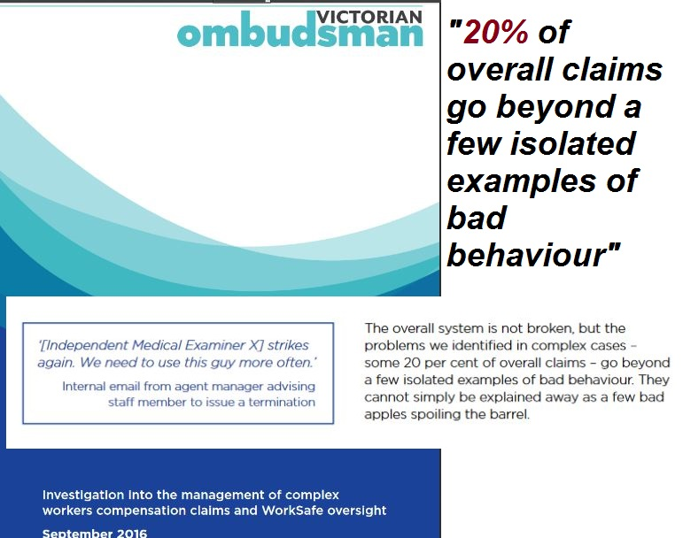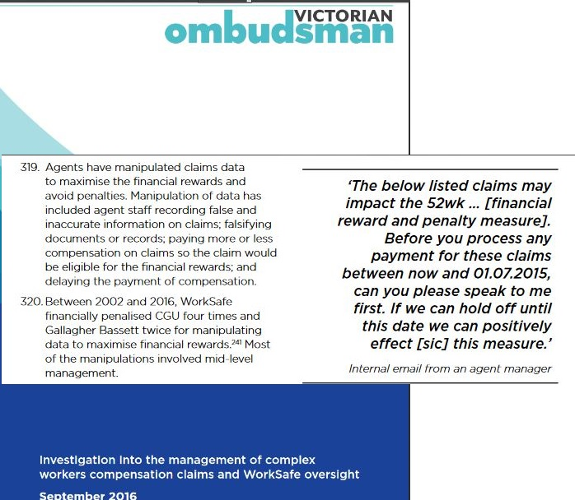

EXTRACTS FROM FAIRFAX/
4 CORNERS’ STORY ON COMMINSURE

Email as published on 4 Corners’ episode:

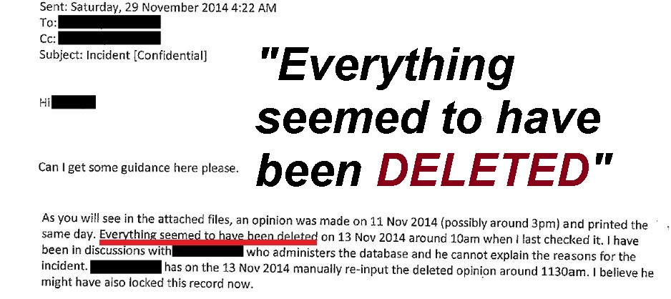

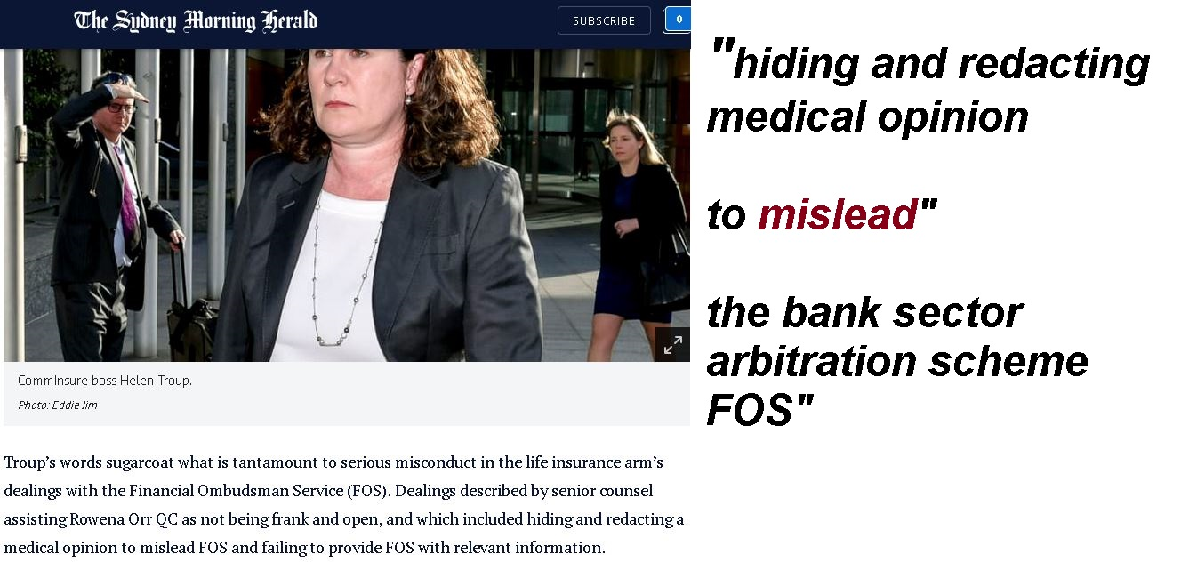

Email as published on 4 Corners’ episode on CommInsure:
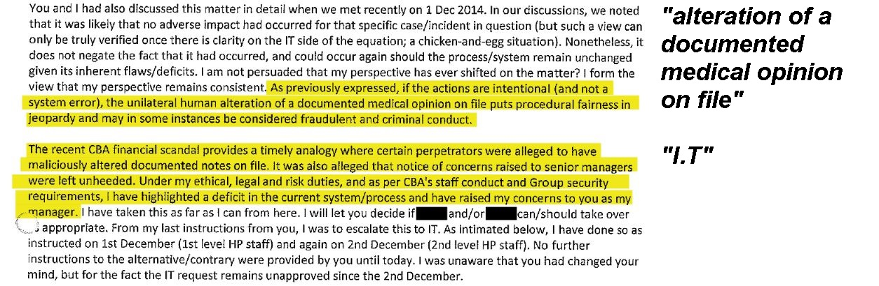
Extract of CBA Whistleblower’s Submission to the Whistleblower Protection Inquiry re traumatic alteration of evidence 