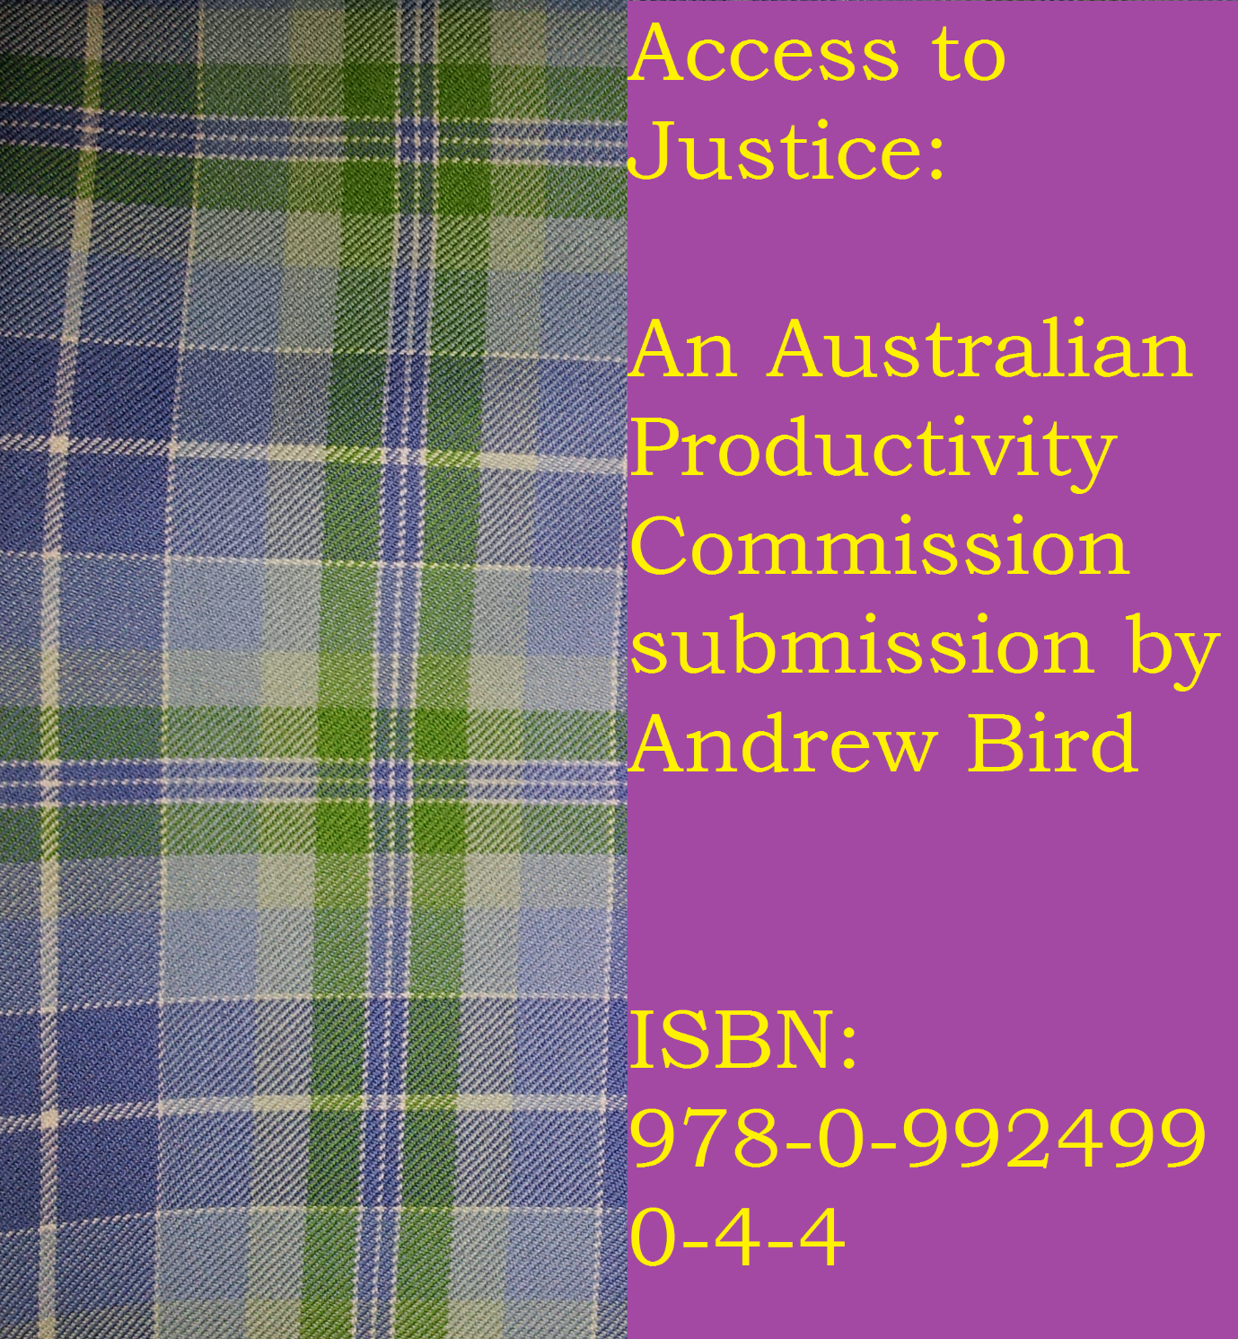
Access to Justice: An Australian Productivity Commission submission by Andrew Bird
This small eBook has been published in an attempt to show how eBook publishing can deliver freedom of speech to minority groups. This eBook has also been published to highlight the Access to Justice benefits of Access Point Law and Safe Sailing(.com.au). This eBook is my formal submission to the Australia Productivity Commission in relation to their Access to Justice Arrangements Public Inquiry of 2013-2014.
The first section of this eBook is my submission cover sheet. The following section is my letter to the Productivity Commission. This eBook and the enclosed letter will be my fifth submission to the Productivity Commission. [This submission will also be produced in word document format to comply with submission requirements]. I acknowledge that my submission in either format may not be accepted. If it is not accepted, it will at the very least be recorded in the Queensland State Library, the Parliamentary Library of Queensland and the National Library of Australia for the future prosperity of all Australians.
Submission Cover Sheet
[Removed by the Productivity Commission]

Letter to Productivity Commission

25 April 2014

Access to Justice
Productivity Commission
GPO Box 1428
Canberra City ACT 2601

Via email – access.justice@pc.gov.au
Via eBook publishing – www.safesailing.com.au
CC Commonwealth Ombudsman via email – ombudsman@ombudsman.gov.au
CC Commonwealth Attorney-General via email - senator.brandis@aph.gov.au
CC Commonwealth Assistant Treasurer - ministerial@treasury.gov.au

Dear Productivity Commission,
SUBMISSION: ACCESS TO JUSTICE ARRANGEMENTS PUBLIC INQUIRY
I thank you for your email dated 24 April 2014.
This is my fifth submission to the Productivity Commission in relation to the Access to Justice Arrangements public inquiry.
This submission is a tribute to my grandfather Neville Bird (deceased), a whistle blower who was subjected to public criticism and attack at a time previous to whistle blower protection. I entirely respect his actions which to my knowledge served to protect and defend innocent and vulnerable children at a boys’ home.
The merits of Access Point Law and how it can deliver access to justice
You today stand privileged to hear what I have to say as a free citizen of Australia. You may ignore what I have to say or you may embrace the sincerity of my words and offer support. The choice is yours and ultimately you have no judge. Apart from public hearing, this is my final written submission to the Productivity Commission.
My earlier submissions were quite reserved primarily because I was focused on actually providing access to justice instead of just talking about it. Now I will talk about it and I will be frank and provide open dialogue on this matter which I believe is of prime importance to society.
The birth of Access Point Law – a new model
The original thinking behind Access Point Law was conducted in January 2012. The preliminary thinking however originated from earlier times. During my first year at university studying a law degree, I kept asking myself ‘Why should I be privileged to know the law when everyone else does not?’ This was not an easy question to answer. This type of thinking lead me to embrace ideas of codification and eventually lead me to place my ideas down on paper and send onto the law reform organisations of Australia and other common law countries. For the ideas promoted in December 2011 by letter, please don’t hesitate to check out my eBook ‘Revolutionising the law in Australia and other common law countries by applying 4 principles’ published on www.safesailing.com.au. Responses to my letter were basically down to just acknowledging receipt. I accepted this quite whole heartedly. My ideas were just ideas. Actioning ideas is always the tricky part. Not long after my letters were sent out in December 2011, I sent letters to government on several other issues I thought were pertinent. The response I received from the Queensland Law Reform Organisation was to the effect ‘Please stop sending us emails. We only receive work from the Queensland Attorney-General’. At this point I was disappointed in the system of government. [Later, I reviewed the Queensland Law Reform Organisation Act of Parliament and learnt that their role is indeed broader that what was stated to me via email.]
My annoyance at the system of government prompted me to take action to implement my ideas. After a review of my ideas, I came to the belief that the only way to improve the system was to demystify the statute law. Once people were enlightened about the statute law, they could see the merits of having the law written in transparent form. This enlightenment might lead to a review of the common law and in my reckoning lead to the codification of the common law.
Access Point Law was born. The rest is say history that can be read in my eBook ‘Access Point Law: Driving Legal Innovation’. This eBook is published on my website www.safesailing.com.au.
The unique access to justice features of Access Point Law
As per my earlier submissions, Access Point Law has three unique attributes. I will attempt to cover these attributes in detail and provide what I believe is the significance of its attributes.
- Free Legal Education
This heading says it all. To my knowledge (even after conducting significant research), this heading is not replicated with merit anywhere else on the internet. This heading in my opinion could easily be replaced with the heading ‘Access to Justice’. This prompts me to ask the question why my earlier submissions did not adequately address the terms of reference of the relevant public inquiry for which I am providing submissions.
To my mind, the only public training that comes close to free legal education is perhaps high school legal studies/citizenship studies and government/community legal centre talks and fact sheets. What becomes apparent from working in government and my review of the legislation is that this training is limited to several key Acts and by the time legislation is reproduced in fact sheets it is made sterile and censored to make sure no mistakes are made at all. What is often the end product is something that is not very helpful. The poor government workers have to keep their words very specific for fear of providing misleading information. It would be a tragic day for a public servant to have feedback that their fact sheet accidentally contravenes another law of Parliament. It would not in fact be their fault if this was to occur.
As at 14 April 2014, I counted that there was 545 Acts of Parliament in Queensland. This is an enormous amount of legislation. To date I have reviewed 280 Queensland Acts of Parliament or 51%. To review this amount of legislation it has taken me at least 2 years and 3 months. At this point, I raise the question ‘Is ignorance of the law an excuse?’ Legally no but morally maybe the answer is an astoundingly ‘Yes’. When this common law rule was brought in, I pose the question to the reader, how many Acts were in existence? How many rules bound society at that time? In early Roman times, laws were so simple and few in number that they were written on walls…
For the record, I don’t mind having numerous laws. What does concern me however is having so many Acts of Parliament that people in society know nothing about. This problem is not actually helped by government fact sheets/talks. Talks and fact sheets often remove legislative references to engage the audience. This method does not empower the people. People would be more empowered if they hold the keys to research the law.
Access Point Law provides the keys (and also the doors) to achieve empowerment. It also provides what I believe is the missing link in the Separation of Powers model.
Review of laws is the key. The judiciary performs this role but only in a limited way. It only provides ad-hoc review at the action of a university professor/activist/other third party. What society should come to expect is persistent, ongoing review of laws. This is the only way legal education can be delivered and the laws improved.
Who can perform this function? Lawyers are suitable candidates. They are trained for this function and are in fact officers of the court, the Judiciary. Lawyers are the every-day interpreters of the law. Many times their interpretations are untested in letters to clients. On several occasions, their interpretations are tested in courts. But the point I am making here is that they are trained to interpret law, like their counterparts Judges.
Unlike Judges however, lawyers have capacity to perform more services to the community. They are not bound by the never-ending caseload that is presented by the current justice system. With the time that is often invested in pro bono work, I present the idea that lawyers like myself should serve the community to actively interpret the laws to provide ongoing free legal education to the public.
This is not a pipe-dream. There is over 9,000 lawyers in Queensland. If only 545 lawyers or 6% decided to be in effect a legislation guardian, there would be legal enlightenment in Queensland in relation to Queensland statute law. It would also be better for lawyers to perform this function over pro bono work for the reason that this work would benefit the whole community and not just a select few. The function would also serve to improve the skills of lawyers and would earn lawyers the ongoing respect of the public.
At the moment, I have summarised 51% and have managed to keep my summaries up-to-date monthly. On average, each update takes 1 to 2 days. I estimate that if a dedicated team of say 4 lawyers worked on this project, the fantastic four would have Queensland statute law, free legal education delivered in its entirety by the end of 2014. If more than 4 lawyers were engaged, legal enlightenment could occur in a faster timeframe.
Legal enlightenment could not occur at a better time. With global economic downturns, the law needs to work faster. Experience and many reports show that the current method is slow and expensive. With education on the law delivered by Access Point Law, individuals can go about their daily business and activities in a faster time-frame. They may research Access Point Law prior to consulting their lawyer for specific outcomes. Their lawyers may in turn use Access Point Law as a resource to deliver timely client outcomes. Faster outcomes = Faster economy and = More productive economy.
How does Access Point Law deliver timely education? Well, it classifies the law into categories. In any other environment, methods and processes are systemically categorised but not the law? Why is this so? I have started classifying Acts into 1 category only. Classification into more than 1 category would lead to poor outcomes in relation to law improvement and possibly confusion. It is my strong belief that government would not be in a position to subjectively classify the law for at least 50 years. The government is not primed or positioned to classify until their law-making abilities have improved. Further, if they classify wrong, they would have public criticism and perhaps the public stating that they did not follow the law due to poor classification. Lawyers and private enterprise do not have these problems.
After classification, summaries are provided to assist general knowledge or to provide an access point for further investigation of the law. If anything more was provided, lawyers would perhaps lose their ability to earn income for research or law speciality. It is not the intent of Access Point Law to do this. I have tried not to cover high end or speciality laws such as manufacturing, commercial shipping, etc. The entities delving into these industries would normally have the benefit of legal counsel. They would not of normal course, require legal education. They are not the disadvantaged or middle-class society.
I reiterate that my summaries do not cover the entire law. If they did, they would not be a summary or access point. If further research is required, a link to the relevant Act of Parliament is provided and links to the government regulator and their resources is also there for the benefit of the reader. It may be argued by some readers that google is an adequate substitute. I argue however that it is not even close. Google doesn’t analyse individual Acts of Parliament and it certainly does not attempt to draw a reader’s attention to unique resources offered by an Act of Parliament. It also may entirely miss the fact that there is more than 1 government regulator for an Act of Parliament which does exist from time to time.
Again I raise the point in passing that the government is not primed or positioned to be subjective in its analysis of the law; this function could only be performed by lawyers/private enterprise. I raise this point again because Access Point Law provides in addition to the above attributes, a critique of the law. Government would never actively critique what they have written. If the government didn’t believe in what was written, law compliance would be at an all-time low. Critique on the other hand by a third party is acceptable. Critique by third parties is beneficial to the government. It shows that law is not perfect, it shows that law can be improved and it allows minorities to highlight any unapparent injustices in the law as it is written. All types of law critique should be promoted by government. It is however, the aim of Access Point Law to highlight critique that is as far as possible objective. It is best for subjective criticism to be left to eBooks and the media.
One attribute of Access Point Law that should not be underestimated is the reason or reasons for an Act of Parliament listed against an Act of Parliament. Where possible, reasons have been extracted from an Act of Parliament’s ‘Objects’ section or ‘Long title’. It is critical for law compliance/access to justice for the public to know why they are following a law. Most new Acts have sound object sections. Most old Acts are deficient in this regard. It is not acceptable in my mind for society or even lawyers to dig up parliamentary readings to find why a law was enacted. The reasons and everything relevant to an Act of Parliament should be housed in the Act or associated regulations/standards. This is fairness and transparency to the people.
New improvements to Access Point will now be covered. I am quite enthused how Safe Sailing(.com.au) and Access Point Law work fluidly together. Access Point Law is able to include ‘Free letter/precedent’ sections, using resources from Safe Sailing(.com.au). I am pleased to announce that a free emergency short term will template and court form guidance for the basic civil litigation forms is available, along with a suite of letters designed to assist those without legal representation resolve disputes outside court. It is my strong belief that basic templates/guidance should be available to those who are disadvantaged. I took it upon myself to address perceived existing deficiencies. These templates are now out in the public arena for public scrutiny/feedback. If you have any feedback or ideas for improvement, please do not hesitate to contact the author.
‘Suggested further reading’ sections are also an improvement to what is currently existing. There are basically 4 major law textbook publishers in Australia. All these publishers are in competition and more often than not, universities have a preference to one or two publishers. The overall outcome is that lists of law textbooks is basically non-existent or poor. Access Point Law has no dilemma in publishing lists of textbooks against Acts of Parliament to assist in the education of the reader. Access to justice is significantly improved by this initiative. Instead of possibly paying a lawyer to research the law for say $200 an hour, a member of the public could purchase a legal textbook for $200. This is cheap but effective way to provide access to justice. It is the author’s belief that all legal knowledge should be brought together wherever possible for the benefit of the public.
Some novel initiatives will now be discussed. Wherever possible Access Point Law is a patron of the arts: writers and artists. The law should not exist in a vacuum and lawyers should not be the only members of the community who shape or interpret the law. Law should, in my opinion, be presented to an audience in a fun and engaging way. By adding ‘Reading for Fun’ sections against an Act of Parliament and individual artwork to represent an Act of Parliament, the law can assume a whole new context and law reading and research may become a regular past-time of members of society. It is the author’s belief that law interaction should be encouraged at all levels.
At this stage, I wish to highlight some learnings from my monthly updates. Over a period of one year, 2 major changes were implemented and there was to my mind, little or no coverage by the government or the law society. 1 change related to pet registration and the other change involved a new code for stock movement. Access Point Law through active law review was able to identify and educate the public on these changes via Facebook/Twitter. I was honoured to be in a position to educate the public on legislative change which was not popular or well promoted.
- Searches
During my legal training, I was exposed to some webpages providing links to government forms/registers, etc. These pages however, were very limited or court based. Access Point Law to my knowledge provides the best listing of useful searches for the citizens of Queensland. If an individual cannot afford a solicitor who may conduct searches on their behalf, the individual may personally attend to searches via Access Point Law and if an adverse result is returned, they have the opportunity to investigate further.
I stand tall with the list that I have created. I have had the benefit of reviewing the services of commercial search providers and even their listings appear to be less comprehensive than what I have achieved.
The listing was created from my Free Legal Education analysis of legislation. Some entries were supplemented by my legal experience. The end result is a polished show piece of Queensland accessible government information. This is a wonderful asset to a society that is more and more familiar with internet, and having information at their fingertips.
Such a listing is also great for the government to show its worth to the public. It may also lead to discussions on where government funding should be directed. I have seen that one resource was removed in the last year and another will be commercialised shortly. It is great for someone in society to monitor the number and status of these resources. If too many public resources are removed, our free Australian society would no longer exist ‘as is’. These resources are key to public transparency and accountability and if removed, we would see Australia move toward ‘2nd world country’ recognition.
It is also relevant to bring to your attention that a new resource was created by Access Point Law and is found in the Searches section. It is called the ‘Register of entities appearing in Queensland Legislation’. In this register, entities found in legislation are listed against each Act of Parliament and the relevant ACN/ABN/other identifier is provided. I don’t believe this table has ever been published on another website to date. This register is critical to public transparency of government funding and/or arrangements. It is important that no entity is receiving government favouritism. Transparency is now more important than ever with companies obtaining more power and resources than government and companies not being responsible for their actions to the wider public. This register is also very useful to those entering into contracts. A quick search of an identifier will disclose whether an entity is affected by government regulation. I encourage government to take an active role in the upkeep of this register or introduce a register of their own. I am open to working together on this initiative. Such a register can only be to the benefit of the community.
A quick mention is made of library resources. The State Library of Queensland databases are second to none and it is easy for Queenslanders to subscribe. Lawyers and the public should not underestimate the knowledge gained from non-legal books and the impact this may have on a legal cause of action.
- Location Gallery
The location gallery published on Access Point Law is another unique feature of the website. Currently, the gallery covers the following cities: Brisbane, Wellington and Singapore. The gallery includes non-sensitive pictures of the following public institutions: Parliament, Courts and Government Departments. The importance of this gallery may be easily overlooked by a city resident. The main reason for this is that to some extent you may already know these buildings and you may have by the very fact of living in a city, a better paying job and access to legal representation who would know these buildings. Those people living in the country are unlikely to know public buildings of significance and may not be able to afford legal assistance (as their jobs may not pay as well).
Access to justice can be delivered in numerous ways. This gallery might be the first attempt to deliver it at a basic level. “See this building. This is the building you should go for your court hearing. Or this is the building where your elected representatives make laws that affect you. Or this is the building that you can go to search government registers or seek publications on an issue that may be affecting you”. This gallery is great for school children and adults alike. It also allows individuals to develop an affinity with their government.
Access Point Law: the rough journey
This is the part of my submission whereby some discerning truths are revealed about our current legal system. I do not intend to embarrass any individuals or corporations with what is written here but I feel it is important to share with you my journey and experiences being part of a minority group ‘a proponent of free legal education’.
Putting it plainly: It is tough. If you don’t go along with the majority, you are immediately open to criticism and worse than that you are ignored. You are not even there. You don’t exist. What is the funniest thing about this scenario is that the majority is in effect limiting society. In the realms of this approach, limited novel ideas are shared and backed. Progress is stalled. Minorities should be respected and given a voice for the benefit of the whole community.
I remember in about May 2012, I met a group of female law students. I shared with them my basic ideas about free legal education. They laughed and ridiculed me and worse than that, one of them actually bet their first year’s wage as a lawyer that I would fail in my endeavours.
In September 2013, I attended the Queensland Law Society Property Law Conference. At that conference I was enthusiastically promoting my new improved website for Access Point Law. I had the privilege of meeting a representative from Lexon Insurance. I shared my business ideas and voiced that Access Point Law would reduce risks for lawyers. I kid you not, this is the response in effect I received from the speaker: ‘I recommend you talk to the ethics committee representative of the Queensland Law Society’. I was taken back. I had not done nothing wrong. In fact, I had done everything right. I had widely notified the profession, the government and the courts of my new business in 2013 and I had not received any negative or adverse response which may have led me to believe that what I was doing was ethically or legally wrong. I immediately consulted the ethics committee representative whilst at the conference and we exchanged business cards. The relevant committee representative was understandably busy preparing for a speech and asked that I contact them on their phone number at a later date. I proceeded the next week to call that number. I was not able to obtain a direct line to that person but I could leave a message. I left a message to the effect that I was eager to talk through my business. I received no call back.
After this encounter, I am unimpressed with any structure in Queensland supported by legislation that gives one company absolute power over any aspect of regulation. There should be at the very least two competitors or if there must be one entity for matters of efficiency, this entity should be a government entity. I implore the government to reconsider the Legal Profession Act and the electronic conveyancing laws.
Another incident was encountered during my journey. I am not sure whether a lawyer would like to be in this situation but for a period of about one to two weeks in 2013, I was refused access to the home page of the Office of the Queensland Parliamentary Counsel. I was not sure what the message was here. I am forgiving however as I believe it was a security response. I was actively involved in downloading Acts of Parliament on regular occasion and linking Acts of Parliament from my website. I would like the reader to pause for a second and consider what it would be like for them not to be able to access the laws which apply to them as a member of society. Further pause for those who are illiterate and for those who do not speak English. They would be affected in the same way.
In closing on this sensitive issue, I would like to highlight that I have had many positive experiences and feedback on my journey. What is apparent though being a minority is that a lot of promises are made but little is delivered. Several organisations promised an article. No follow-ups however were made. Media was contacted but did nothing. Media would only cover my 74 island record attempt. Some members of the profession said that they would advertise on Access Point Law but never followed through. How can members of minorities obtain a voice?
The Safe Sailing Solution
Cheap and straight-forward eBook publishing quite simply is the solution. Safe Sailing(.com.au) provides English language eBook publishing for $200. This is affordable publishing. The impact of a cheap publishing capability is that the voice and stories of disadvantaged Australians can be heard.
It is not adequate for the media to be relied on to deliver this capability. The media is becoming increasing commercialised. They will not deliver a story unless there is commercial benefit. It is therefore my strong belief that disadvantaged Australians cannot afford the luxury of media publication.
There are further benefits of eBook publishing which I will outline. Distribution is not one-off. It is normally ongoing at the discretion of the author. It is a huge advantage for minorities to have their voice not heard on just one occasion but repeatedly. Further, eBooks have another advantage over media publication. The story is not tarnished for effect. It is the words of the author and the author has ultimate control of the content that is sent for ‘print’.
I will now share with you the possible future direction of eBook publishing and its wide capability to provide access to justice:
- Issue closure
If a person cannot afford legal representation to obtain closure of an issue, it is reasonably open to them to publish an eBook. It is open to a person wanting closure on an issue to publish any content that does not breach confidentiality or cause defamation. This is freedom of speech. [Safe Sailing(.com.au) supports freedom of speech where classification laws, etc are not breached]. When freedom of speech is delivered, the benefits to society are numerous. A person may obtain closure, enabling them to move on in their lives and be more productive to society. It would be surprising to research how many legal causes of action are carried out just to ‘get back’ at the other side or ‘to voice one’s opinions’. In addition to the closure benefit, society would obtain information which could be analysed and acted upon at individual/government level. Idea sharing promotes growth and innovation.
- Issue resolution
One of the most interesting effects of cheap eBook publishing is that eBooks may in fact provide a substitute to court action. Let me explain. A person may exercise their right to publish. In their publication, they may provide facts and evidence which would could constitute a legal cause of action. When an eBook is published, it is open to those parties mentioned in eBooks to contact the author. Contact details for authors are in most cases listed on Safe Sailing(.com.au) and is in fact encouraged by the website. Authors who are contacted may be open to negotiations to exercise their right to withdraw an eBook from ongoing distribution. This process may be a cheaper alternative to litigation. I really like this idea as it is up to the parties mentioned in eBooks to review the merits of the contents of the eBook and to gauge whether they are impacted. If they believe the content lacks merit or that the author has no credibility, they may simply ignore the publication and be content with its ongoing distribution.
- Evidence potential
If you analyse what is an eBook, you will notice the following attributes: permanent form, intended for public audience and possessing a unique identifier. In some respects, it is not too different from an affidavit or statutory declaration. There is every possibility for an eBook to be accepted by a court as evidence. I note that once an ISBN is allocated and an eBook is published, limited alteration is allowed following publication. If you research this matter, you would discover that cover design and minor editing changes are allowed but basically if content change was to occur, a new ISBN would be required. An eBook with updated content would be a new publication.
I look forward to an era where persons with issues are encouraged to write eBooks and then if something comes of a matter, to consult a lawyer. This is a good process especially for those who cannot afford a lawyer at the first instance.
Another positive of this process is that facts and evidence are collated perhaps at an earlier time. If a matter is litigated, the facts and evidence presented to the court will be fresher. Better facts may translate to less disputes about the turn of events. Another worthy point to mention is that the public would perceive eBooks from the outset as public documents, subject to public scrutiny. This is not necessarily the case with court documents. What this may mean is that the content that is published (in an eBook) may be of a higher standard.
Conclusion
I thank for you the opportunity to present my submission. I am pleased to outline to the Productivity Commission the merits of my two businesses Access Point Law and Safe Sailing(.com.au). Access Point Law is delivering free legal education to the public reducing the strain placed on government to provide fact sheets, etc. Access Point Law is also educating lawyers to ensure that quick and relevant advice can be provided to clients. Safe Sailing(.com.au) is an eBook publishing business with a difference. It offers a freedom of speech service which is lacking in today’s society. Further, this business may in the future revolutionise the way in which matters are resolved between members of the public. I am honoured to be able to lead the public to new ways of thinking which could in theory position Queensland and Australia as world leaders in relation to access to justice arrangements, should my ideas be supported.
If you have any questions in relation to my submission, please don’t hesitate to contact me on my mobile, via post or via email.
Yours faithfully,

Andrew Bird
Solicitor | Sailor | Leader in Law Improvement

Andrew Bird © 2014
ISBN: (intentionally removed – eBook published in EPUB format only)
Safe Sailing ABN 85 103 203 656
Printed 2014

