Recommendations

Queensland Advocacy Incorporated’s Previous Recommendations

- More government supported representation when there is a prospect of custodial orders (forensic, restrictive practices) of any kind.

- Provision for government assisted representation for persons with diminished capacity facing the prospect of custodial orders or Restrictive Practices

Queensland Advocacy Incorporated recommends in relation to the Draft Report-

- More money available for government assisted representation for persons with diminished capacity facing new or continuing forensic orders.

- More money available for government assisted representation in relation to tribunal hearing regarding restrictive practices

- That Commonwealth and states cooperate to ensure that specialist community legal centres and other agencies that provide services directly to people with intellectual or cognitive disability, acquired brain injury or mental illness are able to adequately meet demand.

- Research to determine the adequacy of funding to Legal Aid Queensland and to assess whether financially disadvantaged sectors of the community are able to access sufficient legal aid, particularly those with intellectual or cognitive disability, acquired brain injury or mental illness .

- Review of current guidelines for grants of legal aid to facilitate the production of psychological or psychiatric reports regarding the capacity and fitness for trial of people with intellectual or cognitive disability, acquired brain injury or mental illness.
About Queensland Advocacy Incorporated
QAI is an independent, community-based, systems and individual legal advocacy organisation. Our mission is to promote and protect the fundamental needs, rights and lives of the most vulnerable people with disability in Queensland. In addition our efforts extend beyond the defence of civil and political rights to the defence of rights without a legal foundation, including rights to belonging, respect embodied in the simple quality of human dignity.
We hold ourselves to account by including people with disability as paid staff, in our membership, and in key board positions. Our board members have experience in advocacy, institutional living, community legal services, private legal practice, legal aid, accountancy and community work. QAI is a member of the national Disability Advocacy Network of Australia (DANA) and Combined Advocacy Groups Qld (CAGQ).
As well as traditional systems advocacy Queensland Advocacy Incorporated's Human Rights Legal Service provides individual legal advocacy to people with a disability in relation to guardianship, administration, discrimination and restrictive practices and assists people required to appear before the Mental Health Review Tribunal. We also provide non-legal advocacy to people with disability at risk from the criminal justice system by working with legal and community.

Why we are submitting on the Draft Report (8 April 2014)
QAI is uniquely placed to make observations about the accessibility of the justice system for people with disabilities, including mental health-related disabilities. We provide individual legal advocacy in support of persons whose disability is at the centre of their legal issue. We run two direct-delivery legal services:

- The Human Rights Legal Service (HRLS)

The HRLS advocates for people with intellectual disability and/or cognitive impairments (including ABI), or who have a dual diagnosis of intellectual disability/cognitive impairment plus mental illness, who have a profound physical disability, and require legal assistance in-
- challenging the use of restrictive practices, including the use of seclusion, containment and chemical, mechanical and physical restraint;
- guardianship and administration matters;
- anti-discrimination matters;
- forensic orders and forensic orders- disability;
- health care and life sustaining measures; or
- abuse, neglect and serious injury.

Much of the work of the HRLS involves representation in administrative tribunals, particularly the Queensland Civil and Administrative Tribunal (QCAT).

- The Mental Health Legal Service (MHLS)-

The MHLS provides advice and representation to people who have matters before the Mental Health Review Tribunal (MHRT) including:
- reviews of involuntary treatment orders (ITOs);
- fitness to plea;
- reviews of forensic orders (FOs);
- applications for electroconvulsive therapy (ECT); and
- applications by involuntary patients who wish to move out of Queensland.

Additional Submission

In the Access to Justice Arrangements - Draft Report 8 April 2014 (‘Draft Report’) - the Productivity Commission (PC) accepts that representation is desirable where it secures fairness and equity:

the Commission also accepts that some degree of representation is inevitable and indeed desirable. For example, where representation would facilitate the identification and resolution of the issues, or where it might be required to facilitate fairness and equity, such as in specialist tribunals dealing with adult guardianship and mental health issues.

The Draft Report also suggests that representatives should be required to support the objectives of the tribunals in which they are seeking leave to appear, and that easier access to alternative dispute resolution (ADR) and more user-friendly arrangements for self-represented litigants will greatly reduce the need for representation in the first place. These are the points we want to address here.

Fairness and Equity

While we agree that alternative dispute resolution and user-friendly arrangements will work for consumer credit/debt, family and neighbourhood type disputes, there are other civil disputes in relation to people with disabilities and mental illness that are qualitatively different in their conduct and particularly in their outcomes. Fundamental human rights-based matters involving the civil restraint and detention of people with impaired capacity and the consideration of their appropriate care and support are not amenable to user-friendly or ADR processes. Such processes are more likely to diminish rather than enhance fairness and equity in relation to these sorts of matters for two reasons.

The first reason is that people with impaired capacity are not always able to successfully engage in alternative dispute resolution (ADR) or ‘user-friendly’ civil justice processes. Their impaired capacity warrants a high level of support for meaningful involvement in any kind of formal procedure- especially those in courts and tribunals.

QAI promotes the recognition of the legal capacity of persons with disabilities on an equal basis with others while at the same time recognising that people with disabilities are entitled to effective access to justice on an equal basis with others. That can only be guaranteed by the provision of procedural accommodations that promote people’s direct or indirect participation. Those accommodations will likely include the provision of better legal support over a longer time. See case study ‘Robert’ below for an example.

But that kind of support is rarely available to the roughly 4000 Queenslanders with impaired capacity who are subject to guardianship or administration orders (hundreds of whom are also subject to restrictive practices or forensic orders) or the thousands of other people with impaired capacity placed on involuntary treatment orders every year in this state.

In fact Queensland has one of the lowest rates of representation in the Mental Health Review Tribunal equivalent in any state or territory. Only some 40% of ‘patients’ actually attend hearings in the first place, and about 2% of ‘patients’ are represented in all matters. Forensic order reviews take place in the Mental Health Review Tribunal, along with hearings to determine whether a person should receive electro-convulsive therapy (ECT), and determination or reviews of Involuntary Treatment Orders. In Queensland that representation occurs in only 2% of matters. (see chart below) By way of contrast, the Attorney-General is represented in some 50% of all matters.

The following tables taken from recent Mental Health Review Tribunal Annual Reports (2012 & 2013) illustrate these low rates of participation.

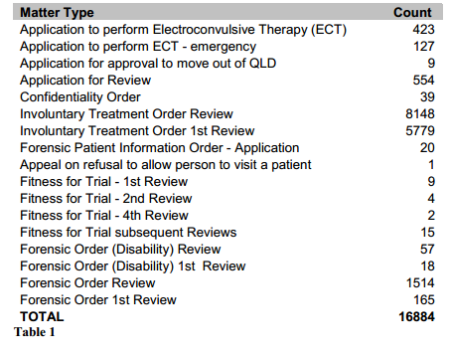
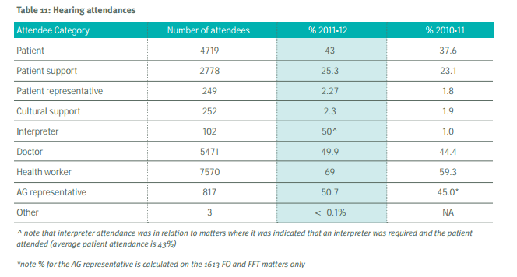

There is a variety of reasons why people do not attend: some are too unwell, some do not wish to contest orders, and others simply trust the tribunal to make the right decision without their input. But many others are actively or passively discouraged from doing so: service providers find it inconvenient to facilitate attendance, or do not consider that the person would gain anything by attending, or engaging a representative may stir things up unnecessarily.

In our view people must be actively supported to take part in legal processes that may determine the degree of liberty that they experience for years to come. In our view both attendance and representation should be the default presumption for the review of forensic orders, and the determination of guardianship, administration, involuntary treatment, ECT and restrictive practice orders.

The second reason is that user-friendly processes are not appropriate when there is so much at stake for the person concerned. Forensic orders, for example, provide a person with impaired capacity with a qualified acquittal. They are not criminally responsible. But they may nevertheless be subject to orders for long terms of containment in locked facilities with limited access to community or loved ones.

It is not uncommon for forensic orders to last longer and to involve more serious deprivation of liberty than ordinary criminal detention subsequent to a finding of guilt in relation to the same fact scenario, even though the person with impaired capacity cannot have the mens rea and has not committed any crime. Legal Aid is available for people proceeding to Queensland’s Mental Health Court, subject to the assets, income and merit tests, but it is not uncommon for people already subject to forensic orders to be unrepresented in scheduled reviews of those orders.

We know of a client who was detained without convition for a number of years in a secure mental health unit and who was transferred to a forensic disability unit four years ago. He is still there. We know of a young ATSI man who has not been convicted of any offence (unfit for trial) yet has been transferred from rehabilitation unit (2 years) to a limited detention unit (18 months) to a medium security unit (2 years) to a forensic disability unit (2+ years) and is still seeking proper representation with a view to returning to the community.

A person with a disability in a group home and subject to restrictive practices cannot self-represent, and they cannot engage in ADR. Nor can the person subject to an Involuntary Treatment Order or Forensic Order. And whether their legal representative, should they be among the few fortunate to have representation, supports the objectives of the tribunal will make little difference to the outcome. It will not change the fact that 98% of people with matters relating to ITOs and FOs will offer no view alternative to that presented by the state employed psychiatrists and psychologists.

“Bret”- By order of the Queensland Civil and Administrative Tribunal Bret was placed under containment in a secure unit west of Brisbane about 4 years ago. His 24/7 support cost the state $800k + per annum. Through his guardian/sister Bret successfully engaged QAI counsel to seek a lessening of his restraints. Counsel devoted considerable time to obtaining instructions and relaying information to and getting information from his client. Bret’s legal representative convinced QCAT to reconsider its earlier decision and agree to transfer Bret to his own home in a community rather than institutional setting and at a fraction of the cost. Without access to free legal advocacy Bret would still be living in an ‘institution for one’ under surveillance and restraint. Others subject to Queensland’s restrictive practices regulation have not been successful in engaging legal representation. Demand outstrips supply despite pro bono work provided by some firms and barristers. Many continue to live subject to conditions that clearly breach the Convention on the Rights of Persons with Disabilities.

Conclusion
According to the Draft Report, people with a disability are also more likely to be deeply socially excluded and having a long-term illness or disability is the strongest predictor of justiciable problems.
For the most vulnerable people with disability the justice system has profound impacts. They are not debtors, but they may have the management of their financial affairs taken from them. When they try to communicate we call this ‘challenging behaviours’ and the tribunal subjects them to restrictive practices. They are not criminals, but they may have their liberty taken from them. Queensland’s appallingly low rates of representation in specialist tribunals must be addressed by increasing legal support and representation.

Physical and Chemical Restraint, Containment and Seclusion pursuant to the Guardianship and Administration Act 2000 & Disability Services Act 2006 Qld
Pursuant to the Public Trustee Act 1978 & Guardianship and Administration Act 2000
Pursuant to the Anti-Discrimination Act 1991 (Qld)
Pursuant to the Mental Health Act 2000 (Qld) et al
Draft Report page 16.
Per Article 12 of the Convention on the Rights of Persons with Disabilities
Per Article 13 of the Convention on the Rights of Persons with Disabilities

