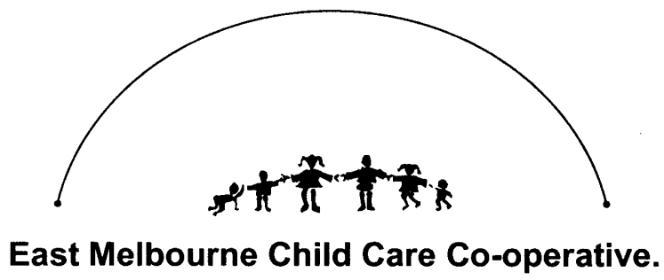
5th September 2014

Introduction:
East Melbourne Childcare Co-operative (EMCC) is a community run, non for profit organisation. It was set up in 1992 to provide high quality childcare and funded Kindergarten programs at affordable prices. We run two Centres in East Melbourne.

Our Mission Statement: EMCC is committed to providing a safe, secure and caring environment that is supportive, stimulating and enriching for all children; allowing them to learn and grow into confident and creative learners. We acknowledge the importance of providing children with high quality education in the early years as this lays the foundation for the future development, health and wellbeing of children.

After considering the Productivity Commission Inquiry Draft Report, EMCC welcomes the following recommendations:
- Introduction of a single subsidy to replace the CCB and CCR and payment directly to the Centre, rather to the families
- Diverting funding from the proposed Paid Parental Leave (PPL) to early childhood education and care
- Ongoing funding by the Australian Government for universal access to 15 hours of Kindergarten
- Implementing a nationally recognised working with children check
- Extending the scope of National Quality Framework to include all Centre and home based services that receive Australian Government assistance
- Increased subsidies for children with disabilities and additional needs
- Exploring ways of making requirements of approving international qualifications simpler – especially qualifications from New Zealand

EMCC disagrees with the following recommendations as we believe their implementation would not be in the best interests of children and their right to access high quality education and care:
- Requiring educators working with children under three to hold only a minimum of Certificate III – no Diplomas required
- Allowing Centres to temporarily operate with staffing levels below required ratios (by averaging over a day of week)
- Simplifying the National Quality Standards and identify standards and elements that can be removed or altered whilst still maintaining quality outcomes for children
- Removal of preschools from National Quality Framework
- Removal of access to subsidies for families that do not meet the work test

EMCC has the following recommendations for the Productivity Commission to consider:

Firstly, every child in Australia should have the right to high quality education and care, provided by highly qualified educators that work in collaboration with families, which compliments and supports their families’ lives.

Requiring educators working with children under three to hold only a minimum of Certificate III – no Diplomas required
We are striving for high quality education and care for all children in the early years and by removing Diplomas we are going backwards as a nation rather than forward. Early childhood is a rapid time of brain development, especially 0-3. Children need quality education and care that is provided by highly qualified educators with extensive knowledge in early childhood education to support children in learning and development and to ensure they are having a positive and enriching experience. This should be the case for all children in the early years, not just 3-4 year olds. There is a lot of research out there that states the first three years of a child’s life is the most important as well as most vulnerable for a child’s development and learning. The recommendation to lower qualifications goes against the research that shows the links between qualifications, quality and positive outcomes for all children.

Certificate III qualifications is minimum qualification that enables educators to have the base foundation for working with children. It is not an adequate requirement when considering aspects of the curriculum, pedagogy, documentation of children’s learning and development, health, education and relationships of young children. Australia should be looking at phasing out Certificate III and having the minimum qualification requirement for early childhood education, a Diploma. All the evidence shows that children who attend high quality education Centres, with high qualified educators achieve better outcomes in terms of their social, cognitive and behavioural learning and development. EMCC recognises and values the expertise and commitment of our educators. To ensure our educators are providing the highest quality and most current practices of education, we support their continuing professional development through further study and training within the community.

To ensure children are also receiving high quality education and care, why is there such a focus on 3-4year olds and not 0-3? 0-3 age group needs our best/most qualified educators. I gained my Bachelor of Education (Teaching) Early Childhood from New Zealand and I worked with a variety of age groups of children. When I came to Australia, I was shocked that I was only considered to be a Kindergarten teacher, and to work with under 3’s I was going to have to be paid a Diploma wage. This disappoints me, as in New Zealand, if you have a Degree or a Diploma, you are paid according to your qualification, not what age group you work in. Why is it only important for 3-4year olds to have access to Degree qualified educators, why can’t all children have the expertise of this qualification? This is how Australia, can provide all children with the highest quality education and care.

An important point that has not been addressed is the need to provide appropriate remuneration for educators to attract and retain qualified educators. We are a low paid profession, for what we offer children. We have Certificates, Diplomas and Degrees and yet we could be paid more for working at a supermarket. What does that say about the importance of the thousands of educators who are educating the nation’s future? All children need quality interactions with consistent educators. There are too many educators leaving the profession every day, because they are underpaid and undervalued by the Government. The Government should not continue to expect Centres to be able to provide affordable early childhood services at the expense of educators. Productivity Commission, please refer to the model that New Zealand has had over the years, where Centres are given money by the Government, in accordance to percentage of qualified educators. This enables Centres to be able to pay educators an appropriate remuneration. Currently the only way to pay educators is to raise the fees every year, which is making childcare very expensive.

“I am a Centre Manager, a degree qualified educator and working mother, who does this job for love and passion of working with children every day, not for the pay. I value the importance of early childhood education in the early years of children’s lives and am thankful my two year old benefits from this from his three qualified educators. Please value the importance of educators in the lives of children, by paying them appropriately and valuing, respecting the profession and work we do every day”

Allowing Centres to temporarily operate with staffing levels below required ratios (by averaging over a day of week)
This will not be providing high quality education and care for all children as well as by putting children’s safety and wellbeing at high risk

Simplifying the National Quality Standards and identify standards and elements that can be removed or altered whilst still maintaining quality outcomes for children
We recommend no changes to be made to the NQS. This is an excellent document and was welcomed highly at EMCC. All seven standards are important and are interrelated.

Introduction of a single subsidy to replace the CCB and CCR and payment directly to the Centre, rather to the families
This is fantastic to have one payment and the payment going directly to the Centre. This enables Centres to not have to chase money that is owed to us. Concern we do have is by putting a limit on the combined incomes of families to receive payments by the Government. $160,000 sounds like a lot of money, however with the rising costs of living, this is not the case. Also, with the proposed PPL, women are giving a lot of money to have a child, however once they want to or need to go back to work; the cost of childcare will implicate this, when there is no support from the Government. We want women in the workforce; let’s not send women back to the 1950’s where, it is better off financially to stay at home, because there is little or no support from the Government. More women are in the workforce, wanting to be the best we can be and to be able to use our qualifications and experience. Our recommendation is, keep the PPL as is, and put the money into early childhood education.

