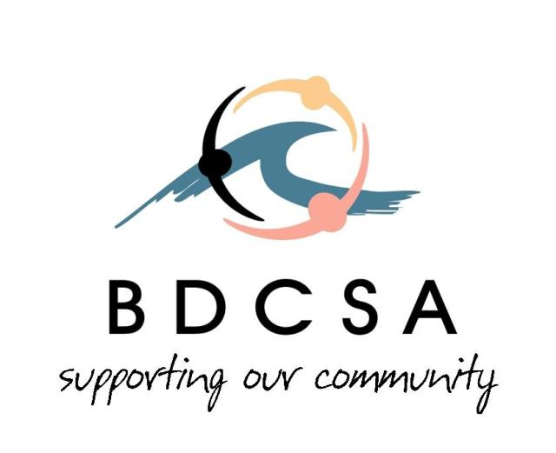
Ballina District Community Services Association Inc
ABN: 62 003 108 424
PO Box 623
BALLINA NSW 2478
Phone: 1300 872 281
Fax: (02) 6686 8693
Email: info@bdcsa.org

Childcare and Early Childhood Learning
Productivity Commission
GPO Box 1428
CANBERRA CITY ACT 2601

To Whom it may Concern
Richmond Tweed Inclusion Support Agency (ISA) is part of the Inclusion Professional Support Program (IPSP) funded by the Department of Education.
As an ISA working directly with Early Childhood Education Care (ECEC) across the Richmond Tweed local government (NSW) areas we strongly believe that the proposals in the draft report do not sufficiently support the inclusion of children with additional needs in ECEC.
The focus of inclusion delivered by ISA’s is to build educators capacity and support early childhood services to build inclusive environments that support families and children, whilst developing skills, strategies and concrete practices that will be sustainable into the future. Providing funding on a child based structure clearly limits ECEC services ability to apply inclusive practices. Is inclusion a focus on an individual (exclusive) or group working together (inclusive)?
Inclusion is something that ECEC services have currently strived towards in order to be successful using the Early Years Learning Framework (EYLF) and National Quality Standards (NQS). A positive step forward and clearly supported by research is that children learn best in group settings and including children with additional needs into settings with typically developing peers supports high quality outcomes.
Inclusion Support Facilitators (ISF’s) support ECEC services to be accessible for all children including those with additional needs. The delivery of the program is flexible and has access to Flexible Support Funding (FSF) to address short term attendance, settling children in, changes in attendance patterns, educator needs and the immediate needs of families in the community. The IPSP supports children without formal diagnosis, some locations throughout the LGA experience extensive wait times to access specialist services for diagnosis; this is frustrating for all ECEC services and families. During the interim ISF’s are available to support children, families and ECEC educators to continue the natural momentum of the child’s development and provide them with support, knowledge and skills to allow the child to be better included in the care environment. As ISF’s we question what will fill this gap if there are no funded ISA’s to support inclusion.
ISF’s work collaboratively with services, all ISF’s have established supportive relationships through face to face visits and the provision of appropriate resources that may be required by the service or individual educators. ISF’s are valued and welcomed by ECEC services. This is clearly evident as services freely contact ISF’s regularly to obtain information and advice over a wide range of topics, including accessing IPSP programs and community networks, assistance with practical service delivery, to seek coaching and mentoring in order to improve inclusive practices.
The proposal in the draft report does not include the continuation of the Inclusion Support Agency. This service has been built up over several years and is a well established and accessed support service for federally funded ECEC services. We see the loss of this model as costly to the government and detrimental to the early childhood sector, with flow on effects into the general community.
Yours sincerely

Jo McIntyre
Manager Client Services

