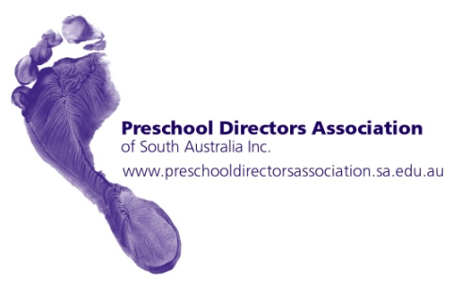
In South Australia, we have a proud history of high quality and affordable preschool provision by successive state government s for many years. We have long had excellent participation rates of four year olds in preschool programs that are provided by highly qualified early childhood educators. This provision has been enhanced by the federal funding that allows us to extend our programs to fifteen hours per week.
I write this submission as President of the Preschool Directors Association of South Australia. This association represents the leaders of the 300 stand-alone preschools in South Australia that are administered by the Department for Education and Child Development.
We take the opportunity to commend and support the draft recommendations of the Productivity Commission Inquiry into Child Care and Early Childhood Learning.
In particular, we would endorse the recommendation to remove dedicated preschools from the National Quality Standards assessment and rating process, where preschools are already or will be part of a systemic quality improvement system.
Our experience in South Australia is that prior to NQS, preschools were part of the rigorous DECD quality assurance and improvement process that applies to all public schools. NQS has added an arduous additional layer of accountability and compliance on preschools that has been superfluous in assuring quality. This is demonstrated by the high level ratings that DECD preschools have achieved so far in the NQS process.
In recognition of the varying needs of families, we ask the Commission to consider that any recommendations it makes allow flexibility in the provision of preschool education.
In conclusion, we would ask that in recommending future funding and benefit models, the Commission ensures that the cost to families of preschool education is affordable.

