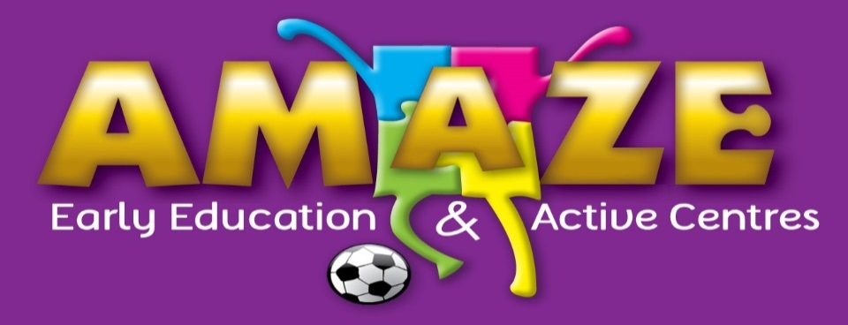

4 September 2014
To Whom it May Concern,

I am the General Manager of 3 childcare centres. One is for early education and the others are school care centres. We see 500 children a week from all different kinds of families. I am concerned with a number recommendations made in the draft report and they impact they will have on our families.
- The removal of the 24 hr subsidy for parents who fail to meet the work/activity test. We are strong believers that early education is essential for all children and it ensures their success at school. We feel this will be a big barrier to our families accessing our early education programmes. We have high quality programs including 3 bachelor trained teachers across our service. Parents who are at home with babies yet still have children under school age are already at a disadvantage as they are often on one income already. Removing this provision would mean that early education would be out of reach financially for quite a number of our families. We also have a number of special needs families who aren’t able to meet this test due to meeting the needs of their special children. These families would be disadvantaged.
- The proposal to discontinue grandparent childcare benefit. These grandparents are actually saving the foster care system from having to find care for these children. We should be continuing to support them as they take responsibility for their grandchildren when the parents are unable to. Whether the grandparents are working or not, there is significant financial outlay at a time of their life where money is usually not as accessible.
- Many of the proposals will have an extremely negative effect on women re-entering the workforce. This is already an issue and will be further exacerbated by these proposals. This would be taking a huge backward step for Australia.
In summary, the main concern to our family is their ability to afford good quality early education. We do not want to see children miss out (thus reducing the educational standard of Australia even further) due to the proposals we adopt.
Kind regards,
Lucy Cook
General Manager
AMAZE Education

