Attachment to Mitchell Shire Council Submission to Disaster Funding Inquiry
Seymour
The town of Seymour has a long history of flooding dating back to its establishment in the 1800s. The 1870 flood resulted in significant inundation of the entire town. Further major floods took place in 1916, 1917 and 1974.
The flood-affected area of Seymour is considered the operational centre for the town. This area is a retail, commercial and industry focus, supplying goods and services for the town and its region, all of which is severely disrupted in the case of a flood.
Disruption to the community including clean-up costs, loss of income, costs of removal, temporary accommodation, interruption to schooling, and loss of personal items are all factors leading to social disruption and human suffering and a decrease in community resilience. Another major social issue is that the operations of and access to both the hospital and police station are severely disrupted.

Mitigation is very likely to reduce the risk of damage from natural disasters and thereby result in lower insurance premiums for home building, home contents, or commercial property insurance
A 2013 ANUFLOOD flood damage assessment has conservatively estimated the cost of flood damage in Seymour at $21.3 million for a 1 in 100 year flood from the Goulburn River. The estimated Annual Average Damages for Seymour is $490,000. This figure represents, on average, the damage bill that the community incurs each year as a result of flooding.
Additionally, statistics from the Insurance Council of Australia estimate the normalised cost of the 1974 flood event that affected Seymour as being $117 million for the north-east Victoria region.
The Seymour Flood Mitigation Project is designed to mitigate the risk of damage to 400 private properties and public infrastructure within the Seymour flood zone by constructing a levee bank.
This will eliminate flood damage from the Goulburn River for all floods of 1 in 100 year severity and less in Seymour. It will have a major impact in reducing flood insurance claims and can be expected to lower flood insurance premiums as a result.
Climate change research has predicted an increased frequency of floods in the future which, if realised, would see the proposed levee bank preventing a higher level of flood damage and insurance claims than currently predicted.

Economic Impact of Flood
The town of Seymour has been identified as a potential strategic employment hub in the Hume Regional Growth Plan which argues that investment in physical and social infrastructure is needed to support increased future demand. However the Mitchell Shire Economic Development and Tourism Strategy Background and Issues Paper 2010, identifies that development in Seymour is hindered by the existing flood risk. That apart, Seymour is an ideal place for industrial development in view of its location on a major regional development corridor. The hinterland (100km) from Melbourne is considered to be a primary area of population growth outside the metropolis..

Flood Overlay Map
Planning Zones in Seymour
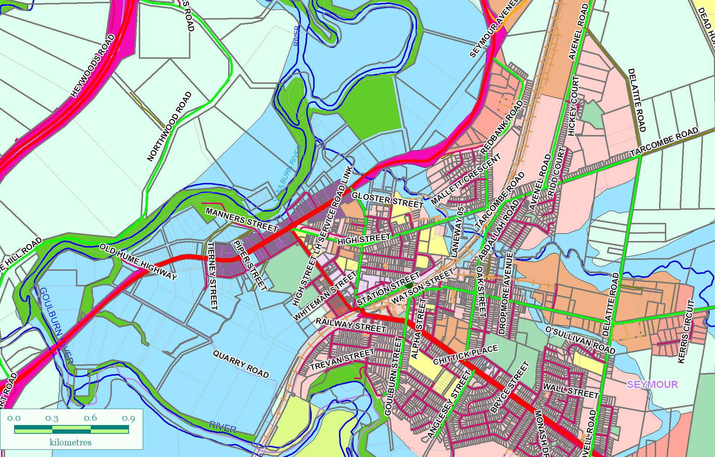

Flood Zone delineated in blue

