Bureau of Meteorology
Submission to the Productivity Commission Inquiry into Natural Disaster Funding Arrangements

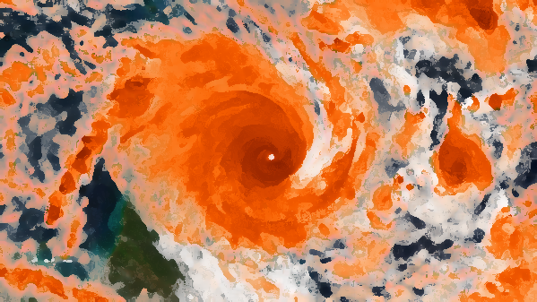

June 2014

For further information on this submission please contact:
Dr Ray Canterford PSM  Division Head  Hazards, Warnings and Forecasts | Carey Robinson  Assistant Secretary (Executive)  Strategy, Parliamentary, International and Communication Branch

Version No: 1 Final | Date of Issue: 27 June 2014

Confidentiality
This is a public submission, it does NOT contain ‘in confidence’ material and can be placed on the Commission’s website.

© Commonwealth of Australia 2014

This work is copyright. Apart from any use as permitted under the Copyright Act 1968, no part may be reproduced without prior written permission from the Bureau of Meteorology. Requests and inquiries concerning reproduction and rights should be addressed to the Communication Section, Bureau of Meteorology, GPO Box 1289, Melbourne 3001. Requests for reproduction of material from the Bureau website should be addressed to AMDISS, Bureau of Meteorology, at the same address.

Table of Contents
This Submission 1
Summary 1
About the Bureau of Meteorology 2
Introduction to the Bureau and its role in natural disaster management 2
Communicating with end users 3
Improving resilience 4
How the Bureau’s services are funded 4
Summary of the Bureau’s funding 4
Recent Funding measures which strengthen the Bureau’s services 5
TOR 1.Sustainability and effectiveness of current measures 5
National coordination and sustainability of riverine flood monitoring infrastructure 6
Effectiveness of flash flood mitigation 8
Impact based forecasts 9
Risk based warnings 9
TOR 2: Risk management measures for asset owners 9
Forecasts and warnings used for risk management 9
Heatwaves service to facilitate risk management measures in the future 12
Seasonal climate forecasts are vital for preparedness 12
Informing urban planning and infrastructure design 15
Commercial services supporting risk management decisions for business 16
Services to the insurance sector 16
Future Service Delivery 16
TOR 3: Funding arrangements and interactions 17
Cost recovery in disaster related activities 17
Standardisation of the Bureau’s hazard services to State & Territory Emergency Services 18
TOR 4: Options for balanced recovery and mitigation expenditure 19
Prioritising mitigation opportunities 19
Evaluating the benefits of meteorological services in disaster mitigation 20
Changes to the risk profile from climate variability and change 20
TOR 5: Projected impacts of identified options 22
TOR 6: Options for implementing proposed reforms 22

This Submission
The Bureau of Meteorology (‘the Bureau’) welcomes the opportunity to make this submission to the Productivity Commission Inquiry into Natural Disaster Funding Arrangements.
Due to the breadth and reach of the Bureau’s services, the submission:
- Introduces the Bureau; and
- Addresses specific aspects of the Productivity Commission Terms of Reference, where applicable, incorporating possible future areas for investment in mitigation to reduce recovery expenditure.
Further information about any aspects of the Bureau’s submission can be provided upon request to Dr Ray Canterford or Carey Robinson (see contact details above).

Summary
The Bureau of Meteorology is Australia’s authoritative and trusted source for hazard related environmental intelligence, providing forecasts, warnings and advice for short-fuse extreme weather and natural disaster events including tropical cyclones, bushfires, floods, thunderstorms and heatwaves. A robust and effective end-to-end weather, flood and ocean warning service is a key tool in disaster mitigation. While some natural hazard events are unforeseen, many can be anticipated, forecast, measured and monitored by the Bureau using its expertise in weather, climate, water and ocean behaviour – this is a primary function of the Bureau.
The Bureau sees two key strategic priorities for reform of the national disaster funding arrangements:
- The need for a greater focus on and investment in planning and prevention to provide more effective responses and minimise recovery requirements for communities and governments. This mitigation of the impacts and enhanced community resilience is one area where the Bureau has the capability to significantly assist government and communities to shift away from the current more reactive approach; and
- The need for greater national consistency and coordination in approaches to natural disaster preparedness.
This submission outlines the case for these two priorities, and the contribution the Bureau can make towards achieving reform.
Based on its experience in the planning, preparation, recovery and review of natural disasters, the Bureau supports the Attorney General’s Department’s (AGD) position that greater emphasis be placed on preparedness and mitigation activities. It is the Bureau’s assessment that opportunities for greater mitigation lie in improving flood monitoring networks for flood forecasting and warning services, developing a nationally consistent approach to managing flash flooding and improving risk analysis relating to bushfires. The Bureau considers that better community and economic outcomes will be achieved by more informed decision making that utilises its forecasts, warnings, seasonal outlooks and other information services ahead of the impact of these events.
Activity is currently being undertaken in developing greater standardisation of service delivery to State and Territory jurisdictions through the work of the Australia-New Zealand Emergency Management Committee’s (ANZEMC) agenda. This is being undertaken by a special ANZEMC Task Team co-chaired by the Bureau and the AGD. Consistent with this approach, the Bureau supports reforms to natural disaster arrangements that are:
- sustainable, using evidence-based risk assessments that utilise historical records as well as future projections (see response to TORs 1,2 and 4), with more work on a consistent approach to risk assessment and the application of funding based on the level of residual risk;
- consistent across jurisdictions, forming part of a nationally coordinated approach, for example in flood monitoring infrastructure (see response to TOR 3). As an agency whose services span the activities of each jurisdiction in all levels of government, the Bureau supports increased coordination and funding for disaster mitigation through existing coordination mechanisms; and
- inclusive of the full costs of service provision, including the cost of the Bureau of Meteorology’s services where these fall outside the Bureau’s standard services (see response to TOR 3).

About the Bureau of Meteorology

Introduction to the Bureau and its role in natural disaster management
The Bureau of Meteorology is Australia’s national weather, climate and water agency. The Bureau operates under the authority of the Meteorology Act 1955 and the Water Act 2007. It is an Executive Agency under the Public Service Act 1999, and a prescribed agency under the Financial Management and Accountability Act 1997. The Meteorology Act 1955 requires the Bureau to fulfil Australia’s international obligations under the Convention of the World Meteorological Organization (WMO) and related international treaties and agreements.
On a 24/7 basis, the Bureau provides observations, alerts, warnings and forecasts for extreme weather events to protect lives and assets on land, at sea and in the air, across Australia’s territory and, in some cases, internationally. The Bureau also contributes to the building of national resilience through the analysis of past climate and predictions of future changes, which provide an understanding of the risks of natural hazards and facilitate the design and implementation of mitigation measures.
The Munro Review of the Bureau’s Capacity to respond to future extreme weather and natural disaster events and to provide seasonal forecasting services found that when extreme weather conditions are imminent, the Bureau warnings and alerts have great significance for the protection of life and property. It also found that as natural disasters unfold, key decisions by the emergency services are predicated on advice from the Bureau, and that emergency planning and preparedness is also assisted by evidence from the Bureau.
Economic activity and public safety are heavily impacted by natural disasters caused by extreme weather events. The high incidence and severity of extreme weather events in Australia, combined with a growing population, settlement patterns and the growth of infrastructure has seen increased demand in services provided by the Bureau. The Bureau’s weather forecasting and warning services are relied upon heavily for rapid onset hazards including bushfires, cyclones, severe thunderstorms (hail, winds and heavy rainfall), floods, storm surge and tsunami. Accurate, timely and reliable weather forecasts and warnings are essential for informing decision making by government, emergency services and the community and are also vital to the resource, construction, aviation, defence, maritime, infrastructure and agriculture sectors. In 2012, the Australian Signals Directorate assessed the Bureau as being in the top five government organisations essential for national security, given the critical importance of the Bureau's services for key sectors.
Data and analyses from the Bureau play a key role in preparing for natural disasters by providing authoritative Intensity Frequency Duration data for:
- urban flood mitigating infrastructure and dam design for extreme rainfall;
- thermal design for infrastructure; and
- housing standards for tropical cyclone, lightning storms and other hazardous weather events.
Through careful application of the Bureau’s information services and data, benefits are derived across the full spectrum of disaster risk reduction including mitigation, preparedness, response and recovery.
The Bureau is in the process of establishing a multidisciplinary Hazard Prediction Services Unit which will sharpen its focus on land use planning, risk management tools and building community resilience, strengthening the Bureau’s interaction with key stakeholders, specifically vulnerable local communities within Australia.
The recent Review of the Bureau of Meteorology’s capacity to respond to future extreme weather and natural disaster events and to provide seasonal forecasting services (The Munro Review) found an increased frequency of natural disaster events led to a heightened level of risk awareness, particularly by State and Local Government agencies. This has led to greater demands on the Bureau to increase its own weather observation and monitoring networks, to assist others with the installation of early warning systems (such as localised flood warning systems), to deliver tailored services, including frequent briefings and updates during hazard events, and to contribute both to planning processes and post-incident reviews. The Bureau anticipates the demand for its services in disaster planning and mitigation will continue to grow in the future.

Communicating with end users
The Bureau’s products and services are made available to the Australian community through the mass media e.g. radio, television and newspapers, the internet, recorded telephone systems, marine high frequency (HF) radio and facsimile, VHF radio and Inmarsat (marine) satellite broadcasts. In 2012-13 the Bureau received 47.6 billion hits on its website with around 6 billion of these occurring in January 2013 during tropical cyclone Oswald. Warnings issued by the Bureau are also the basis for most of the warning messages disseminated to the public by State and Territory Governments, emergency management agencies and the broadcast media. In 2012-13 the Bureau issued 17,728 warnings for hazardous weather, river and ocean conditions.
The Bureau works in partnership with stakeholders across all levels of government, the emergency management sector, business and industry and the community to ensure that warning messages are effective and that communities are informed, prepared and able to make decisions and take actions for their safety and wellbeing.
The Bureau provides a large number of interpretive/support services including:
- seasonal outlook briefings and pre- season meetings;
- media briefings e.g. media conferences, media releases, radio crosses;
- disaster event briefings at State/Territory and Federal levels before, during and after events; and
- the provision of embedded forecasters in some State/Territory control centres (cost recovered).
The Bureau also endeavours to further define and understand stakeholder and community needs through a range of processes including:
- research into the effectiveness of warnings communication, the comprehension of warnings terminology and the level of community understanding;
- research and engagement to improve services to culturally and linguistically diverse communities, Indigenous communities (including the Indigenous media) and the hearing and visually impaired;
- targeted community consultation on existing and potential new products and services through focus groups and working with industry and sector collectives;
- regular consultation and stakeholder engagement through the Bureau’s own network of consultative committees and through other coordination groups such as the Forest and Forest Products Committee (a committee in the Primary Industries Standing Committee framework),the Australasian Fire and Emergency Service Authorities Council and the Rural and Land Management Group;
- participation in the Bushfire and Natural Hazards Cooperative Research Centre (CRC), including in the preparation of fire season outlooks; and
- involvement in post impact assessments and post season reviews to evaluate the effectiveness of warnings and the community response. The lessons learned are fed back into improved services.

Improving resilience
The Bureau works cooperatively with partner agencies across the disaster management spectrum in support of improving community resilience. The Bureau makes a substantial contribution to national and international disaster mitigation and hazard awareness programs and committees, with particular attention given to improving the effective communication of warnings, developing community awareness of hazards and documenting the risk of natural disasters.
The Bureau has membership on the ANZEMC’s Risk Assessment and Mitigation Measurement Sub-committee and Community Engagement Sub-committee and as such contributes to shaping, monitoring and delivering an agreed program of resilience-building projects. The Bureau also participates in a number of forums including: the Australian Tsunami Advisory Group; Disaster Resilient Australia School Education Program Network and the Monash University Disaster Resilience Forum. The Bureau shares the secretariat for the National Flood Risk Advisory Group (NFRAG) with Geoscience Australia. The Bureau also works closely with the Australian Government Disaster Resilience Reference Group.

How the Bureau’s services are funded

Summary of the Bureau’s funding
The Bureau’s operations are funded primarily from government appropriation. Other revenue is derived from several sources including from the sale of goods and services, projects with external organisations and other government agencies, services provided to the aviation industry, defence, and commercial services to the private sector.
In 2012-13, the Bureau’s operating revenue amounted to $283.6 million. Of this, the government contributed $209.9 million or 74 per cent. The remaining $73.7 million was derived from ‘own-source income’, which increased by $5.3 million or 7.7 per cent over the prior financial year. This included revenue from sale of goods and services ($73.3 million) and other income ($0.4 million). In the 2013-14 Budget, the Bureau received $213.3 million as departmental appropriation.

Recent Funding measures which strengthen the Bureau’s services
Commissioned in July 2011 and undertaken by Ms Chloe Munro, the Review of the Bureau of Meteorology’s capacity to respond to future extreme weather and natural disaster events and to provide seasonal forecasting services (the Munro Review) identified 13 Priority Actions to strengthen the Bureau’s capacity requiring early attention and 16 Options that could provide savings, enhance efficiency or increase revenue for the Bureau. As an initial response to the review, in recognition of the value of the Bureau’s services and the decline in its capacity over a number of years, the government provided $4.8 million in 2012-13 to increase the Bureau's frontline capabilities.
On 14 August 2013, the Australian Government released its full response to the Munro Review, providing a $58.5 million package of measures over four years including:
- Increases in the number of frontline meteorologists and flood forecasters;
- Investment in new systems for flood forecasting and storm tide prediction and scoping of an all-hazards decision support system;
- The establishment of a national desk for extreme weather;
- The standardisation of hazard services provided to State and Territory emergency services organisations; and
- Investment in vital infrastructure.
In the 2014-15 Budget, the Government announced funding for a new Supercomputer for the Bureau that will become operational by July 2016. This investment will ensure that the Bureau can continue to deliver timely and accurate forecast and warning services for the Australian community. The new supercomputer will offer the Bureau additional processing power and the ability to run the complex mathematical models used to predict the weather at a higher resolution, as well as more frequently. The Bureau will be able to provide more detailed forecasts for specific events such as bushfires, thunderstorms and floods. Emergency services will use this information to better inform decisions regarding safety, resourcing and response strategies during severe weather events. The supercomputer will enable improved capability for tropical cyclone forecasts to provide greater certainty of the path, intensity, location and timing of coastal crosses.

TOR 1.Sustainability and effectiveness of current measures
  - The sustainability and effectiveness of current arrangements for funding natural disaster mitigation, resilience and recovery initiatives, including – where directly relevant to an improved funding model – the management of disaster relief and recovery.
- National approach to making funding decisions based on risk assessments
The Bureau has recognised that the Australian community, including the general public, individual businesses and industry sectors is increasingly looking for risk-based information on which to make mitigation decisions. A major deliverable under the ANZEMC’s agenda has been the delivery of State and Territory risk assessments according to a nationally consistent risk assessment format. The Risk Assessment, Measurement and Mitigation Sub-Committee (RAMMS) of ANZEMC has been successful in progressing this work, however, a National Risk Register has not yet been achieved. The Bureau’s ability to inform risk management decisions is discussed under TOR 2.
Case study – Effectiveness of fire weather risk assessment
There is no doubt that the threat to life and property from wildfire is a major natural disaster risk today and will continue to be into the future. The Bureau has a major role in mitigating this threat by providing detailed weather forecasts to fire agencies. The forecasts assist fire agencies in making safer and more effective operational decisions to respond to wildfires. The forecasts range from seasonal outlooks leading up to the bushfire season, daily forecasts of fire weather risk and detailed forecasts for both wildfires and back-burning operations.
The Bureau has made significant advances in its forecasting capability through the provision of more detailed fire weather information on both a spatial and temporal scale. Similarly, fire agencies have improved data on vegetation and other factors that affect the level of bushfire risk, and are using this together with the Bureau information to model wildfire behaviour. However, there has been no corresponding development of improved measures of bushfire risk and agencies are relying on fire weather indices developed 50 years ago to determine public Fire Danger Ratings. Developments in this area are essential if fire agencies are to take full advantage of the Bureau's advances in forecasting capability.
The Bureau’s seasonal climate outlooks are also an input into the bushfire outlooks and there is scope to improve these, e.g. through forecasts on the timescale of weeks and by forecasting the likelihood of extremes.

National coordination and sustainability of riverine flood monitoring infrastructure
- National coordination of the planning and implementation of riverine flood monitoring networks should occur and should use a risk based approach;
- Implementation of monitoring infrastructure should include consideration of ongoing maintenance and sustainability; and
- The Bureau’s contribution to planning riverine flood monitoring networks should be costed into proposals.
Effective early flood warning systems and the forecasting of flood peak heights and times can significantly reduce the risk to loss of life and major property damage. Based on the Bureau’s advice, governments and communities make effective decisions about how to mitigate the impending threat. While the Bureau has provided flood warning services for many years, there are systematic weaknesses in the current arrangements. Accurate and near-real time flood data assists with improving flood forecast accuracy and specificity of warnings, greatly impacting on the quality and effectiveness of emergency response. The existing riverine flood data collection infrastructure across Australia is fragmented; and poorly funded, designed and maintained in some locations. With over 2000 river monitoring gauges and 2400 rainfall gauges nationally, owned, managed and operated by over 100 organisations, the lack of common standards is limiting the effectiveness of the warning services used to protect life and property. A nationally coordinated approach would allow targeted funding at high-risk locations to become more effective.
Victoria has initiated a risk based approach to new data collection across the state. This will tend to give higher priority to collecting data from high risk catchments rather than low risk catchments, leading to more efficient investment decisions. The process of developing this innovative methodology has involved many stakeholders, including the Bureau.
The Bureau provides technical input into flood warning systems put forward for funding under the National Partnership Agreement on Natural Disaster Resilience (NPANDR), and also provides advice for organisations, particularly in the mining and local government sectors wanting to design and install flood warning systems at a local scale. The Bureau’s workload associated with these sorts of requests is significant and often unfunded. This was particularly evident with the large number of systems being developed in Queensland and Victoria after widespread flooding in 2010-11. Some jurisdictions have provided limited funding for the Bureau to provide the necessary expertise. However, this is insufficient to address the demand. This shortfall should be recognised in the allocations made under the NPANDR to allow a coordinated approach. The reinstatement of damaged monitoring networks after a flood and further improvement of the network to enhance mitigation does not appear to have been included to date in any “betterment” funding application under the National Disaster Relief and Recovery Arrangements (NDRRA). As a relatively inexpensive mitigation measure compared to most others, consideration might be given to highlighting flood warning in these criteria as a means of encouraging its application more widely. Funding must include not only the supply and installation of river and rainfall monitoring equipment, but also for ongoing maintenance to ensure they continue to work reliably.
Other activities to support flood mitigation have been successful, including current initiatives driven by RAMMS and supported by National Flood Risk Advisory Group (NFRAG). The National Emergency Management Projects (NEMP) program provides for national scale projects benefitting all jurisdictions and has been successful in supporting essential national projects such as development of the floodplain management manual by NFRAG.
The Bureau would like to see development of an Australian Flood Warning Infrastructure Partnership (AFWIP) to achieve national coordination of improved networks. The role of the partnership would be to:
- Oversee the development of national standards for flood data collection to improve data accuracy, interoperability, resilience, latency (data delays) and reduce life cycle (capital and operating) costs;
- Coordinate the development of a forward looking Strategic Flood Monitoring Infrastructure Plan in each jurisdiction for guiding the development and maintenance of flood data collection networks reflective of the flood forecasting and warning services currently provided, or planned for the future. Coordination across jurisdictions will take place for catchments that straddle state borders;
- Utilise a risk-based approach to making trade-off decisions in flood data collection networks requiring funding for establishment and provide advice to the Commonwealth on annual funding priorities for refurbishing or establishing new gauges; and
- Consider whole-of-life costs associated with the implementation of flood warning infrastructure, including costing and funding the application of Australian Government agency expertise, such as that of the Bureau, for system design, implementation and maintenance.
This approach is currently being canvassed with the jurisdictions through the Standardisation of Bureau of Meteorology Services Taskforce under the ANZEMC.

Effectiveness of flash flood mitigation
- As a nation, there is opportunity to improve management of flash flooding and to better mitigate the impacts, which can be severe.
- The Bureau is investigating the scientific and technical feasibility of providing a more automated generalised service as well as the best ways to provide advice for jurisdictions and local governments to establish their own Local Flash Flood Warning Systems (LFFWS).
There is an opportunity to improve the management of flash flooding and to better mitigate the impacts which can be severe given the rapid-onset nature of flash floods. While the Bureau is responsible for issuing riverine flood warnings, there is general agreement that jurisdictions and local government are best placed to provide flash flood warnings which require in-depth local knowledge. The severe weather warning service operated by the Bureau includes the issuing of warnings of weather conditions likely to lead to flash flooding. This service covers all parts of Australia although the content and specificity of the warnings varies depending on the availability of appropriate data for effective monitoring and prediction.
A number of Local Governments have also implemented systems to mitigate the impacts of flash flooding and these have been established with strong technical support from the Bureau. In many cases the funding has come through Commonwealth partnership programs such as the current Natural Disaster Resilience Program (NDRP). These systems typically use the same technology as the Bureau for data ingestion and alerting functions. However, there is no standard system design or readily available guidance that can be used as a reference for emergency services and local government, to ensure appropriate functionality, interoperability and resilience of flash flood warning systems during severe weather events.
While there are challenges associated with improving flash flood warning in Australia, warning systems can be an effective measure to mitigate the impact of the hazard. The potential for saving lives and protecting property is significant.
The Bureau has been investigating technologies for providing better guidance that are in use in the United Kingdom and the United States. Improved services require a clear allocation of responsibilities across all levels of government that takes into account appropriate monitoring networks and effective issuing of warnings. The Bureau is reluctant to assume responsibilities in this area unless it is explicitly funded to do so. However we are confident that good opportunities for mitigation do exist and that the Bureau is the most appropriate institution to provide support in this area.
Through the Standardisation of Bureau of Meteorology Services Taskforce under the ANZEMC, the Bureau is currently canvassing with jurisdictions the possibility of improving its heavy rainfall warning service to provide a more automated generalised services. The Bureau is also exploring options with jurisdictions including:
- Providing technical support to jurisdictions and local Councils with the design and specification of LFFWS on a cost recovery basis; and
- Establishing a National Flash Flood Resource Centre as a portal for channelling advice on best practice and guidance to those local agencies involved in establishing and maintaining LFFWS. A funding mechanism for this would need to be established.

Impact based forecasts
The Bureau is developing an impacts forecasting service which will assist a vast array of key stakeholders, including government and all Australian communities, research organisations and a range of industry sectors such as mining, tourism, agriculture and urban development. The hazards impact service has the potential to support vulnerable communities and user-community organisations to address hazard impacts and resilience matters.
Importantly, this service will have a focus on working closely with communities, user-community organisations and governments to support projects that actively enhance the resilience of communities vulnerable to natural hazards.

Risk based warnings
The Bureau is working towards delivering risk based warnings in order to provide more information to the media and Emergency Managers, to facilitate improved public response and decision making, and to better meet community needs in the most life-threatening weather events.
Impacts based warnings will improve communication of critical information, including:
- enhanced formats to heighten the most valuable information;
- prioritised key warnings in identified coverage areas; and
- flexibility to offer different levels of warning within the same product.
This service will enable users, including broadcasters, to better communicate areas of increased risk prior to events and allow communities to be better prepared and resilient during events.

TOR 2: Risk management measures for asset owners
  - Risk management measures available to and being taken by asset owners – including the purchase of insurance by individuals, business and state, territory and local governments, as well as self-insurance options.

Forecasts and warnings used for risk management
The Bureau provides forecast and warning services that support asset owners in undertaking a range of risk management activities in advance of potential natural disasters. This enables owners to secure their property in order to minimise asset losses as well as to protect lives. Depending on the severe weather or hazard event, the services are provided across a range of timescales and provide the community with the Bureau’s best available guidance on the location, timing and severity of an event. These services, outlined in Table 1 below, are provided largely through the Bureau’s Regional Forecasting Centres in every State capital and in Darwin.

Table 1: Natural Disaster Services and Products Provided by the Bureau of Meteorology
Disaster event | Bureau of Meteorology Services | Products Provided
Floods | The Bureau's flood forecasting and warning service uses rainfall and river level observations, numerical weather predictions and hydrologic models to forecast and warn for possible flood events across Australia.  This information provides the basis for flood response by emergency services and other flood managers and is vital for water resource managers responding to large inflows of water into their dams and rivers. | Watches and warnings - Real time observations of minor, moderate and major flood levels in rivers across the nation.
Tropical cyclones | Tropical cyclones develop over tropical waters around Australia during the warmer months, mostly November to April. The Bureau provides warning services for these cyclones. Warnings are issued for land-based communities under threat and for mariners. The Bureau also issues tropical cyclone seasonal outlooks, communicating the likelihood of a departure from the average tropical cyclone season. | Advice, bulletins, track maps, ocean warnings, international advisories.  Bureau data and analyses provide an important input in standards for construction and design.
Storm surge | A storm surge is a rise above the normal water level along a shore resulting from strong onshore winds and/or reduced atmospheric pressure typically associated with a tropical cyclone. The dangers of potential storm surges are included as part of the Bureau’s cyclone warning services. | Advice and warnings.
Bushfires | Wind, temperature, humidity and rainfall are weather elements that affect the behaviour of bushfires. In Australia there is a system of assessing these in conjunction with the state of the available fuels to determine a measure of "fire danger" or the difficulty of putting out any fires which may occur. The Bureau alerts relevant authorities and the public when conditions are likely to be dangerous. These services products include Fire Weather Warnings and Total Fire Ban Advices. The Bureau also provides cost-recovered services for prescribed burning.  Seasonal forecasts of fire weather support these activities (see seasonal climate forecasts below) | Prescribed burning support, wind change charts, fire weather estimates and forecasts, spot fire forecasts, fire danger indices and fire bans, dangerous fire advice/outlooks.  Bureau data and analyses also provide an important input in standards for construction and design.
Severe weather | Severe weather includes two components. ‘Severe weather’ is defined as including damaging/destructive winds, heavy rainfall possibly leading to flash flooding, damaging surf and abnormally high tides. ‘Severe thunderstorms’ is defined as including tornadoes, destructive winds, heavy rainfall possibly leading to flash flooding and hail.  The Bureau provides general seasonal forecast guidance as to the likelihood of severe weather, and is trialling more detailed objective forecasts products of prolonged climatic departures likely to be associated with hazardous weather conditions. | Severe weather and thunderstorm warnings, cell based thunderstorm warnings.  Bureau data and analyses provide an important input in standards for construction and design, such as for lightning protection, flash flooding and urban design.
Tsunami | Tsunami are generated primarily by undersea earthquakes, which may cause dangerous currents, surges and waves in the marine environment, and also potentially dangerous inundation of low-lying coastal areas for larger events.  The Joint Australian Tsunami Warning Centre (JATWC), jointly operated by the Bureau and Geoscience Australia, detects, monitors, verifies and warns of any tsunami threat to the coastline of Australia and its offshore territories. | ‘No threat’, ‘watch’, ‘marine threat’ and ‘land threat’ bulletins at state and national summary level.
Agricultural warnings | Agricultural warnings provide information to support decision-making by the agricultural sector and include services to protect livestock and equipment. | Numerous. Bureau data and analyses provide an important input in defining suitable envelopes for agricultural activities.
Other | The Bureau provides a range of other warning products to protect people and property.  Some of these warnings relate to dangerous conditions arising from other types of natural hazards such as volcanic ash or space weather.  The Bureau also provides services for disasters caused by man-made hazards such as ocean circulation modelling for oil spill response and atmospheric dispersion of nuclear, biochemical and other hazardous substances. | Numerous including:  - Road Weather Alerts;  - Bushwalkers Alert;  - Marine Wind Warning;  - Dangerous Surf;  - Storm Tide Advices;  - Haze/Air Quality;  - Heat Services;  - Hazmat Incidents;  - Biosecurity Incidents;  - Nuclear Powered Ships Advices;  - Pandemic;  - Volcanic ash advisories;  - Space weather warnings.
The Bureau’s forecasts and alerts also assist emergency management agencies prepare for events and in turn reduce potential risks to assets and lives. Leading up to the bushfire season, this information can assist emergency managers in determining where and when to focus resources on mitigation tasks such as back-burning and establishment of fire breaks. During flood events, dam operators use the Bureau’s forecast rainfall information and forecast streamflow to make decisions about water releases to mitigate risk on downstream properties.
Case study - The Impacts of Improved Decision Making
In January and February 2013, three tropical cyclones (Narelle, Peta and Rusty) threatened the Pilbara Coast of Western Australia. As a result, production at the Port of Dampier was ceased three times incurring a total cost of lost production of $333 million. In deciding to shut down production, Port Managers took into account Bureau warnings, which were based on best available cyclone forecasts and necessarily included a risk-based margin to reflect the Bureau’s level of uncertainty in the predictions. The Port Managers applied this information to their own models, or decision-support systems, to determine the optimum strategy and included their own risk-based margins. Individual operators in the port then applied their own decision-support systems to decide on their own specific course of action, allowing their own risk-based margins.
As the Bureau increases its ability to deliver more accurate, frequent and timely ensemble-based forecasts at higher resolution, as it is scheduled to do from mid-2016, it will substantially influence the outcomes of such events. In addition to better warnings, this improved information will provide port managers with greater confidence in making decisions to mitigate the risks associated with tropical cyclones. If tropical cyclone tracks and intensity could have been provided with an articulated and increased confidence level, it would potentially have avoided the production shut-down for at least two if not three of these cyclones and substantially reduced the production loss.
In future events, with increased confidence in the quality of the outputs derived by the Bureaus forthcoming supercomputer upgrade, the Bureau would apply a lower risk-based margin to warning and forecast outputs. Improved probabilistic information from the Bureau through, ensemble forecasting for example, would mean Port Managers could benefit by making risk based decisions.

Heatwaves service to facilitate risk management measures in the future
Heatwaves are often considered a more ‘passive’ hazard than catastrophic events such as cyclones. However, the impact of heatwaves on the health of Australian community and on infrastructure is significant. The heatwave in the lead-up to the Black Saturday bushfires of 2009 caused an estimated 374 deaths – more than the fires themselves [State of Victoria, January 2009 Heatwave in Victoria: an assessment of Health Impacts (2009)]. While the Bureau acknowledges that heatwaves are outside the terms of reference of this Inquiry, it has been engaging with key stakeholders such as health authorities over the last three years to determine the potential benefit of developing an operational service to support heat warning and forecast services. So far, the Bureau has made use of non-operational systems to conduct a national pilot providing Heatwave Forecasts as a set of graphical maps of heatwaves, severe heatwaves and extreme heatwaves for the current day extending out for the next four days. The pilot is being evaluated with positive stakeholder feedback received to date.

Seasonal climate forecasts are vital for preparedness
- Extreme events are foreseeable weeks to months in advance through intraseasonal and seasonal climate predictions from the Bureau’s models; and
- These predictions play a vital role in natural disaster preparedness as well as longer-term planning.
Many extreme events are foreseeable weeks to months in advance through intraseasonal and seasonal climate predictions from the Bureau’s models as well as through the analysis of the climatological record and its trends. Seasonal climate forecasting systems look out from one to three months ahead and potentially as far as nine months. Many sectors are now starting to utilise seasonal forecasts to mitigate risks posed by climate variability, including the energy, health, insurance and finance sectors. This uptake is likely to increase in the future with strong interannual climate variability facilitated by long-term climate trends.
The Bureau provides a climate watch service for Australia and its surrounds using models and analysis of the climate record and its trends. As well as being the custodian of Australia’s national climate record, dating back more than a hundred years, the Bureau analyses, monitors, and reports on climate and hydrological variability on timescales from a week to several years, as well as long-term climate trends including the state of the key drivers that impact Australia’s climate, particularly El Niño and La Niña. Priority is given to the monitoring of extreme events that pose a risk to life, property, and economic activity which are foreseeable weeks and months in advance.
The Bureau’s seasonal climate prediction service provides outlooks of temperature, rainfall and streamflow for the coming three months, and forecasts on the state of key climate drivers out to nine months. Unlike weather forecasts that predict a specific outcome in terms of temperature or rainfall, seasonal forecasts are probabilistic in nature. For example, they provide the probability of a region exceeding averages of temperature and rainfall for the three months ahead. Where these forecasts indicate a high probability of conditions that have the potential for natural disasters, such as above average rainfall that could lead to flooding, or increased temperatures that would increase fire risk, disaster managers are able to plan in advance, using the forecast probability to guide mitigation activities in the coming period.
A seasonal outlook for tropical cyclones is also produced in October for the coming summer/wet season and updated in December. Outlooks focusing on specific applications are also produced in partnership with major stakeholders, such as for fire season planning, and preparation for the tropical cyclone and summer storm seasons. Emergency managers will generally publicly communicate these predictions of heightened risk in helping the community prepare themselves and their properties or other assets ahead of the severe weather season.

Case Study – Climate forecasts to support disaster preparedness
The extreme conditions that gave rise to the severe heatwave and fires in Victoria in January 2014 were evident in the Bureau’s climate forecasts several weeks in advance (see forecasts below). The forecast from the Bureau’s climate prediction modelling highlighted that this two week period would be unusually hot in the southeast and rainfall was likely to be very low – a combination ripe for fire outbreaks. In this case, the heightened risk of these events was foreseeable, giving the relevant emergency services advance notice of the heightened risk.
Likelihood of cooler, neutral or warmer temperatures: mid to late Jan 2014
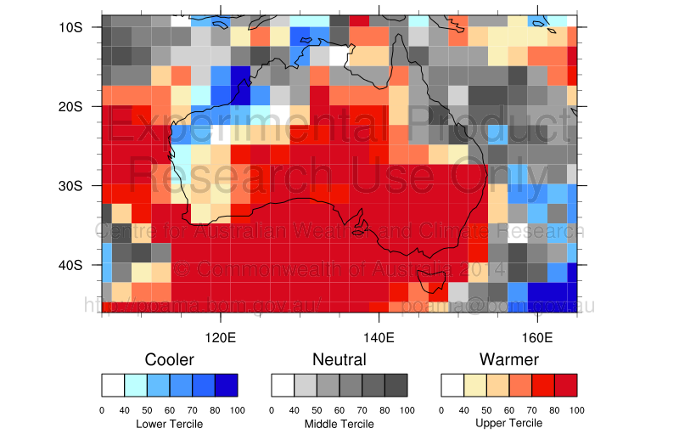

Likelihood of drier, neutral or wetter conditions: mid to late Jan 2014
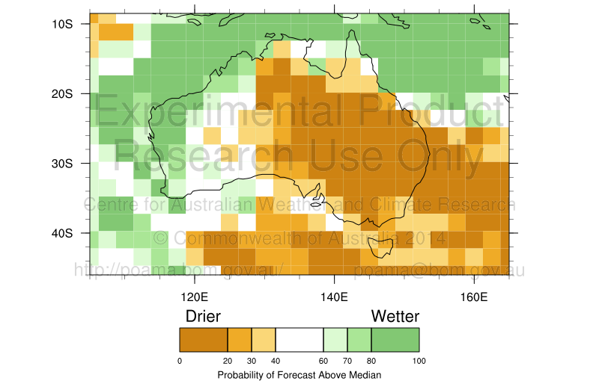
This period saw a record heatwave in Victoria, and coincided with the large scale fire outbreaks in western areas including the Grampians. The actual recorded temperatures (provided below) for the same period highlight the warmer than average conditions for that time of year experienced in the south east of the country.

Actual temperature anomalies (or departures from average): mid to late Jan 2014
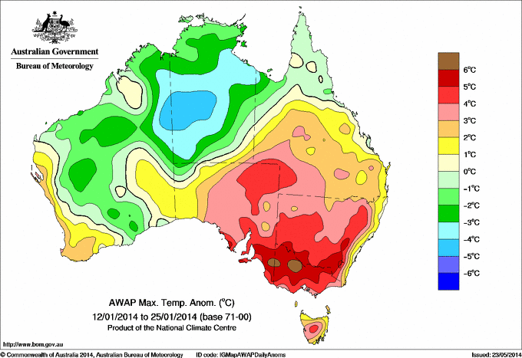

Seasonal climate forecasting models perform best when there are clear climate influences operating, such as a strong El Nino Southern Oscillation (ENSO) signal or a strong monsoon signal. Conversely, the models perform less well when these climate drivers are weak (or neutral).The Bureau’s seasonal forecasting model is undergoing continuous research and development and its accuracy is expected to increase over time. Investment in this area of research and development has declined in recent years, so model skill improvements are slowing. Increased investment could reverse this trend and bring forward significant benefits for disaster preparedness.

Informing urban planning and infrastructure design
Using its rainfall and flood records, including documented extreme rainfall events, the Bureau produces rainfall estimates for various frequencies of occurrences, e.g. a one in 100 year event. Such design rainfall estimates are used to carry out flood mapping, which in turn provides the information base for effective land-use / urban planning and risk assessment. By applying these design rainfall estimates, civil engineers are able to design infrastructure such as bridges, culverts, roofs, stormwater drains, flood levees, and retarding basins in consideration of the risks associated with extreme rainfall and flooding in that location.
In June 2013, the Bureau completed a four-year project to revise rainfall estimates for Australia as part of a broader project to update the Engineers Australia Australian Rainfall and Runoff handbook for civil engineers. The completion of the revision was funded by the Australian Government in association with the National Flood Risk Information Project (NFRIP). By giving engineers reliable information on the regular and extreme rainfall conditions likely in a particular area, the resultant infrastructure is more likely to be fit for purpose and to withstand extreme events. The revision will also help users understand potential changes to flood risk in the long term from possible climate change impacts.
Analysis of the Bureau’s climate records such as wind speed, rainfall, temperature, humidity and severe weather is used in infrastructure design and building standards, for example wind loadings, rainfall intensity-frequency- durations for drainage and dam design and occurrence of hail for building design.

Commercial services supporting risk management decisions for business
In recent years, the Bureau has begun to increase its business development capability to better meet the needs of private industry through tailored commercial arrangements, including for disaster preparedness and to mitigate the impact of severe weather events. An example of a possible area for future growth is the provision of improved weather services to the oil and gas industry, particularly off Australia’s north western shelf.
Case Study - Commercial weather services–Woodside towing forecast
In March 2013, the Bureau provided Woodside with a series of tailored high-resolution forecasts to enable the successful placement of its North Rankin B gas platform onto the seabed off the northwest coast of Australia. Weighing 58 000 tonnes and measuring 100 m in length, 50 m in width and 80 m in height, North Rankin B is the largest offshore platform in the world. It stands in water depths of about 125 m and operates in one of the most cyclone prone areas of the world.
In order to place the platform on the pylons already embedded in the seabed, Woodside had to float the superstructure on a barge from Indonesia to its final location. This required a seven-day window of good weather for the passage across the Indian Ocean and a further three days of near calm conditions to settle the platform in place.
To maximise the success of the tow operation, Bureau forecasters gave Woodside a three week outlook for the prospects of tropical cyclone activity and identified a safe window for towing. For the tow period, the Bureau produced tailored forecasts of wind speed and direction, plus swell height and direction on a daily basis. For the float operation, three hourly forecasts were provided to Woodside over the three-day period.
As a result of the high quality forecasts, the installation was completed without any impact or lost time due to severe weather.

Services to the insurance sector
The insurance industry is a very sophisticated user of the climate data in an effort to understand the frequency and impact of past events and to develop risk indices, in turn applying these to policies issued to asset owners.
The Bureau also provides support to the insurance industry for claims assessment after an event such as a flood or severe thunderstorm on a cost-recovered basis. A cost recovered Thunderstorm Confirmation Service is available on a subscription basis to the insurance industry.

Future Service Delivery
The Bureau is continuing to investigate and develop options to improve its services to better help Australians respond to the threat and risks associated with natural disasters and to increase the nation’s resilience. These may include:
- intra-seasonal forecast products that will bridge the current gap between seven day and three month forecasts, to provide earlier notice of potential disaster conditions;
- improved monitoring and analysis of extreme climate events;
- improved tools and education to support users in maximising use of the Bureau’s probabilistic climate forecasts;
- the introduction of more tailored forecasts for communities as part of a hazard impact service;
- delivery of warnings through mobile platforms and social media to allow people to access important information quickly, anytime, anywhere – especially important for rapid onset events;
- improved use of graphical warning products to help people better understand the threat of severe weather;
- improved community engagement and education, including through the Bureau's Facebook account and blog, such as through recent tropical cyclone awareness bushfire weather campaigns;
- engagement and liaison with Indigenous groups to ensure that the Bureau’s products are relevant and understood by Indigenous communities;
- building capability to educate, prepare, warn and activate emergency plans on behalf of people who are vulnerable or who may have special needs in the event of an emergency, including older and young persons, the homeless, culturally and linguistically diverse groups, and people who have a mental or physical disability.

TOR 3: Funding arrangements and interactions
  - The interaction between Commonwealth natural disaster funding arrangements and relevant Commonwealth/state financial arrangements

Cost recovery in disaster related activities
Although the majority of Bureau products and services provided to support disaster and hazard management are funded through appropriation, some additional services are provided to support the emergency management activities undertaken by State and Territory governments. Examples of these services include those provided in support of prescribed burns and the embedding of forecasters in State and Territory emergency services control centres (see case study below). Any initiatives designed to mitigate the impact of natural disasters should allow for the full costs of service provision, including the cost of the Bureau’s services where these fall outside standard services. The Bureau’s standard services include the meteorological and related information that the Bureau provides for the benefit of the community at large in fulfilment of its general public interest responsibilities under The Meteorological Act 1955. The Bureau undertakes cost recovery or charges commercial rates for services that fall outside the standard set.

Case Study - ’Embedded’ briefing and forecasting during critical events
In Victoria, the most critical weather events are usually those involving extreme fire weather or floods, although destructive winds, large hail, heavy rain causing flash flooding, and occasional tornadoes are also problematic.
The Bureau’s Victorian Regional Office uses an ‘embedded’ meteorologist at the State Control Centre (SCC) to provide targeted forecasting and briefing services in emergency situations. This service is funded by Victorian fire agencies under a Memorandum of Understanding with the Bureau.
The SCC is a shared facility operated by the Victorian Fire Services Commissioner where all State emergency management agencies conduct their emergency command and control functions side by side, facilitating improved inter-agency operability, communication, and collaboration. The Bureau’s role at the control centre is to provide the most up-to-date weather information in various forms to meet the evolving needs of emergency managers.
During the summer season —November to April —the embedded SCC meteorologist focuses on providing fire weather and severe weather briefing services. These include preparation of regular daily forecast products, delivery of formal face-to-face briefings, alerting emergency managers to upcoming periods of potential heightened fire danger or other severe weather risk, and assisting fire behaviour analysts in fine-tuning their fire spread behaviour models.
During the transition season —May to October —the Bureau meteorologist assists fire agencies with planned burning operations while maintaining the severe weather briefing services for events such as floods. Meteorological training for partner agencies is also conducted during the cooler months.

Standardisation of the Bureau’s hazard services to State & Territory Emergency Services
Due to factors including the Bureau’s devolved regional structure, varying susceptibility to hazards and varying local capability and emergency management arrangements there have been some inconsistencies in the services provided in each jurisdiction and the levels of cost-recovery undertaken. In its response to recent Review of the Bureau of Meteorology’s capacity to respond to future extreme weather and natural disaster events and to provide seasonal forecasting services, (the Munro Review), the Australian Government provided funding to allow the Bureau to formalise and standardise service levels provided to emergency services, agree clear allocation of responsibilities to State and Local Government for flood management and apply a consistent cost recovery model to all services delivered to state and territory fire agencies.
This work has commenced though a Taskforce established in October 2013 under the Australia-New Zealand Emergency Management Committee (ANZEMC) reporting to the Law, Crime and Community Safety Council under the Council of Australian Governments (COAG). The Taskforce, jointly chaired by the Bureau and the Australian Attorney-General’s Department, will make its final report to the ANZEMC in October 2014.

TOR 4: Options for balanced recovery and mitigation expenditure
  - Options to achieve an effective and sustainable balance of natural disaster recovery and mitigation expenditure to build the resilience of communities, including through improved risk assessments. The options should assess the relationship between improved mitigation and the cost of general insurance.
  - a. How business, the community, Commonwealth, state, territory and local governments can most effectively fund natural disaster recovery and mitigation initiatives;
N/A
  - b. How to ensure the right incentives are in place to support cost-effective decision making within and across all levels of government, business, non-government organisations and private individuals;
N/A
  - c. Mechanisms and models to prioritise mitigation opportunities and evaluate the costs and benefits of a range of mitigation options;

Prioritising mitigation opportunities
As the custodian of Australia’s historic climatological record, the Bureau has the capability to observe trends in climate phenomena to assist in determining likely risk associated with severe weather events. For example, by providing data on the impact of cyclones across Australia in recent decades (see map below), authorities can identify which communities are at greatest risk. By combining this data with other risk factors such as the topography and nature of the urban landscape, objective decisions about the priority of mitigation activities can be made.
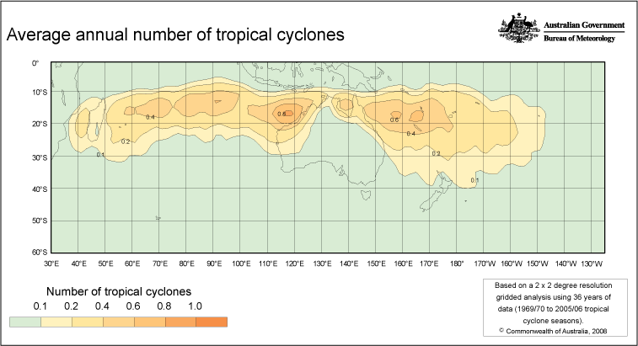
By monitoring and understanding changes in climate patterns, the Bureau’s information services can also better inform of changes in risks to assist in the determination of where mitigation funding may be best targeted. For example, analysis of trends in long-term observations of sea level rise can assist in identifying change in the risk to coastal infrastructure from storm surge, leading to enhanced coastal planning in the longer-term.
The Bureau supports the concept that the development of mitigation activities, including warning services, should be based on need and driven by properly assessed residual risks. A nationally consistent risk assessment framework is vital to have fair distribution of funds commensurate with real risk. The Bureau has contributed actively to COAG-initiated mechanisms for risk assessment such as under the National Risk Assessment Advisory Group. Its role in recent years has been diminished and should be strengthened to provide the best possible information in assisting and contributing to national approaches and local initiatives.

Evaluating the benefits of meteorological services in disaster mitigation
While the costs associated with natural disasters can be reasonably estimated, the costs avoided, and lives saved as a result of effective mitigation and protection measures is more difficult to assess. What can be seen however is that some of the impact from recent events has been much lower than those of the past. During cyclone Tracy of December 1974, 65 lives were lost and most of Darwin was destroyed, but there have been no deaths directly caused by cyclones in recent years. While a lot of factors have contributed to the change, particularly improvements in building standards, the benefits of early warning systems to enable people to prepare, mitigate potential impacts and to seek shelter or evacuate is having a profound effect.
Around the world, the vast majority of natural hazard events are weather or ocean related with virtually all disasters weather affected or exacerbated. A recent World Bank study estimated that in Europe, hydro-meteorological information and early warning systems save several hundreds of lives, avoid between 460 million and 2.7 billion Euros worth of disaster asset losses, and produce between 3.4 and 34 billion Euros worth of additional benefits per year through the optimisation of economic production in weather-sensitive sectors [A Cost Effective Solution to Reduce Disaster Losses in Developing Countries: Hydro-Meteorological Services, Early Warning, and Evacuation (May 2012)].

  - d. Options for urban planning, land use policy and infrastructure investment that support cost-effective risk management and understanding of the changes to the risk profile;

Changes to the risk profile
Due to the influences of El Niño and La Niña events, Australia’s climate is characterised by large year to year variability. These often manifest through long periods of dry and wet conditions and pose challenges for governments, industries and our communities.
The latest climate science indicates there will be changes in the frequency and intensity of extreme events. This will likely change the risk profile of natural disaster events in different locations across Australia.
Disaster impacts reflect a complex interaction between many factors. These factors include the frequency and amplitude of natural disaster and extreme events, the extent to which humans are exposed to these events, and the number, quality and value of assets.
Focusing on the occurrence of extreme weather and climate events, it is evident that some are increasing in frequency and intensity. These include severe fire weather days in southern Australia and extreme heat. Others events are expected to increase as a result of climate trends, including flash flooding (due to rising moisture levels in the atmosphere) and coastal inundation (due to rising sea level). There are dangers in drawing conclusions about future trends from past trends, without suitable care. It is difficult to draw conclusions regarding changes in the frequency and intensity of tropical cyclones in the Australian region because of the shortness of the satellite record, changes in historical methods of analysis, and the high variability in tropical cyclone numbers. The research on cyclone frequency in the Australian region is equivocal, with some studies suggesting no change and others a decrease in numbers since the 1970s. Fewer tropical cyclones are projected for the Australian region, on average, with an increased proportion of intense cyclones. However, confidence in tropical cyclone projections is low.

Increasing demand for services to mitigate risk
One approach to mitigating changes in the risk profile caused by climate variability and change is to continue to improve early warning capability provided by weather and climate models. Early warning systems are an effective and cost-efficient means of mitigating the impacts of such changes. These models, already operational within the Bureau, provide forecasts for up to 10 days ahead and are now a mainstay of emergency response systems.
The Bureau’s climate data and information underpins decision making with large economic consequences. For example, certified data extracts are provided for legal and court purposes and the Bureau is frequently called upon to verify insurance claim information - with all major Insurance companies subscribing to this user pays service.
There is often a mandated requirement or industry standards requiring the use of climate data for the planning and design of infrastructure projects with large safety and economic consequences. For example:
- The Bureau is the 'owner' and primary provider of Australian techniques to estimate quantitative guidance on design rainfalls. The water engineering sector looks to the Bureau to give this quantitative advice which underpins their safety assessments for large dams, roads, bridges, tunnels and drainage.
- The offshore oil and gas industries rely on the Bureau's information on expected significant wave occurrence that must be built into the safe and effective design of their platforms.
- Mining operations require climate information such as wind to calculate noise levels impacting neighbouring areas under mandated environmental assessments and rainfall estimates help ensure the profitable and safe operation of mines.
- Predicting energy demand is highly dependent on maximum temperature and using historical data can help inform likely situations to plan for.
The Bureau is also working with CSIRO to develop climate projections for a range of variables for Australia, based on latest science and modelling capabilities. Projections information will assist in understanding likely future change to risk profiles to enhance land-use planning and long-term investment in infrastructure.

  - e. Options to fund identified natural disaster recovery and mitigation needs, including thresholds for triggering Commonwealth assistance to the states and territories;
N/A

TOR 5: Projected impacts of identified options
  - Projected medium and long term impacts of identified options on the Australian economy and costs for governments as compared to impacts of the current funding arrangements.
N/A

TOR 6: Options for implementing proposed reforms
  - Options for transitioning to and implementing any proposed reforms to national natural disaster funding arrangements.
N/A

