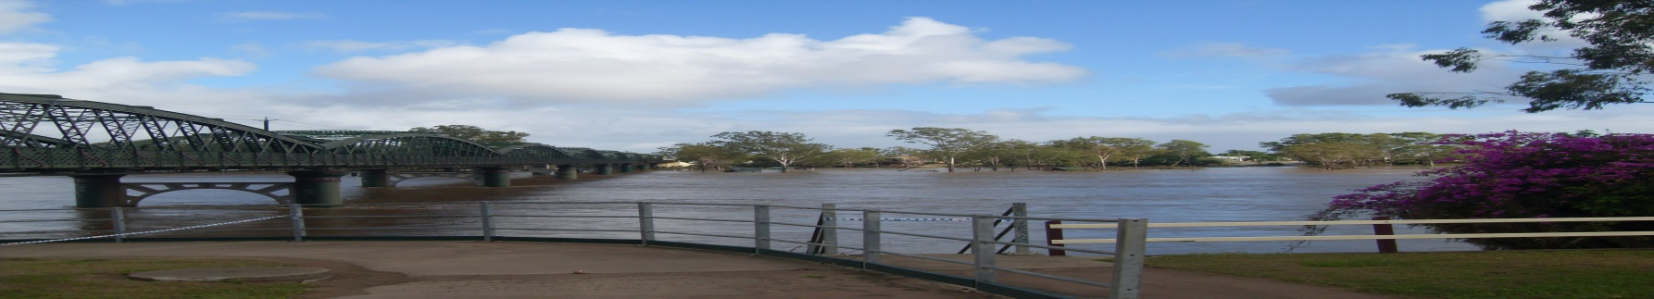
BURNETT RIVER COMMUNITIES FLOOD PREVENTION
ORGANISATION INC. No: IA41525
Postal Address: PO Box 7395 Bundaberg North Qld 4670
President: Warren Osborne
Secretary: Audrey Henderson
Publicity Officer: Christine Hardy

The Productivity Commissioner
Natural Disaster Funding
Dear Sir/Madam,
We, of the above-named organization are writing to you with the concerns of a vast majority of residents in the Bundaberg Region, in particular those affected by the 2013 Floods. Our group was first officially formed in November 2013 when it was perceived that efforts to manage disaster struck areas, were greatly inadequate and sometimes ignored.
Our major request is that accountability and transparency of the funds given to the Bundaberg Regional Council for flood mitigation be made available for public perusal. To date, few if any of the original forty recommendations for flood mitigation , put forward by GHD (the engineering company hired to do the necessary research into alleviating flood damage) which was subsequently given to CRG (community representative group); by whom these recommendations were whittled down to five options.
As a very concerned representative group we have had numerous meetings with the Mayor Mal Forman and Local Councillors; with the State Government Representatives, Mr Jack Dempsey, Mr Stephen Bennett and the Federal Representative, Mr Keith Pitt. A petition was signed by more than 6000 residents in 2013, and has been presented in State Parliament. We see local roads being upgraded, many of which were not flooded. This is not mitigation!
Our information on actual Funding amounts, we have learnt from the local media. A summary of this is printed below.

MEDIA DATE AMOUNT PURPOSE
The News Mail 28 June 2013 5 Million Promised by Minister Crisafulli for Counselling
The News Mail 28 June 2013 8 Million To be used by the Local Council for an Evacuation Centre.
The News Mail 31 July 2013 25 Million 2010/2011 Flood Information given by Minister Crisafulli.
The News Mail 31 July 2013 40 Million 2013 Flood (as above)
The News Mail 18 Jan 2013 04 Million Repair of Hanbury Street (entrance to flood plain).
The News Mail 07 Feb 2014 4.9 Million Repair of damaged rock wall at Port Bundaberg.
The News Mail 06 March 2014 90 Million Rubyanna Sewerage Plant, to be done in stages.
The News Mail 28 March 2014 no estimate Restoration of Riverside Recreation Park
The News Mail 17 April 2014 no estimate Council to buy land for levee in Technology Park. Media Release 24 June 2014 56 Million Betterment program. Copy to be sent under
Separate cover

These are but some of the statements made by the incumbent politicians to the general public. The contradictions in the information are, to say the least, confusing. We are not seeing results in the areas that were most severely inundated, particularly in North, East and South Bundaberg.
Where is the Mitigation? Where is the Betterment?
This is an overview of the situation as perceived by the local residents. Nothing has been done in Mitigation works in 4 years from the 2010/2011 floods up to and including the 2013 disaster.
Awaiting your professional consideration.
Warren Osborne
President
Friday 10 October 2014

