

**Response to the Productivity Commission’s Draft Report on Natural Disaster Funding Reform**

Risk Frontiers, Macquarie University

**Table of Contents**

General Comments 1

Risk Frontiers 2

Our Key Issues 3

Specific issues: 6

Appendix 1 – Is multi-criteria decision analysis good enough for government decision-making? 19

# General Comments

Risk Frontiers is an independent R&D company based at Macquarie University. It enjoys wide support within the insurance industry but the views expressed here are those of Risk Frontiers and should in no way be construed as reflecting those of our sponsor companies or those of the Insurance Council of Australia.

In responding to the Productivity Commission’s draft report (the “Report”), we limit our comments to only a few of the many issues raised, concentrating on those where our experience and credentials are most relevant.

In general, however, Risk Frontiers support both the Productivity Commission’s (“PC” or “the Commission”) Terms of Reference and the Key Points of its conclusions.

The Terms of reference state that:

*The impacts and costs of extreme weather events can be expected to increase in the future with population growth and the expanding urbanisation of coastlines and mountain districts near our cities.*

This statement is consistent with the theme of a great deal of research work undertaken by Risk Frontiers over the last 20 years.

In general we find the Commission’s arguments persuasive and intelligently argued, in particular its identification of weaknesses in land-use planning practices, its support for making hazard data more generally available to the public, preference for pre-funding of mitigation measures rather than post-event handouts, and in trying to get the incentives right to encourage effective risk management at all levels.

Thus in what follows we restrict our responses to what might be generally considered fine points of disagreement. Page, Box and Figure numbers refer to the Report.

This document is constructed as follow: it first briefly describes Risk Frontiers and our interests in the subject matter considered by the Commission. It then lists some issues that in our view warrant clarification or correction. This is followed by more detailed commentary where required. In the Appendix we explore in more detail the role of Multi-Criteria Decision-Making vis-à-vis Cost Benefit Analysis for government investment and policy decision-making.

# Risk Frontiers

Risk Frontiers is an independent Research & Development company that was created to aid better understanding and pricing of natural hazard risks in the Asia-Pacific region. It was founded in 1994 to service the specialised needs of its sponsors in the local insurance and international reinsurance markets. It now undertakes studies on a much wider range of risk-related problems and for a client base that extends beyond the insurance sector, including government and emergency management.

Risk Frontiers’ research and model developments are geared towards providing:

• databases and tools to promote risk-informed underwriting in relation to natural perils

• applications of advanced geospatial and image analysis tools

• multi-peril Probable Maximum Loss (PML) modelling, and

• promoting risk-informed decision-making and the responsible management of natural hazard risks.

Risk Frontiers is based at Macquarie University where it enjoys close collaborative links with a number of key academics. The Centre is self-funded.

# Our Key Issues

**1.** The PC recommends dispersing mitigation funding on a per capita basis. We can do a lot better than this using a risk-based framework. Risk Frontiers’ catastrophe loss models, for example, which help guide insurance negotiations over the cost of risk transfer, could be used for this task. The catastrophe loss models cost risk transfer as a function of the Average Recurrence Interval of losses. Risk Frontiers has already undertaken some work of this kind for the Queensland Department of Community Safety.

**2.** The Insurance Council of Australia (ICA) normalised insurance losses are cited many times in the report and generally used sensibly.

The Commission should acknowledge Risk Frontiers’ role in the creation of these figures. The underlying work was funded by the ICA and carried out by and at the initiative of Risk Frontiers. The correct citation in our view would be:

*Source: ICA/Risk Frontiers* (or vice-versa)*.*

**3**. To our mind, Cost-benefit Analysis (CBA), the default methodology for investment analysis for finance and economics, is given a rather extravagant degree of ‘airtime’ in the Report and to the detriment of Multi-Criteria Decision Analysis (MCA), which is criticized on the basis of a single submission to the Commission. To our mind, these criticisms are invalid and fail to recognise the explosion of research advances achieved in the field of MCA.

MCA is a decision framework for dealing with complex problems with sometimes conflicting criteria and different stakeholders. It can encompass CBA outputs for those decision attributes that can be sensibly monetised, and combine these with assessments of the more intangible, but nonetheless often important, attributes where CBA is wanting. It can do so in a mathematically rigorous manner.

Indeed CBA itself has many *points de faiblesse* that are rarely acknowledged. In later discussion we list some of these shortcomings

**4.** Little consideration in the Report is given to national initiatives. In our view this will lead to further inconsistencies in the funding of mitigation measures, disclosure of natural peril information, and its consideration in land use planning decisions.

One positive example of a national initiative is the National Strategy for Disaster Resilience developed out of COAG’s decision to adopt a *whole-of-nation resilience-based* approach to disaster management. The Department of Communication’s National Map is another.

In the absence of Commonwealth initiatives, it will always be difficult to get States to make concessions to support cross-jurisdictional proposals. A form of the *Tragedy of the Commons* will play out. For example, best practice guidelines for flood modelling, development of decision tools in relation to mitigation priorities, access to information and technology.

**5**. Poor land-use planning is correctly identified as a problem and the fact that natural hazard information is often not considered in the planning of new developments. A graphic example of how poor land-use planning practices has put lives and property at risk is afforded by the outcomes of 2009 Victorian fires. This event resulted in 173 fatalities despite *near perfect* forecasts of fire weather.

A study undertaken by Risk Frontiers for the Royal Commission found that 25% of the homes destroyed in Kinglake and Marysville were located within 1 m of the bushland; 60% lay within 10 m! Here homeowners died under circumstances where they had little to chance of defending homes.

Risk Frontiers closely monitors bushfire building destruction in post-event surveys and we observe the same pattern of destruction repeated again and again, most recently in the Blue Mountains under much more modest fire conditions than those of Victoria in 2009.

**6.** The Report doesn’t find a compelling reason for a national ‘clearing house’ for hazard information (Pages 155- 164). This is a different question to whether information on hazards or risk should be made available and whether or not the Commonwealth should take responsibility for ensuring this takes place. Making this information available as widely as possible is needed to ensure that behaviours match the risk.

The data does not need to be owned by government, but it could take responsibility for making sure that this data is easily visualized and accessible to homeowners. Nation Map is one possible vehicle for this. In the absence of more open disclosure of hazard information, the only way homeowners will learn about their risk is indirectly via insurance premiums that are increasingly risk-informed.

**8.** It is not only local councils who withhold data. The BoM sits on river gauge data, the release of which would be a great impetus to flood modelling. It does so for ostensibly the same reasons as do local councils: IP ownership, data quality and liability issues.

**9.** NFID processes local council flood data to provide water depth above ground level by Average Recurrence Interval (ARI). Where such data is not available, it may only contain depths at one or two ARIs and in others only the extent of flooding in a 1-in-100 year flood. (We note that this 1-in-100 year flood used for land-use planning is not a risk measure – we need to know how the depth changes with ARI.)

Risk Frontiers has been processing council flood data for insurers since the late 1990s and with Willis Re and with the help of the ICA have now accumulated most of the data that is available.

NFID also provides metadata containing a data quality index based on quality of the inputs, resolution of the underlying Digital Elevation Model, etc.

NFID undergoes continuous improvement benefitting from ‘peer-review’ by insurers and also in responding to insurance customer concerns. Many of these concerns are trivial and easily screened out (by the ICA), but others may take up to a week for a trained analyst having access to other more detailed data to reconcile. Any errors found – which usually relate to the quality of the underlying data – are corrected in the next quarterly release. In any event the impost of dealing with these end user enquiries should not be underestimated.

# Specific issues:

**References to the Insurance Council of Australia (ICA) Disaster Losses**

**1.** The Report contains numbers of references to the normalised insurance sector losses caused by natural peril events. These should be explicitly referenced to Risk Frontiers as well as the Insurance Council of Australia (ICA). It was Risk Frontiers’ initiative to create these figures, to develop a credible normalisation methodology (Crompton and McAneney 2008), and to improve upon this in Crompton (2011).

Because of the clear seasonality of most of the weather-dependent perils, which are responsible for some 95% of the losses in the ICA disaster list, the insurance data is accumulated by financial year. It would be therefore instructive if the Report’s figures, for example, Figure 1.1 (Page 46), amongst others, were updated to include 2013-2014 numbers.

It would also be useful for easy comparison, that in at least one place in the Report readers could see the normalized figures in the same form as Figure 1.1 of the Report as shown below:

**Figure 1:** *(a) Raw insurance sector losses aggregated by financial year (July 1 - June 30) for weather related losses (b) as above but normalized to the financial year 2010-11. The final two data points have not been normalized back to 2011 but this makes little difference to the overall pattern.*

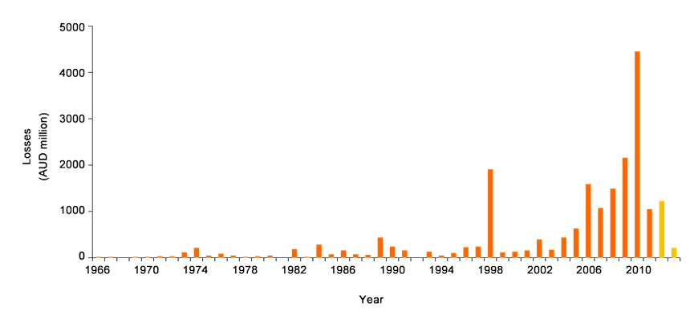

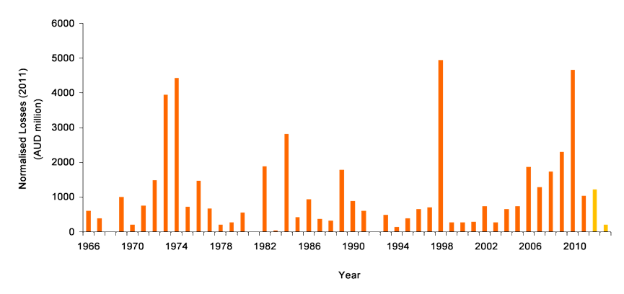

**2.** Figure 2.1 (Page 233) of the Report is potentially misleading. As noted in the Report, inclusion of the ICA natural disaster list is based upon industry losses exceeding a fixed and very low threshold ~ $10 million for most of its history. This being the case, inflation alone will mean more small events are inevitably captured in the database over time as they more easily exceed this threshold. If one adopts a larger threshold, e.g. a $100 million or $250 million loss, then a different and more relevant picture emerges (see Figures 2a and b below). Figure 2b shows the pattern of pre- and post 1990 loss frequencies to be mirror images of each other.

**Figure 2:** *(a) Number of weather-related loss events whose normalised insurance sector loss exceeds $100 million; (b) As for (a) but using a threshold loss of $250 million*

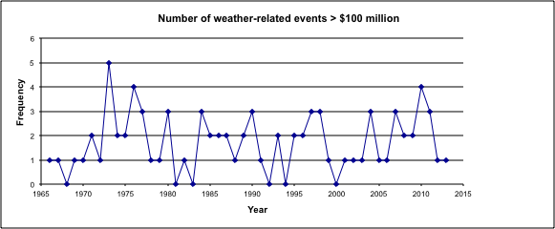

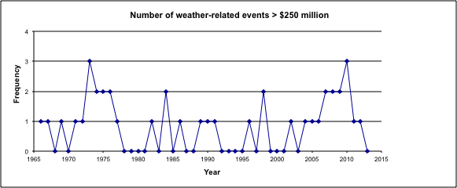

For the sake of completeness, we show the regression analyses, which show no statistical significance, a conclusion that is easily drawn by inspection of the two figures above.

[In confidence, we are happy to share with the Commission, the results of a further study demonstrating the statistical complexities associated with determining changes in frequency and intensity of natural hazard events. The data set is a time series of flood heights reaching back to 1892 from Fiji and which has been recently updated from Yeo *et al.* (2009)[1].]

**Table 1:** *Summary statistics*



This regression shows that there is no statistical relationship between the frequency of weather-related events greater than $100 million and year (F=0.2205, p>0.5). In fact the R2 value is 0.0048 – the regression explains less than 0.5% of the variance in the frequency data.



Same again for events greater than $250 million, but worse. There is no statistical relationship between the frequency of weather-related events greater than $250 million and year (F=0.1052, p>0.5). In fact the R2 value is 0.0023 – the regression explains less than 0.25% of the variance in the frequency data.

**3.** Figure 2.5 (Page 244). We really like this way of presenting the normalised data; it is used many times throughout the Report to good effect and illustrates very clearly what is going on. However, as suggested above we would like to see that the normalised losses to 2011 be shown, along with the more recent losses in their unnormalised form, *in the same form* as Figure 1.1 (p 46) and Figure 2.3 (page 233) (see Figure 1 b of this report).

**4.** Figure 2.6 (Page 245): It is not clear whether normalised losses were used in the creation of this Figure. We suspect that is the case, but this should be made explicit in the figure caption.

[As an aside, the pattern shown in the Figure 2.6 is a natural outcome of the fact that distributions of possible losses are generally ‘heavy- tailed’, and, in practice, often described by a Pareto or some other power-law distribution, rather than the more familiar Normal distribution. This being the case, when ranking losses, the most costly event can be many times greater than the next largest, and so on. This leads to some ‘pathological’ issues in terms of disaster statistics.]

**5.** After citing McAneney and Crompton (2013)[2] on page 266, the Report closes this discussion with the following observation:

*However, climate change is a gradual phenomenon, and it is not surprising that the above study detected no discernible impact over the relatively short period considered.*

We recommend this comment be deleted. While not wrong in itself, its use here casts doubt of the veracity of the previous quote. The quote from McAneney and Crompton (2013) is also true more generally for a much wider body of evidence comprising now some 40 peer-reviewed articles across many different perils and jurisdictions. This includes studies of over a century of normalised economic losses from US hurricanes (Pielke *et al.* 2008) and nearly a century of normalised Australian bushfire home destruction (Crompton *et al.* 2010). Neither of these time series shows any trend over time. The IPCC (SREX report, 2013) comes to the same conclusion.

The correct citation to McAneney and Crompton (2013) is given in footnote 2.

**6**. Box 2.3 (Page 233) -- Sources of Data.

This box does not reference *PerilAUS*, a proprietary database developed by Risk Frontiers staff since its inception. *PerilAus* is the most authoritative data source on Australian natural hazard events that have caused *either* loss of life or property damage. It considers 12 perils:

* Bushfire
* Earthquake
* Flood
* (Wind)gust
* Hail
* Heatwave
* Landslide
* Lightening
* Rain
* Tornado
* Tropical Cyclone
* Tsunami

As of 16 October-2014, *PerilAUS* contains:

* 16,281 events
* 14,513 events from 1900, and
* 18,645 references

*PerilAUS* is considered complete since 1900. It is maintained and updated by two full-time archivists at the expense of Risk Frontiers.

Work based on *PerilAUS* has spawned numerous peer-reviewed scientific papers, some of which played important roles in presentations to the Royal Commission into the 2009 Victorian Bushfires (Haynes *et al.* 2009; Crompton *et al.* 2010)[3].

**7.** Parametric and Index-based Insurance

Box 63 (Page 374): We commend the Commission consideration of these instruments. The Commission may find useful Chapter 5 of the McAneney *et al.* (2013)**[4]** report on research undertaken for the National Climate Change Adaptation and Research Facility into *Market-based mechanisms for climate change adaptation*. That chapter examines the securitization and possible pricing of a hypothetical catastrophe bond dealing with the flood risk on the Hawkesbury-Nepean catchment.

**8.** Data sharing

On Page 162 it is stated*:*

*There is evidence of governments and private providers duplicating efforts in information collection. The Australian Government initiated the National Flood Risk Information Project in 2012 to improve the quality, availability and accessibility of flood information, and to raise community awareness of flood risks (box 4.1). Australian insurers have also developed a flood database — the National Flood Information Database, which was commissioned by the Insurance Council of Australia and developed by Risk Frontiers and Willis Re. Participants suggested that there is some duplication in the content of the two databases*.

We do not believe there is duplication, in the sense that NFRIP contains no data, whereas the National Flood Information Database (NFID) does: it provides flood hazard information at a street address level based on the Geo-located National Address File (G-NAF) identifiers. That is also the case for Risk Frontiers’ Flood Exclusion Zone (FEZ) database, which maps addresses to either within or outside of floodplains (a binary outcome) and does this in a nationally consistent manner. Both NFID and FEZ could provide the data content for NFRIP for either government or public use. We will come back to this point in later discussion.

9. Lessons from other countries: Table 9.3 (Pages 491 and 492)

Some minor mistakes:

a) Table 9.3 (Page 491) Government-backed insurance schemes for natural disasters – selected examples

In Row 2 (United States (national)): NFIP is described incorrectly as a “reinsurance program”. In fact it is an *insurance* programme and in Column 2 (Scheme), the correct name should be given as:

*National Flood Insurance Program* (NFIP).

In the column labeled *Government involvement* the description reads: “*Reinsurance* of flood policies - - -“. This is again incorrect and should read:

*NFIP polices are sold by commercial insurers at subsidized rates.*

**Background:**

The scheme is considered to be an insurance program administered by the Federal Emergency Management Agency (FEMA), and not a reinsurance program. Flood insurance in the US has been provided mainly by the government, since the establishment of the NFIP program in 1968 as a voluntary partnership between federal government and local communities. Private insurance companies have played a large role in selling and servicing policies on behalf of the NFIP.

In addition to riverine flood, the scheme also covers damage to coastal properties due to storm surge.

In a partnership between NFIP and more than 80 private insurance companies, NFIP flood policies are issued through the Write-Your-Own program. The insurers write the policies, and act as claims managers on behalf of the NFIP, and NFIP underwrites the losses. The private insurers do not bear any of the risk, and receive an “expenses allowance” for participating in the program

Pricing is set by NFIP and varies by contract, flood zone and building characteristics. Rates have been less than actuarially sound. The Biggert-Waters Flood Insurance Reform Act of July 2012 attempted to correct this, but in 2014 the Homeowner Flood Insurance Affordability Act reversed proposed rate increases[5].

b) Table 9.3 (Page 492)

(France – *Caisse Centrale de Réassurance*) Clarification is required between the operations of the CCR and the Cat Nat scheme, and the pricing.

Background

The CCR is a French state-owned limited liability reinsurance company created in 1946 that was included in the Cat Nat scheme for disaster cover in 1982. The Cat Nat system was introduced by the French government in 1982 to provide non-risk-based, uniformly priced “uninsurable risks” cover to all French homeowners (the principle of solidarity):

The Cat Nat is a different kind of public/private partnership from the one described above. It requires private insurers to offer “uninsurable risks” cover as an addition to all fire and damages to property and automobile insurance policies, in return for commissions. Policy holders pay private insurers (not the CCR); rates are set by decree at 12% of the sum insured. To protect private insurers from the risk of insolvency they are given the option of transferring a proportion of that risk to the state-owned reinsurer CCR or to private reinsurers. The CCR enjoys an unlimited government guarantee and subsidized reinsurance rates.

CCR has a 50% quota-share arrangement with private insurers; a further 1.5% of the premium collected pays for a stop-loss cover. This means that insurers can transfer 50% of their catastrophe risk and pay the CCR 51.5% of the premium received. The CCR will cover 50% of the insurer’s losses beyond the stop-loss limit.[6]

**10**. Geoscience Australia’s Portal (NFRIP)

The original stated purpose in 2012 of the NFRIP portal was to “make it easier to find existing flood mapping information” as a central point of public access to flood hazard data and flood related imagery.

Since 2004, Geoscience Australia (GA) had a pre-existing **Australian Flood Studies Database**. This was a list of engineering studies known to GA – with no access to data or the engineering reports. Phase 2 of the NFRIP was meant[7] to enable “enhancements to the Australian Flood Studies Database to enable the display and download of available flood mapping.”

Development of the NFRIP has been slow, its functionality is poor and the portal has since been supplanted by better technology and/or better implementations of the same technologies; for example, the ICA’s national DataGlobe, the Queensland Reconstruction Authority’s QuickMap, and that of several local governments (e.g. Moreton Bay Regional Council) with less latency, fewer errors and more data. Additionally the ICA platform also supports the overlay of multiple addresses (for licensees of the Geocoded National Address File (GNAF)) showing residents the community flood exposure using Risk Frontiers/Willis Re’s National Flood Information Database – NFID.

The NFRIP portal’s lack of current spatial data, even in areas with significant flood risk (e.g. Richmond in New South Wales, where only the engineer’s flood study report is available) reduces the accessibility of flood information to non-expert end users. The complexity of flood reports means it is unlikely that non-expert users will be able to determine their flood exposure, a limitation not shared by the other platforms discussed above.

The current version of NFRIP is little more than the addition of a third party mapping engine to the existing Flood Studies Database. In our view and given the small number of flood studies for which spatial data is provided, the use of a mapping environment to display non-existent data is not helpful. It is not clear who is the consumer of this information.

**11**. Page 165: Communicating information to the public

In this policy reform section, the Productivity Commission correctly highlights the importance of community engagement and the provision of risk communication to enhance public preparedness.

Community engagement and two-way communication is critical in understanding community needs and characteristics. Outcomes from these activities will ensure that risk information is clear, specific and targeted.

In our view emergency management agencies should *also* be tasked with undertaking community engagement activities and two-way dialogue. We say “also” because the Report talks about governments being responsible for engagement activities.

It is our perception that the community engagement activities of the Emergency Services are being de-resourced, and an even greater proportion of their efforts geared towards response. In the case of the Fire Services this is of particular worry, because as we saw in 2009, there is little that the emergency response agencies can do to affect outcomes under extreme fire weather conditions, even with near perfect weather forecasts. It is under these sorts of conditions that most bushfire damage occurs, with 10 events since 1925 accounting for nearly 80% of the total damage in normalised building destruction. This being the case, more effort, not less, should be devoted to preparing communities for these scenarios. Then when fire conditions get really bad, much of the emergency services work will have already been done leading to more resilient communities.

**12.** Box 4.9

This needs an additional entry to cover Catastrophe Loss Modelling

Suggestion:

*Risk Frontiers has loss models to help insurers and reinsurers price the risk from natural perils. Risk Frontiers’ Australian suite of models covers the pricing of losses from Earthquake, Tropical Cyclones, Hail, Bushfire and Riverine Flood. Some international loss modelling companies such as RMS, AIR, EQECAT and Impact Forecasting (Aon Benfield) also provide models for select perils. These models are used to inform both premium pricing and reinsurance pricing for risk transfer. These models could also be used to inform government decisions in respect of mitigation priorities and to help the Commonwealth in its disbursement of funding to States under its Natural Disaster Relief and Recovery Arrangements (NDRRA). These could be made on the basis of risk rather than population.*

**13.** Box 4.2 Natural hazard information and research

Risk Frontiers and also *PerilAUS ˆand FEZ are* missing.

*Risk Frontiers:*

*The PerilAUS database catalogues natural hazard event loss information for any event that has caused either loss of life or material property damage. PerilAUS is considered complete since 1900.*

*Identifies in the Flood Exclusion Zone (FEZ) database addresses located either on floodplains or beyond the extent of flooding in a Maximum Possible Flood.*

Also the entry for Geoscience Australia is incorrect. GA does not collect flood information or undertake flood hazard mapping. In respect of flood its portal merely directs inquiries to other websites, which may or may not have this information.

**14.** Chapter 5: Natural disaster mitigation

Pages 329-330 of the Report highlight several key points made to the Commission through the submission process. Two of these demand further clarification:

* (dot point 2 on page 329) *Cost–benefit analysis (CBA) is the preferred technique to quantify the potential net benefits of mitigation and to assess the relative merit of mitigation options.*
* (sub-dot 3 of dot point 3 on page 330) *Decision-making processes such as multi-criteria analysis* [MCA] *have been used to identify and prioritise mitigation options. Such methods have limitations and should only be used as a complement to, and not a substitute for, CBA.*

The Report arrives at these summary points after some discussion on pages 344 and 345 with reference to papers by Dobes and Bennett (2009, 2010)[8].

However the arguments that Dobes and Bennett put forward to support a conclusion that MCA has limitations, and therefore that CBA should be the preferred technique for mitigation decision-making, are flawed. They and others were scrutinized n Appendix 1 of Risk Frontiers (2014)[9] and found to be based on an incomplete understanding of the basic theory and improvements in the practice of MCA. The Appendix to Risk Frontiers (2014) has been reproduced in full as an Appendix to this document.

We also note that while CBA has become the default investment analysis methodology for economists, it has a number of flaws and limitations that are rarely acknowledged. For example:

* The ***choice of discount rate*** is a variable, and can be manipulated to arrive at a result of the analyst’s choice. Even within Australian jurisdictions values of between 1.35% and 7% have been mooted.
* ***Uncertainties about future costs and benefits*** may arise from what is not yet known about the project (e.g. the beneficial effects of prescribed burning) or uncertainties in systems so complex that they are essentially unpredictable at this juncture, the local impacts of future climate change, say. Faced with such uncertainties, it is impossible to provide a precise quantification of the benefits of a given policy or project without employing stochastic modelling. This is rarely done.
* ***Ignoring social equity***. CBA assumes that those who stand to gain from a policy change compensate the losers. In so doing it ignores distributional issues, and the fact that, for example, a wealthy person would be able, and therefore willing to pay more than a poor person for the same improvement in, say, health or environmental quality, even though both cared about it with equal intensity.
* ***Pricing qualitative and incomparable quantities***. The costs and benefits of environmental and social policies are usually not easily expressed in comparable units. While the costs are frequently well defined in economic terms, benefits frequently involve fundamentally non-monetary values, such as human lives saved, or ethical concerns about endangered species. [MCA allows for these decision attributes to be compared in a mathematically rigorous manner with each other and with output from a CBA for ‘monetisable’ attributes.]

In our view CBA is not nearly as perfect as suggested in the Report, nor is MCA as limited as has been claimed in submissions to the Commission. Indeed, on page 345 the Report states that

*… there may be merit in an MCA complementing the use of CBA. Some literature on decision-making methodologies for disaster risk mitigation has explored the use of MCA in combination with CBA to analyse projects where not all of the attributes of the decision can be monetised (Risk Frontiers 2014a).*

It seems eminently sensible to use CBA to evaluate those costs and benefits of the project that can be sensibly monetised, and MCA to evaluate the more intangible (e.g. social, environmental, psychological) costs and benefits. Risk Frontiers (2014) propose ways in which the two methodologies may be rigorously combined.

Therefore we suggest that dot point on point 2 on page 329 be amended to state

* + *Cost–benefit analysis (CBA) is the preferred technique to quantify the potential direct costs and ~~net~~ benefits of mitigation, while MCA is the generally preferred technique to evaluate intangible (social, environmental) costs and benefits. The two methodologies should be combined ~~and~~ to assess the relative merit of mitigation options.*

And that sub-dot 3 of dot point 3 on page 330 be deleted

* + *~~Decision-making processes such as multi-criteria analysis have been used to identify and prioritise mitigation options. Such methods have limitations and should only be used as a complement to, and not a substitute for, CBA.~~*

Furthermore, given that several pages are allocated to describing how to conduct a CBA and good practice in CBA, a similar allocation of space should be apportioned to MCA. Chapter 3 of Risk Frontiers (2014) might provide a starting point for this.

# Appendix 1 – Is multi-criteria decision analysis good enough for government decision-making?

**A1.1 Introduction**

Recent articles by prominent economists in Australia have questioned the use of MCA as a suitable tool for assessing the relative performance of alternative public sector policies or projects (see, for example, Dobes (1999), and Dobes and Bennett (2009, 2010a and 2010b)). They propose cost-benefit analysis (CBA) as the preferred technique.

MCA should be understood as a generalised form of cost-benefit analysis. Whereas in CBA the costs and benefits associated with a project are all *monetised* to a market price (in the case of factors involving marketed goods or services) or a willingness-to-pay (in the case of non-marketed goods or services), in MCA the costs and benefits from a project need not be expressed in money terms, but could take on any *quantitative or qualitative value*. Both quantitative and qualitative values are generally mapped onto a quantitative value scale on the unit interval, which represents the desirability *to the decision maker* of the level of the attribute. This value function need not be linear. The numerical gaps between the scaled values when comparing projects represent the difference in the impact of the projects with respect to the attribute.

This appendix will assess the assertions by Dobes (1999), and Dobes and Bennett (2009, 2010a and 2010b).

**A1.2 What MCA is and is not**

Understanding and structuring complex problems well, and considering multiple criteria explicitly, leads to more informed and better decisions. MCA tools were developed *not*, as the critics referenced above imply, because of the practical difficulties and philosophical qualms of using money as a metric for comparing net benefits from competing resource use options (Dobes and Bennett, 2009, pp.20-21). Rather, the purpose of the MCA discipline is to support decision makers facing complex decision and planning problems involving multiple and often conflicting criteria. Thus the aim of MCA is as much about understanding and structuring the problem as it is about evaluating the alternatives through mathematical tools. CBA places no emphasis on structuring the problem – its sole objective is to provide a methodology to assess and compare the present value of costs and benefits arising from one or more proposed projects.

Typically, a unique optimal solution for such multi-criteria problems may not exist, and it is necessary to use the decision maker’s own preferences to differentiate between solution options. This naturally introduces a degree of subjectivity into the analysis. The end result is a choice (or rank ordering) out of a number of alternative options that is *best for the decision maker*.

But this is how real-life political decisions are made: decision makers from different persuasions are likely to view a complex problem in varying ways, and are likely to weigh similar criteria quite differently. Opposing political parties may arrive at completely different decision outcomes regarding a given policy action. Even if they viewed the decision in the same way, their political agendas would necessarily lead to different weightings of some key criteria, often leading to different decision outcomes. No amount of cost-benefit analysis would lead both parties to the same, “correct” decision.

MCA allows a decision maker to assimilate all the relevant objectives and attributes for the decision problem, and determine the attribute weights that best describe their relative importance to the decision maker in the context of the given problem. In this sense MCA models are descriptive in nature. If recorded, the decision making process can be made available for subsequent inspection. Whilst the decision outcome might not appear to be “optimal” or “correct” to some observers, it is at least transparent – an observer can see what criteria or attributes were used to evaluate the alternative options, and which of these criteria were considered most important to the decision maker.

**A1.3 MCA - a fast developing field of research, methodologies, tools and software**

Dobes (1999), and Dobes and Bennett (2009, 2010a and 2010b) highlight several purported shortcomings with MCA. Before examining these issues it is sensible to first explore Dobes and Bennett’s understanding of advances in the field of MCA and its seminal works, based on the references given in their papers. Dobes (1999) refers to ‘two major [MCA} techniques in current use: the goals achievement matrix (GAM) and the planning balance sheet (PBS)’. PBS was developed by Lichfield in 1956 (Lichfield et al., 1975) and the GAM was first developed by Hill in 1966 (Hill, 1968), hardly recent contributions! Whilst the GAM bears some resemblance to modern multi-attribute value theory, neither is considered state-of-the-art today, nor warrants mention in any modern work on MCA.

As a scientific endeavour, MCA has been around since the 1950s. The International Society on Multiple Criteria Decision Making lists a membership of over 2,000 academics, researchers and practitioners from over 100 countries. A bibliometric analysis of publications in MCA fields undertaken in 2008 shows that the output of research articles in this area has increased exponentially since the early 1990s (Figure A1.1).

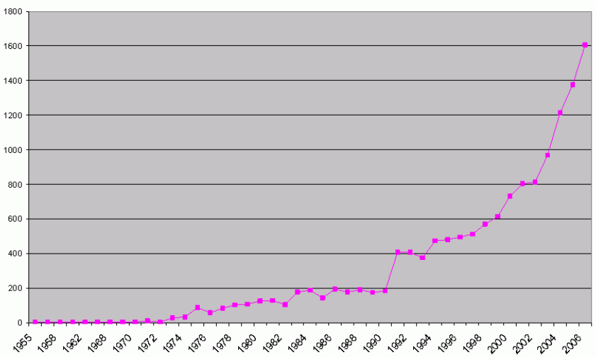

**Figure A1.1:** *Number of research publications in MCA fields, 1955-2007(Source: Bragge et al., 2008).*

If multi-criteria analysis was indeed “atheoretical”, possessing “fatal mathematical flaws”, “founded in conceptual quicksand” and “fundamentally flawed” as asserted by Dobes and Bennett (2009 and 2010a), academic research rivalries would have soon identified these and discredited their mathematical imperfections and practical deficiencies. This has not happened.

Indeed, modern MCA methods have evolved into three broad categories (Belton and Stewart, 2002), only one of which is somewhat related to the references considered by Dobes (1999), and Dobes and Bennett (2009, 2010a and 2010b). These categories, defined in more detail in section 3.2.2 of Chapter 3 of Risk Frontiers (2014), are:

(1) **Value measurement models**. Numerical scores are constructed in order to represent the degree to which one option may be preferred over another. Such scores are developed initially for each individual attribute, and are then synthesized in order to effect aggregation into a higher level preference model. This is the category of models that Dobes and Bennett refer to as “the MCA model”.

(2) **Goal, aspiration or reference level models**. Desirable or satisfactory levels of achievement are established for each attribute. The process then seeks to discover options which are closest to achieving these goals or aspirations.

(3) **Outranking models.** Alternative courses of action are compared pairwise in order to identify the extent to which a preference for one over the other can be asserted. In aggregating such preference information across all relevant attributes, the model seeks to establish the strength of evidence favouring selection of one alternative over another.

Each of the categories above has spawned a multitude of models and tools, and software for their practical implementation now abounds (Weistroffer, Smith and Narula (2005)), indicating a growing practical demand for the methodology and faith in the outputs.

**A1.4 Alleged shortcomings in MCA**

Dobes (1999), and Dobes and Bennett (2009, 2010a and 2010b) highlight several issues that they contend constitute shortcomings with MCA, in particular, the following:

1. MCA has *no established theoretical framework* or uniform set of principles, implying that different analysts can apply quite different criteria for the evaluation of the same project.
2. The weights of the attributes in a MCA are *totally subjective* making it easy for an analyst or decision maker to manipulate the outcome to a pre-favoured result.
3. Whilst CBA is carried out from the viewpoint of society as a whole, MCA has no such *perspective* – the views of certain key or influential stakeholders can easily dominate other interests, and so the model can end up promoting the views of a single group or stakeholder.
4. The attributes in MCA are most often expressed in *different or incompatible units* (like comparing apples and oranges), thus breaching the *dimensionality* principle.
5. MCA is *incapable of comparisons between unrelated programs* (e.g. build a road or a hospital), because their impacts or attributes are most likely to be different.

In what follows these criticisms are discussed in turn.

1. **MCA has *no established theoretical framework* or uniform set of principles, implying that different analysts can apply quite different criteria for the same project.**

In an MCA the usual approach is to develop a value tree – a diagram of objectives, attributes and alternatives. Structuring the problem in this way, and considering multiple criteria explicitly, will lead to more informed and better decisions.

The process of *Value Focused Thinking* (Keeney, 1992) can be used to articulate values by identifying and structuring a complete set of objectives qualitatively. Simple models of value can be constructed. This approach can uncover hidden objectives, direct the collection of further information, improve communication, facilitate collective decision-making, and guide strategic thinking. This process is best carried out in workshops with a wide range of stakeholders and will result in a richer view of the problem, a better understanding of the key drivers, and incorporate multiple perspectives. It is true that the different analysts could apply different criteria when evaluating a set of projects, but if a rigorous consultative framework with a wide range of stakeholders is employed, it is likely that there will be satisfaction with the decision outcome.

The end result is a schema of the decision problem, incorporating all concerns, both quantitative and qualitative, to all stakeholder groups. This will provide a much richer view of the problem than a CBA model, which of necessity only considers welfare costs and benefits that can be readily monetised.

1. **The weights of the attributes in a MCA are *totally subjective* – this makes it easy for an analyst or decision maker to manipulate the outcome to a pre-favoured result.**

The attribute weights are chosen to represent a decision maker’s assessment of the relative importance of each attribute in the context of the decision problem. Several rigorous mathematical methods are now available for setting weights (e.g. SMART (Simple Multi Attribute RaTing), swing weighting, pairwise comparisons of attribute importance (the AHP approach) to name just a few (Hӓmӓlӓinen et al. 2014). Thus the process is certainly not arbitrary as Dobes and Bennett contend.

Whatever tool is used, the resulting weights are indeed *subjective* and represent the importance of each attribute to the given decision maker. This is a descriptive rather than a normative model of how real-life decisions are made: decision makers from different persuasions are likely to view a complex problem in different ways, and are likely to weigh similar criteria quite differently. This is an inevitable reality of complex decisions.

It is certainly possible that a decision maker could set attribute weights in such a way as to manipulate the final decision outcome to an option most favourable to him or her, but this is a distortion of the process. If the outcome desired is already determined *a priori* then no analysis -- MCA or CBA or any other approach -- is necessary.

The value of any comparative analysis of a set of decision options should be to keep the decision maker honest; if the process, weights and preferences are recorded and made publically available, an independent observer can see what criteria or attributes were used to evaluate the alternative options, which of these criteria were most important to the decision maker, and what the decision maker thought of each alternative when evaluated under each attribute. Political debate around the attributes and weights can ensue. Whilst the decision outcome might not appear to be “optimal” or “correct” to the observer, it has the virtue of transparency, and while the debate may be messy, that again is the nature of difficult decisions.

No analytical decision tool is exempt from this concern over manipulation of outcomes. For example, the discount rate in CBA can often be fixed in such a way as to manipulate the final decision outcome to an option most favourable to the decision maker, as can the expected future revenue stream. Indeed, cost-benefit analyses of a number of high-profile infrastructure projects – e.g. the Cross-City Tunnel in Sydney – have been shown to have been based on quite flawed assumptions of the expected revenue streams based on usage. The economic purity embodied in CBA is often illusory and may dismiss important attributes of a decision that are difficult to monetise.

1. **Whilst CBA is carried out from the viewpoint of society as a whole, MCA has no such *perspective* – the views of certain key or influential stakeholders can easily dominate other interests, and the model can end up promoting the views of a single group or stakeholder.**

CBA compares the value of the resource use that the community must forgo to implement a government action or policy against the resulting benefits over time. All expected costs and benefits are monetised and assumed to represent the costs and benefits that would accrue to the community as a whole. However there is an implicit assumption that the marginal utility of money does not differ between individuals. This is generally not the case - an additional dollar may have different utility for individuals with different incomes. Thus CBA is really only valid for the *average marginal utility* of the community.

Furthermore, *prospect theory*, pioneered by 2002 Nobel Prize winner Daniel Kahneman and his colleague Amos Tversky as a key notion in the field of behavioural economics (Kahneman and Tversky, 1979), is based on empirical studies in psychology, and describes the way people choose between [probabilistic](http://en.wikipedia.org/wiki/Probabilistic) alternatives that involve [risk](http://en.wikipedia.org/wiki/Risk). Prospect theory relies on three observations of human nature:

1) Decision makers judge consequences on the basis of a reference point;

2) A decision maker values losses more than gains; and

3) Decision makers are risk-averse for gains and risk-acceptant for losses ([Kanner, 2004](http://www.stabilityjournal.org/article/view/sta.cd/124" \l "B18)).

These observations all run contrary to pure rational choice theory, the framework on which CBA is based. Thus a utility maximising decision maker, a basic assumption of CBA, is a rather unlikely individual!

As stated earlier, decision makers from different persuasions are likely to (a) view a complex problem in different ways, and in the case of a MCA model are (b) likely to weigh similar criteria quite differently and (c) value a given alternative under a given attribute quite differently. This would seem to point to an MCA model being a descriptive mode of an *individual’s* decision problem.

So how might multiple decision makers, each having differing viewpoints in the model, be catered for?

Issue (a) is solved through decision workshops with a wide range of stakeholders. This is a process that can take considerable time for a complex and vexing problem, but will inevitably result in a rich view of the problem. Issues (b) and (c) can be addressed by considering a wide range of MCA methodologies and software which have been developed to allow *group decision making*, and which specifically considers the range of different responses likely amongst group members as an interval or a probability distribution (see, for example, Mustajoki et al. (2005), Van den Honert (1998, 2001), Arbel (1989), Salo and Hӓmӓlӓinen (1992, 1995, 2001)).

MCA tools can thus incorporate widely divergent views likely in a group. If undertaken correctly, over-influential stakeholders will not be able to dominate, and the voices of those with less major influence will be heard, ensuring that the model will promote the views of all stakeholders, rather than a single stakeholder.

1. **The attributes in MCDA are most often expressed in *different or incompatible units* (like comparing apples and oranges), breaching the *dimensionality* principle.**

In the class of value measurement MCA models, a value function *v(x)* is constructed which assigns a *value* on the unit interval [0,1] to each level of the attribute under consideration. The value function may be linear or non-linear. Examples of non-linear value functions are shown in Figure A1.2. The mapped value (in the range 0 to 1) describes the subjective desirability to the decision maker of the corresponding attribute level.

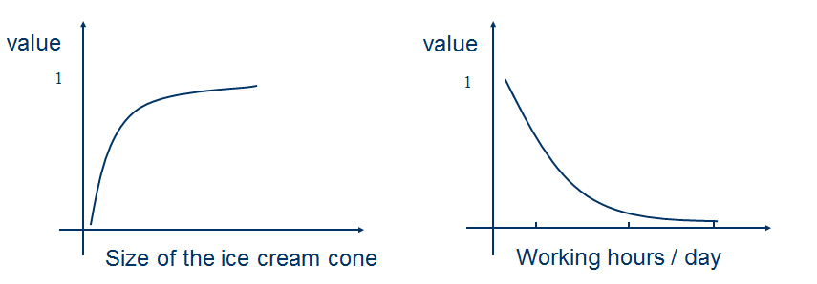

**Figure A1.2:** *Examples of non-linear value functions (Source: Hӓmӓlӓinen, 2009)*

The key point is that the mapped values are *unitless*, and therefore the subjective preference values derived from a set of different attributes (which may each be expressed in different units, say $, km and kW) may legitimately be aggregated together (via a linear combination of weights *wi* and unitless attribute values *v(i)*) to give an overall (unitless) preference value for a given decision option. Assuming that Σ*wi* =1, the overall preference value for each decision option will be in the range [0,1].

Thus Dobes (1999), and Dobes and Bennett (2009, 2010a and 2010b) assertion that MCA models attempt to combine quantities of different units, and thus breach the principle of dimensionality, is incorrect.

1. **MCDA is *incapable of comparisons between unrelated programs* (e.g. build a road or a hospital), because their impacts or attributes are most likely to be different.**

It is asserted that if the goal of the decision is to choose between projects of different types - building a road or a hospital, say - then MCA is inappropriate, since the impacts (objectives) of the different projects will differ so markedly. A road project will be characterised by improved travel times, increased travel volumes, etc, whilst a hospital project will be characterised by improvements to health in a community, reduced bed waiting times, etc.

The Value Focused Thinking approach (Keeney, 1992) should be a guide in these instances. Instead of having any pre-conceived ideas of what alternative projects might be considered, the decision makers should start by identifying the stakeholders’ objectives – what would they like to achieve from the investment of several million dollars? After all, a government’s role is to maximize a community’s welfare with the resources at its disposal.

Once the range of objectives is extracted, attributes can be devised that will serve as measures as to how well alternative projects meet the objective. This is done independent of and preferably before the determination of the alternative projects. Once the attributes have been developed into a value tree, alternative projects that might meet those objectives can be explored. In general this may well include projects of different types (e.g. roads and hospitals), but the attributes will be measurable quantities that are relevant to all the projects.

The MCDA approach, if carried out correctly, is thus capable of dealing with the comparison of projects of widely differing types. The onus rests on the decision maker to devise attributes that reflect the overall objectives of the decision problem, rather than focusing on attributes that are specific to the decision alternatives themselves.

**A1.5 Conclusions**

This Appendix has considered attacks on the use of MCA as a tool for assessing the relative performance of alternative public-sector policies or projects and who propose cost-benefit analysis (CBA) as the preferred technique (Dobbes, 1999; Dobbes and Bennett, 2009, 2010a and b). In our view, these criticisms of MCDA are unfounded and based on flawed assertions. MCA tools and models are entirely appropriate for use in government decision-making, and should be employed alongside other analytical tools such as CBA. No other methodology can deal with the complexity and uncertainty embodied in many government investment and policy decisions. Nonetheless these decisions still need to be made, and rather than simplifying much of this complexity and ignoring competing interests, MCA attempts to deal with them honestly and directly. Ronald Reagan was quoted as stating that economists are people who see something that works in practice and say, “Yes, but will it work in theory?” MCA attempts to give some rigor to the way political decision-making has always been undertaken.

**References**

Arbel, A (1989) Approximate Articulation of Preference and Priority Derivation. *European Journal of Operational Research*, 43, 317-326.

Belton, V and Stewart, T J (2002) *Multiple Criteria Decision Analysis – An Integrated Approach*. Kluwer Academic Publishers, Massachusetts, 372 pp.

Bragge, J, Korhonen, P, Wallenius, J and Wallenius, H (2008) Bibliometric Analysis of Multiple Criteria Decision Making/Multiattribute Utility Theory. *Paper presented at the 19th International Conference on MCDM, Auckland, New Zealand*.

Dobes L (1999) Multi-Criteria Analysis, Chapter 13 (pp 187-204) in: Luskin D and Dobes L (1999) *Facts and Furphies in Benefit-Cost Analysis: Transport*, Bureau of Transport Economics, Report 100, Canberra.

Dobes, L and Bennett, J (2009) Multi-Criteria Analysis: “Good Enough” for Government Work? *Agenda: A Journal of Policy Analysis and Reform*, 16(3), 7-29.

Dobes, L and Bennett, J (2010a) Multi-Criteria Analysis: Ignorance or Negligence? *Australasian Transport Research Forum 2010 Proceedings*, Canberra, Australia. Available at <http://www.atrf.info/papers/2010/2010_Dobes_Bennett.pdf>.

Dobes, L and Bennett, J (2010b) Multicriteria Analysis and the Emperor’s new clothes. EERH Policy Brief, Environmental Economics Research Hub, Australian National University, June 2010. Available at <https://crawford.anu.edu.au/research_units/eerh/pdf/policy_brief/2010/dobes_and_bennett.pdf>.

Hӓmӓlӓinen, R P (2009) *Introduction to Value Tree Analysis*. Systems Analysis Laboratory, Helsinki University of Technology. Available at <http://view.officeapps.live.com/op/view.aspx?src=http%3A%2F%2Fmcda.aalto.fi%2Fvalue_tree%2Flearning-modules%2Fshort_intro%2Fslides%2Fintro.PPT>

Hӓmӓlӓinen, R P, Van den Honert, R C and Ison, N (2014) *Making Hard Decisions in Complex Situations: Master Class in Multi-Criteria Analysis*. Systems Analysis Laboratory, Aalto University, School of Science and University of Technology, Sydney.

Hill, M (1968) A goals-achievement matrix for evaluating alternative plans. *Journal of the American Institute of Planners*, 34(1), 19-29.

Kanner M (2004) Framing and the Role of the Second Actor: An Application of Prospect Theory to Bargaining. *Political Psychology*, **25**(2), 213–239.

Kahneman D and Tversky A (1979) Prospect Theory: An Analysis of Decision Under Risk. *Econometrica*, 47(2), 263–291.

Keeney, R L (1992) *Value-Focused Thinking: A Path to Creative Decision Making.* Harvard University Press, 432 pp.

Lichfield, N, Kettle, P and Whitbread, M (1975) *Evaluation in the Planning Process*. Pergamon Press, Oxford.

Mustajoki, J, Hӓmӓlӓinen, R P and Salo, A (2005) Decision support by SMART/SWING – Incorporating Imprecision in the SMART and SWING Methods. *Decision Sciences*, 36(2), 317-339.

Salo A and Hӓmӓlӓinen, R P (1992) Preference Assessment by Imprecise Ratio Statements. *Operations Research*, 40(6), 1053-1061.

Salo A and Hӓmӓlӓinen, R P (1995) Preference Programming through Approximate Ratio Comparisons. *European Journal of Operational Research*, 82, 458-475.

Salo A and Hӓmӓlӓinen, R P (2001) Preference Ratios in Multiattribute Evaluation (PRIME) – Elicitation and Decision Procedures under Incomplete Information. *IEEE Transactions on Systems, Man and Cybernetics – Part A: Systems and Humans*, 31(6), 533-545.

Van den Honert R C (1998) Stochastic Group Preference Modelling in the Multiplicative AHP: A Model of Group Consensus. *European Journal of Operational Research*, 110, 99-111.

Van den Honert R C (2001) Decisional Power in Group Decision Making: A Note on the Allocation of Group Members’ Weights in the Multiplicative AHP and SMART. *Group Decision and Negotiation*, 10, 275-286.

Weistroffer, H R, Smith, C and Narula, S (2005) Multiple Criteria Decision Support Software, Chapter 24 (pp 989-1018) in: Figueiro, J, Greco, S and Ehrgott, M (2005) *Multiple Criteria Decision Analysis: State of the Art Surveys.* Springer Verlag.

1. Yeo, S.W, Blong, R.J. and K.J. McAneney. 2007. Flooding in Fiji: findings from a 100-year historical series. *Hydrological Sciences Journal*. 52:1004-1015.
2. McAneney, J. and R. Crompton, 2013. *What is driving the rising cost of natural disasters?* Trébol, No. 67, pages 4-17, Mapfre Re, Spain [<http://www.mapfre.com/mapfrere/docs/html/revistas/trebol/n67/en/articulo1.html>].
3. Haynes, K.A., Handmer, J., McAneney, K.J., Tibbits, A. and L. Coates, 2009. Australian civilian bushfire fatalities: 1900 – 2007. *Environ. Sci. & Policy* 13:185-194: Crompton, R. P., K. J. McAneney, K. Chen, R. A. Pielke Jr., and K. Haynes, 2010. Influence of Location, Population and Climate on Building Damage and Fatalities due to Australian Bushfire: 1925-2009. Weather, Climate and Society, Vol. 2: pp. 300-310.
4. McAneney, J, Crompton, R, McAneney, D, Musulin, R, Walker, G and Pielke Jr, R. 2013, *Market-based mechanisms for climate change adaptation: Assessing the potential for and limits to insurance and market based mechanisms for encouraging climate change adaptation*, NCCARF Publication 75/13, National Climate Change Adaptation Research Facility, Gold Coast, 99 pp.

  
5. Michel-Kerjan, E., 2010. *Catastrophe Economics: The National Flood Insurance Program*. Available at: http://dev.journalistsresource.org/wp-content/uploads/2013/02/National-Flood_Michel-Kerjan-2010.pdf
6. Grislain-Letrémy, C., 2013. Natural Disasters: Exposure and Underinsurance, pp6-9. Available at: <https://acpr.banque-france.fr/fileadmin/user_upload/acp/Chaire-ACP/2013-10-29-Underinsurance-CGrislainLetremy.pdf>.
7. http://www.ga.gov.au/scientific-topics/hazards/flood/capabilities/about-national-flood-risk-information-project/nfrip-update-1.html
8. Dobes L (1999) Multi-Criteria Analysis, Chapter 13 (pp 187-204) in: Luskin D and Dobes L (1999) *Facts and Furphies in Benefit-Cost Analysis: Transport*, Bureau of Transport Economics, Report 100, Canberra; Dobes, L and Bennett, J (2010a) Multi-Criteria Analysis: Ignorance or Negligence? *Australasian Transport Research Forum 2010 Proceedings*, Canberra, Australia. Available at <http://www.atrf.info/papers/2010/2010_Dobes_Bennett.pdf>.
9. Risk Frontiers (2014) *A Framework For Natural Disaster Mitigation Decision Making*, report for SAFECOM and the Government of South Australia.