Central Highlands Regional Council

REGIONAL SUMMARY

The Central Highlands, Queensland, is a special part of Australia that makes a strong contribution to Australia’s wealth, thanks to our prosperous resources and agricultural industries.

The region covers an area of almost 60,000 square kilometers, including a significant portion of the Bowen Basin – Australia’s largest coal reserve.

The region’s Gross Regional Product is $4.15 billion (2012/13) and the diverse economy is based on:
- A globally competitive coal mining industry, with continuing expansions and developments;

- Traditionally robust and resilient agricultural and horticultural industries, including beef, grain, cotton, grapes, melons and citrus;

- Dynamic small and medium businesses; Professional and government sectors; and
- Availability of commercial, industrial and residential land.

Other competitive economic advantages include a growing tourism market; a booming regional airport in Emerald; a concentration of government facilities; and major health and education services.

According to the Central Highlands Development Register (May 2014), there are billions of dollars allocated for community infrastructure; retail and industrial development; transport and tourism projects; and significant mining expansions in the Bowen and Galilee Basins.

The Central Highlands has a residential population of more than 30,000* and nearly half of those live in Emerald. The region’s projected residential population in 2031 is approximately 55,000, a growth rate that outpaces neighbouring areas and Queensland overall.

In addition, Emerald has been identified as a potential ‘inland city’ due to its central geographic location and rich, abundant natural resources. This is further supported by the State Government’s Queensland Plan which aims to have 50% of Queensland’s population living outside the South East by 2043.

*The 5,585 non-resident workers are excluded from this figure but are worth noting because of the added pressure on infrastructure.

LOCAL BACKGROUND

The Central Highlands Regional Council consists of 16 towns and associated networks within 60,000 square kilometres council area.

These communities are linked by a rural road network of 4,189km including 1,023kms of sealed and 3,166km of unsealed, 35 bridges, and an urban street network of 374km.

Annual Rates Base of $77,030,140 (Actual Total rates 2013/14 financial year – including water base and consumption, waste etc), or $78,876,233 (same figure budgeted for 2014/15 financial year).

The assets of the Central Highlands Regional Council’s communities and road assets have been significantly impacted and impaired by the natural disasters from 2008 through to 2014.

Event Year | Total Income | Total Expenditure | Status
2010 | $93,073,010.88 | $98,080,550.83 | Completed
2012 | $4,471,616.05 | $5,697,075.35 | Submitted- waiting on final payment
2013 | $7,312,379.66 | $11,725,106.31 | Not complete
2014 | $1,112,328.43 | $38,477.43 | Not started

Visual examples of the impacts from these events can be seen on the following pages.

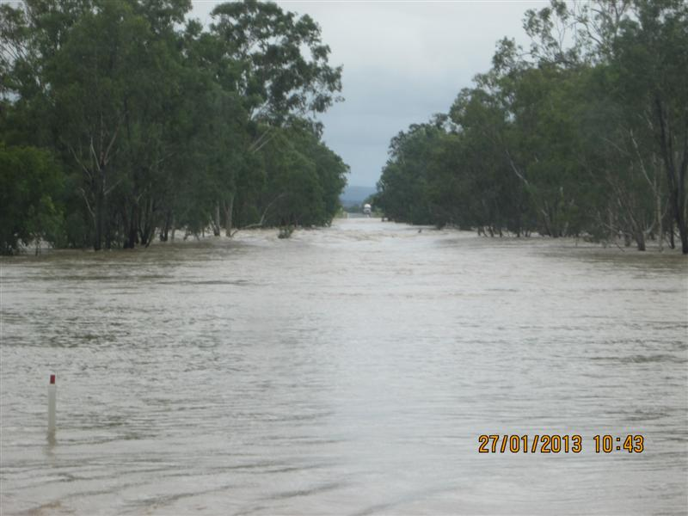  The Dawson River, Capricorn Highway | 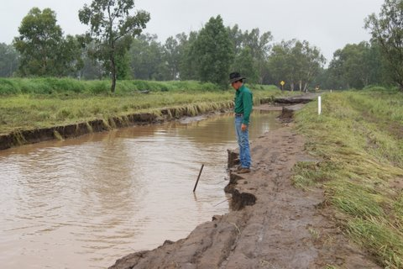  Arcadia Valley Road
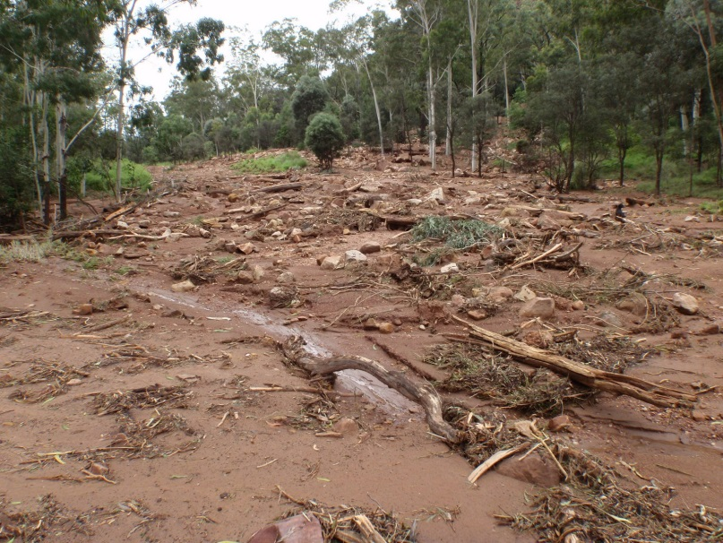  Rewan Road | 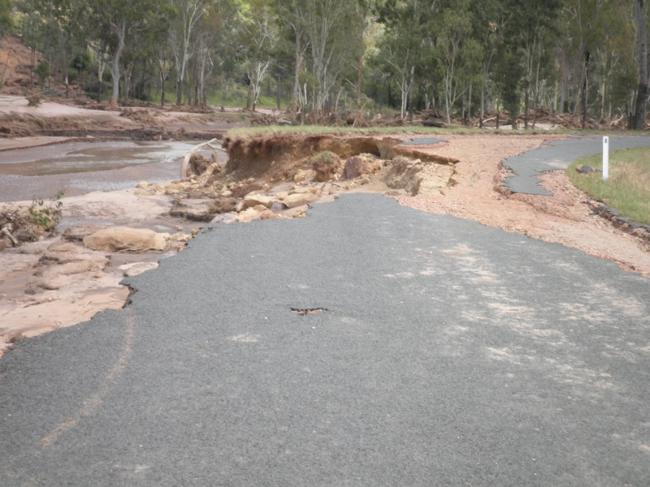  Buckland Road
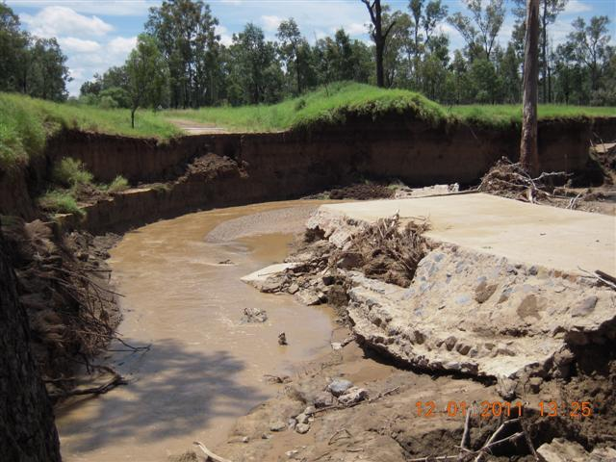  Mungabunda Road | 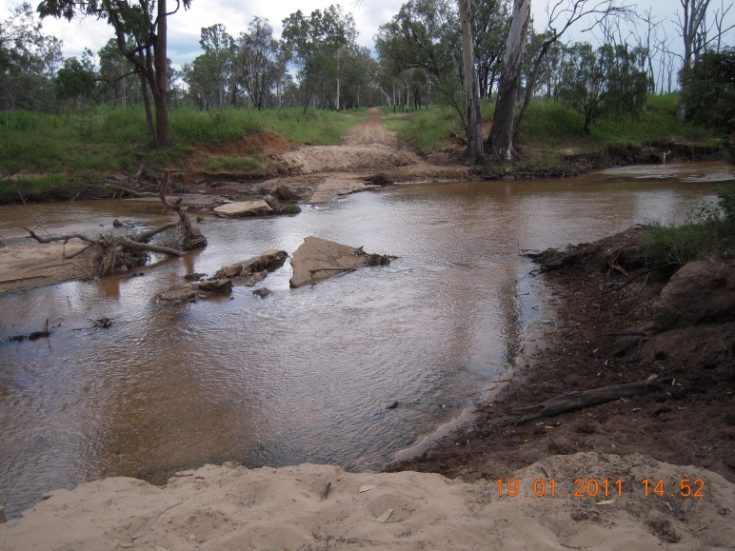  Conomara Road
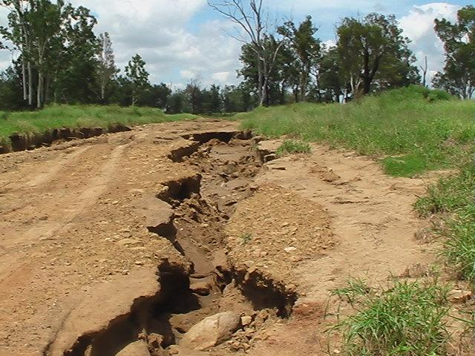  Fairfield Road 10/11 Event | 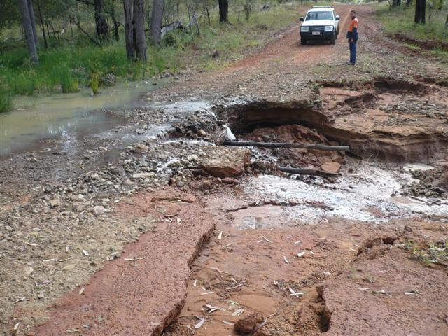  Raby Creek Road 2012 Event

BUDGET TREATMENT OF NATURAL DISASTERS RISKS

Draft Recommendation 3.3

The Australian Government should publish estimates of the future costs of natural disasters to its budget in the Statement of Risks. It should also provision through annual appropriation for some base level of natural disaster risks that can be reasonably foreseen. For more catastrophic, less quantifiable risks, it is likely to be more efficient to finance the related costs if and when the risks are realised.

Central Highlands Regional Council Response:
Agreed

It may be useful for the Australian Government to budget for a reasonable level of natural disaster expenditure, as a provision against the potential expenditure. It is expected however that there may be many potential but unlikely similar levels of expenditure, that could be similarly brought to the budget. If a system that is meaningful can be devised than perhaps all levels of government should follow suit. The accuracy of forward estimates of natural disaster expenditure may however be problematic.

FUNDING ARRANGEMENTS FOR RECOVERY

Draft Recommendation 3.1

The Australian Government should:

- reduce its marginal cost sharing contribution rate to disaster recovery outlays to 50 per cent under the Natural Disaster Relief and Recovery Arrangements
- increase the triggers for Australian Government assistance (small disaster criterion and annual expenditure threshold).

In conjunction with this reduction in funding assistance, the Australian Government should provide state and territory governments with increased autonomy to manage relief and recovery expenditure in a way that reflects the preferences and characteristics of their communities.

Central Highlands Regional Council Response:

- Central Highlands Regional Council like most local governments is most concerned about any reduction in natural disaster funding that it could have access to. Council understands that the Australian Government may have concerns about being perceived as the insurer of last resort, but Council does note that taxation revenue collected by the Australian government is well in excess of 50%.

- Central Highlands Regional Council acknowledges that a $240,000 event could be considered a minor happening and understand that the Australian Government may wish to raise this trigger. However, the local government triggers are already at reasonable levels and any increase could not be sustained.

FUNDING ARRANGEMENTS FOR MITIGATION

Draft Recommendation 3.2

If the Australian Government reduces the relief and recovery funding it provides to state and territory governments, it should increase annual mitigation expenditure gradually to $200 million, distributed to the states and territories on a per capita basis. The amount of mitigation spending could be adjusted over time to reflect the imputed ‘savings’ from reduced relief and recovery funding.

Increased mitigation funding should be conditional on matched funding contributions from the states and territories and best-practice institutional and governance arrangements for identifying and selecting mitigation projects. These would include:

- project proposals that are supported by robust and transparent evaluations (including cost–benefit analysis and assessment of non-quantifiable impacts), consistent with National Emergency Risk Assessment Guidelines risk assessments and long-term asset management plans, and subject to public consultation and public disclosure of analysis and decisions
- considering all alternative or complementary mitigation options (including both structural and non-structural measures)
- using private funding sources where it is feasible and efficient to do so (including charging beneficiaries)
- partnering with insurers to encourage take-up of adequate private insurance and private mitigation through measures such as improved information sharing and reduced premiums.

Central Highlands Regional Council Response:

Central Highlands Regional Council agrees and supports any increase in mitigation funding. It is not appropriate for Australia to contribute to fund recovery with like for like. Similarly, any post event reconstructions is normally when recovery resources are most scarce, rates are highest and time is of the essence, making betterment problematic. In certain cases it can be beneficial to plan and fund betterment and mitigation strategies between events. However for certain natured projects, like up and / or downstream road margin protection with a bitumen seal, distinct economics of scale can be generated during the reconstruction effort.

$200m per annum does however seem incredibly light, given the natural disaster exposure faced by the nation. Emerald alone is investigating protection strategies aimed at reducing $12m of average annual damage from flood risk.

INTERACTION WITH FEDERAL FINANCIAL RELATIONS

Draft Recommendation 3.6

The Commonwealth Grants Commission should revisit its assessment of ‘average state policy’ and accompanying accountability requirements for natural disaster policies once the Australian Government has announced its decision regarding relief and recovery funding arrangements.

Central Highlands Regional Council Response:

Central Highlands Regional Council makes no submission to the Productivity Commission in regards to changes that the Grants Commission’s process and procedures.

GOVERNMENT INSURANCE

Draft Recommendation 3.4

State, territory and local governments should further investigate non-traditional insurance products for roads. Where they do not already do so, state, territory and local governments should compile and publish detailed registers of road asset condition and maintenance for all roads over which they have jurisdiction (and have these registers independently audited). This may help insurance markets to understand and price the risk. Consideration should be given to the Victorian model in this regard.

Central Highlands Regional Council Response:

Insurance is useful for small individuals who can be severely crippled financially due to a loss of an asset. It would appear that the volume of public assets sought to be protected by the NDRRA process would be sufficiently substantial to warrant the Australian Government being self-insured by taxation revenues, after the event. If the risk could be accurately priced then in the longer term the cost of the insurance premiums ought to be in excess of the cost of recovery. Such an excess ought to be kept in the hands of taxpayers rather than the insurance industry.

MANAGING SHARED RISKS

Draft Recommendation 3.5

The Australian Government should:
- cease reimbursement to state and territory governments under the Natural Disaster Relief and Recovery Arrangements for relief payments for emergency food, clothing or temporary accommodation and assistance to businesses and primary producers (including concessional loans, subsidies, grants and clean-up and recovery grants)
- reduce the amount provided under the Australian Government Disaster Recovery Payment (AGDRP). The Australian Government Crisis Payment may provide a reasonable benchmark in this regard
- legislate the eligibility criteria for the AGDRP and the Disaster Recovery Allowance and make these not subject to Ministerial discretion.
- Please also refer reports produced by Lawrence Consulting – Economic Impact of January 2008 on Central Highlands Regional Business and Industry and Economic Impact of 2010 / 11 Floods on Central Highlands Regional Business and Industry I

Central Highlands Regional Council Response:

Central Highlands Regional Council is concerned that there is potential for abuse and over payment to individuals and that eligibility should be more tightly controlled, and in particular not be subjected to ministerial discretion.

INFORMATION

Draft Recommendation 4.1

When collecting new natural hazard data or undertaking modelling, all levels of governments should:

- make information publicly available where it is used for their own risk management and/or there are significant public benefits from doing so
- use private sector providers where cost effective, and use licencing arrangements that allow for public dissemination. Where there are costs involved in obtaining intellectual property rights for existing data, governments should weigh up these costs against the public benefits of making the data freely accessible
- apply cost recovery where governments are best placed to collect or analyse specialist data for which the benefits accrue mostly to private sector users.

Central Highlands Regional Council Response:
Agreed

There is nothing to be gained by the withholding of natural hazard risk or in all levels of government should be encouraged or required if necessary to make their data and their modelling result freely available, subject only to modest handling charges when required.

Refer to www.myfloodinfo.com.au ; an initiative of Central Highlands Regional Council in conjunction with the Emerald Flood Mitigation Plan.

Draft Recommendation 4.2
State and territory governments, local governments and insurers should explore opportunities for collaboration and partnerships. Partnerships, for example, could be formed through the Insurance Council of Australia and state-based local government associations (or regional organisations of councils). Consideration could be given to the Trusted Information Sharing Network model, and involve:

- governments sharing natural hazard data that they already hold and undertaking land use planning and mitigation to reduce risk exposure and vulnerability
- insurers sharing expertise and information (for example, claims data) to inform land use planning and mitigation
- collaboration to inform households of the risks that they face and adequacy of their insurance to fully cover rebuilding costs, and to encourage private funding of mitigation through incentives such as reduced premiums.

Central Highlands Regional Council Response:
Agreed

Draft Recommendation 4.3

State and territory governments should hasten implementation of the Enhancing Disaster Resilience in the Built Environment Roadmap, including reviewing the regulatory components of vendor disclosure statements. Furthermore, the Land Use Planning and Building Codes Taskforce should consider possibilities for regular, low-cost dissemination of hazard information to households by governments and insurers (for example, the work of the Insurance Council of Australia to develop natural hazard ratings at a household level).

Central Highlands Regional Council Response:
Agreed

A national uniform hazard rating would be a significant achievement

REGULATING THE BUILT ENVIRONMENT

Draft Recommendation 4.4

State governments should:
- clearly articulate the statewide natural hazard risk appetite in land use planning policy frameworks
- provide local governments with guidance on how to prioritise competing objectives within land use planning
- provide local government with guidance on how to integrate land use planning and building standards. Consideration should be given to Victoria’s Integrated Planning and Building Framework for Bushfire in this regard.

Furthermore, local governments should publish the reasoning behind development assessment decisions.

Central Highlands Regional Council Response:
Agreed

Central Highlands Regional Council supports integrated land use planning and building standards.

Draft Recommendation 4.5

The onus is on state governments to ensure that local governments in their jurisdiction are sufficiently resourced to effectively implement their land use planning responsibilities. State governments should review the adequacy of local governments’ resources and capabilities, and provide further resources and support where they are not adequate.

Central Highlands Regional Council Response:
Agreed.

Central Highlands Regional Council is concerned that some of the regulation of mitigation structures, specifically levees in Queensland that has recently been devolved to local government. Council considered this an abrogation of responsibility that involves risks and regulation best kept at a state level.

Draft Recommendation 4.6

State governments should provide additional support and guidance to local governments that addresses the extent of local governments’ legal liability when releasing natural hazard information and making changes to land use planning regulations.

Central Highlands Regional Council Response:
Agreed

State Governments should provide Councils with an indemnity against releasing natural hazard information to the community in good faith.

Draft Recommendation 4.7

The provisions in the Queensland Sustainable Planning Act 2009 for injurious affection should be repealed.

Central Highlands Regional Council Response:

Injurious affection has no place in a robust and substantial planning system unless of course there is an equal and opposite system for obtaining “betterment” fees for increasing land values. If the prospect of having to compensate a party for zoning land in recognition of its natural hazards is impeding such zoning, then the system is potentially flawed. There should be no case for compensating land owners for a zone that the land may never have been entitled to.

Draft Recommendation 4.10

All governments should put in place best-practice institutional and governance arrangements for the provision of public infrastructure, including road infrastructure. These should include:
- stronger processes for project selection that incorporate requirements for cost–benefit analyses that are independently scrutinised and publicly released
- consideration of natural disaster risk in project selection
- a clearer link between road-user preferences and maintenance and investment decisions.

Central Highlands Regional Council Response:
Agreed

INSURANCE

Draft Recommendation 4.8

State and territory taxes and levies on general insurance should be phased out and replaced with less distortionary taxes.

Central Highlands Regional Council Response:
Agreed

Draft Recommendation 4.9

Insurers should provide additional information to households regarding their insurance policies, the natural hazards they face and possible costs of rebuilding after a natural disaster. This work could be led by the Insurance Council of Australia to ensure consistency in the provision of information across insurers.

Central Highlands Regional Council Response:
Agreed

