Submission to the Australian Productivity Commission Processed Fruit Safeguards Inquiry Hearing in Melbourne on October 28^{th 2013}

Introduction

Thank you for the opportunity to present a Submission.

This submission is in support of my original submission to the Inquiry and a response to the Commission’s recent Accelerated report to Government.

Fairness

The notion of fairness is strong within the population of Australia. It influences many of the attitudes, behavior and actions of our society, including our laws and is generally considered to be an important consideration when making decisions. It is the attitudinal backbone of our democracy.

I know that fairness was not part of the Terms of Reference for this fruit industry hearing. If it was, I suspect that the Commission’s Accelerated report would have been considerably different. We appear to be confined to interpretations that are reached as a result of WTO rules.

The canning fruit industry in Victoria operates in an international and national environment that is substantially unfair. The term “a level playing field” is an illusion that is totally absent from the trading environment in which many Australian manufacturers and SPCA operate.

Prime examples of unfairness are:-

- Australia has one of the highest per capita incomes in the world, but is also one of the most expensive countries in which to live. Employment costs for businesses are close to the highest in the world, set by our protected industrial award system that substantially uses social criteria to determine base wage rates and employment conditions. This system protects our wage earners from the international competition that our manufacturers face. The system has become bloated and workplace practices inefficient, especially in industries that are not exposed to international competition.
Manufacturers and farmers are expected to sell their products in open competition markets but purchase their cost inputs in an expensive closed and protected market.
As a result, we just cannot compete with very cheap labour countries like China and South Africa.
Does this meet the fairness test? No.

- The difference between Australian border duties and those of our international competitors for processed peaches and pears and is very substantial and certainly doesn’t meet the fairness test. The figures below show the anomalies but they do not show the additional support that the EU producers receive via a range of subsidies.
I believe that China is still partly a centrally controlled economy and I suspect that benefits flow to fruit processors and fruit growers as a result of this centralization of power.
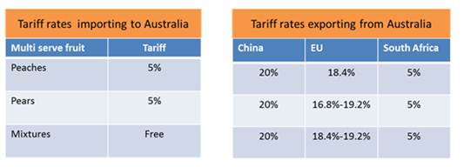
Allowing imports to come into our country, unfairly replacing Australian production is effectively exporting our production capacity, our investments and jobs to another country, providing “foreign” aid to like industries in these countries, funded, not by our Government, but by our manufacturers, farmers and our workers jobs.
Past Governments did the Australian fruit processing industry a major disservice by agreeing to sign the WTO agreement with these tariff rate disparities included.
Does this meet the fairness test? No.

- I understand there are significant disparities between the hygiene and food production standards in Australia and some of the countries we import food products from. Australia has strict laws regarding food standards for local farmers and food processors that, I understand, are not required or not policed on entry into Australia from foreign lands. If this is the case, is it because “cheapness overcomes all evils” or is it a case of Australia being over zealous in setting stringent food production standards for our food producers?
Does this meet the fairness test? No.

- Carbon Tax. Despite the fact that the present Government has stated that they will repeal the current legislation regarding the Carbon Tax/Emissions Trading Scheme, it is still in place. It is a cost that is imposed on industry, including ours. My understanding is that imports are not required to pay this tax, and unless the imports are from countries that have similar or greater levels of carbon emissions charges, we are at a disadvantage.
Does this meet the fairness test? I suspect not.

Despite the demonstrated unfairness of our position in the world, what can the Government do about it?

- Firstly, they agree to support SPCA along the lines they requested. This is necessary for the survival of the canning fruit industry in the Goulburn Valley.

If SPCA decide to close their fruit processing operations resulting from a lack of Government support, the industry closes and orchards disappear, in excess of 1000 jobs are lost and the Goulburn Valley community is decimated by the loss of revenue, I estimate to be approximately $60 - $70 million in year one. This is would be the result of a reduction from 22,000 tonnes intake of peaches and pears estimated to be processed in 2014, to zero in 2015.
The intake of peaches and pears has been declining over the last 10 years. In 2005, the intake for the season was approximately 100,000 tonnes of peaches and pears. If the cannery closes in 2014, I estimate that this will have resulted in a reduction of economic activity the Goulburn Valley of in excess of $300 million a year, in today’s terms, when compared to 2005.

In respect of the possibility of the closure of SPCA’s fruit processing, I think the chances of closure are quite high without Government support or a significant devaluation of the A$. I can’t see that they have a viable business, processing only 20 – 30,000 tonnes of peaches and pears.

The photo of recently grubbed pear trees resulting from the reduction of intake tonnages announced by SPCA was featured in an article in the local newspaper, “Tip of the Iceberg”. With growers fruit prices representing approximately 16% of the wholesale price of canned fruit, it is the final 84%, the part you can’t see, representing the added value that could sink the Goulburn Valley.

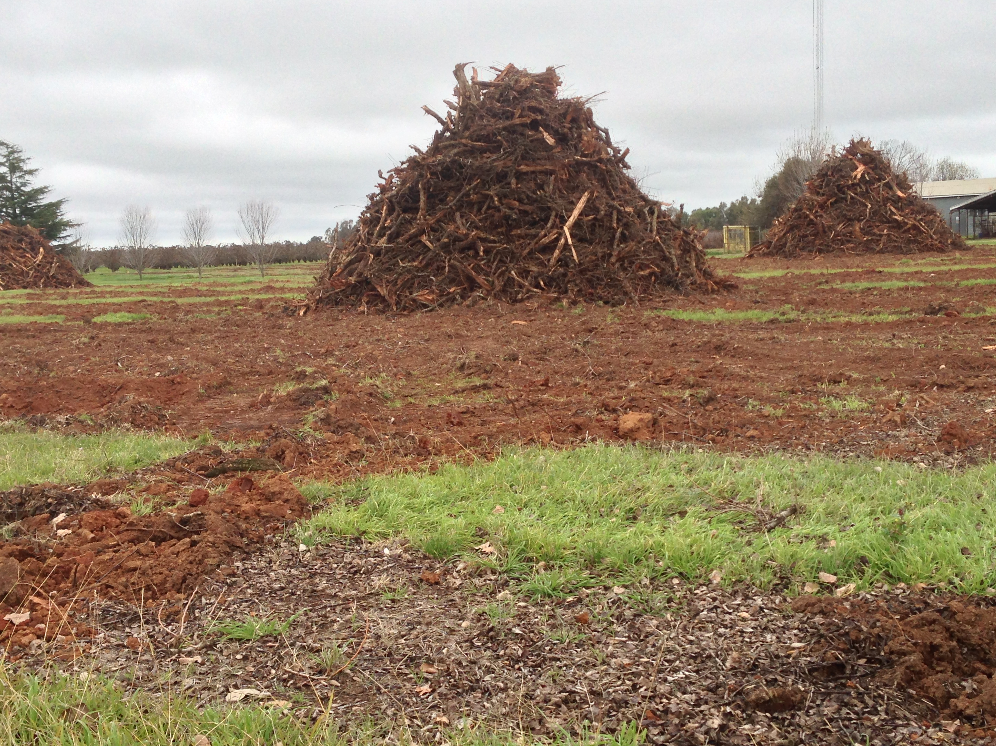
2. Secondly, the Government needs to recognize the problem created by a highly valued and volatile A$, and put in place a mechanism to exercise some control over the effects of the currency market, which is being distorted by huge volumes of money seeking a “safe haven” country with high interest rates (relative to other countries).

I offered a possible solution in my initial submission that could well be unworkable and certainly be politically difficult to achieve. I introduced the idea to stimulate thought amongst people who believe there is a need to a find workable solution to stabilize our currency at a realistic level, to encourage investment in industries that face international competition.

If the A$ was trading at levels applicable 8 to 10 years ago we wouldn’t be sitting here today.

To coin a tired old phrase, we need to be the “clever country”, to develop ideas and strategies to deal with a rapidly changing world.

Orchard Biosecurity

I would like to raise one further issue. The cutback in intake tonnages has resulted in number of orchards closing down sections or all of their orchards, in some cases, not having sufficient money to remove the trees. These orchards, left untended, represent a significant problem to neighboring orchards, with pests and diseases, such Queensland fruit fly, proliferating, and invading the neighboring properties.
The application of extra chemicals and the fruit damage that occurs is resulting in significantly higher costs and loss of income for remaining Growers.
More money in the system, or a tree pull scheme, could help these depart the industry in a more orderly fashion.

Thank you

Ross Turnbull 23/10/13

