Dear Commissioners

If it is appropriate and timely, I would like to make a few comments on the post October 28th 2013 submission by the by the South African Fruit and Vegetable Canners’ Association in regard to their comments on the Private label influence on the reducing consumption of processed fruits and other matters (Item 3.2).

Australian supermarkets private labels strategy

- The reason retailers/supermarkets around the world prefer private label
products on their shelves is that it gives them flexibility in sourcing the products, buying from the cheapest, acceptable source

- The reason for SPCA (SPC Ardmona) would resist supplying product for private label could only be due to the price supermarkets were willing to pay for their product.

- Not being privy to SPCA’s pricing structure, I can only say that the retail shelf price differential of approximately $2 per can of 825 gr peaches (see photos) is large. I know from experience that the profit margins on canners labeled product are nowhere near sufficient to make up the difference between the locally produced canned fruit prices and the import prices.

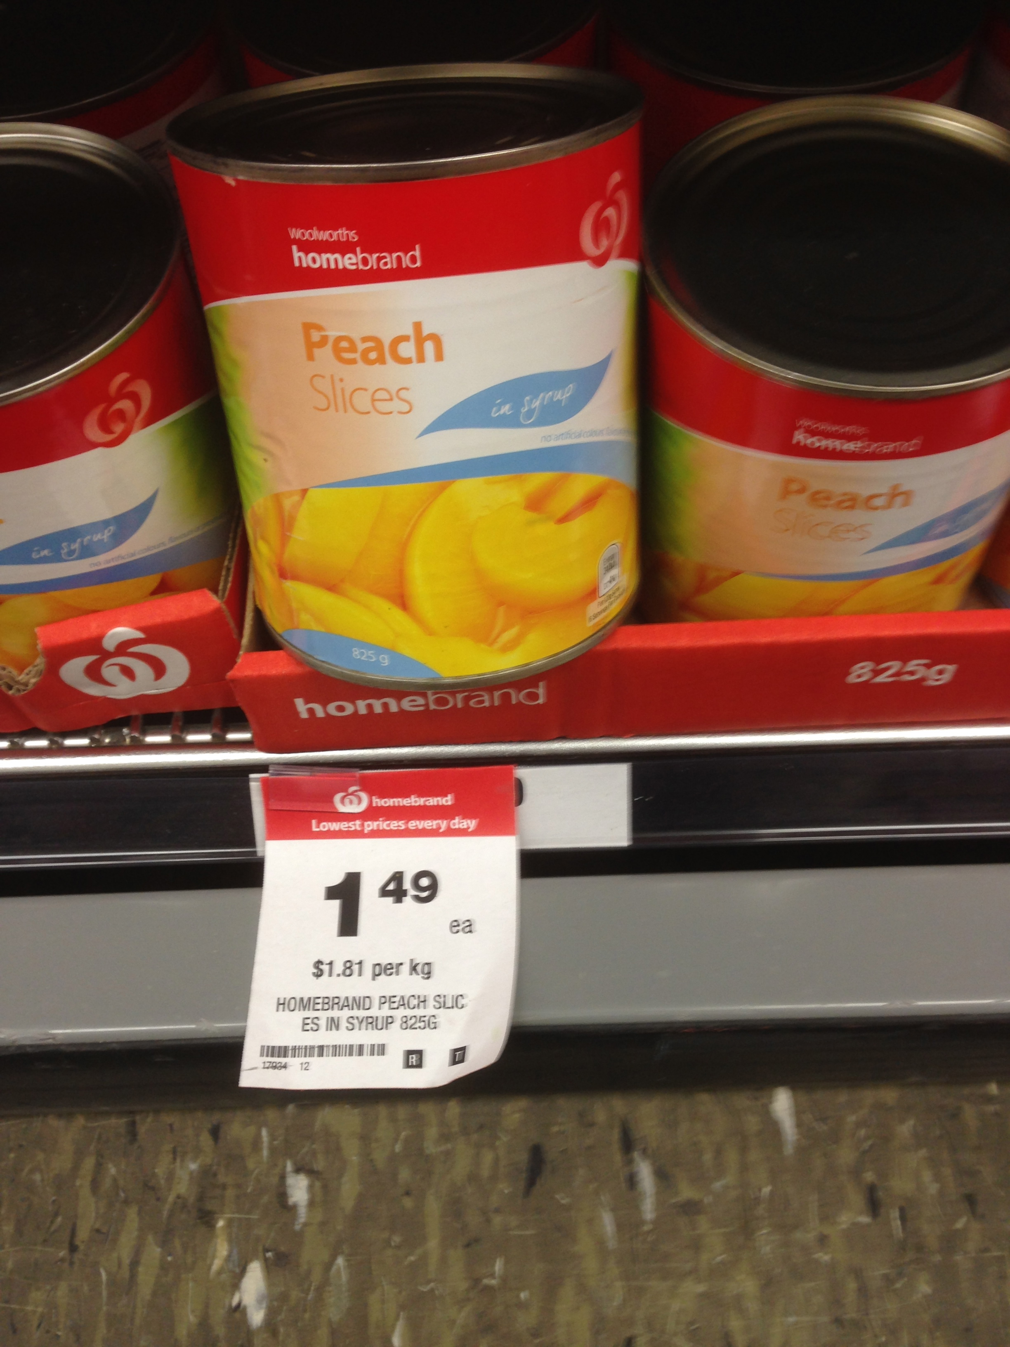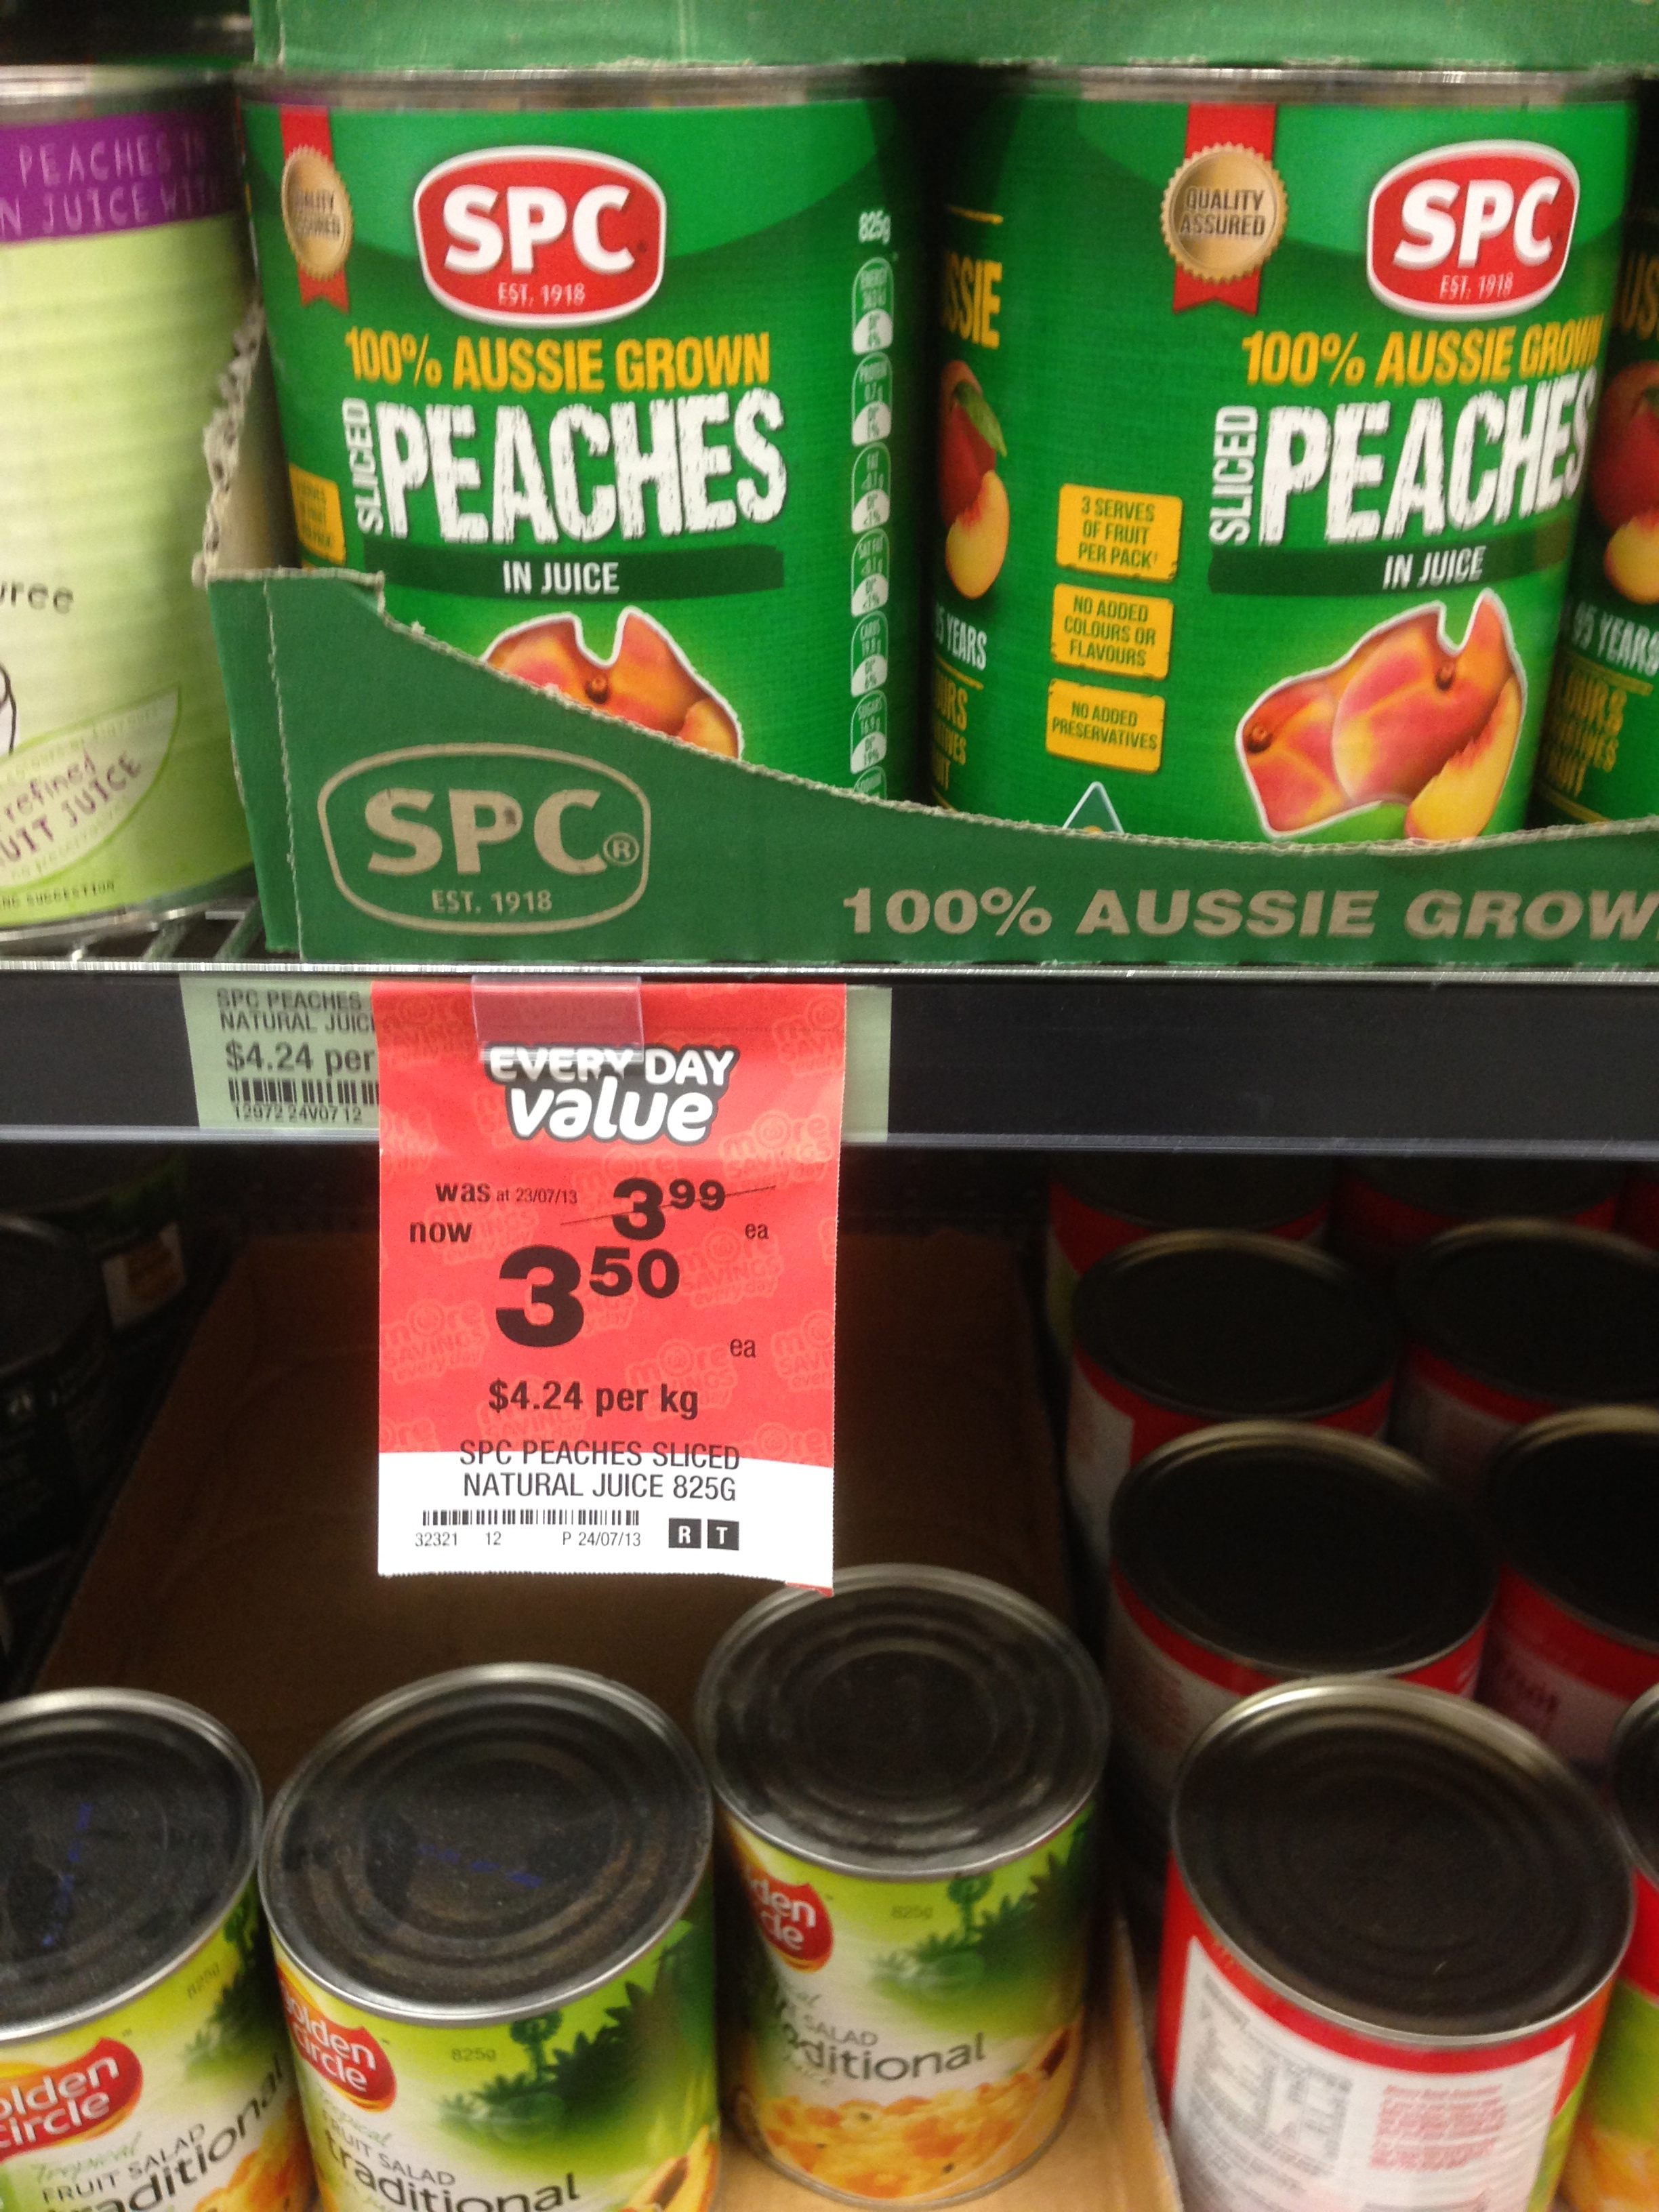
South African produced 825gr peaches @ Woolworths, Mooroopna
20/11/2013 price $1.49
Australian produced 825gr peaches @ Woolworths, Mooroopna
20/11/2013 price $3.50

4. Virtually all the successful packaging and product innovation for processed peaches, pears and apricots in the last 30 years has come from Australian canners. Why is this so?

Up until the recent surge in private labels and imports, the Australian processed fruit market had been dominated by Canners brands, unlike most other world markets.

Australian Canners have innovated, promoted and advertised to create interest in their product range. This stimulated the category and improved sales and per capita consumption by increasing consumer awareness. They have invested in their products to achieve longer term awareness of their brands to improve profitability. They are not unique. It’s the same strategy used by most producers of “own branded” consumer products.

SPCA’s “Achilles heel” is private brands at low prices.

Private brands tend to “milk” the goodwill generated by the manufacturers brands, re-investing little or nothing towards innovation, product development and longer term promotion.

The reality has been, due to the cheapness and availability of imported product, the Australian supermarkets simply have taken the market away from SPC Ardmona.

Australian Supermarkets “support” for Australian produced processed fruit

1. The most likely reason for the “Australian produced canned fruit only” change in attitude by supermarkets is because of the negative publicity they have received, resulting from the press coverage of the plight of the Goulburn Valley canning fruit industry.

Therefore, it is likely that once the press momentum has subsided, or the end of a defined “Australian only” period is reached, then it will be back to their normal sourcing policy.

2. The price that the supermarkets will pay for Australian sourced canned fruit for private label is likely to be significantly influenced by notional import prices from around the world.

Viability of the canning fruits industry is unlikely to be a significant influencing factor!

Substitution

1. The South African’s challenge to my assertion that the supermarkets private label policy regarding processed fruit, is a “category killer”, is somewhat simplistic.

To assert that the consumer simply substitutes processed fruit with fresh fruit is tenuous at best.

Fresh fruit and processed fruit are two quite distinct and separate products and are used by many consumers for different purposes. There also is a difference in the appearance, flavour, texture and presentation.

For example, Goulburn Valley snack pack peaches are often used in school lunch boxes because they are nutritious, convenient, robust and they taste good, whereas, fresh peaches and many other fruits are delicate products and don’t stand up to the rigors of children’s school bags.

Goulburn Valley 1kg plastic packs peaches are frequently used as breakfast cereal toppings for speed and convenience, and they are nutritious. Fresh fruit at breakfast generally needs preparation when families are rushing, and is less likely to be used.

Both of these Goulburn Valley products can be stored before opening at ambient temperatures in the pantry for long periods without deterioration, unlike most fresh fruits. In the case of the 1kg pack, it can be resealed, refrigerated and reused if all is not eaten at the one meal.

There are many other examples highlighting the differences in the two products.

2. The Australian fresh fruit industry has “improved its game” in recent years, introducing new varieties of many products.

This has been brought about by plant variety rights being given lawful status, stimulating new businesses developing new and improved varieties who then allocate them to industry groups who can control the marketing and the volume planted in defined markets. This is an example of an innovative industry taking some control away from the supermarkets with commodity products.

This has improved the profitability of the industry and grown their market share of the desert/snack market category (not just replacing processed fruit).

International Private label supply and implications

1. The South Africans assertion that processors can supply innovative private label products to supermarkets is simplistically correct, but in practice, it is nigh impossible to get them to list an unproven product.

When I was Chairman of Ardmona Foods Limited, we tried to launch our successful 1kg plastic “Fridge Pack” in the UK. Tesco, the largest supermarket chain in the UK, told us they would consider it when we had proven the product in the UK market, under our own label.

This highlights the attitude of supermarkets to new and innovative products. For their private labels they very much prefer a proven market product.

General comment:

As Chairman of the Canned Fruits Industry Council of Australia in the 1990’s, I attended bi annual World Canning Fruit Conferences as leader of the Australian delegation.

I knew many of the international Canners. Their general view was that there was a reluctance by the international supermarkets to support canners branded products in the market. When further questioned about declining consumer consumption, the answer inevitably was, “What can we do about it”?

There was very little they could do about it, considering the strength of the supermarkets and their preference for their own private labels.

Ross Turnbull 26/11/2013

