

**Productivity Commission - SUBMISSION**

**SAFEGUARDS INQUIRY INTO THE IMPORTS**

**OF PROCESSED FRUIT PRODUCTION**

1. **STRUCTURE OF THE PROCESSED FRUIT INDUSTRY REPRESENTATION**

CFICA is the peak industry body for the processing deciduous fruit industry in Australia. It is formally recognized as such by the Commonwealth Minister for Agriculture. It is a B class member of Horticulture Australia Ltd. CFICA is structured with two members; SPCA is the sole processor member and ACFA represents fruit growers.

ACFA’s membership, in turn, consists of FGVL and the Victorian Peach and Apricot Growers Association “VPAGA” which are two closely aligned fruit grower associations. VPAGA and FGVL both have individual fruit growers as their membership.

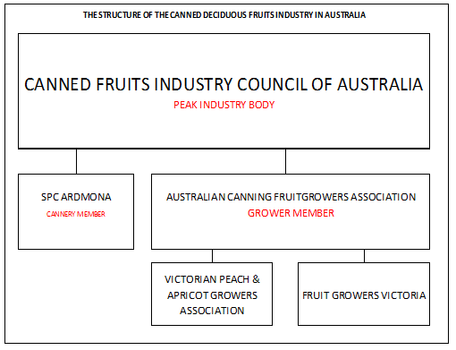

**Australian Canned Fruits Industry Representation Structure**

1. **OBJECTIVES OF THIS SUBMISSION**

This submission was prepared by John Wilson, general manager of Fruit Growers Victoria Limited “FGVL”, in his capacity as secretary of the Australian Canning Fruitgrowers Association (“ACFA”) and secretary of the Canned Fruits Industry Council of Australia (“CFICA”).

The objective of this submission is to provide evidence to support the case for safeguard action requested by SPC Ardmona (“SPCA”) with respect to the importation of processed deciduous fruits.

This submission refers to the economic circumstances faced by orchardists who have supplied fruit to SPCA in the period 2008 to 2013 as well as prospective suppliers for 2014. It will provide information of the impacts of the SPCA cutbacks on growers and subsequently on their communities based on an understanding of revenue, profitability, debt, ability to raise capital, cash flow, employment, dependence on SPCA and succession planning.

1. **CHANGES IN WORLD SUPPLY & DEMAND BALANCE**

In October 2008, the CFICA secretary attended the SIAL Food Fair at Parc D’Esposition in Paris France. The primary reason for this journey was to participate in an informal meeting of representatives of countries which manufacture processed deciduous fruit. (This group will be referred to herein as the World Canned Fruits Group “World Group”).

The World Group meets formally at World Deciduous Canned Fruits Conferences which are normally held every eighteen months and alternate from northern hemisphere to southern hemisphere. In this way, producers in each hemisphere have the opportunity to see the other hemisphere every three years. Australia hosted the 2009 World Deciduous Canned Fruits Conference “Cancon09”.

The World Deciduous Canned Fruits Conferences are the primary source of information exchange for the World Group, with each country presenting a formal country report. Conferences also provide the platform for networking and production comparison.

The October 2008 Paris meeting was attended by representatives from Greece, Spain, USA, China, Argentina, Chile, South Africa and Australia. These representatives compared production and demand. They agreed on an estimate that the world supply and demand was in balance.

**Six months later in March 2009, Cancon09 was held in Shepparton Australia and the same exercise was repeated. It revealed that there had been a dramatic change in circumstances with approximately one million cartons of peaches available on the world market surplus to demand.**

The cause of this abrupt change was the contraction of the USA and European markets as the global financial crisis took hold of those economies.

1. **COST OF PRODUCTION COMPARISON**

Outside of conferences the World Group also benchmarks information, including productions costs, from time to time. Roberto Lamm, from Industrias Alimenticias in Argentina collates information on wages, fruit cost and the cost of producing a can of peaches. The one kilogram can of peaches is used as the standard benchmark for the exercise.

The $US is used as the standard currency for the comparison in the benchmarking exercise.

SPC Ardmona was contributing to this comparison but ceased doing so because, as the sole Australian cannery, they were risking exposure of commercially sensitive information. Consequently the last such report received by CFICA is dated 31st March 2009.



**2009 International Production Cost Comparison by R. Lamm (Argentina)**

The report reveals that Australia (i.e. SPCA) had an equivalent cost of $US0.221 and the median of the eight countries’ costs calculates at $US0.241.

This indicates in 2009 SPCA was at 92% of the world median cost of production.

1. **THE EFFECT OF THE HIGH AUSTRALIAN DOLLAR**

Although there are no cost benchmark comparisons, later than 2009, available; it is possible to estimate the effect of the escalating Australian dollar on SPCA’s competiveness. This can be achieved by substituting later exchange rates in Roberto Lamm’s 2009 calculations.

This exercise was done by the CFICA secretary for a Senate Inquiry in 2012.



**The Effect of the Escalated $AUD in 2012 on the 2009 International Production Cost Comparison**

The preceding chart uses the exchange rates prevailing in 8th March 2012. In the intervening period the $US had weakened against the $AUD by 35% or conversely the Australian dollar had strengthened by 53%.

Other currencies had also moved against the $US but none so significantly as $AUD.

It must be noted that this exercise does NOT reveal the real costs prevailing at that time. Other factors, such as labour rates, tin plate cost, fruit costs, sugar etc., would also have changed and would impact the actual costs. However, the exercise demonstrated the dramatic effect of an escalating $AUD with the SPCA comparative cost moving to 120% of the median.

**This suggests that the effect of the escalating Australian dollar moved SPCA from being 8% competitive on price to being 20% non-competitive on price.**

1. **AUSTRALIAN RETAILERS**

From 2008 through 2013, Australian food retailers were presented with an extremely advantageous price position with regards to the process fruits sector where they had increased buying power through the Australian dollar concurrent with over supply available on the world market. As the Australian dollar climbed the retailers took full advantage of their position and replaced SPCA product with imports.

At a grower/supplier meeting on 10th April 2013, the SPCA managing director reported that the SPCA domestic market share had declined to 33% and imports now held a 58% market share. He also reported that SPCA export volumes had declined by 90% since 2008.

The retailers have actively marketed imported processed fruit in a way that could be considered to be deceptive. They have used copycat packaging to mimic the Australian product, positioned imported product for optimum visibility in their stores and they have been very careful to not draw attention to country origin.

This can be demonstrated on the Woolworths and Coles online shopping websites where there is no identification of country of origin at all. The Woolworths internet link is;

<http://www2.woolworthsonline.com.au/Shop/BrowsingTheStore#url=/Shop/SearchProducts%3Fsearch%3Dcanned%2Bfruit>

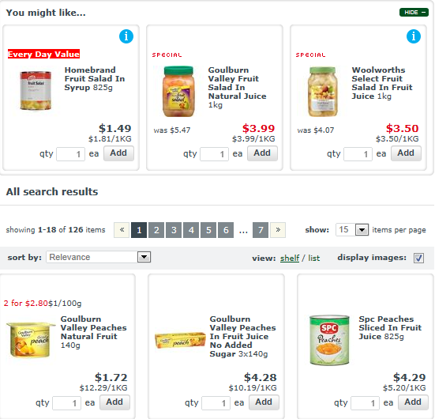

**Woolworths Online Shopping Website**

The Coles internet link is; <http://shop.coles.com.au/online/SearchDisplay?storeId=10502&catalogId=10554&langId=-1&pageSize=40&beginIndex=0&browseView=false&searchSource=Q&sType=SimpleSearch&resultCatEntryType=2&showResultsPage=true&pageView=image&searchTerm=canned+fruit>

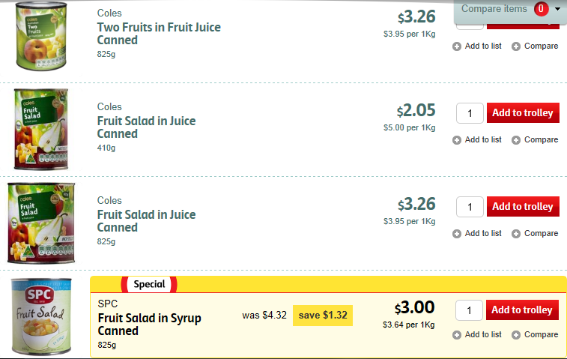

**Coles Online Shopping Website**

We contend that the retailers want consumers to make their buying decisions based on price without patriotic loyalty to being a factor because by pricing the imported fruit just under the Australian product, they will still make more gross profit because they have a lower cost price on the imported product.

Such tactics accelerate the transferral of market share to imports. This in turn reduces the throughput for the domestic manufacturer which is forced to spread overhead recovery over a smaller volume. As a consequence the domestic manufacturer’s unit cost price increases and it becomes further less competitive with the imports.

This is a classic example of the law of diminishing returns. It positions the retailers in a more advantageous negotiating position with the domestic manufacturer. We contend that this process contributes significantly to sudden circumstances now facing the Australian processing fruit industry.

1. **DECLINE IN FRUIT INTAKE**

In January 2009 SPCA announced that its fruit intake for the 2009 season would be of the order of the 2008 intake. This disappointed the orchardists because it was significantly below the 2009 crop which was not subject to the climatic limiting factors of previous years. The growers then had an expectation that the intake would return to the pre-drought situation.

ACFA met with SPCA on 16th January 2009. The participants at the meeting were; S. Perkins (SPCA acting managing director, S. Mills (SPCA supply manager), I. Routley (Orchardist & ACFA chairman), P. Hall (Orchardist), A. Plunkett (orchardist), J. Cornish (Orchardist) and J. Wilson (FGVL general manager & ACFA secretary).

During that meeting the SPCA managing director advised that SPCA would lose a Woolworths contract and that SPCA considered the cannery’s long-term go forward position would be an intake of 35,000 to 40,000 tonnes of peaches *(refer following handwritten note from the January 2009 meeting.)* This was considered to be a worst case scenario.

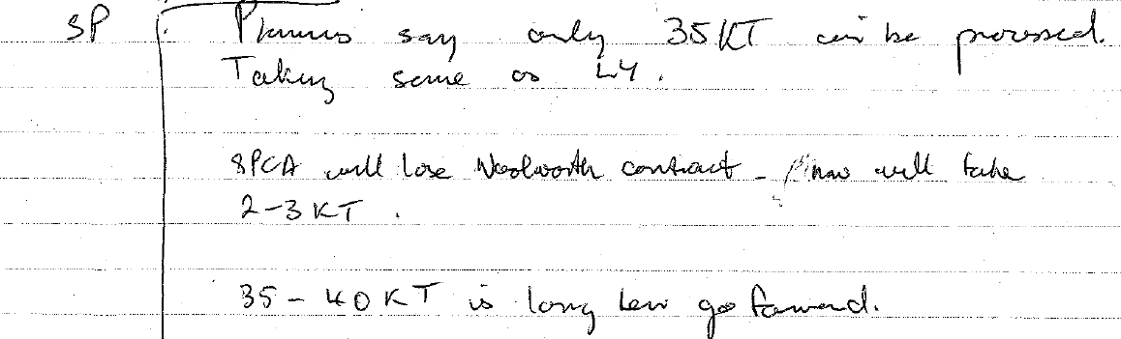

**Meeting Notes 16/1/2009**

That worst case scenario would now be good news for growers because 2009 was the beginning of the decline in intake that culminated with the April 10th 2013 announcement that the 2014 SPCA intake of peaches would be between 13,000 and 17,000 tonnes and the 2014 SPCA intake of pears would be between 9,000 and 11,000 tonnes.

**The proposed 2014 peach and pear intake is approximately 60% below what SPCA itself believed it would be just four years ago.**

Over the last four years there has been an average annual decline of 8% in SPCA peach intake and an average annual decline of 9% in SPCA pear intake.

**The proposed 2014 peach intake is a 50% reduction in one year compared to the recent average annual reduction of 8% per year. The proposed 2014 pear intake is a 47% reduction in one year compared to the recent average annual reduction of 9% per year.**



**SPCA Peach & Pear Intakes**

The following diagrams depict the percentage annual changes in peach and pear intakes by SPCA since 2008 and include the forecast intakes in 2014. They are provided to demonstrate the dramatic acceleration in the rate of decline that will confront the processing fruit growing industry in 2014.

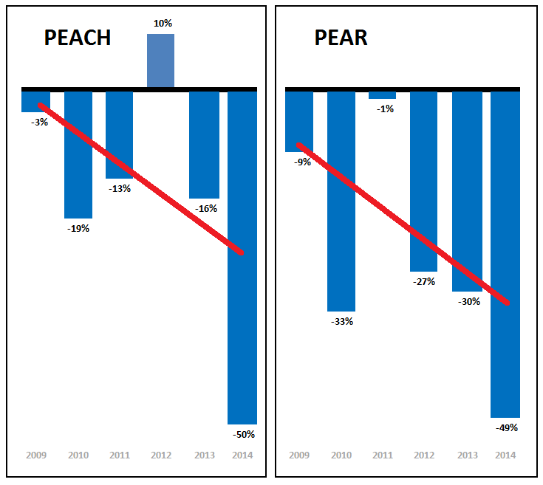

**Percentage Annual Changes in Peach and Pear**

The red lines are approximate trend lines. They intersect the 2014 columns well above the respective nadirs to indicate the decline in 2014 will be precipitous compared the declines since 2008.

Orchardists can cope with changes in an orchard in order of 5% to 10% in normal circumstances. Indeed it is good practice to have a program of orchard renewal. A renewal program of 5% would mean that an entire orchard would be renewed over a twenty year cycle. Such a program is always contingent of the availability of capital.

However these circumstances are not normal. They are extraordinary and unprecedented and the required change is large. Only orchard businesses with exceptional financial rigour will have the ability to make quick adjustment without support. The risk of market failure is real.

**The quantum of proposed reduction in the SPCA 2014 peach and pear intake is sudden and unexpected by orchardists most of whom cannot adjust to the changed business conditions within one season.**

1. **SPCA FRUIT GROWER/SUPPLIERS CIRCUMSTANCES**

SPCA made the announcement of the intended 2014 intake reductions at a grower meeting on 10th April 2013. SPCA representatives then visited each of its grower/suppliers to advise them of their own specific go forward situation. SPCA completed these grower visits on 29th April.

ACFA then held grower only meetings on 30th April and 1st May in Shepparton and Cobram respectively. Those meetings revealed many significant issues that required further investigation and subsequently ACFA conducted a survey of growers in May 2013 to discover their circumstances in more detail.

Ninety-eight (98) survey forms were posted to the registrants at the ACFA grower meetings. This meant that the survey reached 35% of all 2013 SPCA suppliers. However, when mango, tomato, citrus, grape and juice suppliers are excluded from this calculation, to arrive at the proportion of suppliers affected by the 2014 intake cutbacks, the recalculation reveals that 66% of affected grower/suppliers were sent a survey.

The response rate was 67% with sixty-four (65) survey forms returned. Of these respondents, fifty-five (55) were peach and/or pear suppliers in 2013. This means that 48% of all 2013 SPCA peach and pear suppliers responded. Peach and/or pear suppliers are the growers who are most affected by the 2014 cutbacks.



Sixty-two per cent (62%) of the respondents were from the City of Greater Shepparton and thirty-eight per cent (38%) were from the Moira Shire. Just over half (54%) of them were sole traders or partnerships. Companies and trusts accounted for the remaining orchard business entities but very few are corporations with the vast majority of orchard businesses being owner operators.

**Fifty-seven per cent (57%) advised that orcharding was their only business activity.** The percentage of solely orchard businesses is higher among small businesses *(less than $250,000 turnover)* at 70%. This drops dramatically to 10% for medium sized businesses *($250,000 to $1 million turnover).* None of the large businesses are solely orchards.

Business activities that growers participate in are; packing, domestic marketing, exports marketing and cool stores.

The growers were asked to reveal their profitability, debt, supply history to SPCA,

Business turnovers were estimated mathematically by applying known net cannery payments per tonne and extrapolating for the proportion of cannery income compared to the whole of the respondents’ businesses. This revealed that the majority of cannery suppliers are small businesses with turnovers less than $250,000 with only 12% of the respondents having turnovers greater than $1 million.

**Consequently, the reduction in revenue for the majority of cannery suppliers will have a significant negative impact because of limited scope to adjust their business models in a short time frame. This will produce results with no upside that will vary from reduced profitability (or increased losses) to unviability.**

There is a critical need to mitigate the impact the drop in revenue

The respondents were asked to state and predict whether their business made or would make a profit in financial years 2012, 2013 and 2014. Only fifty-six per cent (56%) of respondents reported that they traded at a profit in FY2012. This has declined to 39% this year and only 23% of 2013 cannery suppliers think they will be able to make a profit in FY2014. Thirty-four per cent (34%) of 2013 SPCA suppliers indicated that think they will make their third annual loss in a row in FY2014 and twenty-six (26%) of the growers.

**Grower losses have been accelerating in concert with SPCA Ardmona’s accelerating loss of market share.**

Twenty per cent (20%) of the respondents advised that they have no debt. However 50% of respondents who have debt, have a debt to equity ratio greater than 50%. This indicates that approximately **40% of 2013 SPCA suppliers have no capacity to raise capital**, which in turn means they will be unable to restructure the hectares rendered redundant by the cannery reductions.

Forty-eight per cent (48%) of respondents are currently not paying their trade creditors on time and 33% state they are not able to meet debt repayments schedules to financial institutions with 17 % of them currently undergoing debt mediation.

Sixty-six per cent (66%) of the respondents stated that their orchard was their only asset. **Therefore the value of the investment in their properties is the major part of growers’ retirement planning.**

The median average age of all employees in the respondents’ businesses is 44 years. The median age of the principal in each business is 53 years, however **43% of the business principals are already over 55 years of age** with 10% being older than 65. Only 8% of business principals are under the age of 35.

When it announced the reductions in April 2013, SPCA stated that its 2014 requirements would be between 9,000 and 11,000 tonnes of pears and between 13,000 and 17,000 tonnes of peaches. The lower of the ranges suggests reductions of 11,000 and 12,000 tonnes for pears and peaches respectively. This suggests a reduction of $10.5 million in orchard revenue.



The respondents advised that they have already reacted to their future drop in income and have reduced their permanent workforce by 46%. This includes both full time and part time positions. No full time equivalence information was gathered in the survey. This represents an estimated loss of 533 jobs in peach & pear orchards alone.

Approximately one in five (21%) of respondents advised that they feel depressed and think they need emotional support. A further 58 % of respondents advised that they know someone else who they think is depressed and might need emotional support.

It is presumed that some of those whose mental health is most vulnerable would be unable or unwilling to identify themselves as being in need of support.

Every grower that was contacted with regards to the survey or who attended the ACFA grower meetings or who provided feedback at subsequent reviews of the survey data growers raised the spectre of the danger of a major outbreak of pests and diseases in orchards if fruit is left on trees next year**.**

The significance of this cannot be understated because this ACFA survey establishes that the processing fruit growing industry will not have the financial means to attend this major threat, not only to the processing fruit industry, but to all fruit growing in northern Victoria.

**Pests like light brown apple moth, oriental fruit month, codling moth and Queensland fruit fly, as well as fungal diseases such as brown rot and black spot, will spread unchecked unless the unwanted fruit is prevented from growing.**

There are only three options available to prevent this. These are; the removal of the trees, the removal of blossom in spring or the removal of the fruit itself.

The removal of the fruit itself is a costly and wasteful exercise that no one would seriously consider as practical management.

The removal of blossom in spring is a practical solution where an orchardist wishes to save the tree for future budding over to another variety. This will only apply to young trees and would only continue until suitable bud wood is available.

The removal of the trees is the only practical large scale option that will prevent a phytosanitary and quarantine disaster with significant marketing implications and additional costs to all growers.

1. **REBOUND**

There are 61 growers who have lost all of the quotas for peach and pears. There are another 53 who will continue to supply SPCA with peaches and pears in 2014. So there are two different future scenarios for the growers affected by the SPCA cut backs.

Those growers who have lost all supply must find a way of moving on. They must transition their orchards to something else. The most practical way of achieving this is to remove the trees. Once this is done there is no quick return possible because it takes between four and six years to bring a new orchard into economic production.

This means that any safeguard action will not directly benefit this group of growers. However they would receive indirect benefit because there is a flow-on effect of SPCA activities into the fresh fruit sector.

There are two indirect flow-on benefits from increased SPCA intake as a result of safeguard action. The first is that less fruit will be diverted to the fresh market and therefore reducing the downward pressure on farm-gate prices for the fresh fruit sector by oversupply. The second is the increased capacity of SPCA to take fruit, rejected by fruit packing sheds, for pulp and juice.

The latter benefit has a huge effect on setting the floor price for fresh fruit in the markets. As a significant portion of SPCA suppliers also grow for the fresh market, they would benefit considerably.

Those growers who have not lost all supply will also benefit indirectly as well as directly from safeguard action.

These growers are the future of the processing fruit industry and their survival is critical. Almost all of them will have surplus cannery fruit in 2014. So any increase in SPCA intake will have an immediate positive effect on profitability, cash flow, investment and employment. They are the growers who will have the capacity to expand as the SPCA market share returns a fair level.

1. **SUMMARY**

The Australian Canning Fruit Growers Association and its grower association members support SPCA’s bid for safeguard action. We support it on the basis that the effect, of the loss of SPCA market share to imports, on the Australian processing fruit industry is both sudden and substantial and as a consequence the industry has no opportunity to respond effectively to the changed circumstances.

The information that this submission provides confirms that circumstances inflicted on the processing food industry were caused by the sudden increase in imports from 2009 which has accelerated to the point where good businesses operating under world best practice will fail.

We have provided evidence that no-one, not even SPCA itself, predicted the size and rapidity of the decline in its market share. We have demonstrated the devastating effect that it has had on orchardists who supply SPCA and the scope and degree of the issues that confront them.

And, we have shown that the cause is the opportunistic behaviour of Australian retailers that have taken advantage of world oversupply and the extra buying power of the $AUD; both of which were predicated by the decline in the strength of the major northern hemisphere economies from 2008.

And, we have demonstrated that the processing fruit growing industry has the capacity to rebound, albeit, as a restructured sector.

The Australian market cannot adjust to such a large volume of imported fruit in quick time. The resultant unwanted 25,000 tonnes of peaches and pears in Australian orchards is physically a very…..very large amount of fruit.

**The reduction in SPC Ardmona peach and pear intakes over 2013 and 2014 could fill the entire playing surface of the MCG with bins of fruit to a height of 2.5 metres.**

The Australian processing fruit industry urgently needs safeguard action to help it meet challenge to provide practical solutions to the crisis it faces. Such support will reduce the harshness of the landing that awaits the growing industry as a result of the previous cannery cutbacks and those proposed in 2014.

**John Wilson**

*General Manager – Fruit Growers Victoria Limited*

*Secretary – The Canned Fruit Industry Council of Australia*

*Secretary – Australian Canning Fruit Growers Association*