Cover letter

The Productivity Commission
Inquiry into Public Infrastructure
Level 12, 530 Collins Street
Melbourne VIC 3000

By e-mail: infrastructure@pc.gov.au
7 January 2014
Dear Sirs,
INFRASTRUCTURE FINANCING: SUBMISSION ABOUT THE MISUSE OF COST-BENEFIT ANALYSIS IN DECISION MAKING

This submission is about the misuse of cost-benefit analysis to justify a rail project in the Sydney region.The project is the expansion of the Northern Sydney Freight Corridor (NSFC) between North Stratfield and Broadmeadow by insertion of 14.6 km of additional track into the corridor which is 151.94 km in length. The cost benefit analysis (CBA) or business case was carried out by Deloitte on behalf of Transport for NSW. It attempts to show that the rail expansion will lower the cost of freight haulage compared to transporting the same amount of freight by road.

The attached audit of the Deloitte analysis which is the substance of this submission, shows that this finding of lower costs is fallacious in that there are no cost savings resulting from the expanded use of rail instead of road. The submission gives detailed reasons for this conclusion.

The false justification of this project by the misuse of CBA means that capital amounts of between $700m and $1100m have been misallocated.This misallocation can undermine productivity of freight haulage and competition in the freight transport industry and also undermine public (taxpayer) and private(investor) confidence.

Yours faithfully
Dr John L. Goldberg
Former Honorary Associate

Inquiry into Public Infrastructure
Submission to the Productivity Commission

An audit of the cost-benefit analysis for the Northern Sydney Freight Corridor Program prepared by Deloitte on behalf of Transport for NSW (2011).

John L. Goldberg
Former Honorary Associate
The University of Sydney

10 January 2014

An audit of the Deloitte cost benefit analysis for the Northern Sydney Freight Corridor
John L Goldberg
Former Honorary Associate
The University of Sydney

Summary of findings
A business case for upgrading the Northern Sydney Freight Corridor Program (NSFCP) was commissioned by Transport for NSW in 2011 and carried out by the accounting firm Deloitte.The upgrade involves four components, namely the North Strathfield bypass, the Epping to Thornleigh Third Track (ETTT), the Hexham and Gosford passing Loops
The Deloitte findings indicated that the project was economically viable as the benefits exceeded the costs by a factor of about three. But previous research by the author (Goldberg, 2010) into the economic effect of marginally increasing the capacity of a transport system does not support such a large increase in benefit to cost ratio (BCR). For example, this research has shown that widening a road from four to six lanes increases the capacity by 50% yet the benefit to cost ratio of the upgrade was only 0.27.
With the four component upgrade of the rail corridor between North Strathfield and Broadmeadow the capacity increase is only 9.6%. Moreover, Australian Infrastructure Statistics (2012) for NSW shows that road freight demand is nearly seven times greater than that of rail freight and its rate of increase is nearly double that of rail. This evidence has led the author to examine in detail the claims made in the Deloitte document.
The benefits of the proposal are defined by Deloitte as the difference in costs obtained by moving freight by rail compared with moving the same amount of freight by road, but this audit shows that the benefits were not calculated by this method. Instead Deloitte used only the costs of moving freight by the upgraded rail system and wrongly defined these costs as benefits. This approach had the effect of making the benefits significantly larger and this provided an economic justification for the project.
Consistent with this approach, capital costs involved in the construction have also been redefined as additional benefits and added to the total benefits already wrongly obtained. The entire capital cost of the project which, according to official NSW government sources is $1.1 billion, was claimed by Deloitte to be only $755 million, This cost reduction also contributed to a higher BCR.
On taking account of all the above factors the real BCR was calculated by the author to be only 0.63 over a 30 year period at a discount rate of 7%pa compared to the Deloitte claim of 2.75. or greater. The real benefits are thus less than the costs leading to a compelling reason for not funding the project. To fund such a project would involve a serious misallocation of capital.
This audit shows how a business case can be developed to support an uneconomic infrastructure project.

10 January 2014

Contents
- Introduction

- The Deloitte analysis: general remarks.

- The relative magnitudes of the freight task as carried by road and rail due to the transfer of freight to rail.

3.1 Is there a case for transferring freight carried by heavy road vehicles to rail on the upgraded rail system?

- Detailed numerical examination of the Deloitte business case.

  - Steps in the computation.

- Summary of benefit to cost ratios

- Concluding remarks

- Introduction
This submission examines the cost benefit analysis (CBA) of the Northern Sydney Freight Corridor expansion carried out by Deloitte for Transport for NSW and evaluates its integrity. The author’s experience of CBA for transport systems suggests that relatively small changes in system capacity cannot give rise to disproportionately large increases in benefits. In the case of the four component expansion of the corridor a very high benefit-to-cost (BCR) ratio of between 2 and 3 is claimed, but there is shown to be a number of serious anomalies in the Deloitte analysis which have had the effect of inflating the benefits and the benefit to cost ratio. The Deloitte analysis has been accepted for funding of this demonstrably uneconomic project.
2. The Deloitte analysis: general remarks
The Deloitte analysis is a 60 page document plus appendices which was made available to the author by Infrastructure Australia under the Freedom of Information Act, 1982. The Deloitte document reveals an undiscounted capital cost with an upper limit of $755m which is assumed to include the underpass, the Third Track and two passing loops as described in Table 1 below. .But this cost is substantially less than the amount of $1.1 billion that was given to an industry briefing on 24 January 2012.The official cost summary is given in Table 1 below together with the added rail capacity obtained from the four components.

Table 1.

Estimated costs and increase in rail capacity
Item | Cost $ million | Dimension (km)
North Strathfield Rail Underpass | 435 | 2.4
Epping to Thornleigh Third Track | 520 | 6.1
Gosford Passing Loop | 120 | 4.6
Hexham Passing Loop | 25 | 1.5
Total | 1100 | 14.6
Deloitte claim | 755
N. Strathfield to Broadmeadow |  | 151.94

The increase in rail capacity is only 9.6%. Yet the Deloitte document claims a benefit to cost ratio of about 3.0 (actually 2.75 according to the spread sheet in Appendix C-Economic Evaluation Results, 30 year period. Only part of the explanation for the very high BCR lies in the understated capital cost, which was further reduced by discounting.

There are two significant statements in the Deloitte document. The first one is
“the additional capacity allows additional freight traffic to be transported by rail compared to the base case and this difference in rail freight demand forms the basis of the benefit estimation described below” (page 36).
The second statement is:
“Within the benefit components, the largest contributor to the benefit stream is the reduction in freight transport operating costs resulting from a switch from road to rail being passed on by freight operators through lower prices”.(page 57).
Although both these statements define the expected method of determining benefits, the actual method used by Deloitte is shown to be quite different.
It will be shown that Deloitte has calculated the costs of moving freight by the total upgraded rail system, not the costs attributable to the increased capacity of the system alone and has then wrongly defined these costs as benefits. There was no evaluation of the cost savings that would have been obtained by comparison with road usage. This approach is shown to have had the effect of generating benefits that would adequately justify the project on economic grounds.
Consistent with this requirement to justify the project, capital costs involved in the construction have also been wrongly redefined as benefits and added to the original series of benefits already obtained. The entire cost of the project which according to official NSW government sources is $1.1 billion as described in Table 1 was reduced by Deloitte to $755 million. To reduce the capital cost still further, part of the amount of $755 was discounted. These cost reductions contributed significantly to the high BCR.
Table 8.1 (page 56) shows that the claimed benefits of the project are very large, almost double the project cost. The basis of the Deloitte findings is therefore questionable. Such doubts are emphasised when one examines the freight demand to be accommodated by the increase in capacity.

Table 2 below is reproduced from Table 5.13 “Road and rail freight task (net tonne-km million)” in the Deloitte document.
Year | Rail base case | Rail upgrade | Task increment
2010 | 4,372 | 4,372 | 0
2015 | 6,482 | 6,842 | 0
2020 | 8,054 | 10,439 | 2,385
2025 | 8,133 | 14,574 | 6,441
2030 | 8,152 | 16,457 | 8,395
2040 | 8,131 | 16,435 | 8,304

It should be noted that between 2020 and 2040 the freight task increases whereas the relatively small increase in capacity of the corridor remains the same. Obviously this would mean an increase in the number of freight trains per day which may not meet operational requirements of the entire Northern rail system including passenger and freight movements. Nowhere in the Deloitte document is this limiting factor addressed. These very large increases in demand for both the Rail base case and Upgrade case shown in Table 2 have very great uncertainties in tonnage as shown by Deloitte in Table 3.2 which is reproduced below. These uncertainties are not reflected in the final Deloitte result for the benefit to cost ratio.
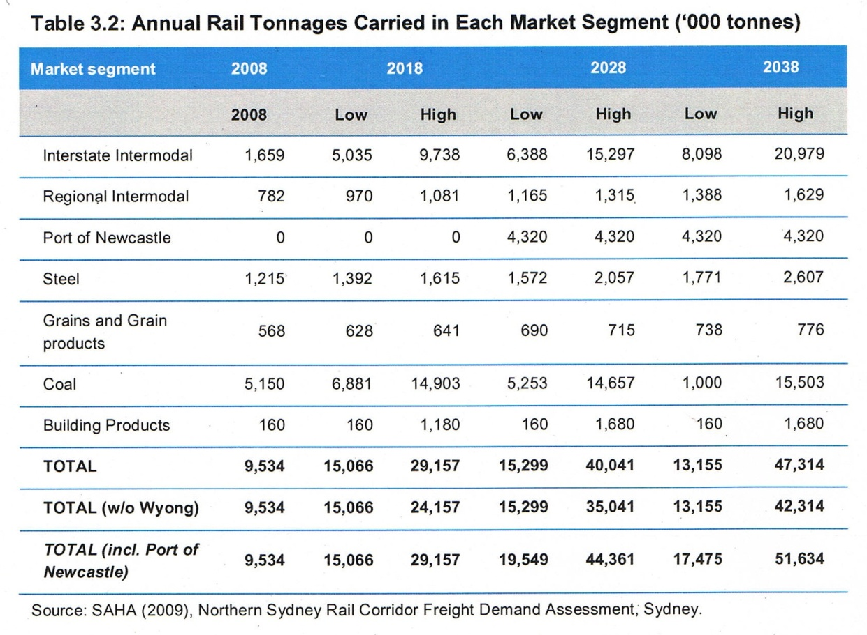
For example, in the year 2038, the annual rail tonnage is forecast to vary from a low value of 15,299 thousand tonnes to a high value of 40,041 thousand tonnes, a very large variation in excess demand.

3. The relative magnitudes of the freight task as carried by road and rail in NSW.
The Australian Bureau of Transport Statistics (BTE, 2012) maintains a complete and comprehensive data base which enables a state by state comparison of rail and road freight tasks.

Between 1999 and 2008, the rail task in NSW was 3 billion tonne-kilometres, whereas that of road freight was 20 billion tonne-kilometres, a factor of nearly seven times greater. The discrepancy is so large as to raise doubts as to the economic relevance of transferring freight from road to rail.

The graph below derived from BTE data shows that the rate of increase of road freight productivity is about twice that of rail. Even if this rate of increase were not maintained it would be unlikely to reinforce the case for transferring freight from road to rail.
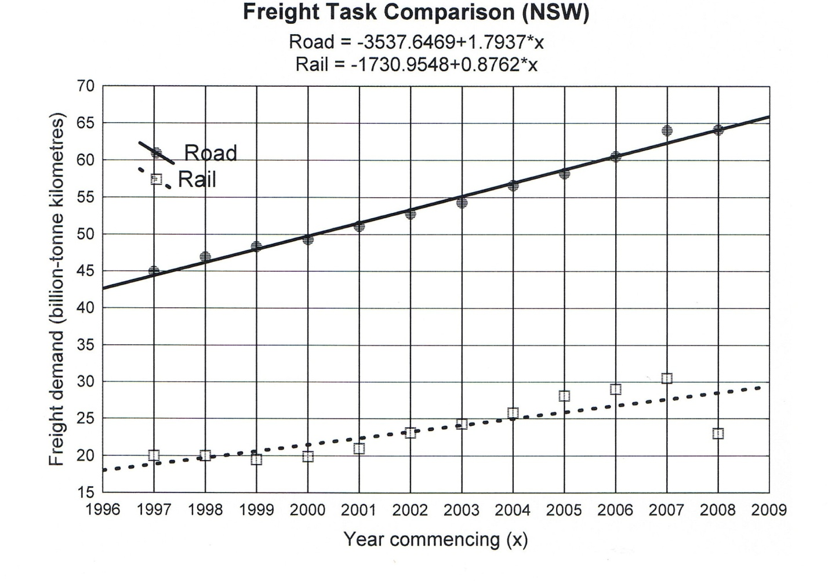
Figure 1.Comparison of freight demand by road and rail in NSW.

  - Is there a case for transferring freight carried by heavy vehicles to rail on the upgraded rail system?

The possibility of transfer and its implications has been examined in more detail using actual freight data obtained from Rail Corp (2012) for two months in March 2012 and in August 2012, which enabled reasonably accurate annual estimate of the freight tonnage carried on the Northern line. This annual estimate is 6.7 million gross tonnes equivalent to 3.7 million net tonnes (using the conversion factor of 1/1.8).
If as claimed by Transport for NSW (2012) 200 000 heavy vehicle movements by road were to be eliminated over a 15 year period as a result of the utilisation of the upgraded rail track, then the freight exchange can be calculated as follows. The heaviest road vehicles in common use are nine-axle B-doubles that can carry a maximum freight load of 68 tonnes each. The corresponding total load transferred to rail would be 13.6 million net tonnes. The claimed annual removal of freight from the roads is therefore between three to four times the net tonnes carried by rail at present. This result raises serious questions about the availability of sufficient rail capacity.
But it has already been established that road freight demand is seven times greater than that of rail and the rate of increase is twice as great. These results suggest that the claimed reduction of heavy vehicle movements is unrealistic and cannot be used to support a case for transfer of road freight to rail.
Nevertheless, Deloitte has attempted to use the argument of reduced road crash cost savings (page 48) to justify rail as against road freight. But apart from quoting a crash cost of $0.40 per net tonne kilometre no other result is given which emphasises the difficulty in properly quantifying the real economic gain from such a proposal.
In relation to heavy vehicle involvement in fatal accidents, two findings have been mentioned (BTRE, 2006). Across the entire road network, the fatal accident rate is higher for heavy vehicles, but on intercapital corridors the fatal accident rate is well below that of all other vehicles.

- Detailed numerical examination of the Deloitte business case

As previously noted Deloitte has calculated the costs of moving freight only by the upgraded rail system. There was no comparison of the cost savings that would have been obtained by comparison with road usage. Deloitte simply redefined as benefits the costs incurred from using rail only. This redefinition is meaningless but it would have the effect of generating benefits so that the project could be justified.

In economic terminology these “benefits” are defined as “consumer surplus”. Deloitte claims to have followed ARTC modelling of the Melbourne-Brisbane inland Rail Alignment Study (2010) in deriving usage costs, but similar data is also available from CRA Pacific National for the more appropriate coastal route Sydney to Brisbane.

The Deloitte usage costs are as follows:

3.4 cents per net tonne-kilometre (2011) for rail and 6.2 cents per net tonne-kilometre (2011) for road.

The Pacific National usage costs are:

$ 32.04 per 1000 net tonne-kilometres (2006) in 2011 dollars, $37.02. for rail and $47.82 per 1000 net tonne kilometres (2006), in 2011 dollars, $55.25 for road.

The agreement between these two independent sources is reasonably satisfactory but the Pacific National (CRA) figures for usage costs are derived from actual operations on the Sydney to Brisbane costal route.
Table 2 below is reproduced from Table 5.13 “Road and rail freight task
(net tonne-km million) of the Deloitte document and for convenience is repeated here.

Year | Rail base case (ntkm) | Rail upgrade (ntkm) | Task increment (ntkm)
2010 | 4,372 | 4,372 | 0
2015 | 6,482 | 6,842 | 0
2020 | 8,054 | 10,439 | 2,385
2025 | 8,133 | 14,574 | 6,441
2030 | 8,152 | 16,457 | 8,395
2040 | 8,131 | 16,435 | 8,304

4.1 Steps in the computation.

The freight task increment is the increase in freight demand that is accommodated by the increase in rail capacity. This increment is supposed to result in the “benefits” claimed by Deloitte for the rail upgrade. The cost savings obtained by transporting the increase in freight by rail rather than by road are calculated as follows. The steps in the calculation are explained as follows.

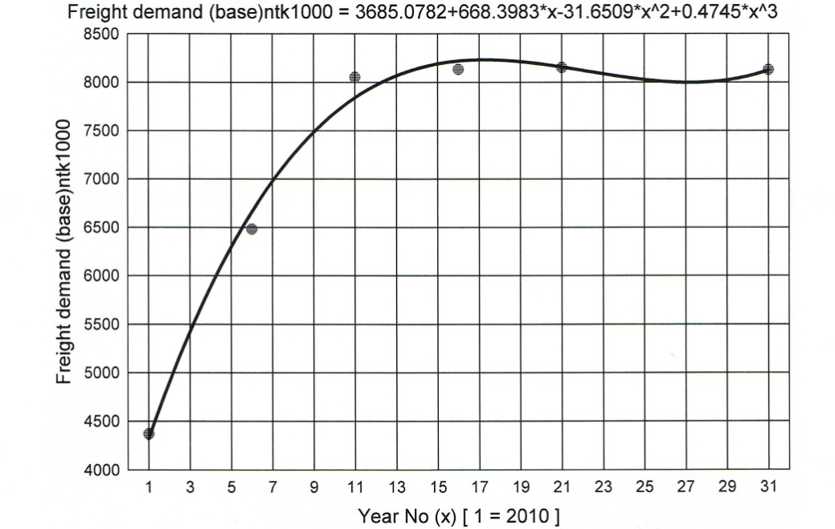

Figure 2. The Base Case freight demand function derived from curve fitting by least squares to the discrete data values given in Deloitte Table 5.13 and reproduced in Table 2 above. The cubic function allows interpolation to obtain values of base case demand each year over a 30 year period.

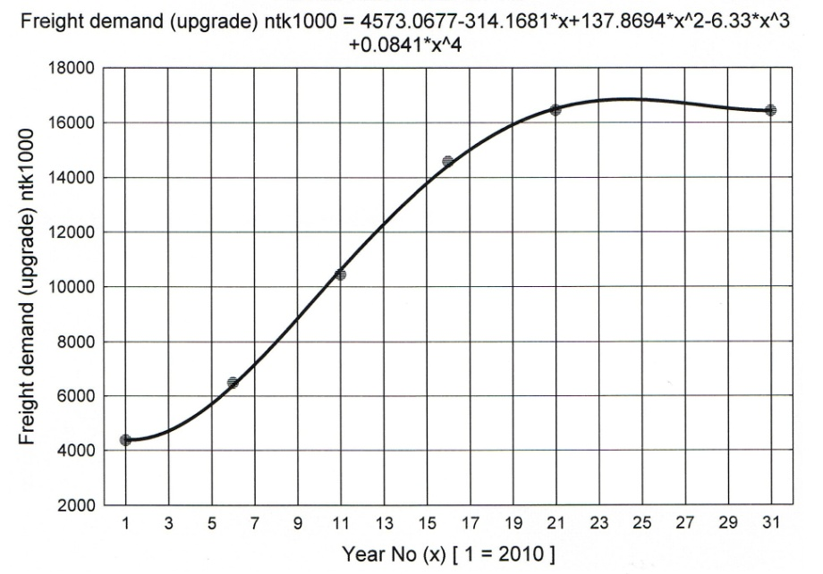

Figure 3. The Upgrade Case freight demand function derived from Deloitte Table 5.13. In this case a quartic function has been fitted to the Deloitte data by the method of least squares and is used for interpolation..

The difference between these two functions shown in Figures 2 and 3 is the excess capacity which is generated as a result of the upgrade. Figure 4 below is the result of differencing the two functions.
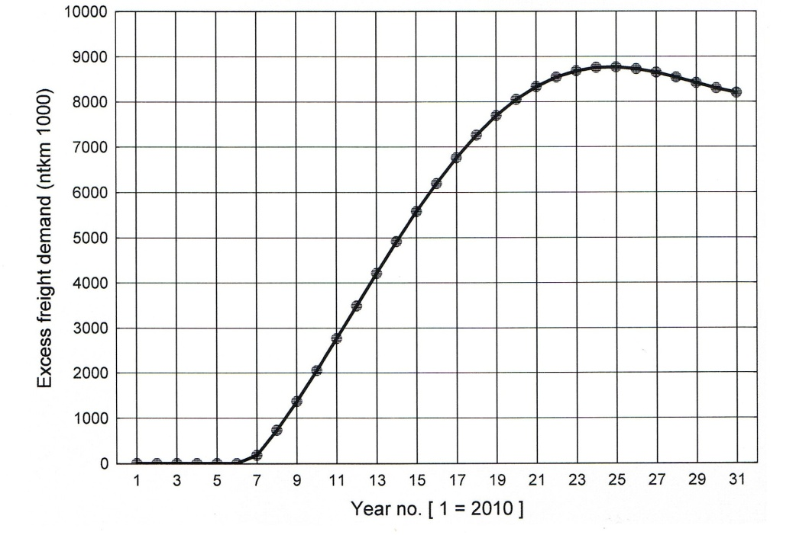
Figure 4. This excess capacity is the variable that must be used in the calculation of benefits. The additional step in the calculation which is needed to evaluate benefits is the difference in usage costs between rail and road applied to the excess capacity.
Deloitte has not used this freight demand difference or excess capacity in calculating costs as it has claimed to have done.
Instead, it has calculated the costs on the assumption that these were derived solely from the use of the whole upgraded rail system. These costs were then wrongly relabelled as benefits. This wrong approach has the effect of inflating the benefits from the project This inflation effect is clearly shown graphically in Figure 5 below.

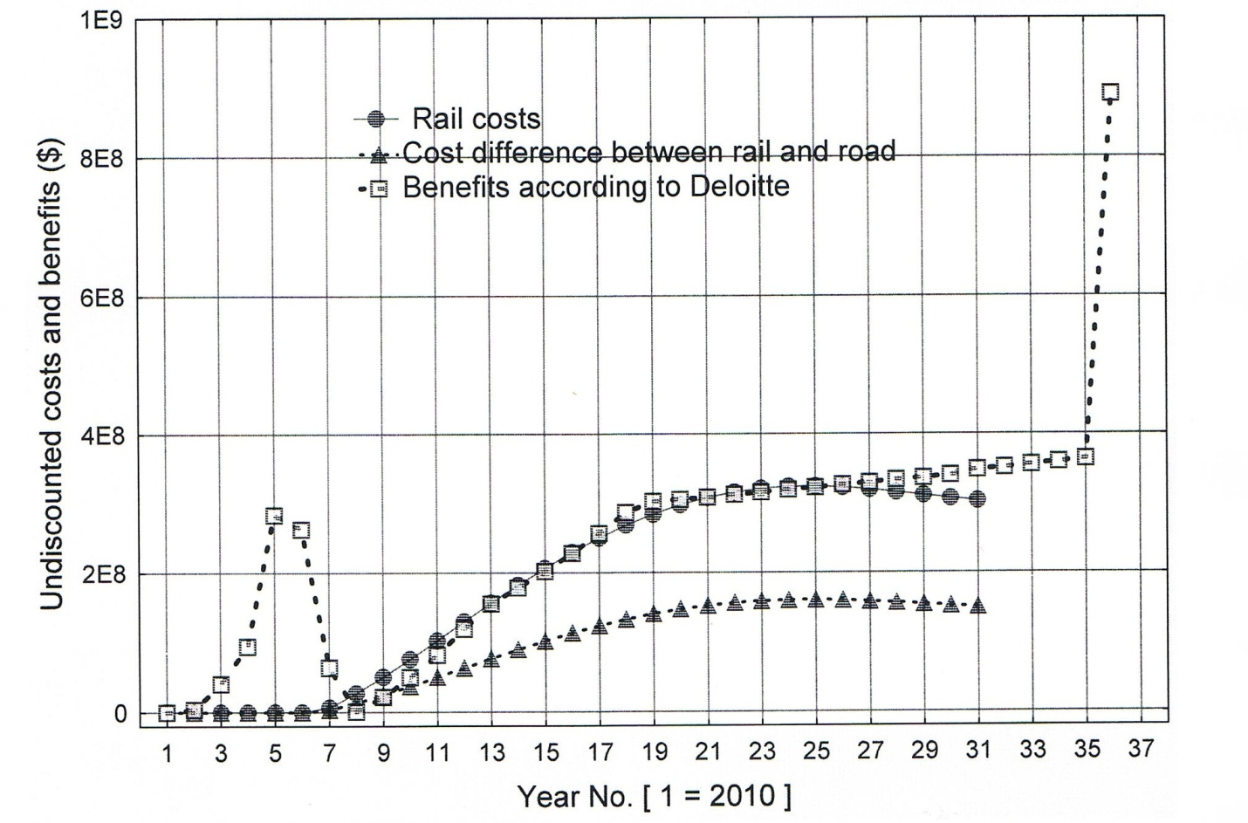
Figure 5 . This graph shows the following three variables
- the rail costs.

- the real benefits correctly obtained as the cost differences between road and rail transport.

- the benefits wrongly obtained by Deloitte by using rail costs as a substitute for real benefits and the addition of capital costs to these benefits.

More specifically, it will be observed that over a major part of a 30 year period the undiscounted rail costs and the benefits claimed by Deloitte are in satisfactory agreement except for the two anomalies namely the addition to the Deloitte benefits of the capital costs during years 2 to 7 and a very large unexplained amount at year 36.

Summary
(1) The Deloitte benefits are not benefits as such but are actually costs obtained by multiplying the actual demand for the use of the upgrade by the rail usage costs. No excess demand figures were used by Deloitte in its calculations as it cliamed to have done.
(2) The real benefits are the result of multiplying the excess demand by the difference between road usage costs and rail usage costs. This was not done by Deloitte although it claimed that this was the method it used.
.
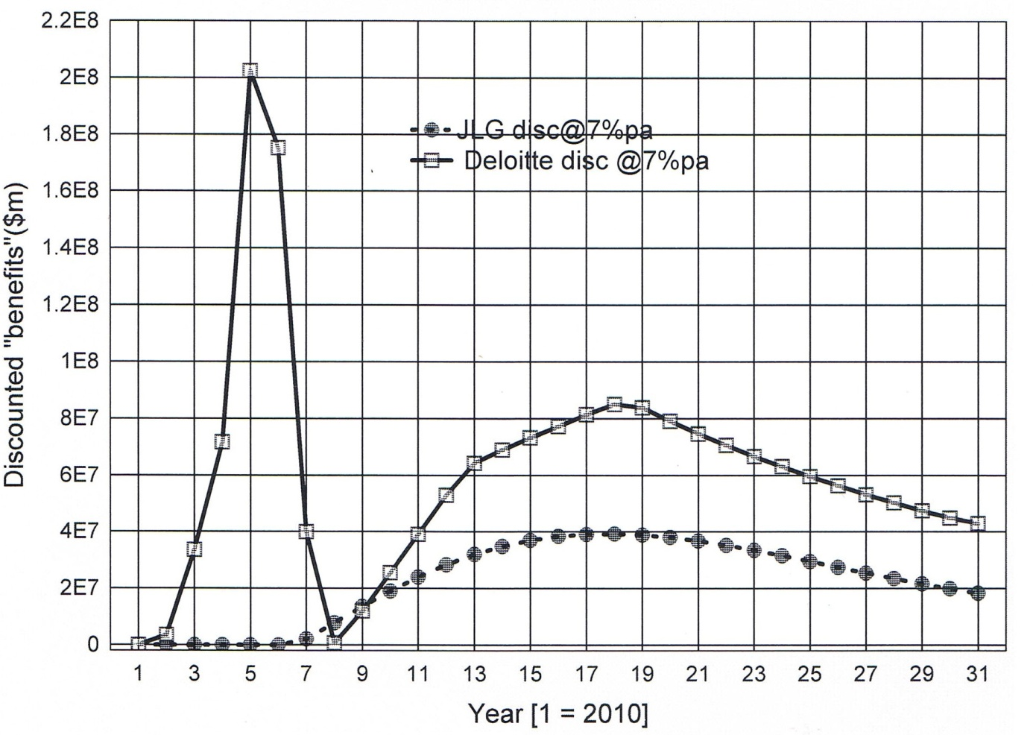
Figure 6 The discounted values of the real benefits which are derived from the difference in rail and road costs, together with the discounted costs of rail usage. wrongly defined by Deloitte as benefits. One can observe the very significant effect of adding capital costs in the early years 2 to 7 to the benefits.

- Summary of benefit to cost ratios
Source | Discount rate 4%pa | Discount rate 7%pa | Discount rate 10%pa
Deloitte (page 58) | 4.0 (4.4) | 2.7 | 1.9
The author (JLG) | 1.12 | 0.63 | 0.37

It will be noted that the ranges of the BCR from both sources do not overlap.
- Concluding remarks
The cost benefit analysis developed by Deloitte for the four element rail upgrade on the Northern Sydney Freight Corridor has been audited and has been found to be misleading. The fatal flaw in the Deloitte derivation is the use of rail cost data as a substitute for the real benefits which should be the savings obtained as the difference between transport by road and transport by rail. This difference was acknowledged by Deloitte as the source of the benefits but it was not used by it in their derivation.
The real value BCR = 0.63, disqualifies this project from being considered economic or worthy of funding.
This investigation was carried out in the public interest and is submitted herewith to the Infrastructure Inquiry sponsored by the Productivity Commission
.References
ARTC (2010) The Melbourne-Brisbane Inland Rail Alignment Study.
Australian Infrastructure Statistics (2012) ( ISBN 978-1-921769-83-2).
BTRE(2006) Submission to the Productivity Commmission. Road and rail freight infrastructure pricing inquiry (August).
CRA International (2006) Two case studies on road versus rail freight costs (CRA Project No: D09396-00. 25 May.
Deloitte (2011) Northern Sydney Freight Corridor Program- Updated Stage 1 Business Case.(commissioned by Transport for NSW).
Goldberg, J.L. (2010) Cost-benefit analysis of road widening proposals with special reference to the M2 Motorway in the Sydney Region. A statistical evaluation. Proceedings of the Australasian Transport Research Forum 2010.
Rail Corp (2012) Letter to the author 14 December 2012. Access application F-2012-370.
Transport for NSW (2012) Epping to Thornleigh Third Track . Environmental Impact Statement. page xv.

Appendices
Algorithms and spread sheets

- Appendix A sets out the 15 variables used in the computations and the mathematical relationship of these variables to each other. Except for updating the costs from 2006 to 2011 dollars, no CPI adjustments were used by Deloitte or the author. Forecasting CPI movements over a 30 year period, is likely to be uncertain and in any case would not change the substance of the arguments used in this audit.

- Appendix B shows the results of the calculations on a year by year basis. These calculations are graphically displayed throughout this audit document.

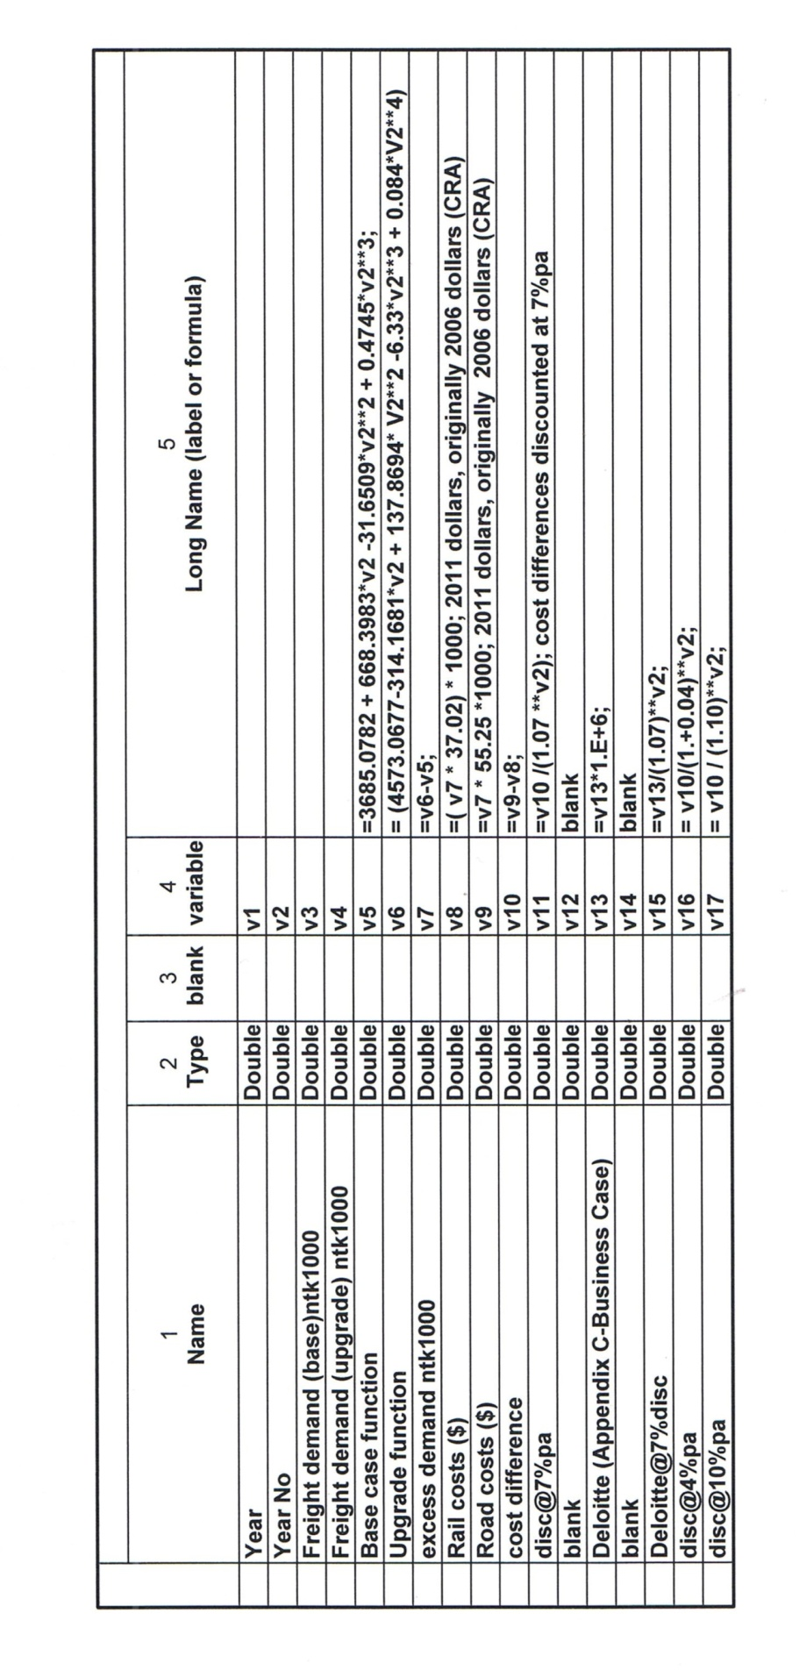Appendix A

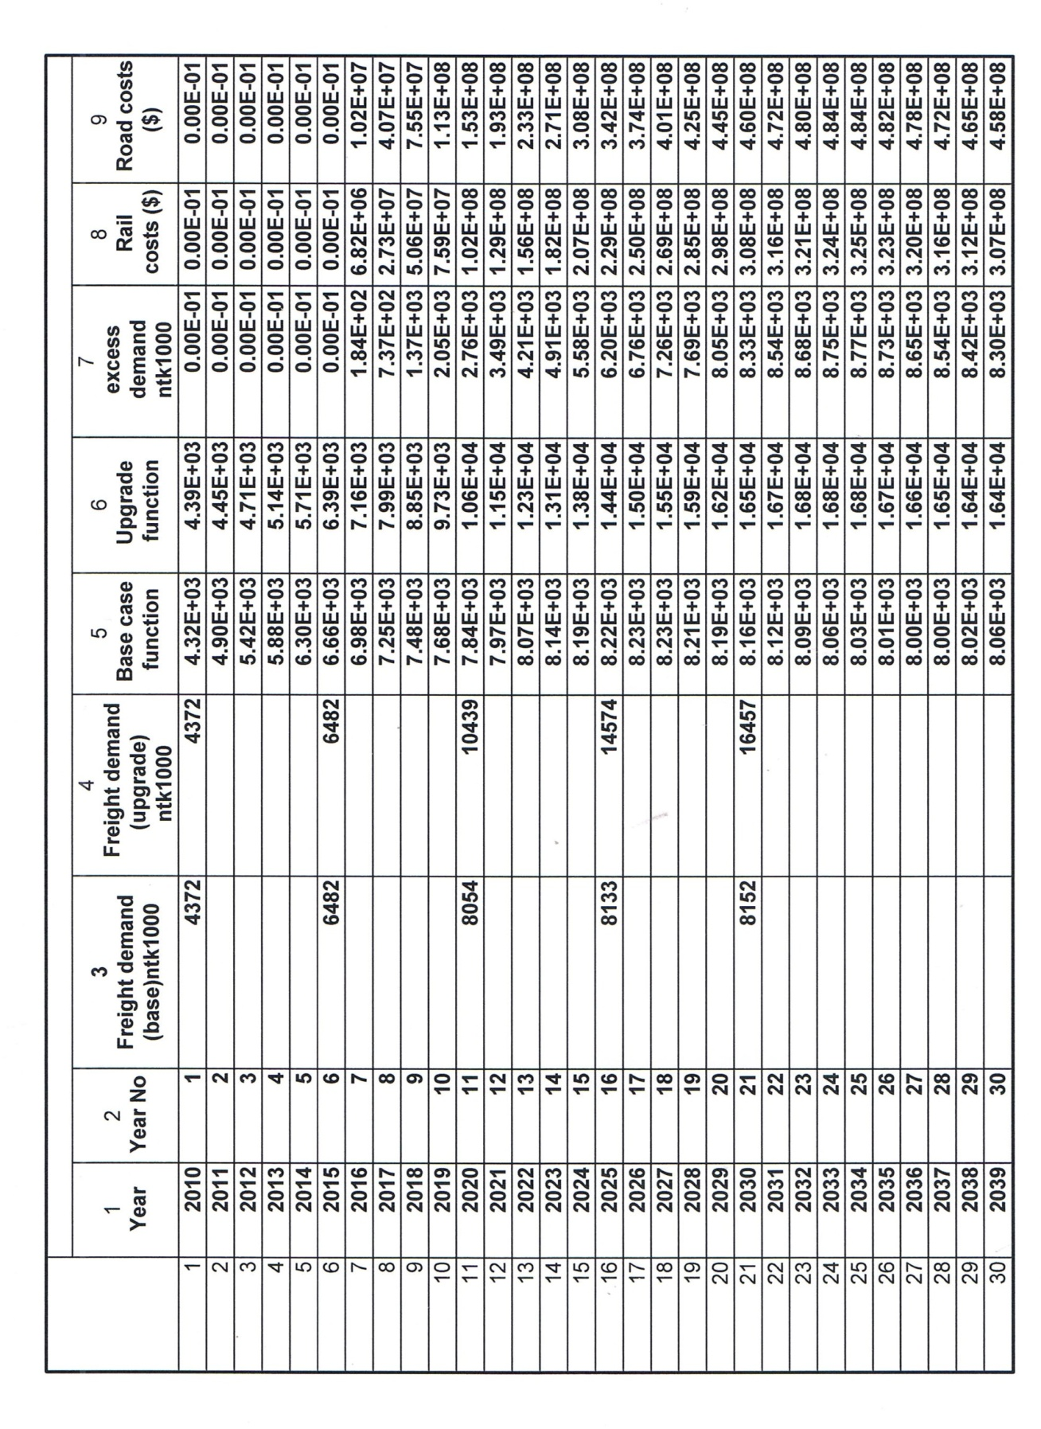Appendix B1

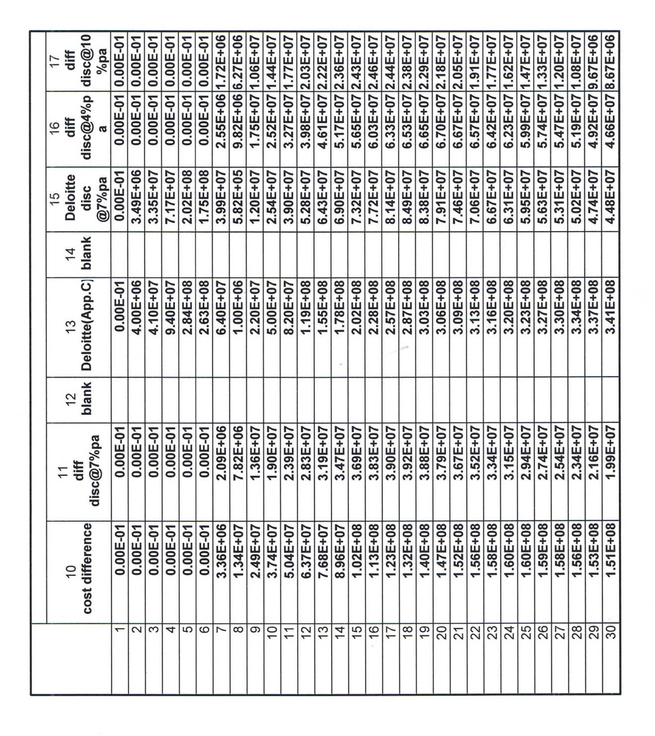Appendix B2

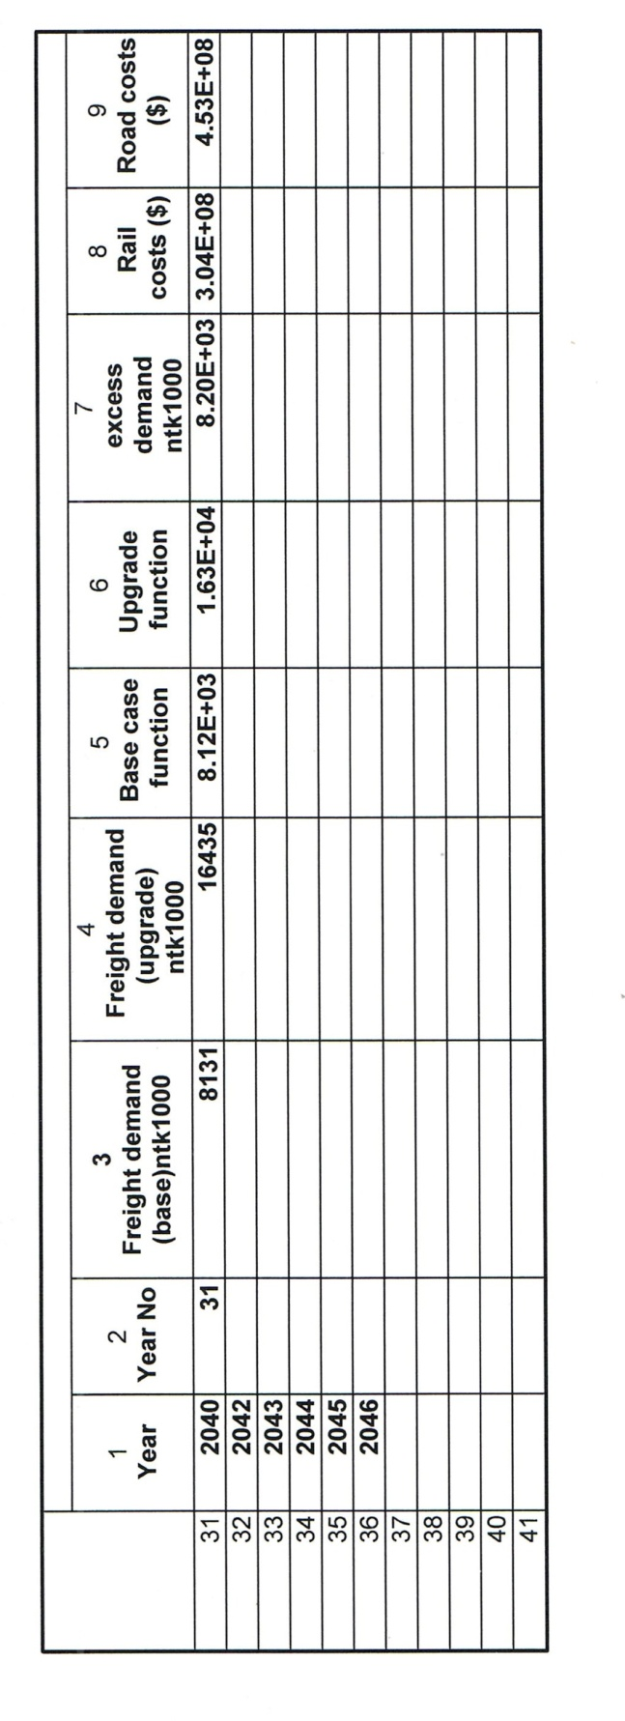Appendix B3

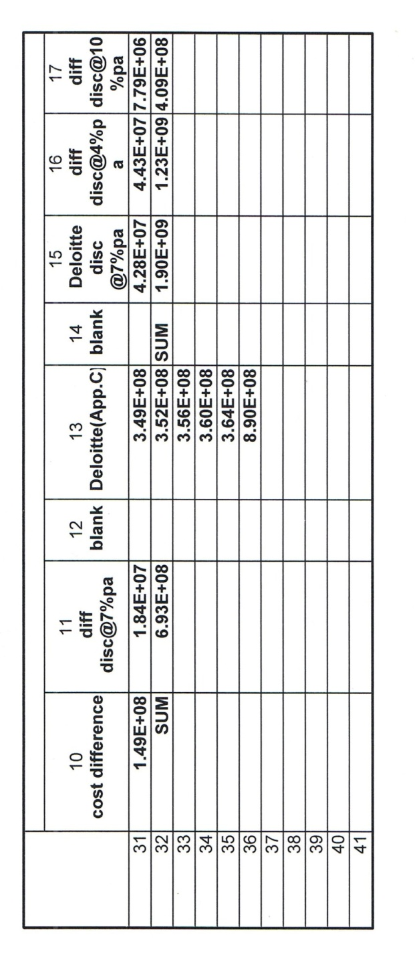

Appendix B4

