**Failure of Geoscience Australia’s ‘Economically Demonstrated Resources’ to Properly Inform Government Policy on Mineral Exploration Incentives**

By Chris Cairns[1], BSc (Hons1) Economic Geology, MAIG

**Executive Summary**

Geoscience Australia (GA) compiles data on Australia’s ‘Economically Demonstrated Resources’ (EDRs) (Geoscience Australia, 2010) to inform Government policy on taxation, mineral resources management and mineral exploration. The data are collated from public company announcements to the Australian Securities Exchange (ASX) on Ore Reserves and Mineral Resources reported in compliance with the JORC Code. This paper concludes that the ASX reported Mineral Resources are not directly compatible with GA’s guidelines for compiling EDRs and this incompatibility has resulted in an overestimation of resources that would be considered ‘economic’ by exploration and mining companies. Further, the term ‘Economically Demonstrated Resources’ has been critically misinterpreted as meaning reserves in the recent Policy Transition Group Report on Mineral Exploration.

GA is encouraged to join with industry and the geoscience and mining professional organisations to review how information relating to Australia’s mineral resources endowment is compiled. Robust, strongly evidence-based data are essential to ensure reporting on the health of Australia’s mining and exploration industry is sound, given the role this data plays in informing Government policymaking. Of particular importance is that the terminology of ‘Economically Demonstrated Resources’ be modified to reflect that the compiled Mineral Resources are not ‘economically demonstrated’ and are more accurately described as Australia’s ‘Identified Mineral Resources’. This would ensure that ‘economic’ status is not implied and that policymakers are not confused into thinking that reported Mineral Resources are Ore Reserves by the use of inappropriate terminology.

**Introduction**

The origins of both Geoscience Australia’s (GA) *National Classification System for Identified Mineral Resources* (Appendix 2 in Geoscience Australia, 2010) and the Joint Ore Reserves Committee (JORC) *Australasian Code for Reporting of Exploration Results, Mineral Resources and Ore Reserves* (JORC Code) can be traced back to a paper in American Scientist in 1972 by Vincent E McKelvey entitled “Mineral Resource Estimates and Public Policy”. McKelvey was then a Director of the United States Geological Survey (USGS). This paper was an extension of work McKelvey was involved with in conjunction with the Federal Power Commission looking at whether *‘industry reported natural gas reserves were an accurate indication of the amount of natural gas actually on hand...’*.

The original resources classification proposed in McKelvey’s work was summarised in what has become known as the McKelvey Diagram, later modified in USGS circular 831 (1980) entitled *Principles of a Resource / Reserve Classification for Minerals*  (Figure 1).

McKelvey is better known for his involvement in deriving estimates of the ultimate crude oil production for the Lower 48 States. In 1963, Duncan & McKelvey of the USGS released an estimate of 650 billion barrels. This estimate was interpreted by Government policy makers to indicate that the USA had abundant resources of recoverable crude oil.

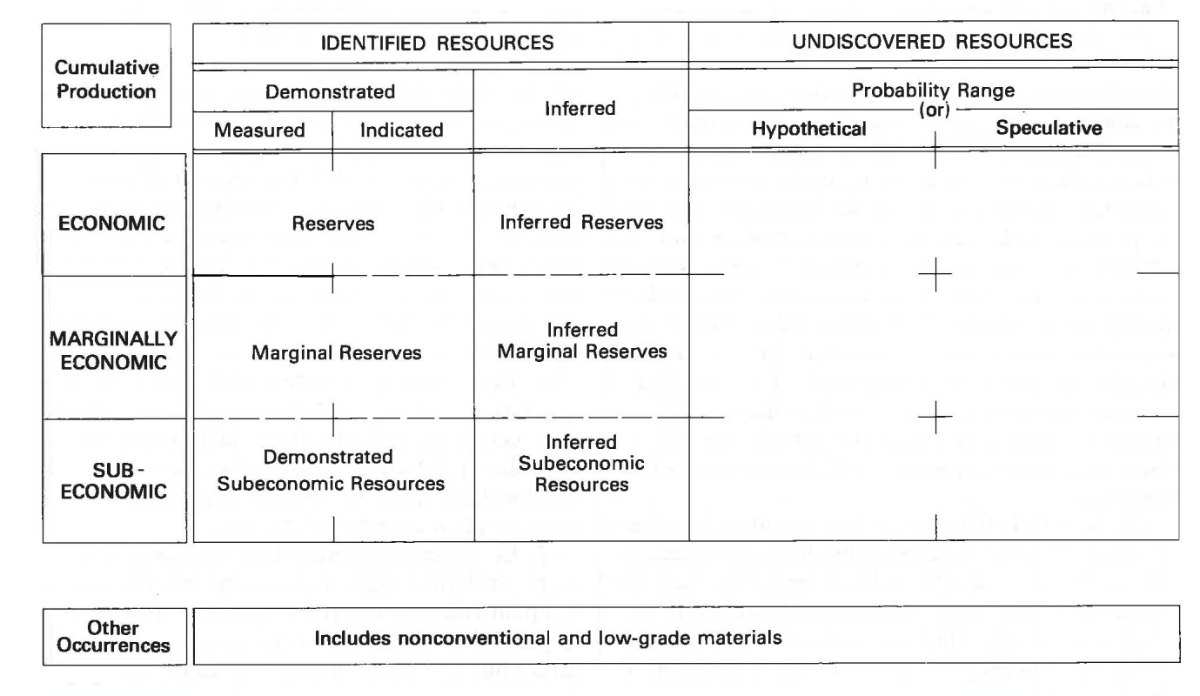

***Figure 1: Modified McKelvey diagram.***

In contrast, M. King Hubbert (employed by Shell Oil Company from 1943 to 1964) published in 1959 an estimate of 150-200 billion barrels of crude oil for the Lower 48 States, later revised in 1972 to 168 billion barrels.

The implications for energy policy in the US was that McKelvey’s much larger resources numbers implied that continental US crude oil production would be sustainable to near the end of the 20th century, while Hubbert’s lower resources figures implied peak oil production for the Lower 48 States to occur in the late 1960s and decrease progressively thereafter. The actual crude oil production data have clearly vindicated Hubbert’s estimates (Figure 2).

An appreciation of this history of the McKelvey Diagram, McKelvey’s role in informing US Government energy policy based on overly optimistic production potential estimates, the disconnect between these estimates and industry reality and the prolonged denial by US policy makers in the face of overwhelming evidence to the contrary, highlight the need for concern regarding the use of the currently reported Australian EDRs in mineral resources policy making.

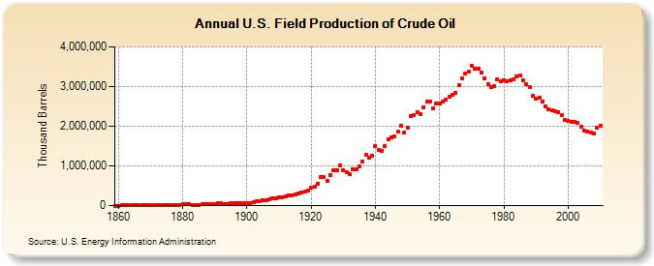

***Figure 2: Actual United States crude oil production.***

The primary contention of this brief discussion paper is that GA’s EDRs provide an overly optimistic representation of the national inventory of mineable precious and base metals resources and further, that these data provide an overly optimistic input to Government policy considerations. For example, consideration of appropriate policy responses to the demonstrable market failure to undertake adequate exploration for mineral resources in Australia (Cairns et al. 2010) clearly needs to take into account the health of the mining sector and the quantity of material available for economic extraction.

**The Purpose of the JORC Code**

The Joint Ore Reserves Committee (JORC) was established in 1971 and published several reports containing recommendations on the classification and Public Reporting of Ore Reserves prior to the release of the first edition of the JORC Code in 1989. In that same year, the ASX incorporated the Code into the ASX Listing Rules such that a Public Report must be made in compliance with the JORC Code.

The intent of the Code is:

*“to provide a minimum standard for Public Reporting, and to ensure that such reporting contains all information which investors and their professional advisors would reasonably require, and reasonably expect to find in the report, for the purpose of making a reasoned and balanced judgement regarding the Exploration Results, Mineral Resources and Ore Reserves being reported.”*

Clearly, the purpose of the Code is to improve the quality of reporting of reserves and resources in order to provide investors with all relevant information on which they may base their investment decisions.

**Reporting of Mineral Resources versus Ore Reserves in Compliance with the JORC Code**

Of particular importance in discussing the validity of GA’s EDR numbers is the distinction of both the Code requirements and the practical application of listed companies reporting of Mineral Resources and Ore Reserves.

As previously discussed, the JORC Code and GA’s EDRs both evolved largely from the work of Vincent E. McKelvey and specifically United States Geological Survey Circular 831 which states the underlying principle of a Mineral Resource or Ore Reserve classification:

*“known resources should be classified from two standpoints:*

*(1) purely geologic or physical / chemical characteristics – such as grade, quality, tonnage, thickness, and depth – of the material in place; and*

*(2) profitability analyses based on costs of extracting and marketing the material in a given economy at a given time.*

*The former constitutes important objective scientific information of the resource and a relatively unchanging foundation upon which the latter more variable economic delineation can be based.”*

As an evolution of the McKelvey classification system, a Mineral Resource as defined in the JORC Code is:

*“a concentration or occurrence of material of intrinsic economic interest in or on the earth’s crust in such form, quality and quantity that there are reasonable prospects for eventual economic extraction. The location, quantity, grade, geological characteristics and continuity of a Mineral Resource are known, estimated or interpreted from specific geological evidence and knowledge.”*

Consequently, Mineral Resources defined by the JORC Code are the ‘technically’ defined in-situ extents, volume, tonnage, grade and characteristics of a particular mineral occurrence broadly consistent with USGS Circular 831’s first ‘technical’ classification ((1) above) with the added requirement that such mineralisation be of intrinsic economic interest with “reasonable prospects for eventual economic extraction”.

Ore Reserves under the JORC Code, on the other hand, are the logical extension of McKelvey’s second standpoint – that being the subset of technically defined resources which are amenable to economic extraction in the short to medium term when economic and metal market assumptions are applied.

This practical application is supported in the JORC Code by the requirement that both Mineral Resources and Ore Reserves should be reported with reference to the Code’s Table 1 *“Checklist of Assessment and Reporting Criteria”*. For the reporting of Mineral Resources, the focus is on geologic and technical parameters including ‘mining factors and assumptions’ and ‘metallurgical factors and assumptions’ – i.e. assumptions pertaining to the operating parameters and, by extension, when considering the ‘prospects for eventual economic extraction’, those costs on an operating basis.

In contrast, for the reporting of Ore Reserves the JORC Code Table 1 has the additional requirements of ‘cost and revenue factors’ and ‘market assessment’. Of particular importance is the explanation of ‘cost and revenue factors’ to include *“The derivation of, or assumptions made, regarding the projected* ***capital and operating costs****”* (emphasis added).

Intuitively, this distinction between the consideration of an operating cost basis only when assessing the ‘reasonable prospects for eventual economic extraction’ test as it applies to reportable Mineral Resources as opposed to the additional requirement to also consider capital costs for reporting of Ore Reserves makes practical sense.

Given the fundamental purpose of reporting Mineral Resources in compliance with the JORC Code is to provide investors with all relevant information on which they can make informed investment decisions, the reporting of Mineral Resources of intrinsic economic interest, yet possibly not of sufficient scale to justify the capital cost of development, is an important interim step towards Ore Reserves. It may be that future mineral discoveries or the establishment of new infrastructure to achieve the scale or accessibility is required before the reported Mineral Resource becomes feasible for development. It is this potential for a future event which is accommodated by the inclusion of ‘eventual’ in the ‘reasonable prospect for eventual economic extraction’ criteria for reporting of Mineral Resources. Two example case studies are provided below.

**Case Study – Additional Discovery: Integra Mining**

In February 2006 Integra Mining announced a 1.2 million ounce total Indicated plus Inferred Mineral Resource for Integra’s project areas east of Kalgoorlie. Of this total resource, 660,000 ounces of gold were located in the Randalls Gold Project. A pre-feasibility study on open pit production from these assets indicated a positive economic outcome; however, the company informed the market that additional discovery was required given the balanced assessment of capital development risks.

On the 3rd May 2007, Integra announced a new discovery at Salt Creek within the Randalls Gold Project. Over the ensuing 6 months, the Mineral Resource at Salt Creek grew to 410,000 ounces and in July 2009 a Feasibility Study declared the Randalls Gold Project economically viable with initial Ore Reserves of 320,000 ounces. The Randalls Gold Project is now in production and is one of Australia’s lowest cost gold producers.

**Case Study – Infrastructure Development: BC Iron**

In April 2009, BC Iron Ltd announced to the ASX a 50.7 million tonne DSO iron Mineral Resource at the Nullagine Iron Ore Project located 140 kilometres north of Newman in the Pilbara. Clearly, the scale of the Mineral Resource was of insufficient size to justify the construction of a dedicated railway and port loading facility for delivery of product to international markets. On 24 August 2009 BC Iron and Fortescue Metals Group entered into the Nullagine Joint Venture which enabled ore mined from BC Iron’s leases to be transported and loaded onto ships using Fortescue’s recently developed rail and port infrastructure. The Nullagine Joint Venture is now in production with XX million tonnes DSO iron Mineral Reserves.

Both case studies demonstrate the validity of the ‘eventual’ aspect of the economics of Mineral Resources reporting. Neither Integra nor BC Iron were in a position to declare Ore Reserves prior to the additional discovery of the Salt Creek deposit or access to Fortescue’s infrastructure respectively. The reporting of these pre-event Mineral Resources was entirely in keeping with informing investors as to the size, quality and grade of the respective company’s assets allowing investors to make an informed investment decision.

However, it is worth noting that these examples are the exception rather than the rule. A significant proportion of ASX announced Mineral Resources may never be developed as they may never see the ‘future event’ required to justify development.

Ironically, due to the capital hurdle / access issues, the Inferred Resources (low technical level of confidence) at an existing operation are more likely to be produced than many Measured Resources (high level of technical confidence) in isolated locations devoid of infrastructure.

**Geoscience Australia’s reporting of Australia’s Economically Defined Resources (AEDRs)**

The Introduction to the *National Classification System for Identified Mineral Resources* states (Appendix 2 in Geoscience Australia, 2010):

*“Australia's mineral resources are an important component of its wealth, and knowledge of the location, quantity and quality of such resources – including estimates of resources yet to be discovered –* ***is an essential prerequisite of formulating sound policies on resources****, land-access, land-use and conservation. Results of resource assessment can also be used to set priorities for exploration and mineral potential which are important inputs to decisions where alternative land uses are being considered.”* – emphasis added

At a national level it is important that policy makers are provided with accurate and unambiguous information on Australia’s economic minerals endowment.

Further, under the heading Classification Principles:

*“Geoscience Australia classifies known (identified) mineral resources according to two parameters: degree of assurance of occurrence (degree of geological assurance) and degree of economic feasibility of exploitation. The former takes account of information on quantity (tonnage) and grade;* ***the latter takes account of changing economic factors such as commodity prices, operating costs, capital costs, and discount rates.****” –* emphasis added

These classification principles remain broadly consistent with the original McKelvey classification system.

**Why Australia’s EDRs are Incompatible with JORC defined Mineral Resources**

Under the *National Classification System for Identified Mineral Resources*, Economically Demonstrated Resources (EDRs) are described as:

*“In essence, EDR combines the JORC Code categories of ‘Proved Reserves’, ‘Probable Reserves’, plus ‘Measured Resources’ and ‘Indicated Resources’.”*

The next sentence in the document encapsulates the problem –

*“This is considered to provide a reasonable and objective estimate of what is likely to be available to mining in the long term.”*

Further, an additional claim is made in GA’s publication *Australia’s Identified Mineral Resources* that *“Most current JORC Code Measured and Indicated Resources are also likely to be mined”*. It is this disputable contention that lies at the heart of the difference between ASX announced JORC Code compliant Mineral Resources and GA’s EDRs.

According to the definitions of the *National Classification System for Identified Mineral Resources*, an Identified (Mineral) Resource includes economic and subeconomic components. The economic component (EDR) is defined as implying:

*“that at the time of determination, profitable extraction or production under defined investment assumptions has been established, analytically demonstrated, or assumed with reasonable certainty.”*

Clearly, profitable extraction or production under defined investment assumptions has not been demonstrated, nor is it required, for Mineral Resources announced to the ASX in compliance with the JORC Code.

Further, the *National Classification System for Identified Mineral Resources* guidelines for classifying Mineral Resources as EDRs includes those resources at existing operations, those resources currently in development, resources at those operations on care and maintenance and those:

*“undeveloped resources which are judged to be economic on the basis of a financial analysis using actual, estimated, or assumed variables – viz.,* ***the tax rate, capital and operating costs, discount rate (which reflects the long-term bond rate), commodity prices, and depreciation schedules; the values for the economic variables used in an assessment must be realistic for the circumstances prevailing at the time of the assessment.”*** *–* emphasis added

Clearly, the additional parameters the *National Classification System for Identified Mineral Resources* requires GA to consider for the classification of EDRs go much further than simply a summation of all the Measured and Indicated Mineral Resources announced to the ASX in compliance with the JORC Code. Specifically, the requirement to consider capital costs and other more detailed economic parameters such as discount rate, depreciation etc. are not a requirement for any Mineral Resources announced to the ASX in compliance with the JORC Code. The requirement for GA to consider these additional economic criteria in assessing EDRs, above and beyond what is publically reported as Mineral Resources under the JORC Code, is not applied by GA in practice.

While there are considerable challenges confronting GA in trying to conform to the *National Classification System for Identified Mineral Resources* requirements in determining which Mineral Resources are economic and which are not, the practice of simply summing the Mineral Resources announced to the ASX and declaring them all ‘economic’ is not an appropriate response.

Importantly, the National Classification System requirements to consider *‘defined investment assumptions’* and the requirement to include capital as well as operating costs in the determination of EDRs is more compatible with the JORC Code definition of Ore Reserves, while JORC defined Mineral Resources are not specifically required to consider capital costs nor defined investment assumptions. Further, the guidance defining EDRs would appear to require GA to consider the capital investment circumstances prevailing *“at the time of assessment”*. This would preclude the inclusion of the majority of ASX announced Measured and Indicated Resources in the EDR data as the majority of these resources would not currently justify the capital investment for development at this time. While inconsistent with the definition of allowable EDRs, these ASX announced resources are entirely consistent with the ‘prospects for eventual extraction’ provision within the JORC Code as a future event can render these resources economic to develop. Should such an event occur, subject to appropriate technical and financial studies and in compliance with the JORC Code there would be a conversion of Mineral Resources to Ore Reserves. GA does not have the latitude of assuming future events in the definition of what resources qualify as EDRs – nor should they.

**Australia’s Economically Demonstrated Resources are not Economic**

As argued above, what GA reports as Australia’s Economically Demonstrated Resources – while essentially a compilation of Ore Reserves plus Measured and Indicated Resources in public announcements to the ASX – contain a large percentage of resources that are not ‘economically demonstrated’ at all. No economic study — Scoping Study, Pre-feasibility Study, or Feasibility Study - is required for the announcement of Mineral Resources under the JORC Code.

The numbers that GA report as EDRs are more accurately defined as Australia’s Identified Mineral Resources. It is of critical importance that the terminology of EDRs be changed to remove the assertion that resources referred to are ‘economic’.

A recent example of how misleading the term Economically Demonstrated Resources has been is illustrated by the Policy Transition Group’s *Report to the Australian Government on Minerals and Petroleum Exploration*, which contains a tabulation of EDRs from Geoscience Australia and in the text of the report:

*“Australia has accumulated a significant inventory of unexploited known mineral and petroleum reserves. Table 1 presents data on Australia’s accessible, economically demonstrated resources for a range of commodities.”*

This misinterpretation of the national minerals inventory and production longevity is further exacerbated by GA’s own assertions (in the referred to Table attached below) that current production rates for various minerals can be sustained for implausible durations based on GA’s EDR data.

It is beyond question that GA’s primary client – the Government of Australia – has misunderstood the EDRs as being *‘accessible economically demonstrated resources’* and as *‘reserves’*. Using these data as indicating that *“Australia’s resources stocks remain plentiful”*, the Policy Transition Group and subsequently, the Federal Government, has determined that there is no need for exploration incentives in Australia.

GA is aware that the metals production, whether it is gold, silver, copper, lead, zinc, or nickel, is reliant upon a small number of large operations most of which are mature (Dr Chris Pigram pers comm.). The reality is unless new major deposit discoveries are forthcoming, Australia’s production of all these metals will inevitably decline in the medium term (less than 10 years).

*The table below taken from the Policy Transition Group Report to the Australian Government: Minerals and Petroleum Exploration – page 10*



As another example, in its publication *Australia’s Identified Mineral Resources 2010*, Geoscience Australia claims that the EDR for gold is some 7,399 tonnes (238 million ounces) which, at the 2009 annual rate of production, would allow continued production (at that rate) for another 29 years.

A major issue is that approximately 25% of this EDR is attributable to the Olympic Dam deposit alone and even assuming the mine expansion is approved (which is not currently likely), it would take some 80 years to produce this portion of the gold EDR. As with other metals, the long term production of gold is underpinned by a small number of large, long-life mines while smaller operations are far more ephemeral. As an exercise, GA’s EDR and production projection for gold was compared with actual production volumes and Ore Reserve duration for the top ten gold producers in Australia (Figure 3). The graph below demonstrates that while the top 10 gold producers account for 74% of Australia’s annual gold production, there would appear to be a significant discrepancy between the longevity of Ore Reserves of those operations and the quantity of gold the Government has been led to believe the country will be producing over the next 30 years.

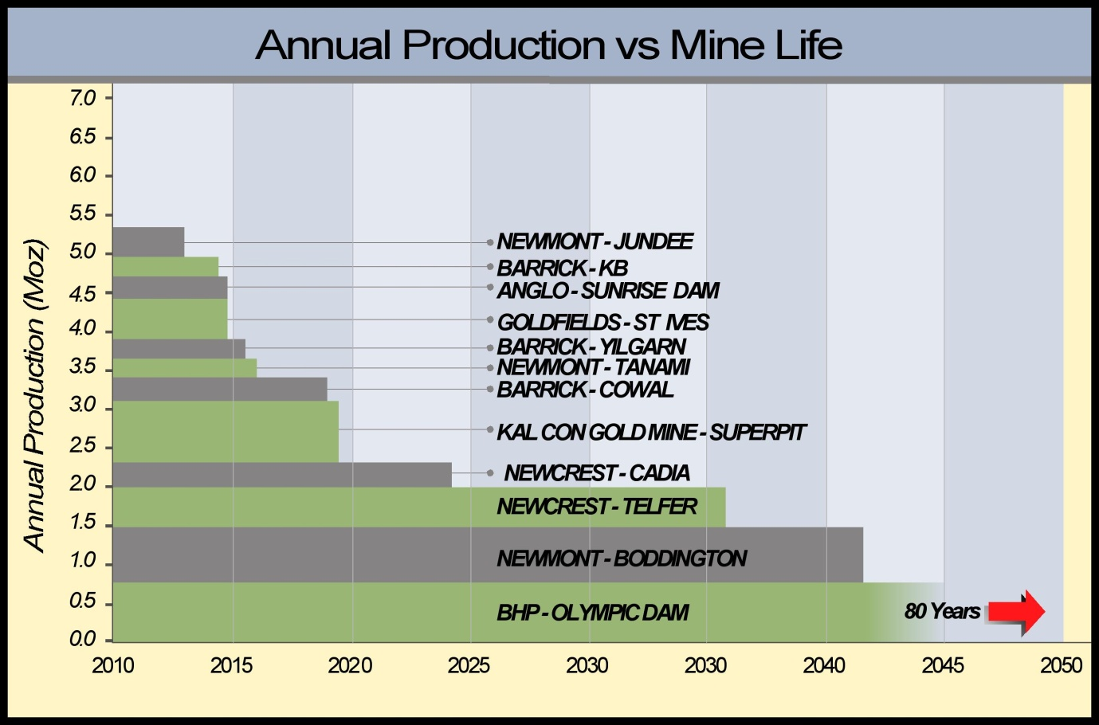***Figure 3: Current production rates and Ore Reserve life for Australia’s top 10 gold producers vs. GA’s 30 years of production at current rates.***

**7.2 million ounces per year** – the production rate GA say Australia can maintain over the next 30 years based on EDRs

The commercial reality is that, with ready access to capital, any truly ‘economic’ resources are either in production, in development or in feasibility. There is no market impediment to development. So, by default the remaining resources are not economic to develop.

The only ‘economically demonstrated’ resources in Australia are those announced by companies to the ASX as Ore Reserves.

**Conclusions and Recommendations**

The terminology ‘Economically Demonstrated Resources’ should change to remove any suggestion that all of these resources are ‘economically demonstrated’. This fundamentally is a problem with an archaic terminology originating some 40 years ago with McKelvey and the USGS and is not appropriate in the modern Australian context. The EDR terminology is demonstrably misleading and is not compatible with the JORC Code or those Mineral Resources reported to the ASX in compliance with the Code. It is strongly recommended that GA’s compiled minerals inventory be renamed as Australia’s Identified Mineral Resources (IMRs).

It is further recommended that Geoscience Australia review the public statements to the effect that “most of Australia’s EDRs will be mined” – this statement is not supported by science or economic studies.

It is essential that the Government is properly informed of the actual status of the metals mining industry in order to implement appropriate policy responses, without which, a decline in metals production is inevitable. This decline in metals production will have national implications for export earnings, terms of trade and quality of life in Australia.

**References**

Chris Cairns, Jon Hronsky, and Richard Schodde, 2010. Market Failure in the Australian Mineral Exploration Industry: The Case for Fiscal Incentives.

Geoscience Australia, 2010. Australia’s Identified Mineral Resources 2010. Geoscience Australia, Canberra.

Stewart Udall, Charles Conconi, David Osterhout, The Energy Balloon, 1974, McGraw Hill Book Co.

1. Director Northern Platinum Pty Ltd

   Member AIG

   Committee Member, WA AIG

   JORC Committee Member

   Director, Australian Prospectors and Miners Hall of Fame

  