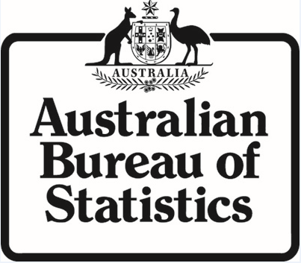

Productivity Commission Draft Report:
Regulator Engagement with Small Business

Public submission

By the Australian Bureau of Statistics

1 The Australian Bureau of Statistics (ABS) welcomes the opportunity to make a submission to the draft report on Regulator Engagement with Small Business (the draft report), released 3 July 2013.

2 The ABS relies on the support of small business to collect a range of statistical information about their activity. This information feeds into monthly and quarterly indicators that provide up-to-date snapshots on the state of the whole economy as well as detailed analysis to provide a comprehensive picture of specific industries and business activities to support business and government decision making.

3 In addition to being useful in their own right, the results of these business surveys are also essential inputs into quarterly and annual updates of the Australian National Accounts including Australia’s Gross Domestic Product (GDP).

4 Good statistical information provides a sound basis for decision making on where and how resources can be efficiently allocated. All levels of Australian government, businesses and various industry associations use this information to evaluate and plan for the future and build a better, more productive society.

5 Statistics produced by the ABS also enable Australia to be compared with other countries throughout the world. These comparisons provide important indicators of Australia's position internationally and potential opportunities for Australian businesses.

Work the ABS is undertaking to reduce the burden on business
6 The methods that the ABS uses when selecting businesses seek to minimise the sample required and to ensure that smaller businesses are not selected in more than one survey wherever possible.

7 As part of the commitment to transparency, the ABS reports on the provider load as one of the key performance indicators in its Annual Report. Provider load for small businesses has decreased in recent years (see Graph 1, below) and the ABS continually works to reduce the load for businesses associated with our collections by: using existing alternative sources of information (such as administrative data) rather than direct collection wherever possible; using best practice sample design to minimise sample sizes and integrate our collections; and investing in new technology, such as e-form capability, to make it easier to respond to our collections. Since launching the e-form service, the ABS has seen a large number of businesses embrace this new technology.

8 In addition, the ABS operates the Statistical Clearing House on behalf of the Australian Government to: reduce duplication; minimise the burden on business; and ensure that surveys are fit for purpose.

Graph 1: Provider load(a) ('000 hours) - published in the ABS's 2011-12 Annual Report
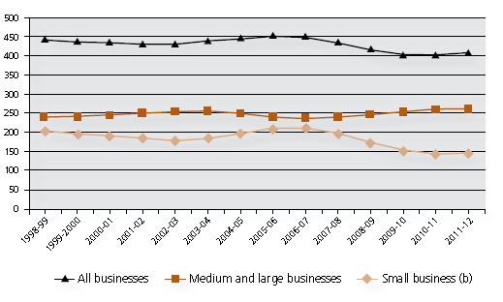
(a) Smoothed using an 11-term Henderson moving average. This process smooths the effect of irregular and regular contributors to provider load, such as the five yearly Agricultural Census last conducted in 2011-12.
(b) Businesses with less than 20 employees.

9 The ABS Surveys Charter, 2010 (1008.0) explains the ABS’s role as the national statistical agency and outlines the way the ABS interacts with respondents, as well as providing information on how to make a complaint to the organisation.

10 The Survey Participant Information page on the ABS website provides information to those selected in both household and business surveys, with references to the Charter, as well as answers to frequently asked questions.

Definition of a regulator
11 The ABS notes that the current draft report includes ABS as a 'regulator' which is not consistent with the definition provided in the Productivity Commission's report:

"The term ‘regulator’ is used throughout this report to denote government officials, departmental units and independent statutory authorities that are empowered by legislation to administer and enforce regulation, or more specifically to: grant approvals (including registration and licensing); monitor compliance; and enforce laws. Regulators will often have complementary roles such as: developing and reviewing regulations or standards; providing information or education about regulatory requirements; resolving disputes and giving regulatory advice to third parties. Given the scope of this study, the Commission focuses on regulators that have a direct impact on business, particularly small business, or its employees (for example, through required professional accreditation)."

12 The ABS operates under the provisions of the Australian Bureau of Statistics Act 1975 and the Census and Statistics Act 1905. These Acts establish the ABS as Australia's official statistical agency and authorise the ABS to collect data for statistical and research purposes only. The ABS has been established solely for statistical purposes and has no regulatory purpose. The Census and Statistics Act 1905 confers significant responsibilities on all ABS staff to protect the information entrusted to us and the Act includes large fines and prison terms for breaches of confidentiality. The ABS will never use the statistical data we collect for non-statistical regulatory or compliance purposes and the confidentiality provisions under which ABS operates means that others can't use the data for these purposes either.

13 Therefore, the ABS does not believe that the ABS fits the definition as a regulator. Classing the ABS as the same as organisations with legislated obligations to monitor compliance and enforce laws, potentially jeopardises the ABS's reputation as an independent provider of information and threatens to weaken one of the ABS's core values: the trust of our providers. It is crucial that the businesses and households providing information to the ABS understand that their information will not be used for regulatory or compliance purposes.

14 Further, the ABS does not fit the definition in the Department of Finance and Deregulation's (DoFD's) Commonwealth Government Framework for Regulators which states that: "A 'regulator' is defined as a Government body that operates to oversee the operation of or enforce 'regulation'." The DoFD framework states that this means "the regulator functions with one or more of the following powers: inspection, regulatory advice to a third party, licensing, accreditation and standards monitoring, and enforcement".

15 The ABS sees some merit in using the pre-existing DoFD definition of regulators for the final report on Regulator Engagement with Small Business, to ensure a common understanding of which bodies are regulators.

16 The ABS looks forward to continuing to work with the Productivity Commission to support government initiatives to reduce the burden on small business.

