National Sea Highway

Attachment

Hansard Tasmania - GBE Hearing -TT Line - December 2012 - TT Line Chairman Grainger and Shadow infrastructure Minister Tasmania, Hidding..
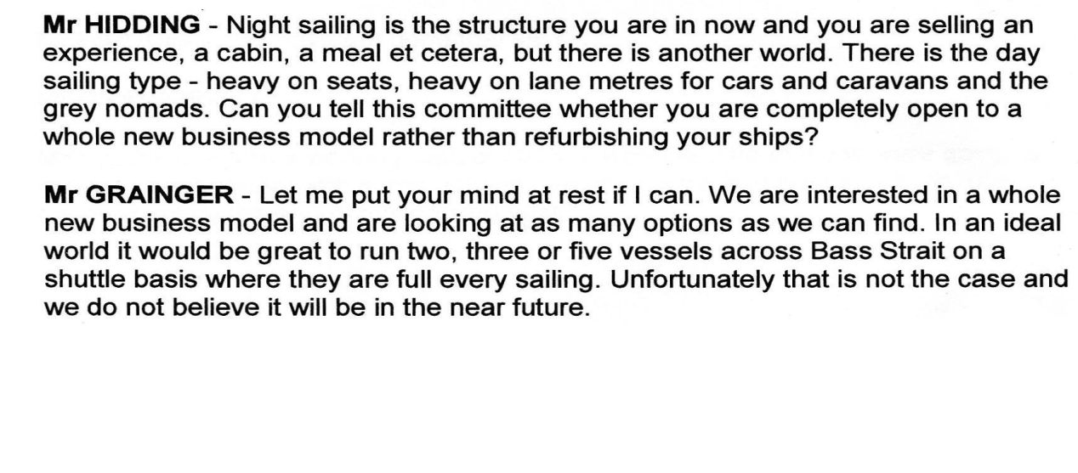

Public support for the BSPVES was to achieve this "other world", and more. Support was not aimed at promoting just niche marketing on one side of Bass Strait.

Only low highway - based fares will substantially increase demand for travel, bring more tourists (applying the general version of tourism), and impact positively on growth in jobs, investment and population.

Federal monitoring doesn't cover this other world.

Niche marketing any national Highway will not bring benefits that this nation expects and deserves.

As with any punt, the priorities of a punt operator are never allowed to dictate the use of the billion-dollar public highways it connects.

Also just imagine if a punt or bridge was compelled to carry southbound consumables and international exports at higher rates than all other freight.

Full revision of the policy and practices causing existing blockages relating to the movement of people, vehicles and freight needs to occur.

We note the following acknowledgements listed in a BSPVES -BITRE report - "BITRE gratefully acknowledges the assistance provided by TT-Line, Tourism Tasmania, the Tasmanian Transport Programs team at Department of Human Services, and the Surface Transport Policy Division of the Department of Infrastructure and Transport". It seems to us that a far wider list of Tasmanian and national stakeholders could and should have been consulted. Peter Brohier

