Remote area tax concessions and payments — draft report
Remote Area Allowance
Introduced in 1984 as a companion payment to the zone tax offset (ZTO), the remote area allowance (RAA) is a supplementary payment for income support recipients in eligible areas. This study is the first broad-based review of the RAA since its introduction.
The Australian Government spends $44 million on the RAA each year, benefitting over 113 000 people. Fortnightly payments are $18.20 for a single recipient, $15.60 for each person in a couple and $7.30 for each dependent child. The average RAA payment per recipient is $387 a year.
RAA areas include special areas and ordinary Zone A (but not ordinary Zone B), as defined in taxation legislation for the purpose of the ZTO (map below).
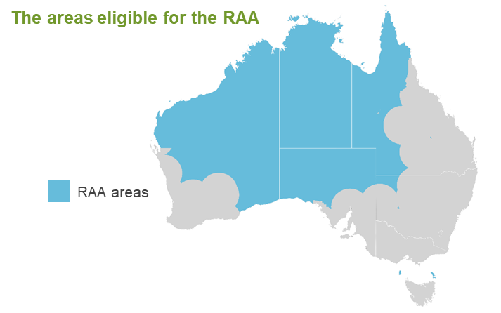
Some notable characteristics of remote area allowance recipients
- Most RAA recipients reside in very remote and remote areas of Australia (as defined by the Australian Bureau of Statistics remoteness classification).
- The majority are located in the Northern Territory, with one in five Northern Territorians over the age of 15 years in receipt of the payment.
- Half are located within areas of the highest socio-economic disadvantage.
- Almost 65 per cent of recipients are Indigenous Australians.
- The large majority are in receipt of either the age pension, the disability support pension, Newstart allowance or parenting payment.
- Just over half have been in receipt of an income support payment for over five years.
[MORE]
The RAA has a legitimate role …
The Commission has found that the RAA has a legitimate role in helping income support recipients meet some of the higher costs associated with living in remote areas. Unlike most ZTO recipients, RAA recipients face barriers to mobility and do not benefit from remote area wage premiums.
… but is in need of a refresh
RAA areas are outdated and payment rates have not increased in 20 years.
To ensure that the RAA is fit-for-purpose in contemporary Australia, the Commission is recommending that RAA areas be aligned with ABS very remote and remote areas (map below). This would increase the number of income support recipients eligible for the RAA by an estimated 43 000, at an additional cost to the Australian government of $17 million a year. Current recipients in Darwin would no longer be eligible for the RAA as Darwin is classified by the ABS as outer regional.
The Commission is also recommending that the Australian Government revise RAA payment rates following the completion of this study, and that the RAA be reviewed periodically thereafter to ensure it remains appropriate and effective.
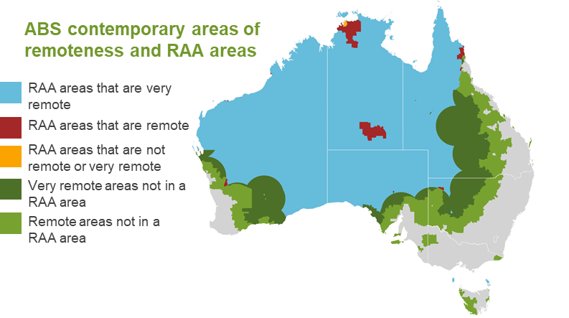
What next?
The Productivity Commission welcomes feedback on this draft report. You are welcome to make a written submission to the Commission by Friday 11 October. Alternatively, you can leave a brief comment. The draft report and information on how to submit submissions and brief comments is available on the study’s website: www.pc.gov.au/remote-tax.
[END]

