Observations on Productivity, National Income and the Demographic Outlook
Peter Harris
Chairman, Productivity Commission
I seem to be doing quite a few speeches in Perth.
It has been unkindly suggested to me that I’m doing this just to get out of Canberra.
In fact it has more to do with the substantial relevance of the West to today’s Australian economic environment.
Since we are breakfasting here this morning, and I’m very much not a morning person, this speech is going to be in easily digestable bite-sized chunks.
There are three hot topics in the productivity debate in Australia today.
And rather than attempt to draw them together and tie them up with a neat intellectual bow, I’m going to make some observations on them and leave it to the Q&A to see what else may be of interest to you.
The three things are:

- In the context of the Commonwealth Government’s Commission of Audit and review of competition policy, what we can learn from Australia’s economic performance over the last two decades, with strong domestic and international open market access.
- The outlook for productivity growth, which should now be looking up after many years of unrequited capital investment; but where we have a long way to go if we expect productivity growth to offset other negative trends in our economic outlook.
- The pressures evidently developing on budgets at all levels of government from expectations of better service quality, particularly social services, and the contribution that could be made to that from some structural changes, in advance of these issues becoming unmanageable.
Our success economically as a nation over the past two decades has been driven by many factors, but two powerful forces, one substantially under our control and one less so, stand out.
The force under our control has been domestic competition. We have unambiguously embraced a two decade long focus on removing barriers to competition, international and domestic – attracted by the potential for innovation and ability to meet a consumer interest – wherever practical.
This was a choice, and we made the right choice.
The Hilmer Committee provided its report twenty years ago this year, and its effect is still felt today. The Productivity Commission has recently provided the Commonwealth Government with a final report on the Hilmer domestic access regime. That report shows where improvements can be made, but the principle is not in question.
Domestically, the ACCC is the public face of this policy push. But the strength of the principle extends well beyond the regulator. In our investigations, the Productivity Commission has regularly found a strong public consensus that the economy benefits greatly from governments eliminating barriers to competition; a consensus that we have documented in the past, showing it to be based on substance, and one widely embedded at the policy level nationally and at State level.
The other force is international in nature and consequently one where have less control of our destiny. This is simply because it involves an international consensus that must be continuously nurtured – particularly when global economic conditions turn down, as they have recently – between nations, to allow the most open access possible for exports - our exports, their exports.
Demand in China for resources is often and justifiably cited as a key to Australia’s recent trading success; but major external contributions to Australia’s national welfare have also come from the relatively unimpeded acceptance, by a wide variety of nations, of our exports of education and tourism services, energy products, dairy, meat and grains.
The nations importing these products are a diverse group, often poorer than us on an income per capita comparison, and usually engaged in their own struggle to improve competitiveness - domestically and internationally. We nevertheless expect that they will allow the most open access possible for our exports. It is, after all, in their own interests to have access to minerals, energy, food and education services at the least cost, in order that their own industries can apply these and thrive.
This is the simple but immensely powerful model that has guided our – and much of the world’s – better economic thinking through recent decades of growth.
For us, it has unambiguously worked.
Aside from the City-States, we are now amongst the wealthiest nations in the world. Our unemployment is relatively low and our social policy standards are high. Our income distribution has not skewed towards inequality, even as we have increased wealth very substantially. It surprises many people to know that we are now much wealthier per head than the US, up there now with Norway and Switzerland.
One consequence of this persistent success is that our domestic prices are often high. Not just housing, but many other consumer goods are not cheap in Australia. And we are a high-wage country, giving us relatively high disposable incomes.
This makes us an attractive destination for foreign producers. And our willingness to allow them to invest and to supply freely gives us choice and serves to keep some check on price rises, in what is otherwise a small domestic market easily dominated by one or two firms.
All this amounts to substantial consumer benefit.
In such a context, it is worrying to see a view arising that – perhaps ironically because of our growing wealth – we can afford to indulge ourselves with a bit of protectionism being added to the national policy mix.
This approach is not only against our interests when we see what open accessibility has demonstrably provided us over the last twenty years, but it has direct implications for each of us as consumers and businesses.
Raising barriers to competition is only likely to increase prices or reduce choice, or both, over time.
This will all add, inevitably, to our already high cost structure.
We cannot indulge our way to even greater success.
All we will do is to reduce our future flexibility, and as income growth declines with the terms of trade, make the task of adjustment even harder.
..
Let me now go to the second of my hot topics, the outlook for national productivity growth.
Adding barriers or costs to innovation and competition has longer term consequences, not just for consumers and investors. Productivity is strongly encouraged where firms are under pressure to innovate, invest or exit in the face of foreign or domestic competition. So impeding competition is likely to weaken incentives to improve productivity.
Australia’s productivity performance has been weak through the past decade
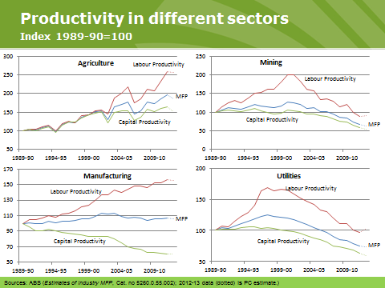
but the income effect has been disguised by our improved purchasing power through cheap imports and strong employment growth.
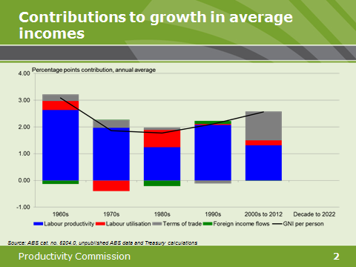
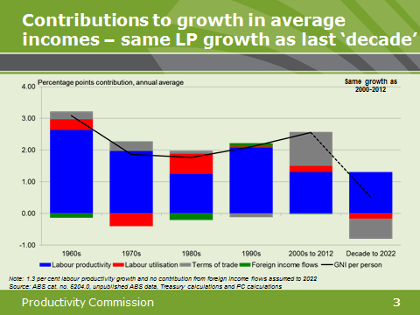
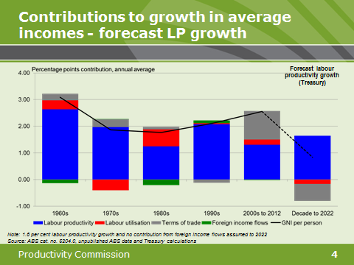
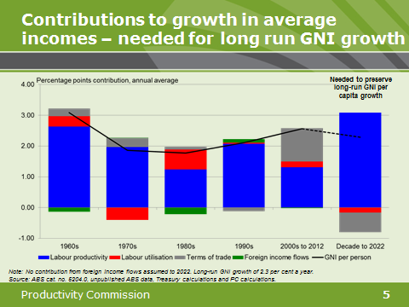
We can see strongly demonstrated here Paul Krugman’s dictum that while productivity isn’t everything, but in the long run it’s almost everything.
It has certainly been Australia’s primary driver of national income, for fifty years, until the last decade.
While it is at one level trite to keep saying this, the current economic debate is really paying much too little attention to productivity.
I don’t doubt the importance in management of the economy and the role of financial markets of monetary policy, but perhaps an exclusive public focus on the monthly interest rate/dollar/budget revenue paradigm comes at the risk of ignoring the vital medium term issue of productivity and its role in income growth.
Without a serious effort to resume sustained productivity growth – an effort genuinely to be shared between governments, business and employees – the truth inherent in these slides is that with the terms of trade declining from an unparalleled height, our national income growth looking forward will be at best a pale reflection of the past decade.
And not even comparable to that of preceding decades.
Since we are in WA, you may feel that this terms of trade thing has been overblown. After all, iron ore exports continue to increase and prices have kept steadier than some analysts expected.
And surely, you might argue, if I’m not in mining or primary industries, the impact on our incomes of the terms of trade will not be that large? Surely productivity will return naturally after some of the unique circumstances of recent times?
It would be foolish to deny that in the sweep of national income growth across decades, there are not wide variations from year to year in particular economic circumstances. And I could retire tomorrow if I could forecast reliably the movements in the exchange rate in any short run period. So these graphs tell a story that is shorn of these variations that are important at the human scale.
But the story is still correct.
First because export prices for some other commodities are already down.
Second because the terms of trade includes an import effect, and imports matter as inputs to a variety of firms and as consumption.
And third because the average of long-term productivity growth has been 1.6 percentage points or so in a 2 per cent income growth story, decade after decade. But through the last decade we are today still below that long term average, even with a good recent figure for 2012-13.
We need to see such higher figures sustained for much longer than historically we have been able to deliver, in order to sustain national income growth in the future.
We won’t see big shifts in numbers like these without unique efforts. There is no substitute for a major boost to productivity, at the national level and at the enterprise level.
..
If we do choose to undertake a structural reform process, we should consider both the short term and the longer term policy agendas.
A primary issue for the longer term – and the third hot topic I mentioned - will be the fiscal pressure for increasing the quality of social services confronting the budgets of all governments. And while budgets and the associated tax announcements don’t appear on first glance to have much to do with productivity, in fact they control to a large extent things like quality and volume of labour, the skewing of investment via taxation and a fair part of saving.
On top of that, they fund services– in areas like health and education for which we have very limited ability to measure productivity, but which are big users of resources.
The budget pressures in all these areas are immense and unrelenting.
A simple analysis of the WA State Budget, which is generally consistent with that of other States, shows that something like 64% of expenditure is locked in to social services, health, education and housing.
For the Commonwealth, the equivalent number is about 60% but when revenue assistance to the States for pretty much the same purposes is added in, the number rises to around 73%.
Adding to that, demographic change and the ageing of the Australian population are likely to impose increasing expectations of both better quality care as well as more demand for it, as we move through this decade and beyond.
While these trends have been forecast for some time – and it’s almost as if we’ve become comfortable with them due to familiarity – they will bite and bite quite hard in terms of budget flexibility.
When we think of budget pressures, the discussion generally runs straight on to new tax measures; or new expenditures, offset by cuts in other areas.
Almost without thinking we pass straight by the choice of structural change - altering the policy paradigm to encourage people to prepare better.
Of course, that option is ruled out immediately if we have left it too late to allow people to prepare. As often we have tended to do.
In my public comments this year, I have tried to remind those interested in good public policy that we have a history of being good in crisis – but the unfortunate corollary is that we then wait for the next crisis. We seem to need crisis in order to justify taking action.
We don’t have to do that.
On the topic of demographic change, we still have time to actively prepare; and a substantial new research Paper we will release later this week will offer some ideas on preparation in advance of major pressures.
Preparation that does not need to involve budget cuts or new taxes, if policy decisions are taken well in advance.
The new research Paper is quite a wide ranging look at demographic change. Although done to tight time-frames, in a period of four months, the Paper looks at issues including:
- The growth and age-characteristics of the population and the future workforce
- The coming fall in the labour participation rate, after many years of growth
- Fiscal impacts, both Commonwealth and State
- The investment calls likely from increases in population
- New and updated policy concepts, to address some of the pressures in the fields of the age pension, health care and aged care.
The brief for the research team was to provide a substantial input document to Treasury’s next InterGenerational Report (IGR), which is due during this term of Government; and to consider some useful reform options.
You can see why a time-limit was necessary. The policy aspects are fascinating.
The Paper assesses that fiscal pressures for both health and the aged pension remain substantially as found in the last Treasury InterGenerational Report in 2010 – that is, large and serious - but that pressures for aged care will be higher than previously indicated. We expect aged care costs to rise from 0.8% of GDP today to around 2.6% of GDP by 2060.
Of course, you could say that this is hardly surprising. Lots of us plan to be around for some decades yet, and there’s lots more of us entering the retirement phase relative to past generations. But the size of the cost increase is clearly significant in a context of fiscal pressure.
The data in the Paper certainly supports the view that my generation will be around for some time yet. The number of people aged over 75 will increase by about 4 million between now and 2060, to about 14% of the population, whereas today it’s just over 6%. In 2012, there was one person aged over 100 for every 100 babies born. In 2060, there will be 25. I plan to be one of them.
These are forecast trends, they can mislead if you adopt them as precise outcomes; but they are nevertheless highly indicative of the need to consider further policy reform.
One idea we revisit in the new research Paper comes from an earlier Productivity Commission report (2011), that found quite a lot of favour in principle but not yet in practice. That idea was to establish a genuine government-protected ability to draw down the value of a housing asset, in order to induce the market to supply a wider range of quality accommodation and care options; and so increase the choices available to older Australians.
There was wide support for this concept, driven by the desire of older people to see better choices developed, and provide them with the ability to choose how to apply any government funding. But no action.
The current system does not offer this level of supply, or of choice. While reverse mortgages and similar options are not unknown in Australia, they are little used. And being little used and not promoted as a policy, they do not alter planning and supply by the market. There is a good case for such a strong incentive for new products to support older Australians.
There is also no doubt that resources exist to make this a substantial policy option. Current rates of home ownership are around 80% for 65 year olds, with equity approaching 100%, and unlikely to reduce for the coming retiree cohort. The value of this housing is growing strongly. Tellingly, the rise in home value exceeds the rise in health costs, in the past decade.
This approach also ensures that there is no loss of access to a housing asset or indeed any other direct impact on retiree disposable income during the lifetime of a couple, or an individual.
Overall, we estimate that having individuals contribute via this method only half of the annual real increase in their housing asset towards aged care services could reduce government spending by around 30%, perhaps more.
It’s not a budget cut, it’s not a tax. It’s a shift to the structure of policy, with plenty of capacity for fine judgements on timing and transition.
But we can’t really expect such a model to be introduced effectively, if we wait til the wave of baby boomer retirees rises to a peak. The planning system – and by this I mean not just the aged care system but planning more broadly – needs to anticipate this model and deliver for it. This will take a few years. We still have those few years. But in a few more years, we won’t.
Complementary reforms in age pension arrangements were also recommended in the 2011 Report, and the new research Paper will look further at that as well.
We think this Paper could be of value to the Commonwealth Government’s Commission of Audit.
While it was designed as new form of research with the next InterGenerational Report in mind, it covers a number of areas of specific interest to the Commission of Audit and offers ways of addressing longer term issues.
Of course, its benefits will be primarily achieved over the long term, consistent with the focus at the time we designed the Paper. Immediate budgetary gains were not part of our research objective, although the concepts can potentially be adapted.
But this should not stop it being considered for more immediate application. At the risk of repeating myself, there is good reason to apply thought now to these kinds of concepts, given the size of the coming demographic shift.
..
My conclusion is a simple one.
We can’t allow self-indulgent thinking to undermine the strong open market structures that have so helped us in the past couple of decades.
We need them, and we need them to be fully functional, if we are to deliver the kind of productivity growth which can offset the decline in the terms of trade from historical highs.
The alternative is a low growth scenario, and one that involves far less capacity and policy flexibility to deliver on the social expectations of the inevitably ageing Australia.

Australian Institute of Company Directors, breakfast address, Perth, 19 November 2013

