Productivity and the National Income Outlook
Peter Harris
Chairman, Productivity Commission
A few months ago, on taking up this job, I made my first formal speech as Chairman. This is in many ways a follow up to that address.
As Chair of an independent body, I am in the unique position for a public servant of being statutorily obliged to make occasional forays into the public arena. The purpose of that being to improve the public understanding on issues of productivity.
So I am in fact hard at work here this evening.
I used the occasion of my first formal speech to suggest a bipartisan return to the microeconomic reform model used by successive Commonwealth Governments in the late 80s through to the late 90s.
I spoke about such a step being important to altering national expectations, across business and unions and the bureaucracy.
Thus instead of piecemeal, ad hoc change driven by occasional crisis, we might recommit in this country to regular reform statements, formally delivered once a term.
I did not publish a list of my preferred reforms. The Productivity Commission’s role is to undertake reform analysis at the request of the Commonwealth Government.
We will do what we are asked to do.
Of course, we hope to be asked to do quite a lot.
And there was another reason for not submitting a reform list.
It is that there is an important step that needs to be made before getting to questions of lists. I have spent some time in past positions advising how elected agendas can be matched to the task of necessary reform. I know that, to be successful, a deep commitment is required. And this in turn requires a shared acceptance across the community that the objective is worth the effort.
We will talk more about that in a moment.
Let me show you a picture:
Figure 1 Contributions to growth in average incomes
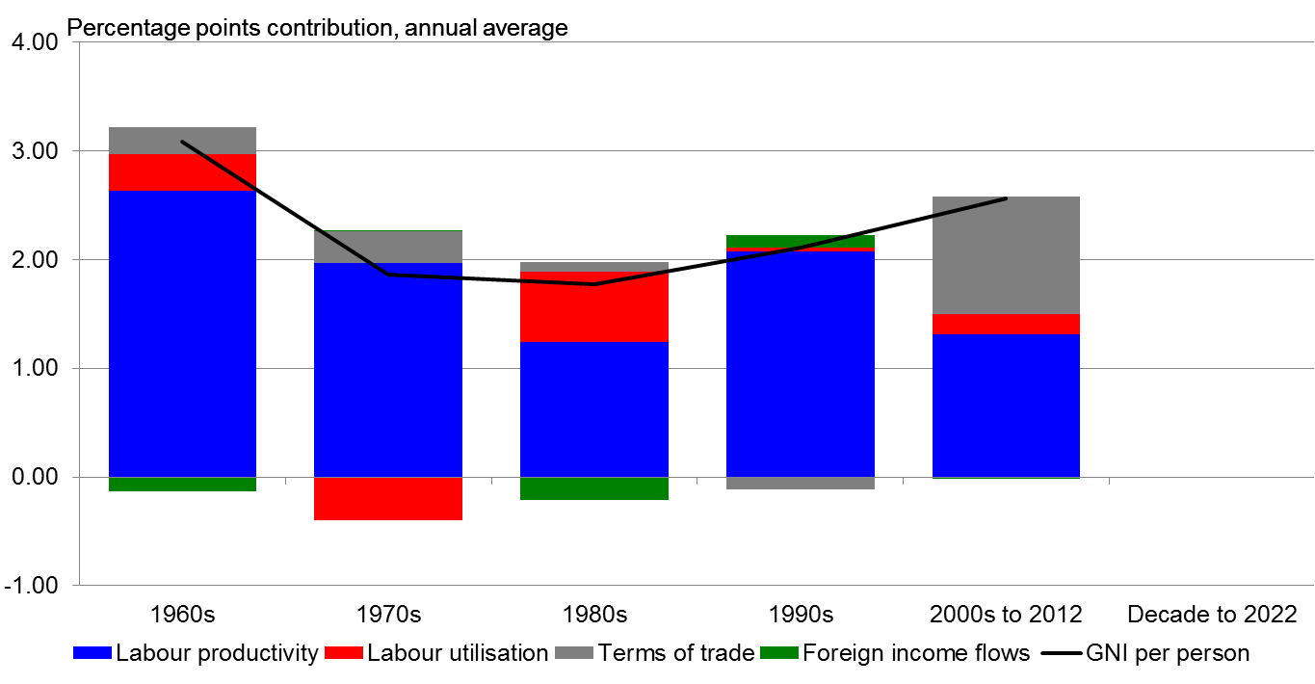
Source: ABS cat no. 5204.0, unpublished ABS data and Treasury Calculations
This picture shows the nature of our economy over five decades, in terms of the sources of growth in Australian incomes.
To me, it is the single most telling representation of the need to comprehensively review how Australia addresses productivity reform.
The primary factors represented here are productivity, labour force and the terms of trade. Or how we work; how many of us work; and how much foreigners are prepared to pay for what we produce versus what they sell to us.
And thus you’ll see that over fifty years, other than this last decade up until 2012, the terms of trade have not offered that much to our incomes growth nationally.
Since I am in the West tonight, it might seem heresy to suggest that the price of minerals just hasn’t been that important.
And viewed over shorter periods than fifty years, it has been a powerful force, on occasion.
But generally speaking and pretty much always over the long haul, national incomes reflect our productivity performance.
The picture also shows how unique the recent minerals price boom in the 2000s has been; and how effectively it has disguised a weak productivity performance for much of that period.
And although I won’t wade through the data tonight, the Productivity Commission’s research has demonstrated that if we drop down from this kind of national focus to look at specific sectors, the contribution of productivity amongst a variety of industries at the firm level has been much less impressive than even this relatively low-achieving decade suggests.
And if we move on to look at the next decade, we will see a few significant events emerging:
Figure 2 Contributions to growth in average incomes – same LP growth as last ‘decade’
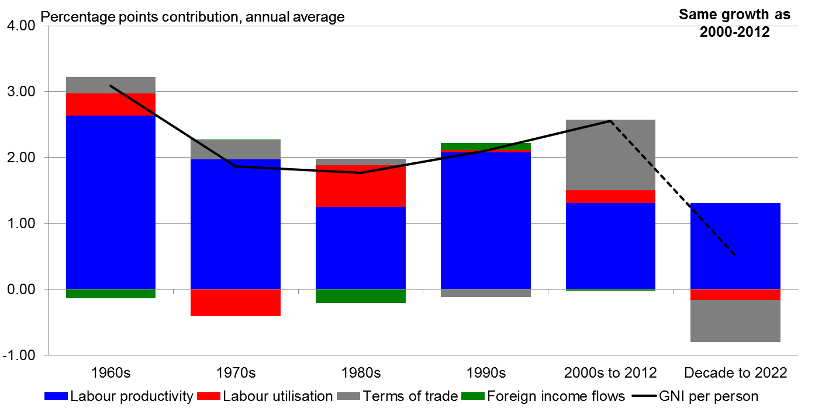
Note.1.3 per cent labour productivity growth and no contribution from foreign income flows assumed to 2022.
Source: ABS cat. no. 5204.0, unpublished ABS data, PC calculations.
First, demography is getting to us – we’re getting older, as a nation. This will mean lower labour utilisation, the red bar is now not adding to growth but detracting from it. The proportion of us working will fall from now on, probably for several decades. There’s possibly a bit we can do to slow this down but as you can see, it’s not likely to be a big influence on national income anyway.
Second, the terms of trade will decline. It’s also not really a choice. The decline has already started. And it too is also not an area amenable to government policy initiatives.
The size of the decline shown here is consistent with a steady return to long-run levels, but it could fall faster or slower. However it goes, it will be a negative influence on national income.
And this leaves us with productivity as a positive influence. And only productivity. At least here we do have choices. Choices for all of us, not just for governments.
We could choose to maintain the productivity performance of the 2000s. As indicated in the chart, this would give us net national income growth per person of about half a per cent per year.
Such a low growth level is likely to translate into circumstances that have not been experienced over a sustained period in the memories of any of our working population. The dark line shows the fall.
Our income expectations, I suggest, are currently focused much higher, although it is not my role to give that a number. You can easily pick your own. Let me say that the average in recent decades is something around the 2% level.
So that choice – weak income growth via productivity at the point of the last decade (around 1.3%) – is hardly to be preferred.
Or we could choose to aim higher, returning to our long run productivity growth (around 1.6%):
Figure 3 Contributions to growth in average incomes – forcast LP growth
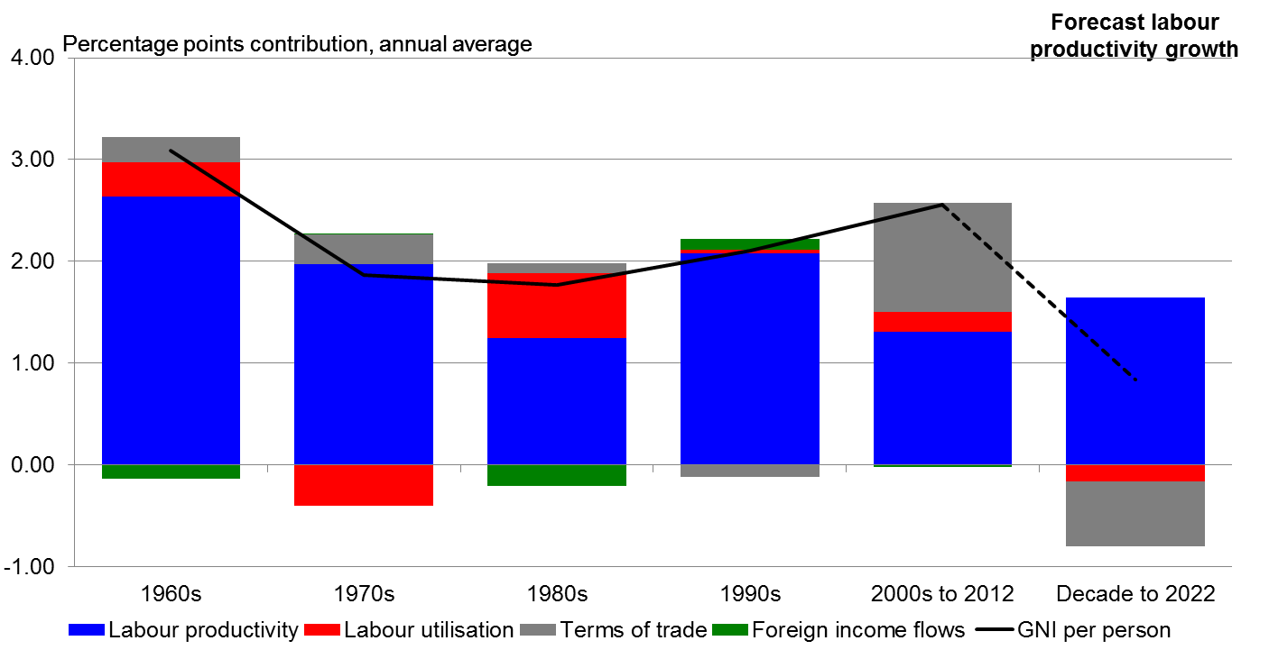
Note:1.6 per cent labour productivity growth and no contribution from foreign income flows assumed to 2022.
Source: ABS cat. no. 5204.0, unpublished ABS data and Treasury calculations.
Some people will argue this will occur naturally, as the recent big capital investments of some industries, including here in the West, come on line and start producing.
While some improvement should be possible, I’m not that sanguine; and for reasons that have little to do with what we all hope will be a resurgence in the productivity of the resources sector.
In thinking of a national rebound, let us consider our largest employing sectors – health, aged care, retail, construction, education. While productivity is difficult to measure in some of these areas, services are dominant in our economy. Yet there is no equivalent built-in shift in capital, waiting to harvest large efficiency returns as they come on line.
And demography is making these areas crucial to future economic performance, as well as their inherent social purposes.
Then consider infrastructure. The discussion today on what are the most important investments in transport infrastructure does not appear to be driven by assessments of their contribution to productivity.
The focus of our attention is rather on a debate over funding options for a handful of icon projects. What happens to the less iconic, but higher benefit project in such a skewed competition for funds?
And then there is the digitisation of things, a globally significant shift in the nature of some important business services – think cloud computing – as well as certain consumer markets and retailing.
When markets are rapidly transformed globally – as they are being - it is quite possible that the services outcomes will not reflect the public interest in competitive outcomes.
Barriers to entry and exploitation of regulatory or intellectual property entitlements have been a common symptom of such shifts. This may prove to be the larger issue.
It certainly appears so overseas. Australia may or may not be a beneficiary.
And in energy, there are equally transformational global trends in gas resource development in the US - and potentially in Europe - as well as here, that should be closely considered now rather than receive ad hoc policy attention as they alter our energy mix.
These trends may shift the dial one way or the other on productivity. So I prefer to think of a return to long term productivity trends as not being just a matter of business as usual, locked in by large capital investments of the past decade.
It is more like a legitimate aspiration.
Nevertheless, and here’s the real crunch, even if we do lift our game and productivity returns to long term trends over the coming decade, I must disappoint you and say that even this may only lift that half a per cent annual growth to something less than 1%.
Over a decade.
These are, of course, forecasts. As I noted earlier, the terms of trade decline may be a bit more or less, although there is little reason to think it will have a positive influence.
But in the case of productivity, the numbers don’t tend to react quickly. We should not think that the pattern shown in these scenarios is easily altered.
Productivity tends to become locked in - by natural forces; by investment patterns and market structures determined over periods of years; in sum, by prior decisions which take time to play out. It is a space where big shifts occur in response only to big events.
And we have rarely out-performed this long-term productivity trend in recent decades.
The few years when we did so were achieved during the high point of the reform period in the 1990s, and in circumstances not just of persistent, repeated reforms affecting all levels of firms and government enterprises over a decade, but also of recovery from a major recession.
With all that such a recession meant in terms of altered expectations.
Expectations. Expectations of strong income growth in the 90s were not high, I recall clearly from many policy-making forums.
So the willingness of workforces and businesses to embrace change and try new forms of collective commitment was accordingly all that much higher then.
My overall contention tonight is that we need to consider altering our expectations.
We need to do this by undertaking a serious reflection on productivity by firms and at the workplace level, as well as across governments. If we do not, the limit of our reasonable expectations is a slower-than-expected income growth scenario.
…
I probably should add a health warning at this point. Nothing I’m saying tonight is a judgment about the outlook for the distribution of national income, at the level of wages growth or dividend payments or tax revenues.
Who will get what share of the slower growing cake is a matter for other forums. And undoubtedly there will be shifts back and forth over a decade.
What’s important is that even if we get productivity growth back to long-term trend, it still won’t support national income growth at long term trend. The rate of growth may be about half that we have been used to over the last 50 years.

And now to add a dose of optimism, here is what out-performance looks like:
Figure 4 Contributions to growth in average incomes – needed for long run GNI growth
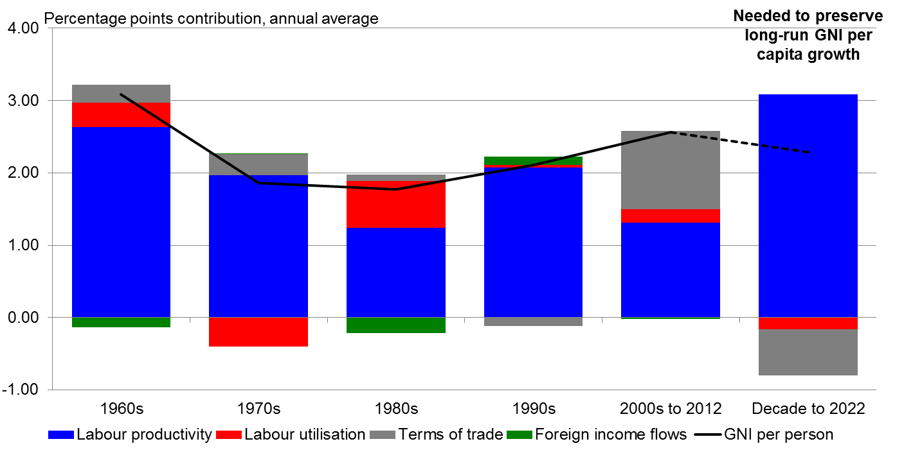
Note: No contribution from foreign income flows assumed to 2022. Long-run GNI growth of 2.3 per cent a year.
Source: ABS cat. no. 5204.0, unpublished ABS data, PC calculations.
This chart shows that if we are to keep income growth at long term trend, we have to outperform, in a way we have not done for many years, and for a sustained period.
And such an out-performance needs in my view to draw on the lessons we learned in the much-celebrated reform period of the 1990s.
In the 90s, labour productivity growth moved up from around the 1.3% level to around 2% and even higher in a few years – numbers in the 3s.
To deliver this optimistic scenario, we will need at least this kind of performance again. The question is how.
…
I referred at the start of this speech to the need for a shared commitment to a reform agenda.
The commitment to such a shift is not just a matter for governments. The commitment needed is such that it alters attitudes and expectations across the board, if it is to make shifts of this magnitude possible.
And it is not a plea for a productivity target. So many parties have a hand in what must be achieved year on year, it is not possible for a government to accept that level of risk, alone.
Yet such a shift in attitudes across an economy is possible. Let me show you how.
…
I love economic histories. ... Probably lost half the crowd with that remark, I’m sure.
The analysis of how economies, economics and economists learn their painful lessons of failure.
And how they compete, across gaps of decades since circumstances were last this way, to discern the real rather than the perceived bases for their successes.
This is so important to not repeating the mistakes of the past. And even more important to repeating the successful strategies, if we could be sure we know them.
For those reaching already for the port bottle, this isn’t going to descend into a recitation of my favourite moments in economics.
Except for one.
Some of you may recall from an earlier but more notably fraught time the Paul Keating remark
“I guarantee that if you walk in to any pet shop in Australia the resident galah will be talking about micro-economic policy”.
I was working in Canberra’s micro-economic reform effort when that remark was made.
That remark is about attitudes and expectations - that the knowledge of structural reform had become so widely heard and, for a time, was so embedded in the national psyche, that every pet shop galah could repeat it.
As I recall it, the remark was more about the galah in question than the guarantee.
But tonight I would like you to reflect on the fact that it was so powerful not because it was pithy, but because it was true.
Success in achieving widespread recognition of the breadth of the problem is a central part of subsequent success in addressing it.
And getting across to a wider community that there is a need for change to our attitudes is part of the task facing us all – governments, employers and employees – today.
The circumstances of the 1980s were an economy facing a significant decline in the terms of trade. Much as we do today. There were also fiscal policy challenges.
But a significant difference was that the economy itself was less resilient, less able to flex in response to international shifts in demand and price than today’s Australian economy.
Rampant inflation, inflexible labour markets and the grand bargain of putting a bit of lead in the saddle bags of exporting and import-utilising industries via tariff protection, as a way of trying to guarantee domestic employment in areas where we had no comparative advantage – this was the 1980s context.
The float of the dollar a couple of years earlier was a catalyst for change. The ability to change the nation’s economic structure quickly enough to adjust to the new openness was the consequent great challenge for Australia.
And the way we changed was ultimately quite structured.
First, there was a public commitment made to focus on the micro-economy.
Then an agenda of reforms was put together.
And over a sustained period, in 1988 and 1991, 1992, 1995 and through a government change on to 1999, a formal reform Statement was made the model for selling the reasons why change was necessary.
Words were powerful in creating the expectation that this was a task for the long haul.
The Statements created the narrative and updated it. The politics of the day varied and yet the reform process continued. The Canberra bureaucracy, employers large and small, and unions were all required to make judgements in an environment pervasively focused on reforming the economy, triggered initially in order to offset an expected deep decline in national income.
By contrast, I do not see much evidence today that we are conscious of the scale of change that is reflected in the picture we look at tonight.
There have been relatively few contributions on how we might change the national discussion.
And shift expectations in the way that may be required.
Today’s economic discussion is instead dominated by debt and deficit.
Both of which can of course more sustainably be solved by focussing on productivity improvement.
The lists of things governments, State and Commonwealth, might do if they are to remake the economy in anticipation of the future lowering of growth in national income are have been put together and are well known. In the right environment, they will help answer the question ‘what should we do?’
But without a commitment to comprehensive, continuous change, the items on the lists will at best be addressed only as they present themselves, and the policy and enterprise-level reforms will be fought out as discrete isolated events.
Three things simultaneously need to be present and aligned for broad productivity-enhancing reform to actually have an impact on expectations:
- a government predisposed to consider change, with strong political authority
- a process that allows reforms to be critically reviewed before attempting implementation, so that the design kinks can be ironed out; and
- a community informed of the outlook, with expectations shifted such that there is an incentive to proceed, even in the face of self-interested opposition.
Rarely are these factors all present at the one time. But we do now have that opportunity.
We need to overcome the desire to only proceed in the face of an immediate crisis. It may make the arguments simpler, but if we wait for a crisis, the second point is very likely to be ignored.
Even worse, we limit ourselves to waiting. Surely it is preferable to undertake reform in advance of a crisis?
And individual reforms of the kind likely to lift productivity or national income by even one-tenth of a percentage point are not common.
Even less likely is that a suite of them will spontaneously emerge, each sponsored by a separate Ministerial commitment and each with the ability to design an effective policy, critique it and implement it.
Thus my advocacy is for the return of a national economic reform Statement, equivalent to those developed in the late 80s and 90s, where the process and the authority come in a single package.
And where as a consequence of such a commitment a shift in national expectations may emerge.
I know of no other model that is likely to create the incentive for reform on a scale likely to address the kind of national income growth constraint that may be in prospect, implied by the picture we have reviewed tonight.
And neither do they know of any better model overseas. The structural reforms of the Monti Government in Italy last year and the Abe Government’s recent less successful packaging of the third arrow of reform are models of a similar kind to Australia’s of the 80s and 90s.
And their focus, too, was on trying to achieve a shift in expectations by a breadth of reform – expectations in bond markets, in stock markets, amongst consumers.
As I said in my first speech on this topic some months ago, expectations are a very powerful policy weapon. But they cannot be created by an agenda of occasional reform.
…
Let me finish by making a final observation on the value of encouraging productivity as a policy priority.
The recent election campaign gave much attention to fiscal policy.
More attention will undoubtedly be given by commentators in the next few months to the choice of measures; and the timing of measures is also sure to be a delicate matter.
But if some part of this discussion shifted to the means to pursue a lift in national productivity, based on the contribution that could be made to national income that is evident in tonight’s picture, a sustainable contribution to fiscal circumstances over the medium term should be achieved.

Trans-Tasman Business Circle Productivity Series dinner, Perth, 18 September 2013

