October 2023



**PC productivity insights**

Quarterly productivity bulletin — September 2023

|  |
| --- |
| The Productivity Commission acknowledges the Traditional Owners of  Country throughout Australia and their continuing connection to land,  waters and community. We pay our respects to their Cultures, Country and Elders past and present.  The Productivity Commission  The Productivity Commission is the Australian Government’s independent research and advisory body on a range of economic, social and environmental issues affecting the welfare of Australians. Its role, expressed most simply, is to help governments make better policies, in the long term interest of the Australian community.  The Commission’s independence is underpinned by an Act of Parliament. Its processes and outputs are open to public scrutiny and are driven by concern for the wellbeing of the community as a whole.  Further information on the Productivity Commission can be obtained from the Commission’s website (www.pc.gov.au).  © Commonwealth of Australia 2023  CC By logo  With the exception of the Commonwealth Coat of Arms and content supplied by third parties, this copyright work is licensed under a Creative Commons Attribution 4.0 International licence. In essence, you are free to copy, communicate and adapt the work, as long as you attribute the work to the Productivity Commission (but not in any way that suggests the Commission endorses you or your use) and abide by the other licence terms. The licence can be viewed at: https://creativecommons.org/licenses/by/4.0.  The terms under which the Coat of Arms can be used are detailed at: www.pmc.gov.au/government/commonwealth-coat-arms.  Wherever a third party holds copyright in this material the copyright remains with that party. Their permission may be required to use the material, please contact them directly.  An appropriate reference for this publication is: Productivity Commission 2023, *Quarterly productivity bulletin — September 2023,* PC Productivity insights, Canberra, October  Publication enquiries:  Phone 03 9653 2244 | Email publications@pc.gov.au |

Contents

Key points 4

Australians worked longer, but productivity fell 4

More productive industries reduced hours worked 5

Abbreviations 8

References 9

|  |  |
| --- | --- |
| Key points | |
|  | Labour productivity decreased by 2% for the whole economy in the June 2023 quarter, which resulted in an expected 3.2% fall in productivity from 2021‑22 to 2022‑23.  The output of twelve industries grew but did not keep up with the growth in hours worked.  Only four industries saw productivity growth in the June quarter. |
|  | Australians worked more hours than ever before in the June quarter. The increase in hours worked could be due to:  more hours worked by people already in employment, possibly to compensate for the significant recent decline in inflation-adjusted household net wealth  a historically tight labour market which was associated with record high participation rates, with more people entering the workforce and working longer  an unwinding of the COVID-19 pandemic restrictions in 2021‑22, resulting in workers returning to work. |

[Used for spacing, do not delete | Style: No Spacing]

This bulletin provides a brief on the most recent trends in productivity from the Australian National Accounts June 2023 quarter, published in September 2023. Quarterly data can be volatile and may deviate from the long-term trend. Therefore, medium- and long-term trends are also used to provide potential explanations for productivity developments. A primer on productivity, as well as productivity data and their revisions, are included in the appendix.

Australians worked longer, but productivity fell

### Growth in hours worked outpaced growth in output

Productivity is about working smarter, not working harder or longer. Australia experienced a large decrease in labour productivity for the whole economy (-2.0%) and the market sector (-1.7%) in the June 2023 quarter, resulting in an expected 3.2% fall in annual productivity from 2021‑22 to 2022‑23, as indicated in figure 1 (ABS 2023a). This is largely because hours worked increased more than output. Output was up 0.4%, while hours worked for the whole economy and the market sector increased by 2.4% and 2.2% – the largest quarterly increase on record, outside the COVID-19 pandemic (ABS 2023a).

The surge in hours worked during the June quarter of 2023 was predominantly a result of employed workers working longer hours rather than an influx of new entrants. Specifically, 87.5% of the increase in total hours worked can be attributed to the rise in hours worked per employee.

Figure 1 – Productivity fell in Q2, leading to an expected fall in annual productivity

Labour productivity growth index

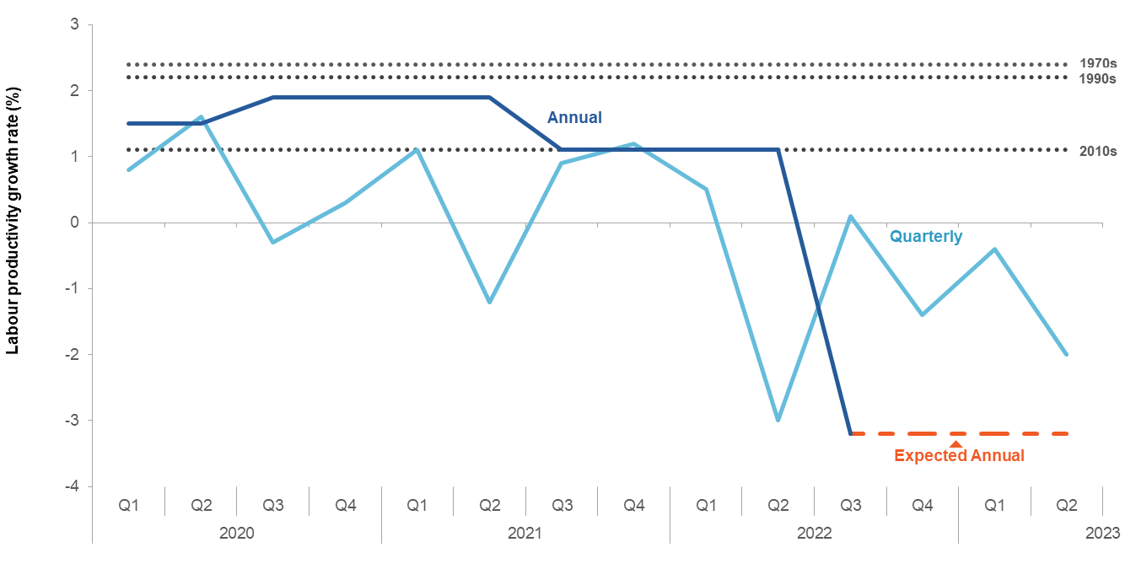

 Source: ABS (2023, *Australian National Accounts*, June 2023, Cat. no. 5206.0, table 1).

The increase in hours worked might be a short-term trend that moderates as slowing economic conditions change the balance between labour supply and demand. As the post-pandemic recovery slows and interest rates rise this may reduce aggregate demand, and therefore, labour demand (RBA 2023b). The recent sharp increase in net arrivals from overseas may help alleviate worker shortages (Bullock 2023). While labour demand might slow, labour supply could increase due to tighter budget constraints (discussed below).

Despite short-term fluctuations in hours worked, sustained labour productivity growth over the long-term is only achieved when output growth exceeds growth in hours worked. Therefore, greater attention should be directed toward increasing output through increased investment, efficiency and innovation, rather than just focusing on fluctuations in labour hours.

More productive industries reduced hours worked

### Productivity decreased in most industries

15 out of 19 industries experienced a decline in labour productivity over the 2023 June quarter (figure 2, blue circles). Most industries saw large increases in hours worked, with output staying flat or rising slightly, leading to a decline in productivity. The largest decline in productivity occurred in the arts and recreation services industry (-7.6%), which was also the industry with the largest increase in hours worked (9.3%), but output only rose by 0.9%. This story was borne out in 12 industries in which hours worked outpaced output growth (figure 2), while three sectors saw more hours worked and a decline in output.

Only the transport, postal and warehousing industry (figure 2, sector I) experienced an increase output that exceeded an increase in additional hours worked.

In contrast, three industries saw a reduction in hours worked, and all of them experienced increased productivity growth. The administrative and support services industry (N) and accommodation and food services industry (H) saw output rise while hours worked fell. Wholesale traders (F) reduced both hours worked and output, but hours worked decreased by more than output, and so measured productivity increased. [Used for spacing, do not delete | Style: No Spacing]

Figure 2 – Productivity decreased in most industries with hours worked outpacing output growth

Growth in gross value added (chain volume) and hours workeda by industry, Mar-June 2023

This figure is a scatter plot of hours worked growth on the x-axis and output growth on the y-axis, weighted by contribution to output, by industry in the June 2023 quarter. The figure shows that most industries experienced faster growth in hours worked than output, which resulted in a decline in productivity growth. Only four industries experienced an increase in productivity growth, which was mainly due to output increasing while hours worked decreased.


**a.** Hours worked by industry uses the hours actually worked by industries in the quarterly labour account. Bubble sizes indicate relative GVA weights of the industry in the June 2023 quarter. Industries are represented by their Australian and New Zealand Standard Industrial Classification (ANZSIC) letter code. A=Agriculture, forestry and fishing, B= Mining, C= Manufacturing, D=Electricity, gas, water and waste services, E=Construction, F= Wholesale trade, G=Retail trade, H=Accommodation and food services, I=Transport, postal and warehousing, J=Information, media and telecommunications, K=Financial and insurance services, L= Rental, hiring and real estate services, M=Professional, scientific and technical services, N=Administrative and support services, O=Public administration and safety, P=Education and training, Q=Health care and social assistance, R=Arts and recreation services, S=Other services.

Source: Commission estimates based on ABS (2023, *Australian National Accounts: National Income, Expenditure and Product*, June 2023, Cat. no. 5206.0, table 1) and ABS (2023, *Labour Account Australia*, June 2023, industry summary table).

#### Three industries contributed to 46% of the overall labour productivity decline

Mining (B), along with the electricity, gas, water and waste services (D) and information, media and telecommunications (J) industries, drove a 1.4 percentage point fall in total labour productivity – collectively accounting for 46% of the overall labour productivity decline (figure 3).

Themining industry alone made up around one-third of the total labour productivity decline (figure 3, right column). Although hours worked increased, there was a large decline in mining output – and associated with that, a large decline in labour productivity. The decline in mining output was mainly driven by a decrease in iron ore mining and oil and gas extraction, as adverse weather and planned maintenance reduced production capacity (ABS 2023b). As mining historically accounts for about one quarter of Australia’s measured labour productivity growth, the impact of this industry translated to a large drop in overall productivity.

Figure 3 – Decomposed economy-wide growth in hours worked, output and productivity

Growth in aggregate labour productivitya, aggregate gross value added (chain volume) and aggregate hours workedb decomposed by the top 3 industries, Mar-June 2023

This figure contains three stacked bar charts that decompose economy-wide hours worked, output and labour productivity growth by industry. The figure highlights the three top contributors for each chart. Education and training; professional, scientific and technical services; and construction were the largest contributors to the increase in hours worked. Rental, hiring and real estate services; construction; and mining were the largest contributors to the increase in output growth. Information media and telecommunications; electricity, gas, water and waste services; and mining were the largest contributors to the decrease in productivity growth.

**a.** Labour productivity is estimated through dividing industry GVA by hours actually worked across 19 industries. Total change aggregates the 19 industries' GVA per hour worked. Therefore, it is different to gross domestic product (GDP) per hour worked. **b.** Industry hours worked uses the hours actually worked by industries in the quarterly labour account.

Source: Commission estimates using ABS (2023, Australian National Accounts: National Income, Expenditure and Product, June 2023, Cat. no. 5206.0, table 1) and ABS (2023, Labour Account Australia, June 2023, industry summary table.

Decomposing the economy-wide growth in hours worked (figure 3) showed that education and training (P); construction (E); and professional, scientific and technical services (M)were the largest contributors to growth in hours worked – contributing to over 40% of the aggregate increase. These industries represent a larger share of total hours worked in the Australian economy and therefore fluctuations in these industries drive total hours worked.

#### The quarterly trend in some industries deviated from the yearly trend

Quarterly statistics tend to fluctuate and short-term changes may deviate from the long-term trend. For example, industry-level revisions to productivity data can be large due to these quarterly fluctuations (appendix). Therefore, the Commission used average quarterly growth in labour productivity from the past four quarters to evaluate the year trend and highlight any notable deviations.

Despite a large increase in hours worked that led to a drop in labour productivity for the information, media and telecommunications industry in the June 2023 quarter, the industry experienced the second-highest growth in labour productivity throughout 2022‑23; averaging a 1% increase over the past four quarters (appendix). This growth might reflect the sustained impact of increased remote working arrangements and improved telecommunication infrastructure that emerged during the COVID-19 pandemic (PC 2023, p. 11).

Similarly, the wholesale trade industry had a small increase in labour productivity in the 2023 June quarter, but had the second-largest fall in labour productivity throughout 2022‑23, averaging a 2.5% decrease over the past four quarters (appendix). This decline was due to an increased number of hours worked, accompanied by stagnating output growth because of weakening retail demand for some goods (ABS 2023b).

#### Explaining the increase in aggregate hours worked

Three factors could help explain the increase in aggregate hours worked.

1. **Cost-of-living pressures and reductions in real household net wealth** – high inflation rates and interest rates erode the real value of household net wealth (RBA 2023a). The household saving ratio has fallen to its lowest level since June 2008 (ABS 2023b). As cost-of-living pressures bite further, workers may respond to this negative real wealth shock by seeking to work more hours to try to maintain a reasonable standard of living over time. At an industry level, the highest increases in hours worked were in industries where it is relatively easier for this to occur (construction, manufacturing, education, arts) as opposed to administrative and support services where hours are more likely set by employers, and where hours worked declined.
2. **A tight labour market** – the percentage of the population employed reached a historically high level in June 2023 (ABS 2023a). This drove a rise in hours worked as more people entered work and more people worked longer. All else being equal, new entrants and more marginal workers would have – on average – lower skills (PC 2022, p. 2) and there would be on average less capital per worker, thereby reducing measured productivity, at least in the short term.
3. **The COVID-19 pandemic** – the decline in productivity since 2022 in part reflects an unwinding of the measured increase in productivity due to the COVID-19 pandemic. However, with productivity now at its lowest level since March 2016, this can only be part of the explanation. As the Productivity Commission has previously noted, the pandemic caused a short-term measured increase in productivity from 2020 to 2022 because the sectors that were closed down or shrunk by restrictions had lower productivity (PC 2023, pp. 5–6). As COVID-19 restrictions unwound in 2021-22, less productive industries and workers returned to work. This may have caused hours worked to grow faster than output and the end of the COVID-19 ‘productivity bubble’.

Abbreviations

|  |  |
| --- | --- |
| **ABS** | Australian Bureau of Statistics |
| **ANZSIC** | Australian and New Zealand Standard Industrial Classification |
| **GDP** | Gross Domestic Product |
| **GVA** | Gross Value Added |
| **PC** | Productivity Commission |

References

ABS (Australian Bureau of Statistics) 2023a, *11 Things That Happened in the Australian Economy During the June Quarter*, Australian Bureau of Statistics, https://www.abs.gov.au/articles/11-things-happened-australian-economy-during-june-quarter (accessed 7 September 2023).

—— 2023b, *Australian National Accounts: National Income, Expenditure and Product, June 2023*, https://www.abs.gov.au/statistics/economy/national-accounts/australian-national-accounts-national-income-expenditure-and-product/latest-release (accessed 12 September 2023).

Bullock, M 2023, *Achieving Full Employment*, Reserve Bank of Australia, (accessed 11 September 2023).

PC (Productivity Commission) 2022, *5-year Productivity Inquiry: A more productive labour market*, Interim Report 6, Canberra, October.

—— (Productivity Commission) 2023, *PC Productivity Insights: Bulletin 2023*, 7 January.

RBA (Reserve Bank of Australia) 2023a, *Statement on Monetary Policy – August 2023 – 2. Domestic Economic Conditions*, https://www.rba.gov.au/publications/smp/2023/aug/domestic-economic-conditions.html (accessed 28 September 2023).

—— 2023b, *Statement on Monetary Policy – August 2023 – 5. Economic Outlook*, https://www.rba.gov.au/publications/smp/2023/aug/economic-outlook.html (accessed 25 September 2023)