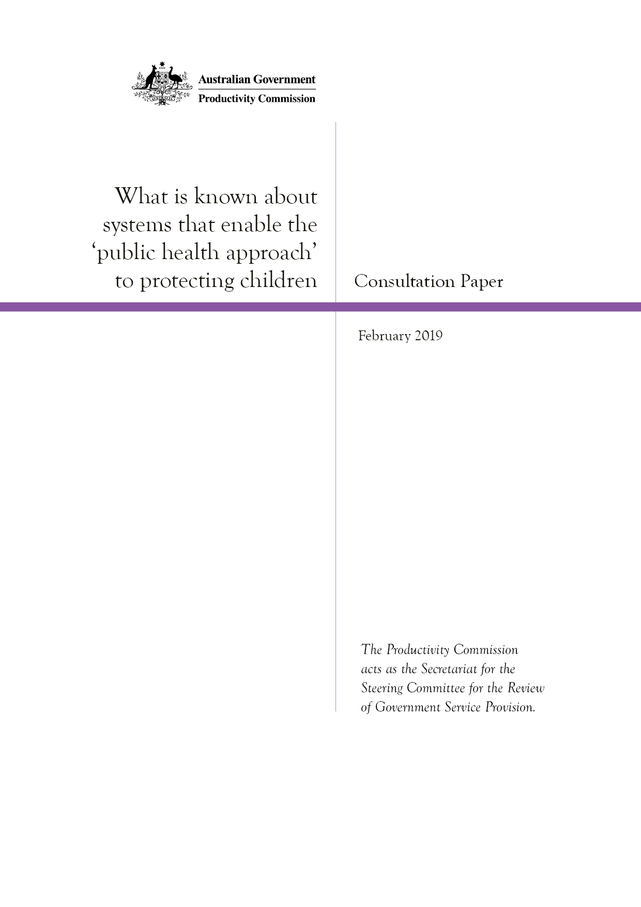

Contents
1 Purpose of this consultation paper 1
2 Background to this project 2
3 What is known about the desirable characteristics of a system based on the public health approach? 4
4 What is known about ‘what works’ to make this system function as a whole? 6
References 10
Attachment A: How to provide feedback 12

1 Purpose of this consultation paper
The Secretariat for the Steering Committee for the Review of Government Service Provision is seeking input from individuals and organisations on the second What Works project (box 1). This project investigates what is known about systems that enable the ‘public health approach’ to protecting children. The focus will be on systems that protect children from abuse and neglect that occurs within families (to minimise duplication with recent work on child abuse in institutional settings).
Australian governments have committed to taking a public health approach to protecting children under the National Framework for Protecting Australia’s Children 2009–2020. A range of approaches have been used to date, but there is growing concern that efforts are still too crisis oriented, focused on responding to child abuse and neglect after they have occurred, rather than on prevention. This project will look specifically at system design: what is known about ‘what works’ to build a system where all the parts are working together to enable the public health approach to protecting children. It will highlight system-change approaches that appear effective, but will not assess the effectiveness of individual programs or interventions.
Feedback is due by Thursday, 21 March 2019 and can be submitted online at: www.pc.gov.au/research/ongoing/report-on-government-services/what-works/child-protection. The feedback will be incorporated into the final research report, along with other research and evidence, including on national and international system reforms and global peer-reviewed and grey literature on systems that enable the public health approach to protecting children. International research is limited to high-income developed countries with a similar social structure to Australia, as these are more likely than other countries to have system design features that could be replicated in the Australian context.

Box 1 What are What Works projects?
What Works projects complement the performance reporting in the Report on Government Services by reviewing current global evidence on what works (or does not) to achieve particular outcomes for government services. The aim is to improve the wellbeing of all Australians through providing decision makers with high quality information on what works to address existing social policy needs.
The projects are intended to be targeted at policy issues, be rigorous yet timely and balance the overall evidence with practical advice and theory. The specific topic for each project is agreed by the Steering Committee for the Review of Government Service Provision (Steering Committee). What Works projects are produced by the Productivity Commission in its role as Secretariat for the Steering Committee.
Further information on What Works can be found on the Commission’s website:
www.pc.gov.au/research/ongoing/report-on-government-services/what-works

2 Background to this project

What is the problem?
The primary objective of the child protection system is to protect children from abuse and neglect, meaning any intentional or unintentional behaviour by a parent, carer or other person that causes physical or emotional harm to a child. The five main types are physical abuse, sexual abuse, emotional abuse, neglect and witnessing domestic violence (CFCA 2014).
The consequences of child abuse and neglect can be severe. They can lead to childhood trauma and stress, and negatively affect all domains of childhood development and outcomes. Chronic maltreatment reoccurring over a prolonged period is particularly detrimental, resulting in worse outcomes than temporary or isolated incidents (CFCA 2014).
The incidence of child abuse and neglect is hard to measure. Available data show that involvement with child protection services has been increasing in Australia (figure 1). However, this is likely to partly reflect changes in policies and community awareness, broadening definitions of what constitutes abuse and neglect, and increasing reporting requirements (Katz et al. 2016). It is not clear to what extent the underlying level of child abuse and neglect has also changed.
Governing any child protection system is challenging and those in Australia are no exception. These systems are often dealing with the most vulnerable and disadvantaged children and families who have significant and complex needs. Given this, there will also be a need for some tertiary/statutory services to ensure the protection of some children.
Nevertheless, there is recognition that the child protection system is overly crisis oriented and needs to be re-oriented toward prevention and early intervention (AMA 2018; Broadley and Goddard 2014; Higgins 2015; O’Donnell, Scott and Stanley 2008). Australian governments aware of some of these shortcomings are already planning or undertaking changes to systems for protecting children (Wise 2017).

Figure 1 Involvement with tertiary/statutory child protection services
Source: SCRGSP (Steering Committee for the Review of Government Service Provision) 2019, Report on Government Services 2019, Productivity Commission, Canberra.

What is the public health approach to protecting children?
In essence, a public health approach to protecting children means a focus on preventing child abuse and neglect from occurring in the first place by addressing underlying risk factors that increase the likelihood that a child will experience abuse or neglect, or where problems do occur, to intervene as early as possible to minimise harm (Barlow and Calam 2011, Richmond-Crum et al. 2013). Under the National Framework for Protecting Australia’s Children 2009–2020, Australian governments recognised the need to shift from tertiary/statutory responses to abuse and neglect to a public health approach that focuses more on prevention and early intervention to promote the safety and wellbeing of children (COAG 2009).
Under the public health approach, priority is placed on universal (primary) support for all families (for example, maternal child health services or positive parenting media campaigns), with more intensive (secondary) prevention targeted to vulnerable or higher-risk families, often with a focus on early intervention (for example, parenting programs that build skills and address mental health problems) (figure 2). Tertiary (statutory) child protection services (for example, care and protection orders and out-of-home care) are seen as a last resort when abuse or neglect has occurred and use of alternative non-statutory approaches (for example, family support services) is not possible.

Figure 2 The Public Health Approach to protecting children
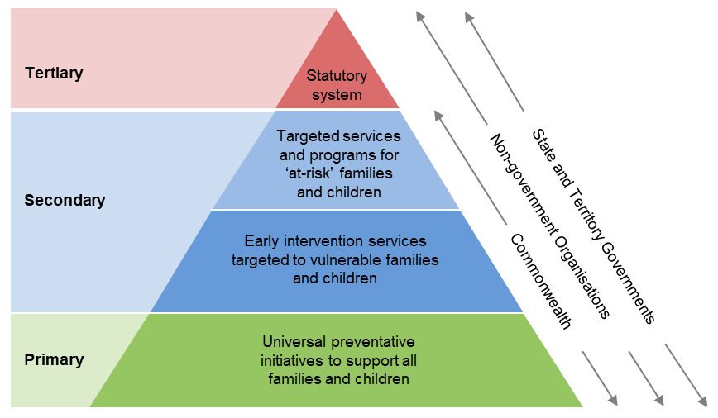
Source: COAG (2009) [National Framework for Protecting Australia’s Children 2009–2020, www.dss.gov.au/sites/default/files/documents/child_protection_framework.pdf and Productivity Commission.

3 What is known about the desirable characteristics of a system based on the public health approach?
Systems are often complex and those designed to protect children are no exception. Systems are a combination of identifiable processes and structures (for example, agencies and organisations, funding and accountability arrangements), and more difficult to identify normative elements (for example, attitudes, expectations and implicit assumptions that drive behaviours) (Fox et al. 2015).
The literature points to several desirable characteristics of a public health approach to designing a system to protect children — as represented in figure 3. Children are at the centre, along with their families and parents, and communities. These groups are the focus of system efforts and the recipients of evidence-based prevention and early intervention programs that match their needs. The system characteristics that support these programs include:
- a skilled and professional workforce who deliver services/programs (Allen Consulting Group 2008)
- organisations located in multiple settings where families and children often go (such as
pre-schools and maternal health clinics), with the capacity and knowledge to identify risks and intervene early (Higgins 2014; Put et al. 2017; Wilson et al. 2015)
- good quality information and data that provide evidence on the problem (such as data on the prevalence of child abuse and neglect), on what programs and services are effective, and what outcomes the system is delivering (Broadley and Goddard 2014; Herrenkohl et al. 2015; Jack 2010; O’Donnell, Scott and Stanley 2008)
- strong links across organisations, settings and government agencies that facilitate collaboration and coordination (Moxley, Squires and Lindstrom 2012; Waterhouse 2008)
- shared norms and values along with supportive rules, regulations and governance arrangements that are consistent across the system and align with the overall objective (Allen Consulting Group 2008; Richmond-Crum et al. 2013).

Figure 3 Key system characteristics for a public health approach to protecting children identified in the literature
Source: Productivity Commission.

request for information
We intend to use the key system characteristics to structure our review of the literature on systems that enable the public health approach to protecting children. We are seeking information and evidence on any other key system characteristics a system should have to enable the public health approach to protecting children.

4 What is known about ‘what works’ to make this system function as a whole?
While there is considerable literature on the desirable characteristics of the system, how to build such a system is less clear and appears to be the major challenge in moving toward the public health approach.
The key question is what is required for a system that works (that is, what are the system design features), where all the parts are working toward the objective of preventing child abuse and neglect, rather than supporting a system that focuses on tertiary-based approaches (after abuse and neglect has occurred). Crucially, what works in one context or jurisdiction may not work well in another — understanding the reasons for success (or failure) are essential for learning the right lessons. And building a new system will inevitably mean adapting and working with the existing system that is already in place. If an existing system is already under pressure and does not act as a good ‘host’ for new programs and services (no matter how effective they are), they are likely to fail (Ghate 2016).

Challenges that need a system-design approach
Some of the challenges in implementing the public health approach that need a system-design approach include how to ensure:
- norms and values consistent with prevention of child abuse and neglect are present throughout the system — for example, norms at the community level to support parents seeking ‘help’ are reinforced by norms at the service (organisation and workforce) level to facilitate this (Curtis, Burkett and Vanstone 2018)
- ‘at-risk’ families who are most likely to benefit from early intervention programs, but least likely to engage, are attracted to and retained in these programs — for example, vulnerable parents may be unwilling to participate in programs that explicitly target child abuse prevention for fear of having their child removed from them (especially if the system is perceived as tertiary focussed) (Katz et al. 2016; Prinz 2016)
- services are matched to the needs of particular families — for example, family support services designed for lower risk families (to stop problems developing) are not delivered to higher risk families due to their more urgent needs and lack of more appropriate services, and are also tailored to the local context
- governance and funding arrangements provide incentives to focus on the prevention and early intervention, rather than reinforcing a tertiary response
- organisations in different settings facilitate families easily accessing services, and coordinate their efforts so that services are not duplicated and do not undermine other services.

Some potential answers, but do they work and are there others?
Shifting the design of a child protection system is likely to require change at multiple levels. Change may be needed at local, regional and national levels, with approaches ranging from bottom-up to top-down (Curtis, Burkett and Vanstone 2018). Bottom-up approaches focus directly on changing families’ experiences and outcomes (for example, implementing evidence-based programs). In contrast, top-down approaches involve building the capacity and conditions of the system to ensure the bottom-up approaches are successful (for example, supportive rules and regulations and funding arrangements) (Curtis, Burkett and Vanstone 2018).
We will be reviewing a range of initiatives in the course of this project, such as those noted below.
Models for addressing system design challenges, which combine top-down and bottom-up approaches, have been applied within individual (local) communities. These models generally involve new ways of connecting at-risk children and families with appropriate services. The challenge is replicating their success on a larger scale (Fox et al. 2015).
- Network models — these models can involve government in funding and governance, but development and implementation are driven by local organisations and leaders (Fox et al. 2015). One example is Strong Communities for Children (in the United States) that uses a principles-based, rather than prescriptive, approach focussed on community mobilisation through volunteers and community organisations. It involves community engagement and leadership development to encourage a community to accept responsibility for parent support and child safety and to develop solutions tailored to the local context (the public health approach to focus on prevention/early intervention). Evaluations of this approach show decreases in child maltreatment rates, relative to a community where the approach was not adopted (McLeigh et al. 2015).
- Centre-based models — these models involve integrated service centres that target parents of young children through an accessible universal service platform (for example, a school) with other services important to families such as child care and parenting support co-located, as well as being able to refer ‘at risk’ families to more intensive supports which may be located elsewhere (the public health approach of prevention and if required early intervention through referral). Integrated service centres have a number of potential benefits:
- vulnerable families will be more comfortable attending these universally accessible centres (as there is no stigma attached — being involved in child protection services can mean being seen as ‘bad parents’ (Hinton 2013)), which can facilitate the early detection of problems
- links can be easily built across services for a coordinated approach (Fox et al. 2015).
Large-scale system designs have sought to apply similar approaches across whole regions or countries, though the evidence available on their success varies:
- Children’s Trust (UK) — Children’s Trusts were established across the UK in 2004 and involve interagency governance and decision-making power to determine how government service providers (such as hospitals, health services and police), voluntary groups and non-government services coordinate and integrate their service delivery and tailor it to meet needs of local children. In addition, a Safeguarding Children Board was established in each Trust to focus on the needs of vulnerable and at-risk children using a whole-of-population needs assessment (Fox et al. 2015).
- Getting it right for every child (Scotland) — this model seeks to reform service systems to focus on early intervention and prevention (the public health approach) by prioritising the role of universal services. It designates a ‘named person’ for every child who is in the health or education sectors (and who is already known to the child, such as a school principal) and a ‘lead professional’ for children and families with more complex needs. The ‘named person’ and ‘lead professional’ work closely together (where relevant) and are responsible to ensure the children and their families get the help they need to promote their wellbeing. A pilot of this model showed a substantial reduction in children’s involvement with child protection services over the period of the pilot, and relative to other regions (Fox et al. 2015).
Given the crisis-oriented nature of the current system, the temptation may be to address system design challenges by focussing efforts on implementing bottom-up approaches that directly engage individual families, without giving sufficient attention to top-down approaches to build the capacity and conditions for long-term success. Some top-down strategies that may support bottom-up approaches include the following (although no evidence of their success is currently available):
- Having strong system leaders (with decision-making authority) who can foster cooperation and coordination across the system to embed a focus on ‘co-creating future action’ — an approach known as ‘system stewardship’ (Wise 2017).
- Using intergovernmental funding arrangements to give State Governments a financial incentive to provide services (such as mental health services and in-home parenting training) to families at risk of entering the child protection system — an approach recently adopted in the United States via legislation in the Family First Prevention Services Act (First Focus: Campaign for Children 2018).

request FOR INFORMATION
We are seeking your views, evidence and other relevant information on:
- the main barriers and enablers to implementing the public health approach in a system to protect children in Australia (with a focus on working across the entire system)
- examples of approaches to address system design and implementation challenges and their applicability to, or success in, the Australian context (including across different cultural groups and locations)
- public health approaches used in other social service areas and the lessons they provide for designing a system to protect children.
Both quantitative and qualitative evidence is welcome.

References
Allen Consulting Group 2008, Inverting the Pyramid: Enhancing Systems for Protecting Children, Australian Research Alliance for Children and Youth (ARACY), Melbourne.
AMA (Australian Medical Association) 2018, Campaign for a public health approach to preventing child abuse, ama.com.au/ausmed/campaign-public-health-approach-preventing-child-abuse (accessed 6 August 2018).
Barlow, J. and Calam, R. 2011, ‘A Public Health Approach to Safeguarding in the 21st Century’, Child Abuse Review, vol. 20, pp. 238–266.
Broadley, K. and Goddard, C. 2014, ‘A public health approach to child protection: Why data matter’, Children Australia, vol. 40, no. 1, pp. 69–77.
CFCA (Child Family Community Australia) 2014, Effects of child abuse and neglect for children and adolescents, CFCA Resource Sheet, Australian Institute of Family Studies (AIFS), Melbourne.
COAG (Council of Australian Governments) 2009, Protecting Children is Everyone’s Business: National Framework for Protecting Australia’s Children 2009–2020, Australian Government, Council of Australian Governments, Canberra.
Curtis, C., Burkett, I. and Vanstone, C. 2018, Examples and emerging insights from TACSI’s big change work: What we’re learning about systems change through practice., The Australian Centre for Social Innovation, Adelaide.
First Focus: Campaign for Children 2018, Family First Prevention Services Act: Bill Summary, First Focus, Washington, DC.
Fox, S., Southwell, A., Stafford, N., Goodhue, R., Jackson, D. and Smith, C. 2015, Better Systems, Better Chances: A Review of Research and Practice for Prevention and Early Intervention, Australian Research Alliance for Children and Youth (ARACY), Canberra.
Ghate, D. 2016, ‘From Programs to Systems: Deploying Implementation Science and Practice for Sustained Real World Effectiveness in Services for Children and Families’, Journal Of Clinical Child And Adolescent Psychology, vol. 45, no. 6, pp. 812–826.
Herrenkohl, T.I., Higgins, D.J., Merrick, M.T. and Leeb, R.T. 2015, ‘Positioning a public health framework at the intersection of child maltreatment and intimate partner violence: Primary prevention requires working outside existing systems’, Child Abuse and Neglect, vol. 48, pp. 22–28.
Higgins, D.J. 2014, Safe and supportive family environments, www3.aifs.gov.au/cfca /2014/07/29/safe-and-supportive-family-environments (accessed 16 October 2018).
—— 2015, ‘A public health approach to enhancing safe and supportive family environments for children’, Family Matters, no. 96, pp. 39–52.
Hinton, T. 2013, Parents in the child protection system, Anglicare Tasmania, Hobart.
Jack, S.M. 2010, ‘The role of public health in addressing child maltreatment in Canada’, Chronic Diseases in Canada, vol. 31, no. 1, pp. 39–44.
Katz, I., Cortis, N., Shlonsky, A., Mildon, R. and UNSW Social Policy Research Centre 2016, Modernising Child Protection in New Zealand: Learning from system reforms in other jurisdictions, UNSW Social Policy Research Centre, Sydney.
McLeigh, J.D., Katz, C., Davidson-Arad, B. and Ben-Arieh, A. 2015, ‘The Cultural Adaptation of a Community-Based Child Maltreatment Prevention Initiative’, Family Process, vol. 56, no. 2, pp. 393–407.
Moxley, K.M., Squires, J. and Lindstrom, L. 2012, ‘Early Intervention and Maltreated Children: A Current Look at the Child Abuse Prevention and Treatment Act and Part C’, Infants and Young Children, vol. 25, no. 1, pp. 3–18.
O’Donnell, M., Scott, D. and Stanley, F. 2008, ‘Child abuse and neglect — Is it time for a public health approach?’, Australian and New Zealand Journal of Public Health, vol. 32, no. 4, pp. 325–330.
Prinz, R.J. 2016, ‘Parenting and family support within a broad child abuse prevention strategy’, Child abuse & neglect, vol. 51, pp. 400–406.
Put, C.E. van der, Bouwmeester-Landweer, M.B.R., Landsmeer-Beker, E.A., Wit, J.M., Dekker, F.W., Kousemaker, N.P.J. and Baartman, H.E.M. 2017, ‘Screening for potential child maltreatment in parents of a newborn baby: The predictive validity of an Instrument for early identification of Parents At Risk for child Abuse and Neglect (IPARAN)’, Child Abuse & Neglect, vol. 70, pp. 160–168.
Richmond-Crum, M., Joyner, C., Fogerty, S., Ellis, M.L. and Saul, J. 2013, ‘Applying a public health approach: the role of state health departments in preventing maltreatment and fatalities of children’, Child Welfare, vol. 92, no. 2, pp. 99–117.
Waterhouse, L. 2008, ‘Child Abuse’, The Blackwell companion to social work, 3rd edn, pp. 18–26.
Wilson, M.L., Tumen, S., Ota, R. and Simmers, A.G. 2015, ‘Predictive Modeling: Potential Application in Prevention Services’, American Journal of Preventative Medicine, vol. 48, no. 5, pp. 509–519.
Wise, S. 2017, Developments to strengthen systems for child protection across Australia (CFCA Paper No. 44), Child Family Community Australia information exchange, Australian Institute of Family Studies (AIFS), Melbourne.

Attachment A: How to provide feedback

How to provide feedback
Feedback may range from a short paragraph outlining your views on a particular topic to much more substantial feedback covering a range of issues. Where possible, please provide evidence, such as relevant data and documentation, to support your views.

Generally
- Feedback, except for anything supplied in confidence, may be used and attributed to you in the final report.
- The Secretariat reserves the right to not use your material particularly if it is offensive, potentially defamatory, or clearly out of scope for the project.

In confidence material
- The final report will be public and all feedback should be provided so it can be used by the Secretariat for others to read. However, information which is of a confidential nature or which is submitted in confidence can be treated as such by the Commission, provided the cause for such treatment is shown.
- We may also request a non-confidential summary of the confidential material it is given, or the reasons why a summary cannot be provided.
- Material supplied in confidence should be clearly marked ‘IN CONFIDENCE’.
- You are encouraged to contact us for further information and advice before submitting such material.

Privacy
- A list of people who provided feedback during the consultation processes for this consultation paper will be included in the final report for this project.
- You may wish to remain anonymous. Please note that, if you choose to remain anonymous, the Secretariat may place less weight on your feedback.

How to lodge feedback
- Feedback should be lodged using the online form on the Productivity Commission’s website at www.pc.gov.au/research/ongoing/report-on-government-services/what-works/child-protection. You will also be able to provide links, or load documents as part of your feedback.
- Please do not send password protected documents.
If you do not receive notification of receipt of your feedback, please contact the Secretariat via email at gsp.whatworks@pc.gov.au.

Due date for feedback on information requests in this consultation paper:
Thursday, 21 March 2019.

For example, the Royal Commission into Institutional Responses to Child Sexual Abuse.

