C Gas market modelling results
This appendix contains illustrative modelling results from the gas market model developed for this project, including sensitivity analysis of key parameters. The model is a stylised representation of the eastern Australian gas market (as described in appendix B) and is not suitable for forecasting prices or evaluating potential investment proposals. Rather, the results presented below illustrate the economic mechanisms and broad orders of magnitude of effects associated with the application of selected policies to the eastern Australian gas market.

C.1 Results
Three baseline scenarios have been modelled to account for the effects of considerable uncertainty in future liquefied natural gas (LNG) prices in the Asia–Pacific market: a ‘low LNG price’ scenario, a ‘central LNG price’ scenario and a ‘high LNG price’ scenario. In the baseline scenarios, no investment in new coal seam gas (CSG) production is allowed in New South Wales or Victoria before September 2015, reflecting current policy settings in those states (chapter 5).
To investigate the effects of current and proposed gas market policies, as well as delays in transmission pipeline investment, baseline simulations are compared against three policy simulations.
- CSG moratoria: No investment in new CSG production is allowed in New South Wales or Victoria throughout the entire 40 year simulation period.
- Domestic gas reservation: Any fields not producing gas in the first model year are required to supply a specified proportion of their gas production to domestic users as they begin production (that is, modelled fields that are already producing gas are not subject to reservation).
- Delays in transmission pipeline investment: Investments in expansion or construction of transmission pipelines that are potentially subject to regulatory coverage are delayed by 5 years between investment and commissioning (in addition to the usual time taken to build and operationalise new transmission assets).

Baseline scenarios
The purpose of the baseline scenarios is twofold: to illustrate the effects of linking to the Asia–Pacific gas market through development of LNG export capacity (including relationships between different gas prices); and to provide a baseline against which to investigate the effects of policy options. Baseline scenarios should not be interpreted as price forecasts, as the model does not contain detail on domestic gas supply contracts and there is substantial uncertainty associated with well deliverability constraints, both of which are important for forecasting short-term prices.
All baseline scenarios include existing LNG contracts associated with the three LNG export projects at Gladstone. Baseline results suggest that although eastern Australian gas market prices will move with LNG prices, this link would be weaker if LNG prices are low.
In the central and high LNG price scenarios, LNG prices are sufficiently high to trigger investment to expand LNG export plants. Modelling results indicate that prices in the eastern Australian gas market will converge to netback prices (the export price of LNG less the costs of transport and liquefaction) (figure C.2). Where there are no constraints on transmission investment, prices across different locations within Australia do not diverge by more than the variable costs of transmission (appendix B).
In the low LNG price scenario, LNG prices are too low to make the expansion of LNG export plants viable. Existing export commitments must still be met, however, so there is limited scope to shift supply to the eastern Australian gas market in response to a decline in the LNG price. This leads to modelled prices for users in the eastern market that temporarily exceed LNG netback prices.
For modelling results in each LNG price scenario, supply comes predominantly from the Surat–Bowen basins as these basins have the largest reserves and provide the majority of gas for LNG exports. The Gippsland basin supplies the second largest quantity of gas. While other basins make up a smaller share of production, total production is much higher in some of these basins under the high LNG price scenario, as prices increase sufficiently to bring on gas fields at these basins that would otherwise be uneconomic. For example, production in the Bass basin is three times higher in the high LNG price scenario than the low LNG price scenario (figure C.1).

Figure C.1 Demand and supply (Petajoules (PJ) per year)
Three LNG price scenarios, by source of demand and supply basin
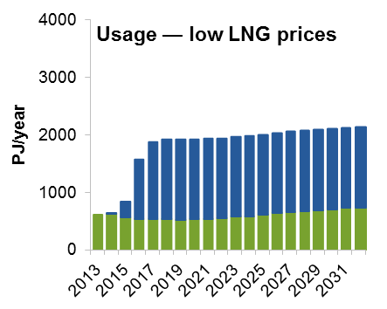 | 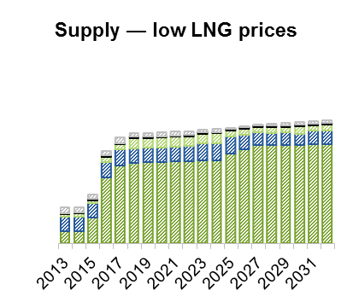
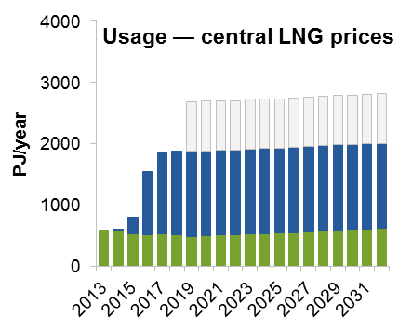 | 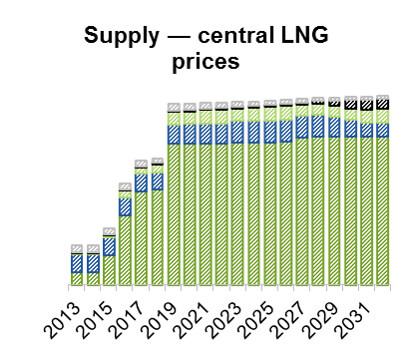
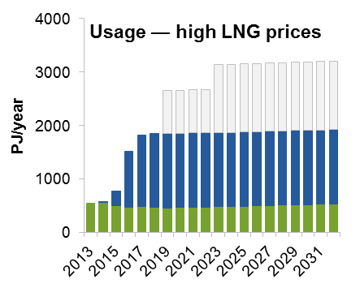 | 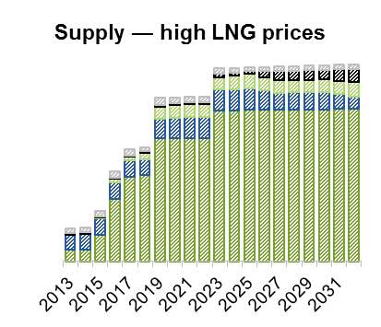
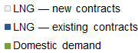

Source: Commission estimates.

Figure C.2 Capital city and LNG prices
Three LNG price scenarios ($ per gigajoule)
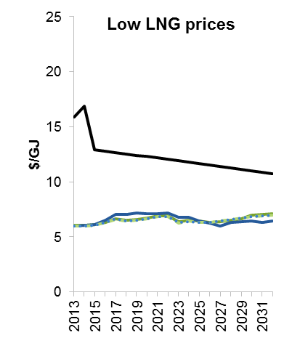 | 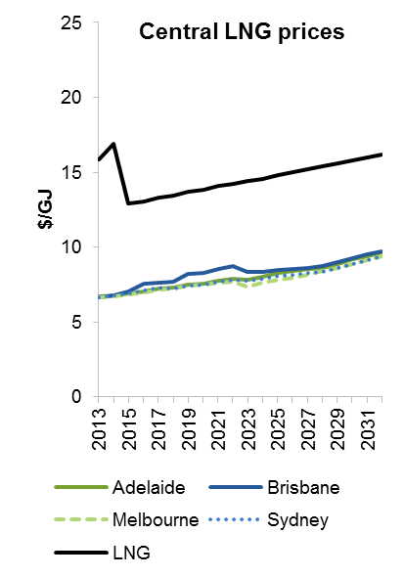
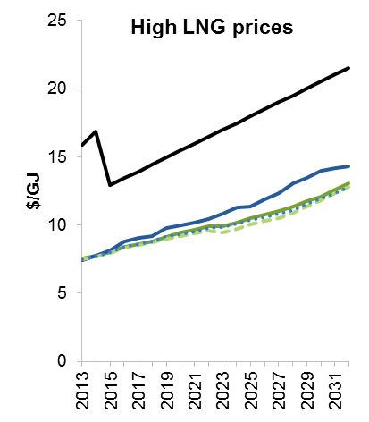

Source: Commission estimates.
Investment in production, transmission and LNG export plants occurs where the benefits from investing outweigh the costs and investors are able to recoup their investment costs (including a rate of return on capital investment that reflects risks associated with investment — appendix B). As noted above, LNG export plants are modelled to expand under central and high LNG price scenarios, with commensurate increases in LNG export plants. Some of the increase in LNG export capacity under the high LNG price scenario comes from building a new LNG plant, as the limit on expansion of the three existing plants is met (table C.1).
Additional investment in production capacity is required under the central and high LNG price scenarios in order to serve greater export demand. This investment is modelled to occur predominantly in the Surat–Bowen basins.
Modelled investment in transmission pipelines is also substantially higher under a high LNG price scenario. Baseline simulations indicate that under a high LNG price scenario, an efficient response to the growth in Queensland LNG exports will require existing pipelines to be expanded. Investment will be needed throughout the eastern Australian gas market. The majority of investment is estimated to occur on the Surat–Bowen to Gladstone route, serving LNG export facilities in Queensland. Under the low LNG price scenario, most pipeline investment occurs in pipelines serving domestic markets (table C.1).

Table C.1 Model estimates of new investment in baseline simulations
Three LNG price scenarios, 2013 to 2032 (petajoules per year of capacity)
 | Low LNG prices | Central LNG price | High LNG prices
Production | 2 335 | 2 938 | 3 302
Surat–Bowen basins | 1 655 | 2 200 | 2 527
Transmission | 183 | 1 170 | 1 894
Cooper to Mt Isa | 11 | – | –
Cooper to Surat–Bowen | 44 | 151 | 265
Cooper to Young | – | – | 70
Gippsland to Sydney | 21 | – | –
Gunnedah to Young | – | – | –
Melbourne to Otway | 108 | 93 | 90
Melbourne to Young | – | 35 | 67
Surat–Bowen to  Gladstone | – | 891 | 1 402
LNG exports plants
Expansion | – | 810 | 810
New plants | – | – | 468

– Nil or rounded to zero.
Source: Commission estimates.

Coal seam gas moratoria
To illustrate the broad effects of CSG moratoria, no investment in new CSG production is allowed in New South Wales or Victoria throughout the entire 40 year simulation period. This simulation is compared against baseline scenarios in which CSG moratoria are in place until September 2015.
Moratoria on CSG production in New South Wales and Victoria impose a constraint on the supply of gas in the eastern Australian gas market. New production in the Gunnedah, Gloucester and Sydney basins in New South Wales is unable to proceed and is replaced by more expensive sources of supply. Modelling results suggest that these alternate supply sources are primarily CSG from the Surat–Bowen basins and shale gas from the Cooper basin, but also conventional gas from the Bass and Gippsland basins in Victoria.
The costs of CSG moratoria will be influenced by many factors, including: LNG prices in the Asia–Pacific market; characteristics of the domestic demand for gas on the east coast of Australia; the costs of gas production from the supply sources affected by the moratoria; and the costs of alternative sources of supply on the east coast (chapter 5).
Modelling results give some indication of the extent to which future LNG prices can affect the magnitude of costs imposed on gas market participants by CSG moratoria (figure C.3). The costs of moratoria are estimated to be greater where LNG prices are sufficiently high to create the incentive for a significant increase in production in the eastern Australian gas market, but where gas producers are prevented from doing so by the moratoria.
Future LNG prices will also determine the distribution of the costs of CSG moratoria. Where moratoria reduce gas production relative to a situation without moratoria, but do not affect the quantity of gas exported (for example, where all exports are already locked-in through long-term contracts) the effect will be largely felt by gas users within the eastern Australian gas market through higher prices. Model results show no change in the quantity of gas exported over the next 20 years under the low and central LNG price scenarios.
In the longer term — in particular if LNG prices increase over time — decreases in production resulting from the moratoria could lead to lower gas supply (including for export) and, as a consequence, reduced royalty and taxation revenue. Modelling results indicate that this will occur under the high LNG price scenario. Modelled price increases due to CSG moratoria in the high LNG price scenario are concentrated in the southern states, as gas supply from those states declines relative to the baseline.

Figure C.3 Modelled effects of coal seam gas moratoria
Three LNG price scenarios. Effects relative to baselines with CSG moratoria until September 2015
Changes in quantities | Changes in domestic prices
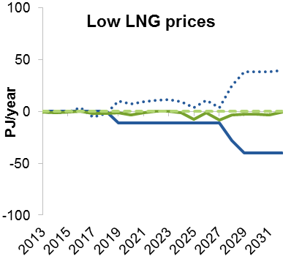 | 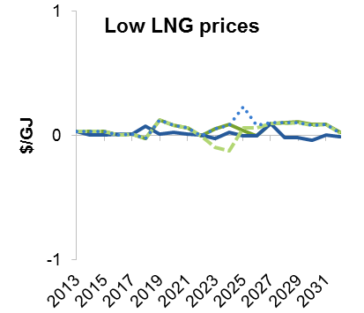
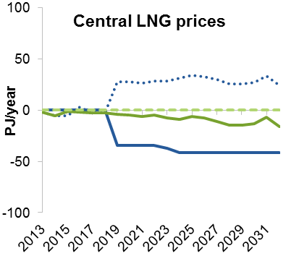 | 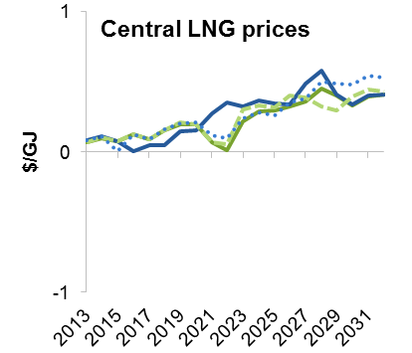
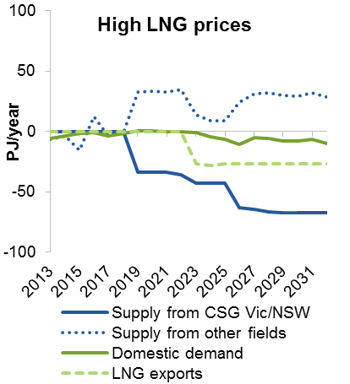 | 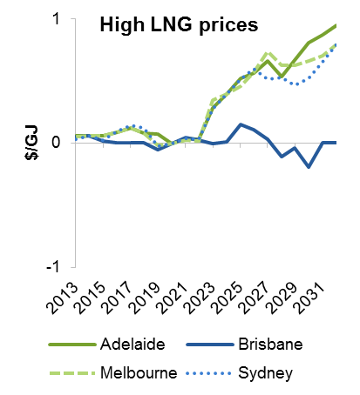

Source: Commission estimates.
Results from the model can be used to indicate the broad magnitude of economic welfare effects of CSG moratoria for gas market participants. This analysis is not a cost–benefit assessment of CSG moratoria, in particular because the modelling does not include environmental effects associated with replacing CSG production in New South Wales and Victoria with other sources of gas. Nevertheless, estimated economic welfare effects provide an indication of the efficiency costs of CSG moratoria and demonstrate that efficiency costs are likely to increase with future LNG prices (table C.2).
The size and distribution of the modelled costs of CSG moratoria are heavily dependent on relative supply costs between CSG in New South Wales and Victoria and alternative sources of gas. The effects of relative supply costs are explored as part of sensitivity testing below. There is substantial uncertainty regarding the costs of producing CSG in New South Wales and Victoria, in part because moratoria are preventing exploration activity that could provide a measure of the size and commercial viability of affected gas reserves.
Similarly, the modelled costs of CSG moratoria would increase over time if CSG in New South Wales and Victoria becomes relatively less costly compared with alternative sources of supply. In particular, this might happen if production costs in alternative gas fields increase as production moves to more marginal deposits. Due to a lack of robust data, the results presented in this appendix are based on constant costs of production in each gas field over time (including for any additional reserves built up through exploration). If costs increase over time for alternative sources of gas, the opportunity costs of CSG that remains undeveloped in New South Wales and Victoria will become greater.

Table C.2 Estimated economic welfare effects of CSG moratoria
Net present value 2013 to 2032, relative to baseline with CSG moratoria until September 2015 ($ million)
 | Low LNG prices | Central LNG prices | High LNG prices
Consumer surplusa | -185 | -953 | -623
Royalties | 1 | 385 | 18
Terminal value of reserves and assetsb | -554 | -838 | -4 499
Producer surplusc
Export revenue | – | – | -2 050
Domestic revenue | 44 | 358 | 180
less Investment costs | -74 | -168 | -881
less Operating costs | -455 | -684 | -4 794
Total producer surplus | 574 | 1 210 | 3 806
Total economic welfare | -164 | -196 | -1 299

a Consumer surplus for gas users within the eastern Australian gas market. b The terminal value of reserves and assets is the value of remaining gas reserves and gas supply assets at the end of 2032, including the value of gas production and use between 2033 and 2052. c Producer surplus is calculated as the change in revenue less the change in costs in a competitive market equilibrium (that is, in the absence of any market power). – Nil or rounded to zero.
Source: Commission estimates.

Domestic gas reservation
The proportion of gas that would need to be reserved for domestic users in order to change market outcomes will depend on a number of factors.
- The share of gas production subject to gas reservation: If reservation applied to a smaller share of production (for example, if it excluded projects that have already received development approval from governments) then a higher proportion of gas would need to be reserved to achieve the same effect on supply to the domestic market.
- Future gas demand in the eastern Australian gas market: If future demand for gas in the eastern Australian gas market were higher, then a higher proportion of gas would need to be reserved to achieve the same effect on supply to the domestic market.
- Existing contracts to supply the eastern Australian gas market: If a substantial proportion of domestic demand is covered by existing contracts, then a smaller proportion of additional gas would need to be reserved to have the same effect on supply to other domestic users. This effect will reduce over time as contracts expire. Gas supply contracts were not included in the modelling for this report (appendix B).
- Future LNG prices in the Asia–Pacific market: A higher proportion of gas would likely need to be reserved to have an effect on prices in the eastern Australian gas market if future LNG prices are lower, as there would likely be less gas produced and exported.
To give an indication of the mechanisms through which domestic gas reservation would affect market outcomes in the eastern Australian gas market and the potential magnitude of effects, a domestic gas reservation policy applying to all gas fields that were not producing gas in 2013 was modelled. This means that the policy applies to new production to supply LNG projects at Gladstone, but excludes existing gas fields such as those in Gippsland, the Cooper basin and pre-existing fields in Queensland.
Modelling results indicate that under a central LNG price scenario, at least 25 per cent of gas produced from new gas fields in the eastern Australian gas market would need to be reserved to hold down prices. A lower reservation requirement, for example, 15 per cent or 20 per cent, results in little or no additional gas being supplied to domestic users (and therefore imposes costs for little or no reduction in long-term gas prices).
Even with 25 per cent of gas from new gas fields reserved for domestic consumption, modelling of domestic gas reservation suggest there would be little additional gas supply or price declines for domestic users (figure C.4). The policy is estimated to reduce economic welfare because it diverts the supply of gas from its highest value use, reflected in the higher prices prevailing for LNG in the Asia–Pacific (table C.3).
The effects of a 25 per cent domestic gas reservation policy were also tested under low and high LNG price scenarios. Under low LNG prices, a 25 per cent domestic gas reservation policy is not binding — that is, it has no effect on modelled market outcomes, because domestic demand is already greater than 25 per cent of production from new fields (figure C.4).

Figure C.4 Modelled effects of 25 per cent domestic gas reservation policy
Central and high LNG price scenarios. Effects relative baselines with no domestic gas reservation policy
Changes in quantities | Changes in domestic prices
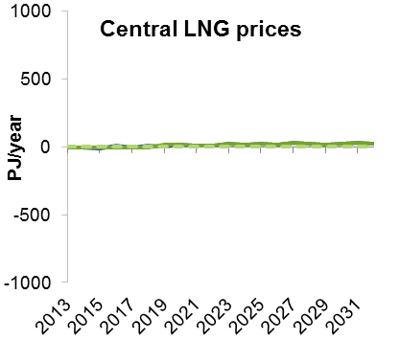 | 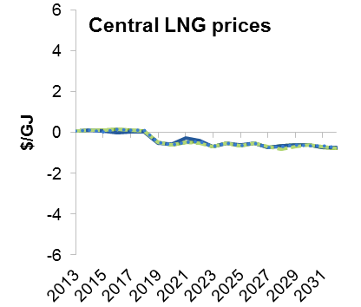
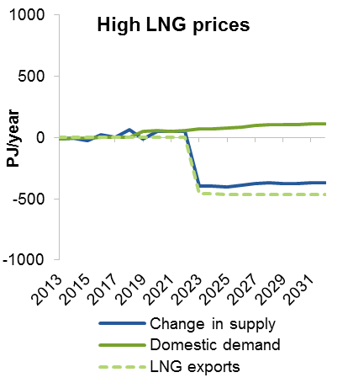 | 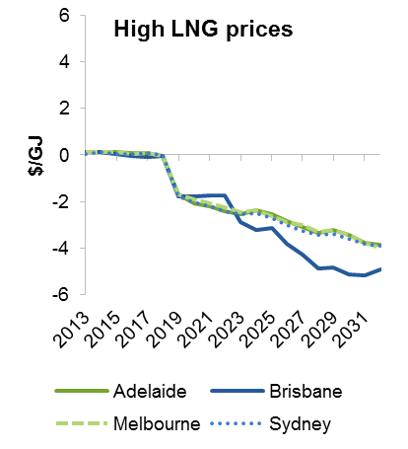

Source: Commission estimates.
The greatest costs of domestic gas reservation are imposed under high LNG prices, with an estimated net present value decline in economic welfare for gas market participants of about $24 billion. Domestic gas reservation delivers greater benefits for consumers under high LNG prices, but also increases the opportunity costs for producers and losses in royalty income. The policy is also estimated to reduce investment in new LNG production, which further lowers economic output and royalty revenue (table C.3).

Table C.3 Estimated economic welfare effects of a 25 per cent domestic gas reservation policy
Net present value 2013 to 2032, relative to baseline with no domestic gas reservation policy ($ million)
 |  | Central LNG prices | High LNG prices
Consumer surplusa |  | 1 422 | 6 939
Royalties |  | -915 | -7 806
Terminal value of reserves and assetsb |  | -819 | -14 184
Producer surplusc
Export revenue |  | – | -35 164
Domestic revenue |  | -381 | -2 073
less Investment costs |  | 451 | -14 574
less Operating costs |  | 1 077 | -13 788
Total producer surplus |  | -1 909 | -8 875
Total economic welfare |  | -2 221 | -23 926

a Consumer surplus for gas users within the eastern Australian gas market. b The terminal value of reserves and assets is the value of remaining gas reserves and gas supply assets at the end of 2032, including the value of gas production and use between 2033 and 2052. c Producer surplus is calculated as the change in revenue less the change in costs in a competitive market equilibrium (that is, in the absence of any market power). – Nil or rounded to zero.
Source: Commission estimates.

Delays in transmission pipeline investment
Effects of delays in transmission pipeline investment were illustrated by comparing model outcomes under a ‘what if’ scenario where future investments in transmission pipelines serving the eastern Australian gas market are delayed by five years. All large capital investments involve a lag between when a final investment decision is made and when the investment becomes operational. However, delays to gas transmission pipeline investments beyond this lag can impose costs on gas market participants and the broader community (chapter 6).
Modelling results suggest that five year delays in transmission pipeline investment would constrain gas supply to regions where there are pipeline constraints, leading to higher prices in those regions. For example, under the central LNG price scenario, completion of an expansion of the South West Queensland Pipeline is delayed from 2019 to 2024, increasing modelled prices in Brisbane between 2019 and 2023. Over this period, there is estimated to be a disparity between prices in Brisbane and other capital cities that exceeds the costs of developing and using pipeline capacity. Modelled prices do not increase in Brisbane by as much over the same period under the low LNG price scenario because there is less gas supplied and therefore less need for new transmission investment. Modelled prices also do not increase in Brisbane to the same extent under the high LNG price scenario because pipeline investment delays in turn delay investment in new LNG export plants in 2023, taking some pressure off supply to the domestic market (figure C.5).
The variability of prices increases with regulatory delays to pipeline investment across all LNG price scenarios, as delays to transmission investments required to maintain linkages between gas prices across different locations lead to short-term price spikes in specific locations.
Overall, the effects of transmission investment delays are estimated to be modest. In part, this is because of a limited need for additional transmission investment to meet domestic demand, reflecting relatively slow domestic demand growth projections under the Australian Energy Market Operator’s (AEMO’s) gas forecasting report.
The economic welfare effects of delays to transmission investment are estimated to be greater under high LNG price projections (table C.4). Under high LNG prices, gas supply is estimated to increase more rapidly and more transmission investment is required to get that gas to market. Delays in transmission investment are therefore likely to be more costly, and can lead to delays in the development of further LNG export capacity.

Figure C.5 Modelled effects of delays in transmission pipeline investment
Three LNG price scenarios. Effects relative to baselines with no delays in transmission pipeline investment
Changes in quantities | Changes in domestic prices
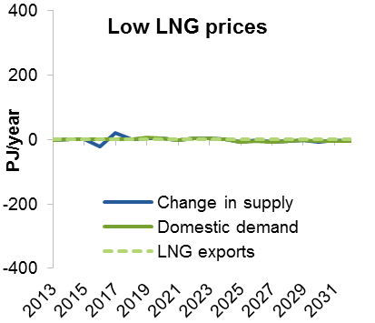 | 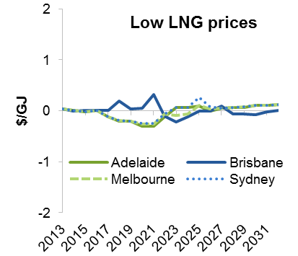
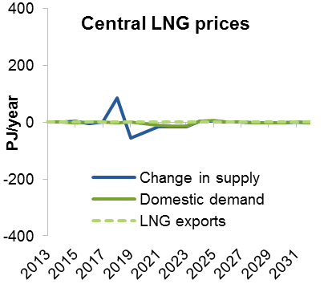 | 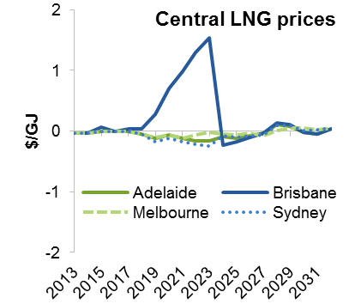
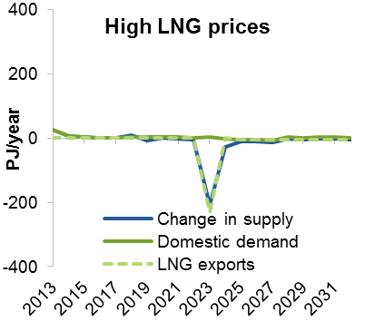 | 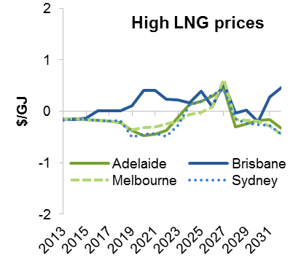

Source: Commission estimates.

Table C.4 Estimated economic welfare effects of delays in gas transmission pipeline investments
Net present value 2013 to 2032, relative to baseline with no delays ($ million)
 | Low LNG prices | Central LNG prices | High LNG prices
Consumer surplusa | -15 | -173 | 351
Royalties | -20 | 363 | 126
Terminal value of reserves and assetsb | -146 | 184 | -1 215
Producer surplusc
Export revenue | – | – | -2 330
Domestic revenue | -18 | -26 | 19
less Investment costs | 140 | 463 | -713
less Operating costs | -163 | 28 | -2 130
Total producer surplus | 5 | -517 | 531
Total economic welfare | -175 | -144 | -208

a Consumer surplus for gas users within the eastern Australian gas market. b The terminal value of reserves and assets is the value of remaining gas reserves and gas supply assets at the end of 2032, including the value of gas production and use between 2033 and 2052. c Producer surplus is calculated as the change in revenue less the change in costs in a competitive market equilibrium (that is, in the absence of any market power). – Nil or rounded to zero.
Source: Commission estimates.

C.2 Sensitivity analysis
Sensitivity analysis has been undertaken to explore the sensitivity of results to selected parameters (table C.5). These parameters have been selected because their true values are uncertain, they are likely have an important influence on market outcomes and are key parameters in the model (table C.6). For each sensitivity analysis, a single parameter was varied, holding other parameters constant. All sensitivity analysis was undertaken with central estimates for LNG prices.

Table C.5 Sensitivity analysis
Sensitivity analysis | Motivation
Reserves growth | There is considerable uncertainty about future gas reserves, which will depend on the level and timing of exploration. Reserves place constraints on production from each field and affect which fields gas is sourced from, and consequently can affect market outcomes.
Production costs | There is substantial variation in publicly available estimates of the costs of producing gas, particularly for marginal gas fields. Production costs can have a significant effect on results, as production costs account for the majority of gas supply costs.
CSG development costs in New South Wales and Victoria | Development costs for CSG in New South Wales and Victoria are particularly uncertain, as drilling for exploration and production has been constrained by CSG moratoria. CSG development costs in New South Wales and Victoria are important in assessing the costs of CSG moratoria.
System use of gas in transmission | System use of gas varies across pipelines. However, the model has a generic estimate of system use of gas because pipeline-specific data are not publicly available. The primary effect of system use of gas is on the short run marginal cost of transmitting gas, which is an important factor in estimating price differences across geographic locations.
Domestic demand elasticity | Limited data are available to provide reliable elasticity estimates for domestic demand. The price elasticity of demand affects the shape of the demand curve for each demand type (electricity generation, industrial and residential and commercial) at each model node, and hence the equilibrium quantity and price.
Domestic demand growth | There is considerable uncertainty about future demand for gas in the eastern Australian gas market. Domestic demand growth parameters affect how demand functions at each node shift over the model simulation period, with implications for market outcomes.

Table C.6 Sensitivity analysis — parameter changes relative to baseline parameters
Sensitivity test | Low parameters | High parameters
Reserves growth | Annual growth in gas reserves is 50 per cent lower in each field. | Annual growth in gas reserves is 50 per cent higher in each field.
Production cost estimates | Baseline estimates are adjusted downward using the percentage difference between low and reference production costs estimates in Core Energy Group (2015a). | Production costs are based on field-specific estimates prepared by ACIL Tasman (2013). These production cost estimates in Core Energy Group (2015a).
CSG development costs in New South Wales and Victoria | CSG fields in New South Wales andb  Victoria cost 50 per cent less to develop. | CSG fields in New South Wales andb  Victoria cost 50 per cent more to develop.
System use of gas in transmission | System use of gas is equal to 0.9 per cent of gas transported. | System use of gas is equal to 1.3 per cent of gas transported.
Domestic demand elasticitiesa | Elasticities are 0.2 percentage points lower for generation and 0.1 percentage points lower for residential and commercial use. For industrial elasticities, AEMO’s low estimates are used (AEMO 2014c). | Elasticities are 0.2 percentage points higher for generation and 0.1 percentage points higher for residential and commercial use. For industrial elasticities, AEMO’s high estimates are used (AEMO 2014c).
Domestic demand growth | Based on low gas consumption outlook in the National Gas Forecasting Report (AEMO 2014d). | Based on high gas consumption outlook in the National Gas Forecasting Report (AEMO 2014d).

a The model has elasticities at each node for the electricity generation, industrial and residential and commercial sectors. b Consistent with the magnitude of variation across recent estimates of the cost of CSG production in New South Wales (Core Energy Group 2012a, 2015a).
The sensitivity analysis indicates that results are more sensitive to varying some parameters than others (figures C.6 and C.7).
- Reserves growth and production costs have relatively large effects on total supply and average prices because these parameters affect all gas fields in the eastern Australian gas market.
- CSG development costs in New South Wales and Victoria affect a subset of fields and have a smaller effect on overall market outcomes than production costs for all fields. However, CSG development costs are an important determinant of the cost of CSG moratoria in New South Wales and Victoria.
- System use of gas has a relatively small effect on prices across geographical locations, and even smaller effects on aggregate demand and supply.
- Domestic demand assumptions have a relatively small effect on overall market outcomes, as LNG supply constitutes the majority of total supply and LNG prices are a more important determinant of prices in the eastern Australian gas market.

Figure C.6 Effects of sensitivity analysis on supply
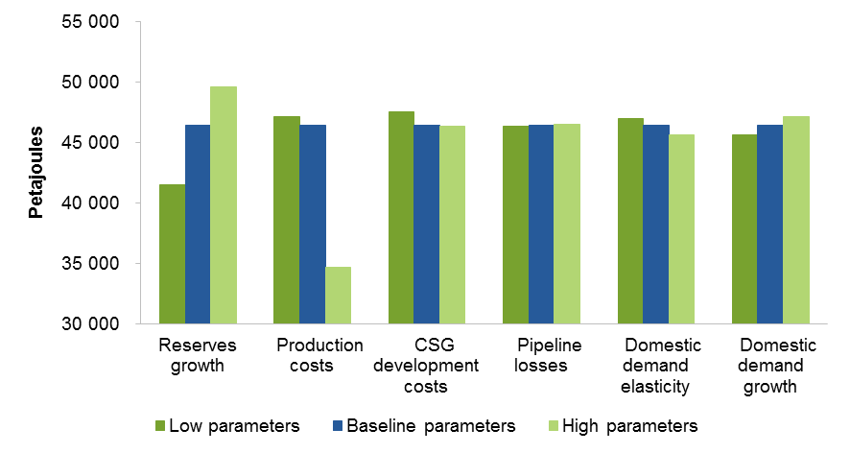

Source: Commission estimates.

Figure C.7 Effects of sensitivity analysis on weighted average capital city gas pricesa
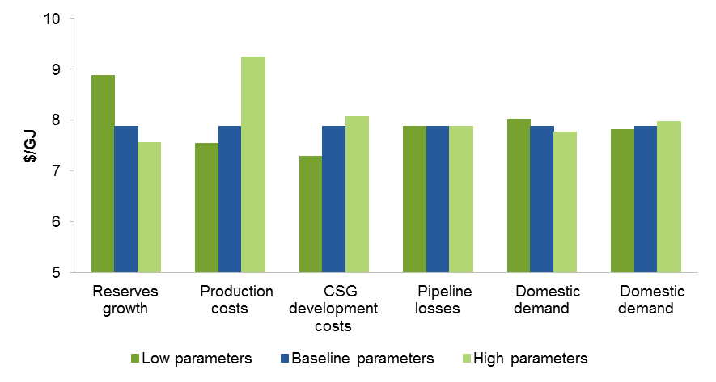

a Weighted averages of modelled prices in Adelaide, Brisbane, Melbourne and Sydney.
Source: Commission estimates.

Reserves growth
Lower reserves growth reduces available gas and means that cheaper sources of gas are exhausted more quickly and replaced by more expensive sources, which reduces supply and increases prices relative to the baseline. Most of the reduction in supply is estimated to be in the Surat–Bowen basins as this is where reserves growth is projected to be greatest between 2013 and 2032 (appendix B). Conversely, higher reserves growth increases available gas and means that less costly sources of gas last for longer, delaying use of more expensive sources, which increases supply. However, prices are estimated to fall only marginally because domestic prices in the model are largely determined by the LNG price (figure C.8).

Figure C.8 Sensitivity of modelling results to reserves growth rates
Relative to baseline reserves growth
50 per cent lower reserves growth
Changes in quantities | Changes in domestic prices
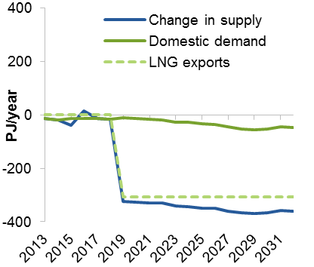 | 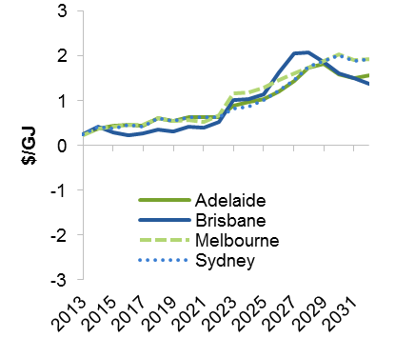
50 per cent higher reserves growth
Changes in quantities | Changes in domestic prices
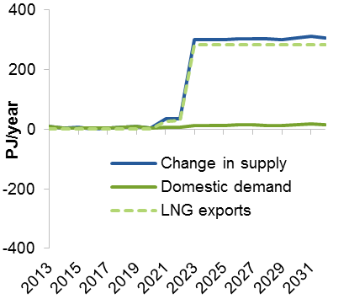 | 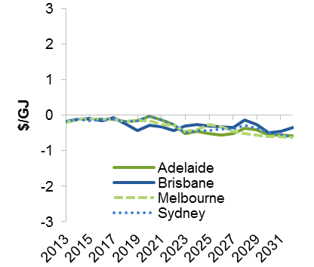

Source: Commission estimates.

Production costs
Production costs for marginal fields (the most costly fields that are economic to develop) have the largest effect on equilibrium prices (figure C.9). Using higher production cost estimates has a much greater effect on results than using lower production cost estimates for two reasons.
- The difference between higher and baseline production cost estimates for marginal fields are larger than the difference between lower and baseline estimates.
- Most LNG demand is already contracted (about 1400 PJ per year from 2019). These contracts must be met even with higher production costs.

Figure C.9 Sensitivity of modelling results to production cost parameters
Relative to baseline production costs estimates
Lower production costs
Changes in quantities | Changes in domestic prices
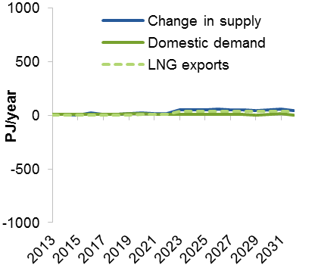 | 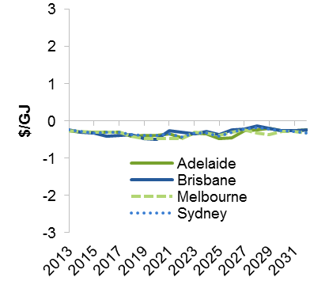
Higher production costs
Changes in quantities | Changes in domestic prices
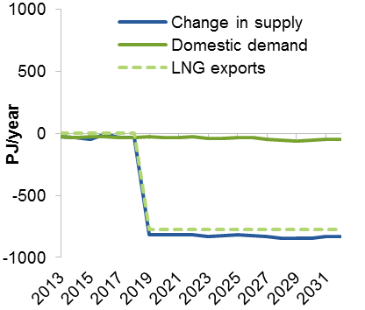 | 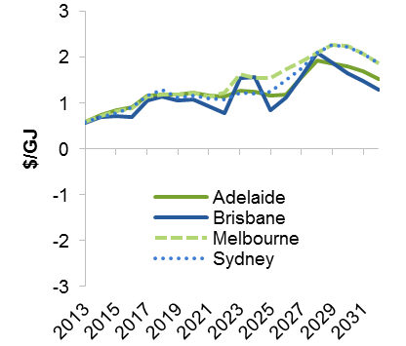

Source: Commission estimates.

CSG development costs in New South Wales and Victoria
This sensitivity analysis explores the effects of CSG development costs in New South Wales and Victoria on the costs of CSG moratoria, rather than effects on baseline results.
Lower CSG development costs in New South Wales and Victoria increase the cost of CSG moratoria. Overall economic welfare is estimated to fall by more than $5 billion over the period from 2013 to 2032 with lower development costs, compared with $200 million under baseline development costs (table C.7). Price differences are greatest in Brisbane (figure C.10) because moratoria prevent development of gas in the Clarence–Moreton basin, which is connected by a new pipeline directly to Brisbane. Where CSG development costs in New South Wales and Victoria are higher, CSG moratoria are estimated to have minimal effects on supply, demand, prices and overall welfare since there is little supply from CSG fields in New South Wales and Victoria with higher CSG development costs, even in the absence of moratoria.

Table C.7 Sensitivity of economic welfare effects of CSG moratoria to CSG development costs in New South Wales and Victoria
Net present value 2013 to 2032, relative to baseline with CSG moratoria until September 2015 ($ million)
 | Lower CSG development costs | Baseline with baseline CSG development costs | Higher CSG development costs
Consumer surplusa | -3 048 | -953 | -166
Royalties | 1 224 | 385 | 138
Terminal value of reserves and assetsb | -624 | -838 | -296
Producer surplusc
Export revenue | -3 927 | – | –
Domestic revenue | 973 | 358 | 70
less Investment costs | -407 | -168 | -39
less Operating costs | 240 | -684 | -212
Total producer surplus | -2 788 | 1 210 | 322
Total welfare | -5 236 | -196 | -3

a Consumer surplus for gas users within the eastern Australian gas market. b The terminal value of reserves and assets is the value of remaining gas reserves and gas supply assets at the end of 2032, including the value of gas production and use between 2033 and 2052. c Producer surplus is calculated as the change in revenue less the change in costs in a competitive market equilibrium (that is, in the absence of any market power). – Nil or rounded to zero.
Source: Commission estimates.

Figure C.10 Sensitivity of effects of CSG moratoria to CSG development costs in New South Wales and Victoria
Relative to baseline with CSG moratoria until September 2015. Lower, baseline and higher development costs
Changes in quantities | Changes in domestic prices
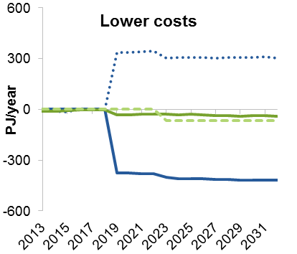 | 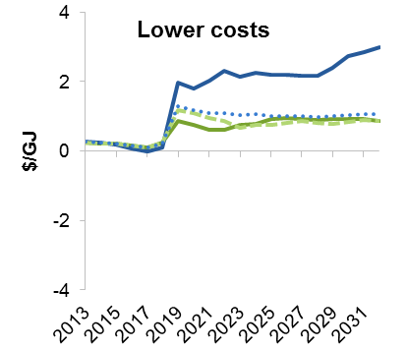
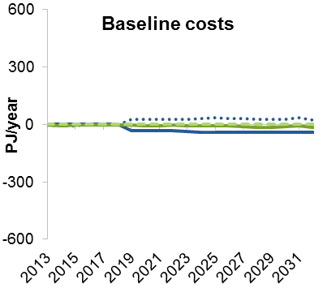 | 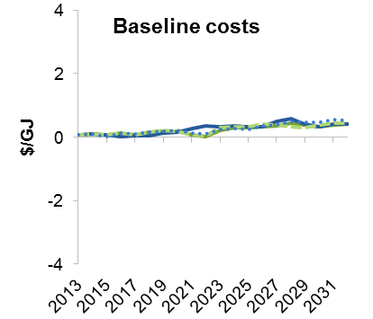
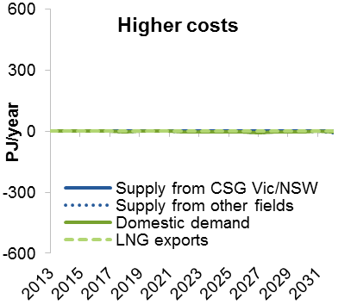 | 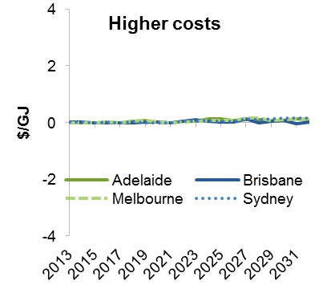

Source: Commission estimates.

System use of gas in transmission
Using alternative estimates of system use of gas in transmission has only a small effect on results (figure C.11). Price differences across different geographical locations increase slightly with higher system use of gas (prices rise slightly in locations with relatively high prices and fall slightly in locations with relatively low prices) and decrease slightly with lower system use of gas. Supply changes marginally to cover greater or smaller system use of gas.

Figure C.11 Sensitivity of modelling results to system use of gas
Relative to baseline system use of gas estimate
Lower system use of gas
Changes in quantities | Changes in domestic prices
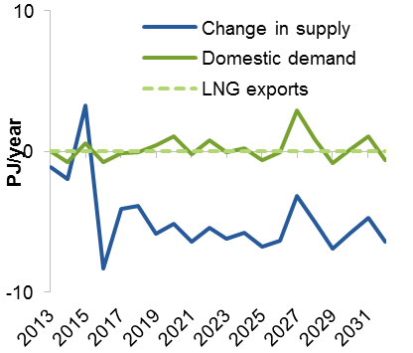 | 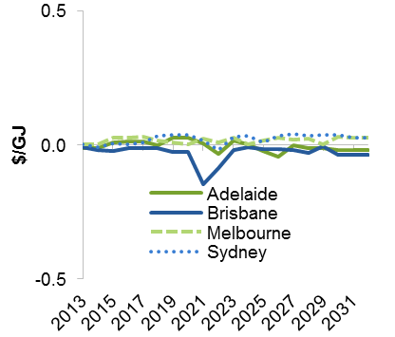
Higher system use of gas
Changes in quantities | Changes in domestic prices
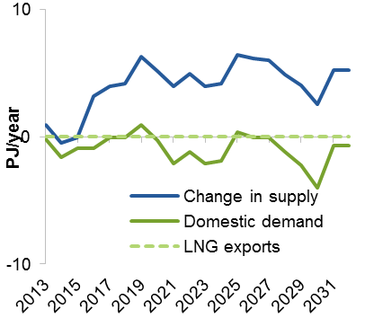 | 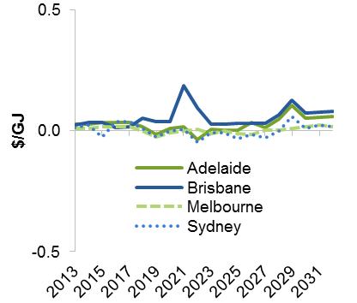

Source: Commission estimates.

Domestic demand elasticities
Within the range tested, domestic demand elasticities have little effect on gas prices in the eastern Australian gas market (figure C.12). This is because the Asia–Pacific LNG price remains the key determinant of domestic prices. Lower domestic demand elasticities lead to slightly higher modelled demand (and supply), as modelled price increases over time have a smaller effect on quantities demanded than in the baseline. Conversely, higher domestic demand elasticities amplify the effect of price increases, leading to slightly lower quantities demanded (and supplied).
Modelled prices change slightly under different demand elasticities without having any effect on LNG export quantities. As noted above, existing LNG trains are expanded to full capacity under the central LNG price scenario, but LNG prices are not high enough for it to be economic to build any LNG plants beyond the three committed projects at Gladstone. Domestic demand (and thus prices) can therefore fluctuate within a small range before this is sufficient to trigger either investment in new LNG plants or delays to expansion of existing plants.

Figure C.12 Sensitivity of modelling results to domestic demand elasticities
Relative to baseline elasticity estimates
Lower elasticities
Changes in quantities | Changes in domestic prices
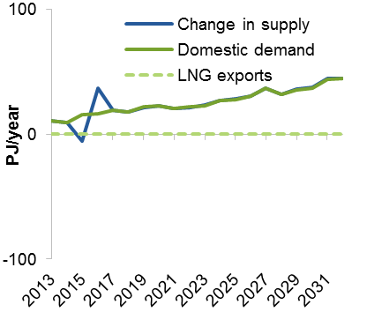 | 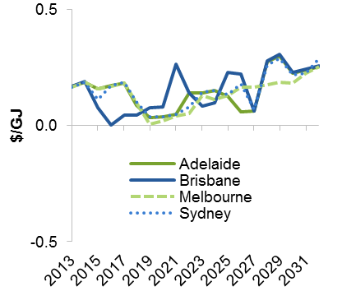
Higher elasticities
Changes in quantities | Changes in domestic prices
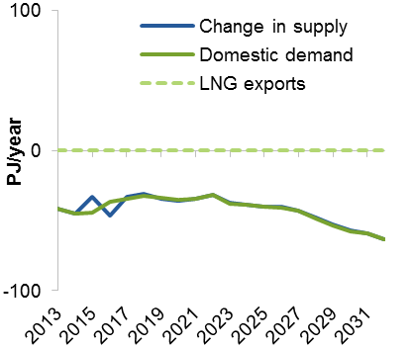 | 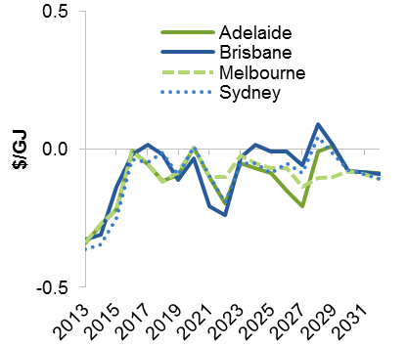

Source: Commission estimates.

Domestic demand growth
The lower and higher domestic demand growth parameters tested have only a small effect on modelled domestic prices and total supply (figure C.13). As for the demand elasticity sensitivity testing, the LNG price continues to be the key determinant of domestic prices.

Figure C.13 Sensitivity of modelling results to domestic demand growth parameters
Relative to baseline demand growth estimates
Lower demand growth
Changes in quantities | Changes in domestic prices
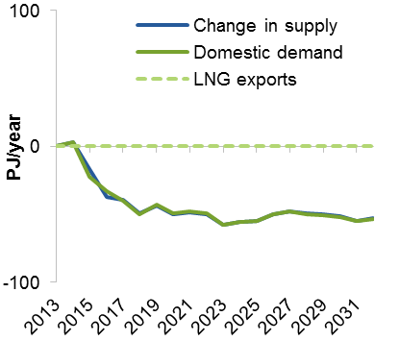 | 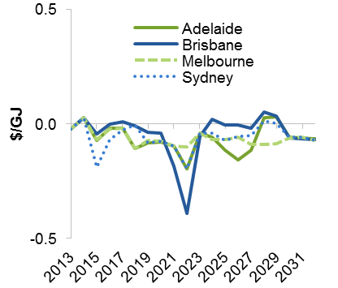
Higher demand growth
Changes in quantities | Changes in domestic prices
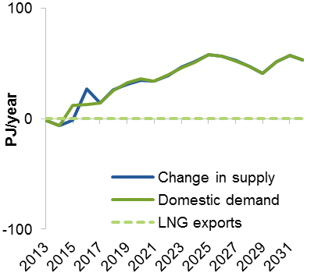 | 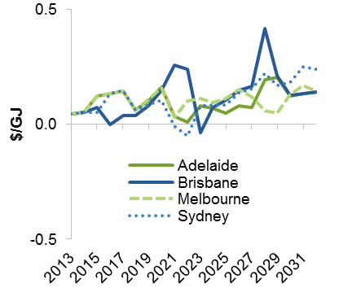

Source: Commission estimates.

The modelled increase in illustrative royalty revenue under the low and central LNG price scenarios (despite decreased total gas supply) is due to higher gas prices in the domestic market, as royalties are paid as a proportion of wellhead prices.
Illustrative estimates of state royalties are calculated at a rate of 10 per cent of wellhead prices (appendix B). Under domestic gas reservation, wellhead prices could be estimated using prices prevailing in the eastern Australian gas market, or some measure of netback prices. For the results presented here, wellhead prices were based on gas prices in the domestic market. The decline in royalty payments under domestic gas reservation would be smaller if wellhead prices were based on estimated netback prices, as gas reservation causes a wedge between domestic and export prices.

