Productivity Commission Research Paper – Tourism
AUSTRALIA'S INTERNATIONAL TOURISM INDUSTRY: TRENDS, DRIVERS AND BARRIERS TO GROWTH

South Australian Tourism Commission Official Submission
The role of government
Tourism is a key driver of the South Australian economy and is vital to the continued success and future growth of our State. Representing $5.2b in expenditure and directly employing 31,000 South Australians (three times more than the mining industry). Tourism is a substantial industry with strong growth prospects into the future, as evidenced by Deloitte’s recent Positioning for Prosperity report where tourism was identified as one of five super growth sectors. The South Australian government has also recognised the core role of tourism in the state’s future, and has singled it out as one of its ten economic priorities: http://www.premier.sa.gov.au/images/feature_article/Economic_Priorities.pdf.

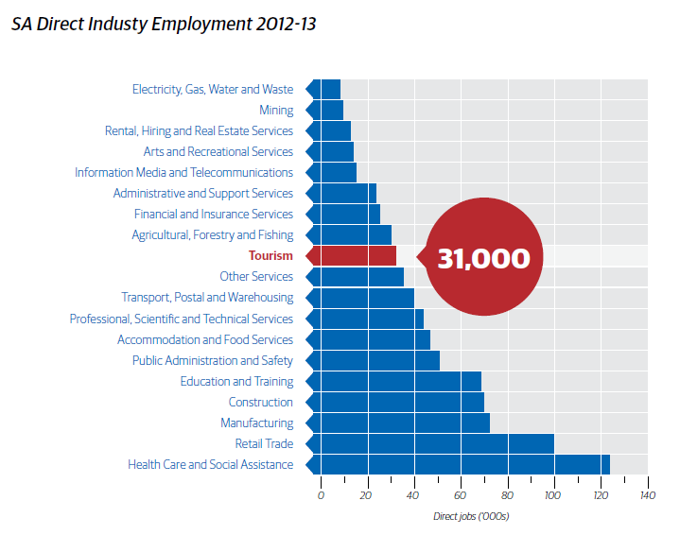
Source: Tourism Satellite Account 2012-13

One of Tourism’s strengths is that it is broadly distributed across the state and the nation, benefiting a wide range of businesses including cafés, restaurants, shops, hotels and other accommodation providers, transport operators, tour companies, wineries and event organisers. The down side to this is that tourism is predominantly conducted by Small to Medium Enterprises, who have little incentive, and little capacity, to invest in the broader promotion of the destination. It is for this reason that the government has a crucial role to play in the industry, both as a driver of destination demand through consumer marketing campaigns, but also ensuring a supportive environment for these businesses to thrive.

Provision of Consumer Marketing
Across the country, Tourism is dominated by small businesses and South Australia is no exception. Almost 90% of 18,000 tourism businesses in South Australia employ less than 20 people. These small organisations represent the core of the tourism experience. However, being small businesses, it is not efficient to conduct extensive partnership marketing programs directly with the SATC or Tourism Australia. To the extent possible, the industry invests in coordination through membership based organisations across the state, such as the South Australian Tourism Industry Council (SATIC), member based Regional Tourism Organisations (e.g. Tourism Barossa) and subsidiaries of national bodies such as the SA divisions of the Australian Tourism Export Council (ATEC) and the Australian Hotels Association (AHA). The SATC also encourages operators to implement aligned tactical campaigns to support the broader work of the SATC.

The larger organisations are relatively few in number; 200 Medium sized businesses (20-199 employees) and 39 large businesses (200+ employees). The SATC and federal bodies such as Tourism Australia conduct extensive partnership marketing with these organisations where possible to leverage marketing dollars and ensure efficiency through the use of a consistent message.

A recent report by Webber Quantitative Consulting identified a marginal return on marketing investment of between 13 and 16 to 1. For each extra dollar invested there are between $13 and $16 dollars spent in the Australian tourism economy. The average returns are even greater; between $21.75 and $30.45 per dollar invested. http://www.tourismaccommodation.com.au/wp-content/uploads/2012/08/RETURN-ON-MARKETING-INVESTMENT-FOR-AUSTRALIAN-TOURISM-vrp2-16_7_14.pdf

Where possible, the SATC seeks to coordinate with Tourism Australia in the delivery of marketing and trade partnership programs, ensuring the investment from both organisations is maximised. This includes embedding staff within the offices of Tourism Australia (e.g. China, UK) and implementing joint marketing programs across various media in international markets.

Case Study: Barossa. Be Consumed Marketing Campaign

First launched in June 2013, the Barossa. Be Consumed campaign showcases the Barossa as a premium food and wine destination across TV, cinema, press and online channels. Impact in the Barossa region has been very positive, with the visitor information centre in Tanunda reporting accommodation bookings during July and August 2013 were the busiest months on record, up nearly 100% on 2012. The TV commercial has also gained extensive media coverage for the Barossa and won numerous international film awards, culminating in being named the “World’s Best Tourism Film” in Vienna in November 2014.

Funding of Tourism Research
As previously stated, the rationale for tourism marketing being supported by government is due to the small size of the average business, compared to the large overall size of the tourism economy. The same argument is true for tourism research, where it is vastly more efficient for the research to be conducted in a consistent manner across the country, allowing for substantial economies of scale to be realised. Considerable effort and money could easily be wasted if inconsistent and non-comparable methods are used by individual stakeholders.

The SATC is strongly supportive of the work of Tourism Research Australia in their world-leading research into the tourism industry. This information underpins tourism investment business cases and leverages further support for the tourism industry by other funding partners such as local councils and development bodies.

The key research outputs include the National Visitor Survey, the International Visitor Survey, Tourism Satellite Accounts and the Destination Visitor Survey programs. The information sources are then distributed widely to underpin tourism investment business cases, funding proposals and guide the strategic direction of destination marketing organisations such as the SATC, which in turn drives increased economic activity and employment.

Events Grants
Events act as a key economic driver for South Australia and provide a tangible time-limited motivation to visit a destination. Major events also have a vital role to play in generating positive media coverage for the destination, which in turn drives increased leisure visitation at a later time.

For example, the Santos Tour Down Under, which is managed by the South Australian Tourism Commission, injected $45.9m into the SA economy in 2014, with over 36,000 interstate and international visitors travelling to Adelaide for the event, while also generating 324 hours of television screened internationally, promoting South Australia to a global audience.

High profile events and festivals help grow awareness of South Australia as a diverse and attractive place to visit. Events drive the overall positive perception of the destination and consequently contribute to increasing overall visitation. In addition, events and festivals directly drive visitation giving potential visitors a reason to visit South Australia now. South Australia is well known for its active events and festivals calendar, and so is well positioned to further leverage off this established strength.

Many visitors already plan their holidays to South Australia specifically around these events. Both the major Adelaide events and regional offerings are relevant here. Utilising events and festivals to create reasons to visit across the whole year and strengthen the quieter seasons is a core aim.

While growing the size and number of events is the primary aim, the challenge is also to encourage visitors to stay longer and add more touring options, which ultimately leads to greater visitor expenditure in the destination, and to create repeat visitation.

Business events are also a core economic driver. The Adelaide Convention Bureau reports that as at July 2014 there was $117m in estimated economic benefit for FY13/14, 134,000 bed nights, with an ROI of 33:1.

Case Study: Cricket World Cup
The SATC recognised the potential in winning premium fixtures in Adelaide for the 2015 Cricket World Cup, particularly with significant content involving the defending champions, India.

As a result of negotiations with the Local Organising Committee of the event and the strategic support of key influencers, the SATC not only secured getting India based in Adelaide pre-tournament but also their first match against arch-rivals Pakistan, which is arguably the biggest game in world cricket. With a broadcast audience of up to one billion expected to watch, it will give the State an unrivalled opportunity to leverage tourism, trade and investment opportunities.

Provision of Public Infrastructure
The South Australian Tourism Plan 2020 talks specifically to the need to support public infrastructure, and the fact that this was an area consistently raised by industry during the public consultation. The most substantial piece of recent tourism-related public infrastructure in South Australia is the redevelopment of Adelaide Oval and the Riverbank precinct, which has already shown tangible benefits to the industry (see case study below).

More generally, the priorities for public infrastructure, as identified by the South Australian Tourism Plan 2020 are:
- Easy access both to South Australia and within South Australia is critical
- Access by road and air, but also sea (including cruising), rail and public transport.
- Increased traveller connectivity through access to telecommunications services
- Improved and more reliable essential services and utilities such as power, water and other core needs, especially in remote areas of the state
- Improved way-finding and road infrastructure, including road pullovers and signage

Case Study: Adelaide Oval
The redevelopment of Adelaide Oval and the surrounding riverbank precinct has been a substantial infrastructure project for South Australia. While the benefits of this infrastructure primarily flow to the local Adelaide population, there have also been substantial associated tourism benefits. In analysis of the first AFL season held at Adelaide oval, the SATC determined there was a substantial increase in Adelaide hotel occupancy attributable to the redevelopment. Port Adelaide home games increased hotel occupancy by 21.1 pts (70.5% to 91.5%) and Adelaide Crows home games drove a 15.9 pt increase (68.8% to 84.7%). This is based on a like for like comparison of the hotel occupancy rates experienced during home games held previously at AAMI stadium outside of the CBD.

Although data is not available for the other sectors of the tourism economy, anecdotal evidence indicates a similar increase was experienced across the tourism sector, including restaurants, cafes, bars, taxi services and airlines.

The effect of aviation policy and regulation
Increased aviation capacity has been a key driver of the recent visitor growth experienced by South Australia. Direct air access into South Australia reduces time and cost barriers and makes South Australia a more appealing destination.

Adelaide Airport’s ‘Regional’ status brings the strategic advantage of being able to participate in the Regional Benefits Package and the Enhanced Regional Benefits Package as outlined in the Federal Government’s Aviation White Paper, 2009. In the situation where bilateral negotiations for air capacity between countries fails to deliver supply of seat capacity ahead of demand, the opportunity for Adelaide to attract a new carrier using the ERBP remains an advantage. However the Federal Government generally seeks to negotiate supply ahead of demand which removes the strategic advantage for Adelaide and other ‘Regional’ airports.

Case Study: Air Access
Adelaide Airport has consistently recorded the highest international passenger growth of any of the major Australian Airports for the past 2 years. In 2012, with substantial financial support from the South Australian government, growth in new routes was triggered by Emirates when they initiated direct flights from Dubai (129,000 seats per annum), followed in 2013 by Air Asia X commencing Kuala Lumpur flights (80,000 seats per annum). Several existing carriers also increased their flight frequencies during this time. Collectively this grew Adelaide’s international weekly seats by 67% since March 2012, as well as driving a 14% increase in overall international visitation to South Australia and a 54% increase in direct arrivals to Adelaide airport.

Effect of land-management policy & regulation
While there is little land use regulation directly controlled by Tourism agencies at any level of government, tourism agencies play a key role in ensuring that tourism development is not unnecessarily hampered by planning and policy restrictions. Tourism agencies also play an essential role in negotiating with other ‘control’ oriented regulatory organisations to ensure there is a competitive policy environment in which the tourism industry can flourish. Tourism agencies play an important role in this space, representing an industry predominantly made up of SMEs who struggle to have a unified voice.

Tourism agencies advocate on behalf of tourism operators to ensure that an acceptable balance is maintained between the economic development and employment aims of tourism, and the needs of the local community and the environment. These two objectives are not mutually exclusive, and the key is successful engagement with regulation agencies and the local community to ensure that all benefit from tourism growth.

Tourism agencies are also well placed to negotiate with other government agencies who manage public land (eg national parks) to facilitate a positive whole of government approach to facilitating tourism development at key sites that are on public land.

It is also worth noting that public infrastructure is used by both international and domestic tourists, and as such the case for its development is strengthened by the returns generated by the domestic tourist as well. Recent actions in this space include the work of the Investment and Regulatory Reform Working Group
http://www.austrade.gov.au/ArticleDocuments/5499/2013-Investment-and-Regulatory-Reform-Report-Card.pdf.aspx, the SATC’s input into the review of South Australia’s planning system: http://www.thinkdesigndeliver.sa.gov.au/ and the overall focus of Tourism 2020 in reducing red tape.

