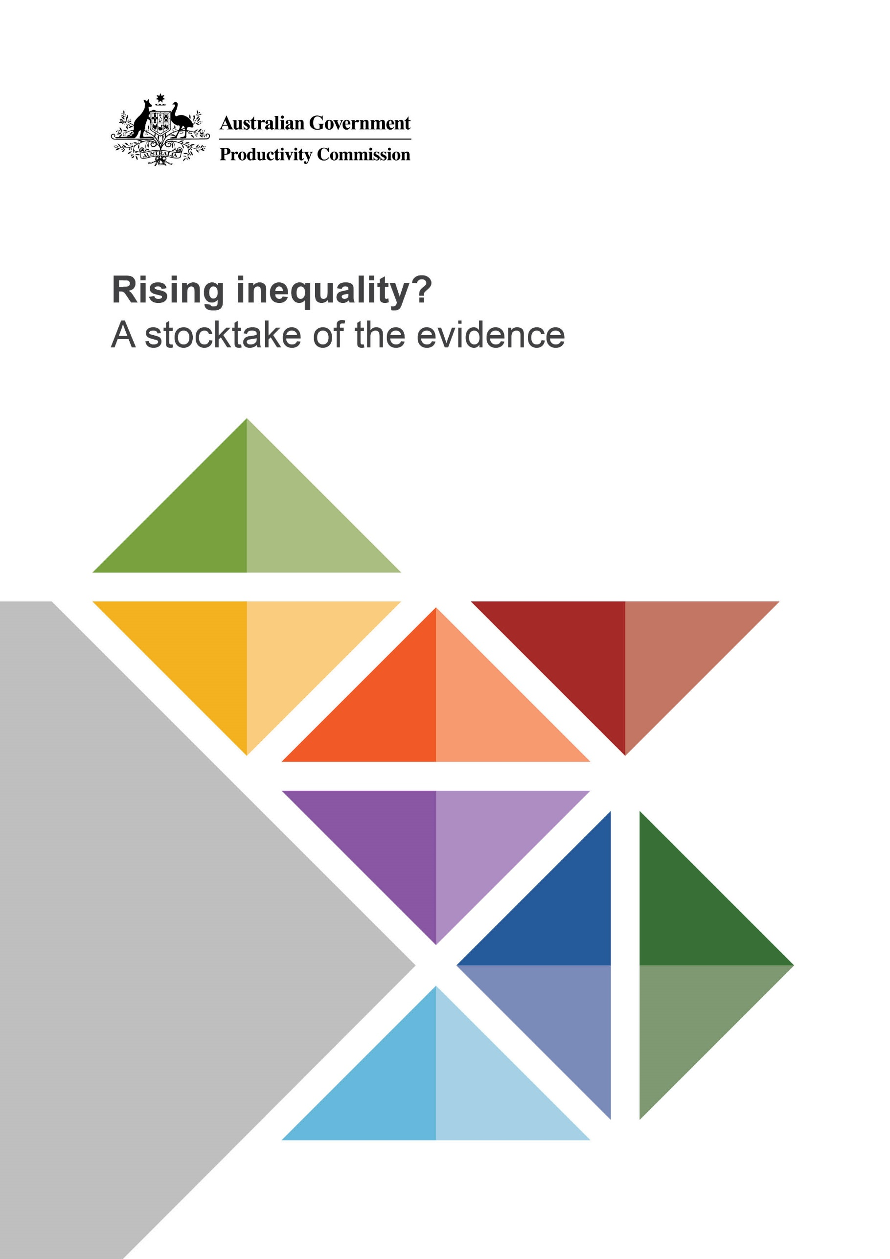
Rising inequality? A stocktake of the evidenceRising inequality? Astooctake of the evidence

Contents
Executive summary 4
A visual summary of inequality in Australia 10
Key points 24

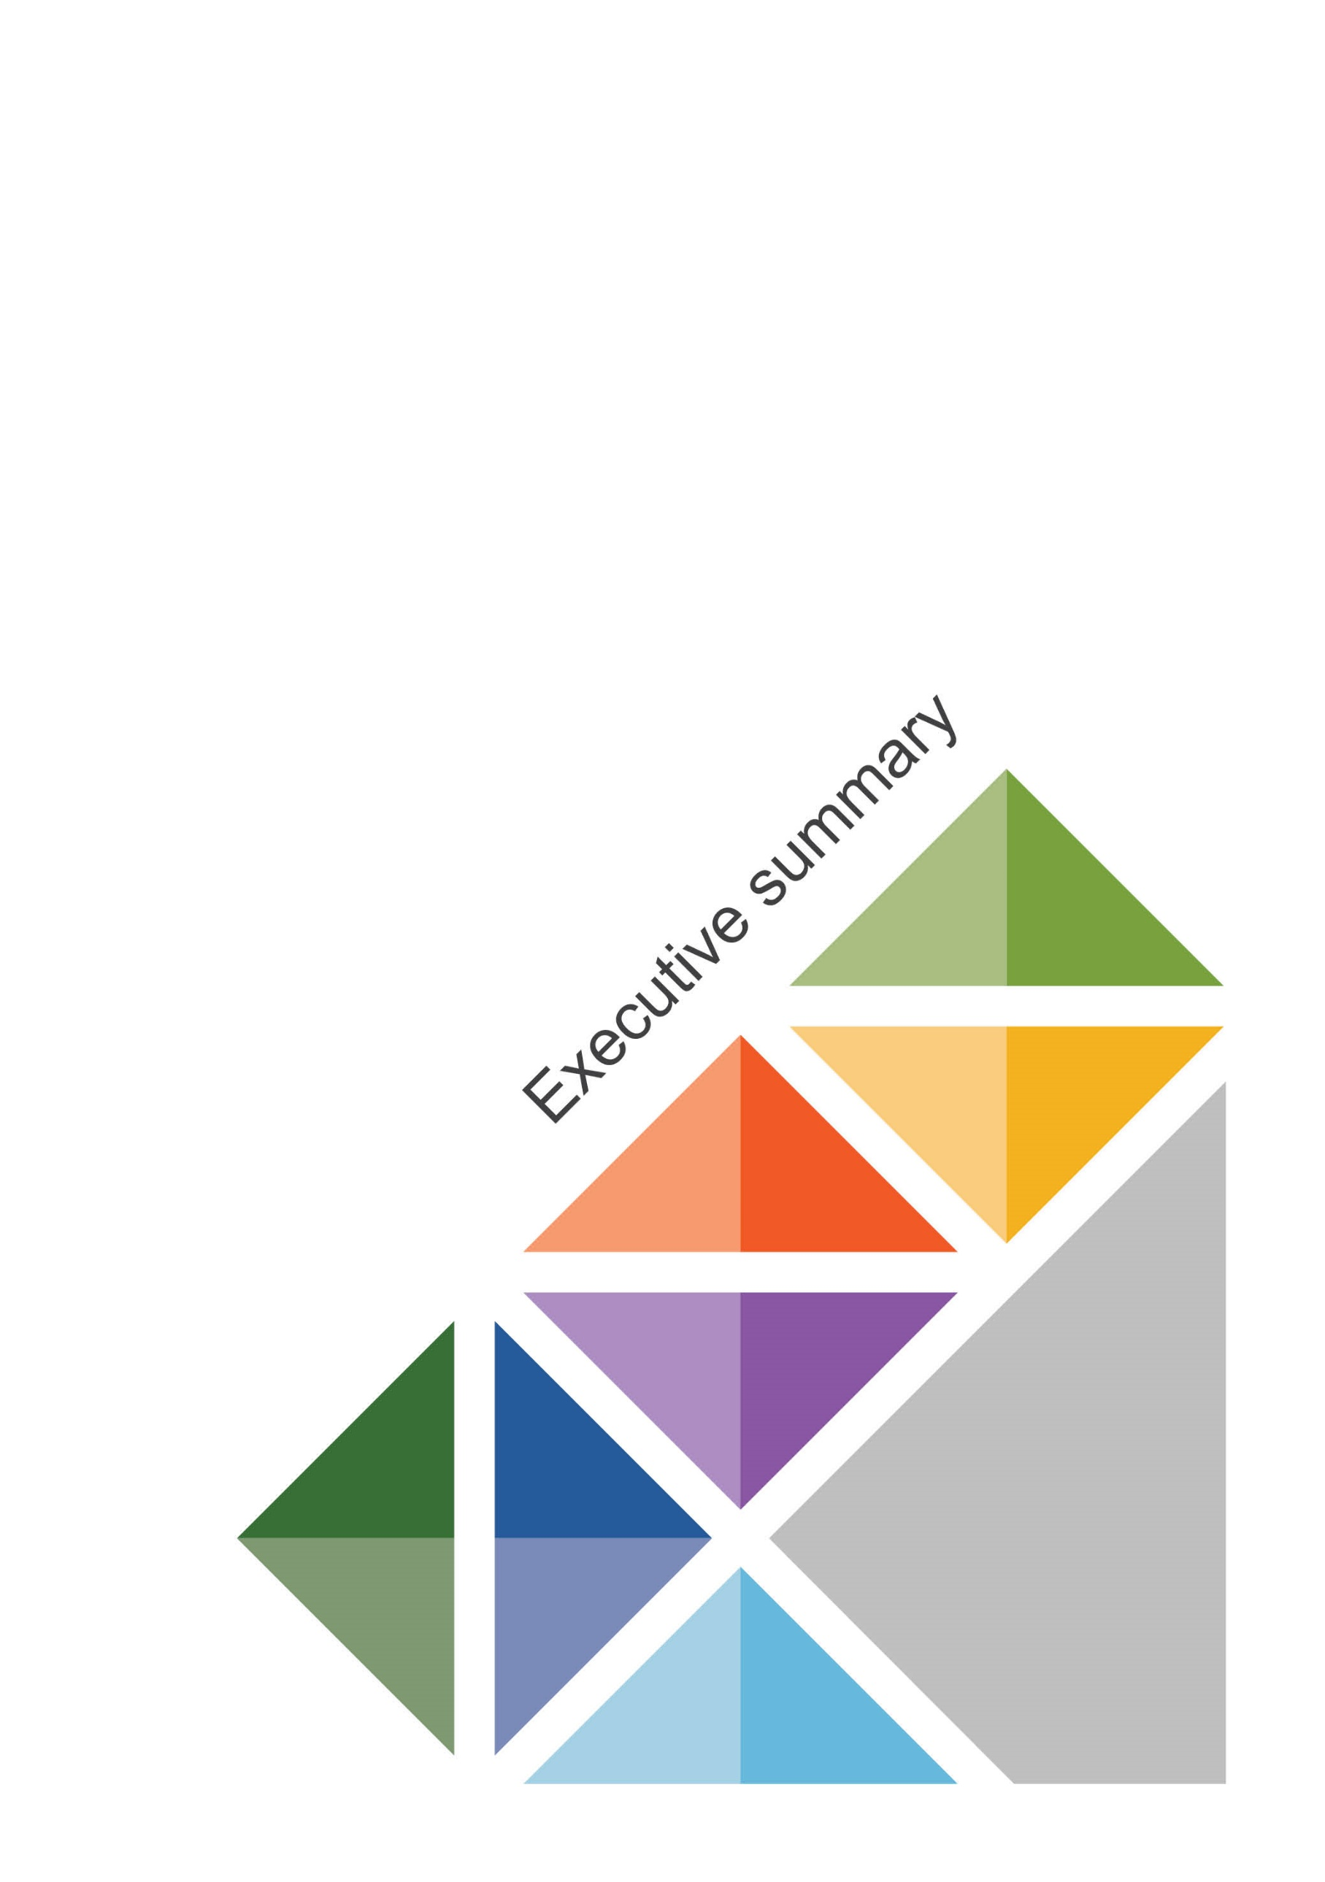

Executive summary

Over nearly three decades, inequality has risen slightly in Australia
In all societies some inequality occurs due to differences in ability, opportunity, effort and luck. Institutional and policy constructs can add to this, or detract from it.
Moreover, excessive inequality and entrenched disadvantage can erode social cohesion and hinder growth. It can also sap investment in education and skills and slow productivity growth. Yet there is no precise causative relationship, let alone a consensus on how much inequality matters. It is a topic that continues to draw diverse and competing views.
This study does not directly enter these debates. Rather, its purpose is to contribute a foundation to an informed discussion on inequality and its social impacts, bringing together and taking stock of the latest and most complete evidence measuring the level of and trends in inequality, poverty and disadvantage in Australia via multiple means.
While comprehensive, this study is not exhaustive; other studies examine geographic, racial or gender inequality.
Even this modest level of ambition is not without its challenges. No single metric is sufficient to give a definitive answer to the seemingly straightforward question: have inequality, poverty and disadvantage in Australia risen, fallen or remained steady in recent years?
Our focus, therefore, eschews the specific and often self-serving use of any one measure of inequality. Instead we use an array of indicators that examine the distributions of household incomes, consumption and wealth, their composition and importantly, movement within the distributions over time, and in response to life events, such as transitions to work, divorce and retirement. For poverty and disadvantage our approach goes beyond the standard metrics, giving weight to measures that capture the experience of those households in the bottom part of the distribution.
The broader context for this study has been an evident reduction in global income inequality and poverty since the late 1980s, the time-frame we most often apply. At the same time, however, there has been rising inequality within many developed countries. We review the Australian experience, which is less dire than some would have it, but not exemplary.

Sustained growth has delivered significantly improved living standards for the average Australian in every income decile
What also distinguishes Australia from most other developed countries has been its unprecedented 27-year period of uninterrupted economic growth, prompting many to ask how the economic gains from growth have been shared. While growth is no guarantee against a widening disparity between rich and poor, we show that it has delivered for the average Australian household in every income decile significantly improved living standards. This is in contrast with the United States (which had a similar rate of increase in income inequality as Australia) where the distribution is much more uneven, with income growth in the lower deciles about a quarter of that for Australian households.
What matters more than economic growth for understanding trends in inequality are the sources of income growth (labour, capital and transfers). These fluctuate in ways that sometimes favour those on high incomes and sometimes favour those on low incomes. For example, the mining boom was a period that favoured high income earners and capital income, lifting measures of inequality. In contrast, the post-Global Financial Crisis period has benefited lower income groups, despite weak overall growth in labour income. Among the various forces acting on inequality and poverty, the one constant that matters is having a job.
Over recent decades income growth rates by age group have also varied substantially, but for the most part, the variation reflects overall trends in the strength of income growth. That is, when the economy is strong, all age groups tend to benefit from higher income growth and when the economy is weak, all age groups tend to experience lower income growth. But at different times, some age groups have benefited more or less than others. Most recently, young people’s incomes have grown relatively slowly. On average, however, each new generation has earned more income than the last at a given age, and reaches the same level of income earlier in life.
Examining more closely the demographics of the income distribution provides additional insights. We know for example that Australians in their prime working years are more likely to be in the middle and upper income deciles, whereas over-65 year olds are over-represented in lower income deciles, reflecting retirement and reliance on the Age Pension. We also know that individuals living in households where no person is in paid work are strongly concentrated in the lower deciles, especially if there are dependent children in the household. Similarly, households with dependent children and two or more income earners are over-represented in middle and upper income deciles, and working households without dependent children tend to be over-represented at the top of the distribution.

Australia’s progressive tax and highly targeted transfer systems substantially reduce inequality
Another clear message from the data is that Australia’s progressive tax system and highly targeted transfer system substantially reduce income inequality. Income tax and government transfers have typically lowered the measure of overall income inequality (the Gini coefficient) by 30 per cent, an equalising effect that far outweighs the overall increase in the measure since the late 1980s. This equalising effect has fluctuated over time, but overall there has been no material change in the past thirty years. Redistributive tax policies can, however, also have unintended negative consequences on economic efficiency, for example, inciting a reduction in labour supply.
While income is usually given prominence in debates about inequality, how evenly consumption is distributed is often a better measure, as consumption contributes most directly to wellbeing. Moreover, income patterns alone do not capture the importance of in-kind transfers from government, such as health, education, childcare subsidies and government housing. These in-kind transfers have an additional equalising effect, because people with low incomes (and households with children) receive the largest amount of in-kind transfers. When the more expansive measure of final consumption is used, overall inequality (the Gini coefficient) is about 30 per cent lower again than that for disposable household income. In-kind transfers can also bear on future inequality by opening doors to greater opportunities and lifting incomes later on.
The distinction between income and consumption comes out most strongly in analysis by age. For example, while 25 to 34 year olds are over-represented in upper deciles for income, they are over-represented in lower deciles for final consumption. This reflects reduced reliance on the education and health system in this age group, as well as higher rates of savings. On the other hand, those aged 65 or older, who are strongly over-represented in lower deciles for income, are under-represented in lower deciles for final consumption.
The distribution of wealth is relevant too. Household welfare depends not just on resources at a point in time, but over time as well, and wealth provides a sense of financial security. Wealth can also provide an important safety net for older Australians, many of whom have relatively low incomes but high wealth, in terms of managing aged care costs and longevity risk.
Similar to income, growth in wealth has been spread widely across the population. On average, households in all but the bottom decile experienced real increases in wealth, predominantly in housing assets and superannuation balances over the past fifteen years. However, with the growth in wealth strongest in the upper deciles, some measures of wealth inequality have risen. While wealth distribution in Australia somewhat predictably is more unequal than income or consumption, Australia’s wealth distribution remains less skewed than in other countries. Among 28 OECD countries, Australia ranks eighth most equal, as measured by the Gini coefficient of wealth.
The fact that inequality levels are so different among developed countries hints strongly at the scope for policies, institutions and political environments to shape inequality.

Economic mobility is high in Australia, with almost everyone moving across the income distribution over the course of their lives …
The standard inequality measures considered thus far give a snapshot of the distribution at a point in time. While they show some widening of the gap between households, that does not mean that the rich and the poor households at the beginning and the end of the period are the same households.
The distinction is important because a society with a given level of inequality, and where household incomes are static over time, faces different and more serious policy challenges than a society with the same level of inequality but where household incomes are mobile.
There are two types of mobility: intergenerational mobility and life course mobility. Intergenerational mobility refers to the relationship between a person’s economic position and that of their parents, and life course mobility refers to changes in a person’s economic position throughout their life. The limited timeframe of Australian longitudinal data limits our capacity to assess intergenerational mobility. Instead, we present original analysis on the degree of life course mobility in Australia using the HILDA dataset. In other words, how much people move across the distribution for income or wealth from year to year.
It turns out that almost everyone moves across the income distribution over the course of their lives. Over a 16-year period, the average Australian was classified in five different income deciles; and for less than one per cent of people, the decile to which they belonged remained unchanged over the whole period. And nine per cent spent time in both the top and the bottom income decile. A lower, but still significant level of mobility was also apparent across the wealth distribution. This highlights the fluid nature of income and wealth: over time, any given decile consists of a different group of people — most of the people in the top decile today were not there fifteen years ago.
Life events — such as transitioning from education into work, career advancement, household formation, having children, divorce and retirement — underpin some of the observed trends in economic mobility. Typically, income rises during the working years, though this can be interrupted by childbearing and other life events, such as ill health. Similarly, Australians accumulate wealth in their middle years, and draw on this wealth in retirement when their earnings drop. These changes in income and wealth allow people to ‘smooth’ their consumption.

… but some Australians experience entrenched economic disadvantage
While life course mobility affects households across the entire distribution, the ends of the distribution are ‘stickier’ than the middle. Households in the top and bottom two income deciles at the beginning of the period were the most likely to be in the same decile fifteen years later. About three per cent of households were stuck in one of the bottom two deciles throughout the period. Stickiness at the ends of the distribution is indicative of some entrenched inequality.
Accordingly, the last chapter of this study updates earlier Commission research on the nature and extent of deep and persistent disadvantage in Australia. Disadvantage is a multidimensional concept that can take the form of low economic resources (poverty), inability to afford the basic essentials of life (material deprivation) or being unable to participate economically and socially (social exclusion). Because the elements of disadvantage encompass a diverse range of indicators, it is difficult to reach a single conclusion about the overall trend in disadvantage.
Many Australians experience economic disadvantage at some stage in their lives, but for most, it is temporary. About nine per cent of Australians (2.2 million people) experienced relative income poverty (income below 50 per cent of the median) in 2015-16, with children and older people having the highest rates of relative income poverty. This aggregate figure has fluctuated since 1988-89 but, despite 27 years of uninterrupted growth, has not declined.
Persistent and recurrent poverty affects a small, but significant proportion of the population. About three per cent of Australians (roughly 700 000 people) have been in income poverty continuously for at least the last four years. People living in single-parent families, unemployed people, people with disabilities and Indigenous Australians are particularly likely to experience income poverty, deprivation and social exclusion. For people in these circumstances, there is an elevated risk of economic disadvantage becoming entrenched, limiting their potential to seize economic opportunities or develop the skills with which to overcome these conditions.
These risks are particularly elevated for children living in jobless households, which is a group that has stood out among the multiple measures of inequality and disadvantage.
How the future of inequality in Australia evolves will depend on the opportunities that citizens have to improve their living standards today. For by far the largest number of us, sustained economic growth and reliable access to employment — complemented by skills and education improvements as specified in our 2017 report, Shifting the Dial — will offer these opportunities and the ability to embrace them.
But for a significant albeit much smaller group, the challenges are much more complex. Growth and complementary improvements in skills and education policies will not be enough. In some previous research, we found that needs in housing or health policies could better be fashioned to address more directly than today quite specific needs — what might be termed ‘hand-made’ policy — as we look out towards a fourth decade of uninterrupted economic growth.

A visual summary of inequality in Australia
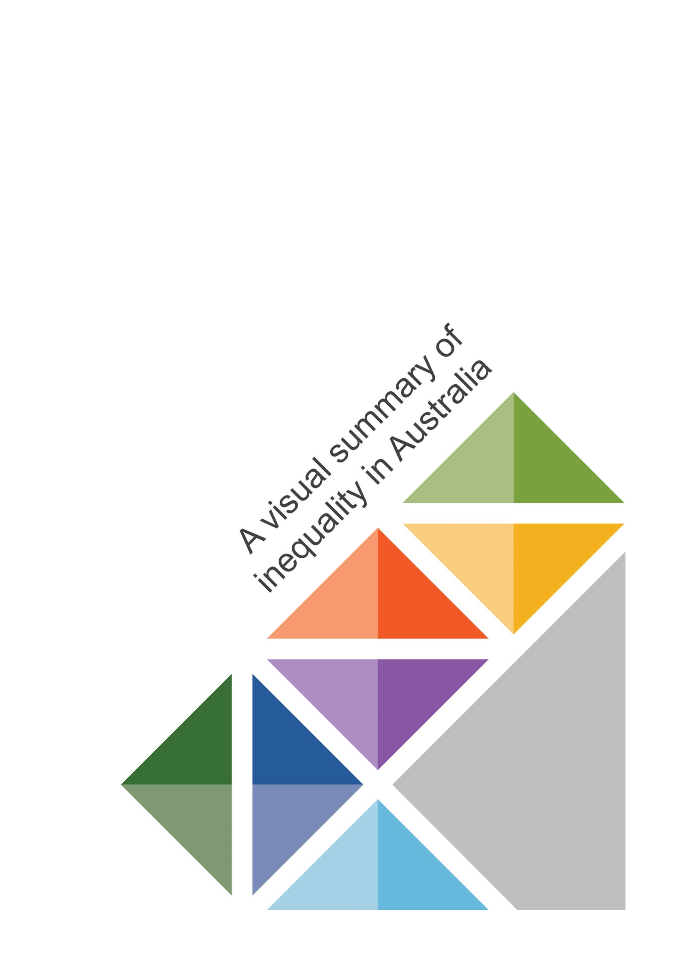

Since the late 1980s, income has grown on average for all
income deciles …
Average equivalised disposable income by income decile, 1988-89 to 2015-16
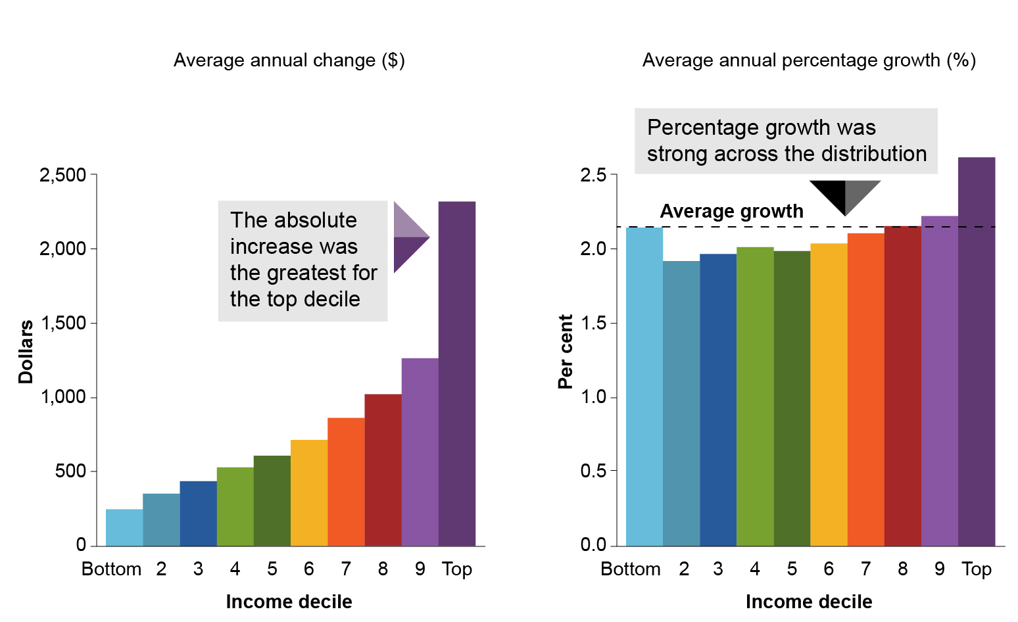

… with the pace of growth fluctuating over time
Average annual growth rates in equivalised disposable income by time period and income decile

Income and consumption inequality in Australia has risen slightly according to some measures …
… but other sources reveal no clear trend for
income inequality

Income inequality is also rising elsewhere, and Australia is close to the OECD average
Gini coefficients of equivalised disposable income and recent growth in Gini coefficients for selected OECD countries
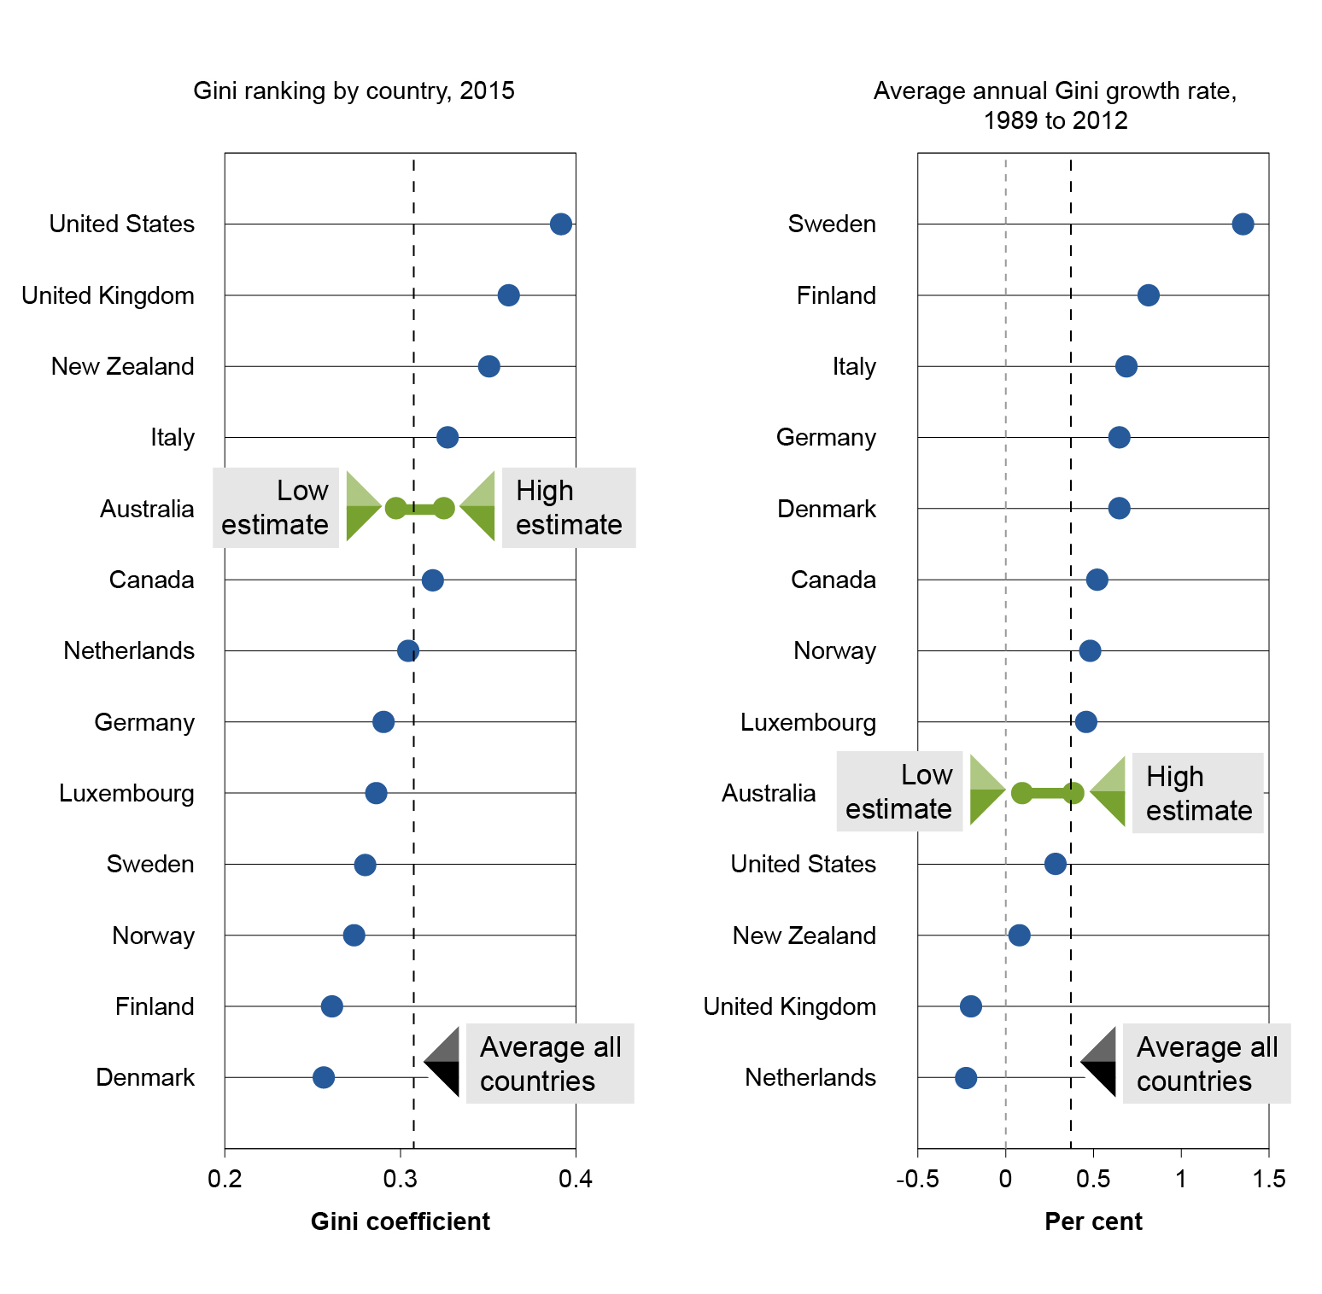

Australia’s progressive income tax and highly targeted transfer system has a powerful equalising effect on household incomes …
Gini coefficients for equivalised income
… and in-kind transfers from government, like education and health, substantially reduce consumption inequality
Gini coefficients for equivalised disposable income, private consumption and final consumption

Young people have seen little income growth recently …
Average annual growth rates in equivalised disposable household income by time period and age group
… however, each new generation has earned more income than the last at a given age, and reaches the same level of income earlier in life
Average disposable personal income by age and birth decade, 1988-89 to 2015-16

Wealth has increased across the distribution, especially for the top half of the distribution …
Average equivalised wealth by wealth decile
… with housing and superannuation balances accounting
for most of the increase
Absolute change in average household wealth by wealth type, for each wealth decile, 2003-04 to 2015-16

Wealth inequality in Australia has risen…
Gini coefficient of equivalised wealth, HILDA and SIH
… but is low by international standards
Gini coefficients of (unequivalised) household wealth, 2017
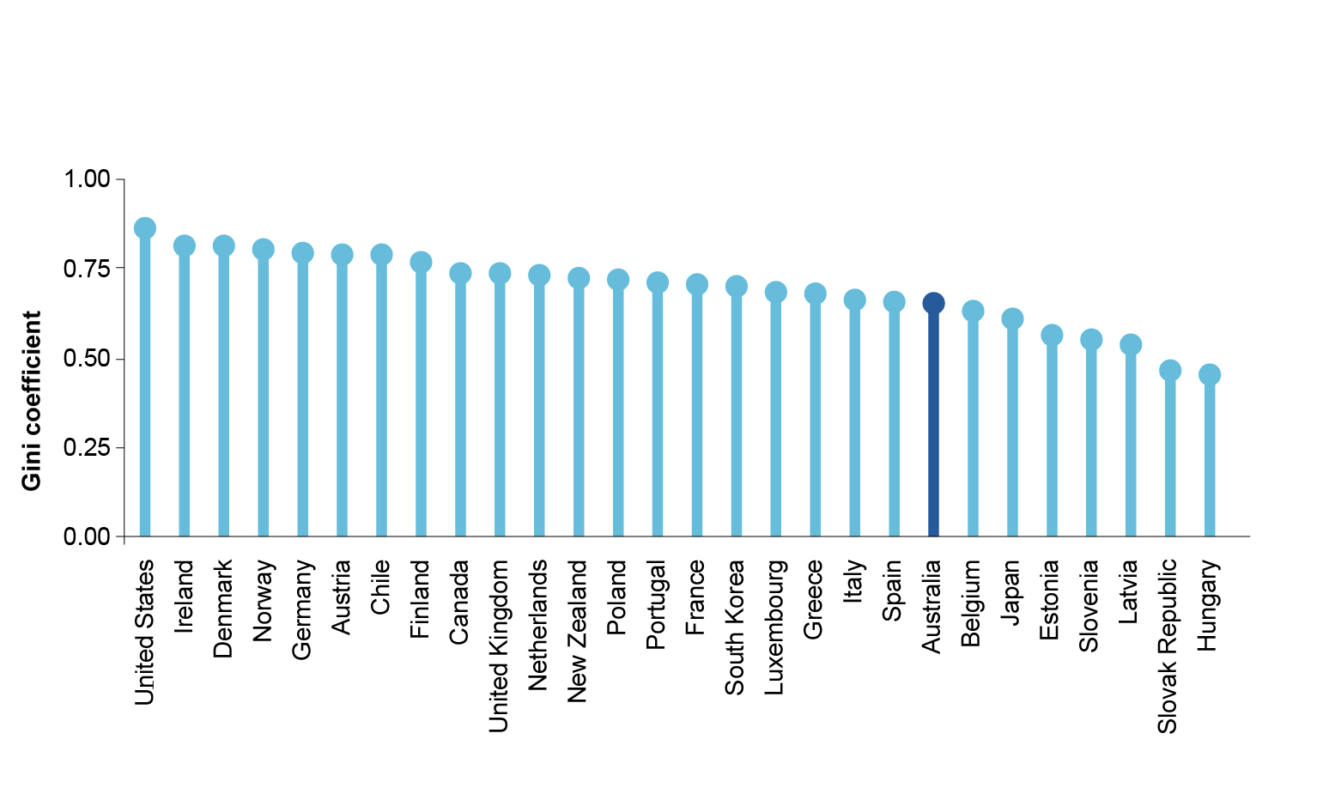

Many older people have lower incomes but higher wealth
Share of age group in each income and wealth decile, 2015-16

While a son’s position in the income distribution is affected by his dad’s …
Probability of a son occupying a given position in the lifetime earnings distribution, given his father’s position
… life course mobility in Australia is relatively high
Share of working age people moving income quintile over a four-year span

There is significant movement between income deciles
Proportion of people in the top, 5th and bottom income deciles in 2000-01, by income decile in 2015-16

Relative income poverty has fallen in recent years …
Relative income poverty rates, 2000-01 to 2015-16
... with poverty concentrated in households without paid work
Relative poverty rates by household type, 2015-16

Most poverty spells are short in duration
Proportion remaining in relative income poverty at each spell duration, 2000-01 to 2015-16
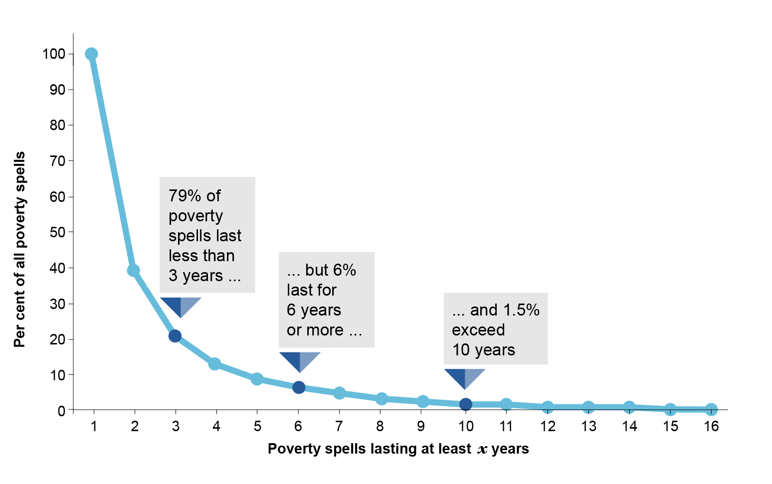

Economic insecurity is higher among those below the poverty line
Volatility of income and private consumption, 2005-06 to 2015-16

Lone parents, people who are unemployed, Indigenous Australians and those with a disability are most prone to multiple deprivation
Per cent of people deprived of at least two essential items, 2014

Key points
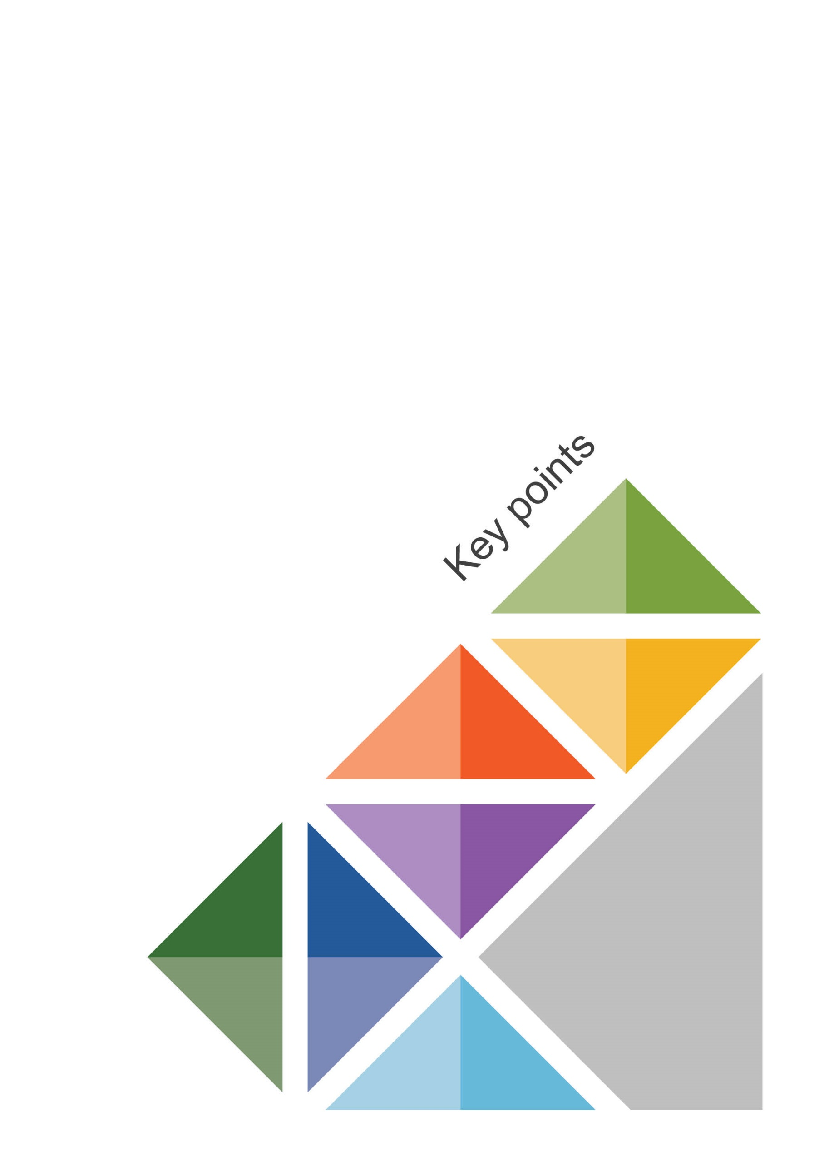

Framework and approach

Key points
- Inequality, disadvantage and economic mobility are related concepts that each affect wellbeing in different ways.
- Inequality affects people’s wellbeing through their values and preferences in relation to the societal distribution of resources as well as their expectations about acceptable living standards.
- Disadvantage (including poverty) directly impacts on wellbeing by limiting people’s ability to achieve the life outcomes they value.
- Economic mobility is an important indicator of the extent of, and access to, opportunities for people to improve their economic situation.
- Our approach focuses on analysing the distribution of three broad measures of economic resources: income, consumption and wealth. We consider how the distributions vary over time and across groups, and examine some of the contributors to their movements.
- The measures of income, consumption and wealth are linked in an accounting sense and provide better insights than a single measure does. Analysing these three measures together has become possible with the maturing of Australian household surveys.
- The analysis is based on equivalised household measures of income, consumption and wealth to account for differences in household composition and ‘economies of scale’ when sharing living costs.
- Many indicators can be used to analyse and report on inequality, mobility and disadvantage. It is even possible for two metrics to lead to different findings on the level of, or trends in, inequality. This is in part because of multiple data collections using different methodologies and sampling techniques. Accordingly, we present and draw conclusions based on an array of indicators.

Income and consumption inequality

Key points
- Income inequality has increased modestly since the late 1980s, but the extent of the increase is contested, and since the global financial crisis the trend indicates a slight decline.
- Most developed countries have also experienced rising income inequality, and at a faster pace than in Australia.
- Australia’s level of inequality is close to the OECD country average.
- The fact that inequality levels are so different among developed countries hints at the scope for policies, institutions and political environments to shape inequality.
- Unlike some other developed countries, Australia had relatively strong growth in incomes across all deciles. However, the sources of income growth (capital, labour and transfers) have fluctuated in ways that sometimes favoured those on high incomes and sometimes favoured those on low incomes, affecting ‘point in time’ measures of inequality.
- In Australia, the increase in inequality occurred during the mining boom, an era that favoured high-income earners and capital income.
- More generally, when the economy was strong, all age groups benefited from higher income growth and when the economy was weak, all age groups endured lower income growth. But at different times, some age groups have benefited more or less than others.
- Most recently, young people’s incomes have grown relatively slowly. On average, however, each new generation has earned more income than the last at a given age, and reaches the same level of income earlier in life.
- Part of income inequality is also explained by life cycle effects.
- People are most likely to have high household disposable income late in their working lives. This is when their labour earnings peak, their accumulated assets increase capital earnings and their children start earning income or leave home.
- Australia’s progressive income tax and highly targeted transfer system has a powerful equalising effect on household incomes.
- On average, income tax and transfers reduce income inequality by about one third.
- Redistributive tax policies can, however, also have unintended negative consequences on economic efficiency, for example, by encouraging a reduction in labour supply.
- While income is usually given prominence in debates about inequality, consumption is a better measure as it contributes more directly to wellbeing.
- Inequality of private consumption is only slightly lower than that of disposable income, but once in-kind government transfers (such as education and healthcare) are accounted for, final consumption inequality is 30 per cent lower than that of disposable income.
- The benefits of in-kind transfers are also felt over time. They can open the door to greater opportunities, lift future incomes and in this way bear on future inequality.

Wealth inequality

Key points
- The distribution of wealth is important because economic wellbeing depends on people’s consumption today and over time, and because wealth provides a sense of financial security.
- Measures of the distribution of wealth thus complement measures of income and consumption distribution by providing an indicator of both current and future inequality.
- Average wealth in Australia has steadily increased over the 12 years to 2015-16.
- Average equivalised household wealth rose by 43 per cent over the period, to just under $530 000.
- The gains have been across the distribution, but growth was stronger for the top half of the distribution.
- Owner-occupied housing and superannuation balances accounted for most of the increase in wealth.
- Wealth inequality increased over the same period — the Gini coefficient based on the ABS Survey of Income and Housing rose by 7 per cent. However, not all measures show a clear upward trend.
- Almost all the rise in wealth inequality occurred in the mining boom period through to 2010 (income inequality also rose during this period). The trend has since been fairly stable.
- Wealth is much less evenly distributed than income and consumption.
- The Gini coefficient for wealth (at about 0.6) is close to double the Gini coefficient for income (at about 0.3) and nearly triple that for final consumption (at about 0.2).
- The person at the 90th percentile of the wealth distribution has almost forty times as much wealth as the person at the 10th percentile; for income, they have four times as much.
- Australia’s households are wealthy, and household wealth is relatively evenly distributed, compared to other developed countries. Among 28 OECD countries:
- Australia ranked fifth in average household wealth and third in median household wealth
- Australia has the eighth most equal wealth distribution, as measured by the Gini coefficient.
- Considering wealth and income together provides a more complete picture of the economic resources available to support current and future consumption.
- People in higher wealth deciles have, on average, higher income and consumption.
- Low wealth or low income alone do not imply low material wellbeing, but low wealth and low income together usually means low consumption also, and relatively poor material wellbeing. Families with dependent children and no labour income are particularly likely to fall in this latter category.
- Age is a key driver of wealth patterns, as most people accumulate wealth over their lives.
- Many retirees have low incomes, but considerable wealth accumulated over an entire working life, while many young adults have relatively high incomes but little wealth.
- On average each new generation has accumulated more wealth than the last at a given age, and reaches the same level of wealth earlier in life.

Economic mobility

Key Points
- People’s incomes and wealth change over the course of their lives. The rich or poor people at one point in time may not be the same rich or poor people later on.
- Measures of economic mobility complement standard inequality measures that only give a snapshot of the distribution at a point in time.
- A high level of mobility is a proxy measure for equality of opportunity, although mobility at the lower end of the distribution could also reflect economic insecurity.
- Income mobility in Australia compares favourably with many other developed economies.
- Close to 90 per cent of people had a difference of at least three deciles between the top and bottom income deciles they spent time in between 2000-01 and 2015-16. Less than 1 per cent of people remained in the same income decile over the whole period.
- Adults move between income deciles more in Australia than in the United States, the United Kingdom or Italy, and less than in Canada and some Scandinavian countries.
- High inequality does not imply high intergenerational mobility. Countries with high inequality tend to have low mobility, and countries with low inequality tend to have high mobility.
- Mobility allows inequality to be smoothed out over time. Australia’s Gini coefficient for income falls 18 per cent when calculated using 16-year average income, instead of annual income.
- Wealth also changes over the course of people’s lives, though there is less wealth mobility than income mobility, and more ‘stickiness’ at the top and bottom of the wealth distribution.
- About 40 per cent of people had a difference of three or more deciles between the top and bottom wealth deciles they spent time in across the years that wealth data are available (2002-03, 2006-07, 2010-11 and 2014-15).
- Only 10 per cent of people remained in the same wealth decile in all four survey years.
- Moving between income, consumption or wealth deciles is related to life events.
- Income shifts may be due to moving from education into work, career advancement, having children, and/or retirement.
- Most people build up wealth over their working lives.
- Consumption typically fluctuates less than income and wealth, but often rises during a person’s adult life, before levelling off in retirement.
- Intergenerational mobility — the relationship between parents’ economic position and their children’s — is neither very high nor very low compared to other developed countries.
- If a father’s lifetime earnings are 10 per cent above average for his generation, we would expect his son’s lifetime earnings to be 2–4 per cent above average for his generation.
- A son is about four times more likely to be in the top decile for lifetime earnings if his father was in the 95th percentile than if his father was in the 5th percentile.

Economic disadvantage

Key points
- Disadvantage is about ‘impoverished lives’, not just ‘depleted wallets’. It encompasses poverty (low economic resources), material deprivation (an inability to afford the ‘basic essentials of life’), and social exclusion (an inability to fully participate in the ordinary activities of a community).
- Nine per cent of Australians (2.2 million people) lived below the relative income poverty line (half of median disposable income) in 2015-16.
- The relative income poverty rate in Australia has fluctuated, but is currently close to its average level over the past three decades.
- Changes in relative income poverty are often driven by changes in median income. This form of poverty increased during the mining boom when the median income grew strongly.
- Using a different poverty line anchored to the 1988-89 median income in real terms, the rate of poverty fell from 9 per cent in 1988-89 to 3 per cent (700 000 people) in 2015-16.
- The demographics of poverty reveal that jobless households, particularly those with children, experience the highest poverty rates. Age-wise, children and older people (65+ years) have been the most likely to experience both income and consumption poverty.
- The length of time people spend in poverty is as important as the rate of poverty.
- About half of Australians experienced income poverty at some point between 2001 and 2016. Most of these experiences (79 per cent) lasted less than three years.
- However, a small proportion of people get ‘stuck’ in poverty for extended periods. Six per cent of poverty spells lasted six years or longer.
- Many people who exit poverty re-enter at a later date. Of those who were in income poverty in 2001, 30 per cent had returned to (or were still in) income poverty in 2016.
- People in poverty often experience more fluctuations in their incomes than others. Between 2006 and 2016, people below the poverty line experienced more than twice as much income volatility, year on year, as people above the poverty line.
- Deprivation metrics provide a more accurate reflection of the balance between resources available and basic needs that have to be met.
- Material deprivation affects a slightly higher proportion of Australians (a little under 12 per cent) than does income poverty. But the two often do not overlap; many people experience deprivation without being in poverty, and vice versa.
- Children, lone parents, those with a disability, the unemployed and Indigenous Australians are most at risk of multiple deprivation.
- Social exclusion metrics are closely related to deprivation, but incorporate a focus on participation in the economic and social activities of a community. They help us to examine the relationship between poverty and the characteristics that make it difficult to participate economically.
- The prevalence of marginal social exclusion was relatively steady between 2006 and 2015, but deep social exclusion showed a small and sustained rise after 2012.

