What Works pilot outcomes
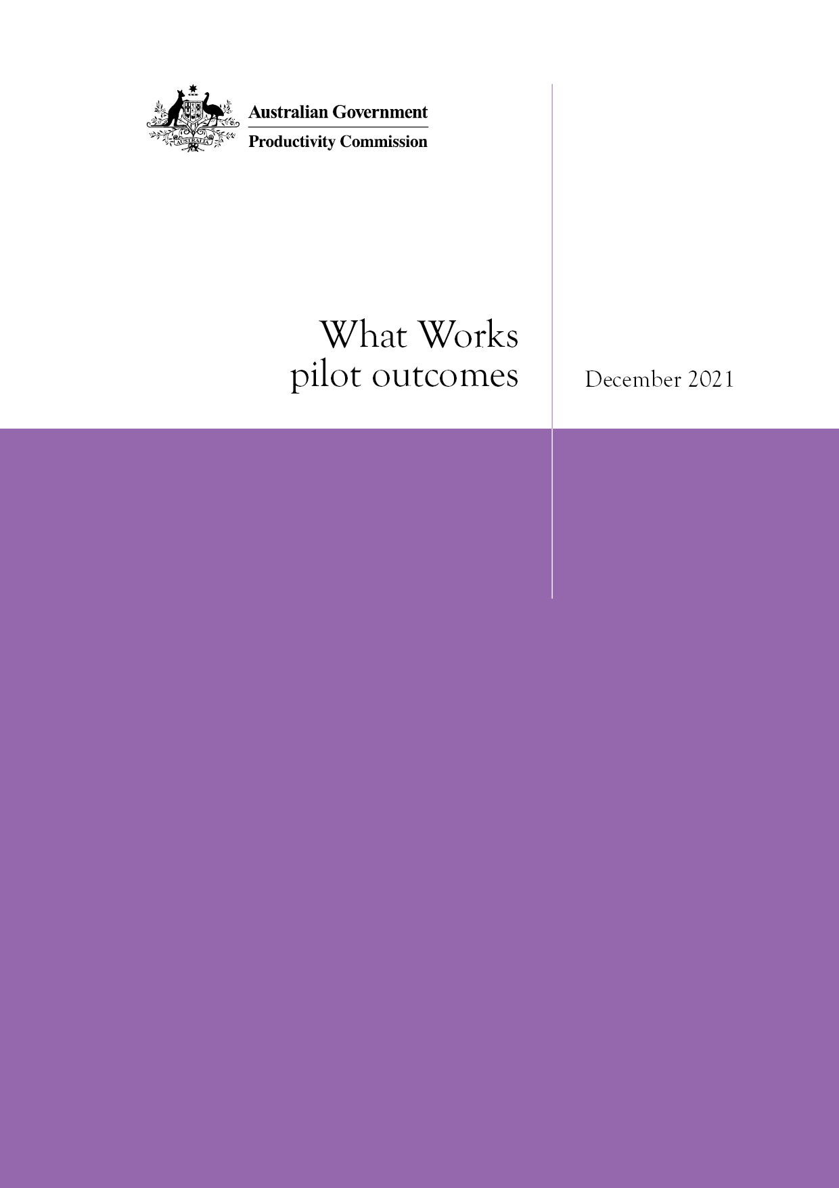
Productivity Commission

Commonwealth of Australia 2021
Except for the Commonwealth Coat of Arms and content supplied by third parties, this copyright work is licensed under a Creative Commons Attribution 3.0 Australia licence. To view a copy of this licence, visit http://creativecommons.org/licenses/by/3.0/au. In essence, you are free to copy, communicate and adapt the work, as long as you attribute the work to the Productivity Commission (but not in any way that suggests the Commission endorses you or your use) and abide by the other licence terms.
Use of the Commonwealth Coat of Arms
Terms of use for the Coat of Arms are available from the Department of the Prime Minister and Cabinet’s website: https://www.pmc.gov.au/government/commonwealth-coat-arms
Third party copyright
Wherever a third party holds copyright in this material, the copyright remains with that party. Their permission may be required to use the material, please contact them directly.
Attribution
This work should be attributed as follows, Source: Productivity Commission, What Works pilot outcomes.
If you have adapted, modified or transformed this work in anyway, please use the following, Source: based on Productivity Commission, What Works pilot outcomes.
An appropriate reference for this publication is:
Productivity Commission 2021, What Works pilot outcomes, Canberra.
Publications enquiries
Media, Publications and Web, phone: (03) 9653 2244 or email: mpw@pc.gov.au

The Productivity Commission
The Productivity Commission is the Australian Government’s independent research and advisory body on a range of economic, social and environmental issues affecting the welfare of Australians. Its role, expressed most simply, is to help governments make better policies, in the long term interest of the Australian community.
The Commission’s independence is underpinned by an Act of Parliament. Its processes and outputs are open to public scrutiny and are driven by concern for the wellbeing of the community as a whole.
Further information on the Productivity Commission can be obtained from the Commission’s website (www.pc.gov.au).

Acknowledgments
The Commission is grateful to all those who have given their time and expertise in support of the pilot of the What Works method.
The Commission wishes to particularly thank the Steering Committee for the Review of Government Service Provision, under the auspices of which the pilot was undertaken and the first review report was produced, and the Centre for Evidence and Implementation who provided guidance and feedback at various points throughout the process.

What Works pilot outcomes

Introduction
The Steering Committee for the Review of Government Service Provision agreed in 2016 to develop a reporting framework that would provide a practical approach to identify from existing research what works to improve service outcomes in areas covered by the Report on Government Services (RoGS).
Performance reporting (such as the RoGS) provides information about the delivery of outputs and outcomes, but not about how different inputs — involving government recurrent expenditure of around $276 billion annually — can be used to influence outcomes in service areas. Without analysis of causal links, long-term and cost-effective improvements in outcomes are only likely to be achieved through trial and error. A more rigorous and nuanced evidence base would enable governments to draw on policies, programs and interventions that work, and to learn from those that have not worked, and so deliver services more efficiently and effectively.

The What Works method
After considering different approaches, the Steering Committee decided to test a specialised What Works method. This method involves using a rigorous review protocol, similar to those used for systematic evidence assessments, which outlines how to develop the research question and to gather, synthesise and report the evidence (box 1). Key aspects of the method are to:
- use existing research, drawing on national and international evidence that meets an agreed evidence standard, to identify what works and key research gaps, to target where individual evaluations may be required
- report the evidence on what works, focusing on a specific aspect of a service that is causally linked to service outcomes, and consider tangible levers for governments/policy makers/providers to directly influence service outputs and outcomes
- reveal what doesn’t work (to prevent ‘re-inventing the wheel’)
- include, where possible, the costs and benefits for what works.

Box 1 What Works Review Protocol
The Protocol contains the following steps:
- develop a structured research question: define the scope of the review
- set inclusion/exclusion criteria and search strategy: refine the search and information repositories to be searched
- screen literature: apply inclusion/exclusion criteria and remove duplicate studies
- extract evidence: record material relevant to the review question
- assess evidence (for effectiveness studies): assess the robustness of the studies
- synthesise evidence: provide a narrative synthesis of the evidence coverage (and identify gaps), the findings and their implications, and areas for further research
- communicate findings: through written reports and other media
- follow up: monitor whether findings have been used, and implications for future studies.
Source: SCRGSP (2018). What Works Review Protocol, Productivity Commission, Canberra.
The approach involved the Productivity Commission (in its role as secretariat to the Steering Committee) piloting two types of reviews — an effectiveness review and a scoping review — to test the feasibility and usefulness of the What Works method. An effectiveness review examines whether one intervention is more effective than another or no intervention, and is typically used where an intervention is thought to cause a change or have an impact on a target group. Where little is known about a topic a scoping review is appropriate, which looks at what is known about an issue in a particular area.
The effectiveness review — published in October 2018 — considered interventions to support carers of people with dementia to prevent or delay entry into residential aged care. The review identified 44 randomised controlled trials of interventions, of which 26 were from studies assessed as high-quality. Only three of these 26 interventions were found to be effective. This result prevented conclusions being drawn from the review. However, there may be value in further testing.
The topic chosen for the scoping review was to find out what is known about systems that enable the public health approach to protecting children. A consultation paper was published in 2019 and the Commission then undertook a desktop analysis of feedback on this paper, and of the literature collected using the scoping review method. This analysis concluded that a coherent and well-communicated vision of the outcomes required from a system for protecting children is important for success. Governments must undertake wide ranging commissioning actions to turn the vision into reality, and face significant barriers in doing so. Key lessons are that governments need to adopt a systems approach to analysis, and should broaden the membership of those involved in system governance, reconfirm the vision, and improve commissioning processes.
While there have been some useful results from the two studies, the Steering Committee has decided to discontinue use of the What Works method, after considering:
- the degree to which the two pilot projects met the objectives of the What Works trial
- the benefits for policy makers, governments, service providers, researchers and clients
- the resources and capabilities required to undertake What Works reporting.

Lessons from the two pilot studies
The two chosen topics were relevant, and undertaking two different types of review was appropriate in the context of a pilot process. The first (effectiveness) review produced information that was accessible to the target audience (governments, policy makers, service providers, researchers and clients) — for example, it was well received by the limited number of industry representatives who were briefed on it prior to release and two respondents to a questionnaire saw value in future development of the review.
However, using the effectiveness review method meant that only a small number of studies were sufficiently rigorous to be included. While the project identified things that ‘work’, they were few in number and it was difficult to identify whether the findings were scalable. The small volume of evidence from Australia limited the utility of the review’s findings. For example, the review identified a successful case management intervention in Hong Kong, but Hong Kong has a different cultural context and aged care system. These features of the effectiveness review may have limited its usefulness for policy makers.
It was easier to maintain evidence standards in the effectiveness review, where standard tools can be used to assess peer reviewed quantitative evidence. By contrast, the limited evidence available on systems for protecting children meant that the second (scoping) review used a combination of peer reviewed literature, grey literature and feedback in response to a publicly released consultation paper. Applying the scoping review method to such a complex topic — involving analysis of the systems that enable the public health approach to protecting children — led to some material that might have been useful and relevant being omitted because it was not directly linked to systems and to the public health approach. It became difficult to assimilate the various literature types (particularly when overlaying the ‘systems’ focus on to child protection issues) and to accord them priority. The use of qualitative evidence of differing degrees of rigour led to researchers drawing conclusions that may have appeared to be ‘opinions’ when in fact it was the research process itself, by bringing in less rigorous evidence that was difficult to assess, which required judgements to be made.
Undertaking these reviews identified two capabilities needed to conduct them successfully. Staff need to understand the research methods used for systematic evidence assessments, and to possess sufficient subject matter expertise to interpret material identified through the reviews. The focus on ‘systems’ in the second review was challenging in its complexity — requiring additional consideration to determine the relevance of any piece of information to systems (rather than practices which result from systems) as well as to child protection.
Access to infrastructure such as academic databases is also needed. Many organisations that would ordinarily use this research method are affiliated with universities.
Overall, while systematic evidence reviews using the What Works method have the benefit of a rigorous process, they may not always yield practical and useful information for policymakers. In complex areas such as social policy where interventions are often far more context dependent, judgments based on informal knowledge and practical wisdom are also needed to make assessments of the quality and usefulness of evidence. For the scoping review, while the Commission applied the method up to the point of sourcing evidence, it decided from then onwards to make its own interpretation of this evidence in order to draw out conclusions that were relevant for policy makers.
It remains important for policy makers to build their understanding of ‘what works’ but there are other ways in which this can be done, including through the Commission’s research program and inquiries. A key lesson is the importance of tailoring the research method to the question, rather than developing the method and then forcing it on the question.

The Steering Committee has 22 members from central agencies across Commonwealth, State and Territory Governments. It collects and publishes data enabling ongoing comparisons of the efficiency and effectiveness of Commonwealth and State government services, including intra-government services.
Steering Committee for the Review of Government Service Provision (SCRGSP) (2021) Report on Government Services, Part A section 1 https://www.pc.gov.au/research/ongoing/report-on-government-services/2021/approach/performance-measurement.
Effectiveness reviews assess the quality of published evidence. Scoping reviews are used when there is limited evidence on a topic.
SCRGSP (2018) Interventions to support carers of people with dementia, Productivity Commission, Canberra.
SCRGSP (2019) What is known about systems that enable the ‘public health approach’ to protecting children, Productivity Commission, Canberra.
The Commission completed this analysis following the cessation of the What Works pilot. Therefore, the findings were published as a Commission report, not a Steering Committee report. See Productivity Commission (2021) Enabling the public health approach to protecting children, What Works, Canberra

