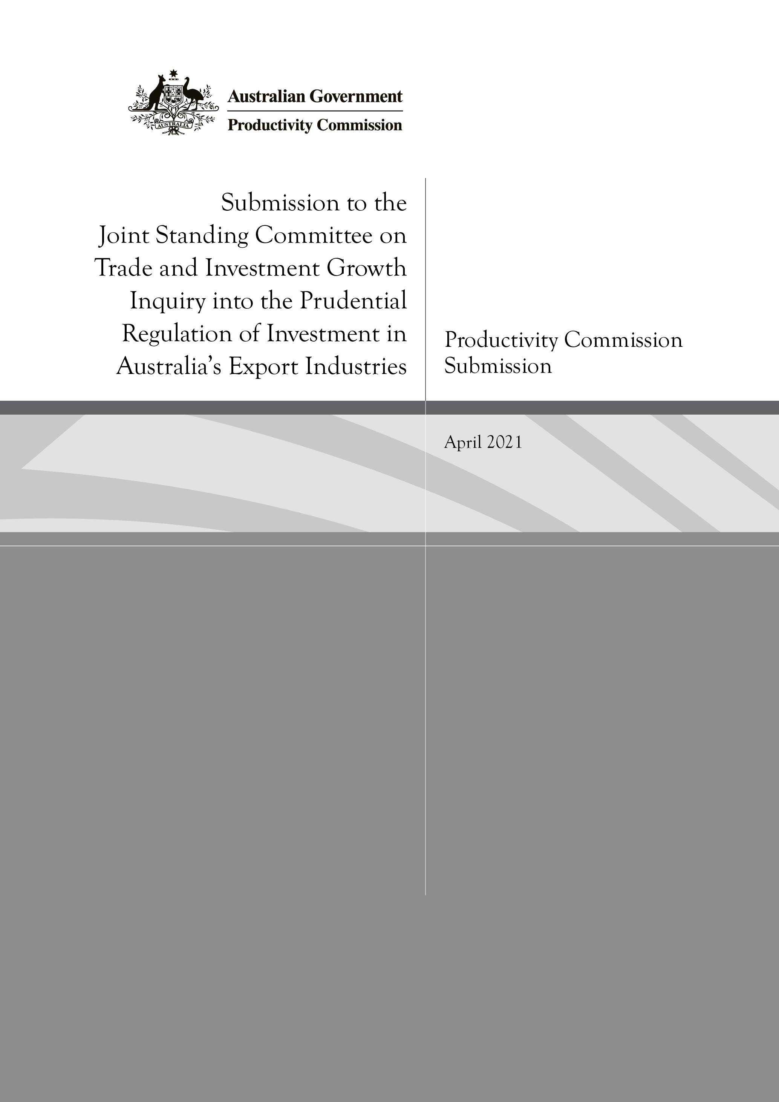

Submission to the Joint Standing Committee on Trade andInvestment Growth Inquiry into the Prudential Regulation of Investment in Australia’s Export Industries
Productivity Commission submission to the

Thank you for inviting the Productivity Commission to make a submission to this Inquiry.
As you are aware the Commission completed a report into Competition in the Australian Financial System in June 2018. In that report we did not distinguish between export industries and other Australian businesses that rely on finance through Australia’s regulated financial institutions. However, we did note that some businesses, in particular small and medium size enterprises (SMEs), can face significant hurdles to gaining funding due to the prudential regulation imposed on authorised deposit-taking institutions (ADIs).
In particular, we noted two underlying factors:
- The high level of regulatory capital under the Australian Prudential Regulation Authority’s (APRA) standard risk weight rules that a bank needs to hold for a SME loan that is not secured by a residential property.
We noted that (at the time of our report):
For SME loans, APRA currently applies a single risk weight (of 100%) to all SME lending not secured by a residence, with no delineation allowed for the size of borrowing, the form of borrowing (term loan, line of credit or overdraft) or the risk profile of the SME borrowing the funds (p. 32).
The Commission noted that the standardised risk weights applied by APRA for SME lending tend to exceed the Basel II and Basel III standards and ‘are in many cases higher than those applied in other countries’ (p. 449 and table 16.1).
- The reduction in effective competition across ADIs due to the difference in risk weights for SME loans under APRAs standard approach and the weights applied by the small number of (generally large) ADIs that can use an internal risk-weight (IRB) model.
As a consequence, for a SME loan that is not secured by a residence, Australia’s smaller banks need to hold up to twice as much capital as the major banks — in effect, paying up to twice as much to be able to offer loans to their customers. This difference is smaller for loans secured against a residence (p. 32)
The Commission noted that, as a consequence of APRA’s approach, ADIs have ‘a strong preference for home loan lending over business lending (unless secured by residential property)’ (p. 32). Further, lending to SMEs is dominated by the four major banks (p. 443).
The Commission recommended a change to the existing approach (recommendation 16.1):
Instead of applying a single risk weight to all small and medium business lending not secured by a residence, APRA should provide for a broader schedule of risk weights in its Australian Prudential Standard (APS 112).
It should take into account the different risk profile and the type of lending (such as the value of the loans made to an individual business and alternative forms of loan security including commercial property and differing loan to value ratios on this security) to better reflect the Basel Committee’s standardised risk weightings.
In light of apparent major improvements in the collection and use of data (including via the New Payments Platform), APRA should also consider proposals by authorised deposit-taking institutions (ADIs) for variations from the standardised risk assessment for small and medium enterprise lending, based on the ADI improving its data and risk management systems. International best practice should be closely considered as APRA reviews proposals from ADIs.
The Commission recognises that not all exporters are SMEs. Nor do all exporters have to rely on finance from an ADI. However, we consider the recommended change of approach by APRA can create significant benefits for many SMEs, including those involved in export sectors.
Finally, the Commission notes that we are currently investigating a competitive neutrality complaint regarding the recently established Australian Business Growth Fund (ABGF) which relates to the prudential rules associated with the provision of finance by ADIs to SMEs. The ABGF is a consortium of banks and the Australian Government that intends to provide equity funding to SMEs with growth potential. APRA applies lower risk weights for the equity investments by the ABGF than would normally be the case for equity financing by ADIs. A complaint has alleged that the lower weights reflect the Australian Government’s involvement in the Fund. The Commission has not yet determined whether in this particular context the lower risk rating breaches Commonwealth competitive neutrality principles, though will advise the Committee of our conclusion if that is produced in time. Regardless, evidence from the Australian Government Treasury and APRA before the Economic Legislation Committee (13 February 2020) on the Australian Business Growth Fund Bill 2019 may be useful more generally on how capital requirements are considered for financing by ADIs.

