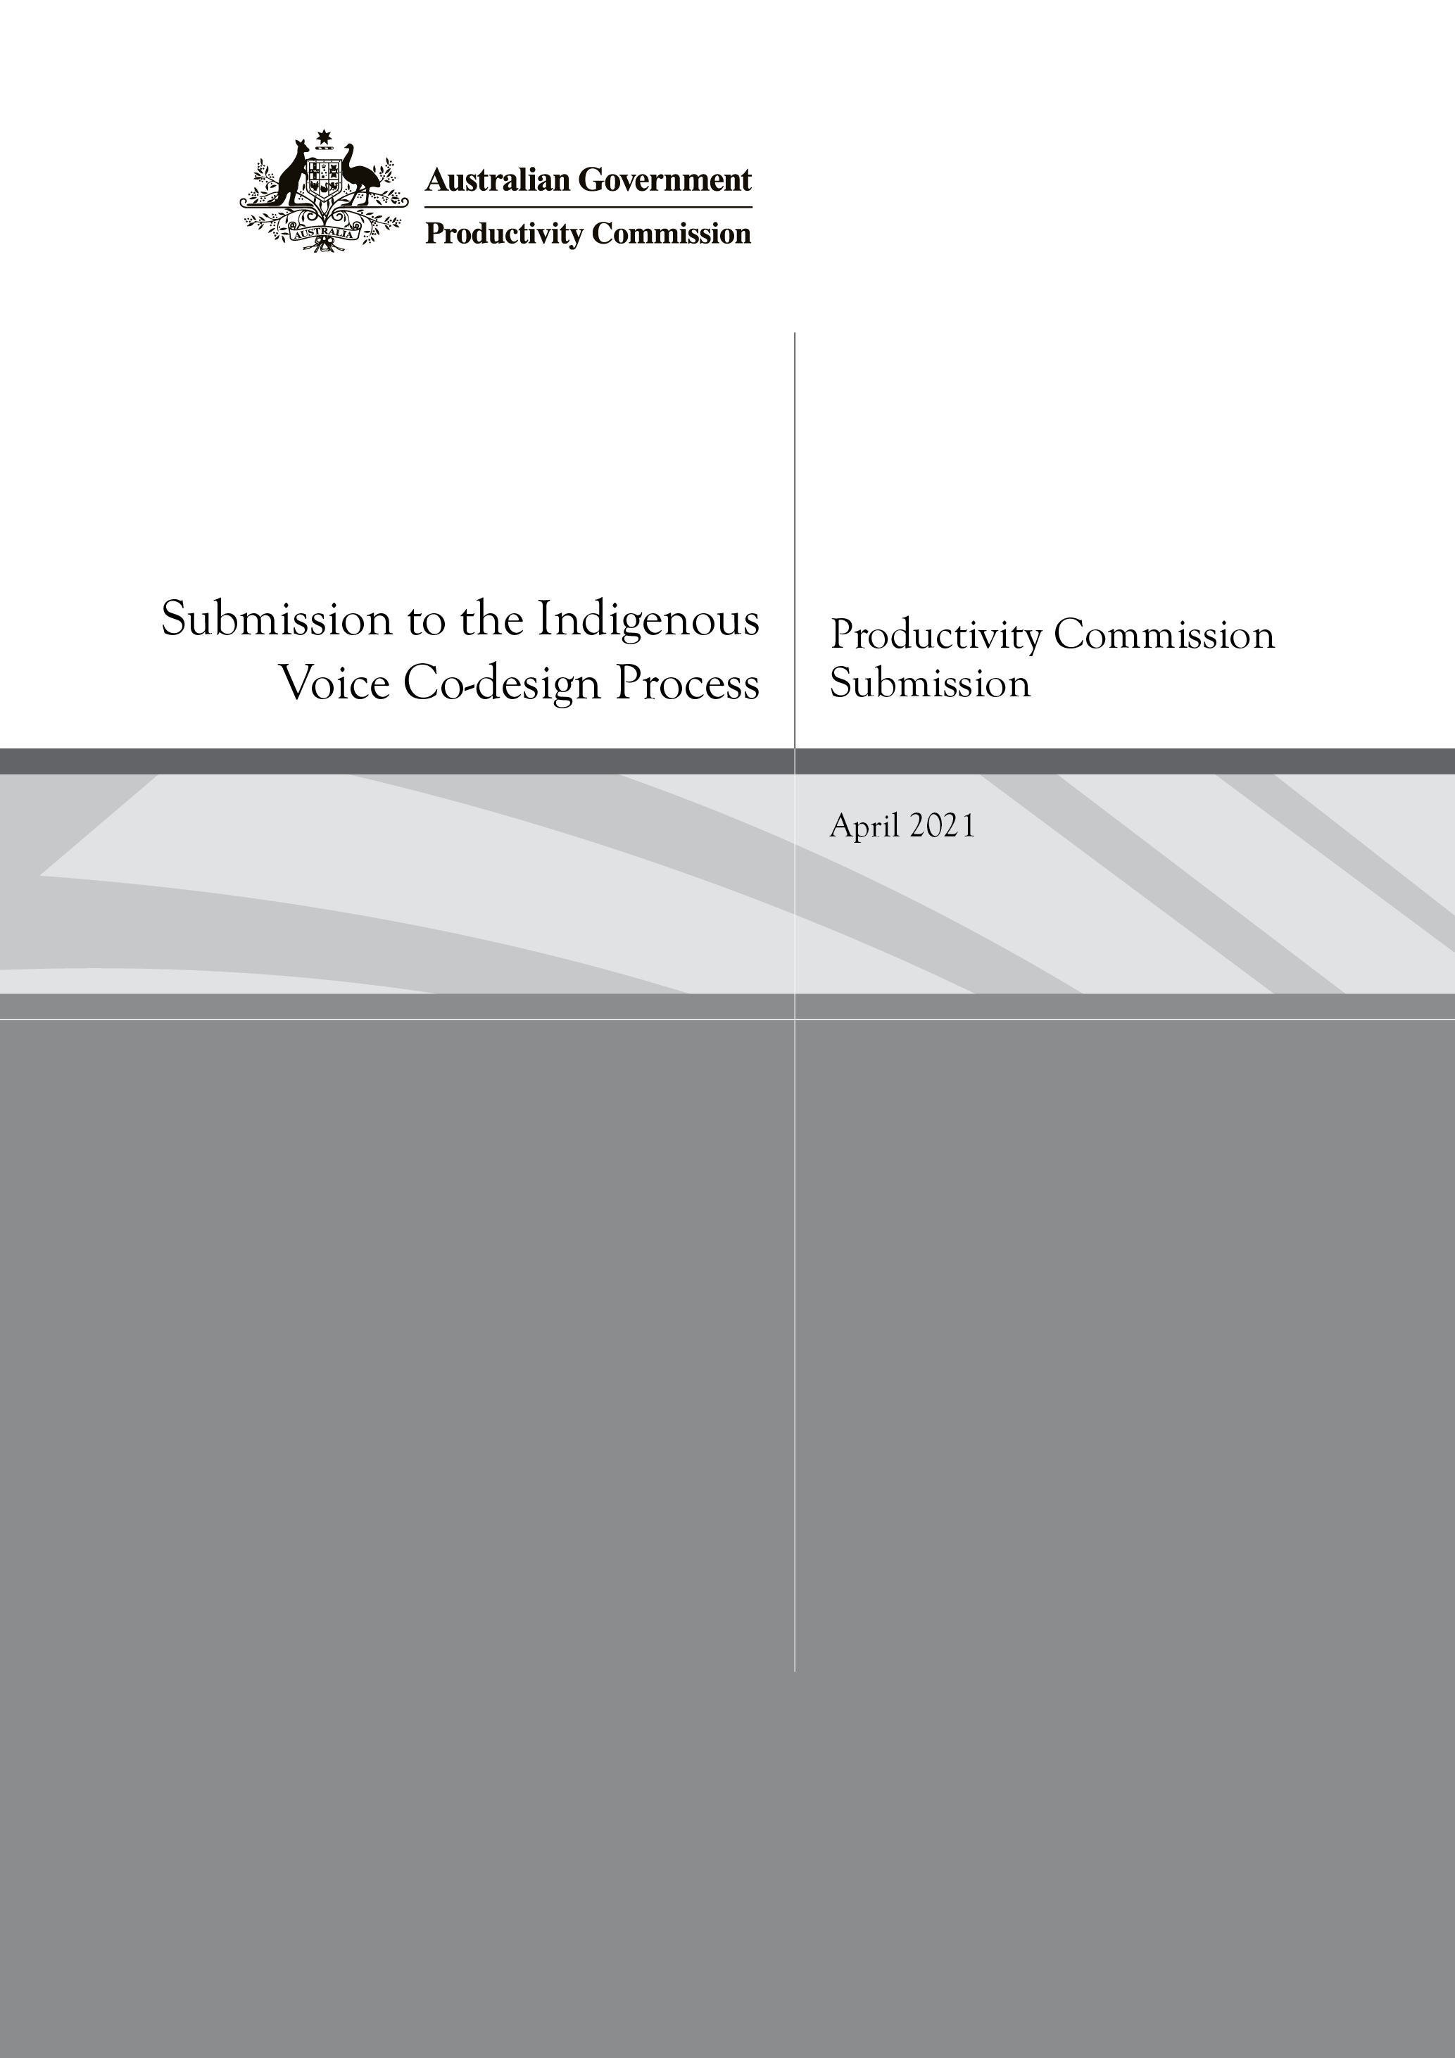
Productivity Commission Submission to the Indigenous Voice Co-design Process
April 2021

The Productivity Commission is pleased to offer this submission to the Indigenous Voice Co-design Process as part of the consultation on proposals presented in the Interim Report. The submission outlines aspects of the Commission’s work that may be relevant in supporting the Indigenous Voice, noting that the proposal for the National Voice envisages drawing on policy and expert input.
The Commission is the Australian Government’s independent research and advisory body on a range of economic, social and environmental issues affecting the welfare of Australians. It contributes by providing quality advice and information to inform government decision making, and on the communication of ideas and analysis.
Key features of the Commission include its independence — while the Australian Government largely determines the work program, the Commission’s findings and recommendations are based on its own analyses and judgments — and its open and transparent processes, which allow for extensive public engagement and input.
The Commission’s activities cover all levels of government, and encompass all sectors of the Australian economy, as well as social and environmental issues.
The Commission has several work streams. It conducts public inquiries at the request of the Australian Government on key policy or regulatory issues bearing on Australia’s economic performance and community wellbeing. In addition, we undertake research at the request of the Government, as well as ongoing reporting in several areas and self-initiated research. The Commission acts as secretariat to the inter-governmental Review of Government Service Provision. We also have reporting and review functions under the National Agreement on Closing the Gap. These are outlined in more detail below.
Across these work streams, the Commission examines issues that affect the Australian community broadly (‘mainstream’ policy), as well as some that are specific to Aboriginal and Torres Strait Islander people. Examples are provided below.
The Commission comprises its Chair and between four and twelve other Commissioners. The Productivity Commission Act 1998 requires that some Commissioners have particular skills and experience in: environmental issues; social policy; Australian industry; and policies and programs affecting Aboriginal and Torres Strait Islander people and in Indigenous communities. The work of the Commission is assisted by a professional staff of Australian Public Service employees.
In undertaking its work, and as reflected in the Corporate Plan 2020-2021, the Productivity Commission is committed to continuing to develop its cultural capability — including our understanding of and responsiveness to Aboriginal and Torres Strait Islander people, their cultures, histories, knowledges, and perspectives — and adapt its processes to engage and work more effectively with Aboriginal and Torres Strait Islander people.
Public inquiries and research requested by Government
Work commissioned by the Australian Government generally takes two forms — public inquiries and research studies — with similar processes applying in respect of both.
Where policy issues to be addressed by the Commission require extensive public consultation and exposure — either because they may have a significant impact on different groups within society, or are otherwise contentious or complex to assess — they are typically handled through formal public inquiries.
The Commission’s focus in inquiries is guided by a terms of reference sent by the Treasurer. The terms of reference reflects the focus and scope agreed by the Australian Government, often in consultation with other governments and community groups given the Commission’s community-wide focus. Some references arise from other processes, such as parliamentary inquiries, or from legislation.
In order to allow participants time to prepare submissions and respond to a draft report, including through public hearings, most inquiries specify a duration of 12 months. More pressing matters can be dealt with in six months or less, and some take longer because of their complexity and/or to ensure adequate time for engagement.
The Commission may be required to provide the Government with policy options representing alternative means of addressing the issues, as well as a preferred option. The Commission may also make recommendations on any matters it considers relevant to the inquiry, consistent with its statutory policy guidelines.
Submissions and transcripts of public hearings are posted on the Commission’s website as the inquiry progresses. Final inquiry reports must be tabled in Parliament within 25 sitting days of the Government receiving the report.
Some recent inquiries include:
- Mental Health (2020), which looked at key influences on mental health and its implications, and made recommendations for an improved mental health system that is person centred. Several of the recommended actions relate specifically to empowering Aboriginal and Torres Strait Islander people to make decisions about their social and emotional wellbeing, while some others go to mainstream services being culturally capable.
- Murray Darling Basin Plan: Five Year assessment (2109) and National Water Reform (2018), which are regular review functions of the Commission under the Water Act 2007 (Cth), and include consideration of Indigenous values and uses of water.
- Human Services (2018), which made recommendations on how to apply increased competition, contestability and informed user choice to improve outcomes for users and the community as a whole. This included in respect of social housing, public dental services, and services in remote Indigenous communities.
In some cases, the Government may ask the Commission to conduct research on a topic which, while important, is seen as requiring less formal public consultation than a public inquiry. The processes for a research study are similar to that for an inquiry, including with respect to the development and issuance of a terms of reference. The key differences are that there are no public hearings (but there are roundtables, workshops and other consultative forums, as well as generally submissions and the release of a draft report) and the final report is not tabled in the Parliament (it is released by the Commission).
Some recent examples of research studies are:
- Expenditure on Children in the Northern Territory (2020), which arose from the Royal Commission into the Protection and Detention of Children in the Northern Territory. The study was about how the Commonwealth and the Northern Territory governments can work more collaboratively to improve outcomes for children and families.
- Resources Sector Regulation (2020), which examines regulation of the resources sector, identifying issues and leading practice approaches to addressing them. This included consideration of Indigenous heritage protection regimes, and community engagement and benefit sharing.
The Commission has review functions in respect of nationally significant sector-wide inter-governmental agreements which are undertaken as research studies. The Commission has reviewed the National Disability Agreement (2018) and the National Agreement for Skills and Workforce Development (2020).
In addition, the Commission has a role in contributing to better evaluation of policies and programs affecting Aboriginal and Torres Strait Islander people. This includes the development of a proposed Indigenous Evaluation Strategy, which puts Aboriginal and Torres Strait Islander people at its centre and provides a framework for Australian Government agencies for evaluating policies and programs affecting Aboriginal and Torres Strait Islander people.
The Commission also produces productivity reform case studies for the Council on Federal Financial Relations. The most recent was on Innovations in Care in Chronic Health Conditions, which included innovations in Indigenous health.
Self-initiated research
The Commission has a statutory mandate to conduct a program of research to support its inquiries, annual reporting and other responsibilities, including promoting community awareness and understanding of various productivity and regulatory issues.
A key part of the Commission’s research program are reports which provide evidence on topical policy issues and help to outline future directions for reform. The Commission identifies research topics based on issues emerging in its other work and in public debate.
Research papers over recent years have included: young people’s incomes (2020), inequality (2018), and Indigenous primary school achievement (2016).
Performance monitoring and reporting
The Commission provides secretariat and research support to the inter-governmental Steering Committee for Review of Government Service Provision, which was established under the Council of Australian Governments. With the Commission’s support, the Steering Committee undertakes three streams of reporting for the Commonwealth, State and Territory Governments.
- The Report on Government Services (RoGS)
- The annual RoGS provides information on the equity, effectiveness and efficiency of a range of government services, including health, education, justice, housing and community services, and has a reference list for performance indicator data disaggregated for Aboriginal and Torres Strait Islander people. The RoGS encourages improved service delivery by providing governments, taxpayers and users of services with meaningful, balanced, credible, comparative information.
- The Overcoming Indigenous Disadvantage: Key indicators report (OID)
- The OID, last published in December 2020, is a regular report on outcomes for Aboriginal and Torres Strait Islander people, across a strategic framework of indicators. This report’s long-term objective is to inform Australian governments and Aboriginal and Torres Strait Islander people about whether policies and programs are achieving positive outcomes for Aboriginal and Torres Strait Islander people.
- The Indigenous Expenditure Report
- The Indigenous Expenditure Report, last published in October 2017, provides estimates of expenditure on services to Aboriginal and Torres Strait Islander people. These estimates, when combined with other information (such as outcomes for Aboriginal and Torres Strait Islander people) are intended to contribute to a better understanding of the adequacy, effectiveness and efficiency of government services provided to Aboriginal and Torres Strait Islander people.
In addition, the Commission maintains the Performance Reporting Dashboard, which provides a single, streamlined source of information on progress towards key commitments made by the Council of Australian Governments.
Closing the Gap functions
The Commission has a significant role under the National Agreement on Closing the Gap. The Commission is developing and maintaining a publicly accessible dashboard and annual data compilation report, underpinned by an information repository, to inform reporting on progress. The first editions of the dashboard and report are scheduled for late June and late July 2021 respectively. The Commission will also undertake an independent review of progress every three years, which will be complementary to a three-yearly Aboriginal and Torres Strait Islander-led review.
______
In summary, across its various streams of work, the Commission examines a range of issues and produces information sets that may be relevant in supporting the Indigenous Voice. There are a variety of means by which the work is initiated — terms of reference from the Treasurer, specific legislation, work on behalf of inter-governmental groups, the National Agreement on Closing the Gap, and some self-initiated — common features across the Commission’s work are independence and transparency.

The Commission is required under its Act to report annually not only on its activities, but also on industry and productivity performance generally, as well as on the effects of industry assistance and regulation. The annual Trade and Assistance Review and Productivity Insights series are the relevant publications.

